LOCATION.--Lat 42°13'32", long 92°36'39" referenced to North American Datum of 1927, Tama County, IA, Hydrologic Unit 07080205, on left bank 10 ft downstream from bridge on I Avenue, 4.4 mi southeast from Lincoln, 1.0 mi upstream from Half Mile Creek, and 5.5 mi upstream from mouth.

DRAINAGE AREA.--13.78 mi².

PERIOD OF RECORD.--Discharge records from October 1962 to September 1967, October 1969 to September 1974, June 1976 to September 1980.

GAGE.--Water-stage recorder and concrete control with V-notch sharp-crested weir. Datum of gage is 931.26 ft above National Geodetic Vertical Datum of 1929.

A summary of all available data for this streamgage is provided through the USGS National Water Information System web interface (NWISWeb). The following link provides access to current/historical observations, daily data, daily statistics, monthly statistics, annual statistics, peak streamflow, field measurements, field/lab water-quality samples, and the latest water-year summaries. Data can be filtered by parameter and/or dates, and can be output in various tabular and graphical formats.
http://waterdata.usgs.gov/nwis/inventory/?site_no=05464130

The USGS WaterWatch Toolkit is available at:
http://waterwatch.usgs.gov/?id=ww_toolkit
Tools for summarizing streamflow information include the duration hydrograph builder, the cumulative streamflow hydrograph builder, the streamgage statistics retrieval tool, the rating curve builder, the flood tracking chart builder, the National Weather Service Advanced Hydrologic Prediction Service (AHPS) river forecast hydrograph builder, and the raster-hydrograph builder. Entering the above number for this streamgage into these toolkit webpages will provide streamflow information specific to this streamgage.

A description of the statistics presented for this streamgage is available in the main body of the report at:
http://dx.doi.org/10.3133/ofr20151214
A link to other streamgages included in this report, a map showing the location of the streamgages, information on the programs used to compute the statistical analyses, and references are included in the main body of the report.

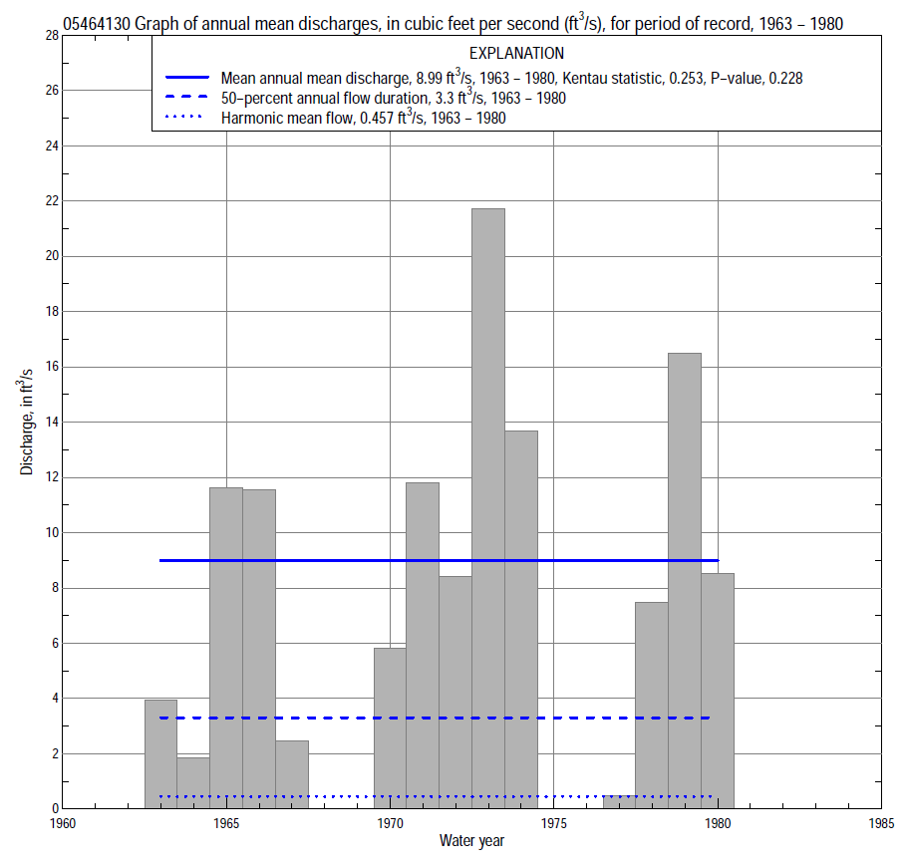

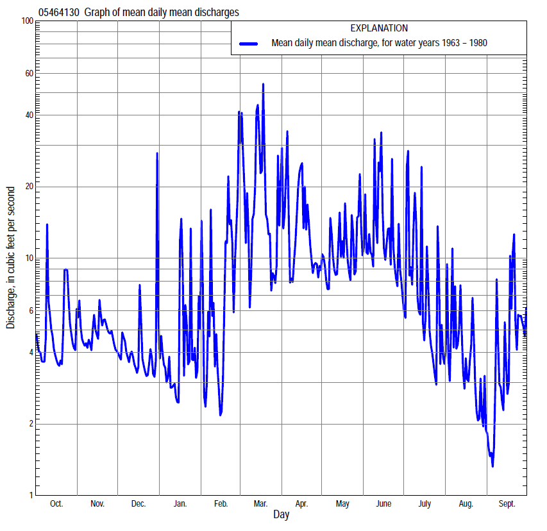

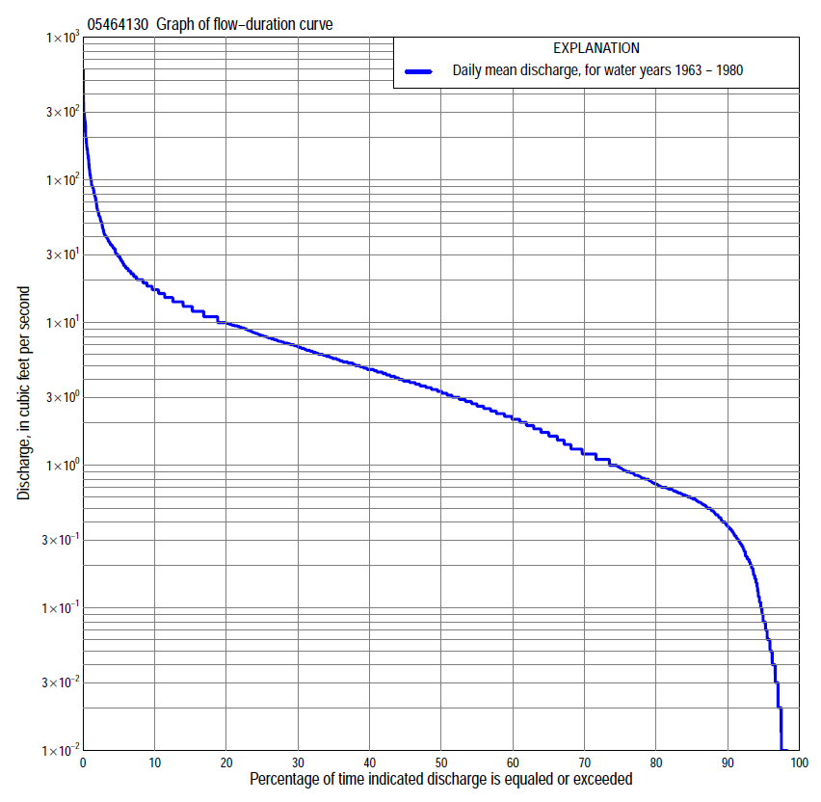

Statistics Based on the Entire Streamflow Period of Record
05464130 Monthly and annual flow durations, based on 1963–67, 1970–74, 1977–80 period of record (14 years)
Percentage of days discharge equaled or exceeded |  |  |  |  | Discharge (cubic feet per second) |  |  |  |  |  |  |  |  | Annual flow durations
 | Oct | Nov | Dec | Jan | Feb | Mar | Apr | May | June | July | Aug | Sept | Annual | Kentau statistic | P-value
99 | 0.06 | 0.04 | 0.00 | 0.00 | 0.00 | 0.18 | 0.07 | 0.01 | 0.01 | 0.01 | 0.04 | 0.02 | 0.00 | 0.209 | 0.161
98 | 0.07 | 0.05 | 0.00 | 0.00 | 0.00 | 0.22 | 0.11 | 0.01 | 0.01 | 0.01 | 0.06 | 0.03 | 0.01 | 0.209 | 0.161
95 | 0.09 | 0.08 | 0.00 | 0.00 | 0.00 | 0.36 | 0.41 | 0.03 | 0.04 | 0.02 | 0.14 | 0.04 | 0.08 | 0.121 | 0.485
90 | 0.21 | 0.52 | 0.28 | 0.36 | 0.33 | 0.65 | 2.0 | 1.2 | 1.2 | 0.58 | 0.29 | 0.23 | 0.37 | 0.308 | 0.097
85 | 0.47 | 0.59 | 0.42 | 0.45 | 0.50 | 0.85 | 2.4 | 1.9 | 1.9 | 0.85 | 0.41 | 0.32 | 0.59 | 0.286 | 0.147
80 | 0.62 | 0.64 | 0.53 | 0.55 | 0.62 | 1.1 | 2.8 | 2.6 | 2.6 | 1.1 | 0.55 | 0.45 | 0.74 | 0.176 | 0.392
75 | 0.68 | 0.71 | 0.68 | 0.68 | 0.72 | 1.9 | 3.5 | 3.0 | 3.5 | 1.3 | 0.62 | 0.59 | 1.0 | 0.209 | 0.308
70 | 0.80 | 0.81 | 0.80 | 0.81 | 1.0 | 2.9 | 3.9 | 3.3 | 4.2 | 1.6 | 0.78 | 0.75 | 1.2 | 0.187 | 0.365
65 | 1.0 | 1.5 | 1.0 | 1.0 | 1.2 | 3.9 | 4.5 | 3.7 | 5.3 | 2.0 | 0.90 | 0.82 | 1.7 | 0.220 | 0.285
60 | 1.3 | 1.8 | 1.2 | 1.2 | 1.3 | 4.5 | 4.8 | 4.1 | 6.1 | 2.5 | 1.1 | 0.90 | 2.1 | 0.275 | 0.182
55 | 2.2 | 2.1 | 1.4 | 1.3 | 1.6 | 5.3 | 5.3 | 5.0 | 6.9 | 2.9 | 1.3 | 1.1 | 2.6 | 0.264 | 0.202
50 | 2.6 | 2.5 | 1.8 | 1.6 | 2.0 | 6.9 | 5.9 | 6.4 | 7.6 | 3.4 | 1.6 | 1.3 | 3.3 | 0.220 | 0.292
45 | 3.0 | 3.4 | 3.2 | 2.3 | 2.3 | 8.0 | 7.2 | 7.9 | 8.4 | 3.9 | 2.0 | 1.5 | 3.9 | 0.220 | 0.294
40 | 3.7 | 4.1 | 3.9 | 2.9 | 2.4 | 9.3 | 8.8 | 8.8 | 9.8 | 4.5 | 2.3 | 1.8 | 4.7 | 0.275 | 0.186
35 | 4.7 | 5.2 | 4.8 | 3.3 | 3.4 | 11 | 9.9 | 9.6 | 11 | 5.3 | 2.7 | 2.0 | 5.6 | 0.231 | 0.272
30 | 5.3 | 6.2 | 5.5 | 3.8 | 4.7 | 14 | 11 | 11 | 13 | 6.4 | 3.2 | 2.3 | 6.8 | 0.275 | 0.184
25 | 6.1 | 7.6 | 6.0 | 4.4 | 5.8 | 16 | 12 | 13 | 14 | 7.4 | 3.9 | 3.0 | 8.1 | 0.264 | 0.206
20 | 7.4 | 9.3 | 7.0 | 5.1 | 6.6 | 20 | 14 | 16 | 17 | 8.5 | 4.6 | 4.5 | 9.9 | 0.209 | 0.321
15 | 9.8 | 10 | 7.7 | 6.5 | 8.6 | 28 | 17 | 18 | 20 | 11 | 5.7 | 6.5 | 13 | 0.176 | 0.409
10 | 13 | 13 | 8.8 | 8.5 | 14 | 40 | 23 | 24 | 27 | 14 | 7.0 | 9.7 | 17 | 0.176 | 0.411
5 | 18 | 15 | 12 | 13 | 40 | 84 | 36 | 35 | 39 | 22 | 18 | 21 | 29 | 0.209 | 0.323
2 | 25 | 20 | 15 | 26 | 80 | 167 | 130 | 61 | 89 | 76 | 30 | 40 | 61 | 0.220 | 0.298
1 | 40 | 24 | 24 | 70 | 120 | 258 | 245 | 104 | 108 | 123 | 42 | 53 | 108 | 0.242 | 0.250

05464130 Annual exceedance probability of instantaneous peak discharges, in cubic feet per second (ft³/s), based on the Weighted Independent Estimates method,
Annual exceed-ance probability | Recur-rence interval (years) | Discharge (ft³/s) | 95-percent lower confi-dence interval (ft³/s) | 95-percent upper confi-dence interval (ft³/s)
0.500 | 2 | 458 | 334 | 629
0.200 | 5 | 937 | 711 | 1,240
0.100 | 10 | 1,440 | 1,100 | 1,880
0.040 | 25 | 2,240 | 1,690 | 2,970
0.020 | 50 | 2,790 | 2,050 | 3,780
0.010 | 100 | 3,300 | 2,360 | 4,620
0.005 | 200 | 4,040 | 2,770 | 5,890
0.002 | 500 | 4,520 | 2,950 | 6,910
and based on the expected moments algorithm/multiple Grubbs-Beck analysis computed using a historical period length of 18 years (1963–1980)
0.500 | 2 | 425 | 265 | 607
0.200 | 5 | 742 | 507 | 1,090
0.100 | 10 | 959 | 665 | 1,540
0.040 | 25 | 1,230 | 844 | 2,320
0.020 | 50 | 1,420 | 956 | 3,060
0.010 | 100 | 1,610 | 1,050 | 3,960
0.005 | 200 | 1,790 | 1,130 | 5,050
0.002 | 500 | 2,020 | 1,210 | 6,850
Kentau statistic |  | 0.429
P-value |  | 0.037
Begin year |  | 1963
End year |  | 1980
Number of peaks |  | 14

05464130 Annual exceedance probability of high discharges, based on 1963–67, 1970–74, 1977–80 period of record (14 years)
Annual exceedance probability | Recur-rence interval (years) | Maximum average discharge (ft³/s) for indicated number of consecutive days
 |  | 1 | 3 | 7 | 15 | 30
0.990 | 1.01 | 20 | 10 | 4.8 | 3.0 | 1.9
0.950 | 1.05 | 46 | 23 | 12 | 7.3 | 4.7
0.900 | 1.11 | 68 | 35 | 18 | 11 | 7.3
0.800 | 1.25 | 105 | 55 | 30 | 18 | 12
0.500 | 2 | 214 | 118 | 69 | 42 | 27
0.200 | 5 | 377 | 218 | 135 | 82 | 54
0.100 | 10 | 479 | 285 | 182 | 111 | 73
0.040 | 25 | 597 | 365 | 242 | 147 | 98
0.020 | 50 | 675 | 419 | 284 | 173 | 115
0.010 | 100 | 745 | 470 | 325 | 198 | 132
0.005 | 200 | 807 | 516 | 364 | 221 | 148
0.002 | 500 | 880 | 572 | 412 | 250 | 168
Kentau statistic |  | 0.111 | 0.085 | 0.124 | 0.111 | 0.137
P-value |  | 0.542 | 0.647 | 0.493 | 0.542 | 0.446

 | 05464130 Annual nonexceedance probability of low discharges, based on April 1963 to March 1967, April 1970 to March 1974, April 1977 to March 1980 period of record (11 years)
Annual nonexceed-ance probability | Recur-rence interval (years) | Minimum average discharge (cubic feet per second) for indicated number of consecutive days
 |  | 1 | 3 | 7 | 14 | 30 | 60 | 90 | 120 | 183
0.01 | 100 | 0.00 | 0.00 | 0.00 | 0.00 | 0.01 | 0.01 | 0.01 | 0.03 | 0.18
0.02 | 50 | 0.00 | 0.00 | 0.00 | 0.01 | 0.01 | 0.02 | 0.02 | 0.05 | 0.26
0.05 | 20 | 0.00 | 0.00 | 0.00 | 0.03 | 0.04 | 0.05 | 0.07 | 0.12 | 0.43
0.10 | 10 | 0.06 | 0.06 | 0.07 | 0.08 | 0.09 | 0.13 | 0.16 | 0.25 | 0.67
0.20 | 5 | 0.13 | 0.15 | 0.17 | 0.18 | 0.22 | 0.33 | 0.40 | 0.54 | 1.1
0.50 | 2 | 0.31 | 0.37 | 0.44 | 0.60 | 0.84 | 1.4 | 1.8 | 2.0 | 3.0
0.80 | 1.25 | 0.73 | 0.9 | 1.0 | 1.4 | 2.1 | 3.6 | 5.6 | 5.8 | 7.5
0.90 | 1.11 | 1.2 | 1.4 | 1.6 | 1.8 | 3.0 | 5.1 | 8.7 | 9.4 | 12
0.96 | 1.04 | 2.0 | 2.3 | 2.5 | 2.7 | 4.0 | 6.8 | 13 | 15 | 19
0.98 | 1.02 | 2.9 | 3.2 | 3.4 | 3.6 | 4.5 | 7.8 | 16 | 19 | 26
0.99 | 1.01 | 4.1 | 4.4 | 4.5 | 4.6 | 5.0 | 8.6 | 19 | 24 | 33
Kentau statistic |  | 0.200 | 0.218 | 0.164 | 0.200 | 0.273 | 0.164 | 0.127 | 0.091 | 0.200
P-value |  | 0.436 | 0.390 | 0.533 | 0.436 | 0.276 | 0.533 | 0.640 | 0.756 | 0.436

05464130 Annual nonexceedance probability of seasonal low discharges, based on October 1962 to September 1967, October 1969 to September 1974, July 1976 to September 1980 period of record (14–15 years)
Annual nonexceed-ance probability | Recur-rence interval (years) | Minimum average discharge (cubic feet per second) for indicated number of consecutive days
 |  | 1 | 7 | 14 | 30 |  | 1 | 7 | 14 | 30
 |  | January-February-March |  |  |  |  | April-May-June
0.01 | 100 | 0.00 | 0.00 | 0.00 | 0.00 |  | 0.00 | 0.00 | 0.01 | 0.01
0.02 | 50 | 0.00 | 0.00 | 0.00 | 0.00 |  | 0.01 | 0.01 | 0.02 | 0.04
0.05 | 20 | 0.00 | 0.00 | 0.00 | 0.00 |  | 0.05 | 0.07 | 0.09 | 0.16
0.10 | 10 | 0.10 | 0.15 | 0.23 | 0.37 |  | 0.19 | 0.23 | 0.29 | 0.48
0.20 | 5 | 0.20 | 0.34 | 0.46 | 0.64 |  | 0.64 | 0.79 | 0.93 | 1.4
0.50 | 2 | 0.58 | 1.0 | 1.2 | 1.5 |  | 3.2 | 3.8 | 4.2 | 5.7
0.80 | 1.25 | 1.8 | 2.6 | 2.8 | 4.2 |  | 7.0 | 7.8 | 8.9 | 11
0.90 | 1.11 | 3.4 | 4.3 | 4.5 | 7.4 |  | 8.4 | 9.1 | 11 | 13
0.96 | 1.04 | 6.9 | 7.2 | 7.4 | 15 |  | 9.3 | 9.8 | 12 | 14
0.98 | 1.02 | 10 | 10 | 10 | 23 |  | 9.5 | 10 | 12 | 15
0.99 | 1.01 | 12 | 13 | 14 | 36 |  | 9.7 | 10 | 12 | 15
Kentau statistic |  | 0.198 | 0.264 | 0.253 | 0.209 |  | 0.297 | 0.253 | 0.253 | 0.253
P-value |  | 0.351 | 0.207 | 0.228 | 0.324 |  | 0.155 | 0.228 | 0.228 | 0.228
 |  | July-August-September |  |  |  |  | October-November-December
0.01 | 100 | 0.00 | 0.00 | 0.01 | 0.02 |  | 0.00 | 0.00 | 0.00 | 0.00
0.02 | 50 | 0.00 | 0.01 | 0.01 | 0.03 |  | 0.00 | 0.00 | 0.00 | 0.00
0.05 | 20 | 0.00 | 0.02 | 0.03 | 0.07 |  | 0.00 | 0.00 | 0.00 | 0.01
0.10 | 10 | 0.04 | 0.06 | 0.07 | 0.14 |  | 0.07 | 0.10 | 0.14 | 0.18
0.20 | 5 | 0.14 | 0.15 | 0.17 | 0.29 |  | 0.19 | 0.28 | 0.37 | 0.49
0.50 | 2 | 0.50 | 0.60 | 0.68 | 0.92 |  | 0.74 | 1.0 | 1.3 | 1.7
0.80 | 1.25 | 1.3 | 1.6 | 1.8 | 2.3 |  | 2.5 | 3.1 | 3.6 | 4.8
0.90 | 1.11 | 1.9 | 2.4 | 2.7 | 3.3 |  | 4.8 | 5.4 | 6.0 | 8.0
0.96 | 1.04 | 2.8 | 3.2 | 3.7 | 4.6 |  | 9.5 | 9.7 | 10 | 13
0.98 | 1.02 | 3.5 | 3.8 | 4.4 | 5.5 |  | 15 | 15 | 15 | 19
0.99 | 1.01 | 4.2 | 4.2 | 4.9 | 6.3 |  | 20 | 20 | 20 | 25
Kentau statistic |  | -0.010 | -0.010 | 0.029 | 0.124 |  | 0.088 | 0.099 | 0.099 | 0.121
P-value |  | 1.000 | 1.000 | 0.921 | 0.553 |  | 0.701 | 0.661 | 0.661 | 0.584

