LOCATION.--Lat 42°12'40", long 92°36'39" referenced to North American Datum of 1927, Tama County, IA, Hydrologic Unit 07080205, on right bank 10 ft downstream from bridge on I Avenue, 5.0 mi northeast of Gladbrook, and 0.7 mi upstream from mouth.

DRAINAGE AREA.--1.33 mi².

PERIOD OF RECORD.--Discharge records from October 1962 to September 1967, October 1969 to September 1974, June 1976 to September 1980.

GAGE.--Water-stage recorder and V-notch sharp-crested weir. Datum of gage is 948.16 ft above National Geodetic Vertical Datum of 1929.

A summary of all available data for this streamgage is provided through the USGS National Water Information System web interface (NWISWeb). The following link provides access to current/historical observations, daily data, daily statistics, monthly statistics, annual statistics, peak streamflow, field measurements, field/lab water-quality samples, and the latest water-year summaries. Data can be filtered by parameter and/or dates, and can be output in various tabular and graphical formats.
http://waterdata.usgs.gov/nwis/inventory/?site_no=05464133

The USGS WaterWatch Toolkit is available at:
http://waterwatch.usgs.gov/?id=ww_toolkit
Tools for summarizing streamflow information include the duration hydrograph builder, the cumulative streamflow hydrograph builder, the streamgage statistics retrieval tool, the rating curve builder, the flood tracking chart builder, the National Weather Service Advanced Hydrologic Prediction Service (AHPS) river forecast hydrograph builder, and the raster-hydrograph builder. Entering the above number for this streamgage into these toolkit webpages will provide streamflow information specific to this streamgage.

A description of the statistics presented for this streamgage is available in the main body of the report at:
http://dx.doi.org/10.3133/ofr20151214
A link to other streamgages included in this report, a map showing the location of the streamgages, information on the programs used to compute the statistical analyses, and references are included in the main body of the report.

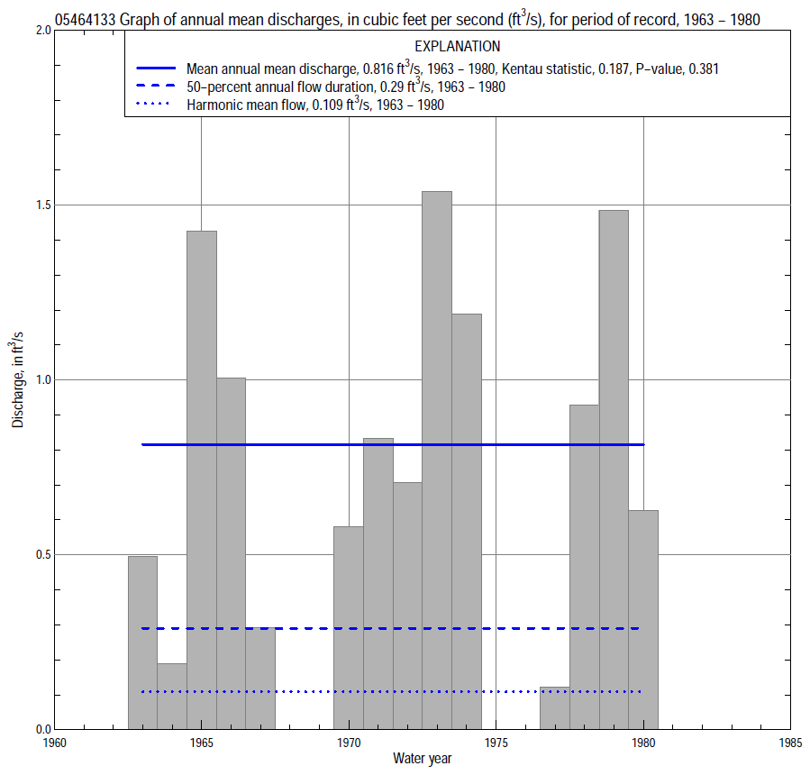

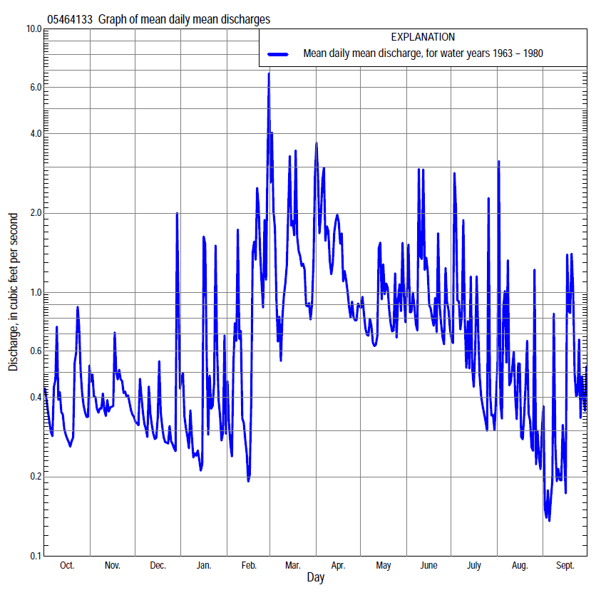

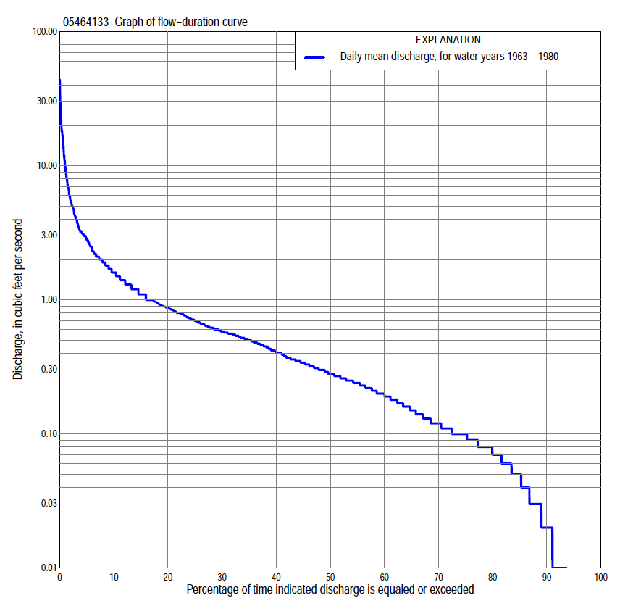

Statistics Based on the Entire Streamflow Period of Record
05464133 Monthly and annual flow durations, based on 1963–67, 1970–74, 1977–80 period of record (14 years)
[ND, not determined]
Percentage of days discharge equaled or exceeded |  |  |  |  | Discharge (cubic feet per second) |  |  |  |  |  |  |  |  | Annual flow durations
 | Oct | Nov | Dec | Jan | Feb | Mar | Apr | May | June | July | Aug | Sept | Annual | Kentau statistic | P-value
99 | 0.00 | 0.00 | 0.00 | 0.00 | 0.00 | 0.02 | 0.01 | 0.00 | 0.00 | 0.00 | 0.00 | 0.00 | 0.00 | 0.000 | ND
98 | 0.00 | 0.00 | 0.00 | 0.00 | 0.00 | 0.02 | 0.01 | 0.00 | 0.00 | 0.00 | 0.00 | 0.00 | 0.00 | 0.000 | ND
95 | 0.00 | 0.00 | 0.00 | 0.00 | 0.00 | 0.04 | 0.03 | 0.01 | 0.00 | 0.00 | 0.01 | 0.00 | 0.00 | 0.000 | ND
90 | 0.00 | 0.03 | 0.02 | 0.00 | 0.02 | 0.08 | 0.18 | 0.12 | 0.08 | 0.03 | 0.01 | 0.01 | 0.02 | 0.000 | ND
85 | 0.00 | 0.07 | 0.04 | 0.04 | 0.03 | 0.10 | 0.23 | 0.16 | 0.11 | 0.05 | 0.01 | 0.01 | 0.05 | 0.000 | ND
80 | 0.04 | 0.08 | 0.05 | 0.06 | 0.07 | 0.12 | 0.26 | 0.19 | 0.20 | 0.08 | 0.02 | 0.03 | 0.07 | 0.000 | ND
75 | 0.08 | 0.08 | 0.07 | 0.07 | 0.09 | 0.17 | 0.30 | 0.22 | 0.26 | 0.10 | 0.03 | 0.04 | 0.10 | 0.000 | ND
70 | 0.09 | 0.10 | 0.09 | 0.10 | 0.10 | 0.26 | 0.34 | 0.26 | 0.32 | 0.12 | 0.04 | 0.05 | 0.12 | 0.000 | ND
65 | 0.10 | 0.15 | 0.11 | 0.12 | 0.11 | 0.30 | 0.40 | 0.31 | 0.39 | 0.14 | 0.06 | 0.07 | 0.15 | 0.000 | ND
60 | 0.13 | 0.21 | 0.14 | 0.14 | 0.12 | 0.36 | 0.47 | 0.39 | 0.48 | 0.18 | 0.09 | 0.09 | 0.20 | 0.000 | ND
55 | 0.23 | 0.23 | 0.17 | 0.16 | 0.15 | 0.45 | 0.54 | 0.44 | 0.53 | 0.24 | 0.11 | 0.10 | 0.24 | 0.000 | ND
50 | 0.30 | 0.27 | 0.22 | 0.18 | 0.20 | 0.56 | 0.60 | 0.53 | 0.58 | 0.30 | 0.12 | 0.12 | 0.28 | 0.000 | ND
45 | 0.35 | 0.30 | 0.25 | 0.20 | 0.23 | 0.69 | 0.68 | 0.62 | 0.64 | 0.36 | 0.15 | 0.14 | 0.34 | 0.000 | ND
40 | 0.36 | 0.35 | 0.30 | 0.22 | 0.25 | 0.85 | 0.80 | 0.77 | 0.74 | 0.44 | 0.18 | 0.18 | 0.41 | 0.033 | 0.804
35 | 0.42 | 0.40 | 0.37 | 0.25 | 0.26 | 1.0 | 0.89 | 0.92 | 0.84 | 0.51 | 0.22 | 0.21 | 0.50 | 0.154 | 0.235
30 | 0.48 | 0.50 | 0.45 | 0.28 | 0.33 | 1.3 | 1.1 | 1.0 | 0.92 | 0.61 | 0.28 | 0.27 | 0.58 | 0.209 | 0.161
25 | 0.56 | 0.56 | 0.50 | 0.33 | 0.50 | 1.6 | 1.3 | 1.2 | 1.1 | 0.72 | 0.37 | 0.34 | 0.70 | 0.308 | 0.056
20 | 0.61 | 0.60 | 0.56 | 0.40 | 0.67 | 1.9 | 1.7 | 1.5 | 1.2 | 0.86 | 0.52 | 0.43 | 0.87 | 0.275 | 0.116
15 | 0.71 | 0.78 | 0.60 | 0.58 | 1.0 | 2.4 | 2.1 | 1.7 | 1.5 | 1.0 | 0.74 | 0.57 | 1.1 | 0.176 | 0.351
10 | 0.87 | 1.1 | 0.68 | 0.86 | 2.1 | 3.2 | 2.5 | 2.0 | 2.6 | 1.4 | 1.1 | 0.77 | 1.6 | 0.319 | 0.106
5 | 1.2 | 1.3 | 0.88 | 1.3 | 5.0 | 5.5 | 4.8 | 2.6 | 3.7 | 3.0 | 2.0 | 1.4 | 2.8 | 0.154 | 0.456
2 | 2.1 | 1.6 | 1.4 | 2.8 | 9.0 | 10 | 15 | 4.2 | 6.0 | 4.7 | 4.3 | 4.1 | 5.5 | 0.121 | 0.579
1 | 3.2 | 1.9 | 2.7 | 5.0 | 14 | 16 | 20 | 6.8 | 9.8 | 9.3 | 5.5 | 7.7 | 9.9 | 0.165 | 0.442

05464133 Annual exceedance probability of instantaneous peak discharges, in cubic feet per second (ft³/s), based on the Weighted Independent Estimates method,
Annual exceed-ance probability | Recur-rence interval (years) | Discharge (ft³/s) | 95-percent lower confi-dence interval (ft³/s) | 95-percent upper confi-dence interval (ft³/s)
0.500 | 2 | 151 | 114 | 201
0.200 | 5 | 297 | 225 | 392
0.100 | 10 | 461 | 349 | 610
0.040 | 25 | 739 | 549 | 995
0.020 | 50 | 942 | 682 | 1,300
0.010 | 100 | 1,140 | 798 | 1,630
0.005 | 200 | 1,440 | 964 | 2,140
0.002 | 500 | 1,660 | 1,050 | 2,600
and based on the expected moments algorithm/multiple Grubbs-Beck analysis computed using a historical period length of 18 years (1963–1980)
0.500 | 2 | 147 | 100 | 209
0.200 | 5 | 248 | 175 | 383
0.100 | 10 | 324 | 225 | 553
0.040 | 25 | 428 | 287 | 858
0.020 | 50 | 510 | 331 | 1,170
0.010 | 100 | 597 | 373 | 1,570
0.005 | 200 | 687 | 412 | 2,080
0.002 | 500 | 814 | 461 | 2,970
Kentau statistic |  | 0.330
P-value |  | 0.112
Begin year |  | 1963
End year |  | 1980
Number of peaks |  | 14

05464133 Annual exceedance probability of high discharges, based on 1963–67, 1970–74, 1977–80 period of record (14 years)
Annual exceedance probability | Recur-rence interval (years) | Maximum average discharge (ft³/s) for indicated number of consecutive days
 |  | 1 | 3 | 7 | 15 | 30
0.990 | 1.01 | 5.8 | 2.5 | 1.2 | 0.68 | 0.42
0.950 | 1.05 | 9.0 | 4.0 | 2.0 | 1.2 | 0.78
0.900 | 1.11 | 11 | 5.0 | 2.6 | 1.6 | 1.1
0.800 | 1.25 | 14 | 6.6 | 3.6 | 2.3 | 1.5
0.500 | 2 | 22 | 11 | 6.4 | 4.2 | 2.8
0.200 | 5 | 33 | 17 | 11 | 7.5 | 4.8
0.100 | 10 | 39 | 22 | 15 | 10 | 6.2
0.040 | 25 | 47 | 27 | 20 | 13 | 7.9
0.020 | 50 | 52 | 32 | 24 | 16 | 9.1
0.010 | 100 | 58 | 36 | 28 | 19 | 10
0.005 | 200 | 62 | 40 | 33 | 22 | 11
0.002 | 500 | 69 | 46 | 39 | 25 | 13
Kentau statistic |  | -0.033 | 0.026 | 0.059 | 0.046 | 0.059
P-value |  | 0.879 | 0.909 | 0.760 | 0.819 | 0.760

 | 05464133 Annual nonexceedance probability of low discharges, based on April 1963 to March 1967, April 1970 to March 1974, April 1977 to March 1980 period of record (11 years)
Annual nonexceed-ance probability | Recur-rence interval (years) |  | Minimum average discharge (cubic feet per second) for indicated number of consecutive days
 |  |  | 1 |  | 3 |  | 7 |  | 14 |  | 30 |  | 60 |  | 90 |  | 120 |  |  | 183
0.01 | 100 |  | 0.00 |  | 0.00 |  | 0.00 |  | 0.00 |  | 0.00 |  | 0.00 |  | 0.00 |  | 0.01 |  |  | 0.03
0.02 | 50 |  | 0.00 |  | 0.00 |  | 0.00 |  | 0.00 |  | 0.00 |  | 0.00 |  | 0.01 |  | 0.01 |  |  | 0.04
0.05 | 20 |  | 0.00 |  | 0.00 |  | 0.00 |  | 0.00 |  | 0.00 |  | 0.00 |  | 0.01 |  | 0.02 |  |  | 0.06
0.10 | 10 |  | 0.00 |  | 0.00 |  | 0.00 |  | 0.00 |  | 0.00 |  | 0.01 |  | 0.02 |  | 0.03 |  |  | 0.09
0.20 | 5 |  | 0.00 |  | 0.00 |  | 0.00 |  | 0.00 |  | 0.01 |  | 0.02 |  | 0.04 |  | 0.06 |  |  | 0.14
0.50 | 2 |  | 0.02 |  | 0.02 |  | 0.03 |  | 0.03 |  | 0.05 |  | 0.10 |  | 0.15 |  | 0.18 |  |  | 0.32
0.80 | 1.25 |  | 0.05 |  | 0.06 |  | 0.07 |  | 0.08 |  | 0.16 |  | 0.31 |  | 0.41 |  | 0.47 |  |  | 0.67
0.90 | 1.11 |  | 0.07 |  | 0.09 |  | 0.11 |  | 0.12 |  | 0.27 |  | 0.48 |  | 0.65 |  | 0.73 |  |  | 0.96
0.96 | 1.04 |  | 0.11 |  | 0.14 |  | 0.16 |  | 0.20 |  | 0.42 |  | 0.72 |  | 1.0 |  | 1.1 |  |  | 1.4
0.98 | 1.02 |  | 0.15 |  | 0.19 |  | 0.22 |  | 0.27 |  | 0.53 |  | 0.89 |  | 1.3 |  | 1.4 |  |  | 1.7
0.99 | 1.01 |  | 0.19 |  | 0.25 |  | 0.28 |  | 0.36 |  | 0.64 |  | 1.1 |  | 1.6 |  | 1.8 |  |  | 2.1
Kentau statistic |  |  | 0.145 |  | 0.145 |  | 0.200 |  | 0.145 |  | 0.164 |  | 0.200 |  | 0.055 |  | 0.127 |  |  | 0.345
P-value |  |  | 0.574 |  | 0.574 |  | 0.424 |  | 0.582 |  | 0.533 |  | 0.436 |  | 0.876 |  | 0.640 |  |  | 0.161
05464133 Annual nonexceedance probability of seasonal low discharges, based on October 1962 to September 1967, October 1969 to September 1974, July 1976 to September 1980 period of record (14–15 years)
Annual nonexceed-ance probability |  | Recur-rence interval (years) |  | Minimum average discharge (cubic feet per second) for indicated number of consecutive days
 |  |  |  | 1 |  | 7 |  | 14 |  | 30 |  |  |  | 1 |  | 7 |  | 14 |  |  | 30
 |  |  |  | January-February-March |  |  |  |  |  |  |  |  |  | April-May-June
0.01 |  | 100 |  | 0.00 |  | 0.00 |  | 0.00 |  | 0.00 |  |  |  | 0.00 |  | 0.00 |  | 0.00 |  |  | 0.00
0.02 |  | 50 |  | 0.00 |  | 0.00 |  | 0.00 |  | 0.00 |  |  |  | 0.00 |  | 0.00 |  | 0.00 |  |  | 0.00
0.05 |  | 20 |  | 0.00 |  | 0.00 |  | 0.00 |  | 0.00 |  |  |  | 0.00 |  | 0.00 |  | 0.00 |  |  | 0.00
0.10 |  | 10 |  | 0.00 |  | 0.00 |  | 0.00 |  | 0.03 |  |  |  | 0.04 |  | 0.05 |  | 0.05 |  |  | 0.08
0.20 |  | 5 |  | 0.02 |  | 0.03 |  | 0.03 |  | 0.06 |  |  |  | 0.08 |  | 0.09 |  | 0.11 |  |  | 0.16
0.50 |  | 2 |  | 0.08 |  | 0.10 |  | 0.11 |  | 0.15 |  |  |  | 0.19 |  | 0.22 |  | 0.26 |  |  | 0.39
0.80 |  | 1.25 |  | 0.20 |  | 0.23 |  | 0.27 |  | 0.36 |  |  |  | 0.41 |  | 0.48 |  | 0.58 |  |  | 0.85
0.90 |  | 1.11 |  | 0.31 |  | 0.34 |  | 0.39 |  | 0.57 |  |  |  | 0.62 |  | 0.72 |  | 0.89 |  |  | 1.3
0.96 |  | 1.04 |  | 0.48 |  | 0.51 |  | 0.56 |  | 0.94 |  |  |  | 0.96 |  | 1.1 |  | 1.4 |  |  | 1.9
0.98 |  | 1.02 |  | 0.63 |  | 0.64 |  | 0.70 |  | 1.3 |  |  |  | 1.3 |  | 1.5 |  | 1.9 |  |  | 2.4
0.99 |  | 1.01 |  | 0.80 |  | 0.82 |  | 0.85 |  | 1.8 |  |  |  | 1.6 |  | 1.9 |  | 2.5 |  |  | 3.0
Kentau statistic |  |  |  | 0.110 |  | 0.154 |  | 0.143 |  | 0.143 |  |  |  | 0.451 |  | 0.429 |  | 0.407 |  |  | 0.363
P-value |  |  |  | 0.620 |  | 0.476 |  | 0.511 |  | 0.511 |  |  |  | 0.028 |  | 0.037 |  | 0.049 |  |  | 0.080
 |  |  |  | July-August-September |  |  |  |  |  |  |  |  |  | October-November-December
0.01 |  | 100 |  | 0.00 |  | 0.00 |  | 0.00 |  | 0.00 |  |  |  | 0.00 |  | 0.00 |  | 0.00 |  |  | 0.00
0.02 |  | 50 |  | 0.00 |  | 0.00 |  | 0.00 |  | 0.00 |  |  |  | 0.00 |  | 0.00 |  | 0.00 |  |  | 0.00
0.05 |  | 20 |  | 0.00 |  | 0.00 |  | 0.00 |  | 0.00 |  |  |  | 0.00 |  | 0.00 |  | 0.00 |  |  | 0.00
0.10 |  | 10 |  | 0.00 |  | 0.00 |  | 0.00 |  | 0.01 |  |  |  | 0.00 |  | 0.00 |  | 0.00 |  |  | 0.01
0.20 |  | 5 |  | 0.00 |  | 0.00 |  | 0.01 |  | 0.02 |  |  |  | 0.00 |  | 0.00 |  | 0.02 |  |  | 0.03
0.50 |  | 2 |  | 0.02 |  | 0.03 |  | 0.04 |  | 0.07 |  |  |  | 0.09 |  | 0.10 |  | 0.12 |  |  | 0.18
0.80 |  | 1.25 |  | 0.06 |  | 0.10 |  | 0.11 |  | 0.19 |  |  |  | 0.23 |  | 0.27 |  | 0.32 |  |  | 0.44
0.90 |  | 1.11 |  | 0.11 |  | 0.17 |  | 0.20 |  | 0.30 |  |  |  | 0.34 |  | 0.40 |  | 0.49 |  |  | 0.65
0.96 |  | 1.04 |  | 0.20 |  | 0.29 |  | 0.33 |  | 0.49 |  |  |  | 0.51 |  | 0.57 |  | 0.74 |  |  | 0.92
0.98 |  | 1.02 |  | 0.31 |  | 0.40 |  | 0.47 |  | 0.68 |  |  |  | 0.65 |  | 0.69 |  | 0.94 |  |  | 1.0
0.99 |  | 1.01 |  | 0.48 |  | 0.57 |  | 0.65 |  | 0.92 |  |  |  | 0.82 |  | 0.83 |  | 1.2 |  |  | 1.4
Kentau statistic |  |  |  | 0.067 |  | 0.076 |  | 0.010 |  | 0.114 |  |  |  | 0.110 |  | 0.110 |  | 0.077 |  |  | 0.143
P-value |  |  |  | 0.760 |  | 0.726 |  | 1.000 |  | 0.586 |  |  |  | 0.617 |  | 0.620 |  | 0.742 |  |  | 0.511

