LOCATION.--Lat 42°12'07", long 92°33'44" referenced to North American Datum of 1927, Tama County, IA, Hydrologic Unit 07080205, at bridge on County Highway T69, 4.5 mi west of Traer, and 2.0 mi upstream from mouth.

DRAINAGE AREA.--19.51 mi².

PERIOD OF RECORD.--Discharge records from October 1962 to September 1974, October 1975 to January 1981.

GAGE.--Water-stage recorder and V-notch sharp-crested weir. Datum of gage is 905.87 ft above National Geodetic Vertical Datum of 1929.

REMARKS.--Records good except for estimated daily discharges, which are poor.

A summary of all available data for this streamgage is provided through the USGS National Water Information System web interface (NWISWeb). The following link provides access to current/historical observations, daily data, daily statistics, monthly statistics, annual statistics, peak streamflow, field measurements, field/lab water-quality samples, and the latest water-year summaries. Data can be filtered by parameter and/or dates, and can be output in various tabular and graphical formats.
http://waterdata.usgs.gov/nwis/inventory/?site_no=05464137

The USGS WaterWatch Toolkit is available at:
http://waterwatch.usgs.gov/?id=ww_toolkit
Tools for summarizing streamflow information include the duration hydrograph builder, the cumulative streamflow hydrograph builder, the streamgage statistics retrieval tool, the rating curve builder, the flood tracking chart builder, the National Weather Service Advanced Hydrologic Prediction Service (AHPS) river forecast hydrograph builder, and the raster-hydrograph builder. Entering the above number for this streamgage into these toolkit webpages will provide streamflow information specific to this streamgage.

A description of the statistics presented for this streamgage is available in the main body of the report at:
http://dx.doi.org/10.3133/ofr20151214
A link to other streamgages included in this report, a map showing the location of the streamgages, information on the programs used to compute the statistical analyses, and references are included in the main body of the report.

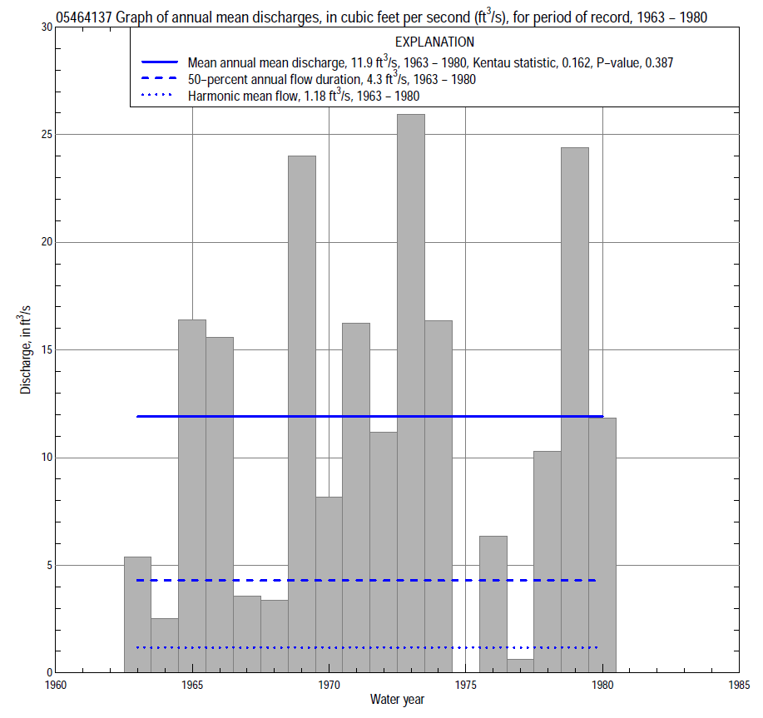

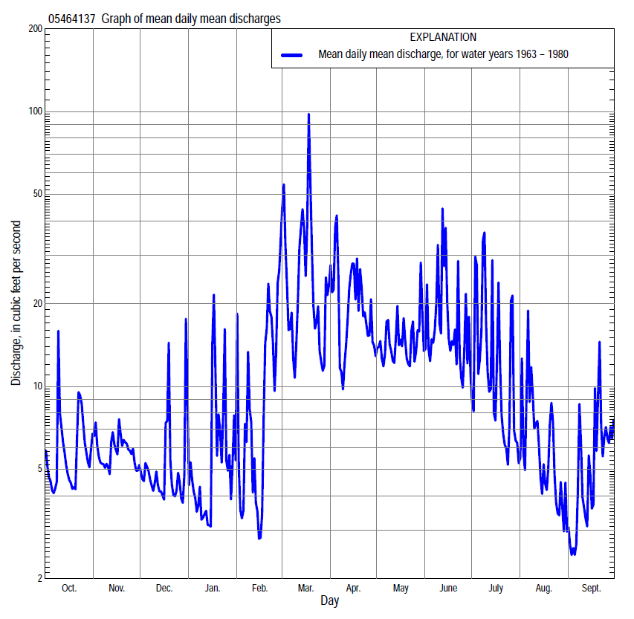

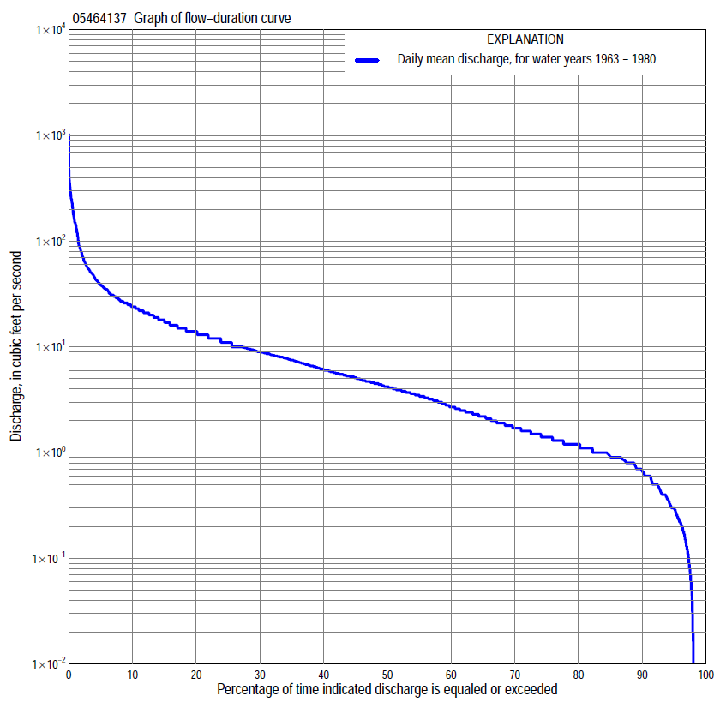

Statistics Based on the Entire Streamflow Period of Record
05464137 Monthly and annual flow durations, based on 1963–74, 1976–80 period of record (17 years)
Percentage of days discharge equaled or exceeded |  |  |  |  | Discharge (cubic feet per second) |  |  |  |  |  |  |  |  | Annual flow durations
 | Oct | Nov | Dec | Jan | Feb | Mar | Apr | May | June | July | Aug | Sept | Annual | Kentau statistic | P-value
99 | 0.09 | 0.10 | 0.00 | 0.00 | 0.00 | 0.40 | 0.22 | 0.05 | 0.00 | 0.00 | 0.11 | 0.13 | 0.00 | 0.103 | 0.500
98 | 0.14 | 0.17 | 0.00 | 0.00 | 0.00 | 0.48 | 0.38 | 0.07 | 0.00 | 0.00 | 0.17 | 0.15 | 0.01 | 0.096 | 0.534
95 | 0.24 | 0.29 | 0.00 | 0.00 | 0.01 | 0.68 | 1.3 | 0.25 | 0.04 | 0.14 | 0.30 | 0.23 | 0.29 | 0.301 | 0.068
90 | 0.41 | 0.90 | 0.50 | 0.40 | 0.58 | 1.1 | 2.8 | 2.0 | 1.6 | 1.0 | 0.47 | 0.38 | 0.65 | 0.154 | 0.378
85 | 0.90 | 1.0 | 0.60 | 0.60 | 0.80 | 1.4 | 3.3 | 2.6 | 2.1 | 1.2 | 0.69 | 0.60 | 0.94 | 0.191 | 0.279
80 | 1.0 | 1.0 | 0.82 | 0.70 | 1.0 | 1.7 | 4.0 | 3.6 | 2.8 | 1.6 | 0.80 | 0.86 | 1.2 | 0.228 | 0.205
75 | 1.1 | 1.1 | 1.0 | 0.90 | 1.1 | 2.4 | 4.8 | 4.1 | 3.9 | 1.9 | 1.0 | 1.1 | 1.4 | 0.199 | 0.273
70 | 1.2 | 1.3 | 1.2 | 1.0 | 1.3 | 3.6 | 5.6 | 4.7 | 5.0 | 2.4 | 1.2 | 1.2 | 1.8 | 0.213 | 0.235
65 | 1.3 | 1.8 | 1.6 | 1.2 | 1.6 | 5.2 | 6.2 | 5.4 | 6.0 | 2.8 | 1.5 | 1.4 | 2.3 | 0.199 | 0.278
60 | 1.5 | 2.4 | 1.8 | 1.5 | 1.8 | 6.2 | 7.1 | 6.4 | 6.9 | 3.4 | 1.7 | 1.5 | 2.9 | 0.176 | 0.336
55 | 2.4 | 2.8 | 2.1 | 1.6 | 2.1 | 7.4 | 8.1 | 8.4 | 8.4 | 3.9 | 2.0 | 1.7 | 3.6 | 0.162 | 0.379
50 | 3.1 | 3.2 | 2.3 | 2.1 | 2.4 | 9.0 | 9.1 | 10 | 9.6 | 4.7 | 2.4 | 2.0 | 4.3 | 0.118 | 0.533
45 | 3.7 | 3.9 | 2.7 | 3.3 | 3.3 | 10 | 11 | 12 | 12 | 5.5 | 3.2 | 2.3 | 5.2 | 0.132 | 0.481
40 | 4.2 | 4.5 | 3.7 | 4.2 | 3.7 | 13 | 13 | 13 | 13 | 6.7 | 3.8 | 2.7 | 6.3 | 0.154 | 0.408
35 | 5.5 | 5.2 | 5.4 | 4.6 | 4.0 | 15 | 14 | 14 | 15 | 8.4 | 4.9 | 3.1 | 7.7 | 0.191 | 0.301
30 | 6.5 | 7.0 | 6.6 | 5.1 | 5.0 | 19 | 16 | 16 | 17 | 9.4 | 5.8 | 3.5 | 9.1 | 0.221 | 0.231
25 | 7.5 | 8.8 | 7.9 | 5.6 | 6.9 | 22 | 19 | 20 | 20 | 11 | 7.2 | 4.5 | 11 | 0.228 | 0.215
20 | 9.2 | 10 | 8.6 | 6.6 | 8.2 | 26 | 22 | 23 | 25 | 13 | 8.1 | 6.3 | 14 | 0.199 | 0.281
15 | 12 | 13 | 9.7 | 8.6 | 11 | 35 | 28 | 27 | 30 | 18 | 10 | 7.9 | 18 | 0.140 | 0.457
10 | 15 | 16 | 12 | 11 | 20 | 55 | 37 | 32 | 37 | 24 | 14 | 11 | 24 | 0.096 | 0.621
5 | 22 | 20 | 15 | 19 | 54 | 120 | 64 | 43 | 52 | 38 | 23 | 26 | 39 | 0.191 | 0.303
2 | 32 | 26 | 20 | 40 | 94 | 250 | 179 | 62 | 126 | 128 | 38 | 44 | 79 | 0.147 | 0.434
1 | 45 | 31 | 28 | 62 | 150 | 358 | 250 | 86 | 155 | 232 | 69 | 57 | 150 | 0.118 | 0.537

05464137 Annual exceedance probability of instantaneous peak discharges, in cubic feet per second (ft³/s), based on the Weighted Independent Estimates method,
Annual exceed-ance probability | Recur-rence interval (years) | Discharge (ft³/s) | 95-percent lower confi-dence interval (ft³/s) | 95-percent upper confi-dence interval (ft³/s)
0.500 | 2 | 541 | 416 | 703
0.200 | 5 | 1,000 | 780 | 1,290
0.100 | 10 | 1,500 | 1,170 | 1,940
0.040 | 25 | 2,320 | 1,770 | 3,040
0.020 | 50 | 2,890 | 2,150 | 3,870
0.010 | 100 | 3,420 | 2,470 | 4,730
0.005 | 200 | 4,160 | 2,890 | 5,990
0.002 | 500 | 4,670 | 3,090 | 7,050
and based on the expected moments algorithm/multiple Grubbs-Beck analysis computed using a historical period length of 18 years (1963–1980)
0.500 | 2 | 512 | 373 | 680
0.200 | 5 | 821 | 618 | 1,170
0.100 | 10 | 1,040 | 776 | 1,620
0.040 | 25 | 1,310 | 961 | 2,390
0.020 | 50 | 1,520 | 1,080 | 3,130
0.010 | 100 | 1,730 | 1,200 | 4,020
0.005 | 200 | 1,940 | 1,300 | 5,090
0.002 | 500 | 2,220 | 1,410 | 6,850
Kentau statistic |  | 0.449
P-value |  | 0.013
Begin year |  | 1963
End year |  | 1980
Number of peaks |  | 17

05464137 Annual exceedance probability of high discharges, based on 1963–74, 1976–80 period of record (17 years)
Annual exceedance probability | Recur-rence interval (years) | Maximum average discharge (ft³/s) for indicated number of consecutive days
 |  | 1 | 3 | 7 | 15 | 30
0.990 | 1.01 | 22 | 9.6 | 5.6 | 3.1 | 2.1
0.950 | 1.05 | 47 | 23 | 14 | 8.4 | 5.6
0.900 | 1.11 | 68 | 35 | 22 | 14 | 8.9
0.800 | 1.25 | 106 | 57 | 36 | 23 | 15
0.500 | 2 | 227 | 133 | 84 | 54 | 35
0.200 | 5 | 444 | 277 | 173 | 108 | 70
0.100 | 10 | 608 | 389 | 239 | 146 | 95
0.040 | 25 | 830 | 541 | 327 | 193 | 125
0.020 | 50 | 1,000 | 659 | 392 | 225 | 146
0.010 | 100 | 1,170 | 778 | 456 | 255 | 166
0.005 | 200 | 1,350 | 898 | 519 | 283 | 184
0.002 | 500 | 1,580 | 1,060 | 600 | 316 | 206
Kentau statistic |  | -0.020 | 0.046 | 0.085 | 0.078 | 0.124
P-value |  | 0.940 | 0.820 | 0.649 | 0.677 | 0.495

 | 05464137 Annual nonexceedance probability of low discharges, based on April 1963 to March 1974, April 1976 to March 1980 period of record (15 years)
Annual nonexceed-ance probability | Recur-rence interval (years) | Minimum average discharge (cubic feet per second) for indicated number of consecutive days
 |  | 1 | 3 | 7 | 14 | 30 | 60 | 90 | 120 | 183
0.01 | 100 | 0.00 | 0.00 | 0.00 | 0.00 | 0.00 | 0.00 | 0.00 | 0.02 | 0.05
0.02 | 50 | 0.00 | 0.00 | 0.00 | 0.00 | 0.00 | 0.00 | 0.00 | 0.04 | 0.10
0.05 | 20 | 0.00 | 0.00 | 0.00 | 0.00 | 0.00 | 0.00 | 0.00 | 0.12 | 0.25
0.10 | 10 | 0.00 | 0.00 | 0.00 | 0.00 | 0.05 | 0.08 | 0.13 | 0.26 | 0.51
0.20 | 5 | 0.17 | 0.20 | 0.22 | 0.22 | 0.25 | 0.38 | 0.49 | 0.63 | 1.1
0.50 | 2 | 0.47 | 0.57 | 0.65 | 0.75 | 1.1 | 1.7 | 2.3 | 2.5 | 3.7
0.80 | 1.25 | 1.1 | 1.3 | 1.5 | 1.7 | 2.8 | 4.3 | 6.2 | 6.9 | 9.0
0.90 | 1.11 | 1.8 | 2.0 | 2.3 | 2.6 | 3.9 | 6.0 | 9.3 | 10 | 13
0.96 | 1.04 | 3.0 | 3.2 | 3.7 | 4.0 | 5.0 | 7.7 | 13 | 15 | 17
0.98 | 1.02 | 4.2 | 4.3 | 5.0 | 5.4 | 5.6 | 8.7 | 16 | 18 | 20
0.99 | 1.01 | 5.7 | 5.7 | 6.6 | 7.2 | 7.4 | 9.6 | 19 | 21 | 22
Kentau statistic |  | 0.124 | 0.124 | 0.124 | 0.152 | 0.124 | 0.143 | 0.124 | 0.162 | 0.181
P-value |  | 0.550 | 0.552 | 0.552 | 0.457 | 0.553 | 0.488 | 0.553 | 0.428 | 0.373

05464137 Annual nonexceedance probability of seasonal low discharges, based on October 1962 to September 1974, October 1975 to December 1980 period of record (17–18 years)
Annual nonexceed-ance probability | Recur-rence interval (years) | Minimum average discharge (cubic feet per second) for indicated number of consecutive days
 |  | 1 | 7 | 14 | 30 |  | 1 | 7 | 14 | 30
 |  | January-February-March |  |  |  |  | April-May-June
0.01 | 100 | 0.00 | 0.00 | 0.00 | 0.00 |  | 0.00 | 0.00 | 0.00 | 0.02
0.02 | 50 | 0.00 | 0.00 | 0.00 | 0.00 |  | 0.00 | 0.00 | 0.00 | 0.05
0.05 | 20 | 0.00 | 0.00 | 0.00 | 0.00 |  | 0.00 | 0.00 | 0.00 | 0.22
0.10 | 10 | 0.15 | 0.22 | 0.30 | 0.59 |  | 0.80 | 1.1 | 1.2 | 1.2
0.20 | 5 | 0.30 | 0.45 | 0.57 | 0.90 |  | 1.4 | 1.8 | 2.0 | 2.1
0.50 | 2 | 0.89 | 1.3 | 1.5 | 2.0 |  | 3.2 | 3.9 | 4.4 | 8.6
0.80 | 1.25 | 2.5 | 3.3 | 3.5 | 4.9 |  | 7.2 | 8.3 | 9.8 | 16
0.90 | 1.11 | 4.4 | 5.2 | 5.5 | 8.4 |  | 11 | 13 | 15 | 18
0.96 | 1.04 | 8.1 | 8.6 | 9.1 | 16 |  | 18 | 20 | 24 | 24
0.98 | 1.02 | 12 | 12 | 13 | 24 |  | 25 | 27 | 32 | 32
0.99 | 1.01 | 16 | 16 | 17 | 37 |  | 34 | 35 | 43 | 44
Kentau statistic |  | 0.169 | 0.221 | 0.235 | 0.169 |  | 0.213 | 0.176 | 0.221 | 0.221
P-value |  | 0.364 | 0.232 | 0.202 | 0.364 |  | 0.248 | 0.343 | 0.232 | 0.232
 |  | July-August-September |  |  |  |  | October-November-December
0.01 | 100 | 0.00 | 0.00 | 0.02 | 0.11 |  | 0.00 | 0.00 | 0.00 | 0.00
0.02 | 50 | 0.00 | 0.00 | 0.04 | 0.15 |  | 0.00 | 0.00 | 0.00 | 0.00
0.05 | 20 | 0.00 | 0.00 | 0.09 | 0.25 |  | 0.00 | 0.00 | 0.00 | 0.00
0.10 | 10 | 0.08 | 0.18 | 0.18 | 0.39 |  | 0.15 | 0.23 | 0.31 | 0.40
0.20 | 5 | 0.24 | 0.36 | 0.37 | 0.63 |  | 0.33 | 0.46 | 0.59 | 0.76
0.50 | 2 | 0.83 | 0.94 | 1.2 | 1.5 |  | 1.0 | 1.3 | 1.6 | 2.1
0.80 | 1.25 | 2.0 | 2.2 | 2.7 | 3.3 |  | 3.0 | 3.6 | 4.1 | 5.3
0.90 | 1.11 | 3.0 | 3.3 | 3.9 | 4.8 |  | 5.3 | 6.1 | 6.8 | 8.8
0.96 | 1.04 | 4.2 | 5.0 | 5.2 | 6.9 |  | 9.6 | 11 | 12 | 15
0.98 | 1.02 | 5.1 | 6.6 | 6.8 | 8.6 |  | 14 | 16 | 17 | 21
0.99 | 1.01 | 6.0 | 8.4 | 9.0 | 11 |  | 20 | 22 | 23 | 29
Kentau statistic |  | -0.051 | -0.029 | 0.015 | 0.118 |  | 0.150 | 0.118 | 0.098 | 0.144
P-value |  | 0.805 | 0.902 | 0.967 | 0.537 |  | 0.404 | 0.519 | 0.596 | 0.426

