LOCATION.--Lat 42°15'05.5", long 92°17'56.0" referenced to North American Datum of 1983, in SE 1/4 NE 1/4 NE 1/4 sec.24, T.86 N., R.13 W., Tama County, IA, Hydrologic Unit 07080205, on right bank 20 ft upstream from bridge on County Highway V37, 5.0 mi north of Dysart, and 12.1 mi upstream from mouth.

DRAINAGE AREA.--299 mi².

PERIOD OF RECORD.--Discharge records from October 1995 to September 1998, May 2001 to current year.

GAGE.--Water stage recorder. Datum of gage is 835.00 ft above National Geodetic Vertical Datum of 1929, from topographic map.

A summary of all available data for this streamgage is provided through the USGS National Water Information System web interface (NWISWeb). The following link provides access to current/historical observations, daily data, daily statistics, monthly statistics, annual statistics, peak streamflow, field measurements, field/lab water-quality samples, and the latest water-year summaries. Data can be filtered by parameter and/or dates, and can be output in various tabular and graphical formats.
http://waterdata.usgs.gov/nwis/inventory/?site_no=05464220

The USGS WaterWatch Toolkit is available at:
http://waterwatch.usgs.gov/?id=ww_toolkit
Tools for summarizing streamflow information include the duration hydrograph builder, the cumulative streamflow hydrograph builder, the streamgage statistics retrieval tool, the rating curve builder, the flood tracking chart builder, the National Weather Service Advanced Hydrologic Prediction Service (AHPS) river forecast hydrograph builder, and the raster-hydrograph builder. Entering the above number for this streamgage into these toolkit webpages will provide streamflow information specific to this streamgage.

A description of the statistics presented for this streamgage is available in the main body of the report at:
http://dx.doi.org/10.3133/ofr20151214
A link to other streamgages included in this report, a map showing the location of the streamgages, information on the programs used to compute the statistical analyses, and references are included in the main body of the report.

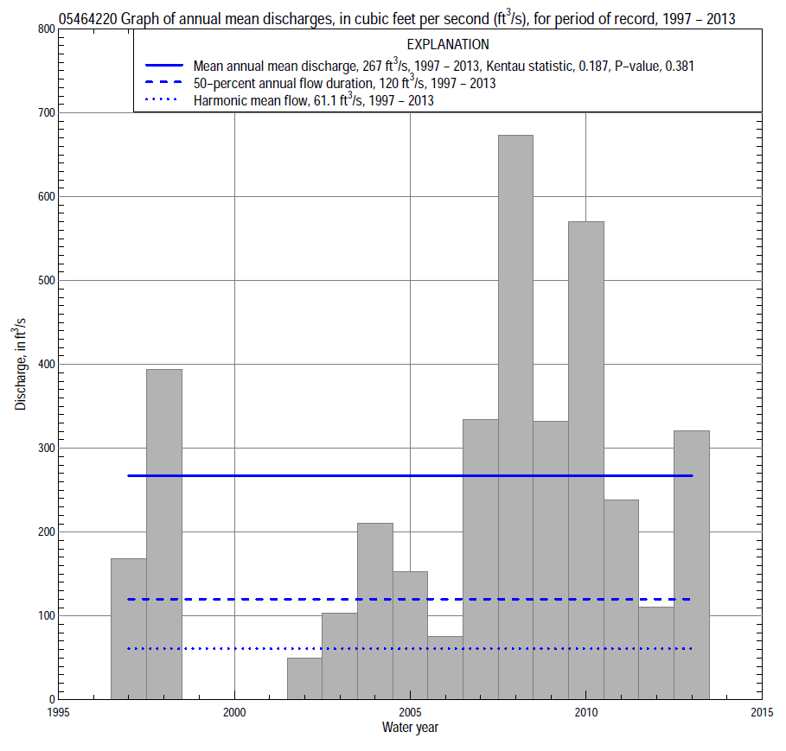

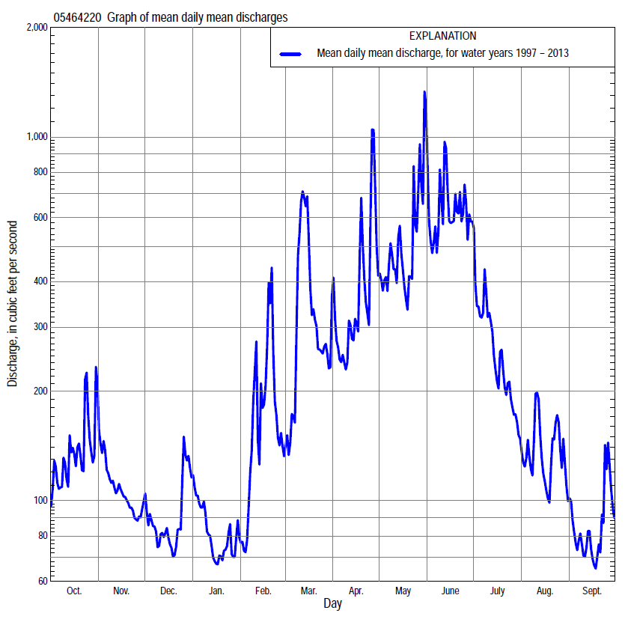

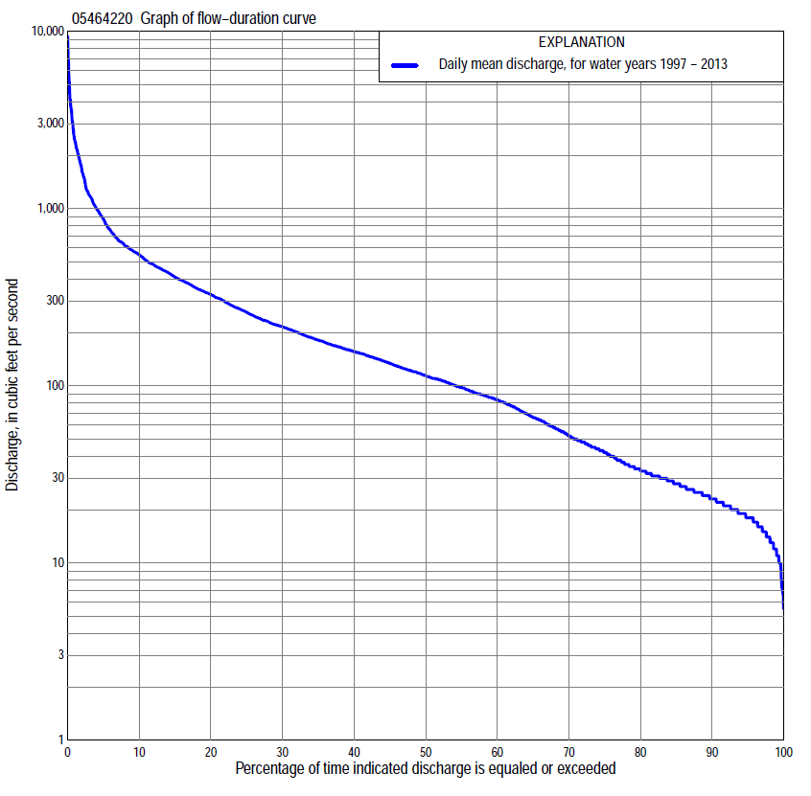

Statistics Based on the Entire Streamflow Period of Record
05464220 Monthly and annual flow durations, based on 1997–98, 2002–13 period of record (14 years)
Percentage of days discharge equaled or exceeded |  |  |  |  | Discharge (cubic feet per second) |  |  |  |  |  |  |  |  | Annual flow durations
 | Oct | Nov | Dec | Jan | Feb | Mar | Apr | May | June | July | Aug | Sept | Annual | Kentau statistic | P-value
99 | 12 | 17 | 6.7 | 7.1 | 15 | 16 | 25 | 77 | 81 | 29 | 14 | 10 | 12 | 0.132 | 0.546
98 | 13 | 18 | 7.3 | 8.1 | 16 | 18 | 28 | 91 | 86 | 31 | 15 | 10 | 14 | 0.132 | 0.545
95 | 16 | 20 | 16 | 12 | 18 | 25 | 34 | 127 | 101 | 37 | 21 | 12 | 19 | 0.099 | 0.661
90 | 19 | 22 | 19 | 15 | 21 | 32 | 49 | 152 | 115 | 49 | 26 | 18 | 24 | 0.110 | 0.622
85 | 22 | 25 | 20 | 17 | 24 | 43 | 89 | 174 | 132 | 63 | 32 | 22 | 29 | 0.121 | 0.583
80 | 24 | 28 | 22 | 20 | 26 | 57 | 115 | 203 | 154 | 85 | 38 | 26 | 34 | 0.165 | 0.443
75 | 26 | 31 | 24 | 24 | 37 | 83 | 133 | 224 | 185 | 103 | 42 | 29 | 44 | 0.132 | 0.546
70 | 28 | 41 | 27 | 27 | 53 | 100 | 146 | 241 | 207 | 118 | 45 | 30 | 56 | 0.154 | 0.476
65 | 30 | 48 | 36 | 32 | 64 | 117 | 157 | 266 | 253 | 135 | 51 | 32 | 72 | 0.209 | 0.323
60 | 32 | 58 | 49 | 40 | 72 | 136 | 169 | 296 | 322 | 150 | 56 | 33 | 88 | 0.253 | 0.228
55 | 36 | 73 | 71 | 50 | 80 | 152 | 182 | 323 | 368 | 166 | 63 | 35 | 103 | 0.253 | 0.228
50 | 40 | 81 | 85 | 57 | 89 | 169 | 192 | 343 | 395 | 180 | 70 | 41 | 120 | 0.253 | 0.228
45 | 50 | 88 | 91 | 68 | 98 | 188 | 215 | 373 | 439 | 196 | 79 | 47 | 140 | 0.143 | 0.511
40 | 66 | 94 | 100 | 80 | 116 | 210 | 302 | 402 | 470 | 214 | 90 | 55 | 162 | 0.187 | 0.381
35 | 96 | 107 | 111 | 87 | 135 | 244 | 374 | 450 | 522 | 233 | 107 | 63 | 188 | 0.209 | 0.324
30 | 107 | 130 | 119 | 92 | 153 | 286 | 416 | 504 | 595 | 267 | 122 | 83 | 222 | 0.231 | 0.274
25 | 128 | 155 | 123 | 105 | 169 | 335 | 475 | 554 | 675 | 312 | 151 | 106 | 271 | 0.242 | 0.250
20 | 209 | 168 | 134 | 126 | 217 | 432 | 540 | 627 | 834 | 379 | 179 | 129 | 338 | 0.209 | 0.324
15 | 267 | 193 | 147 | 161 | 263 | 512 | 604 | 743 | 1,090 | 457 | 244 | 172 | 430 | 0.209 | 0.324
10 | 383 | 259 | 188 | 233 | 318 | 744 | 724 | 966 | 1,490 | 593 | 335 | 227 | 566 | 0.209 | 0.324
5 | 591 | 332 | 234 | 280 | 610 | 1,490 | 1,320 | 1,210 | 2,250 | 878 | 492 | 284 | 906 | 0.231 | 0.274
2 | 783 | 464 | 325 | 330 | 1,440 | 2,600 | 2,590 | 3,390 | 3,550 | 1,260 | 922 | 467 | 1,750 | 0.209 | 0.324
1 | 1,240 | 609 | 676 | 351 | 2,180 | 3,720 | 4,170 | 6,670 | 3,810 | 1,390 | 1,020 | 591 | 2,480 | 0.121 | 0.584

05464220 Annual exceedance probability of instantaneous peak discharges, in cubic feet per second (ft³/s), based on the Weighted Independent Estimates method,
Annual exceed-ance probability | Recur-rence interval (years) | Discharge (ft³/s) | 95-percent lower confi-dence interval (ft³/s) | 95-percent upper confi-dence interval (ft³/s)
0.500 | 2 | 3,790 | 2,520 | 5,700
0.200 | 5 | 8,080 | 5,740 | 11,400
0.100 | 10 | 11,600 | 8,460 | 16,000
0.040 | 25 | 16,800 | 12,200 | 23,100
0.020 | 50 | 20,200 | 14,400 | 28,400
0.010 | 100 | 23,600 | 16,200 | 34,300
0.005 | 200 | 29,500 | 19,400 | 44,800
0.002 | 500 | 32,400 | 20,200 | 52,000
and based on the expected moments algorithm/multiple Grubbs-Beck analysis computed using a historical period length of 18 years (1996–2013)
0.500 | 2 | 3,550 | 1,970 | 5,810
0.200 | 5 | 7,780 | 4,670 | 13,800
0.100 | 10 | 11,400 | 6,820 | 23,200
0.040 | 25 | 16,800 | 9,690 | 42,700
0.020 | 50 | 21,300 | 11,800 | 65,300
0.010 | 100 | 26,100 | 13,800 | 96,900
0.005 | 200 | 31,400 | 15,600 | 141,000
0.002 | 500 | 38,900 | 17,800 | 226,000
Kentau statistic |  | 0.105
P-value |  | 0.621
Begin year |  | 1996
End year |  | 2013
Number of peaks |  | 15

05464220 Annual exceedance probability of high discharges, based on 1997–98, 2002–2013 period of record (14 years)
Annual exceedance probability | Recur-rence interval (years) | Maximum average discharge (ft³/s) for indicated number of consecutive days
 |  | 1 | 3 | 7 | 15 | 30
0.990 | 1.01 | 222 | 170 | 125 | 84 | 90
0.950 | 1.05 | 515 | 423 | 301 | 202 | 180
0.900 | 1.11 | 784 | 657 | 462 | 309 | 255
0.800 | 1.25 | 1,270 | 1,070 | 746 | 501 | 382
0.500 | 2 | 2,950 | 2,430 | 1,670 | 1,140 | 780
0.200 | 5 | 6,200 | 4,730 | 3,270 | 2,260 | 1,480
0.100 | 10 | 8,820 | 6,350 | 4,400 | 3,080 | 2,020
0.040 | 25 | 12,500 | 8,340 | 5,840 | 4,150 | 2,740
0.020 | 50 | 15,400 | 9,750 | 6,880 | 4,930 | 3,310
0.010 | 100 | 18,400 | 11,100 | 7,870 | 5,690 | 3,900
0.005 | 200 | 21,600 | 12,300 | 8,810 | 6,430 | 4,500
0.002 | 500 | 25,800 | 13,800 | 10,000 | 7,370 | 5,310
Kentau statistic |  | 0.272 | 0.316 | 0.316 | 0.287 | 0.331
P-value |  | 0.137 | 0.083 | 0.083 | 0.116 | 0.069

 | 05464220 Annual nonexceedance probability of low discharges, based on April 1996 to March 1998, April 2002 to March 2013 period of record (13 years)
Annual nonexceed-ance probability | Recur-rence interval (years) | Minimum average discharge (cubic feet per second) for indicated number of consecutive days
 |  | 1 | 3 | 7 | 14 | 30 | 60 | 90 | 120 | 183
0.01 | 100 | 3.8 | 4.4 | 4.5 | 4.5 | 6.9 | 7.8 | 9.1 | 9.2 | 9.3
0.02 | 50 | 4.7 | 5.4 | 5.7 | 5.8 | 8.3 | 9.3 | 11 | 11 | 12
0.05 | 20 | 6.5 | 7.4 | 7.9 | 8.3 | 11 | 12 | 15 | 16 | 16
0.10 | 10 | 8.7 | 9.7 | 11 | 11 | 14 | 16 | 19 | 21 | 22
0.20 | 5 | 12 | 14 | 15 | 16 | 19 | 22 | 27 | 30 | 32
0.50 | 2 | 24 | 26 | 29 | 32 | 36 | 42 | 51 | 60 | 70
0.80 | 1.25 | 45 | 48 | 53 | 60 | 71 | 84 | 100 | 119 | 155
0.90 | 1.11 | 62 | 67 | 73 | 81 | 102 | 122 | 143 | 172 | 237
0.96 | 1.04 | 88 | 94 | 102 | 112 | 153 | 185 | 212 | 254 | 375
0.98 | 1.02 | 110 | 118 | 125 | 136 | 199 | 245 | 274 | 327 | 509
0.99 | 1.01 | 134 | 144 | 151 | 162 | 255 | 317 | 347 | 410 | 670
Kentau statistic |  | 0.218 | 0.256 | 0.256 | 0.256 | 0.295 | 0.231 | 0.179 | 0.179 | 0.179
P-value |  | 0.328 | 0.246 | 0.246 | 0.246 | 0.179 | 0.300 | 0.428 | 0.428 | 0.428

05464220 Annual nonexceedance probability of seasonal low discharges, based on January 1996 to September 1998, July 2001 to September 2013 period of record (14–16 years)
Annual nonexceed-ance probability | Recur-rence interval (years) | Minimum average discharge (cubic feet per second) for indicated number of consecutive days
 |  | 1 | 7 | 14 | 30 |  | 1 | 7 | 14 | 30
 |  | January-February-March |  |  |  |  | April-May-June
0.01 | 100 | 2.9 | 3.5 | 4.6 | 6.8 |  | 12 | 13 | 15 | 18
0.02 | 50 | 3.8 | 4.6 | 5.9 | 8.5 |  | 17 | 18 | 21 | 25
0.05 | 20 | 5.6 | 6.9 | 8.5 | 12 |  | 26 | 27 | 32 | 39
0.10 | 10 | 7.9 | 9.8 | 12 | 16 |  | 37 | 40 | 46 | 57
0.20 | 5 | 12 | 15 | 17 | 22 |  | 56 | 61 | 70 | 89
0.50 | 2 | 26 | 32 | 36 | 43 |  | 118 | 129 | 151 | 202
0.80 | 1.25 | 57 | 67 | 74 | 85 |  | 228 | 252 | 301 | 434
0.90 | 1.11 | 86 | 97 | 107 | 120 |  | 313 | 347 | 421 | 634
0.96 | 1.04 | 132 | 143 | 157 | 175 |  | 428 | 477 | 588 | 937
0.98 | 1.02 | 174 | 182 | 201 | 223 |  | 518 | 580 | 723 | 1,200
0.99 | 1.01 | 222 | 226 | 251 | 277 |  | 610 | 686 | 864 | 1,480
Kentau statistic |  | 0.257 | 0.295 | 0.352 | 0.295 |  | 0.210 | 0.219 | 0.276 | 0.352
P-value |  | 0.197 | 0.138 | 0.075 | 0.138 |  | 0.298 | 0.276 | 0.166 | 0.075
 |  | July-August-September |  |  |  |  | October-November-December
0.01 | 100 | 7.9 | 8.2 | 9.1 | 9.8 |  | 3.5 | 4.4 | 5.6 | 7.4
0.02 | 50 | 8.9 | 9.5 | 11 | 11 |  | 4.4 | 5.4 | 7.0 | 9.0
0.05 | 20 | 11 | 12 | 13 | 14 |  | 6.2 | 7.5 | 9.7 | 12
0.10 | 10 | 14 | 15 | 16 | 18 |  | 8.6 | 10 | 13 | 16
0.20 | 5 | 18 | 19 | 21 | 24 |  | 13 | 15 | 19 | 23
0.50 | 2 | 31 | 35 | 38 | 45 |  | 28 | 32 | 40 | 46
0.80 | 1.25 | 62 | 68 | 75 | 93 |  | 65 | 75 | 86 | 98
0.90 | 1.11 | 91 | 99 | 109 | 140 |  | 101 | 119 | 131 | 148
0.96 | 1.04 | 143 | 151 | 168 | 224 |  | 165 | 199 | 208 | 234
0.98 | 1.02 | 194 | 203 | 225 | 308 |  | 227 | 280 | 282 | 317
0.99 | 1.01 | 259 | 266 | 295 | 415 |  | 305 | 370 | 372 | 418
Kentau statistic |  | 0.167 | 0.183 | 0.167 | 0.200 |  | 0.330 | 0.275 | 0.220 | 0.165
P-value |  | 0.391 | 0.344 | 0.392 | 0.300 |  | 0.112 | 0.189 | 0.298 | 0.443

