LOCATION.--Lat 41°58'19", long 91°40'01" referenced to North American Datum of 1927, in SW 1/4 SW 1/4 NE 1/4 sec.28, T.83 N., R.7 W., Linn County, IA, Hydrologic Unit 07080205, on right bank 400 ft upstream from bridge on 8th Avenue in Cedar Rapids, 2.7 mi upstream from Prairie Creek, and 85.4 mi upstream from mouth of Cedar River.

DRAINAGE AREA.--6,510 mi².

PERIOD OF RECORD.--Discharge records from October 1902 to current year. Prior to September 1927, monthly mean discharge for some periods published in WSP 1308.

GAGE.--Water-stage recorder. Datum of gage is 700.47 ft above National Geodetic Vertical Datum of 1929. Prior to August 20, 1920, non-recording gage at same site and datum.

REMARKS.--Flow affected by city hydroelectric dam, 0.5 mile upstream, since June 1979.

EXTREMES OUTSIDE PERIOD OF RECORD.--Flood in June 1851 reached a stage of about 20 ft, discharge about 65,000 ft³/s.

A summary of all available data for this streamgage is provided through the USGS National Water Information System web interface (NWISWeb). The following link provides access to current/historical observations, daily data, daily statistics, monthly statistics, annual statistics, peak streamflow, field measurements, field/lab water-quality samples, and the latest water-year summaries. Data can be filtered by parameter and/or dates, and can be output in various tabular and graphical formats.
http://waterdata.usgs.gov/nwis/inventory/?site_no=05464500

The USGS WaterWatch Toolkit is available at:
http://waterwatch.usgs.gov/?id=ww_toolkit
Tools for summarizing streamflow information include the duration hydrograph builder, the cumulative streamflow hydrograph builder, the streamgage statistics retrieval tool, the rating curve builder, the flood tracking chart builder, the National Weather Service Advanced Hydrologic Prediction Service (AHPS) river forecast hydrograph builder, and the raster-hydrograph builder. Entering the above number for this streamgage into these toolkit webpages will provide streamflow information specific to this streamgage.

A description of the statistics presented for this streamgage is available in the main body of the report at:
http://dx.doi.org/10.3133/ofr20151214
A link to other streamgages included in this report, a map showing the location of the streamgages, information on the programs used to compute the statistical analyses, and references are included in the main body of the report.

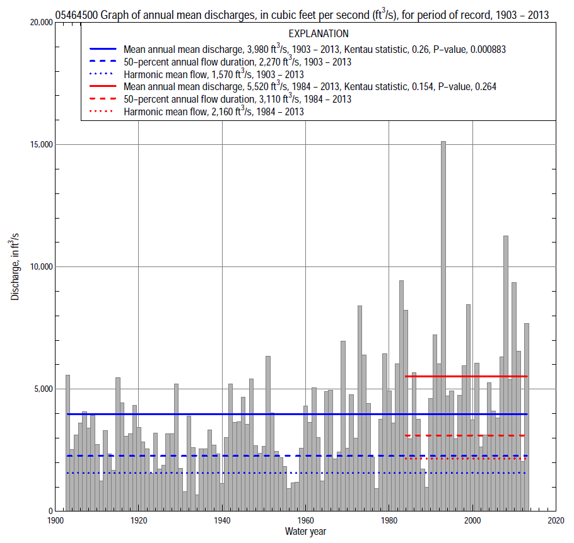

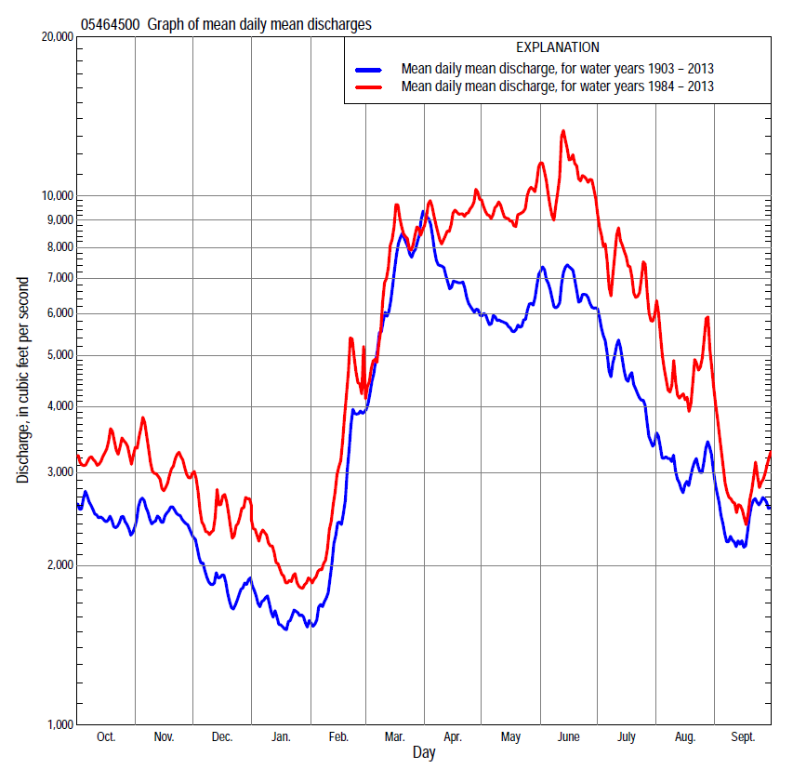

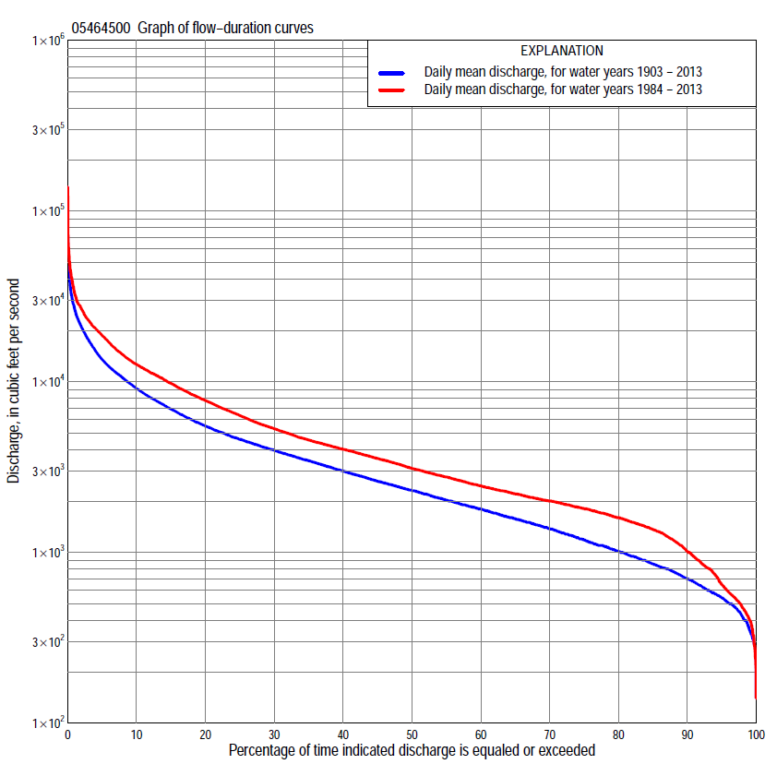

Statistics Based on the Entire Streamflow Period of Record
05464500 Monthly and annual flow durations, based on 1903–2013 period of record (111 years)
Percentage of days discharge equaled or exceeded |  |  |  |  | Discharge (cubic feet per second) |  |  |  |  |  |  |  |  | Annual flow durations
 | Oct | Nov | Dec | Jan | Feb | Mar | Apr | May | June | July | Aug | Sept | Annual | Kentau statistic | P-value
99 | 460 | 403 | 304 | 285 | 290 | 570 | 916 | 662 | 499 | 472 | 385 | 428 | 345 | 0.238 | 0.000
98 | 480 | 480 | 340 | 310 | 326 | 657 | 996 | 820 | 564 | 509 | 426 | 475 | 417 | 0.251 | 0.000
95 | 558 | 560 | 400 | 358 | 406 | 852 | 1,260 | 1,100 | 890 | 621 | 570 | 580 | 544 | 0.259 | 0.000
90 | 664 | 680 | 500 | 450 | 547 | 1,100 | 1,660 | 1,440 | 1,210 | 912 | 736 | 690 | 694 | 0.251 | 0.000
85 | 778 | 774 | 580 | 520 | 620 | 1,520 | 2,090 | 1,760 | 1,490 | 1,100 | 853 | 800 | 845 | 0.262 | 0.000
80 | 858 | 900 | 690 | 620 | 740 | 1,900 | 2,430 | 2,020 | 1,920 | 1,360 | 978 | 902 | 1,000 | 0.255 | 0.000
75 | 950 | 1,050 | 800 | 700 | 820 | 2,350 | 2,770 | 2,350 | 2,320 | 1,560 | 1,100 | 1,020 | 1,150 | 0.241 | 0.000
70 | 1,050 | 1,190 | 900 | 750 | 920 | 2,780 | 3,130 | 2,730 | 2,640 | 1,770 | 1,220 | 1,130 | 1,340 | 0.226 | 0.000
65 | 1,160 | 1,350 | 1,000 | 850 | 1,020 | 3,180 | 3,430 | 3,050 | 2,990 | 2,020 | 1,360 | 1,260 | 1,540 | 0.225 | 0.000
60 | 1,280 | 1,480 | 1,100 | 950 | 1,150 | 3,590 | 3,790 | 3,350 | 3,450 | 2,290 | 1,500 | 1,380 | 1,750 | 0.247 | 0.000
55 | 1,470 | 1,620 | 1,250 | 1,020 | 1,330 | 3,960 | 4,160 | 3,720 | 3,880 | 2,590 | 1,630 | 1,500 | 1,990 | 0.254 | 0.000
50 | 1,670 | 1,750 | 1,400 | 1,100 | 1,600 | 4,380 | 4,670 | 4,080 | 4,330 | 2,950 | 1,840 | 1,640 | 2,270 | 0.238 | 0.000
45 | 1,840 | 1,920 | 1,540 | 1,230 | 1,850 | 4,880 | 5,230 | 4,580 | 4,780 | 3,310 | 2,080 | 1,820 | 2,580 | 0.243 | 0.000
40 | 2,060 | 2,110 | 1,720 | 1,400 | 2,000 | 5,620 | 6,000 | 5,040 | 5,420 | 3,720 | 2,300 | 1,990 | 2,950 | 0.252 | 0.000
35 | 2,320 | 2,360 | 1,900 | 1,570 | 2,300 | 6,440 | 6,910 | 5,580 | 6,150 | 4,190 | 2,540 | 2,200 | 3,410 | 0.248 | 0.000
30 | 2,600 | 2,650 | 2,080 | 1,750 | 2,580 | 7,440 | 7,860 | 6,410 | 7,220 | 4,750 | 2,840 | 2,430 | 3,930 | 0.258 | 0.000
25 | 3,100 | 3,000 | 2,340 | 1,940 | 2,950 | 8,600 | 9,010 | 7,370 | 8,260 | 5,520 | 3,290 | 2,750 | 4,550 | 0.255 | 0.000
20 | 3,650 | 3,590 | 2,760 | 2,250 | 3,500 | 10,100 | 10,500 | 8,340 | 9,640 | 6,300 | 3,840 | 3,100 | 5,430 | 0.253 | 0.000
15 | 4,300 | 4,240 | 3,270 | 2,600 | 4,280 | 12,000 | 12,100 | 9,840 | 11,500 | 7,550 | 4,640 | 3,740 | 6,820 | 0.255 | 0.000
10 | 5,120 | 5,080 | 3,810 | 3,240 | 5,600 | 15,500 | 14,500 | 12,000 | 14,500 | 9,240 | 5,830 | 4,800 | 8,960 | 0.256 | 0.000
5 | 7,080 | 6,960 | 4,820 | 4,520 | 8,310 | 20,800 | 20,200 | 17,600 | 20,400 | 13,200 | 9,010 | 6,930 | 13,100 | 0.246 | 0.000
2 | 10,200 | 9,600 | 7,040 | 6,000 | 13,100 | 28,500 | 30,300 | 23,500 | 28,400 | 21,600 | 18,400 | 11,400 | 20,400 | 0.201 | 0.002
1 | 13,000 | 12,000 | 8,930 | 8,600 | 17,400 | 33,200 | 40,100 | 29,100 | 34,900 | 30,700 | 25,600 | 14,000 | 26,200 | 0.148 | 0.022

05464500 Annual exceedance probability of instantaneous peak discharges, in cubic feet per second (ft³/s), based on the Weighted Independent Estimates method,
Annual exceed-ance probability | Recur-rence interval (years) | Discharge (ft³/s) | 95-percent lower confi-dence interval (ft³/s) | 95-percent upper confi-dence interval (ft³/s)
0.500 | 2 | 25,200 | 22,200 | 28,500
0.200 | 5 | 42,300 | 37,300 | 48,000
0.100 | 10 | 54,200 | 47,300 | 62,100
0.040 | 25 | 70,200 | 59,600 | 82,600
0.020 | 50 | 81,700 | 67,600 | 98,700
0.010 | 100 | 92,800 | 74,500 | 115,000
0.005 | 200 | 107,000 | 83,400 | 138,000
0.002 | 500 | 120,000 | 89,200 | 161,000
and based on the expected moments algorithm/multiple Grubbs-Beck analysis computed using a historical period length of 111 years (1903–2013)
0.500 | 2 | 25,200 | 22,100 | 28,600
0.200 | 5 | 42,300 | 37,200 | 48,600
0.100 | 10 | 54,700 | 47,600 | 64,400
0.040 | 25 | 71,100 | 60,500 | 88,200
0.020 | 50 | 83,800 | 69,600 | 109,000
0.010 | 100 | 96,600 | 78,000 | 133,000
0.005 | 200 | 110,000 | 85,800 | 160,000
0.002 | 500 | 128,000 | 95,400 | 200,000
Kentau statistic |  | 0.097
P-value |  | 0.133
Begin year |  | 1903
End year |  | 2013
Number of peaks |  | 111

05464500 Annual exceedance probability of high discharges, based on 1903–2013 period of record (111 years)
Annual exceed-ance probability | Recur-rence interval (years) | Maximum average discharge (ft³/s) for indicated number of consecutive days
 |  | 1 | 3 | 7 | 15 | 30
0.990 | 1.01 | 3,720 | 3,470 | 2,970 | 2,260 | 1,700
0.950 | 1.05 | 6,810 | 6,300 | 5,340 | 4,110 | 3,160
0.900 | 1.11 | 9,210 | 8,490 | 7,160 | 5,530 | 4,290
0.800 | 1.25 | 13,000 | 12,000 | 10,000 | 7,750 | 6,040
0.500 | 2 | 24,000 | 22,000 | 18,100 | 13,900 | 10,800
0.200 | 5 | 41,300 | 37,800 | 30,400 | 23,100 | 17,600
0.100 | 10 | 53,400 | 49,000 | 38,900 | 29,200 | 22,000
0.040 | 25 | 68,900 | 63,400 | 49,700 | 36,800 | 27,200
0.020 | 50 | 80,400 | 74,100 | 57,600 | 42,200 | 30,700
0.010 | 100 | 91,800 | 84,800 | 65,300 | 47,500 | 34,100
0.005 | 200 | 103,000 | 95,500 | 72,900 | 52,500 | 37,200
0.002 | 500 | 118,000 | 109,000 | 82,700 | 58,900 | 41,000
Kentau statistic |  | 0.089 | 0.103 | 0.141 | 0.181 | 0.211
P-value |  | 0.167 | 0.111 | 0.029 | 0.005 | 0.001

 | 05464500 Annual nonexceedance probability of low discharges, based on April 1903 to March 2013 period of record (110 years)
Annual nonexceed-ance probability | Recur-rence interval (years) | Minimum average discharge (ft³/s) for indicated number of consecutive days
 |  | 1 | 3 | 7 | 14 | 30 | 60 | 90 | 120 | 183
0.01 | 100 | 178 | 200 | 204 | 214 | 229 | 254 | 279 | 302 | 336
0.02 | 50 | 205 | 229 | 239 | 250 | 269 | 299 | 331 | 362 | 406
0.05 | 20 | 254 | 281 | 300 | 316 | 341 | 382 | 428 | 472 | 539
0.10 | 10 | 308 | 337 | 368 | 388 | 421 | 474 | 536 | 596 | 690
0.20 | 5 | 389 | 422 | 469 | 497 | 542 | 617 | 704 | 788 | 927
0.50 | 2 | 614 | 656 | 740 | 793 | 875 | 1,020 | 1,180 | 1,330 | 1,610
0.80 | 1.25 | 978 | 1,040 | 1,160 | 1,260 | 1,410 | 1,670 | 1,960 | 2,220 | 2,760
0.90 | 1.11 | 1,250 | 1,320 | 1,460 | 1,590 | 1,800 | 2,170 | 2,550 | 2,880 | 3,640
0.96 | 1.04 | 1,630 | 1,720 | 1,860 | 2,050 | 2,330 | 2,860 | 3,370 | 3,800 | 4,860
0.98 | 1.02 | 1,940 | 2,050 | 2,170 | 2,410 | 2,750 | 3,420 | 4,040 | 4,530 | 5,840
0.99 | 1.01 | 2,270 | 2,400 | 2,500 | 2,780 | 3,200 | 4,010 | 4,740 | 5,300 | 6,880
Kentau statistic |  | 0.185 | 0.216 | 0.290 | 0.294 | 0.280 | 0.259 | 0.236 | 0.211 | 0.196
P-value |  | 0.004 | 0.001 | 0.000 | 0.000 | 0.000 | 0.000 | 0.000 | 0.001 | 0.002

05464500 Annual nonexceedance probability of seasonal low discharges, based on October 1902 to September 2013 period of record (111 years)
Annual nonexceed-ance probability | Recur-rence interval (years) | Minimum average discharge (cubic feet per second) for indicated number of consecutive days
 |  | 1 | 7 | 14 | 30 |  | 1 | 7 | 14 | 30
 |  | January-February-March |  |  |  |  | April-May-June
0.01 | 100 | 203 | 213 | 222 | 239 |  | 350 | 403 | 422 | 486
0.02 | 50 | 236 | 250 | 261 | 282 |  | 434 | 496 | 522 | 606
0.05 | 20 | 295 | 318 | 333 | 364 |  | 596 | 674 | 716 | 842
0.10 | 10 | 362 | 395 | 415 | 458 |  | 786 | 883 | 946 | 1,120
0.20 | 5 | 464 | 514 | 544 | 608 |  | 1,090 | 1,220 | 1,320 | 1,580
0.50 | 2 | 760 | 857 | 919 | 1,060 |  | 1,990 | 2,220 | 2,460 | 3,020
0.80 | 1.25 | 1,270 | 1,440 | 1,570 | 1,880 |  | 3,540 | 3,950 | 4,510 | 5,660
0.90 | 1.11 | 1,670 | 1,910 | 2,090 | 2,560 |  | 4,730 | 5,300 | 6,150 | 7,800
0.96 | 1.04 | 2,250 | 2,570 | 2,850 | 3,570 |  | 6,390 | 7,210 | 8,520 | 10,900
0.98 | 1.02 | 2,740 | 3,120 | 3,480 | 4,450 |  | 7,730 | 8,770 | 10,500 | 13,500
0.99 | 1.01 | 3,270 | 3,720 | 4,180 | 5,430 |  | 9,140 | 10,400 | 12,600 | 16,400
Kentau statistic |  | 0.206 | 0.256 | 0.256 | 0.219 |  | 0.293 | 0.295 | 0.297 | 0.283
P-value |  | 0.001 | 0.000 | 0.000 | 0.001 |  | 0.000 | 0.000 | 0.000 | 0.000
 |  | July-August-September |  |  |  |  | October-November-December
0.01 | 100 | 290 | 324 | 335 | 375 |  | 184 | 249 | 261 | 290
0.02 | 50 | 331 | 368 | 382 | 426 |  | 217 | 290 | 308 | 343
0.05 | 20 | 407 | 448 | 468 | 521 |  | 277 | 366 | 393 | 440
0.10 | 10 | 492 | 539 | 566 | 630 |  | 345 | 450 | 489 | 551
0.20 | 5 | 626 | 680 | 720 | 805 |  | 449 | 578 | 637 | 724
0.50 | 2 | 1,020 | 1,100 | 1,180 | 1,340 |  | 746 | 941 | 1,060 | 1,230
0.80 | 1.25 | 1,720 | 1,850 | 2,010 | 2,370 |  | 1,240 | 1,540 | 1,760 | 2,090
0.90 | 1.11 | 2,290 | 2,480 | 2,700 | 3,270 |  | 1,610 | 2,000 | 2,300 | 2,760
0.96 | 1.04 | 3,150 | 3,430 | 3,760 | 4,710 |  | 2,140 | 2,650 | 3,060 | 3,730
0.98 | 1.02 | 3,900 | 4,270 | 4,700 | 6,010 |  | 2,570 | 3,180 | 3,680 | 4,540
0.99 | 1.01 | 4,740 | 5,220 | 5,760 | 7,550 |  | 3,030 | 3,740 | 4,340 | 5,420
Kentau statistic |  | 0.249 | 0.240 | 0.220 | 0.223 |  | 0.114 | 0.188 | 0.228 | 0.210
P-value |  | 0.000 | 0.000 | 0.001 | 0.001 |  | 0.077 | 0.003 | 0.000 | 0.001

Statistics Based on the 1984–2013 Streamflow Period of Record
05464500 Monthly and annual flow durations, based on 1984–2013 period of record (30 years)
Percentage of days discharge equaled or exceeded |  |  |  |  | Discharge (cubic feet per second) |  |  |  |  |  |  |  |  | Annual flow durations
 | Oct | Nov | Dec | Jan | Feb | Mar | Apr | May | June | July | Aug | Sept | Annual | Kentau statistic | P-value
99 | 426 | 401 | 240 | 319 | 392 | 546 | 1,300 | 1,080 | 598 | 488 | 386 | 449 | 405 | -0.005 | 0.986
98 | 438 | 462 | 284 | 337 | 470 | 658 | 1,350 | 1,430 | 698 | 561 | 419 | 469 | 474 | 0.000 | 1.000
95 | 532 | 636 | 510 | 490 | 550 | 1,450 | 1,720 | 1,950 | 1,040 | 777 | 583 | 574 | 647 | 0.016 | 0.915
90 | 824 | 1,060 | 722 | 629 | 713 | 2,050 | 2,030 | 2,730 | 1,970 | 1,160 | 842 | 963 | 1,010 | -0.002 | 1.000
85 | 1,100 | 1,360 | 860 | 839 | 1,000 | 2,290 | 2,760 | 3,130 | 2,700 | 1,900 | 1,370 | 1,220 | 1,360 | -0.007 | 0.972
80 | 1,250 | 1,570 | 1,150 | 960 | 1,200 | 2,630 | 3,060 | 3,570 | 3,500 | 2,450 | 1,730 | 1,410 | 1,600 | -0.016 | 0.915
75 | 1,380 | 1,690 | 1,340 | 1,110 | 1,440 | 2,880 | 3,490 | 4,020 | 4,070 | 2,830 | 1,980 | 1,490 | 1,800 | -0.016 | 0.915
70 | 1,560 | 1,830 | 1,500 | 1,320 | 1,600 | 3,240 | 3,890 | 4,610 | 4,460 | 3,260 | 2,150 | 1,580 | 2,000 | -0.032 | 0.817
65 | 1,700 | 1,930 | 1,650 | 1,420 | 1,760 | 3,580 | 4,360 | 5,120 | 5,000 | 3,750 | 2,320 | 1,680 | 2,200 | -0.041 | 0.762
60 | 1,840 | 2,050 | 1,790 | 1,520 | 1,900 | 3,900 | 5,010 | 5,690 | 5,860 | 4,250 | 2,490 | 1,790 | 2,450 | 0.016 | 0.915
55 | 1,960 | 2,150 | 1,950 | 1,610 | 2,010 | 4,250 | 5,560 | 6,590 | 6,940 | 4,720 | 2,650 | 1,900 | 2,770 | 0.039 | 0.775
50 | 2,080 | 2,300 | 2,060 | 1,750 | 2,160 | 4,650 | 6,500 | 7,420 | 7,910 | 5,120 | 2,880 | 2,020 | 3,110 | 0.057 | 0.669
45 | 2,290 | 2,510 | 2,200 | 1,880 | 2,310 | 5,340 | 7,490 | 7,940 | 9,100 | 5,690 | 3,130 | 2,160 | 3,550 | 0.076 | 0.568
40 | 2,520 | 2,770 | 2,390 | 2,020 | 2,500 | 6,000 | 8,740 | 8,670 | 10,100 | 6,220 | 3,400 | 2,300 | 4,020 | 0.090 | 0.498
35 | 3,040 | 3,080 | 2,700 | 2,200 | 2,640 | 6,650 | 9,920 | 9,570 | 11,200 | 6,860 | 3,710 | 2,460 | 4,560 | 0.103 | 0.432
30 | 3,610 | 3,640 | 2,970 | 2,400 | 2,920 | 7,470 | 11,200 | 10,300 | 12,400 | 7,690 | 4,170 | 2,700 | 5,300 | 0.131 | 0.318
25 | 4,230 | 4,000 | 3,310 | 2,580 | 3,360 | 8,750 | 12,200 | 11,100 | 13,800 | 8,360 | 4,580 | 2,970 | 6,330 | 0.129 | 0.326
20 | 4,660 | 4,410 | 3,560 | 2,870 | 3,940 | 11,000 | 13,300 | 13,700 | 16,000 | 9,570 | 5,280 | 3,310 | 7,760 | 0.129 | 0.326
15 | 5,370 | 5,030 | 3,950 | 3,330 | 4,800 | 13,200 | 15,200 | 16,800 | 18,800 | 11,500 | 6,110 | 4,010 | 9,780 | 0.166 | 0.205
10 | 6,870 | 5,770 | 4,480 | 3,840 | 6,630 | 16,600 | 18,800 | 19,800 | 22,700 | 15,100 | 8,390 | 5,280 | 12,600 | 0.166 | 0.205
5 | 9,600 | 7,500 | 6,300 | 4,730 | 10,900 | 20,700 | 25,400 | 25,500 | 28,400 | 21,400 | 16,500 | 9,510 | 18,700 | 0.149 | 0.254
2 | 14,300 | 10,200 | 8,380 | 5,720 | 14,600 | 28,200 | 34,200 | 33,100 | 39,100 | 34,000 | 28,500 | 12,800 | 26,700 | 0.163 | 0.212
1 | 15,600 | 11,800 | 9,760 | 6,530 | 19,400 | 35,000 | 41,100 | 43,500 | 61,300 | 44,300 | 35,600 | 17,500 | 33,100 | 0.182 | 0.164

05464500 Annual exceedance probability of high discharges, based on 1984–2013 period of record (30 years)
Annual exceed-ance probability | Recur-rence interval (years) | Maximum average discharge (ft³/s) for indicated number of consecutive days
 |  | 1 | 3 | 7 | 15 | 30
0.990 | 1.01 | 5,290 | 4,730 | 4,150 | 3,390 | 2,930
0.950 | 1.05 | 8,500 | 7,700 | 6,770 | 5,640 | 4,810
0.900 | 1.11 | 11,000 | 9,990 | 8,760 | 7,340 | 6,200
0.800 | 1.25 | 14,900 | 13,700 | 11,900 | 10,000 | 8,320
0.500 | 2 | 26,800 | 24,900 | 21,300 | 17,600 | 14,200
0.200 | 5 | 48,100 | 45,100 | 37,700 | 30,100 | 23,100
0.100 | 10 | 65,400 | 61,500 | 50,500 | 39,300 | 29,400
0.040 | 25 | 90,700 | 85,500 | 68,700 | 51,700 | 37,400
0.020 | 50 | 112,000 | 106,000 | 83,700 | 61,400 | 43,500
0.010 | 100 | 135,000 | 128,000 | 99,700 | 71,400 | 49,700
0.005 | 200 | 161,000 | 153,000 | 117,000 | 81,800 | 55,800
0.002 | 500 | 199,000 | 188,000 | 142,000 | 96,000 | 64,000
Kentau statistic |  | 0.179 | 0.168 | 0.177 | 0.154 | 0.145
P-value |  | 0.169 | 0.199 | 0.175 | 0.239 | 0.269

 | 05464500 Annual nonexceedance probability of low discharges, based on April 1983 to March 2013 period of record (30 years)
Annual nonexceed-ance probability | Recur-rence interval (years) | Minimum average discharge (ft³/s) for indicated number of consecutive days
 |  | 1 | 3 | 7 | 14 | 30 | 60 | 90 | 120 | 183
0.01 | 100 | 122 | 172 | 212 | 221 | 245 | 287 | 314 | 340 | 357
0.02 | 50 | 162 | 219 | 276 | 290 | 320 | 369 | 407 | 441 | 471
0.05 | 20 | 242 | 306 | 396 | 421 | 461 | 524 | 585 | 635 | 694
0.10 | 10 | 336 | 405 | 528 | 566 | 617 | 696 | 784 | 852 | 953
0.20 | 5 | 483 | 554 | 718 | 776 | 843 | 950 | 1,080 | 1,180 | 1,350
0.50 | 2 | 872 | 937 | 1,150 | 1,250 | 1,370 | 1,560 | 1,810 | 1,980 | 2,400
0.80 | 1.25 | 1,390 | 1,450 | 1,590 | 1,730 | 1,930 | 2,290 | 2,700 | 2,950 | 3,760
0.90 | 1.11 | 1,700 | 1,750 | 1,800 | 1,950 | 2,210 | 2,670 | 3,180 | 3,480 | 4,560
0.96 | 1.04 | 1,970 | 1,980 | 1,990 | 2,150 | 2,470 | 3,060 | 3,680 | 4,030 | 5,420
0.98 | 1.02 | 2,070 | 2,080 | 2,090 | 2,250 | 2,610 | 3,300 | 3,990 | 4,370 | 5,970
0.99 | 1.01 | 2,150 | 2,160 | 2,170 | 2,330 | 2,720 | 3,500 | 4,240 | 4,650 | 6,450
Kentau statistic |  | 0.007 | 0.002 | 0.025 | 0.048 | 0.021 | 0.044 | -0.034 | -0.021 | -0.057
P-value |  | 0.972 | 1.000 | 0.858 | 0.721 | 0.887 | 0.748 | 0.803 | 0.887 | 0.669

05464500 Annual nonexceedance probability of seasonal low discharges, based on October 1983 to September 2013 period of record (30 years)
Annual nonexceed-ance probability | Recur-rence interval (years) | Minimum average discharge (cubic feet per second) for indicated number of consecutive days
 |  | 1 | 7 | 14 | 30 |  | 1 | 7 | 14 | 30
 |  | January-February-March |  |  |  |  | April-May-June
0.01 | 100 | 182 | 256 | 271 | 292 |  | 432 | 484 | 487 | 589
0.02 | 50 | 234 | 323 | 342 | 370 |  | 579 | 640 | 653 | 780
0.05 | 20 | 333 | 448 | 476 | 517 |  | 875 | 952 | 990 | 1,170
0.10 | 10 | 447 | 587 | 626 | 682 |  | 1,230 | 1,330 | 1,400 | 1,650
0.20 | 5 | 625 | 795 | 850 | 932 |  | 1,800 | 1,930 | 2,090 | 2,460
0.50 | 2 | 1,110 | 1,320 | 1,420 | 1,580 |  | 3,370 | 3,650 | 4,120 | 4,970
0.80 | 1.25 | 1,800 | 2,000 | 2,170 | 2,450 |  | 5,610 | 6,280 | 7,400 | 9,330
0.90 | 1.11 | 2,240 | 2,410 | 2,620 | 2,980 |  | 7,020 | 8,030 | 9,680 | 12,600
0.96 | 1.04 | 2,770 | 2,870 | 3,120 | 3,600 |  | 8,630 | 10,200 | 12,500 | 17,100
0.98 | 1.02 | 3,140 | 3,180 | 3,460 | 4,010 |  | 9,710 | 11,700 | 14,600 | 20,500
0.99 | 1.01 | 3,490 | 3,500 | 3,760 | 4,390 |  | 10,700 | 13,100 | 16,700 | 24,000
Kentau statistic |  | -0.106 | -0.018 | 0.016 | -0.011 |  | 0.182 | 0.205 | 0.211 | 0.218
P-value |  | 0.422 | 0.901 | 0.915 | 0.943 |  | 0.164 | 0.116 | 0.104 | 0.094
 |  | July-August-September |  |  |  |  | October-November-December
0.01 | 100 | 351 | 382 | 389 | 415 |  | 129 | 225 | 244 | 286
0.02 | 50 | 414 | 447 | 458 | 492 |  | 173 | 290 | 322 | 374
0.05 | 20 | 531 | 568 | 588 | 637 |  | 263 | 414 | 474 | 545
0.10 | 10 | 663 | 705 | 735 | 805 |  | 371 | 556 | 648 | 741
0.20 | 5 | 870 | 921 | 968 | 1,080 |  | 542 | 770 | 913 | 1,040
0.50 | 2 | 1,470 | 1,560 | 1,660 | 1,910 |  | 1,010 | 1,320 | 1,580 | 1,800
0.80 | 1.25 | 2,510 | 2,690 | 2,870 | 3,470 |  | 1,670 | 2,040 | 2,400 | 2,780
0.90 | 1.11 | 3,330 | 3,620 | 3,860 | 4,790 |  | 2,070 | 2,470 | 2,860 | 3,340
0.96 | 1.04 | 4,510 | 4,980 | 5,300 | 6,800 |  | 2,510 | 2,940 | 3,330 | 3,950
0.98 | 1.02 | 5,500 | 6,140 | 6,530 | 8,570 |  | 2,810 | 3,250 | 3,610 | 4,330
0.99 | 1.01 | 6,580 | 7,440 | 7,890 | 10,600 |  | 3,070 | 3,520 | 3,850 | 4,660
Kentau statistic |  | 0.101 | 0.087 | 0.055 | 0.085 |  | -0.018 | -0.094 | -0.099 | -0.099
P-value |  | 0.443 | 0.509 | 0.682 | 0.521 |  | 0.901 | 0.475 | 0.454 | 0.454

