LOCATION.--Lat 41°55'22", long 91°47'02" referenced to North American Datum of 1927, in NW 1/4 SW 1/4 SE 1/4 sec.09, T.82 N., R.8 W., Linn County, IA, Hydrologic Unit 07080205, on right bank 10 ft upstream from bridge on State Highway 149 in Fairfax, and 10.3 mi upstream from mouth.

DRAINAGE AREA.--178 mi².

PERIOD OF RECORD.--Discharge records from October 1966 to September 1982.

GAGE.--Water-stage recorder. Datum of gage is 737.00 ft above National Geodetic Vertical Datum of 1929.

A summary of all available data for this streamgage is provided through the USGS National Water Information System web interface (NWISWeb). The following link provides access to current/historical observations, daily data, daily statistics, monthly statistics, annual statistics, peak streamflow, field measurements, field/lab water-quality samples, and the latest water-year summaries. Data can be filtered by parameter and/or dates, and can be output in various tabular and graphical formats.
http://waterdata.usgs.gov/nwis/inventory/?site_no=05464640

The USGS WaterWatch Toolkit is available at:
http://waterwatch.usgs.gov/?id=ww_toolkit
Tools for summarizing streamflow information include the duration hydrograph builder, the cumulative streamflow hydrograph builder, the streamgage statistics retrieval tool, the rating curve builder, the flood tracking chart builder, the National Weather Service Advanced Hydrologic Prediction Service (AHPS) river forecast hydrograph builder, and the raster-hydrograph builder. Entering the above number for this streamgage into these toolkit webpages will provide streamflow information specific to this streamgage.

A description of the statistics presented for this streamgage is available in the main body of the report at:
http://dx.doi.org/10.3133/ofr20151214
A link to other streamgages included in this report, a map showing the location of the streamgages, information on the programs used to compute the statistical analyses, and references are included in the main body of the report.

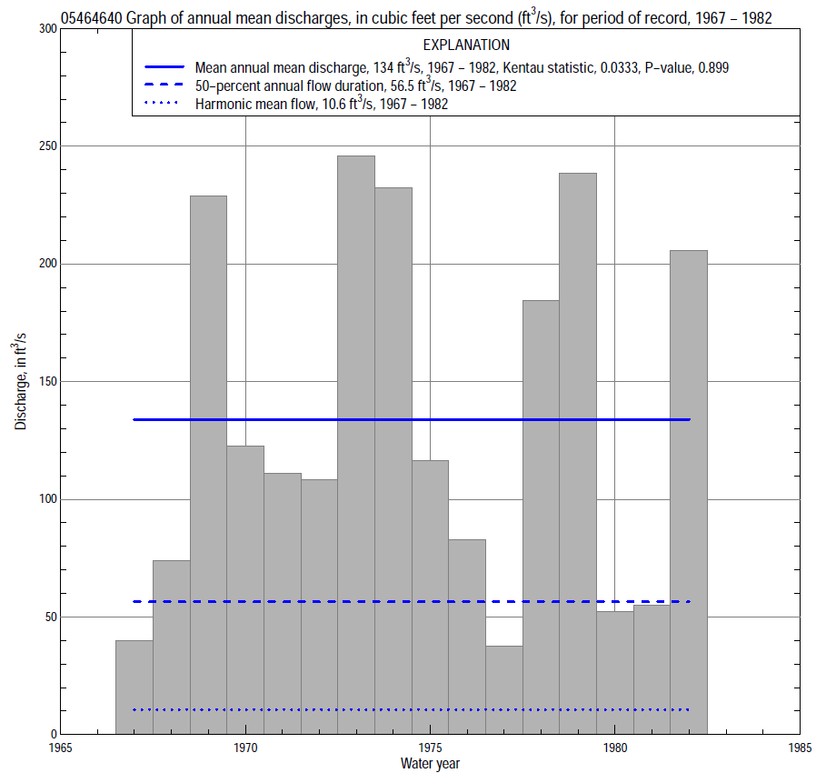

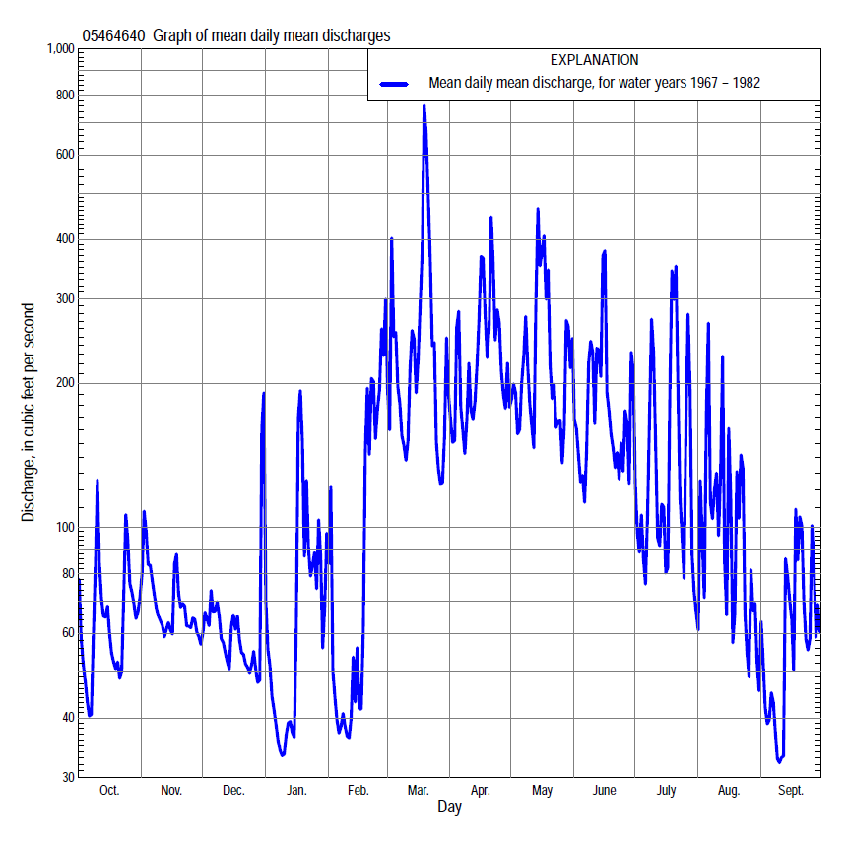

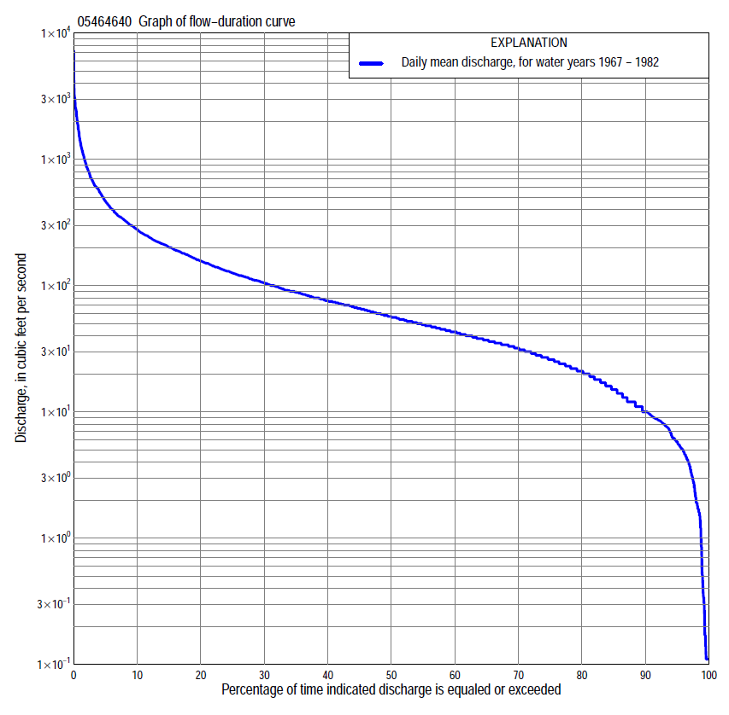

Statistics Based on the Entire Streamflow Period of Record
05464640 Monthly and annual flow durations, based on 1967–82 period of record (16 years)
Percentage of days discharge equaled or exceeded |  |  |  |  | Discharge (cubic feet per second) |  |  |  |  |  |  |  |  | Annual flow durations
 | Oct | Nov | Dec | Jan | Feb | Mar | Apr | May | June | July | Aug | Sept | Annual | Kentau statistic | P-value
99 | 4.0 | 4.2 | 1.5 | 0.11 | 0.11 | 12 | 7.4 | 3.1 | 1.2 | 0.00 | 1.9 | 2.9 | 0.46 | 0.142 | 0.470
98 | 4.6 | 4.5 | 1.6 | 0.11 | 0.17 | 14 | 7.7 | 3.7 | 1.7 | 0.17 | 4.4 | 3.1 | 1.9 | 0.108 | 0.588
95 | 5.5 | 5.3 | 1.9 | 0.36 | 6.8 | 21 | 11 | 5.9 | 2.7 | 1.9 | 8.6 | 4.3 | 5.8 | 0.050 | 0.821
90 | 8.2 | 8.8 | 6.0 | 5.8 | 15 | 29 | 43 | 27 | 22 | 18 | 12 | 8.5 | 10 | 0.075 | 0.718
85 | 9.2 | 11 | 9.6 | 6.3 | 16 | 34 | 54 | 34 | 36 | 23 | 13 | 10 | 15 | 0.058 | 0.786
80 | 11 | 12 | 13 | 10 | 21 | 40 | 60 | 42 | 48 | 28 | 14 | 13 | 21 | 0.150 | 0.443
75 | 15 | 19 | 19 | 16 | 26 | 45 | 66 | 50 | 58 | 33 | 16 | 17 | 26 | 0.200 | 0.300
70 | 21 | 24 | 23 | 18 | 29 | 62 | 73 | 59 | 67 | 38 | 20 | 19 | 32 | 0.150 | 0.444
65 | 25 | 27 | 28 | 22 | 31 | 77 | 85 | 76 | 75 | 43 | 24 | 22 | 37 | 0.100 | 0.620
60 | 30 | 35 | 33 | 24 | 34 | 90 | 100 | 89 | 83 | 47 | 30 | 26 | 43 | 0.058 | 0.787
55 | 35 | 41 | 41 | 33 | 37 | 98 | 117 | 102 | 91 | 52 | 34 | 29 | 49 | 0.025 | 0.928
50 | 38 | 49 | 48 | 35 | 39 | 117 | 132 | 116 | 107 | 56 | 39 | 32 | 56 | 0.075 | 0.718
45 | 42 | 58 | 55 | 38 | 44 | 129 | 151 | 143 | 121 | 62 | 44 | 38 | 66 | 0.008 | 1.000
40 | 47 | 64 | 65 | 43 | 48 | 143 | 172 | 166 | 137 | 67 | 51 | 43 | 76 | 0.008 | 1.000
35 | 53 | 73 | 68 | 48 | 54 | 164 | 200 | 198 | 154 | 75 | 59 | 49 | 89 | -0.033 | 0.893
30 | 70 | 83 | 73 | 51 | 65 | 190 | 231 | 222 | 176 | 90 | 69 | 54 | 105 | -0.008 | 1.000
25 | 83 | 102 | 80 | 64 | 80 | 219 | 262 | 253 | 199 | 103 | 79 | 61 | 126 | -0.008 | 1.000
20 | 98 | 113 | 87 | 80 | 100 | 280 | 303 | 297 | 232 | 124 | 98 | 75 | 157 | 0.017 | 0.964
15 | 116 | 135 | 98 | 95 | 145 | 370 | 359 | 364 | 292 | 165 | 131 | 94 | 201 | 0.050 | 0.822
10 | 147 | 165 | 120 | 130 | 235 | 537 | 540 | 500 | 363 | 273 | 198 | 132 | 278 | 0.033 | 0.893
5 | 212 | 194 | 160 | 260 | 400 | 886 | 700 | 756 | 518 | 513 | 344 | 196 | 465 | 0.033 | 0.893
2 | 330 | 248 | 200 | 500 | 950 | 1,530 | 1,140 | 1,220 | 1,060 | 1,350 | 838 | 390 | 877 | 0.000 | 1.000
1 | 458 | 319 | 248 | 750 | 1,100 | 2,610 | 1,720 | 2,420 | 1,670 | 2,040 | 1,470 | 611 | 1,400 | 0.033 | 0.893

05464640 Annual exceedance probability of instantaneous peak discharges, in cubic feet per second (ft³/s), based on the Weighted Independent Estimates method,
Annual exceed-ance probability | Recur-rence interval (years) | Discharge (ft³/s) | 95-percent lower confi-dence interval (ft³/s) | 95-percent upper confi-dence interval (ft³/s)
0.500 | 2 | 3,180 | 2,380 | 4,240
0.200 | 5 | 5,440 | 4,170 | 7,080
0.100 | 10 | 7,460 | 5,740 | 9,690
0.040 | 25 | 10,500 | 8,020 | 13,900
0.020 | 50 | 12,600 | 9,380 | 17,000
0.010 | 100 | 14,600 | 10,500 | 20,300
0.005 | 200 | 17,600 | 12,200 | 25,400
0.002 | 500 | 19,400 | 12,800 | 29,300
and based on the expected moments algorithm/multiple Grubbs-Beck analysis computed using a historical period length of 16 years (1967–82)
0.500 | 2 | 3,140 | 2,200 | 4,280
0.200 | 5 | 5,110 | 3,770 | 7,490
0.100 | 10 | 6,460 | 4,760 | 10,500
0.040 | 25 | 8,180 | 5,880 | 15,400
0.020 | 50 | 9,440 | 6,610 | 20,000
0.010 | 100 | 10,700 | 7,230 | 25,500
0.005 | 200 | 11,900 | 7,780 | 32,000
0.002 | 500 | 13,500 | 8,390 | 42,700
Kentau statistic |  | 0.025
P-value |  | 0.928
Begin year |  | 1967
End year |  | 1982
Number of peaks |  | 16

05464640 Annual exceedance probability of high discharges, based on 1967–82 period of record (16 years)
Annual exceedance probability | Recur-rence interval (years) | Maximum average discharge (ft³/s) for indicated number of consecutive days
 |  | 1 | 3 | 7 | 15 | 30
0.990 | 1.01 | 347 | 192 | 113 | 73 | 46
0.950 | 1.05 | 651 | 399 | 235 | 150 | 97
0.900 | 1.11 | 890 | 569 | 335 | 213 | 139
0.800 | 1.25 | 1,270 | 846 | 499 | 316 | 210
0.500 | 2 | 2,370 | 1,650 | 979 | 613 | 424
0.200 | 5 | 4,080 | 2,870 | 1,710 | 1,060 | 769
0.100 | 10 | 5,270 | 3,660 | 2,200 | 1,350 | 1,010
0.040 | 25 | 6,770 | 4,620 | 2,790 | 1,700 | 1,310
0.020 | 50 | 7,860 | 5,280 | 3,200 | 1,940 | 1,530
0.010 | 100 | 8,930 | 5,890 | 3,580 | 2,160 | 1,740
0.005 | 200 | 9,980 | 6,470 | 3,940 | 2,370 | 1,940
0.002 | 500 | 11,300 | 7,170 | 4,380 | 2,630 | 2,200
Kentau statistic |  | 0.017 | 0.017 | 0.033 | -0.017 | 0.000
P-value |  | 0.964 | 0.964 | 0.893 | 0.964 | 1.000

 | 05464640 Annual nonexceedance probability of low discharges, based on April 1967 to March 1982 period of record (15 years)
Annual nonexceed-ance probability | Recur-rence interval (years) | Minimum average discharge (cubic feet per second) for indicated number of consecutive days
 |  | 1 | 3 | 7 | 14 | 30 | 60 | 90 | 120 | 183
0.01 | 100 | 0.00 | 0.00 | 0.00 | 0.03 | 0.03 | 0.18 | 0.44 | 0.87 | 1.6
0.02 | 50 | 0.00 | 0.00 | 0.02 | 0.08 | 0.10 | 0.39 | 0.85 | 1.5 | 2.8
0.05 | 20 | 0.00 | 0.00 | 0.11 | 0.35 | 0.45 | 1.2 | 2.1 | 3.1 | 6.1
0.10 | 10 | 0.32 | 0.32 | 0.47 | 1.1 | 1.4 | 2.7 | 4.3 | 5.7 | 11
0.20 | 5 | 2.6 | 2.7 | 2.9 | 3.3 | 4.1 | 6.5 | 9.1 | 11 | 21
0.50 | 2 | 12 | 13 | 15 | 15 | 18 | 23 | 28 | 32 | 52
0.80 | 1.25 | 23 | 25 | 33 | 33 | 39 | 50 | 61 | 71 | 90
0.90 | 1.11 | 25 | 27 | 40 | 40 | 47 | 64 | 81 | 99 | 108
0.96 | 1.04 | 25 | 27 | 44 | 45 | 52 | 76 | 100 | 132 | 140
0.98 | 1.02 | 25 | 27 | 46 | 47 | 54 | 82 | 111 | 154 | 160
0.99 | 1.01 | 25 | 28 | 46 | 48 | 55 | 86 | 120 | 174 | 180
Kentau statistic |  | -0.105 | -0.105 | -0.105 | -0.048 | -0.048 | 0.029 | 0.010 | -0.029 | 0.029
P-value |  | 0.620 | 0.621 | 0.621 | 0.843 | 0.843 | 0.921 | 1.000 | 0.921 | 0.921

05464640 Annual nonexceedance probability of seasonal low discharges, based on October 1966 to September 1982 period of record (16 years)
Annual nonexceed-ance probability | Recur-rence interval (years) | Minimum average discharge (cubic feet per second) for indicated number of consecutive days
 |  | 1 | 7 | 14 | 30 |  | 1 | 7 | 14 | 30
 |  | January-February-March |  |  |  |  | April-May-June
0.01 | 100 | 0.05 | 0.05 | 0.05 | 0.06 |  | 0.24 | 0.51 | 0.72 | 1.1
0.02 | 50 | 0.14 | 0.15 | 0.15 | 0.20 |  | 0.65 | 1.2 | 1.6 | 2.3
0.05 | 20 | 0.60 | 0.66 | 0.69 | 0.96 |  | 2.5 | 3.7 | 4.6 | 6.5
0.10 | 10 | 1.8 | 2.0 | 2.2 | 3.1 |  | 6.5 | 8.6 | 10 | 14
0.20 | 5 | 5.3 | 6.2 | 6.7 | 9.5 |  | 17 | 20 | 23 | 32
0.50 | 2 | 22 | 25 | 27 | 39 |  | 53 | 59 | 69 | 99
0.80 | 1.25 | 45 | 48 | 51 | 72 |  | 87 | 101 | 127 | 189
0.90 | 1.11 | 53 | 55 | 58 | 82 |  | 95 | 115 | 150 | 227
0.96 | 1.04 | 58 | 58 | 61 | 87 |  | 98 | 122 | 165 | 256
0.98 | 1.02 | 59 | 59 | 62 | 88 |  | 99 | 125 | 171 | 268
0.99 | 1.01 | 60 | 60 | 63 | 88 |  | 99 | 126 | 174 | 275
Kentau statistic |  | 0.075 | 0.067 | 0.067 | -0.033 |  | 0.017 | 0.033 | 0.067 | 0.083
P-value |  | 0.718 | 0.753 | 0.753 | 0.893 |  | 0.964 | 0.893 | 0.753 | 0.685
 |  | July-August-September |  |  |  |  | October-November-December
0.01 | 100 | 0.00 | 0.01 | 0.21 | 0.28 |  | 0.27 | 0.71 | 0.85 | 0.84
0.02 | 50 | 0.00 | 0.04 | 0.47 | 0.60 |  | 0.56 | 1.2 | 1.4 | 1.5
0.05 | 20 | 0.00 | 0.31 | 1.4 | 1.7 |  | 1.5 | 2.4 | 2.9 | 3.2
0.10 | 10 | 1.3 | 1.4 | 3.1 | 3.7 |  | 3.1 | 4.4 | 5.3 | 6.0
0.20 | 5 | 5.3 | 5.4 | 7.1 | 8.4 |  | 6.8 | 8.3 | 9.9 | 12
0.50 | 2 | 16 | 24 | 25 | 27 |  | 22 | 23 | 27 | 33
0.80 | 1.25 | 28 | 37 | 40 | 55 |  | 46 | 49 | 55 | 70
0.90 | 1.11 | 36 | 39 | 48 | 69 |  | 60 | 67 | 73 | 94
0.96 | 1.04 | 45 | 47 | 53 | 81 |  | 73 | 88 | 93 | 119
0.98 | 1.02 | 51 | 53 | 55 | 87 |  | 80 | 101 | 106 | 135
0.99 | 1.01 | 56 | 58 | 60 | 90 |  | 84 | 114 | 117 | 149
Kentau statistic |  | 0.008 | -0.033 | -0.017 | 0.000 |  | 0.158 | 0.167 | 0.200 | 0.217
P-value |  | 1.000 | 0.893 | 0.964 | 1.000 |  | 0.417 | 0.392 | 0.300 | 0.260

