LOCATION.--Lat 41°40'10.5", long 91°21'01.7" referenced to North American Datum of 1927, in NW 1/4 NE 1/4 NE 1/4 sec.07, T.79 N., R.4 W., Cedar County, IA, Hydrologic Unit 07080206, on right bank at footbridge, 0.25 mi upstream of the Hoover Presidential Library at the Hoover National Historical Site in West Branch.

DRAINAGE AREA.--2.58 mi².

PERIOD OF RECORD.--Discharge records from April 2000 to September 2011, August 2012 to current year.

GAGE.--Water-stage recorder. Datum of gage is 704.89 ft above National Geodetic Vertical Datum of 1929.

EXTREMES OUTSIDE PERIOD OF RECORD.--Flood of June 7, 1967, reached a stage of about 10.5 ft, discharge about 1,500 ft³/s, from indirect discharge measurement, based on high-water marks at Downey Street bridge, 1,100 ft downstream. Flood of August 16, 1993, reached a stage of about 10.3 ft, discharge about 1,650 ft³/s, from indirect discharge measurement, based on high-water marks at Hoover National Historic Site.

A summary of all available data for this streamgage is provided through the USGS National Water Information System web interface (NWISWeb). The following link provides access to current/historical observations, daily data, daily statistics, monthly statistics, annual statistics, peak streamflow, field measurements, field/lab water-quality samples, and the latest water-year summaries. Data can be filtered by parameter and/or dates, and can be output in various tabular and graphical formats.
http://waterdata.usgs.gov/nwis/inventory/?site_no=05464942

The USGS WaterWatch Toolkit is available at:
http://waterwatch.usgs.gov/?id=ww_toolkit
Tools for summarizing streamflow information include the duration hydrograph builder, the cumulative streamflow hydrograph builder, the streamgage statistics retrieval tool, the rating curve builder, the flood tracking chart builder, the National Weather Service Advanced Hydrologic Prediction Service (AHPS) river forecast hydrograph builder, and the raster-hydrograph builder. Entering the above number for this streamgage into these toolkit webpages will provide streamflow information specific to this streamgage.

A description of the statistics presented for this streamgage is available in the main body of the report at:
http://dx.doi.org/10.3133/ofr20151214
A link to other streamgages included in this report, a map showing the location of the streamgages, information on the programs used to compute the statistical analyses, and references are included in the main body of the report.

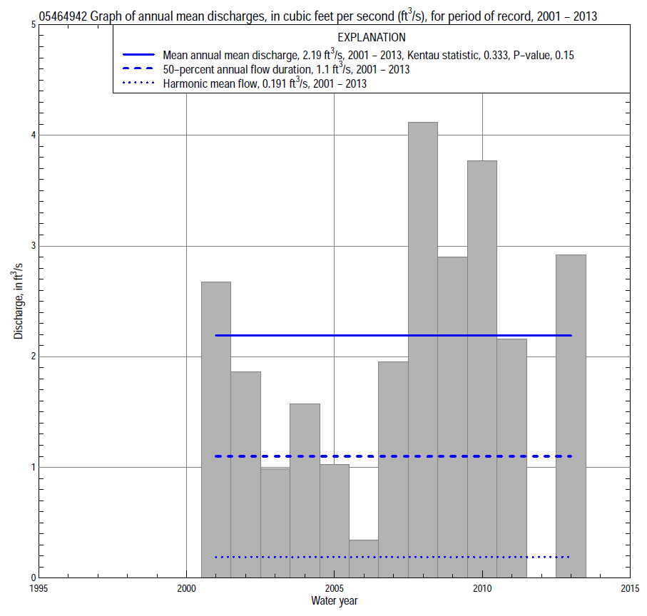

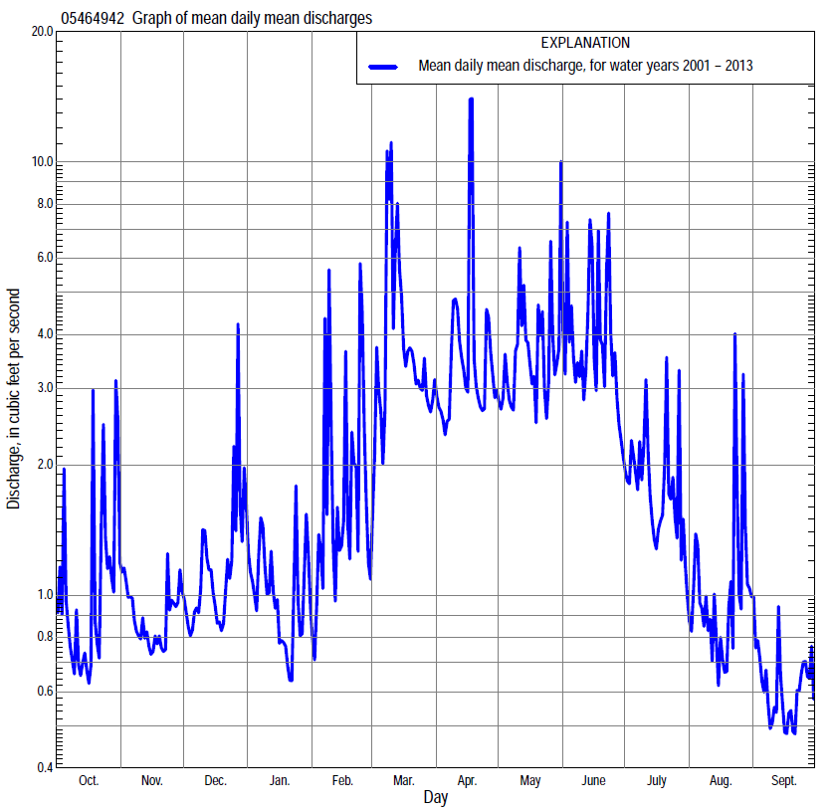

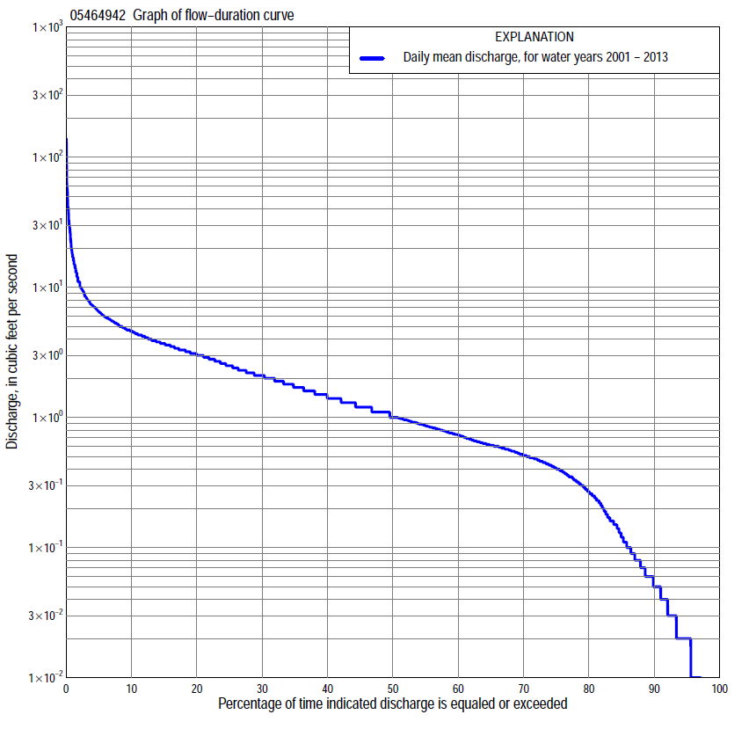

Statistics Based on the Entire Streamflow Period of Record
05464942 Monthly and annual flow durations, based on 2001–11, 2013 period of record (12 years)
[ND, not determined]
Percentage of days discharge equaled or exceeded |  |  |  |  | Discharge (cubic feet per second) |  |  |  |  |  |  |  |  | Annual flow durations
 | Oct | Nov | Dec | Jan | Feb | Mar | Apr | May | June | July | Aug | Sept | Annual | Kentau statistic | P-value
99 | 0.00 | 0.00 | 0.00 | 0.02 | 0.00 | 0.00 | 0.32 | 0.57 | 0.42 | 0.02 | 0.00 | 0.00 | 0.00 | 0.000 | ND
98 | 0.00 | 0.00 | 0.00 | 0.02 | 0.00 | 0.23 | 0.33 | 0.57 | 0.43 | 0.05 | 0.00 | 0.00 | 0.00 | 0.000 | ND
95 | 0.00 | 0.01 | 0.02 | 0.03 | 0.02 | 0.32 | 0.43 | 0.63 | 0.49 | 0.16 | 0.00 | 0.00 | 0.02 | 0.106 | 0.385
90 | 0.00 | 0.03 | 0.06 | 0.08 | 0.12 | 0.47 | 0.88 | 0.80 | 0.80 | 0.30 | 0.02 | 0.01 | 0.05 | 0.106 | 0.385
85 | 0.02 | 0.05 | 0.08 | 0.17 | 0.19 | 0.62 | 1.0 | 0.92 | 1.0 | 0.43 | 0.03 | 0.01 | 0.12 | 0.106 | 0.385
80 | 0.04 | 0.07 | 0.18 | 0.30 | 0.29 | 0.80 | 1.2 | 1.1 | 1.2 | 0.57 | 0.05 | 0.02 | 0.27 | 0.106 | 0.385
75 | 0.07 | 0.13 | 0.35 | 0.40 | 0.35 | 1.3 | 1.4 | 1.3 | 1.3 | 0.69 | 0.08 | 0.03 | 0.42 | 0.182 | 0.237
70 | 0.09 | 0.31 | 0.49 | 0.47 | 0.44 | 1.5 | 1.7 | 1.7 | 1.5 | 0.76 | 0.11 | 0.03 | 0.53 | 0.227 | 0.196
65 | 0.17 | 0.39 | 0.54 | 0.50 | 0.54 | 1.8 | 1.8 | 2.1 | 1.7 | 0.87 | 0.16 | 0.05 | 0.62 | 0.258 | 0.144
60 | 0.26 | 0.46 | 0.57 | 0.54 | 0.60 | 2.3 | 2.0 | 2.6 | 1.9 | 1.0 | 0.24 | 0.09 | 0.75 | 0.258 | 0.144
55 | 0.35 | 0.57 | 0.63 | 0.61 | 0.67 | 2.7 | 2.2 | 2.9 | 2.1 | 1.1 | 0.35 | 0.14 | 0.88 | 0.379 | 0.045
50 | 0.57 | 0.64 | 0.69 | 0.70 | 0.76 | 3.0 | 2.6 | 3.1 | 2.4 | 1.3 | 0.46 | 0.21 | 1.0 | 0.348 | 0.098
45 | 0.66 | 0.71 | 0.83 | 0.79 | 0.93 | 3.1 | 2.8 | 3.3 | 2.8 | 1.5 | 0.61 | 0.40 | 1.2 | 0.258 | 0.238
40 | 0.75 | 0.77 | 1.0 | 0.87 | 1.1 | 3.3 | 3.2 | 3.6 | 3.1 | 1.6 | 0.75 | 0.51 | 1.5 | 0.227 | 0.310
35 | 1.0 | 0.87 | 1.2 | 1.0 | 1.2 | 3.7 | 3.6 | 3.9 | 3.4 | 1.9 | 0.88 | 0.59 | 1.8 | 0.333 | 0.119
30 | 1.1 | 1.0 | 1.3 | 1.1 | 1.4 | 3.8 | 4.0 | 4.1 | 3.9 | 2.1 | 1.0 | 0.65 | 2.1 | 0.333 | 0.129
25 | 1.3 | 1.2 | 1.6 | 1.2 | 1.7 | 4.2 | 4.5 | 4.6 | 4.3 | 2.2 | 1.3 | 0.79 | 2.5 | 0.288 | 0.201
20 | 1.5 | 1.4 | 1.8 | 1.3 | 2.0 | 4.8 | 5.0 | 5.2 | 4.9 | 2.5 | 1.6 | 1.0 | 3.1 | 0.197 | 0.397
15 | 1.7 | 1.7 | 2.1 | 1.6 | 2.5 | 5.7 | 5.7 | 5.9 | 5.8 | 3.0 | 2.1 | 1.4 | 3.7 | 0.197 | 0.397
10 | 2.1 | 2.3 | 2.5 | 2.0 | 3.8 | 7.5 | 6.4 | 7.1 | 7.4 | 3.4 | 2.6 | 1.9 | 4.6 | 0.182 | 0.439
5 | 3.6 | 3.0 | 3.4 | 3.0 | 7.0 | 10 | 8.5 | 9.5 | 11 | 4.3 | 3.9 | 2.7 | 6.5 | 0.227 | 0.334
2 | 6.4 | 3.9 | 4.7 | 5.3 | 11 | 18 | 13 | 18 | 22 | 6.6 | 5.8 | 3.9 | 11 | 0.227 | 0.336
1 | 17 | 4.3 | 6.6 | 6.6 | 32 | 33 | 16 | 19 | 40 | 7.4 | 8.5 | 4.3 | 17 | 0.167 | 0.492

05464942 Annual exceedance probability of instantaneous peak discharges, in cubic feet per second (ft³/s), based on the Weighted Independent Estimates method,
Annual exceed-ance probability | Recur-rence interval (years) | Discharge (ft³/s) | 95-percent lower confi-dence interval (ft³/s) | 95-percent upper confi-dence interval (ft³/s)
0.500 | 2 | 198 | 143 | 274
0.200 | 5 | 514 | 384 | 687
0.100 | 10 | 824 | 619 | 1,100
0.040 | 25 | 1,310 | 968 | 1,770
0.020 | 50 | 1,670 | 1,200 | 2,320
0.010 | 100 | 2,040 | 1,410 | 2,940
0.005 | 200 | 2,620 | 1,730 | 3,960
0.002 | 500 | 3,010 | 1,890 | 4,820
and based on the expected moments algorithm/multiple Grubbs-Beck analysis computed using a historical period length of 47 years (1967–2013)
0.500 | 2 | 188 | 86 | 345
0.200 | 5 | 479 | 244 | 842
0.100 | 10 | 757 | 383 | 1,370
0.040 | 25 | 1,200 | 593 | 2,420
0.020 | 50 | 1,610 | 770 | 3,660
0.010 | 100 | 2,060 | 957 | 5,480
0.005 | 200 | 2,570 | 1,150 | 8,140
0.002 | 500 | 3,340 | 1,400 | 13,600
Kentau statistic |  | 0.212
P-value |  | 0.372
Begin year |  | 2001
End year |  | 2013
Number of peaks |  | 12

05464942 Annual exceedance probability of high discharges, based on 2001–2011, 2013 period of record (12 years)
Annual exceedance probability | Recur-rence interval (years) | Maximum average discharge (ft³/s) for indicated number of consecutive days
 |  | 1 | 3 | 7 | 15 | 30
0.990 | 1.01 | 1.2 | 1.4 | 1.1 | 0.92 | 0.78
0.950 | 1.05 | 4.1 | 3.2 | 2.5 | 1.9 | 1.6
0.900 | 1.11 | 7.3 | 4.9 | 3.6 | 2.6 | 2.2
0.800 | 1.25 | 14 | 8.0 | 5.5 | 3.9 | 3.2
0.500 | 2 | 37 | 19 | 12 | 7.9 | 6.1
0.200 | 5 | 79 | 41 | 23 | 15 | 10
0.100 | 10 | 108 | 59 | 31 | 20 | 13
0.040 | 25 | 143 | 85 | 43 | 26 | 16
0.020 | 50 | 167 | 106 | 51 | 32 | 18
0.010 | 100 | 188 | 128 | 60 | 37 | 20
0.005 | 200 | 207 | 151 | 69 | 42 | 21
0.002 | 500 | 228 | 183 | 80 | 49 | 23
Kentau statistic |  | 0.077 | 0.051 | 0.179 | 0.205 | 0.179
P-value |  | 0.760 | 0.855 | 0.428 | 0.360 | 0.428

 | 05464942 Annual nonexceedance probability of low discharges, based on April 2001 to March 2011 period of record (10 years)
Annual nonexceed-ance probability | Recur-rence interval (years) | Minimum average discharge (cubic feet per second) for indicated number of consecutive days
 |  | 1 | 3 | 7 | 14 | 30 | 60 | 90 | 120 | 183
0.01 | 100 | 0.00 | 0.00 | 0.00 | 0.00 | 0.00 | 0.00 | 0.00 | 0.01 | 0.01
0.02 | 50 | 0.00 | 0.00 | 0.00 | 0.00 | 0.00 | 0.00 | 0.01 | 0.01 | 0.02
0.05 | 20 | 0.00 | 0.00 | 0.00 | 0.00 | 0.00 | 0.01 | 0.02 | 0.02 | 0.06
0.10 | 10 | 0.00 | 0.00 | 0.00 | 0.00 | 0.01 | 0.02 | 0.04 | 0.05 | 0.13
0.20 | 5 | 0.00 | 0.00 | 0.00 | 0.01 | 0.02 | 0.05 | 0.09 | 0.13 | 0.29
0.50 | 2 | 0.08 | 0.09 | 0.10 | 0.11 | 0.16 | 0.27 | 0.38 | 0.50 | 0.92
0.80 | 1.25 | 0.29 | 0.41 | 0.48 | 0.53 | 0.70 | 0.99 | 1.2 | 1.4 | 1.8
0.90 | 1.11 | 0.47 | 0.61 | 0.82 | 1.0 | 1.2 | 1.8 | 2.0 | 2.2 | 2.3
0.96 | 1.04 | 0.78 | 0.79 | 1.2 | 1.8 | 2.0 | 3.1 | 3.2 | 3.3 | 3.4
0.98 | 1.02 | 1.2 | 1.3 | 1.4 | 2.4 | 2.6 | 4.2 | 4.3 | 4.4 | 4.5
0.99 | 1.01 | 1.4 | 1.5 | 1.6 | 3.1 | 3.2 | 4.7 | 4.9 | 5.0 | 5.1
Kentau statistic |  | 0.444 | 0.444 | 0.489 | 0.422 | 0.422 | 0.422 | 0.378 | 0.378 | 0.467
P-value |  | 0.077 | 0.085 | 0.059 | 0.107 | 0.107 | 0.107 | 0.152 | 0.152 | 0.074

05464942 Annual nonexceedance probability of seasonal low discharges, based on July 2000 to September 2011, October 2012 to September 2013 period of record (12–13 years)
Annual nonexceed-ance probability | Recur-rence interval (years) | Minimum average discharge (cubic feet per second) for indicated number of consecutive days
 |  | 1 | 7 | 14 | 30 |  | 1 | 7 | 14 | 30
 |  | January-February-March |  |  |  |  | April-May-June
0.01 | 100 | 0.00 | 0.00 | 0.00 | 0.01 |  | 0.16 | 0.17 | 0.17 | 0.18
0.02 | 50 | 0.00 | 0.00 | 0.01 | 0.02 |  | 0.21 | 0.22 | 0.23 | 0.24
0.05 | 20 | 0.00 | 0.01 | 0.02 | 0.05 |  | 0.31 | 0.32 | 0.34 | 0.38
0.10 | 10 | 0.01 | 0.03 | 0.06 | 0.12 |  | 0.41 | 0.45 | 0.48 | 0.57
0.20 | 5 | 0.05 | 0.08 | 0.13 | 0.25 |  | 0.57 | 0.65 | 0.71 | 0.89
0.50 | 2 | 0.20 | 0.33 | 0.45 | 0.66 |  | 1.0 | 1.2 | 1.4 | 1.9
0.80 | 1.25 | 0.53 | 0.71 | 0.88 | 1.1 |  | 1.7 | 2.1 | 2.5 | 3.7
0.90 | 1.11 | 0.77 | 0.87 | 1.1 | 1.2 |  | 2.1 | 2.6 | 3.2 | 4.9
0.96 | 1.04 | 0.82 | 0.97 | 1.2 | 1.3 |  | 2.7 | 3.3 | 4.1 | 6.6
0.98 | 1.02 | 0.88 | 1.0 | 1.2 | 1.3 |  | 3.1 | 3.8 | 4.7 | 7.8
0.99 | 1.01 | 0.90 | 1.0 | 1.3 | 1.3 |  | 3.4 | 4.3 | 5.4 | 8.9
Kentau statistic |  | 0.045 | 0.121 | 0.212 | 0.242 |  | 0.212 | 0.242 | 0.303 | 0.273
P-value |  | 0.891 | 0.631 | 0.373 | 0.304 |  | 0.370 | 0.304 | 0.193 | 0.244
 |  | July-August-September |  |  |  |  | October-November-December
0.01 | 100 | 0.00 | 0.00 | 0.00 | 0.00 |  | 0.00 | 0.00 | 0.00 | 0.00
0.02 | 50 | 0.00 | 0.00 | 0.00 | 0.01 |  | 0.00 | 0.00 | 0.00 | 0.00
0.05 | 20 | 0.00 | 0.00 | 0.00 | 0.01 |  | 0.00 | 0.00 | 0.00 | 0.00
0.10 | 10 | 0.00 | 0.00 | 0.01 | 0.02 |  | 0.00 | 0.00 | 0.00 | 0.01
0.20 | 5 | 0.00 | 0.00 | 0.02 | 0.05 |  | 0.01 | 0.01 | 0.03 | 0.05
0.50 | 2 | 0.10 | 0.11 | 0.13 | 0.20 |  | 0.12 | 0.15 | 0.24 | 0.31
0.80 | 1.25 | 0.61 | 0.63 | 0.69 | 0.79 |  | 0.48 | 0.66 | 0.81 | 1.1
0.90 | 1.11 | 1.1 | 1.4 | 1.5 | 1.6 |  | 0.86 | 1.1 | 1.2 | 1.6
0.96 | 1.04 | 1.7 | 2.8 | 3.3 | 3.6 |  | 1.5 | 1.6 | 1.7 | 2.2
0.98 | 1.02 | 2.1 | 4.2 | 5.3 | 5.9 |  | 2.0 | 2.1 | 2.2 | 2.5
0.99 | 1.01 | 2.5 | 6.0 | 8.0 | 9.2 |  | 2.2 | 2.3 | 2.4 | 2.8
Kentau statistic |  | 0.256 | 0.244 | 0.244 | 0.282 |  | 0.197 | 0.242 | 0.121 | 0.152
P-value |  | 0.239 | 0.271 | 0.271 | 0.200 |  | 0.409 | 0.304 | 0.631 | 0.537

