LOCATION.--Lat 41°24'33", long 91°17'25" referenced to North American Datum of 1927, in SW 1/4 SW 1/4 SW 1/4 sec.02, T.76 N., R.4 W., Muscatine County, IA, Hydrologic Unit 07080206, on right bank 10 ft downstream from bridge on County Highway G28, 3.4 mi northeast of Conesville, 5.2 mi downstream from Wapsinonoc Creek, and 10.8 mi upstream from mouth of Cedar River.

DRAINAGE AREA.--7,787 mi².

PERIOD OF RECORD.--Discharge records from September 1939 to current year.

GAGE.--Water-stage recorder. Datum of gage is 581.95 ft above National Geodetic Vertical Datum of 1929. Prior to February 2, 1940, and April 11, 1952, to July 1, 1954, non-recording gage; February 2, 1940, to April 10, 1952, and July 2, 1954, to September 16, 1963, water-stage recorder at site 150 ft downstream at same datum.

EXTREMES OUTSIDE PERIOD OF RECORD.--Flood in March 1929 reached a stage of 15.8 ft, from information by local residents to U.S. Army Corps of Engineers, discharge not determined.

A summary of all available data for this streamgage is provided through the USGS National Water Information System web interface (NWISWeb). The following link provides access to current/historical observations, daily data, daily statistics, monthly statistics, annual statistics, peak streamflow, field measurements, field/lab water-quality samples, and the latest water-year summaries. Data can be filtered by parameter and/or dates, and can be output in various tabular and graphical formats.
http://waterdata.usgs.gov/nwis/inventory/?site_no=05465000

The USGS WaterWatch Toolkit is available at:
http://waterwatch.usgs.gov/?id=ww_toolkit
Tools for summarizing streamflow information include the duration hydrograph builder, the cumulative streamflow hydrograph builder, the streamgage statistics retrieval tool, the rating curve builder, the flood tracking chart builder, the National Weather Service Advanced Hydrologic Prediction Service (AHPS) river forecast hydrograph builder, and the raster-hydrograph builder. Entering the above number for this streamgage into these toolkit webpages will provide streamflow information specific to this streamgage.

A description of the statistics presented for this streamgage is available in the main body of the report at:
http://dx.doi.org/10.3133/ofr20151214
A link to other streamgages included in this report, a map showing the location of the streamgages, information on the programs used to compute the statistical analyses, and references are included in the main body of the report.

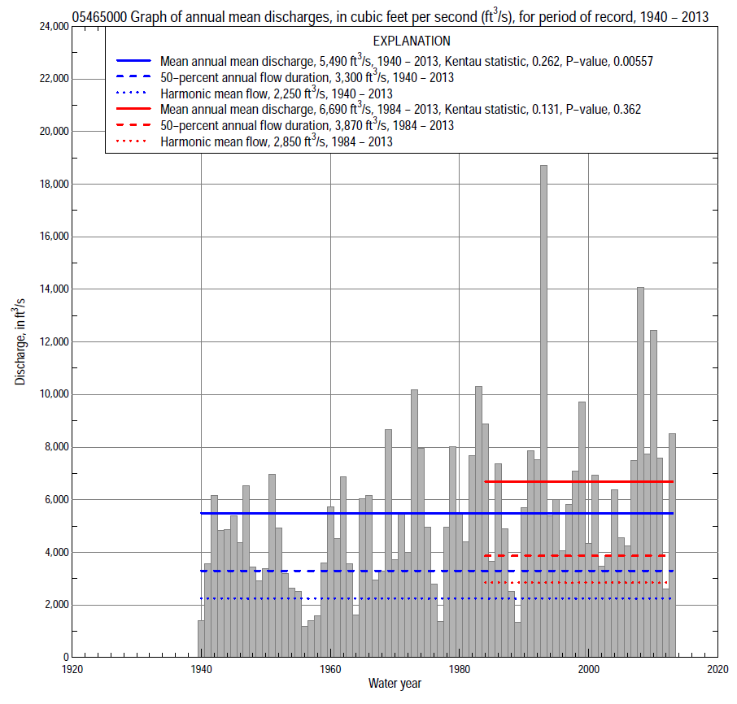

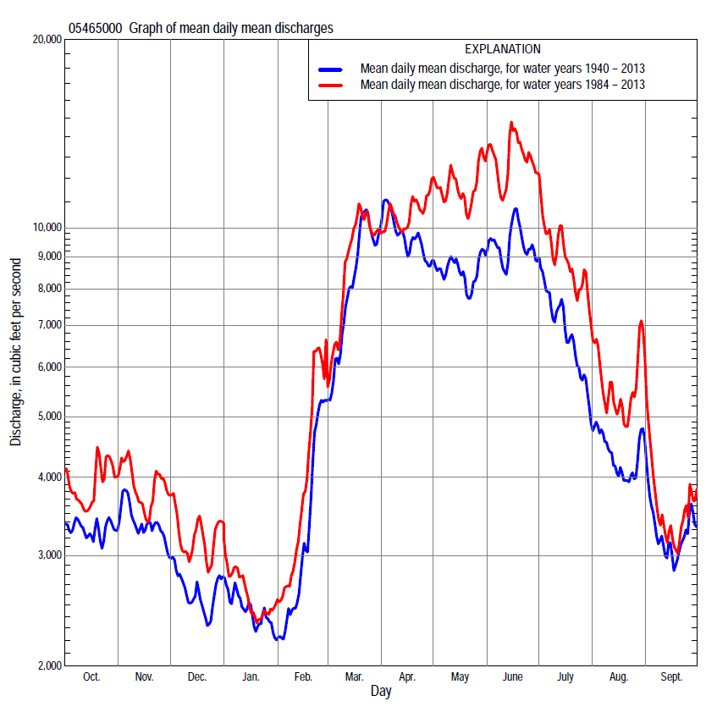

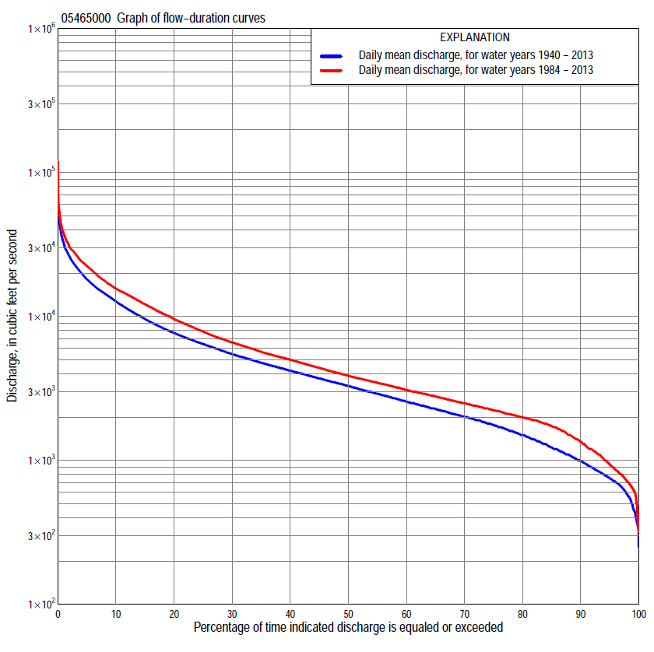

Statistics Based on the Entire Streamflow Period of Record
05465000 Monthly and annual flow durations, based on 1940–2013 period of record (74 years)
Percentage of days discharge equaled or exceeded |  |  |  |  | Discharge (cubic feet per second) |  |  |  |  |  |  |  |  | Annual flow durations
 | Oct | Nov | Dec | Jan | Feb | Mar | Apr | May | June | July | Aug | Sept | Annual | Kentau statistic | P-value
99 | 604 | 500 | 395 | 350 | 360 | 850 | 1,120 | 1,020 | 773 | 686 | 699 | 645 | 464 | 0.260 | 0.001
98 | 637 | 595 | 440 | 380 | 400 | 956 | 1,350 | 1,170 | 870 | 748 | 763 | 700 | 580 | 0.257 | 0.001
95 | 685 | 700 | 540 | 480 | 570 | 1,200 | 1,760 | 1,610 | 1,410 | 1,030 | 917 | 785 | 751 | 0.272 | 0.001
90 | 762 | 827 | 650 | 650 | 780 | 1,600 | 2,300 | 2,310 | 2,050 | 1,430 | 1,090 | 928 | 990 | 0.288 | 0.000
85 | 914 | 940 | 785 | 840 | 1,000 | 2,010 | 3,030 | 2,770 | 2,600 | 1,840 | 1,300 | 1,130 | 1,230 | 0.270 | 0.001
80 | 1,040 | 1,160 | 978 | 970 | 1,200 | 2,650 | 3,580 | 3,280 | 3,100 | 2,230 | 1,610 | 1,360 | 1,500 | 0.263 | 0.001
75 | 1,210 | 1,480 | 1,120 | 1,090 | 1,300 | 3,190 | 4,030 | 3,700 | 3,720 | 2,580 | 1,780 | 1,510 | 1,760 | 0.253 | 0.001
70 | 1,410 | 1,740 | 1,300 | 1,200 | 1,400 | 3,620 | 4,390 | 4,070 | 4,260 | 3,030 | 1,960 | 1,650 | 2,000 | 0.246 | 0.002
65 | 1,580 | 1,960 | 1,530 | 1,400 | 1,560 | 4,100 | 4,860 | 4,510 | 4,820 | 3,450 | 2,160 | 1,790 | 2,280 | 0.251 | 0.002
60 | 1,840 | 2,100 | 1,700 | 1,500 | 1,800 | 4,580 | 5,390 | 4,970 | 5,390 | 3,840 | 2,350 | 1,930 | 2,560 | 0.249 | 0.002
55 | 2,040 | 2,300 | 1,900 | 1,650 | 2,050 | 5,060 | 6,250 | 5,560 | 5,900 | 4,210 | 2,560 | 2,080 | 2,900 | 0.243 | 0.002
50 | 2,270 | 2,510 | 2,070 | 1,800 | 2,300 | 5,520 | 6,970 | 6,160 | 6,450 | 4,640 | 2,780 | 2,260 | 3,300 | 0.242 | 0.002
45 | 2,580 | 2,740 | 2,220 | 2,000 | 2,510 | 6,290 | 7,910 | 6,890 | 7,180 | 5,200 | 3,020 | 2,470 | 3,710 | 0.245 | 0.002
40 | 2,880 | 3,060 | 2,370 | 2,200 | 2,800 | 7,090 | 8,940 | 7,530 | 8,010 | 5,880 | 3,350 | 2,740 | 4,200 | 0.252 | 0.001
35 | 3,260 | 3,390 | 2,600 | 2,400 | 3,050 | 8,120 | 10,200 | 8,450 | 9,190 | 6,530 | 3,680 | 2,990 | 4,760 | 0.253 | 0.001
30 | 3,710 | 3,800 | 2,950 | 2,600 | 3,450 | 9,500 | 11,600 | 9,500 | 10,600 | 7,170 | 4,130 | 3,270 | 5,470 | 0.269 | 0.001
25 | 4,190 | 4,350 | 3,360 | 2,900 | 3,940 | 11,000 | 12,900 | 10,800 | 12,200 | 8,040 | 4,560 | 3,630 | 6,430 | 0.278 | 0.000
20 | 4,790 | 4,860 | 3,750 | 3,200 | 4,740 | 13,100 | 14,600 | 12,600 | 14,100 | 9,200 | 5,160 | 4,080 | 7,690 | 0.266 | 0.001
15 | 5,590 | 5,420 | 4,220 | 3,590 | 5,600 | 15,500 | 16,600 | 14,800 | 16,300 | 10,700 | 6,010 | 4,780 | 9,620 | 0.251 | 0.002
10 | 6,880 | 6,620 | 5,030 | 4,600 | 7,060 | 18,900 | 20,200 | 18,400 | 19,600 | 13,800 | 7,840 | 6,070 | 12,700 | 0.260 | 0.001
5 | 9,420 | 9,000 | 7,090 | 6,600 | 10,500 | 24,000 | 26,400 | 23,900 | 27,100 | 21,900 | 13,600 | 9,530 | 18,100 | 0.227 | 0.004
2 | 13,500 | 13,100 | 10,100 | 9,620 | 16,000 | 30,100 | 34,600 | 29,900 | 36,300 | 31,900 | 25,200 | 15,700 | 26,100 | 0.182 | 0.022
1 | 17,400 | 16,200 | 12,700 | 14,500 | 19,500 | 34,000 | 43,800 | 37,000 | 42,400 | 44,500 | 32,800 | 21,700 | 32,500 | 0.121 | 0.128

05465000 Annual exceedance probability of instantaneous peak discharges, in cubic feet per second (ft³/s), based on the Weighted Independent Estimates method,
Annual exceed-ance probability | Recur-rence interval (years) | Discharge (ft³/s) | 95-percent lower confi-dence interval (ft³/s) | 95-percent upper confi-dence interval (ft³/s)
0.500 | 2 | 29,000 | 25,300 | 33,200
0.200 | 5 | 46,600 | 40,900 | 53,100
0.100 | 10 | 58,000 | 50,400 | 66,700
0.040 | 25 | 72,500 | 61,500 | 85,500
0.020 | 50 | 82,500 | 68,200 | 99,800
0.010 | 100 | 91,800 | 73,700 | 114,000
0.005 | 200 | 104,000 | 81,100 | 135,000
0.002 | 500 | 114,000 | 84,800 | 154,000
and based on the expected moments algorithm/multiple Grubbs-Beck analysis computed using a historical period length of 84 years (1930–2013)
0.500 | 2 | 29,000 | 24,900 | 33,500
0.200 | 5 | 46,900 | 40,700 | 54,600
0.100 | 10 | 59,000 | 50,900 | 70,300
0.040 | 25 | 74,300 | 62,900 | 92,800
0.020 | 50 | 85,400 | 70,900 | 112,000
0.010 | 100 | 96,400 | 78,100 | 133,000
0.005 | 200 | 107,000 | 84,400 | 156,000
0.002 | 500 | 121,000 | 91,800 | 190,000
Kentau statistic |  | 0.093
P-value |  | 0.245
Begin year |  | 1940
End year |  | 2013
Number of peaks |  | 74

05465000 Annual exceedance probability of high discharges, based on 1940–2013 period of record (74 years)
[ND, not determined]
Annual exceed-ance probability | Recur-rence interval (years) | Maximum average discharge (ft³/s) for indicated number of consecutive days
 |  | 1 | 3 | 7 | 15 | 30
0.990 | 1.01 | ND | 4,030 | 3,470 | 2,850 | 2,370
0.950 | 1.05 | ND | 7,470 | 6,450 | 5,220 | 4,330
0.900 | 1.11 | ND | 10,100 | 8,720 | 7,030 | 5,810
0.800 | 1.25 | ND | 14,300 | 12,300 | 9,840 | 8,080
0.500 | 2 | ND | 25,600 | 21,900 | 17,500 | 14,200
0.200 | 5 | ND | 42,200 | 35,500 | 28,500 | 22,600
0.100 | 10 | ND | 53,000 | 44,100 | 35,700 | 28,000
0.040 | 25 | ND | 66,100 | 54,300 | 44,200 | 34,200
0.020 | 50 | ND | 75,200 | 61,300 | 50,200 | 38,500
0.010 | 100 | ND | 83,800 | 67,800 | 55,800 | 42,400
0.005 | 200 | ND | 91,900 | 73,800 | 61,200 | 46,100
0.002 | 500 | ND | 102,000 | 81,200 | 67,800 | 50,500
Kentau statistic |  | 0.105 | 0.119 | 0.125 | 0.175 | 0.194
P-value |  | 0.187 | 0.134 | 0.117 | 0.028 | 0.015

 | 05465000 Annual nonexceedance probability of low discharges, based on April 1940 to March 2013 period of record (73 years)
Annual nonexceed-ance probability | Recur-rence interval (years) | Minimum average discharge (ft³/s) for indicated number of consecutive days
 |  | 1 | 3 | 7 | 14 | 30 | 60 | 90 | 120 | 183
0.01 | 100 | 243 | 266 | 282 | 293 | 318 | 351 | 371 | 393 | 447
0.02 | 50 | 288 | 316 | 338 | 352 | 382 | 422 | 453 | 483 | 553
0.05 | 20 | 370 | 405 | 439 | 461 | 499 | 554 | 605 | 651 | 753
0.10 | 10 | 460 | 503 | 548 | 579 | 627 | 701 | 777 | 842 | 982
0.20 | 5 | 595 | 649 | 711 | 757 | 820 | 925 | 1,040 | 1,140 | 1,340
0.50 | 2 | 959 | 1,030 | 1,130 | 1,220 | 1,330 | 1,540 | 1,770 | 1,960 | 2,340
0.80 | 1.25 | 1,510 | 1,600 | 1,730 | 1,890 | 2,080 | 2,480 | 2,880 | 3,230 | 3,930
0.90 | 1.11 | 1,900 | 1,990 | 2,130 | 2,330 | 2,600 | 3,160 | 3,650 | 4,140 | 5,060
0.96 | 1.04 | 2,420 | 2,480 | 2,630 | 2,890 | 3,250 | 4,040 | 4,660 | 5,320 | 6,550
0.98 | 1.02 | 2,810 | 2,860 | 2,990 | 3,290 | 3,730 | 4,720 | 5,430 | 6,210 | 7,690
0.99 | 1.01 | 3,210 | 3,230 | 3,340 | 3,690 | 4,210 | 5,400 | 6,190 | 7,120 | 8,840
Kentau statistic |  | 0.241 | 0.268 | 0.285 | 0.295 | 0.270 | 0.248 | 0.236 | 0.215 | 0.193
P-value |  | 0.003 | 0.001 | 0.000 | 0.000 | 0.001 | 0.002 | 0.003 | 0.007 | 0.016

05465000 Annual nonexceedance probability of seasonal low discharges, based on October 1939 to September 2013 period of record (74 years)
Annual nonexceed-ance probability | Recur-rence interval (years) | Minimum average discharge (cubic feet per second) for indicated number of consecutive days
 |  | 1 | 7 | 14 | 30 |  | 1 | 7 | 14 | 30
 |  | January-February-March |  |  |  |  | April-May-June
0.01 | 100 | 264 | 267 | 280 | 305 |  | 531 | 579 | 609 | 737
0.02 | 50 | 317 | 329 | 345 | 376 |  | 667 | 727 | 772 | 926
0.05 | 20 | 417 | 444 | 467 | 512 |  | 931 | 1,010 | 1,090 | 1,300
0.10 | 10 | 529 | 574 | 606 | 669 |  | 1,240 | 1,350 | 1,470 | 1,730
0.20 | 5 | 701 | 775 | 822 | 918 |  | 1,730 | 1,880 | 2,080 | 2,450
0.50 | 2 | 1,180 | 1,330 | 1,430 | 1,640 |  | 3,150 | 3,460 | 3,880 | 4,640
0.80 | 1.25 | 1,930 | 2,180 | 2,380 | 2,830 |  | 5,460 | 6,120 | 6,920 | 8,520
0.90 | 1.11 | 2,480 | 2,780 | 3,050 | 3,730 |  | 7,150 | 8,100 | 9,180 | 11,600
0.96 | 1.04 | 3,200 | 3,560 | 3,940 | 4,940 |  | 9,390 | 10,800 | 12,200 | 15,900
0.98 | 1.02 | 3,770 | 4,140 | 4,620 | 5,900 |  | 11,100 | 12,900 | 14,600 | 19,400
0.99 | 1.01 | 4,360 | 4,720 | 5,300 | 6,900 |  | 12,900 | 15,100 | 17,100 | 23,100
Kentau statistic |  | 0.235 | 0.243 | 0.239 | 0.194 |  | 0.265 | 0.263 | 0.262 | 0.244
P-value |  | 0.003 | 0.002 | 0.003 | 0.014 |  | 0.001 | 0.001 | 0.001 | 0.002
 |  | July-August-September |  |  |  |  | October-November-December
0.01 | 100 | 487 | 518 | 540 | 618 |  | 231 | 303 | 309 | 337
0.02 | 50 | 542 | 575 | 601 | 686 |  | 280 | 366 | 380 | 415
0.05 | 20 | 645 | 681 | 714 | 811 |  | 372 | 483 | 515 | 564
0.10 | 10 | 760 | 800 | 842 | 955 |  | 477 | 614 | 667 | 736
0.20 | 5 | 940 | 987 | 1,040 | 1,190 |  | 640 | 814 | 903 | 1,000
0.50 | 2 | 1,470 | 1,550 | 1,650 | 1,910 |  | 1,100 | 1,360 | 1,560 | 1,770
0.80 | 1.25 | 2,450 | 2,590 | 2,780 | 3,330 |  | 1,870 | 2,210 | 2,560 | 3,000
0.90 | 1.11 | 3,270 | 3,480 | 3,750 | 4,610 |  | 2,430 | 2,810 | 3,270 | 3,890
0.96 | 1.04 | 4,530 | 4,860 | 5,270 | 6,710 |  | 3,210 | 3,590 | 4,190 | 5,090
0.98 | 1.02 | 5,660 | 6,120 | 6,640 | 8,680 |  | 3,820 | 4,190 | 4,890 | 6,020
0.99 | 1.01 | 6,970 | 7,580 | 8,250 | 11,100 |  | 4,460 | 4,800 | 5,590 | 6,970
Kentau statistic |  | 0.260 | 0.261 | 0.252 | 0.245 |  | 0.202 | 0.207 | 0.231 | 0.218
P-value |  | 0.001 | 0.001 | 0.002 | 0.002 |  | 0.011 | 0.009 | 0.004 | 0.006

Statistics Based on the 1984–2013 Streamflow Period of Record
05465000 Monthly and annual flow durations, based on 1984–2013 period of record (30 years)
Percentage of days discharge equaled or exceeded |  |  |  |  | Discharge (cubic feet per second) |  |  |  |  |  |  |  |  | Annual flow durations
 | Oct | Nov | Dec | Jan | Feb | Mar | Apr | May | June | July | Aug | Sept | Annual | Kentau statistic | P-value
99 | 616 | 554 | 374 | 510 | 644 | 800 | 1,910 | 1,560 | 930 | 719 | 617 | 709 | 633 | 0.014 | 0.929
98 | 641 | 673 | 420 | 580 | 690 | 956 | 1,950 | 1,930 | 1,190 | 861 | 717 | 735 | 716 | 0.039 | 0.775
95 | 754 | 843 | 719 | 713 | 840 | 1,540 | 2,120 | 2,570 | 1,720 | 1,090 | 934 | 833 | 936 | 0.060 | 0.655
90 | 1,130 | 1,180 | 900 | 950 | 1,100 | 2,560 | 2,680 | 3,430 | 2,530 | 1,440 | 1,100 | 1,270 | 1,350 | 0.074 | 0.580
85 | 1,270 | 1,800 | 1,200 | 1,130 | 1,300 | 3,100 | 3,520 | 3,880 | 3,210 | 2,230 | 1,790 | 1,530 | 1,730 | -0.005 | 0.986
80 | 1,480 | 1,940 | 1,570 | 1,300 | 1,550 | 3,400 | 3,860 | 4,490 | 4,410 | 3,230 | 2,080 | 1,690 | 2,000 | -0.005 | 0.986
75 | 1,750 | 2,040 | 1,700 | 1,470 | 1,800 | 3,760 | 4,350 | 5,100 | 5,190 | 3,740 | 2,350 | 1,800 | 2,230 | -0.016 | 0.915
70 | 1,920 | 2,170 | 1,930 | 1,620 | 2,090 | 4,200 | 4,890 | 6,090 | 5,650 | 4,230 | 2,600 | 1,900 | 2,500 | -0.030 | 0.830
65 | 2,040 | 2,310 | 2,100 | 1,750 | 2,300 | 4,670 | 5,350 | 6,660 | 6,200 | 4,770 | 2,790 | 2,000 | 2,790 | -0.007 | 0.972
60 | 2,170 | 2,460 | 2,230 | 1,900 | 2,500 | 5,090 | 6,160 | 7,350 | 7,130 | 5,400 | 2,990 | 2,170 | 3,090 | 0.000 | 1.000
55 | 2,430 | 2,660 | 2,350 | 2,070 | 2,660 | 5,390 | 6,800 | 8,220 | 8,290 | 6,030 | 3,250 | 2,340 | 3,460 | 0.030 | 0.830
50 | 2,600 | 2,800 | 2,500 | 2,200 | 2,840 | 5,940 | 7,500 | 9,090 | 10,000 | 6,550 | 3,540 | 2,510 | 3,870 | 0.067 | 0.617
45 | 2,840 | 3,020 | 2,800 | 2,370 | 3,010 | 6,670 | 8,800 | 9,920 | 11,500 | 7,040 | 3,880 | 2,650 | 4,390 | 0.053 | 0.695
40 | 3,070 | 3,320 | 3,100 | 2,540 | 3,300 | 7,550 | 10,200 | 10,800 | 12,400 | 7,630 | 4,170 | 2,870 | 5,000 | 0.085 | 0.521
35 | 3,520 | 3,790 | 3,370 | 2,850 | 3,600 | 8,410 | 11,700 | 12,000 | 13,900 | 8,280 | 4,440 | 3,100 | 5,690 | 0.078 | 0.556
30 | 4,100 | 4,340 | 3,640 | 3,000 | 3,900 | 9,510 | 13,000 | 13,400 | 15,100 | 9,320 | 4,840 | 3,360 | 6,600 | 0.117 | 0.372
25 | 4,620 | 4,720 | 3,890 | 3,200 | 4,730 | 10,900 | 14,300 | 14,900 | 16,600 | 10,600 | 5,420 | 3,610 | 7,840 | 0.129 | 0.326
20 | 5,280 | 5,130 | 4,220 | 3,400 | 5,360 | 13,900 | 15,700 | 17,600 | 18,800 | 11,900 | 5,970 | 3,990 | 9,580 | 0.143 | 0.276
15 | 6,400 | 5,940 | 4,800 | 3,900 | 6,270 | 16,400 | 17,800 | 20,400 | 22,600 | 14,500 | 7,190 | 4,830 | 12,100 | 0.124 | 0.344
10 | 8,150 | 7,410 | 6,210 | 5,100 | 8,450 | 19,300 | 21,200 | 24,000 | 27,600 | 19,200 | 11,000 | 6,640 | 15,600 | 0.149 | 0.254
5 | 11,900 | 9,190 | 8,490 | 6,440 | 12,100 | 24,100 | 28,500 | 29,500 | 34,600 | 27,200 | 23,700 | 11,000 | 22,400 | 0.140 | 0.284
2 | 17,200 | 15,200 | 11,100 | 7,700 | 18,400 | 32,700 | 34,500 | 37,400 | 43,400 | 43,500 | 34,600 | 16,900 | 30,500 | 0.179 | 0.169
1 | 20,300 | 18,800 | 14,000 | 8,370 | 23,000 | 37,700 | 39,700 | 46,100 | 56,200 | 50,900 | 37,700 | 22,800 | 37,600 | 0.154 | 0.239

05465000 Annual exceedance probability of high discharges, based on 1984–2013 period of record (30 years)
Annual exceed-ance probability | Recur-rence interval (years) | Maximum average discharge (ft³/s) for indicated number of consecutive days
 |  | 1 | 3 | 7 | 15 | 30
0.990 | 1.01 | 5,740 | 5,490 | 4,860 | 4,170 | 3,690
0.950 | 1.05 | 9,880 | 9,260 | 8,130 | 6,950 | 5,950
0.900 | 1.11 | 13,000 | 12,100 | 10,500 | 8,980 | 7,570
0.800 | 1.25 | 17,800 | 16,400 | 14,300 | 12,100 | 10,000
0.500 | 2 | 31,000 | 28,500 | 24,400 | 20,500 | 16,500
0.200 | 5 | 51,000 | 47,000 | 39,700 | 32,900 | 25,900
0.100 | 10 | 64,800 | 59,800 | 50,200 | 41,300 | 32,200
0.040 | 25 | 82,200 | 76,400 | 63,600 | 51,900 | 40,100
0.020 | 50 | 95,000 | 88,800 | 73,500 | 59,700 | 45,900
0.010 | 100 | 108,000 | 101,000 | 83,300 | 67,400 | 51,500
0.005 | 200 | 120,000 | 114,000 | 93,000 | 74,900 | 57,100
0.002 | 500 | 136,000 | 130,000 | 106,000 | 84,700 | 64,300
Kentau statistic |  | 0.138 | 0.149 | 0.154 | 0.140 | 0.131
P-value |  | 0.292 | 0.254 | 0.239 | 0.284 | 0.318

 | 05465000 Annual nonexceedance probability of low discharges, based on April 1983 to March 2013 period of record (30 years)
Annual nonexceed-ance probability | Recur-rence interval (years) | Minimum average discharge (ft³/s) for indicated number of consecutive days
 |  | 1 | 3 | 7 | 14 | 30 | 60 | 90 | 120 | 183
0.01 | 100 | 325 | 341 | 368 | 370 | 411 | 472 | 506 | 528 | 555
0.02 | 50 | 383 | 409 | 447 | 458 | 502 | 566 | 619 | 648 | 696
0.05 | 20 | 488 | 531 | 589 | 616 | 664 | 736 | 824 | 871 | 961
0.10 | 10 | 601 | 662 | 740 | 785 | 839 | 922 | 1,050 | 1,120 | 1,260
0.20 | 5 | 768 | 851 | 954 | 1,030 | 1,090 | 1,200 | 1,380 | 1,480 | 1,710
0.50 | 2 | 1,200 | 1,320 | 1,460 | 1,590 | 1,700 | 1,910 | 2,220 | 2,420 | 2,910
0.80 | 1.25 | 1,810 | 1,920 | 2,060 | 2,250 | 2,470 | 2,910 | 3,350 | 3,700 | 4,600
0.90 | 1.11 | 2,220 | 2,300 | 2,400 | 2,610 | 2,930 | 3,560 | 4,050 | 4,510 | 5,680
0.96 | 1.04 | 2,730 | 2,740 | 2,770 | 2,990 | 3,430 | 4,370 | 4,880 | 5,470 | 6,970
0.98 | 1.02 | 2,980 | 2,990 | 3,000 | 3,220 | 3,770 | 4,960 | 5,450 | 6,140 | 7,880
0.99 | 1.01 | 3,190 | 3,200 | 3,210 | 3,420 | 4,070 | 5,520 | 5,990 | 6,770 | 8,730
Kentau statistic |  | 0.034 | 0.018 | 0.039 | 0.071 | 0.039 | 0.067 | -0.011 | -0.011 | -0.044
P-value |  | 0.803 | 0.901 | 0.775 | 0.592 | 0.775 | 0.617 | 0.943 | 0.943 | 0.748

05465000 Annual nonexceedance probability of seasonal low discharges, based on October 1983 to September 2013 period of record (30 years)
Annual nonexceed-ance probability | Recur-rence interval (years) | Minimum average discharge (cubic feet per second) for indicated number of consecutive days
 |  | 1 | 7 | 14 | 30 |  | 1 | 7 | 14 | 30
 |  | January-February-March |  |  |  |  | April-May-June
0.01 | 100 | 348 | 414 | 436 | 458 |  | 763 | 773 | 786 | 950
0.02 | 50 | 421 | 499 | 526 | 557 |  | 946 | 967 | 997 | 1,180
0.05 | 20 | 556 | 653 | 691 | 739 |  | 1,300 | 1,340 | 1,410 | 1,640
0.10 | 10 | 704 | 821 | 870 | 940 |  | 1,700 | 1,780 | 1,900 | 2,190
0.20 | 5 | 925 | 1,070 | 1,140 | 1,240 |  | 2,330 | 2,470 | 2,680 | 3,090
0.50 | 2 | 1,500 | 1,700 | 1,830 | 2,030 |  | 4,110 | 4,510 | 5,020 | 5,940
0.80 | 1.25 | 2,330 | 2,580 | 2,810 | 3,170 |  | 6,960 | 7,910 | 8,950 | 11,300
0.90 | 1.11 | 2,870 | 3,150 | 3,440 | 3,920 |  | 9,010 | 10,400 | 11,900 | 15,700
0.96 | 1.04 | 3,540 | 3,840 | 4,230 | 4,840 |  | 11,700 | 13,800 | 15,900 | 22,200
0.98 | 1.02 | 4,030 | 4,340 | 4,790 | 5,520 |  | 13,800 | 16,500 | 19,000 | 27,700
0.99 | 1.01 | 4,500 | 4,810 | 5,340 | 6,170 |  | 15,900 | 19,300 | 22,200 | 33,800
Kentau statistic |  | 0.014 | 0.034 | 0.030 | -0.011 |  | 0.175 | 0.191 | 0.195 | 0.223
P-value |  | 0.929 | 0.803 | 0.830 | 0.943 |  | 0.181 | 0.143 | 0.134 | 0.087
 |  | July-August-September |  |  |  |  | October-November-December
0.01 | 100 | 651 | 701 | 686 | 736 |  | 296 | 358 | 363 | 417
0.02 | 50 | 712 | 760 | 755 | 812 |  | 361 | 445 | 465 | 527
0.05 | 20 | 825 | 871 | 883 | 955 |  | 483 | 606 | 658 | 734
0.10 | 10 | 954 | 1,000 | 1,030 | 1,120 |  | 618 | 782 | 873 | 966
0.20 | 5 | 1,160 | 1,210 | 1,270 | 1,400 |  | 822 | 1,040 | 1,190 | 1,320
0.50 | 2 | 1,800 | 1,870 | 2,000 | 2,290 |  | 1,370 | 1,690 | 1,980 | 2,220
0.80 | 1.25 | 3,060 | 3,200 | 3,440 | 4,190 |  | 2,160 | 2,540 | 2,930 | 3,430
0.90 | 1.11 | 4,200 | 4,440 | 4,750 | 6,000 |  | 2,700 | 3,040 | 3,460 | 4,170
0.96 | 1.04 | 6,050 | 6,490 | 6,880 | 9,110 |  | 3,370 | 3,610 | 4,010 | 5,010
0.98 | 1.02 | 7,800 | 8,470 | 8,900 | 12,200 |  | 3,860 | 3,990 | 4,350 | 5,580
0.99 | 1.01 | 9,910 | 10,900 | 11,300 | 16,000 |  | 4,330 | 4,340 | 4,640 | 6,100
Kentau statistic |  | 0.041 | 0.053 | 0.078 | 0.099 |  | -0.021 | -0.113 | -0.030 | -0.085
P-value |  | 0.762 | 0.695 | 0.556 | 0.454 |  | 0.887 | 0.392 | 0.830 | 0.521

