LOCATION.--Lat 42°01'23", long 93°37'49" referenced to North American Datum of 1927, in SE 1/4 SE 1/4 SW 1/4 sec.03, T.83 N., R.24 W., Story County, IA, Hydrologic Unit 07080105, on left bank 65 ft downstream from bridge on Lincoln Way in Ames, 0.2 mi downstream from College Creek, and 2.5 mi upstream from mouth.

DRAINAGE AREA.--204 mi².

PERIOD OF RECORD.--Discharge records from May 1919 to September 1927, May 1965 to current year. December 1925 to September 1927, monthly mean discharge for some periods published in WSP 1308.

GAGE.--Water-stage recorder and concrete control. Datum of gage is 881.00 ft above National Geodetic Vertical Datum of 1929 (levels by Iowa State University). Prior to March 11, 1925, non-recording gage at site 0.6 mi upstream at different datum; March 11, 1925, to April 30, 1927, non-recording gage at site 65 ft upstream at datum about 4 ft higher.

EXTREMES OUTSIDE PERIOD OF RECORD.--Flood of June 4, 1918, reached a stage of 14.50 ft, from high-water mark, at site and datum in use prior to March 11, 1925, discharge 6,900 ft³/s.

A summary of all available data for this streamgage is provided through the USGS National Water Information System web interface (NWISWeb). The following link provides access to current/historical observations, daily data, daily statistics, monthly statistics, annual statistics, peak streamflow, field measurements, field/lab water-quality samples, and the latest water-year summaries. Data can be filtered by parameter and/or dates, and can be output in various tabular and graphical formats.
http://waterdata.usgs.gov/nwis/inventory/?site_no=05470500

The USGS WaterWatch Toolkit is available at:
http://waterwatch.usgs.gov/?id=ww_toolkit
Tools for summarizing streamflow information include the duration hydrograph builder, the cumulative streamflow hydrograph builder, the streamgage statistics retrieval tool, the rating curve builder, the flood tracking chart builder, the National Weather Service Advanced Hydrologic Prediction Service (AHPS) river forecast hydrograph builder, and the raster-hydrograph builder. Entering the above number for this streamgage into these toolkit webpages will provide streamflow information specific to this streamgage.

A description of the statistics presented for this streamgage is available in the main body of the report at:
http://dx.doi.org/10.3133/ofr20151214
A link to other streamgages included in this report, a map showing the location of the streamgages, information on the programs used to compute the statistical analyses, and references are included in the main body of the report.

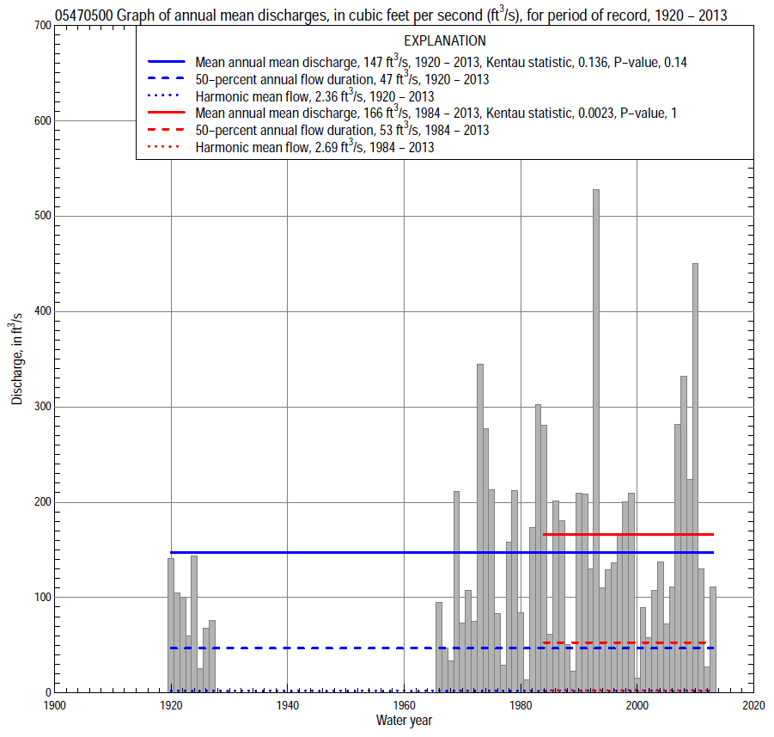

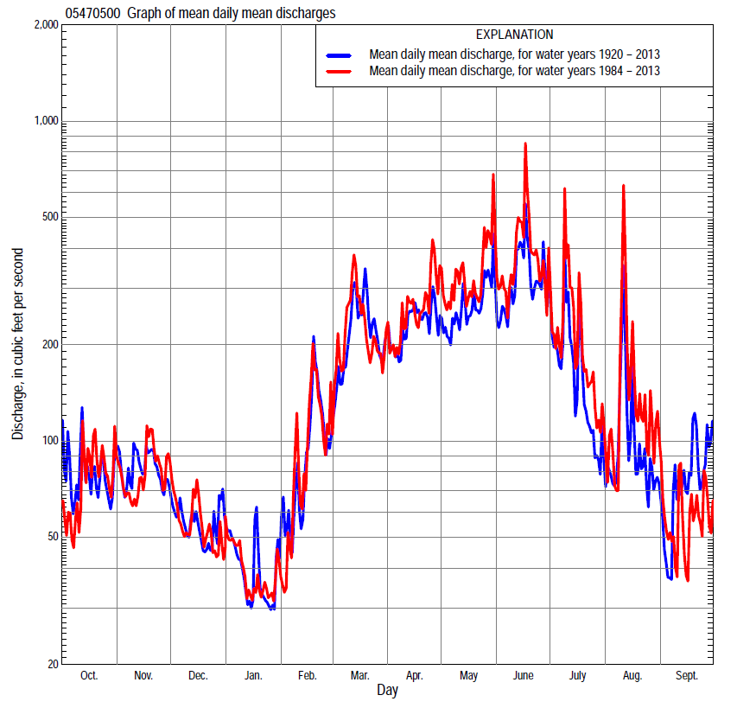

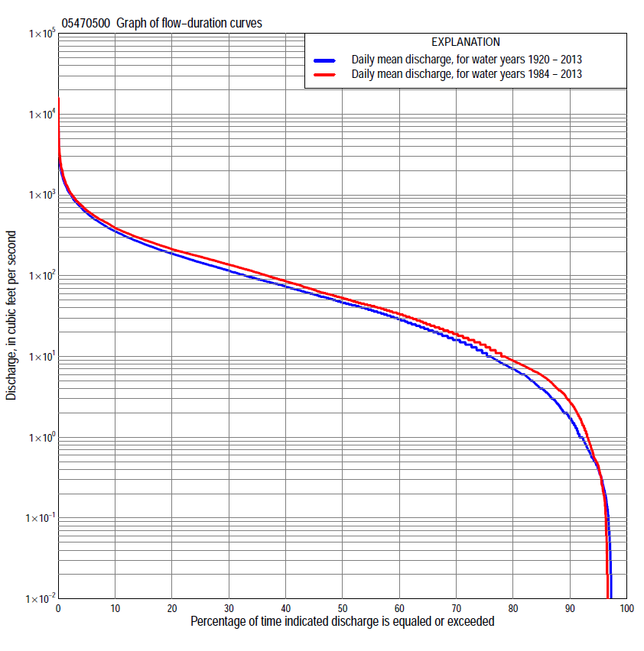

Statistics Based on the Entire Streamflow Period of Record
05470500 Monthly and annual flow durations, based on 1920–27, 1966–2013 period of record (56 years)
Percentage of days discharge equaled or exceeded |  |  |  |  | Discharge (cubic feet per second) |  |  |  |  |  |  |  |  | Annual flow durations
 | Oct | Nov | Dec | Jan | Feb | Mar | Apr | May | June | July | Aug | Sept | Annual | Kentau statistic | P-value
99 | 0.00 | 0.00 | 0.00 | 0.00 | 0.00 | 0.72 | 2.2 | 0.68 | 0.50 | 0.00 | 0.00 | 0.00 | 0.00 | -0.010 | 0.917
98 | 0.00 | 0.00 | 0.00 | 0.00 | 0.00 | 1.4 | 3.4 | 1.1 | 1.0 | 0.21 | 0.00 | 0.00 | 0.00 | -0.029 | 0.752
95 | 0.06 | 0.67 | 0.19 | 0.00 | 0.40 | 4.1 | 5.9 | 4.0 | 5.0 | 1.3 | 0.25 | 0.00 | 0.42 | 0.026 | 0.779
90 | 0.48 | 2.1 | 0.88 | 0.35 | 1.5 | 11 | 14 | 10 | 20 | 3.6 | 1.0 | 0.17 | 1.8 | 0.039 | 0.674
85 | 1.0 | 4.1 | 3.2 | 1.2 | 3.3 | 24 | 24 | 32 | 33 | 7.3 | 2.0 | 0.60 | 4.0 | 0.045 | 0.624
80 | 2.3 | 6.8 | 5.9 | 3.2 | 5.9 | 32 | 38 | 46 | 43 | 12 | 3.0 | 1.0 | 7.0 | 0.035 | 0.707
75 | 3.9 | 9.9 | 8.0 | 5.0 | 7.8 | 43 | 53 | 62 | 57 | 18 | 4.8 | 2.0 | 11 | 0.042 | 0.651
70 | 6.4 | 16 | 11 | 7.0 | 13 | 50 | 68 | 80 | 70 | 24 | 7.2 | 3.5 | 16 | 0.026 | 0.783
65 | 8.8 | 20 | 16 | 8.8 | 17 | 60 | 84 | 98 | 89 | 30 | 9.3 | 5.5 | 22 | 0.031 | 0.740
60 | 13 | 27 | 20 | 13 | 22 | 72 | 103 | 120 | 110 | 38 | 13 | 7.3 | 29 | 0.042 | 0.651
55 | 16 | 35 | 26 | 16 | 26 | 84 | 119 | 140 | 134 | 48 | 16 | 9.7 | 38 | 0.031 | 0.740
50 | 21 | 41 | 32 | 19 | 33 | 102 | 139 | 162 | 160 | 58 | 20 | 12 | 47 | 0.040 | 0.671
45 | 28 | 48 | 38 | 23 | 38 | 124 | 162 | 180 | 191 | 72 | 24 | 15 | 59 | 0.051 | 0.586
40 | 40 | 59 | 43 | 28 | 45 | 143 | 186 | 205 | 218 | 85 | 29 | 19 | 74 | 0.096 | 0.299
35 | 55 | 72 | 49 | 33 | 56 | 163 | 212 | 235 | 255 | 100 | 36 | 23 | 91 | 0.104 | 0.261
30 | 72 | 84 | 59 | 40 | 69 | 195 | 243 | 275 | 297 | 121 | 45 | 32 | 116 | 0.135 | 0.143
25 | 92 | 98 | 68 | 47 | 80 | 244 | 278 | 327 | 350 | 152 | 57 | 48 | 146 | 0.155 | 0.093
20 | 114 | 120 | 81 | 56 | 103 | 301 | 335 | 380 | 424 | 191 | 78 | 68 | 188 | 0.170 | 0.065
15 | 147 | 143 | 99 | 72 | 146 | 394 | 429 | 484 | 541 | 256 | 112 | 106 | 250 | 0.186 | 0.043
10 | 198 | 189 | 129 | 93 | 225 | 531 | 534 | 621 | 767 | 389 | 169 | 205 | 355 | 0.182 | 0.048
5 | 313 | 301 | 181 | 139 | 403 | 862 | 746 | 890 | 1,250 | 696 | 375 | 377 | 600 | 0.177 | 0.055
2 | 582 | 487 | 277 | 228 | 817 | 1,250 | 1,130 | 1,370 | 2,060 | 1,220 | 944 | 748 | 1,040 | 0.109 | 0.238
1 | 818 | 695 | 398 | 313 | 1,040 | 1,700 | 1,740 | 1,790 | 2,690 | 1,670 | 1,460 | 1,110 | 1,480 | 0.090 | 0.329

05470500 Annual exceedance probability of instantaneous peak discharges, in cubic feet per second (ft³/s), based on the Weighted Independent Estimates method,
Annual exceed-ance probability | Recur-rence interval (years) | Discharge (ft³/s) | 95-percent lower confi-dence interval (ft³/s) | 95-percent upper confi-dence interval (ft³/s)
0.500 | 2 | 2,580 | 2,210 | 3,020
0.200 | 5 | 4,880 | 4,110 | 5,780
0.100 | 10 | 6,800 | 5,580 | 8,290
0.040 | 25 | 9,660 | 7,550 | 12,400
0.020 | 50 | 12,100 | 9,030 | 16,100
0.010 | 100 | 14,700 | 10,500 | 20,500
0.005 | 200 | 17,600 | 12,000 | 25,800
0.002 | 500 | 21,600 | 13,900 | 33,800
and based on the expected moments algorithm/multiple Grubbs-Beck analysis computed using a historical period length of 96 years (1918–2013)
0.500 | 2 | 2,590 | 2,110 | 3,120
0.200 | 5 | 4,900 | 4,030 | 5,980
0.100 | 10 | 6,850 | 5,570 | 8,730
0.040 | 25 | 9,810 | 7,740 | 13,700
0.020 | 50 | 12,400 | 9,450 | 18,800
0.010 | 100 | 15,300 | 11,200 | 25,400
0.005 | 200 | 18,500 | 13,000 | 33,900
0.002 | 500 | 23,400 | 15,500 | 48,900
Kentau statistic |  | 0.039
P-value |  | 0.670
Begin year |  | 1920
End year |  | 2013
Number of peaks |  | 57

05470500 Annual exceedance probability of high discharges, based on 1920–27, 1966–2013 period of record (56 years)
Annual exceedance probability | Recur-rence interval (years) | Maximum average discharge (ft³/s) for indicated number of consecutive days
 |  | 1 | 3 | 7 | 15 | 30
0.990 | 1.01 | 336 | 231 | 139 | 92 | 64
0.950 | 1.05 | 568 | 407 | 258 | 173 | 122
0.900 | 1.11 | 752 | 546 | 354 | 239 | 168
0.800 | 1.25 | 1,060 | 774 | 512 | 347 | 244
0.500 | 2 | 2,040 | 1,480 | 996 | 677 | 471
0.200 | 5 | 3,960 | 2,750 | 1,840 | 1,250 | 852
0.100 | 10 | 5,600 | 3,760 | 2,480 | 1,680 | 1,130
0.040 | 25 | 8,140 | 5,210 | 3,370 | 2,260 | 1,500
0.020 | 50 | 10,400 | 6,400 | 4,080 | 2,720 | 1,790
0.010 | 100 | 12,900 | 7,690 | 4,810 | 3,190 | 2,070
0.005 | 200 | 15,700 | 9,060 | 5,560 | 3,680 | 2,360
0.002 | 500 | 20,100 | 11,000 | 6,610 | 4,350 | 2,750
Kentau statistic |  | 0.350 | 0.367 | 0.378 | 0.394 | 0.405
P-value |  | 0.000 | 0.000 | 0.000 | 0.000 | 0.000

 | 05470500 Annual nonexceedance probability of low discharges, based on April 1920 to March 1927, April 1966 to March 2013 period of record (54 years)
Annual nonexceed-ance probability | Recur-rence interval (years) | Minimum average discharge (cubic feet per second) for indicated number of consecutive days
 |  | 1 | 3 | 7 | 14 | 30 | 60 | 90 | 120 | 183
0.01 | 100 | 0.00 | 0.00 | 0.00 | 0.00 | 0.00 | 0.00 | 0.02 | 0.10 | 0.22
0.02 | 50 | 0.00 | 0.00 | 0.00 | 0.00 | 0.00 | 0.00 | 0.06 | 0.22 | 0.45
0.05 | 20 | 0.00 | 0.00 | 0.00 | 0.00 | 0.00 | 0.07 | 0.26 | 0.67 | 1.2
0.10 | 10 | 0.00 | 0.00 | 0.00 | 0.00 | 0.11 | 0.41 | 0.85 | 1.6 | 2.8
0.20 | 5 | 0.00 | 0.06 | 0.27 | 0.28 | 0.81 | 1.8 | 2.9 | 4.3 | 6.9
0.50 | 2 | 1.6 | 1.8 | 2.4 | 4.3 | 7.2 | 12 | 16 | 20 | 30
0.80 | 1.25 | 7.6 | 8.2 | 8.9 | 13 | 19 | 30 | 46 | 60 | 92
0.90 | 1.11 | 13 | 14 | 16 | 18 | 24 | 40 | 63 | 93 | 149
0.96 | 1.04 | 19 | 24 | 26 | 28 | 32 | 46 | 78 | 134 | 230
0.98 | 1.02 | 23 | 31 | 34 | 36 | 40 | 49 | 86 | 163 | 292
0.99 | 1.01 | 27 | 38 | 44 | 46 | 48 | 50 | 91 | 188 | 353
Kentau statistic |  | -0.015 | 0.024 | 0.038 | 0.058 | 0.048 | 0.029 | 0.022 | 0.026 | -0.012
P-value |  | 0.875 | 0.805 | 0.687 | 0.541 | 0.617 | 0.765 | 0.823 | 0.788 | 0.905

05470500 Annual nonexceedance probability of seasonal low discharges, based on July 1919 to September 1927, July 1965 to September 2013 period of record (56–58 years)
Annual nonexceed-ance probability | Recur-rence interval (years) | Minimum average discharge (cubic feet per second) for indicated number of consecutive days
 |  | 1 | 7 | 14 | 30 |  | 1 | 7 | 14 | 30
 |  | January-February-March |  |  |  |  | April-May-June
0.01 | 100 | 0.00 | 0.00 | 0.00 | 0.00 |  | 0.00 | 0.00 | 0.05 | 0.72
0.02 | 50 | 0.00 | 0.00 | 0.00 | 0.00 |  | 0.03 | 0.08 | 1.1 | 1.5
0.05 | 20 | 0.00 | 0.00 | 0.00 | 0.19 |  | 0.80 | 1.4 | 2.8 | 4.2
0.10 | 10 | 0.09 | 0.18 | 0.29 | 0.94 |  | 2.6 | 4.1 | 6.3 | 9.6
0.20 | 5 | 0.92 | 1.4 | 1.6 | 3.0 |  | 7.8 | 11 | 16 | 23
0.50 | 2 | 8.0 | 9.9 | 11 | 15 |  | 37 | 47 | 77 | 91
0.80 | 1.25 | 28 | 34 | 40 | 49 |  | 105 | 128 | 152 | 243
0.90 | 1.11 | 43 | 55 | 63 | 81 |  | 156 | 189 | 270 | 355
0.96 | 1.04 | 59 | 81 | 90 | 128 |  | 216 | 260 | 370 | 487
0.98 | 1.02 | 68 | 99 | 109 | 166 |  | 253 | 307 | 440 | 572
0.99 | 1.01 | 75 | 115 | 124 | 203 |  | 285 | 348 | 500 | 644
Kentau statistic |  | 0.030 | 0.045 | 0.063 | 0.046 |  | 0.238 | 0.236 | 0.245 | 0.242
P-value |  | 0.750 | 0.626 | 0.497 | 0.621 |  | 0.010 | 0.010 | 0.008 | 0.009
 |  | July-August-September |  |  |  |  | October-November-December
0.01 | 100 | 0.00 | 0.00 | 0.00 | 0.02 |  | 0.00 | 0.00 | 0.00 | 0.00
0.02 | 50 | 0.00 | 0.00 | 0.00 | 0.06 |  | 0.00 | 0.00 | 0.00 | 0.01
0.05 | 20 | 0.00 | 0.00 | 0.00 | 0.18 |  | 0.00 | 0.00 | 0.04 | 0.06
0.10 | 10 | 0.00 | 0.00 | 0.03 | 0.47 |  | 0.00 | 0.06 | 0.33 | 0.42
0.20 | 5 | 0.00 | 0.20 | 0.43 | 1.4 |  | 0.52 | 1.1 | 1.5 | 2.6
0.50 | 2 | 1.8 | 2.6 | 5.1 | 7.9 |  | 6.2 | 9.0 | 11 | 25
0.80 | 1.25 | 11 | 14 | 23 | 32 |  | 27 | 34 | 43 | 66
0.90 | 1.11 | 23 | 29 | 44 | 59 |  | 48 | 57 | 72 | 79
0.96 | 1.04 | 48 | 57 | 80 | 102 |  | 79 | 91 | 109 | 110
0.98 | 1.02 | 77 | 85 | 111 | 138 |  | 102 | 116 | 135 | 136
0.99 | 1.01 | 114 | 117 | 147 | 177 |  | 125 | 141 | 158 | 159
Kentau statistic |  | -0.001 | 0.028 | 0.072 | 0.055 |  | -0.112 | -0.093 | -0.095 | -0.065
P-value |  | 1.000 | 0.763 | 0.429 | 0.546 |  | 0.224 | 0.315 | 0.305 | 0.484

Statistics Based on the 1984–2013 Streamflow Period of Record
05470500 Monthly and annual flow durations, based on 1984–2013 period of record (30 years)
Percentage of days discharge equaled or exceeded |  |  |  |  | Discharge (cubic feet per second) |  |  |  |  |  |  |  |  | Annual flow durations
 | Oct | Nov | Dec | Jan | Feb | Mar | Apr | May | June | July | Aug | Sept | Annual | Kentau statistic | P-value
99 | 0.00 | 0.00 | 0.00 | 0.00 | 0.00 | 1.1 | 7.2 | 5.4 | 9.0 | 0.00 | 0.00 | 0.00 | 0.00 | -0.005 | 0.985
98 | 0.00 | 0.00 | 0.00 | 0.00 | 0.47 | 4.0 | 9.2 | 7.2 | 13 | 0.14 | 0.00 | 0.00 | 0.00 | 0.009 | 0.955
95 | 0.00 | 0.43 | 0.18 | 0.00 | 1.5 | 11 | 11 | 22 | 21 | 2.2 | 0.00 | 0.00 | 0.43 | 0.039 | 0.772
90 | 0.32 | 2.8 | 0.93 | 1.0 | 2.9 | 22 | 24 | 48 | 35 | 6.0 | 0.53 | 0.00 | 2.7 | 0.021 | 0.886
85 | 0.81 | 5.9 | 4.1 | 3.0 | 4.6 | 29 | 35 | 71 | 45 | 13 | 1.9 | 0.36 | 5.9 | 0.002 | 1.000
80 | 2.6 | 7.6 | 6.3 | 4.3 | 6.4 | 39 | 48 | 90 | 60 | 19 | 4.0 | 0.99 | 8.9 | 0.011 | 0.943
75 | 3.8 | 10 | 9.0 | 6.6 | 9.2 | 47 | 62 | 112 | 80 | 26 | 7.3 | 2.1 | 14 | -0.011 | 0.943
70 | 5.6 | 15 | 11 | 9.0 | 18 | 54 | 83 | 134 | 106 | 33 | 9.2 | 3.7 | 19 | -0.053 | 0.694
65 | 6.7 | 18 | 14 | 14 | 25 | 63 | 110 | 156 | 125 | 41 | 13 | 5.5 | 25 | -0.078 | 0.556
60 | 8.4 | 20 | 19 | 16 | 31 | 79 | 126 | 174 | 155 | 51 | 17 | 7.0 | 34 | -0.085 | 0.520
55 | 11 | 24 | 26 | 20 | 36 | 93 | 148 | 191 | 182 | 63 | 20 | 8.5 | 42 | -0.071 | 0.592
50 | 15 | 35 | 33 | 25 | 40 | 114 | 171 | 216 | 201 | 76 | 24 | 10 | 53 | -0.041 | 0.762
45 | 19 | 42 | 38 | 31 | 46 | 133 | 187 | 235 | 231 | 91 | 28 | 12 | 67 | -0.046 | 0.735
40 | 24 | 53 | 44 | 36 | 55 | 150 | 208 | 263 | 261 | 109 | 34 | 15 | 86 | -0.007 | 0.972
35 | 34 | 69 | 54 | 43 | 64 | 165 | 235 | 300 | 298 | 130 | 42 | 17 | 109 | -0.039 | 0.775
30 | 55 | 84 | 61 | 47 | 75 | 190 | 268 | 346 | 345 | 159 | 54 | 22 | 137 | -0.039 | 0.775
25 | 89 | 104 | 77 | 53 | 91 | 241 | 308 | 385 | 415 | 189 | 68 | 30 | 172 | -0.005 | 0.986
20 | 123 | 127 | 91 | 59 | 113 | 299 | 371 | 473 | 486 | 243 | 95 | 49 | 213 | -0.007 | 0.972
15 | 164 | 153 | 110 | 71 | 150 | 374 | 457 | 566 | 601 | 331 | 138 | 86 | 280 | 0.034 | 0.803
10 | 205 | 191 | 138 | 87 | 221 | 528 | 573 | 745 | 873 | 496 | 236 | 177 | 389 | 0.037 | 0.789
5 | 316 | 296 | 186 | 120 | 403 | 843 | 786 | 1,070 | 1,440 | 779 | 544 | 304 | 645 | 0.067 | 0.617
2 | 589 | 500 | 271 | 169 | 628 | 1,250 | 1,340 | 1,620 | 2,220 | 1,230 | 1,400 | 508 | 1,110 | 0.025 | 0.858
1 | 784 | 670 | 370 | 285 | 857 | 1,700 | 1,920 | 1,960 | 3,230 | 2,160 | 2,120 | 724 | 1,620 | 0.048 | 0.721

05470500 Annual exceedance probability of high discharges, based on 1984–2013 period of record (30 years)
Annual exceedance probability | Recur-rence interval (years) | Maximum average discharge (ft³/s) for indicated number of consecutive days
 |  | 1 | 3 | 7 | 15 | 30
0.990 | 1.01 | 242 | 195 | 124 | 89 | 65
0.950 | 1.05 | 455 | 357 | 237 | 170 | 124
0.900 | 1.11 | 639 | 494 | 331 | 237 | 173
0.800 | 1.25 | 963 | 729 | 495 | 352 | 255
0.500 | 2 | 2,120 | 1,530 | 1,040 | 730 | 517
0.200 | 5 | 4,700 | 3,200 | 2,150 | 1,460 | 994
0.100 | 10 | 7,140 | 4,700 | 3,100 | 2,080 | 1,370
0.040 | 25 | 11,200 | 7,060 | 4,540 | 2,990 | 1,910
0.020 | 50 | 14,900 | 9,180 | 5,790 | 3,750 | 2,340
0.010 | 100 | 19,400 | 11,600 | 7,180 | 4,600 | 2,800
0.005 | 200 | 24,600 | 14,400 | 8,730 | 5,520 | 3,280
0.002 | 500 | 32,900 | 18,700 | 11,000 | 6,850 | 3,960
Kentau statistic |  | -0.055 | 0.007 | 0.030 | 0.048 | 0.048
P-value |  | 0.682 | 0.972 | 0.830 | 0.721 | 0.721

 | 05470500 Annual nonexceedance probability of low discharges, based on April 1983 to March 2013, period of record (30 years)
Annual nonexceed-ance probability | Recur-rence interval (years) | Minimum average discharge (cubic feet per second) for indicated number of consecutive days
 |  | 1 | 3 | 7 | 14 | 30 | 60 | 90 | 120 | 183
0.01 | 100 | 0.00 | 0.00 | 0.00 | 0.00 | 0.00 | 0.00 | 0.04 | 0.07 | 0.34
0.02 | 50 | 0.00 | 0.00 | 0.00 | 0.00 | 0.00 | 0.01 | 0.11 | 0.17 | 0.66
0.05 | 20 | 0.00 | 0.00 | 0.00 | 0.00 | 0.00 | 0.10 | 0.41 | 0.61 | 1.7
0.10 | 10 | 0.00 | 0.00 | 0.00 | 0.00 | 0.09 | 0.49 | 1.2 | 1.7 | 3.6
0.20 | 5 | 0.00 | 0.08 | 0.47 | 0.58 | 0.94 | 2.2 | 3.6 | 4.9 | 8.2
0.50 | 2 | 2.3 | 2.7 | 2.9 | 3.0 | 9.5 | 14 | 17 | 23 | 32
0.80 | 1.25 | 8.2 | 9.0 | 9.4 | 14 | 21 | 31 | 46 | 63 | 91
0.90 | 1.11 | 12 | 15 | 16 | 18 | 23 | 36 | 63 | 89 | 142
0.96 | 1.04 | 15 | 23 | 26 | 28 | 30 | 39 | 79 | 114 | 212
0.98 | 1.02 | 16 | 28 | 35 | 37 | 38 | 40 | 87 | 128 | 265
0.99 | 1.01 | 17 | 33 | 45 | 47 | 49 | 51 | 92 | 138 | 315
Kentau statistic |  | -0.062 | -0.044 | -0.039 | 0.000 | 0.011 | -0.025 | -0.053 | -0.067 | -0.103
P-value |  | 0.640 | 0.747 | 0.775 | 1.000 | 0.943 | 0.858 | 0.695 | 0.617 | 0.432

05470500 Annual nonexceedance probability of seasonal low discharges, based on October 1983 to September 2013 period of record (30 years)
Annual nonexceed-ance probability | Recur-rence interval (years) | Minimum average discharge (cubic feet per second) for indicated number of consecutive days
 |  | 1 | 7 | 14 | 30 |  | 1 | 7 | 14 | 30
 |  | January-February-March |  |  |  |  | April-May-June
0.01 | 100 | 0.00 | 0.00 | 0.00 | 0.00 |  | 0.56 | 1.6 | 3.0 | 4.6
0.02 | 50 | 0.00 | 0.00 | 0.00 | 0.00 |  | 1.1 | 2.7 | 4.8 | 7.2
0.05 | 20 | 0.00 | 0.00 | 0.07 | 1.0 |  | 3.0 | 5.7 | 9.1 | 14
0.10 | 10 | 0.30 | 0.52 | 0.63 | 2.7 |  | 6.6 | 11 | 16 | 23
0.20 | 5 | 1.6 | 2.5 | 2.7 | 5.8 |  | 15 | 21 | 28 | 43
0.50 | 2 | 9.1 | 12 | 16 | 18 |  | 53 | 62 | 77 | 118
0.80 | 1.25 | 28 | 35 | 43 | 46 |  | 126 | 149 | 174 | 282
0.90 | 1.11 | 42 | 53 | 58 | 70 |  | 174 | 216 | 250 | 418
0.96 | 1.04 | 61 | 76 | 90 | 105 |  | 225 | 303 | 351 | 608
0.98 | 1.02 | 73 | 91 | 111 | 133 |  | 255 | 367 | 427 | 759
0.99 | 1.01 | 84 | 104 | 134 | 163 |  | 279 | 427 | 501 | 912
Kentau statistic |  | -0.140 | -0.115 | -0.113 | -0.122 |  | 0.115 | 0.103 | 0.140 | 0.145
P-value |  | 0.284 | 0.382 | 0.392 | 0.354 |  | 0.382 | 0.432 | 0.284 | 0.269
 |  | July-August-September |  |  |  |  | October-November-December
0.01 | 100 | 0.00 | 0.00 | 0.00 | 0.02 |  | 0.00 | 0.00 | 0.00 | 0.00
0.02 | 50 | 0.00 | 0.00 | 0.00 | 0.05 |  | 0.00 | 0.00 | 0.00 | 0.00
0.05 | 20 | 0.00 | 0.00 | 0.00 | 0.18 |  | 0.00 | 0.00 | 0.06 | 0.07
0.10 | 10 | 0.00 | 0.00 | 0.00 | 0.50 |  | 0.00 | 0.00 | 0.39 | 0.40
0.20 | 5 | 0.00 | 0.17 | 0.34 | 1.5 |  | 0.39 | 1.1 | 1.6 | 2.6
0.50 | 2 | 2.0 | 3.1 | 8.2 | 9.4 |  | 5.6 | 8.2 | 10 | 24
0.80 | 1.25 | 15 | 18 | 27 | 40 |  | 24 | 30 | 38 | 60
0.90 | 1.11 | 33 | 38 | 55 | 73 |  | 42 | 51 | 63 | 70
0.96 | 1.04 | 69 | 75 | 101 | 126 |  | 69 | 82 | 99 | 100
0.98 | 1.02 | 105 | 111 | 141 | 171 |  | 90 | 107 | 124 | 125
0.99 | 1.01 | 150 | 154 | 186 | 218 |  | 111 | 131 | 149 | 150
Kentau statistic |  | -0.087 | -0.062 | -0.009 | 0.011 |  | -0.076 | -0.087 | -0.090 | -0.076
P-value |  | 0.505 | 0.642 | 0.957 | 0.943 |  | 0.567 | 0.509 | 0.498 | 0.568

