LOCATION.--Lat 42°00'24", long 93°35'43" referenced to North American Datum of 1927, in NW 1/4 NE 1/4 NW 1/4 sec.13, T.83 N., R.24 W., Story County, IA, Hydrologic Unit 07080105, on right bank 500 ft downstream from bridge on Southeast 16th Street, 200 ft upstream from bridge on U.S. Highway 30, 2 mi southeast of Ames, 0.2 mi downstream from Squaw Creek, 127 mi upstream from confluence with the North Skunk River, and 221.7 mi upstream from mouth of Skunk River.

DRAINAGE AREA.--556 mi².

PERIOD OF RECORD.--Discharge records from October 1952 to December 1979, October 1991 to current year. Prior to October 1966, published as "Skunk River below Squaw Creek near Ames".

GAGE.--Water-stage recorder. Datum of gage is 857.10 ft above National Geodetic Vertical Datum of 1929. Prior to October 1, 1973, at datum 10.00 ft higher. Prior to October 1991, at site 500 ft upstream.

REMARKS.--Low flows affected by pumpage from surficial aquifers by the Ames Water and Pollution Control Department and do not represent the natural flow of the stream.

EXTREMES OUTSIDE PERIOD OF RECORD.--Flood of June 17, 1990, reached a stage of 25.40 ft, from the office of the Ames Water and Pollution Control Department, at site 500 ft upstream at current datum, discharge about 13,000 ft³/s. Flood of May 19, 1944, reached a stage of 13.00 ft, from high-water mark, at site and datum then in use, discharge 10,000 ft³/s.

A summary of all available data for this streamgage is provided through the USGS National Water Information System web interface (NWISWeb). The following link provides access to current/historical observations, daily data, daily statistics, monthly statistics, annual statistics, peak streamflow, field measurements, field/lab water-quality samples, and the latest water-year summaries. Data can be filtered by parameter and/or dates, and can be output in various tabular and graphical formats.
http://waterdata.usgs.gov/nwis/inventory/?site_no=05471000

The USGS WaterWatch Toolkit is available at:
http://waterwatch.usgs.gov/?id=ww_toolkit
Tools for summarizing streamflow information include the duration hydrograph builder, the cumulative streamflow hydrograph builder, the streamgage statistics retrieval tool, the rating curve builder, the flood tracking chart builder, the National Weather Service Advanced Hydrologic Prediction Service (AHPS) river forecast hydrograph builder, and the raster-hydrograph builder. Entering the above number for this streamgage into these toolkit webpages will provide streamflow information specific to this streamgage.

A description of the statistics presented for this streamgage is available in the main body of the report at:
http://dx.doi.org/10.3133/ofr20151214
A link to other streamgages included in this report, a map showing the location of the streamgages, information on the programs used to compute the statistical analyses, and references are included in the main body of the report.

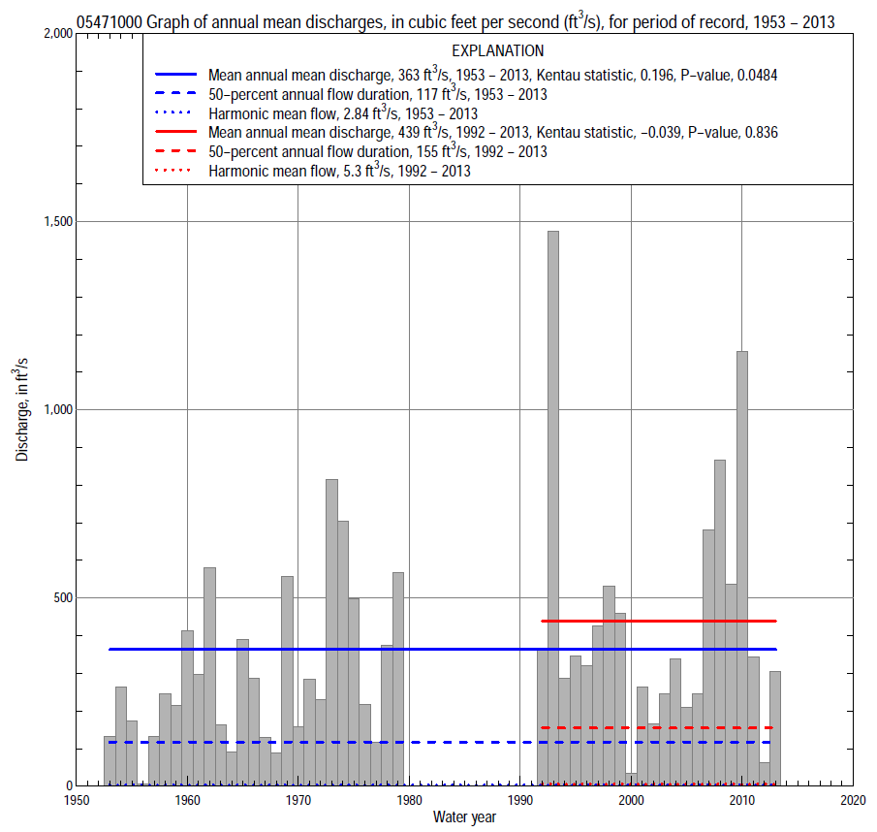

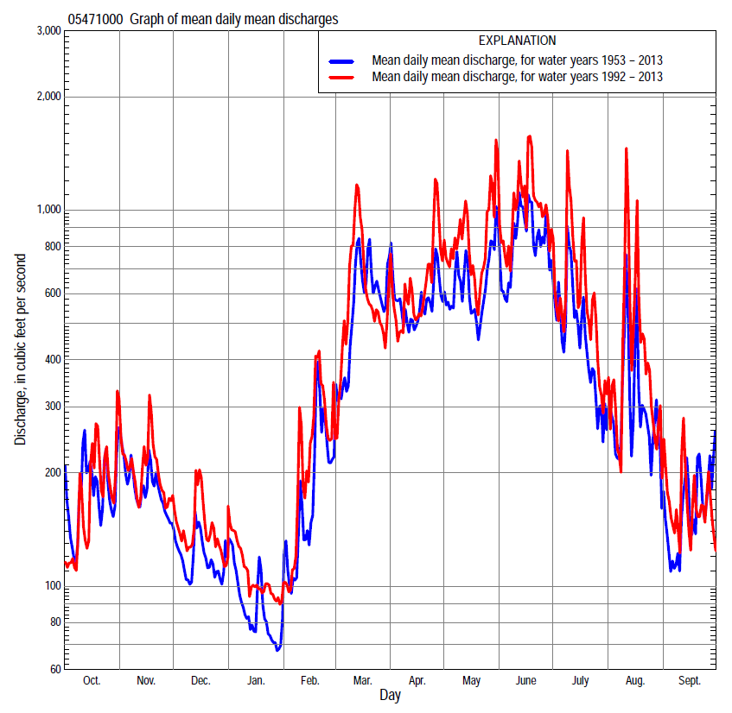

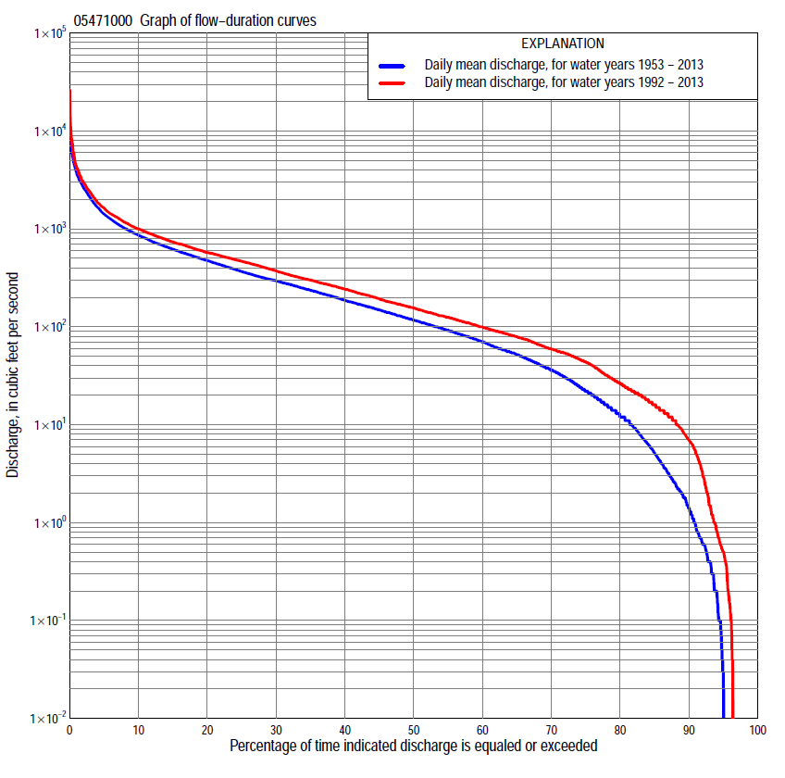

Statistics Based on the Entire Streamflow Period of Record
05471000 Monthly and annual flow durations, based on 1953–79, 1992–2013 period of record (49 years)
Percentage of days discharge equaled or exceeded |  |  |  |  | Discharge (cubic feet per second) |  |  |  |  |  |  |  |  | Annual flow durations
 | Oct | Nov | Dec | Jan | Feb | Mar | Apr | May | June | July | Aug | Sept | Annual | Kentau statistic | P-value
99 | 0.00 | 0.00 | 0.00 | 0.00 | 0.00 | 0.00 | 2.2 | 0.20 | 0.00 | 0.00 | 0.00 | 0.00 | 0.00 | 0.156 | 0.099
98 | 0.00 | 0.00 | 0.00 | 0.00 | 0.00 | 0.00 | 5.2 | 1.7 | 0.00 | 0.00 | 0.00 | 0.00 | 0.00 | 0.162 | 0.093
95 | 0.00 | 0.10 | 0.00 | 0.03 | 0.00 | 5.7 | 10 | 8.6 | 31 | 1.0 | 1.2 | 0.07 | 0.02 | 0.134 | 0.168
90 | 0.20 | 0.60 | 0.10 | 1.5 | 0.10 | 19 | 18 | 48 | 90 | 31 | 4.9 | 0.80 | 1.4 | 0.203 | 0.038
85 | 0.67 | 2.1 | 0.68 | 6.4 | 0.85 | 30 | 54 | 106 | 119 | 46 | 8.5 | 1.8 | 5.2 | 0.196 | 0.046
80 | 1.1 | 4.7 | 3.2 | 15 | 4.0 | 62 | 82 | 153 | 146 | 62 | 12 | 3.4 | 12 | 0.184 | 0.063
75 | 2.1 | 9.0 | 6.6 | 27 | 12 | 86 | 128 | 200 | 185 | 78 | 16 | 5.5 | 22 | 0.185 | 0.061
70 | 5.2 | 16 | 13 | 41 | 21 | 114 | 163 | 252 | 224 | 95 | 22 | 9.2 | 36 | 0.186 | 0.060
65 | 10 | 24 | 21 | 58 | 31 | 130 | 211 | 299 | 269 | 110 | 30 | 13 | 52 | 0.183 | 0.065
60 | 17 | 43 | 34 | 78 | 36 | 151 | 243 | 330 | 312 | 130 | 40 | 19 | 70 | 0.185 | 0.061
55 | 26 | 56 | 47 | 101 | 47 | 176 | 288 | 372 | 372 | 153 | 48 | 25 | 92 | 0.183 | 0.065
50 | 43 | 77 | 60 | 130 | 62 | 210 | 343 | 415 | 429 | 177 | 58 | 32 | 118 | 0.186 | 0.060
45 | 61 | 110 | 84 | 166 | 81 | 260 | 407 | 473 | 513 | 204 | 69 | 41 | 149 | 0.203 | 0.040
40 | 76 | 137 | 98 | 211 | 97 | 322 | 480 | 516 | 591 | 242 | 83 | 51 | 187 | 0.224 | 0.024
35 | 93 | 167 | 117 | 264 | 115 | 400 | 546 | 575 | 667 | 285 | 100 | 61 | 236 | 0.226 | 0.022
30 | 152 | 209 | 142 | 326 | 153 | 502 | 633 | 666 | 764 | 343 | 124 | 74 | 296 | 0.246 | 0.013
25 | 220 | 253 | 170 | 413 | 200 | 615 | 714 | 763 | 887 | 420 | 162 | 98 | 367 | 0.276 | 0.005
20 | 288 | 304 | 210 | 526 | 250 | 791 | 850 | 888 | 1,070 | 515 | 212 | 147 | 474 | 0.274 | 0.006
15 | 370 | 360 | 262 | 686 | 314 | 991 | 1,000 | 1,090 | 1,360 | 655 | 303 | 226 | 620 | 0.241 | 0.015
10 | 473 | 469 | 312 | 949 | 460 | 1,360 | 1,210 | 1,430 | 1,970 | 1,030 | 513 | 444 | 863 | 0.229 | 0.021
5 | 710 | 684 | 393 | 1,580 | 738 | 2,430 | 1,760 | 2,190 | 3,110 | 1,840 | 1,330 | 889 | 1,420 | 0.183 | 0.065
2 | 1,330 | 1,020 | 560 | 2,890 | 1,290 | 3,950 | 3,360 | 3,120 | 4,990 | 3,270 | 3,120 | 1,520 | 2,670 | 0.136 | 0.171
1 | 1,940 | 1,360 | 751 | 4,050 | 1,940 | 5,260 | 4,530 | 3,970 | 6,070 | 5,700 | 4,410 | 2,210 | 3,800 | 0.094 | 0.347

05471000 Annual exceedance probability of instantaneous peak discharges, in cubic feet per second (ft³/s), based on the Weighted Independent Estimates method,
Annual exceed-ance probability | Recur-rence interval (years) | Discharge (ft³/s) | 95-percent lower confi-dence interval (ft³/s) | 95-percent upper confi-dence interval (ft³/s)
0.500 | 2 | 5,600 | 4,930 | 6,360
0.200 | 5 | 9,340 | 8,110 | 10,700
0.100 | 10 | 12,200 | 10,400 | 14,400
0.040 | 25 | 16,300 | 13,300 | 20,100
0.020 | 50 | 19,600 | 15,400 | 25,100
0.010 | 100 | 23,200 | 17,500 | 30,800
0.005 | 200 | 27,100 | 19,500 | 37,400
0.002 | 500 | 32,400 | 22,100 | 47,400
and based on the expected moments algorithm/multiple Grubbs-Beck analysis computed using a historical period length of 95 years (1919–2013)
0.500 | 2 | 5,640 | 4,720 | 6,640
0.200 | 5 | 9,420 | 7,890 | 11,200
0.100 | 10 | 12,400 | 10,300 | 15,100
0.040 | 25 | 16,500 | 13,500 | 21,700
0.020 | 50 | 20,000 | 15,900 | 28,200
0.010 | 100 | 23,700 | 18,400 | 36,500
0.005 | 200 | 27,700 | 20,800 | 47,000
0.002 | 500 | 33,600 | 24,100 | 65,200
Kentau statistic |  | 0.027
P-value |  | 0.789
Begin year |  | 1953
End year |  | 2013
Number of peaks |  | 49

05471000 Annual exceedance probability of high discharges, based on 1953–79, 1992–2013 period of record (49 years)
Annual exceedance probability | Recur-rence interval (years) | Maximum average discharge (ft³/s) for indicated number of consecutive days
 |  | 1 | 3 | 7 | 15 | 30
0.990 | 1.01 | 493 | 303 | 185 | 103 | 69
0.950 | 1.05 | 1,110 | 790 | 511 | 322 | 232
0.900 | 1.11 | 1,640 | 1,230 | 816 | 538 | 395
0.800 | 1.25 | 2,530 | 1,980 | 1,340 | 921 | 681
0.500 | 2 | 5,110 | 4,120 | 2,860 | 2,020 | 1,450
0.200 | 5 | 8,940 | 6,950 | 4,830 | 3,340 | 2,250
0.100 | 10 | 11,300 | 8,490 | 5,870 | 3,960 | 2,570
0.040 | 25 | 14,100 | 10,000 | 6,860 | 4,490 | 2,790
0.020 | 50 | 15,900 | 10,900 | 7,400 | 4,750 | 2,890
0.010 | 100 | 17,500 | 11,600 | 7,820 | 4,930 | 2,940
0.005 | 200 | 19,000 | 12,100 | 8,140 | 5,050 | 2,980
0.002 | 500 | 20,700 | 12,700 | 8,450 | 5,160 | 3,000
Kentau statistic |  | -0.001 | 0.015 | 0.026 | 0.048 | 0.040
P-value |  | 1.000 | 0.871 | 0.769 | 0.587 | 0.648

 | 05471000 Annual nonexceedance probability of low discharges, based on April 1953 to March 1979, April 1992 to March 2013, period of record (47 years)
Annual nonexceed-ance probability | Recur-rence interval (years) | Minimum average discharge (cubic feet per second) for indicated number of consecutive days
 |  | 1 | 3 | 7 | 14 | 30 | 60 | 90 | 120 | 183
0.01 | 100 | 0.00 | 0.00 | 0.00 | 0.00 | 0.00 | 0.00 | 0.00 | 0.00 | 0.00
0.02 | 50 | 0.00 | 0.00 | 0.00 | 0.00 | 0.00 | 0.00 | 0.00 | 0.01 | 0.07
0.05 | 20 | 0.00 | 0.00 | 0.00 | 0.00 | 0.00 | 0.00 | 0.01 | 0.10 | 0.39
0.10 | 10 | 0.00 | 0.00 | 0.00 | 0.00 | 0.00 | 0.05 | 0.19 | 0.53 | 1.47
0.20 | 5 | 0.00 | 0.00 | 0.00 | 0.01 | 0.07 | 0.66 | 1.74 | 2.97 | 6.15
0.50 | 2 | 3.4 | 3.7 | 4.0 | 5.7 | 9.3 | 15 | 28 | 36 | 54
0.80 | 1.25 | 20 | 22 | 27 | 33 | 51 | 91 | 129 | 173 | 246
0.90 | 1.11 | 38 | 40 | 51 | 58 | 85 | 164 | 197 | 290 | 431
0.96 | 1.04 | 66 | 68 | 81 | 86 | 124 | 253 | 257 | 419 | 678
0.98 | 1.02 | 89 | 90 | 101 | 104 | 146 | 306 | 307 | 492 | 847
0.99 | 1.01 | 111 | 111 | 118 | 118 | 163 | 347 | 348 | 546 | 994
Kentau statistic |  | 0.179 | 0.188 | 0.182 | 0.212 | 0.191 | 0.155 | 0.160 | 0.147 | 0.142
P-value |  | 0.076 | 0.062 | 0.071 | 0.036 | 0.058 | 0.126 | 0.115 | 0.147 | 0.163

05471000 Annual nonexceedance probability of seasonal low discharges, based on October 1952 to September 1979, October 1991 to September 2013 period of record (49 years)
Annual nonexceed-ance probability | Recur-rence interval (years) | Minimum average discharge (cubic feet per second) for indicated number of consecutive days
 |  | 1 | 7 | 14 | 30 |  | 1 | 7 | 14 | 30
 |  | January-February-March |  |  |  |  | April-May-June
0.01 | 100 | 0.00 | 0.00 | 0.00 | 0.00 |  | 0.00 | 0.00 | 0.00 | 0.00
0.02 | 50 | 0.00 | 0.00 | 0.00 | 0.00 |  | 0.00 | 0.00 | 0.00 | 0.00
0.05 | 20 | 0.00 | 0.00 | 0.00 | 0.00 |  | 0.63 | 1.1 | 1.5 | 8.2
0.10 | 10 | 0.00 | 0.00 | 0.00 | 0.11 |  | 6.7 | 8.1 | 9.5 | 26
0.20 | 5 | 0.15 | 0.46 | 0.81 | 1.4 |  | 25 | 34 | 41 | 69
0.50 | 2 | 17 | 19 | 21 | 22 |  | 117 | 139 | 208 | 261
0.80 | 1.25 | 75 | 86 | 104 | 125 |  | 277 | 325 | 465 | 605
0.90 | 1.11 | 121 | 145 | 195 | 243 |  | 362 | 433 | 613 | 806
0.96 | 1.04 | 172 | 219 | 319 | 419 |  | 435 | 537 | 768 | 999
0.98 | 1.02 | 203 | 268 | 410 | 553 |  | 470 | 592 | 842 | 1,100
0.99 | 1.01 | 228 | 310 | 495 | 680 |  | 493 | 632 | 882 | 1,180
Kentau statistic |  | 0.223 | 0.236 | 0.230 | 0.219 |  | 0.278 | 0.264 | 0.259 | 0.293
P-value |  | 0.024 | 0.017 | 0.020 | 0.027 |  | 0.005 | 0.008 | 0.009 | 0.003
 |  | July-August-September |  |  |  |  | October-November-December
0.01 | 100 | 0.00 | 0.00 | 0.00 | 0.00 |  | 0.00 | 0.00 | 0.00 | 0.00
0.02 | 50 | 0.00 | 0.00 | 0.00 | 0.00 |  | 0.00 | 0.00 | 0.00 | 0.00
0.05 | 20 | 0.00 | 0.00 | 0.00 | 0.21 |  | 0.00 | 0.00 | 0.00 | 0.00
0.10 | 10 | 0.12 | 0.19 | 0.22 | 0.91 |  | 0.00 | 0.00 | 0.00 | 0.06
0.20 | 5 | 0.87 | 1.4 | 1.8 | 3.4 |  | 0.00 | 0.12 | 0.67 | 1.4
0.50 | 2 | 6.6 | 10 | 14 | 24 |  | 10 | 10 | 17 | 30
0.80 | 1.25 | 34 | 46 | 58 | 97 |  | 67 | 100 | 109 | 153
0.90 | 1.11 | 76 | 92 | 110 | 173 |  | 132 | 217 | 223 | 251
0.96 | 1.04 | 169 | 182 | 203 | 286 |  | 237 | 352 | 398 | 407
0.98 | 1.02 | 280 | 276 | 291 | 375 |  | 326 | 405 | 553 | 557
0.99 | 1.01 | 392 | 393 | 434 | 462 |  | 416 | 441 | 654 | 705
Kentau statistic |  | 0.032 | 0.049 | 0.058 | 0.056 |  | 0.117 | 0.124 | 0.126 | 0.139
P-value |  | 0.750 | 0.623 | 0.563 | 0.575 |  | 0.235 | 0.211 | 0.205 | 0.160

Statistics Based on the 1984–2013 Streamflow Period of Record
05471000 Monthly and annual flow durations, based on 1992–2013 period of record (22 years)
Percentage of days discharge equaled or exceeded |  |  |  |  | Discharge (cubic feet per second) |  |  |  |  |  |  |  |  | Annual flow durations
 | Oct | Nov | Dec | Jan | Feb | Mar | Apr | May | June | July | Aug | Sept | Annual | Kentau statistic | P-value
99 | 0.00 | 0.00 | 0.00 | 0.00 | 0.00 | 1.2 | 10 | 4.3 | 69 | 0.37 | 0.18 | 0.00 | 0.00 | 0.000 | 1.000
98 | 0.00 | 0.00 | 0.00 | 0.00 | 0.00 | 6.0 | 12 | 6.0 | 80 | 0.68 | 0.21 | 0.00 | 0.00 | -0.061 | 0.711
95 | 0.00 | 0.00 | 0.00 | 0.00 | 0.11 | 26 | 49 | 109 | 102 | 19 | 0.83 | 0.00 | 0.50 | -0.095 | 0.551
90 | 0.00 | 6.1 | 0.72 | 0.77 | 3.3 | 64 | 80 | 177 | 129 | 51 | 6.7 | 0.40 | 7.0 | -0.100 | 0.533
85 | 0.62 | 9.2 | 12 | 6.4 | 13 | 82 | 118 | 271 | 186 | 75 | 14 | 1.4 | 16 | -0.095 | 0.552
80 | 1.9 | 16 | 16 | 14 | 22 | 101 | 157 | 312 | 237 | 88 | 21 | 3.6 | 26 | -0.048 | 0.777
75 | 5.7 | 20 | 21 | 21 | 45 | 129 | 205 | 356 | 274 | 105 | 30 | 6.5 | 44 | -0.061 | 0.714
70 | 10 | 32 | 31 | 27 | 56 | 149 | 242 | 400 | 316 | 125 | 38 | 10 | 59 | -0.117 | 0.463
65 | 16 | 43 | 43 | 32 | 67 | 170 | 283 | 452 | 405 | 142 | 48 | 13 | 79 | -0.130 | 0.413
60 | 22 | 56 | 55 | 46 | 81 | 195 | 338 | 486 | 460 | 170 | 55 | 18 | 100 | -0.139 | 0.382
55 | 27 | 74 | 71 | 55 | 93 | 233 | 383 | 523 | 529 | 206 | 65 | 24 | 125 | -0.160 | 0.310
50 | 42 | 102 | 89 | 63 | 110 | 275 | 430 | 565 | 590 | 238 | 75 | 29 | 155 | -0.108 | 0.499
45 | 61 | 130 | 105 | 82 | 125 | 328 | 498 | 628 | 647 | 276 | 86 | 37 | 193 | -0.082 | 0.612
40 | 78 | 155 | 122 | 95 | 155 | 396 | 552 | 699 | 705 | 319 | 98 | 45 | 242 | -0.074 | 0.652
35 | 96 | 195 | 142 | 109 | 188 | 475 | 627 | 767 | 799 | 373 | 114 | 54 | 300 | -0.078 | 0.632
30 | 151 | 233 | 164 | 124 | 230 | 563 | 706 | 856 | 891 | 446 | 137 | 61 | 373 | -0.061 | 0.714
25 | 210 | 273 | 183 | 135 | 260 | 649 | 814 | 982 | 1,030 | 515 | 168 | 76 | 467 | -0.009 | 0.977
20 | 280 | 331 | 236 | 160 | 308 | 798 | 941 | 1,170 | 1,260 | 630 | 214 | 142 | 573 | 0.000 | 1.000
15 | 348 | 411 | 286 | 195 | 400 | 1,000 | 1,070 | 1,420 | 1,520 | 935 | 327 | 219 | 736 | -0.022 | 0.910
10 | 448 | 514 | 332 | 244 | 556 | 1,360 | 1,320 | 1,740 | 2,350 | 1,290 | 711 | 621 | 1,000 | 0.039 | 0.822
5 | 700 | 704 | 456 | 402 | 897 | 2,200 | 1,830 | 2,470 | 4,020 | 2,290 | 2,150 | 957 | 1,630 | 0.056 | 0.735
2 | 1,400 | 987 | 681 | 500 | 1,290 | 3,560 | 3,420 | 3,530 | 5,860 | 4,480 | 4,000 | 1,500 | 2,990 | 0.030 | 0.866
1 | 2,110 | 1,350 | 800 | 700 | 1,510 | 5,990 | 4,150 | 4,660 | 7,880 | 7,550 | 6,810 | 1,840 | 4,270 | 0.056 | 0.735

05471000 Annual exceedance probability of high discharges, based on 1992–2013 period of record (22 years)
Annual exceed-ance probability | Recur-rence interval (years) | Maximum average discharge (ft³/s) for indicated number of consecutive days
 |  | 1 | 3 | 7 | 15 | 30
0.990 | 1.01 | 574 | 459 | 369 | 262 | 208
0.950 | 1.05 | 1,090 | 880 | 665 | 467 | 363
0.900 | 1.11 | 1,530 | 1,230 | 908 | 635 | 486
0.800 | 1.25 | 2,280 | 1,840 | 1,320 | 918 | 689
0.500 | 2 | 4,840 | 3,840 | 2,670 | 1,850 | 1,330
0.200 | 5 | 10,000 | 7,730 | 5,310 | 3,690 | 2,510
0.100 | 10 | 14,600 | 11,000 | 7,580 | 5,280 | 3,470
0.040 | 25 | 21,600 | 15,800 | 11,000 | 7,730 | 4,900
0.020 | 50 | 27,700 | 19,900 | 14,000 | 9,870 | 6,090
0.010 | 100 | 34,600 | 24,400 | 17,300 | 12,300 | 7,400
0.005 | 200 | 42,300 | 29,300 | 21,100 | 15,000 | 8,830
0.002 | 500 | 53,900 | 36,500 | 26,600 | 19,100 | 10,900
Kentau statistic |  | 0.402 | 0.411 | 0.407 | 0.411 | 0.407
P-value |  | 0.002 | 0.001 | 0.002 | 0.001 | 0.002

 | 05471000 Annual nonexceedance probability of low discharges, based on April 1992 to March 2013, period of record (21 years)
Annual nonexceed-ance probability | Recur-rence interval (years) | Minimum average discharge (cubic feet per second) for indicated number of consecutive days
 |  | 1 | 3 | 7 | 14 | 30 | 60 | 90 | 120 | 183
0.01 | 100 | 0.00 | 0.00 | 0.00 | 0.00 | 0.00 | 0.00 | 0.00 | 0.01 | 0.06
0.02 | 50 | 0.00 | 0.00 | 0.00 | 0.00 | 0.00 | 0.00 | 0.01 | 0.06 | 0.20
0.05 | 20 | 0.00 | 0.00 | 0.00 | 0.00 | 0.00 | 0.02 | 0.08 | 0.43 | 1.0
0.10 | 10 | 0.00 | 0.00 | 0.00 | 0.03 | 0.06 | 0.19 | 0.69 | 1.9 | 3.6
0.20 | 5 | 0.27 | 0.32 | 0.37 | 1.3 | 2.5 | 1.8 | 5.3 | 8.5 | 13
0.50 | 2 | 5.8 | 6.5 | 7.5 | 11 | 19 | 31 | 58 | 65 | 87
0.80 | 1.25 | 30 | 32 | 39 | 43 | 61 | 122 | 143 | 193 | 276
0.90 | 1.11 | 58 | 60 | 70 | 72 | 93 | 166 | 166 | 259 | 401
0.96 | 1.04 | 104 | 104 | 111 | 112 | 132 | 194 | 195 | 308 | 521
0.98 | 1.02 | 136 | 137 | 138 | 140 | 157 | 203 | 204 | 327 | 582
0.99 | 1.01 | 159 | 160 | 161 | 167 | 178 | 207 | 208 | 338 | 624
Kentau statistic |  | -0.062 | -0.062 | -0.071 | -0.043 | -0.014 | -0.029 | -0.086 | -0.057 | -0.067
P-value |  | 0.716 | 0.717 | 0.672 | 0.809 | 0.952 | 0.880 | 0.608 | 0.740 | 0.695

05471000 Annual nonexceedance probability of seasonal low discharges, based on October 1991 to September 2013 period of record (22 years)
Annual nonexceed-ance probability | Recur-rence interval (years) | Minimum average discharge (cubic feet per second) for indicated number of consecutive days
 |  | 1 | 7 | 14 | 30 |  | 1 | 7 | 14 | 30
 |  | January-February-March |  |  |  |  | April-May-June
0.01 | 100 | 0.00 | 0.00 | 0.00 | 0.03 |  | 0.53 | 2.2 | 3.4 | 6.0
0.02 | 50 | 0.00 | 0.00 | 0.00 | 0.12 |  | 1.7 | 4.9 | 7.3 | 12
0.05 | 20 | 0.00 | 0.00 | 0.00 | 0.61 |  | 7.4 | 15 | 20 | 32
0.10 | 10 | 0.27 | 0.31 | 0.38 | 2.2 |  | 22 | 33 | 44 | 68
0.20 | 5 | 6.5 | 7.8 | 8.9 | 9.0 |  | 62 | 76 | 95 | 145
0.50 | 2 | 40 | 48 | 53 | 54 |  | 212 | 227 | 273 | 417
0.80 | 1.25 | 94 | 110 | 124 | 168 |  | 339 | 403 | 485 | 769
0.90 | 1.11 | 119 | 139 | 158 | 242 |  | 365 | 467 | 567 | 921
0.96 | 1.04 | 140 | 160 | 184 | 312 |  | 375 | 507 | 622 | 1,040
0.98 | 1.02 | 148 | 169 | 195 | 347 |  | 376 | 521 | 643 | 1,080
0.99 | 1.01 | 153 | 174 | 202 | 371 |  | 377 | 528 | 654 | 1,110
Kentau statistic |  | -0.113 | -0.104 | -0.087 | -0.100 |  | 0.000 | -0.013 | -0.004 | 0.091
P-value |  | 0.481 | 0.516 | 0.592 | 0.535 |  | 1.000 | 0.955 | 1.000 | 0.573
 |  | July-August-September |  |  |  |  | October-November-December
0.01 | 100 | 0.00 | 0.00 | 0.00 | 0.02 |  | 0.00 | 0.00 | 0.00 | 0.00
0.02 | 50 | 0.00 | 0.00 | 0.00 | 0.06 |  | 0.00 | 0.00 | 0.00 | 0.00
0.05 | 20 | 0.00 | 0.00 | 0.00 | 0.26 |  | 0.00 | 0.00 | 0.00 | 0.00
0.10 | 10 | 0.15 | 0.43 | 0.60 | 0.89 |  | 0.00 | 0.00 | 0.09 | 0.18
0.20 | 5 | 0.97 | 2.0 | 2.9 | 3.4 |  | 0.40 | 0.56 | 2.6 | 4.4
0.50 | 2 | 7.0 | 10 | 15 | 29 |  | 12 | 15 | 26 | 39
0.80 | 1.25 | 45 | 55 | 70 | 136 |  | 72 | 100 | 124 | 148
0.90 | 1.11 | 124 | 138 | 163 | 254 |  | 141 | 195 | 122 | 250
0.96 | 1.04 | 377 | 390 | 412 | 433 |  | 253 | 328 | 361 | 392
0.98 | 1.02 | 766 | 789 | 795 | 800 |  | 344 | 422 | 459 | 497
0.99 | 1.01 | 1,360 | 1,520 | 1,580 | 1,600 |  | 436 | 505 | 551 | 597
Kentau statistic |  | -0.195 | -0.165 | -0.156 | -0.143 |  | 0.004 | -0.026 | -0.026 | 0.022
P-value |  | 0.214 | 0.297 | 0.323 | 0.367 |  | 1.000 | 0.888 | 0.888 | 0.910

