LOCATION.--Lat 41°40'53", long 93°14'47" referenced to North American Datum of 1927, in NE 1/4 NE 1/4 SW 1/4 sec.01, T.79 N., R.21 W., Jasper County, IA, Hydrologic Unit 07080105, on left bank 15 ft downstream from bridge on State Highway 117, at northern edge of Colfax, 1.0 mi downstream from Sugar Creek, 2.8 mi upstream from Indian Creek, 95.1 mi upstream from confluence with the North Skunk River, and 189.8 mi upstream from mouth of Skunk River.

DRAINAGE AREA.--803 mi².

PERIOD OF RECORD.--Partial-record low-flow measurements, June 1974 to June 1977; discharge records from October 1985 to current year.

GAGE.--Water-stage recorder. Datum of gage is 770.00 ft above National Geodetic Vertical Datum of 1929.

A summary of all available data for this streamgage is provided through the USGS National Water Information System web interface (NWISWeb). The following link provides access to current/historical observations, daily data, daily statistics, monthly statistics, annual statistics, peak streamflow, field measurements, field/lab water-quality samples, and the latest water-year summaries. Data can be filtered by parameter and/or dates, and can be output in various tabular and graphical formats.
http://waterdata.usgs.gov/nwis/inventory/?site_no=05471050

The USGS WaterWatch Toolkit is available at:
http://waterwatch.usgs.gov/?id=ww_toolkit
Tools for summarizing streamflow information include the duration hydrograph builder, the cumulative streamflow hydrograph builder, the streamgage statistics retrieval tool, the rating curve builder, the flood tracking chart builder, the National Weather Service Advanced Hydrologic Prediction Service (AHPS) river forecast hydrograph builder, and the raster-hydrograph builder. Entering the above number for this streamgage into these toolkit webpages will provide streamflow information specific to this streamgage.

A description of the statistics presented for this streamgage is available in the main body of the report at:
http://dx.doi.org/10.3133/ofr20151214
A link to other streamgages included in this report, a map showing the location of the streamgages, information on the programs used to compute the statistical analyses, and references are included in the main body of the report.

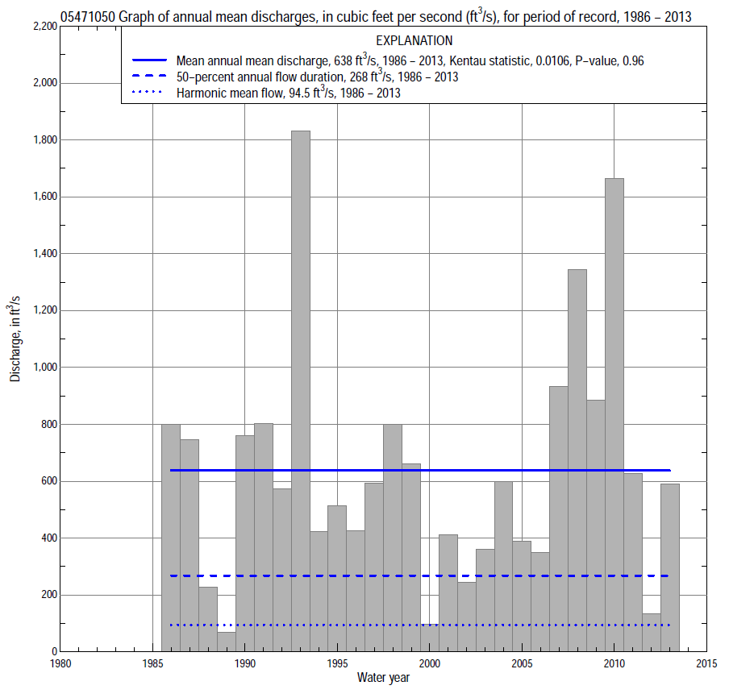

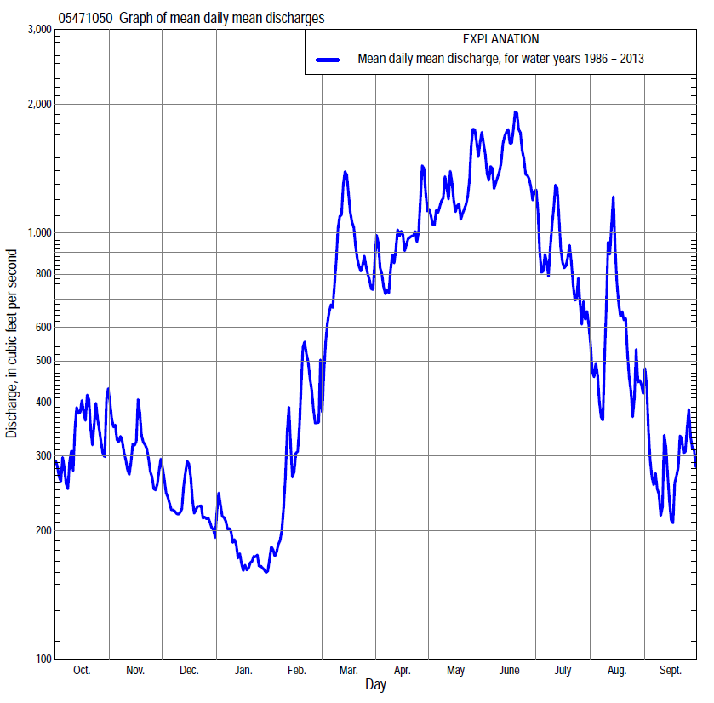

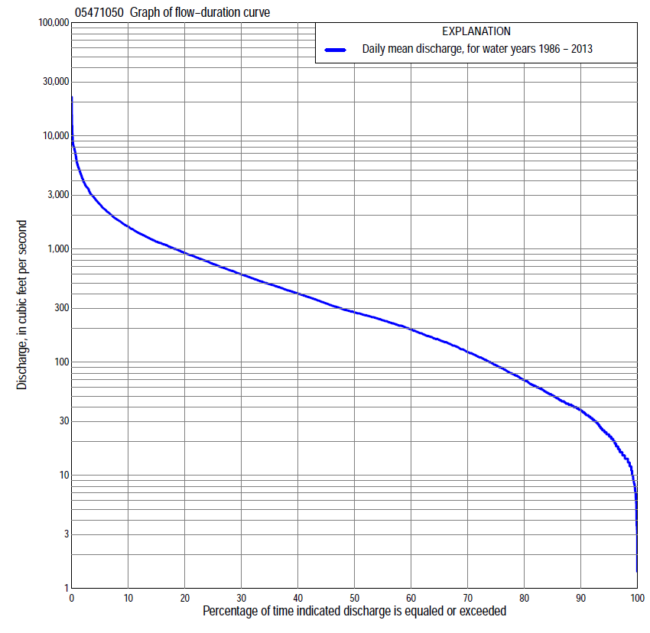

Statistics Based on the Entire Streamflow Period of Record
05471050 Monthly and annual flow durations, based on 1986–2013 period of record (28 years)
Percentage of days discharge equaled or exceeded |  |  |  |  | Discharge (cubic feet per second) |  |  |  |  |  |  |  |  | Annual flow durations
 | Oct | Nov | Dec | Jan | Feb | Mar | Apr | May | June | July | Aug | Sept | Annual | Kentau statistic | P-value
99 | 9.7 | 14 | 10 | 7.4 | 13 | 14 | 41 | 27 | 64 | 22 | 6.0 | 4.0 | 11 | 0.016 | 0.921
98 | 12 | 17 | 12 | 8.4 | 15 | 30 | 48 | 43 | 86 | 30 | 8.6 | 5.9 | 14 | 0.016 | 0.921
95 | 16 | 22 | 15 | 15 | 18 | 62 | 61 | 62 | 133 | 42 | 19 | 14 | 22 | 0.034 | 0.812
90 | 25 | 37 | 20 | 24 | 28 | 101 | 121 | 207 | 203 | 89 | 34 | 24 | 38 | -0.003 | 1.000
85 | 35 | 45 | 36 | 30 | 36 | 147 | 199 | 296 | 251 | 135 | 46 | 30 | 51 | 0.048 | 0.737
80 | 41 | 52 | 45 | 36 | 52 | 210 | 238 | 407 | 310 | 157 | 58 | 35 | 69 | 0.032 | 0.828
75 | 44 | 66 | 69 | 46 | 72 | 250 | 290 | 496 | 418 | 193 | 70 | 42 | 94 | 0.005 | 0.984
70 | 50 | 94 | 79 | 63 | 96 | 276 | 404 | 611 | 541 | 227 | 82 | 51 | 123 | -0.024 | 0.874
65 | 58 | 111 | 91 | 80 | 140 | 313 | 470 | 686 | 634 | 268 | 100 | 60 | 157 | -0.032 | 0.828
60 | 70 | 128 | 115 | 95 | 164 | 370 | 550 | 759 | 737 | 311 | 121 | 68 | 195 | -0.029 | 0.843
55 | 90 | 174 | 144 | 116 | 207 | 455 | 615 | 841 | 840 | 365 | 145 | 79 | 235 | -0.063 | 0.650
50 | 109 | 210 | 168 | 140 | 240 | 531 | 707 | 921 | 944 | 423 | 167 | 95 | 275 | -0.040 | 0.782
45 | 132 | 245 | 190 | 168 | 269 | 595 | 791 | 1,040 | 1050 | 483 | 193 | 112 | 330 | -0.042 | 0.767
40 | 169 | 280 | 217 | 185 | 283 | 680 | 887 | 1,150 | 1160 | 564 | 221 | 127 | 404 | -0.040 | 0.782
35 | 214 | 341 | 259 | 210 | 306 | 782 | 1,010 | 1,250 | 1320 | 653 | 256 | 144 | 489 | -0.042 | 0.767
30 | 307 | 386 | 311 | 230 | 334 | 887 | 1,090 | 1,410 | 1500 | 770 | 288 | 161 | 597 | -0.069 | 0.621
25 | 401 | 437 | 357 | 260 | 390 | 1,030 | 1,210 | 1,580 | 1740 | 909 | 357 | 195 | 737 | -0.013 | 0.937
20 | 495 | 514 | 400 | 280 | 450 | 1,240 | 1,390 | 1,830 | 2070 | 1,130 | 472 | 290 | 921 | 0.016 | 0.921
15 | 637 | 587 | 460 | 317 | 513 | 1,480 | 1,660 | 2,220 | 2530 | 1,600 | 693 | 499 | 1,160 | 0.029 | 0.843
10 | 912 | 700 | 519 | 377 | 746 | 2,080 | 1,990 | 2,830 | 3380 | 2,140 | 1,170 | 903 | 1,580 | 0.069 | 0.621
5 | 1,290 | 900 | 640 | 471 | 1,120 | 2,960 | 2,720 | 3,730 | 5730 | 3,190 | 2,560 | 1,490 | 2,480 | 0.093 | 0.502
2 | 2,080 | 1,180 | 821 | 606 | 1,530 | 4,740 | 4,310 | 5,070 | 8040 | 4,990 | 5,080 | 2,170 | 4,110 | 0.119 | 0.385
1 | 3,230 | 1,600 | 1,040 | 995 | 2,300 | 5,680 | 5,650 | 6,120 | 8790 | 6,840 | 7,840 | 2,820 | 5,650 | 0.124 | 0.363

05471050 Annual exceedance probability of instantaneous peak discharges, in cubic feet per second (ft³/s), based on the Weighted Independent Estimates method,
Annual exceed-ance probability | Recur-rence interval (years) | Discharge (ft³/s) | 95-percent lower confi-dence interval (ft³/s) | 95-percent upper confi-dence interval (ft³/s)
0.500 | 2 | 5,670 | 4,490 | 7,150
0.200 | 5 | 9,560 | 7,640 | 11,900
0.100 | 10 | 11,800 | 9,340 | 14,800
0.040 | 25 | 15,500 | 12,000 | 19,900
0.020 | 50 | 18,000 | 13,600 | 23,900
0.010 | 100 | 20,500 | 15,000 | 28,000
0.005 | 200 | 24,200 | 17,000 | 34,500
0.002 | 500 | 26,600 | 17,700 | 39,800
and based on the expected moments algorithm/multiple Grubbs-Beck analysis computed using a historical period length of 28 years (1986–2013)
0.500 | 2 | 5,620 | 4,320 | 7,150
0.200 | 5 | 9,310 | 7,300 | 12,300
0.100 | 10 | 11,900 | 9,250 | 16,800
0.040 | 25 | 15,200 | 11,500 | 24,000
0.020 | 50 | 17,800 | 13,100 | 30,600
0.010 | 100 | 20,300 | 14,400 | 38,300
0.005 | 200 | 22,800 | 15,600 | 47,200
0.002 | 500 | 26,100 | 16,900 | 61,500
Kentau statistic |  | 0.106
P-value |  | 0.441
Begin year |  | 1986
End year |  | 2013
Number of peaks |  | 28

05471050 Annual exceedance probability of high discharges, based on 1986–2001, 2003–2013 period of record (27 years)
[ND, not determined]
Annual exceed-ance probability | Recur-rence interval (years) | Maximum average discharge (ft³/s) for indicated number of consecutive days
 |  | 1 | 3 | 7 | 15 | 30
0.990 | 1.01 | ND | 560 | 398 | 301 | 241
0.950 | 1.05 | ND | 1,110 | 800 | 600 | 477
0.900 | 1.11 | ND | 1,560 | 1,140 | 850 | 670
0.800 | 1.25 | ND | 2,310 | 1,710 | 1,270 | 988
0.500 | 2 | ND | 4,540 | 3,500 | 2,590 | 1,950
0.200 | 5 | ND | 8,190 | 6,650 | 4,910 | 3,530
0.100 | 10 | ND | 10,800 | 9,050 | 6,680 | 4,660
0.040 | 25 | ND | 14,200 | 12,300 | 9,080 | 6,140
0.020 | 50 | ND | 16,700 | 14,800 | 11,000 | 7,240
0.010 | 100 | ND | 19,100 | 17,400 | 12,900 | 8,330
0.005 | 200 | ND | 21,600 | 20,100 | 14,800 | 9,410
0.002 | 500 | ND | 24,700 | 23,700 | 17,500 | 10,800
Kentau statistic |  | 0.095 | 0.148 | 0.132 | 0.138 | 0.101
P-value |  | 0.489 | 0.277 | 0.333 | 0.314 | 0.465

 | 05471050 Annual nonexceedance probability of low discharges, based on April 1986 to March 2001, April 2003 to March 2013 period of record (25 years)
Annual nonexceed-ance probability | Recur-rence interval (years) | Minimum average discharge (cubic feet per second) for indicated number of consecutive days
 |  | 1 | 3 | 7 | 14 | 30 | 60 | 90 | 120 | 183
0.01 | 100 | 1.4 | 2.3 | 3.0 | 3.5 | 4.6 | 5.5 | 6.1 | 6.5 | 6.6
0.02 | 50 | 2.5 | 3.6 | 4.5 | 5.3 | 6.7 | 8.0 | 9.1 | 9.8 | 10
0.05 | 20 | 5.5 | 6.9 | 8.1 | 9.3 | 11 | 14 | 16 | 18 | 19
0.10 | 10 | 10 | 12 | 13 | 15 | 18 | 22 | 26 | 29 | 33
0.20 | 5 | 20 | 21 | 22 | 25 | 30 | 36 | 43 | 50 | 60
0.50 | 2 | 50 | 51 | 53 | 58 | 69 | 85 | 105 | 128 | 168
0.80 | 1.25 | 97 | 100 | 105 | 115 | 142 | 178 | 221 | 286 | 396
0.90 | 1.11 | 122 | 130 | 140 | 155 | 196 | 248 | 308 | 411 | 583
0.96 | 1.04 | 144 | 164 | 182 | 204 | 266 | 343 | 422 | 583 | 841
0.98 | 1.02 | 156 | 186 | 212 | 238 | 318 | 414 | 507 | 716 | 1,040
0.99 | 1.01 | 164 | 204 | 238 | 269 | 368 | 485 | 590 | 850 | 1,240
Kentau statistic |  | -0.060 | -0.060 | -0.060 | -0.033 | 0.027 | 0.053 | 0.020 | 0.013 | 0.013
P-value |  | 0.691 | 0.691 | 0.691 | 0.834 | 0.870 | 0.726 | 0.907 | 0.944 | 0.944

05471050 Annual nonexceedance probability of seasonal low discharges, based on October 1985 to September 2001, October 2002 to September 2013 period of record (27 years)
Annual nonexceed-ance probability | Recur-rence interval (years) | Minimum average discharge (cubic feet per second) for indicated number of consecutive days
 |  | 1 | 7 | 14 | 30 |  | 1 | 7 | 14 | 30
 |  | January-February-March |  |  |  |  | April-May-June
0.01 | 100 | 3.6 | 4.4 | 4.8 | 5.7 |  | 14 | 15 | 17 | 27
0.02 | 50 | 5.5 | 6.7 | 7.3 | 8.7 |  | 22 | 24 | 27 | 41
0.05 | 20 | 10 | 12 | 13 | 16 |  | 40 | 44 | 51 | 75
0.10 | 10 | 17 | 20 | 22 | 26 |  | 65 | 72 | 86 | 124
0.20 | 5 | 30 | 35 | 39 | 44 |  | 112 | 126 | 151 | 215
0.50 | 2 | 79 | 91 | 100 | 112 |  | 276 | 315 | 386 | 546
0.80 | 1.25 | 177 | 200 | 217 | 244 |  | 570 | 658 | 812 | 1,170
0.90 | 1.11 | 254 | 283 | 306 | 346 |  | 782 | 903 | 1,110 | 1,650
0.96 | 1.04 | 358 | 394 | 423 | 483 |  | 1,040 | 1,210 | 1,490 | 2,270
0.98 | 1.02 | 436 | 477 | 510 | 587 |  | 1,230 | 1,430 | 1,750 | 2,730
0.99 | 1.01 | 514 | 558 | 594 | 689 |  | 1,410 | 1,630 | 1,990 | 3,170
Kentau statistic |  | -0.046 | -0.026 | 0.014 | 0.009 |  | 0.066 | 0.043 | 0.071 | 0.157
P-value |  | 0.754 | 0.868 | 0.934 | 0.967 |  | 0.647 | 0.770 | 0.617 | 0.260
 |  | July-August-September |  |  |  |  | October-November-December
0.01 | 100 | 2.4 | 5.2 | 6.0 | 7.8 |  | 5.2 | 5.4 | 5.7 | 6.8
0.02 | 50 | 3.5 | 6.7 | 7.7 | 9.8 |  | 7.1 | 7.5 | 8.1 | 9.6
0.05 | 20 | 6.3 | 9.8 | 11 | 14 |  | 11 | 12 | 13 | 16
0.10 | 10 | 10 | 14 | 16 | 20 |  | 17 | 19 | 21 | 24
0.20 | 5 | 19 | 22 | 25 | 32 |  | 27 | 30 | 34 | 40
0.50 | 2 | 53 | 55 | 63 | 82 |  | 65 | 75 | 84 | 100
0.80 | 1.25 | 141 | 147 | 170 | 238 |  | 150 | 172 | 193 | 238
0.90 | 1.11 | 228 | 253 | 295 | 438 |  | 229 | 261 | 291 | 366
0.96 | 1.04 | 369 | 462 | 543 | 868 |  | 356 | 398 | 439 | 569
0.98 | 1.02 | 499 | 691 | 818 | 1,380 |  | 470 | 519 | 567 | 750
0.99 | 1.01 | 649 | 999 | 1,190 | 2,130 |  | 601 | 655 | 708 | 956
Kentau statistic |  | -0.154 | -0.157 | -0.123 | -0.105 |  | -0.017 | -0.020 | -0.037 | -0.014
P-value |  | 0.269 | 0.260 | 0.381 | 0.453 |  | 0.917 | 0.900 | 0.802 | 0.934

