LOCATION.--Lat 41°48'19", long 93°18'33" referenced to North American Datum of 1927, in NW 1/4 NW 1/4 NW 1/4 sec.28, T.81 N., R.21 W., Jasper County, IA, Hydrologic Unit 07080105, on left bank 20 ft downstream from bridge on State Highway 117, 2.9 mi northwest of Mingo, 0.7 mi downstream from Wolf Creek, 2.2 mi upstream from Byers Branch, and 11.5 mi upstream from mouth.

DRAINAGE AREA.--276 mi².

PERIOD OF RECORD.--Discharge records from May 1958 to September 1975, October 1985 to current year.

GAGE.--Water-stage recorder. Datum of gage is 810.47 ft above National Geodetic Vertical Datum of 1929.

EXTREMES OUTSIDE PERIOD OF RECORD.--Flood of May 20, 1944, reached a stage of 21.40 ft, from information by local resident, discharge not determined.

A summary of all available data for this streamgage is provided through the USGS National Water Information System web interface (NWISWeb). The following link provides access to current/historical observations, daily data, daily statistics, monthly statistics, annual statistics, peak streamflow, field measurements, field/lab water-quality samples, and the latest water-year summaries. Data can be filtered by parameter and/or dates, and can be output in various tabular and graphical formats.
http://waterdata.usgs.gov/nwis/inventory/?site_no=05471200

The USGS WaterWatch Toolkit is available at:
http://waterwatch.usgs.gov/?id=ww_toolkit
Tools for summarizing streamflow information include the duration hydrograph builder, the cumulative streamflow hydrograph builder, the streamgage statistics retrieval tool, the rating curve builder, the flood tracking chart builder, the National Weather Service Advanced Hydrologic Prediction Service (AHPS) river forecast hydrograph builder, and the raster-hydrograph builder. Entering the above number for this streamgage into these toolkit webpages will provide streamflow information specific to this streamgage.

A description of the statistics presented for this streamgage is available in the main body of the report at:
http://dx.doi.org/10.3133/ofr20151214
A link to other streamgages included in this report, a map showing the location of the streamgages, information on the programs used to compute the statistical analyses, and references are included in the main body of the report.

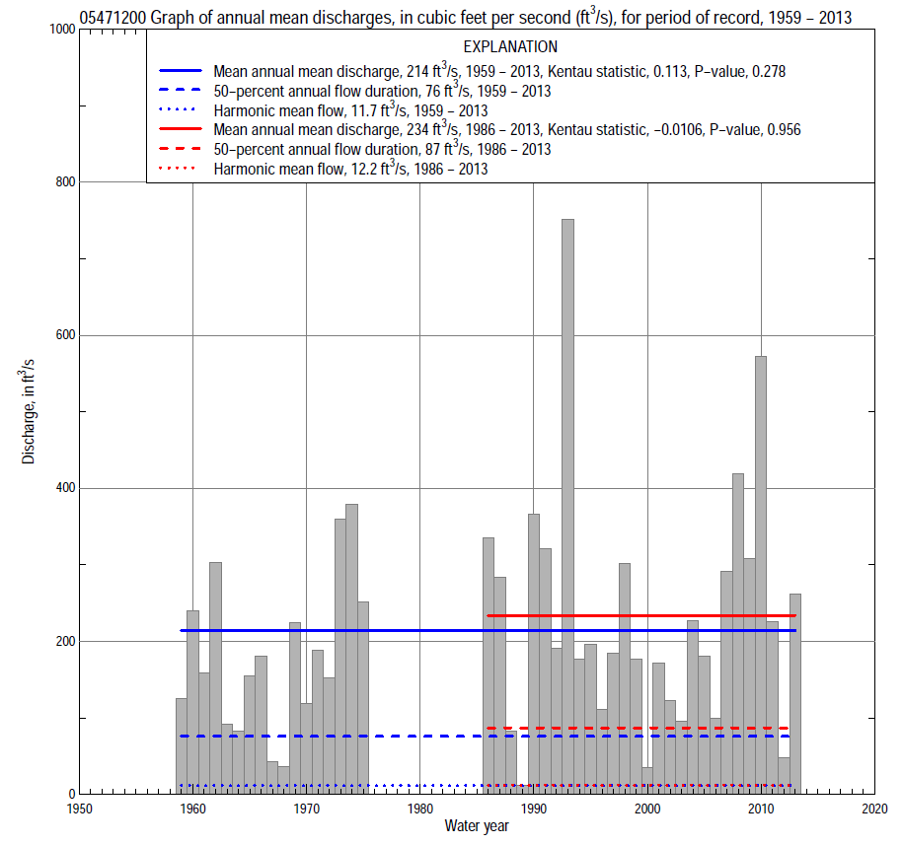

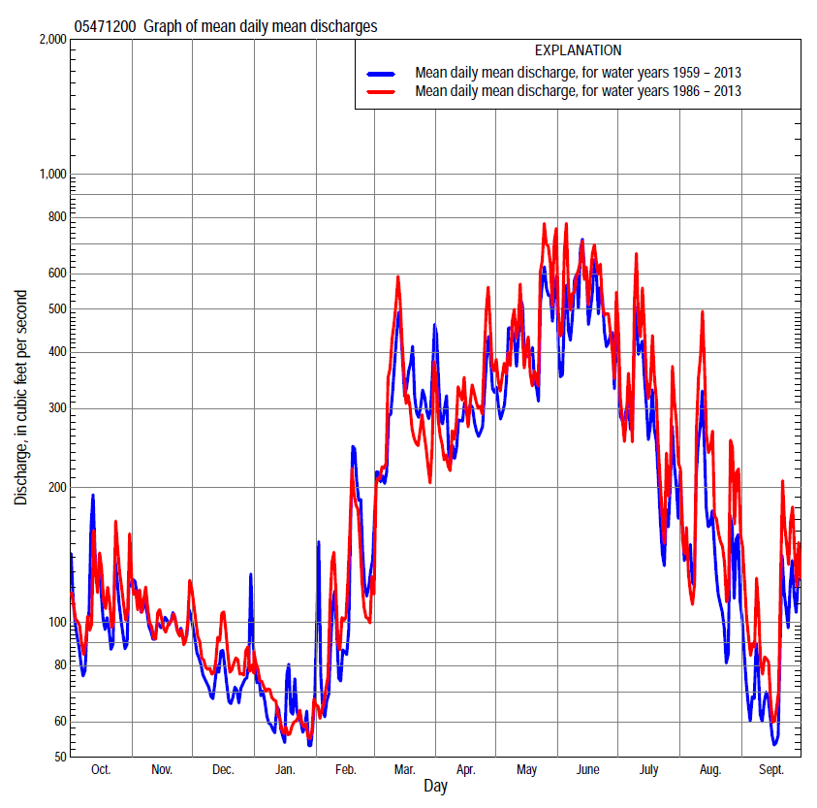

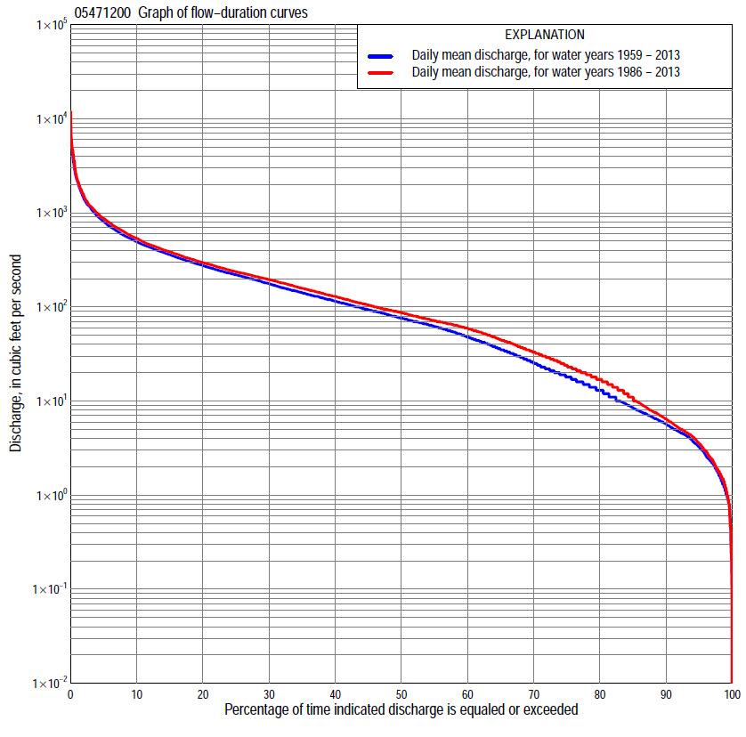

Statistics Based on the Entire Streamflow Period of Record
05471200 Monthly and annual flow durations, based on 1959–75, 1986–2013 period of record (45 years)
Percentage of days discharge equaled or exceeded |  |  |  |  | Discharge (cubic feet per second) |  |  |  |  |  |  |  |  | Annual flow durations
 | Oct | Nov | Dec | Jan | Feb | Mar | Apr | May | June | July | Aug | Sept | Annual | Kentau statistic | P-value
99 | 0.85 | 3.0 | 1.5 | 0.33 | 2.0 | 3.1 | 4.9 | 4.8 | 4.2 | 1.5 | 0.45 | 0.46 | 1.1 | 0.138 | 0.181
98 | 0.90 | 3.5 | 1.7 | 1.2 | 2.2 | 5.7 | 5.8 | 7.2 | 6.7 | 2.4 | 0.97 | 0.81 | 1.6 | 0.144 | 0.163
95 | 1.4 | 4.4 | 3.0 | 2.1 | 2.6 | 11 | 8.7 | 11 | 27 | 6.8 | 2.6 | 1.2 | 3.2 | 0.178 | 0.086
90 | 2.7 | 6.1 | 4.5 | 4.1 | 4.4 | 17 | 23 | 58 | 49 | 16 | 4.6 | 2.2 | 5.6 | 0.169 | 0.104
85 | 4.6 | 7.8 | 6.0 | 5.3 | 6.8 | 30 | 41 | 83 | 66 | 27 | 6.8 | 2.9 | 8.4 | 0.167 | 0.108
80 | 5.8 | 12 | 8.5 | 6.5 | 9.5 | 42 | 59 | 104 | 85 | 38 | 8.7 | 4.2 | 13 | 0.138 | 0.183
75 | 7.3 | 15 | 11 | 8.0 | 15 | 55 | 76 | 134 | 110 | 46 | 11 | 5.5 | 18 | 0.112 | 0.281
70 | 9.4 | 20 | 15 | 10 | 22 | 69 | 96 | 158 | 137 | 56 | 14 | 7.4 | 25 | 0.134 | 0.196
65 | 13 | 25 | 19 | 15 | 32 | 89 | 117 | 189 | 166 | 66 | 17 | 9.8 | 35 | 0.146 | 0.159
60 | 16 | 35 | 25 | 22 | 43 | 103 | 143 | 211 | 195 | 79 | 20 | 12 | 48 | 0.136 | 0.190
55 | 19 | 43 | 33 | 31 | 49 | 130 | 172 | 232 | 227 | 93 | 24 | 15 | 62 | 0.142 | 0.171
50 | 21 | 53 | 50 | 36 | 56 | 157 | 203 | 256 | 260 | 109 | 29 | 18 | 76 | 0.118 | 0.256
45 | 26 | 68 | 63 | 50 | 64 | 190 | 227 | 286 | 294 | 125 | 34 | 22 | 93 | 0.127 | 0.221
40 | 39 | 80 | 74 | 60 | 73 | 216 | 253 | 319 | 329 | 148 | 41 | 25 | 115 | 0.155 | 0.137
35 | 63 | 95 | 86 | 67 | 85 | 251 | 284 | 361 | 380 | 173 | 50 | 30 | 142 | 0.137 | 0.187
30 | 95 | 114 | 102 | 75 | 100 | 317 | 322 | 414 | 450 | 202 | 61 | 37 | 177 | 0.148 | 0.153
25 | 118 | 135 | 120 | 88 | 120 | 375 | 374 | 465 | 529 | 244 | 79 | 52 | 220 | 0.144 | 0.165
20 | 158 | 161 | 131 | 100 | 145 | 445 | 429 | 552 | 653 | 306 | 111 | 71 | 276 | 0.154 | 0.140
15 | 219 | 200 | 150 | 114 | 182 | 542 | 524 | 690 | 855 | 390 | 168 | 111 | 360 | 0.142 | 0.171
10 | 308 | 260 | 180 | 140 | 250 | 710 | 660 | 877 | 1,180 | 568 | 323 | 205 | 494 | 0.144 | 0.165
5 | 463 | 390 | 231 | 195 | 430 | 1,200 | 910 | 1,280 | 1,900 | 985 | 680 | 435 | 809 | 0.126 | 0.225
2 | 730 | 533 | 327 | 301 | 838 | 1,920 | 1,330 | 2,420 | 3,390 | 1,770 | 1,380 | 832 | 1,430 | 0.055 | 0.604
1 | 977 | 638 | 434 | 417 | 1,180 | 2,590 | 2,230 | 3,630 | 4,550 | 3,040 | 2,220 | 1,150 | 2,220 | 0.053 | 0.618

05471200 Annual exceedance probability of instantaneous peak discharges, in cubic feet per second (ft³/s), based on the Weighted Independent Estimates method,
Annual exceed-ance probability | Recur-rence interval (years) | Discharge (ft³/s) | 95-percent lower confi-dence interval (ft³/s) | 95-percent upper confi-dence interval (ft³/s)
0.500 | 2 | 4,010 | 3,330 | 4,830
0.200 | 5 | 7,570 | 6,210 | 9,230
0.100 | 10 | 10,500 | 8,350 | 13,100
0.040 | 25 | 14,700 | 11,100 | 19,300
0.020 | 50 | 18,100 | 13,100 | 25,000
0.010 | 100 | 21,800 | 15,100 | 31,500
0.005 | 200 | 25,800 | 17,000 | 39,200
0.002 | 500 | 31,300 | 19,300 | 50,700
and based on the expected moments algorithm/multiple Grubbs-Beck analysis computed using a historical period length of 70 years (1944–2013)
0.500 | 2 | 4,080 | 3,220 | 5,140
0.200 | 5 | 7,780 | 6,130 | 10,100
0.100 | 10 | 10,900 | 8,390 | 14,800
0.040 | 25 | 15,500 | 11,500 | 23,300
0.020 | 50 | 19,500 | 14,000 | 31,900
0.010 | 100 | 24,000 | 16,500 | 43,100
0.005 | 200 | 28,900 | 19,000 | 57,600
0.002 | 500 | 36,300 | 22,400 | 83,000
Kentau statistic |  | 0.046
P-value |  | 0.656
Begin year |  | 1958
End year |  | 2013
Number of peaks |  | 46

05471200 Annual exceedance probability of high discharges, based on 1959–75, 1986–2013 period of record (45 years)
Annual exceedance probability | Recur-rence interval (years) | Maximum average discharge (ft³/s) for indicated number of consecutive days
 |  | 1 | 3 | 7 | 15 | 30
0.990 | 1.01 | 498 | 342 | 213 | 130 | 80
0.950 | 1.05 | 921 | 640 | 417 | 274 | 188
0.900 | 1.11 | 1,250 | 877 | 582 | 392 | 279
0.800 | 1.25 | 1,780 | 1,260 | 850 | 585 | 428
0.500 | 2 | 3,320 | 2,390 | 1,640 | 1,140 | 830
0.200 | 5 | 5,740 | 4,260 | 2,880 | 1,960 | 1,330
0.100 | 10 | 7,450 | 5,600 | 3,750 | 2,490 | 1,600
0.040 | 25 | 9,640 | 7,370 | 4,850 | 3,110 | 1,870
0.020 | 50 | 11,300 | 8,710 | 5,650 | 3,530 | 2,020
0.010 | 100 | 12,900 | 10,100 | 6,420 | 3,920 | 2,140
0.005 | 200 | 14,500 | 11,400 | 7,180 | 4,280 | 2,230
0.002 | 500 | 16,500 | 13,200 | 8,150 | 4,700 | 2,330
Kentau statistic |  | 0.080 | 0.096 | 0.092 | 0.101 | 0.101
P-value |  | 0.390 | 0.304 | 0.325 | 0.278 | 0.278

 | 05471200 Annual nonexceedance probability of low discharges, based on April 1959 to March 1975, April 1986 to March 2013, period of record (43 years)
Annual nonexceed-ance probability | Recur-rence interval (years) | Minimum average discharge (cubic feet per second) for indicated number of consecutive days
 |  | 1 | 3 | 7 | 14 | 30 | 60 | 90 | 120 | 183
0.01 | 100 | 0.02 | 0.06 | 0.09 | 0.16 | 0.37 | 0.60 | 0.81 | 0.93 | 1.1
0.02 | 50 | 0.05 | 0.11 | 0.17 | 0.27 | 0.57 | 0.90 | 1.3 | 1.5 | 1.7
0.05 | 20 | 0.17 | 0.28 | 0.39 | 0.57 | 1.1 | 1.7 | 2.3 | 2.9 | 3.4
0.10 | 10 | 0.44 | 0.60 | 0.77 | 1.1 | 1.8 | 2.8 | 4.0 | 5.1 | 6.2
0.20 | 5 | 1.2 | 1.4 | 1.7 | 2.2 | 3.4 | 5.2 | 7.5 | 9.8 | 12
0.50 | 2 | 5.7 | 5.8 | 6.4 | 7.7 | 11 | 16 | 23 | 31 | 40
0.80 | 1.25 | 18 | 18 | 19 | 22 | 29 | 44 | 64 | 88 | 116
0.90 | 1.11 | 27 | 29 | 32 | 37 | 48 | 74 | 106 | 144 | 192
0.96 | 1.04 | 38 | 46 | 51 | 59 | 78 | 126 | 175 | 236 | 315
0.98 | 1.02 | 44 | 60 | 68 | 79 | 105 | 175 | 240 | 319 | 426
0.99 | 1.01 | 50 | 74 | 86 | 100 | 137 | 233 | 315 | 414 | 552
Kentau statistic |  | 0.133 | 0.153 | 0.156 | 0.174 | 0.164 | 0.126 | 0.092 | 0.087 | 0.107
P-value |  | 0.213 | 0.152 | 0.143 | 0.103 | 0.124 | 0.237 | 0.391 | 0.414 | 0.315

05471200 Annual nonexceedance probability of seasonal low discharges, based on July 1958 to September 1975, October 1985 to September 2013 period of record (45–46 years)
Annual nonexceed-ance probability | Recur-rence interval (years) | Minimum average discharge (cubic feet per second) for indicated number of consecutive days
 |  | 1 | 7 | 14 | 30 |  | 1 | 7 | 14 | 30
 |  | January-February-March |  |  |  |  | April-May-June
0.01 | 100 | 0.16 | 0.21 | 0.26 | 0.68 |  | 0.91 | 1.3 | 1.9 | 3.7
0.02 | 50 | 0.32 | 0.41 | 0.49 | 1.1 |  | 1.8 | 2.4 | 3.4 | 6.5
0.05 | 20 | 0.78 | 1.0 | 1.2 | 2.2 |  | 4.4 | 5.7 | 7.5 | 14
0.10 | 10 | 1.7 | 2.1 | 2.5 | 4.0 |  | 9.0 | 11 | 15 | 26
0.20 | 5 | 3.8 | 4.9 | 5.6 | 7.9 |  | 20 | 24 | 30 | 51
0.50 | 2 | 15 | 18 | 21 | 26 |  | 65 | 76 | 93 | 147
0.80 | 1.25 | 44 | 52 | 59 | 76 |  | 153 | 175 | 221 | 323
0.90 | 1.11 | 70 | 80 | 90 | 125 |  | 212 | 243 | 315 | 441
0.96 | 1.04 | 107 | 118 | 134 | 207 |  | 278 | 321 | 429 | 576
0.98 | 1.02 | 136 | 146 | 166 | 281 |  | 319 | 370 | 507 | 663
0.99 | 1.01 | 165 | 173 | 197 | 365 |  | 353 | 411 | 576 | 737
Kentau statistic |  | 0.083 | 0.153 | 0.174 | 0.155 |  | 0.156 | 0.134 | 0.152 | 0.202
P-value |  | 0.428 | 0.142 | 0.094 | 0.137 |  | 0.134 | 0.197 | 0.145 | 0.052
 |  | July-August-September |  |  |  |  | October-November-December
0.01 | 100 | 0.04 | 0.19 | 0.33 | 0.69 |  | 0.27 | 0.34 | 0.45 | 0.58
0.02 | 50 | 0.08 | 0.30 | 0.48 | 0.96 |  | 0.43 | 0.53 | 0.70 | 0.92
0.05 | 20 | 0.25 | 0.60 | 0.88 | 1.6 |  | 0.83 | 1.0 | 1.4 | 1.8
0.10 | 10 | 0.64 | 1.1 | 1.5 | 2.5 |  | 1.5 | 1.9 | 2.5 | 3.3
0.20 | 5 | 1.7 | 2.2 | 2.9 | 4.5 |  | 3.0 | 3.7 | 4.9 | 6.6
0.50 | 2 | 8.3 | 8.4 | 9.9 | 15 |  | 11 | 14 | 17 | 23
0.80 | 1.25 | 28 | 30 | 35 | 51 |  | 37 | 47 | 56 | 74
0.90 | 1.11 | 45 | 56 | 66 | 102 |  | 68 | 88 | 100 | 133
0.96 | 1.04 | 68 | 109 | 133 | 218 |  | 131 | 170 | 183 | 241
0.98 | 1.02 | 86 | 166 | 209 | 362 |  | 197 | 258 | 267 | 349
0.99 | 1.01 | 101 | 240 | 314 | 577 |  | 284 | 372 | 373 | 484
Kentau statistic |  | 0.053 | 0.046 | 0.034 | 0.038 |  | 0.076 | 0.129 | 0.125 | 0.109
P-value |  | 0.609 | 0.656 | 0.748 | 0.719 |  | 0.469 | 0.214 | 0.229 | 0.295

Statistics Based on the 1984–2013 Streamflow Period of Record
05471200 Monthly and annual flow durations, based on 1986–2013 period of record (28 years)
Percentage of days discharge equaled or exceeded |  |  |  |  | Discharge (cubic feet per second) |  |  |  |  |  |  |  |  | Annual flow durations
 | Oct | Nov | Dec | Jan | Feb | Mar | Apr | May | June | July | Aug | Sept | Annual | Kentau statistic | P-value
99 | 0.92 | 2.0 | 1.5 | 1.5 | 3.1 | 3.0 | 3.7 | 7.5 | 3.6 | 1.2 | 0.16 | 0.41 | 1.2 | 0.204 | 0.130
98 | 1.2 | 3.3 | 1.7 | 1.7 | 3.6 | 4.6 | 5.1 | 8.1 | 6.7 | 1.7 | 0.48 | 0.54 | 1.8 | 0.177 | 0.190
95 | 2.0 | 4.5 | 2.6 | 2.4 | 4.8 | 11 | 9.7 | 13 | 19 | 3.6 | 1.4 | 1.4 | 3.5 | 0.164 | 0.227
90 | 3.5 | 7.2 | 4.8 | 5.2 | 7.0 | 18 | 25 | 74 | 51 | 16 | 5.4 | 2.4 | 6.5 | 0.040 | 0.782
85 | 4.9 | 13 | 8.5 | 6.9 | 10 | 34 | 40 | 100 | 73 | 30 | 7.9 | 3.4 | 11 | 0.061 | 0.664
80 | 6.3 | 18 | 16 | 10 | 15 | 50 | 64 | 139 | 100 | 42 | 11 | 4.4 | 17 | 0.045 | 0.752
75 | 7.5 | 21 | 21 | 17 | 27 | 66 | 79 | 160 | 135 | 52 | 14 | 5.5 | 24 | 0.032 | 0.828
70 | 9.8 | 27 | 27 | 22 | 37 | 75 | 105 | 190 | 166 | 64 | 17 | 7.3 | 33 | 0.024 | 0.874
65 | 14 | 37 | 33 | 30 | 47 | 94 | 132 | 213 | 200 | 77 | 19 | 9.1 | 45 | -0.011 | 0.953
60 | 17 | 49 | 45 | 35 | 52 | 112 | 170 | 233 | 233 | 89 | 22 | 12 | 59 | -0.013 | 0.937
55 | 20 | 58 | 57 | 42 | 60 | 135 | 199 | 257 | 266 | 106 | 27 | 15 | 71 | -0.040 | 0.782
50 | 24 | 70 | 66 | 52 | 64 | 161 | 221 | 286 | 297 | 123 | 34 | 21 | 87 | -0.045 | 0.752
45 | 33 | 80 | 74 | 60 | 74 | 187 | 245 | 318 | 327 | 143 | 39 | 25 | 105 | -0.026 | 0.859
40 | 66 | 90 | 85 | 66 | 82 | 209 | 270 | 359 | 371 | 170 | 46 | 29 | 130 | -0.013 | 0.937
35 | 94 | 103 | 95 | 72 | 92 | 229 | 302 | 400 | 428 | 199 | 58 | 33 | 158 | -0.048 | 0.737
30 | 110 | 118 | 110 | 80 | 110 | 280 | 356 | 447 | 501 | 234 | 70 | 41 | 195 | -0.013 | 0.937
25 | 131 | 140 | 125 | 92 | 130 | 334 | 406 | 514 | 587 | 280 | 92 | 63 | 237 | -0.021 | 0.890
20 | 167 | 167 | 138 | 100 | 150 | 394 | 470 | 610 | 733 | 339 | 134 | 85 | 297 | 0.024 | 0.874
15 | 220 | 196 | 161 | 116 | 190 | 514 | 560 | 744 | 914 | 463 | 254 | 184 | 386 | 0.016 | 0.921
10 | 325 | 240 | 185 | 140 | 250 | 696 | 698 | 920 | 1,240 | 703 | 454 | 335 | 536 | 0.019 | 0.906
5 | 479 | 324 | 237 | 170 | 394 | 1,170 | 940 | 1,340 | 2,000 | 1,200 | 974 | 598 | 872 | 0.032 | 0.828
2 | 740 | 471 | 329 | 250 | 646 | 1,910 | 1,250 | 2,420 | 3,600 | 2,430 | 2,090 | 1,040 | 1,520 | 0.069 | 0.621
1 | 942 | 567 | 404 | 301 | 900 | 2,350 | 1,710 | 3,630 | 4,570 | 4,410 | 3,510 | 1,270 | 2,290 | 0.114 | 0.406

05471200 Annual exceedance probability of high discharges, based on 1986–2013 period of record (28 years)
Annual exceedance probability | Recur-rence interval (years) | Maximum average discharge (ft³/s) for indicated number of consecutive days
 |  | 1 | 3 | 7 | 15 | 30
0.990 | 1.01 | 377 | 252 | 149 | 90 | 54
0.950 | 1.05 | 715 | 495 | 318 | 208 | 144
0.900 | 1.11 | 995 | 702 | 465 | 315 | 229
0.800 | 1.25 | 1,470 | 1,060 | 722 | 503 | 377
0.500 | 2 | 3,030 | 2,250 | 1,580 | 1,110 | 828
0.200 | 5 | 6,000 | 4,590 | 3,180 | 2,180 | 1,490
0.100 | 10 | 8,460 | 6,540 | 4,460 | 2,950 | 1,880
0.040 | 25 | 12,100 | 9,430 | 6,250 | 3,960 | 2,290
0.020 | 50 | 15,100 | 11,900 | 7,680 | 4,690 | 2,550
0.010 | 100 | 18,400 | 14,500 | 9,170 | 5,410 | 2,760
0.005 | 200 | 22,000 | 17,400 | 10,700 | 6,110 | 2,940
0.002 | 500 | 27,200 | 21,600 | 12,900 | 7,000 | 3,140
Kentau statistic |  | 0.207 | 0.211 | 0.211 | 0.211 | 0.184
P-value |  | 0.112 | 0.104 | 0.104 | 0.104 | 0.159

 | 05471200 Annual nonexceedance probability of low discharges, based on April 1986 to March 2013, period of record (27 years)
Annual nonexceed-ance probability | Recur-rence interval (years) | Minimum average discharge (cubic feet per second) for indicated number of consecutive days
 |  | 1 | 3 | 7 | 14 | 30 | 60 | 90 | 120 | 183
0.01 | 100 | 0.01 | 0.04 | 0.08 | 0.16 | 0.44 | 0.66 | 0.83 | 0.90 | 1.1
0.02 | 50 | 0.03 | 0.08 | 0.15 | 0.28 | 0.69 | 1.0 | 1.4 | 1.6 | 1.8
0.05 | 20 | 0.12 | 0.24 | 0.38 | 0.63 | 1.3 | 2.0 | 2.8 | 3.3 | 4.0
0.10 | 10 | 0.37 | 0.58 | 0.81 | 1.2 | 2.3 | 3.5 | 4.9 | 6.2 | 7.6
0.20 | 5 | 1.2 | 1.5 | 1.9 | 2.7 | 4.4 | 6.6 | 9.36 | 12 | 16
0.50 | 2 | 6.9 | 7.0 | 7.7 | 9.6 | 14 | 20 | 28 | 39 | 51
0.80 | 1.25 | 23 | 23 | 25 | 29 | 36 | 51 | 67 | 96 | 130
0.90 | 1.11 | 36 | 39 | 41 | 47 | 58 | 78 | 100 | 141 | 196
0.96 | 1.04 | 49 | 61 | 66 | 75 | 92 | 120 | 144 | 202 | 286
0.98 | 1.02 | 57 | 78 | 86 | 98 | 122 | 155 | 178 | 247 | 354
0.99 | 1.01 | 63 | 95 | 107 | 124 | 156 | 192 | 212 | 290 | 420
Kentau statistic |  | 0.080 | 0.094 | 0.077 | 0.054 | 0.066 | 0.031 | 0.003 | 0.003 | 0.014
P-value |  | 0.573 | 0.505 | 0.588 | 0.707 | 0.647 | 0.835 | 1.000 | 1.000 | 0.934

05471200 Annual nonexceedance probability of seasonal low discharges, based on October 1985 to September 2013 period of record (28 years)
Annual nonexceed-ance probability | Recur-rence interval (years) | Minimum average discharge (cubic feet per second) for indicated number of consecutive days
 |  | 1 | 7 | 14 | 30 |  | 1 | 7 | 14 | 30
 |  | January-February-March |  |  |  |  | April-May-June
0.01 | 100 | 0.34 | 0.63 | 0.69 | 1.0 |  | 0.78 | 1.2 | 1.7 | 4.5
0.02 | 50 | 0.61 | 1.1 | 1.2 | 1.7 |  | 1.6 | 2.2 | 3.2 | 7.7
0.05 | 20 | 1.4 | 2.3 | 2.6 | 3.7 |  | 4.2 | 5.5 | 7.5 | 16
0.10 | 10 | 2.8 | 4.3 | 4.9 | 6.7 |  | 9.0 | 11 | 15 | 30
0.20 | 5 | 5.8 | 8.4 | 9.7 | 13 |  | 21 | 25 | 32 | 59
0.50 | 2 | 20 | 25 | 29 | 38 |  | 73 | 84 | 105 | 170
0.80 | 1.25 | 51 | 60 | 68 | 84 |  | 179 | 200 | 259 | 378
0.90 | 1.11 | 76 | 87 | 97 | 117 |  | 251 | 280 | 373 | 522
0.96 | 1.04 | 110 | 121 | 132 | 157 |  | 332 | 370 | 514 | 691
0.98 | 1.02 | 135 | 145 | 157 | 184 |  | 381 | 427 | 610 | 803
0.99 | 1.01 | 159 | 168 | 179 | 209 |  | 422 | 475 | 696 | 902
Kentau statistic |  | -0.146 | -0.079 | -0.026 | -0.016 |  | 0.140 | 0.124 | 0.138 | 0.175
P-value |  | 0.286 | 0.567 | 0.859 | 0.921 |  | 0.304 | 0.363 | 0.314 | 0.199
 |  | July-August-September |  |  |  |  | October-November-December
0.01 | 100 | 0.01 | 0.11 | 0.22 | 0.59 |  | 0.25 | 0.36 | 0.52 | 0.72
0.02 | 50 | 0.04 | 0.19 | 0.35 | 0.84 |  | 0.41 | 0.59 | 0.84 | 1.2
0.05 | 20 | 0.14 | 0.43 | 0.71 | 1.4 |  | 0.85 | 1.2 | 1.7 | 2.3
0.10 | 10 | 0.43 | 0.88 | 1.3 | 2.4 |  | 1.6 | 2.2 | 3.1 | 4.2
0.20 | 5 | 1.4 | 2.0 | 2.7 | 4.5 |  | 3.2 | 4.5 | 6.1 | 8.4
0.50 | 2 | 9.1 | 9.2 | 11 | 16 |  | 12 | 16 | 21 | 28
0.80 | 1.25 | 38 | 38 | 44 | 64 |  | 41 | 53 | 63 | 83
0.90 | 1.11 | 65 | 78 | 90 | 139 |  | 76 | 95 | 107 | 139
0.96 | 1.04 | 104 | 163 | 193 | 324 |  | 142 | 172 | 183 | 233
0.98 | 1.02 | 134 | 258 | 316 | 573 |  | 209 | 250 | 254 | 320
0.99 | 1.01 | 161 | 386 | 490 | 968 |  | 294 | 338 | 345 | 419
Kentau statistic |  | 0.053 | 0.037 | 0.005 | 0.011 |  | 0.050 | 0.085 | 0.058 | 0.026
P-value |  | 0.707 | 0.797 | 0.984 | 0.953 |  | 0.722 | 0.540 | 0.678 | 0.859

