LOCATION.--Lat 41°21'20.5", long 92°39'25.8" referenced to North American Datum of 1927, in NE 1/4 NW 1/4 SW 1/4 sec.25, T.76 N., R.16 W., Mahaska County, IA, Hydrologic Unit 07080105, on left bank 10 ft downstream from bridge on U.S. Highway 63, 4.0 mi north of Oskaloosa, 0.3 mi downstream from Painter Creek, 51.2 mi upstream from confluence with North Skunk River, and 145.9 mi upstream from mouth of Skunk River.

DRAINAGE AREA.--1,635 mi².

PERIOD OF RECORD.--Discharge records from October 1945 to current year. Prior to October 1966, published as "Skunk River near Oskaloosa"; prior to October 1948, monthly mean discharge for some periods published in WSP 1308.

GAGE.--Water-stage recorder. Datum of gage is 685.50 ft above National Geodetic Vertical Datum of 1929. Prior to November 21, 1947, non-recording gage at same site and datum; November 21, 1947, to May 3, 1995, at site 400 ft upstream at same datum.

EXTREMES OUTSIDE PERIOD OF RECORD.--Flood in May 1944 reached a stage of 25.8 ft, from high-water mark, discharge 37,000 ft³/s, from rating curve extended above 18,000 ft³/s on basis of velocity-area study.

A summary of all available data for this streamgage is provided through the USGS National Water Information System web interface (NWISWeb). The following link provides access to current/historical observations, daily data, daily statistics, monthly statistics, annual statistics, peak streamflow, field measurements, field/lab water-quality samples, and the latest water-year summaries. Data can be filtered by parameter and/or dates, and can be output in various tabular and graphical formats.
http://waterdata.usgs.gov/nwis/inventory/?site_no=05471500

The USGS WaterWatch Toolkit is available at:
http://waterwatch.usgs.gov/?id=ww_toolkit
Tools for summarizing streamflow information include the duration hydrograph builder, the cumulative streamflow hydrograph builder, the streamgage statistics retrieval tool, the rating curve builder, the flood tracking chart builder, the National Weather Service Advanced Hydrologic Prediction Service (AHPS) river forecast hydrograph builder, and the raster-hydrograph builder. Entering the above number for this streamgage into these toolkit webpages will provide streamflow information specific to this streamgage.

A description of the statistics presented for this streamgage is available in the main body of the report at:
http://dx.doi.org/10.3133/ofr20151214
A link to other streamgages included in this report, a map showing the location of the streamgages, information on the programs used to compute the statistical analyses, and references are included in the main body of the report.

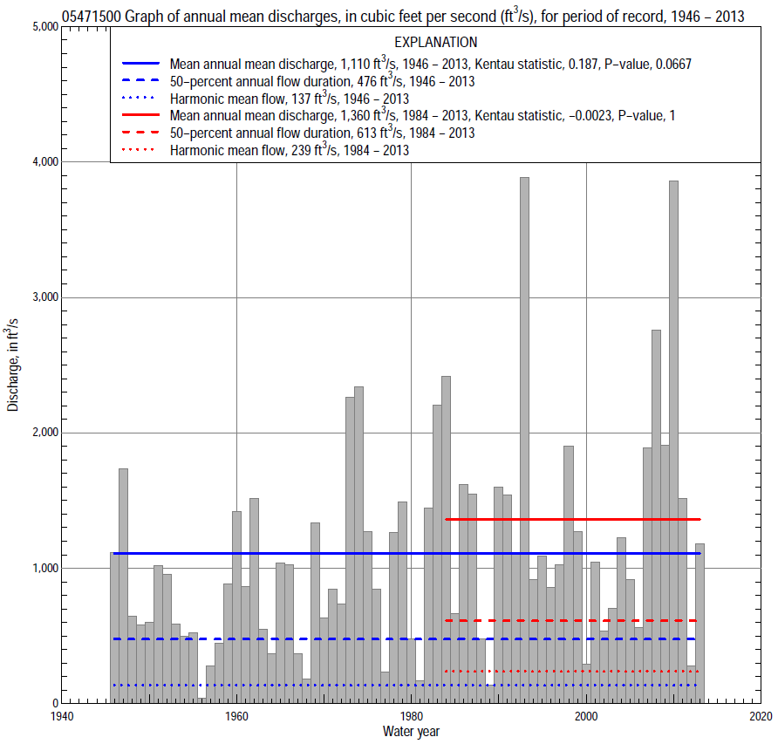

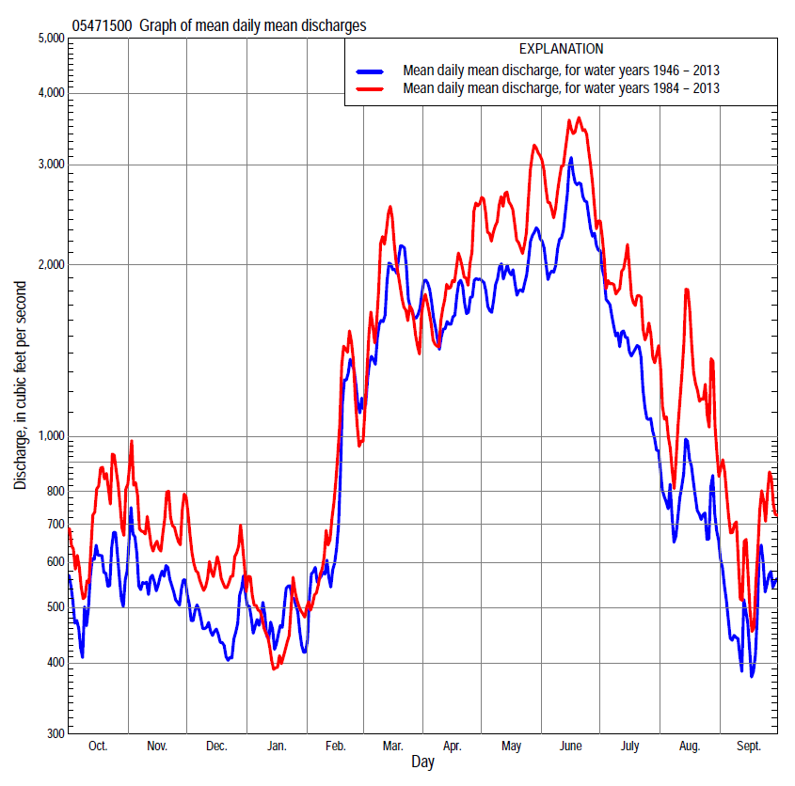

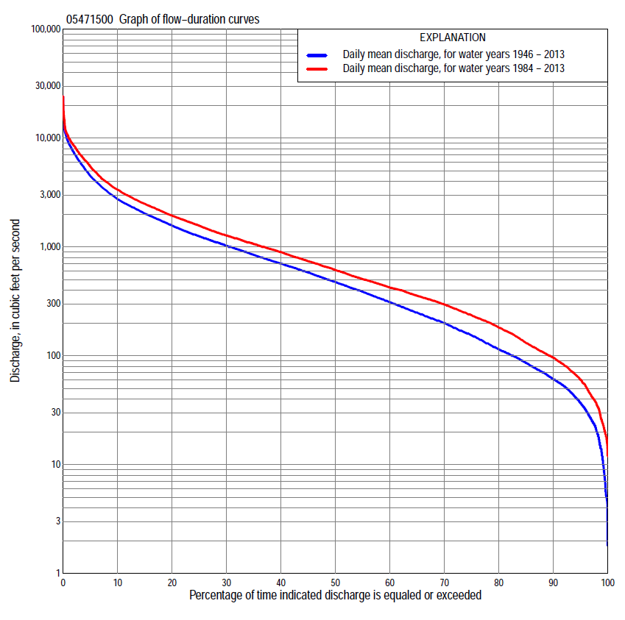

Statistics Based on the Entire Streamflow Period of Record
05471500 Monthly and annual flow durations, based on 1946–2013 period of record (68 years)
Percentage of days discharge equaled or exceeded |  |  |  |  | Discharge (cubic feet per second) |  |  |  |  |  |  |  |  | Annual flow durations
 | Oct | Nov | Dec | Jan | Feb | Mar | Apr | May | June | July | Aug | Sept | Annual | Kentau statistic | P-value
99 | 12 | 15 | 7.2 | 5.0 | 8.7 | 33 | 46 | 60 | 33 | 16 | 25 | 14 | 12 | 0.260 | 0.002
98 | 21 | 20 | 9.4 | 5.3 | 19 | 42 | 68 | 68 | 43 | 24 | 31 | 20 | 20 | 0.262 | 0.002
95 | 27 | 33 | 18 | 12 | 35 | 75 | 86 | 106 | 132 | 83 | 52 | 32 | 37 | 0.266 | 0.001
90 | 46 | 49 | 34 | 28 | 56 | 126 | 164 | 170 | 231 | 157 | 77 | 52 | 61 | 0.269 | 0.001
85 | 55 | 59 | 45 | 38 | 77 | 194 | 265 | 302 | 335 | 219 | 101 | 67 | 86 | 0.263 | 0.002
80 | 61 | 74 | 55 | 66 | 105 | 300 | 374 | 432 | 425 | 282 | 124 | 78 | 115 | 0.251 | 0.003
75 | 72 | 93 | 75 | 84 | 138 | 400 | 489 | 560 | 542 | 333 | 149 | 95 | 154 | 0.233 | 0.005
70 | 84 | 118 | 105 | 100 | 170 | 500 | 585 | 725 | 672 | 398 | 170 | 110 | 200 | 0.221 | 0.008
65 | 100 | 148 | 132 | 120 | 210 | 636 | 674 | 880 | 810 | 476 | 196 | 125 | 250 | 0.207 | 0.013
60 | 118 | 185 | 170 | 170 | 240 | 746 | 799 | 1,000 | 1,030 | 574 | 226 | 141 | 310 | 0.191 | 0.021
55 | 158 | 244 | 223 | 205 | 290 | 880 | 945 | 1,160 | 1,200 | 658 | 261 | 163 | 388 | 0.181 | 0.029
50 | 192 | 306 | 265 | 230 | 360 | 1,020 | 1,090 | 1,310 | 1,400 | 760 | 293 | 189 | 476 | 0.179 | 0.032
45 | 222 | 383 | 320 | 265 | 480 | 1,190 | 1,270 | 1,470 | 1,610 | 850 | 338 | 218 | 582 | 0.174 | 0.037
40 | 259 | 466 | 370 | 320 | 580 | 1,360 | 1,430 | 1,670 | 1,870 | 970 | 385 | 260 | 700 | 0.183 | 0.028
35 | 370 | 560 | 413 | 380 | 690 | 1,600 | 1,610 | 1,900 | 2,140 | 1,100 | 438 | 313 | 845 | 0.197 | 0.018
30 | 533 | 650 | 496 | 478 | 800 | 1,840 | 1,860 | 2,190 | 2,520 | 1,260 | 501 | 370 | 1,030 | 0.188 | 0.024
25 | 666 | 737 | 657 | 550 | 950 | 2,170 | 2,180 | 2,470 | 2,920 | 1,470 | 586 | 431 | 1,250 | 0.205 | 0.014
20 | 850 | 850 | 800 | 660 | 1,200 | 2,550 | 2,530 | 2,880 | 3,630 | 1,770 | 713 | 512 | 1,570 | 0.205 | 0.014
15 | 1,030 | 1,080 | 975 | 810 | 1,640 | 3,120 | 3,030 | 3,570 | 4,660 | 2,290 | 959 | 676 | 2,020 | 0.195 | 0.019
10 | 1,350 | 1,400 | 1,160 | 1,000 | 2,200 | 4,100 | 3,860 | 4,500 | 6,170 | 3,350 | 1,390 | 1,030 | 2,740 | 0.170 | 0.041
5 | 2,200 | 1,970 | 1,480 | 1,500 | 3,200 | 6,290 | 5,740 | 6,530 | 8,730 | 5,800 | 3,000 | 2,120 | 4,490 | 0.156 | 0.061
2 | 3,580 | 2,700 | 2,200 | 3,200 | 4,600 | 8,350 | 8,240 | 8,440 | 11,300 | 8,670 | 7,390 | 4,260 | 7,320 | 0.163 | 0.050
1 | 5,020 | 3,780 | 2,620 | 4,700 | 6,450 | 9,190 | 10,200 | 9,520 | 12,300 | 10,600 | 9,850 | 5,570 | 9,080 | 0.124 | 0.137

05471500 Annual exceedance probability of instantaneous peak discharges, in cubic feet per second (ft³/s), based on the Weighted Independent Estimates method,
Annual exceed-ance probability | Recur-rence interval (years) | Discharge (ft³/s) | 95-percent lower confi-dence interval (ft³/s) | 95-percent upper confi-dence interval (ft³/s)
0.500 | 2 | 8,680 | 7,770 | 9,700
0.200 | 5 | 13,200 | 11,800 | 14,900
0.100 | 10 | 16,300 | 14,300 | 18,700
0.040 | 25 | 20,900 | 17,800 | 24,500
0.020 | 50 | 24,300 | 20,200 | 29,200
0.010 | 100 | 27,600 | 22,300 | 34,100
0.005 | 200 | 31,800 | 24,900 | 40,600
0.002 | 500 | 35,700 | 26,800 | 47,500
and based on the expected moments algorithm/multiple Grubbs-Beck analysis computed using a historical period length of 83 years (1931–2013)
0.500 | 2 | 8,660 | 7,640 | 9,820
0.200 | 5 | 13,100 | 11,500 | 15,100
0.100 | 10 | 16,100 | 14,000 | 19,200
0.040 | 25 | 20,100 | 17,100 | 25,500
0.020 | 50 | 23,200 | 19,200 | 31,000
0.010 | 100 | 26,300 | 21,300 | 37,300
0.005 | 200 | 29,500 | 23,200 | 44,500
0.002 | 500 | 33,800 | 25,600 | 55,700
Kentau statistic |  | 0.107
P-value |  | 0.198
Begin year |  | 1946
End year |  | 2013
Number of peaks |  | 68

05471500 Annual exceedance probability of high discharges, based on 1946–2013 period of record (68 years)
[ND, not determined]
Annual exceedance probability | Recur-rence interval (years) | Maximum average discharge (ft³/s) for indicated number of consecutive days
 |  | 1 | 3 | 7 | 15 | 30
0.990 | 1.01 | ND | 639 | 522 | 365 | 239
0.950 | 1.05 | ND | 1,830 | 1,410 | 999 | 699
0.900 | 1.11 | ND | 2,890 | 2,200 | 1,570 | 1,130
0.800 | 1.25 | ND | 4,580 | 3,490 | 2,540 | 1,860
0.500 | 2 | ND | 8,480 | 6,780 | 5,110 | 3,820
0.200 | 5 | ND | 11,800 | 10,300 | 8,070 | 6,000
0.100 | 10 | ND | 12,800 | 11,800 | 9,440 | 6,950
0.040 | 25 | ND | 13,700 | 13,000 | 10,600 | 7,730
0.020 | 50 | ND | 14,100 | 13,500 | 11,200 | 8,090
0.010 | 100 | ND | 14,400 | 13,900 | 11,600 | 8,330
0.005 | 200 | ND | 14,600 | 14,100 | 11,900 | 8,490
0.002 | 500 | ND | 14,700 | 14,300 | 12,100 | 8,630
Kentau statistic |  | 0.090 | 0.087 | 0.121 | 0.124 | 0.133
P-value |  | 0.280 | 0.295 | 0.145 | 0.137 | 0.110

 | 05471500 Annual nonexceedance probability of low discharges, based on April 1946 to March 2013 period of record (67 years)
Annual nonexceed-ance probability | Recur-rence interval (years) | Minimum average discharge (ft³/s) for indicated number of consecutive days
 |  | 1 | 3 | 7 | 14 | 30 | 60 | 90 | 120 | 183
0.01 | 100 | 2.5 | 2.4 | 2.6 | 3.1 | 3.9 | 5.5 | 7.7 | 8.8 | 15
0.02 | 50 | 4.0 | 4.0 | 4.2 | 5.0 | 6.2 | 8.5 | 12 | 13 | 21
0.05 | 20 | 8.1 | 8.2 | 8.6 | 10 | 12 | 16 | 22 | 25 | 36
0.10 | 10 | 14 | 15 | 15 | 17 | 20 | 27 | 36 | 41 | 58
0.20 | 5 | 27 | 28 | 29 | 32 | 37 | 49 | 64 | 74 | 101
0.50 | 2 | 76 | 79 | 84 | 90 | 105 | 136 | 175 | 209 | 269
0.80 | 1.25 | 174 | 181 | 192 | 209 | 252 | 329 | 420 | 519 | 663
0.90 | 1.11 | 250 | 258 | 273 | 303 | 374 | 496 | 633 | 798 | 1,030
0.96 | 1.04 | 348 | 357 | 377 | 428 | 545 | 739 | 944 | 1,220 | 1,610
0.98 | 1.02 | 419 | 428 | 452 | 522 | 681 | 938 | 1,200 | 1,580 | 2,120
0.99 | 1.01 | 486 | 494 | 521 | 614 | 819 | 1,150 | 1,470 | 1,960 | 2,690
Kentau statistic |  | 0.264 | 0.265 | 0.266 | 0.268 | 0.240 | 0.227 | 0.200 | 0.196 | 0.199
P-value |  | 0.002 | 0.002 | 0.001 | 0.001 | 0.004 | 0.007 | 0.017 | 0.019 | 0.018

05471500 Annual nonexceedance probability of seasonal low discharges, based on October 1945 to September 2013 period of record (68 years)
Annual nonexceed-ance probability | Recur-rence interval (years) | Minimum average discharge (cubic feet per second) for indicated number of consecutive days
 |  | 1 | 7 | 14 | 30 |  | 1 | 7 | 14 | 30
 |  | January-February-March |  |  |  |  | April-May-June
0.01 | 100 | 2.9 | 3.0 | 3.2 | 5.0 |  | 18 | 21 | 25 | 32
0.02 | 50 | 4.8 | 5.0 | 5.4 | 8.3 |  | 28 | 33 | 38 | 49
0.05 | 20 | 9.8 | 11 | 11 | 17 |  | 52 | 61 | 70 | 91
0.10 | 10 | 18 | 20 | 21 | 31 |  | 88 | 102 | 116 | 153
0.20 | 5 | 36 | 40 | 43 | 61 |  | 156 | 180 | 207 | 274
0.50 | 2 | 121 | 135 | 146 | 199 |  | 409 | 468 | 547 | 743
0.80 | 1.25 | 340 | 383 | 415 | 549 |  | 893 | 1,030 | 1,230 | 1,720
0.90 | 1.11 | 547 | 618 | 671 | 875 |  | 1,250 | 1,460 | 1,770 | 2,520
0.96 | 1.04 | 870 | 984 | 1,070 | 1,380 |  | 1,720 | 2,030 | 2,500 | 3,630
0.98 | 1.02 | 1,150 | 1,300 | 1,410 | 1,800 |  | 2,060 | 2,450 | 3,060 | 4,500
0.99 | 1.01 | 1,450 | 1,640 | 1,790 | 2,260 |  | 2,380 | 2,860 | 3,610 | 5,380
Kentau statistic |  | 0.248 | 0.238 | 0.238 | 0.163 |  | 0.242 | 0.212 | 0.205 | 0.229
P-value |  | 0.003 | 0.004 | 0.004 | 0.050 |  | 0.004 | 0.011 | 0.014 | 0.006
 |  | July-August-September |  |  |  |  | October-November-December
0.01 | 100 | 7.5 | 11 | 14 | 23 |  | 3.0 | 3.3 | 4.1 | 6.4
0.02 | 50 | 11 | 15 | 18 | 27 |  | 4.9 | 5.4 | 6.6 | 9.7
0.05 | 20 | 17 | 22 | 26 | 37 |  | 9.9 | 11 | 13 | 18
0.10 | 10 | 26 | 32 | 37 | 49 |  | 18 | 20 | 23 | 30
0.20 | 5 | 43 | 49 | 56 | 71 |  | 34 | 38 | 44 | 56
0.50 | 2 | 107 | 114 | 128 | 160 |  | 107 | 120 | 136 | 167
0.80 | 1.25 | 246 | 268 | 308 | 408 |  | 282 | 315 | 366 | 457
0.90 | 1.11 | 371 | 419 | 496 | 700 |  | 440 | 489 | 580 | 747
0.96 | 1.04 | 564 | 675 | 836 | 1,290 |  | 674 | 746 | 911 | 1,230
0.98 | 1.02 | 732 | 921 | 1,180 | 1,970 |  | 867 | 956 | 1,200 | 1,670
0.99 | 1.01 | 919 | 1,220 | 1,620 | 2,910 |  | 1,070 | 1,180 | 1,500 | 2,190
Kentau statistic |  | 0.198 | 0.191 | 0.178 | 0.164 |  | 0.214 | 0.214 | 0.215 | 0.202
P-value |  | 0.017 | 0.022 | 0.032 | 0.048 |  | 0.010 | 0.010 | 0.010 | 0.015

Statistics Based on the 1984–2013 Streamflow Period of Record
05471500 Monthly and annual flow durations, based on 1984–2013 period of record (30 years)
Percentage of days discharge equaled or exceeded |  |  |  |  | Discharge (cubic feet per second) |  |  |  |  |  |  |  |  | Annual flow durations
 | Oct | Nov | Dec | Jan | Feb | Mar | Apr | May | June | July | Aug | Sept | Annual | Kentau statistic | P-value
99 | 21 | 35 | 15 | 18 | 37 | 42 | 80 | 76 | 117 | 59 | 28 | 21 | 25 | 0.048 | 0.721
98 | 23 | 39 | 17 | 22 | 41 | 55 | 95 | 107 | 152 | 69 | 34 | 24 | 35 | 0.032 | 0.817
95 | 46 | 52 | 31 | 40 | 56 | 151 | 139 | 170 | 213 | 84 | 51 | 34 | 60 | 0.051 | 0.708
90 | 65 | 78 | 47 | 63 | 100 | 250 | 275 | 386 | 292 | 131 | 78 | 73 | 96 | 0.034 | 0.803
85 | 80 | 96 | 74 | 90 | 130 | 328 | 419 | 482 | 397 | 245 | 138 | 94 | 131 | 0.039 | 0.775
80 | 89 | 115 | 110 | 115 | 167 | 416 | 507 | 803 | 561 | 328 | 168 | 108 | 181 | 0.016 | 0.915
75 | 102 | 169 | 165 | 178 | 210 | 527 | 586 | 964 | 777 | 406 | 194 | 119 | 236 | -0.009 | 0.957
70 | 122 | 232 | 220 | 208 | 251 | 652 | 698 | 1,180 | 1,050 | 500 | 223 | 131 | 296 | -0.041 | 0.762
65 | 160 | 286 | 270 | 235 | 311 | 771 | 917 | 1,380 | 1,250 | 597 | 259 | 146 | 356 | -0.055 | 0.682
60 | 192 | 316 | 334 | 265 | 400 | 924 | 1,030 | 1,580 | 1,450 | 709 | 293 | 164 | 424 | -0.076 | 0.568
55 | 221 | 399 | 355 | 300 | 460 | 1,050 | 1,180 | 1,740 | 1,700 | 807 | 336 | 189 | 506 | -0.074 | 0.580
50 | 253 | 461 | 400 | 328 | 530 | 1,160 | 1,340 | 1,940 | 1,930 | 922 | 371 | 213 | 613 | -0.071 | 0.592
45 | 321 | 540 | 422 | 366 | 590 | 1,270 | 1,470 | 2,140 | 2,170 | 1,050 | 412 | 260 | 740 | -0.048 | 0.721
40 | 436 | 613 | 500 | 421 | 660 | 1,440 | 1,660 | 2,350 | 2,500 | 1,200 | 466 | 323 | 897 | -0.025 | 0.858
35 | 544 | 690 | 680 | 500 | 760 | 1,620 | 1,920 | 2,600 | 2,780 | 1,370 | 521 | 370 | 1,060 | -0.021 | 0.887
30 | 663 | 764 | 789 | 580 | 860 | 1,810 | 2,260 | 2,880 | 3,140 | 1,580 | 617 | 416 | 1,270 | -0.044 | 0.748
25 | 813 | 880 | 905 | 650 | 1,050 | 2,140 | 2,560 | 3,350 | 3,750 | 1,820 | 770 | 475 | 1,570 | 0.007 | 0.972
20 | 961 | 1,050 | 1,000 | 740 | 1,300 | 2,540 | 2,890 | 3,810 | 4,770 | 2,270 | 1,030 | 590 | 1,940 | 0.011 | 0.943
15 | 1,210 | 1,270 | 1,140 | 820 | 1,680 | 3,110 | 3,360 | 4,640 | 6,030 | 3,150 | 1,400 | 1,010 | 2,490 | 0.032 | 0.817
10 | 1,920 | 1,640 | 1,300 | 944 | 2,190 | 3,920 | 4,030 | 5,750 | 7,960 | 4,690 | 2,540 | 1,770 | 3,350 | 0.030 | 0.830
5 | 2,770 | 2,170 | 1,610 | 1,100 | 2,930 | 6,400 | 5,680 | 7,500 | 10,500 | 6,850 | 6,990 | 3,410 | 5,470 | 0.076 | 0.568
2 | 4,660 | 3,560 | 2,280 | 1,660 | 4,200 | 8,640 | 7,790 | 8,910 | 12,100 | 9,780 | 9,900 | 5,570 | 8,510 | 0.113 | 0.392
1 | 6,780 | 4,500 | 2,790 | 2,980 | 5,800 | 9,980 | 8,790 | 9,890 | 14,100 | 13,800 | 12,800 | 7,620 | 10,100 | 0.057 | 0.669

05471500 Annual exceedance probability of high discharges, based on 1984–2013 period of record (30 years)
Annual exceed-ance probability | Recur-rence interval (years) | Maximum average discharge (ft³/s) for indicated number of consecutive days
 |  | 1 | 3 | 7 | 15 | 30
0.990 | 1.01 | 1,800 | 1,290 | 875 | 636 | 456
0.950 | 1.05 | 3,060 | 2,430 | 1,740 | 1,290 | 957
0.900 | 1.11 | 3,970 | 3,290 | 2,440 | 1,830 | 1,370
0.800 | 1.25 | 5,340 | 4,630 | 3,560 | 2,700 | 2,050
0.500 | 2 | 8,840 | 8,160 | 6,720 | 5,250 | 4,000
0.200 | 5 | 13,600 | 13,000 | 11,400 | 9,170 | 6,910
0.100 | 10 | 16,600 | 15,900 | 14,500 | 11,800 | 8,800
0.040 | 25 | 20,000 | 19,200 | 18,200 | 15,000 | 11,000
0.020 | 50 | 22,400 | 21,400 | 20,400 | 17,300 | 12,600
0.010 | 100 | 24,600 | 23,400 | 22,400 | 19,400 | 14,000
0.005 | 200 | 26,600 | 25,200 | 24,400 | 21,400 | 15,200
0.002 | 500 | 29,100 | 27,400 | 26,600 | 23,900 | 16,800
Kentau statistic |  | 0.039 | 0.062 | 0.117 | 0.126 | 0.101
P-value |  | 0.775 | 0.643 | 0.372 | 0.335 | 0.443

 | 05471500 Annual nonexceedance probability of low discharges, based on April 1983 to March 2013 period of record (30 years)
Annual nonexceed-ance probability | Recur-rence interval (years) | Minimum average discharge (ft³/s) for indicated number of consecutive days
 |  | 1 | 3 | 7 | 14 | 30 | 60 | 90 | 120 | 183
0.01 | 100 | 8.1 | 8.4 | 9.1 | 10 | 11 | 17 | 19 | 19 | 23
0.02 | 50 | 12 | 12 | 13 | 14 | 16 | 24 | 27 | 28 | 34
0.05 | 20 | 20 | 20 | 22 | 24 | 27 | 39 | 45 | 49 | 59
0.10 | 10 | 30 | 31 | 34 | 38 | 43 | 58 | 69 | 76 | 94
0.20 | 5 | 49 | 51 | 55 | 61 | 70 | 91 | 111 | 127 | 159
0.50 | 2 | 113 | 117 | 126 | 140 | 161 | 203 | 252 | 305 | 394
0.80 | 1.25 | 229 | 235 | 250 | 277 | 326 | 408 | 510 | 641 | 862
0.90 | 1.11 | 314 | 322 | 340 | 377 | 449 | 566 | 706 | 900 | 1,240
0.96 | 1.04 | 425 | 434 | 455 | 503 | 610 | 779 | 969 | 1,250 | 1,760
0.98 | 1.02 | 508 | 516 | 539 | 595 | 729 | 945 | 1,170 | 1,510 | 2,180
0.99 | 1.01 | 589 | 597 | 621 | 684 | 846 | 1,110 | 1,370 | 1,770 | 2,600
Kentau statistic |  | 0.007 | 0.007 | 0.011 | 0.011 | -0.007 | -0.039 | -0.062 | -0.039 | -0.071
P-value |  | 0.972 | 0.972 | 0.943 | 0.943 | 0.972 | 0.775 | 0.643 | 0.775 | 0.592

05471500 Annual nonexceedance probability of seasonal low discharges, based on October 1983 to September 2013 period of record (30 years)
Annual nonexceed-ance probability | Recur-rence interval (years) | Minimum average discharge (cubic feet per second) for indicated number of consecutive days
 |  | 1 | 7 | 14 | 30 |  | 1 | 7 | 14 | 30
 |  | January-February-March |  |  |  |  | April-May-June
0.01 | 100 | 7.4 | 9.8 | 11 | 23 |  | 39 | 44 | 45 | 58
0.02 | 50 | 12 | 16 | 17 | 32 |  | 57 | 63 | 66 | 86
0.05 | 20 | 24 | 29 | 33 | 51 |  | 96 | 106 | 115 | 151
0.10 | 10 | 41 | 50 | 55 | 76 |  | 148 | 164 | 183 | 242
0.20 | 5 | 76 | 89 | 97 | 121 |  | 243 | 268 | 309 | 414
0.50 | 2 | 209 | 233 | 250 | 284 |  | 560 | 623 | 751 | 1,040
0.80 | 1.25 | 472 | 507 | 536 | 619 |  | 1,130 | 1,270 | 1,580 | 2,290
0.90 | 1.11 | 670 | 710 | 744 | 906 |  | 1,560 | 1,760 | 2,220 | 3,300
0.96 | 1.04 | 926 | 970 | 1,010 | 1,330 |  | 2,120 | 2,410 | 3,070 | 4,680
0.98 | 1.02 | 1,110 | 1,160 | 1,190 | 1,700 |  | 2,530 | 2,900 | 3,710 | 5,770
0.99 | 1.01 | 1,290 | 1,330 | 1,370 | 2,090 |  | 2,940 | 3,390 | 4,340 | 6,870
Kentau statistic |  | 0.000 | -0.009 | 0.002 | -0.016 |  | 0.067 | 0.053 | 0.053 | 0.113
P-value |  | 1.000 | 0.957 | 1.000 | 0.915 |  | 0.617 | 0.695 | 0.695 | 0.392
 |  | July-August-September |  |  |  |  | October-November-December
0.01 | 100 | 18 | 20 | 22 | 32 |  | 7.3 | 8.3 | 9.3 | 13
0.02 | 50 | 22 | 24 | 27 | 37 |  | 11 | 13 | 14 | 19
0.05 | 20 | 29 | 32 | 36 | 47 |  | 20 | 23 | 26 | 33
0.10 | 10 | 38 | 43 | 47 | 60 |  | 33 | 37 | 43 | 53
0.20 | 5 | 56 | 62 | 69 | 85 |  | 58 | 66 | 75 | 92
0.50 | 2 | 124 | 137 | 156 | 193 |  | 155 | 173 | 200 | 244
0.80 | 1.25 | 317 | 351 | 412 | 551 |  | 361 | 401 | 463 | 584
0.90 | 1.11 | 547 | 609 | 730 | 1,060 |  | 533 | 590 | 683 | 884
0.96 | 1.04 | 1,020 | 1,150 | 1,410 | 2,280 |  | 779 | 859 | 994 | 1,340
0.98 | 1.02 | 1,560 | 1,770 | 2,220 | 3,920 |  | 977 | 1,070 | 1,240 | 1,720
0.99 | 1.01 | 2,320 | 2,660 | 3,400 | 6,580 |  | 1,180 | 1,300 | 1,500 | 2,140
Kentau statistic |  | -0.007 | 0.011 | -0.011 | -0.016 |  | -0.044 | -0.044 | -0.057 | -0.090
P-value |  | 0.972 | 0.943 | 0.943 | 0.915 |  | 0.748 | 0.748 | 0.669 | 0.498

