LOCATION.--Lat 41°18'03", long 92°12'16" referenced to North American Datum of 1927, in NW 1/4 NE 1/4 SE 1/4 sec.14, T.75 N., R.12 W., Keokuk County, IA, Hydrologic Unit 07080106, on right bank 10 ft downstream from bridge on State Highway 149, 2.2 mi south of Sigourney, 1.2 mi downstream from Cedar Creek, 4.0 mi upstream from Bridge Creek, 19.6 mi upstream from confluence with South Skunk River, and 114.3 mi upstream from mouth of Skunk River.

DRAINAGE AREA.--730 mi².

PERIOD OF RECORD.--Discharge records from October 1945 to current year.

GAGE.--Water stage recorder. Datum of gage is 651.53 ft above National Geodetic Vertical Datum of 1929. Prior to June 10, 1953, non-recording gage at same site and datum.

EXTREMES OUTSIDE PERIOD OF RECORD.--Flood in May 1944 reached a stage of about 22.8 ft, from high-water mark, discharge 14,500 ft³/s.

A summary of all available data for this streamgage is provided through the USGS National Water Information System web interface (NWISWeb). The following link provides access to current/historical observations, daily data, daily statistics, monthly statistics, annual statistics, peak streamflow, field measurements, field/lab water-quality samples, and the latest water-year summaries. Data can be filtered by parameter and/or dates, and can be output in various tabular and graphical formats.
http://waterdata.usgs.gov/nwis/inventory/?site_no=05472500

The USGS WaterWatch Toolkit is available at:
http://waterwatch.usgs.gov/?id=ww_toolkit
Tools for summarizing streamflow information include the duration hydrograph builder, the cumulative streamflow hydrograph builder, the streamgage statistics retrieval tool, the rating curve builder, the flood tracking chart builder, the National Weather Service Advanced Hydrologic Prediction Service (AHPS) river forecast hydrograph builder, and the raster-hydrograph builder. Entering the above number for this streamgage into these toolkit webpages will provide streamflow information specific to this streamgage.

A description of the statistics presented for this streamgage is available in the main body of the report at:
http://dx.doi.org/10.3133/ofr20151214
A link to other streamgages included in this report, a map showing the location of the streamgages, information on the programs used to compute the statistical analyses, and references are included in the main body of the report.

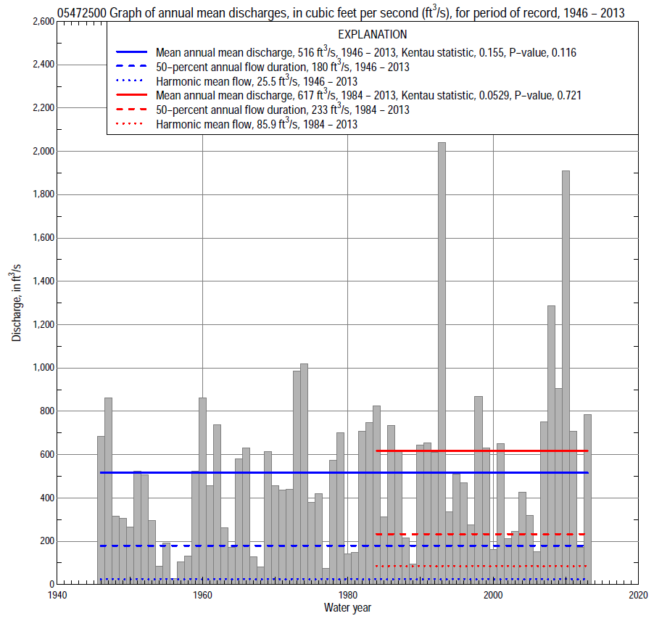

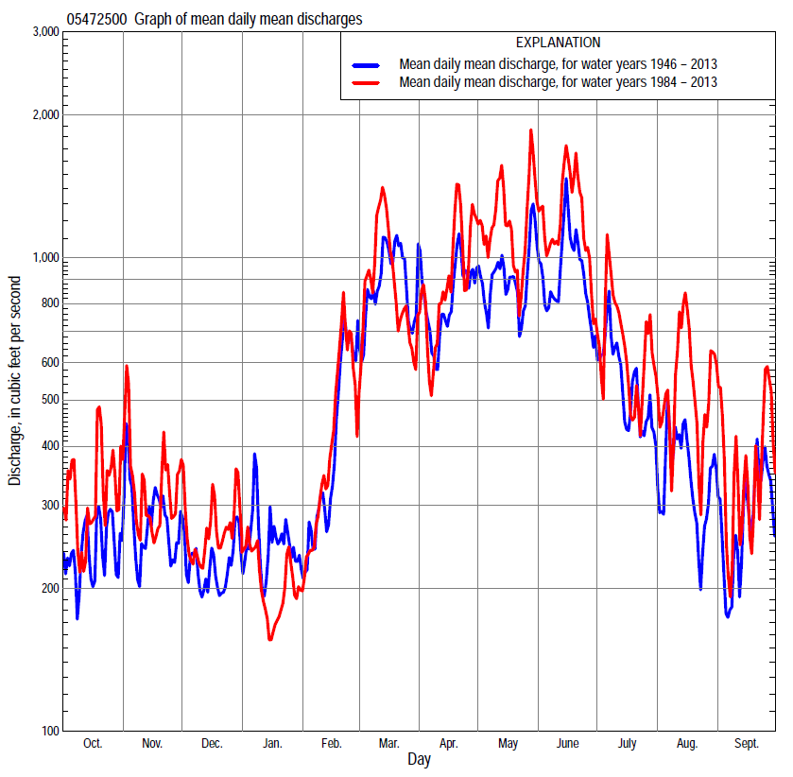

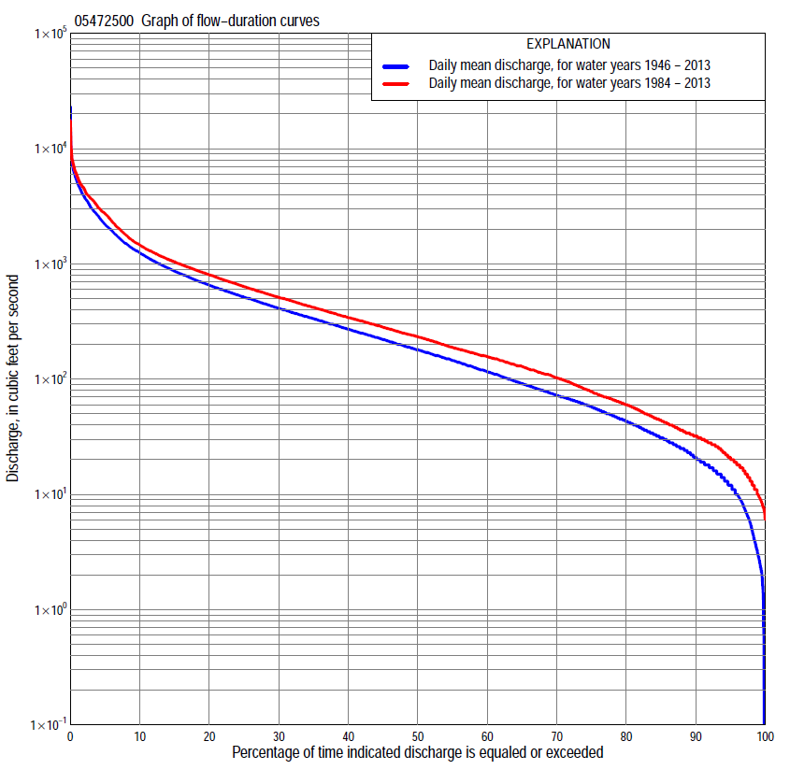

Statistics Based on the Entire Streamflow Period of Record
05472500 Monthly and annual flow durations, based on 1946–2013 period of record (68 years)
Percentage of days discharge equaled or exceeded |  |  |  |  | Discharge (cubic feet per second) |  |  |  |  |  |  |  |  | Annual flow durations
 | Oct | Nov | Dec | Jan | Feb | Mar | Apr | May | June | July | Aug | Sept | Annual | Kentau statistic | P-value
99 | 0.1 | 2.6 | 2.6 | 2.1 | 3.8 | 15 | 13 | 13 | 12 | 6.7 | 7.7 | 1.2 | 2.9 | 0.231 | 0.005
98 | 1.6 | 4.5 | 3.2 | 2.3 | 5.0 | 20 | 19 | 21 | 17 | 9.4 | 9.3 | 2.8 | 5.2 | 0.237 | 0.004
95 | 6.0 | 6.9 | 5.3 | 3.1 | 13 | 39 | 42 | 45 | 40 | 20 | 15 | 8.1 | 12 | 0.234 | 0.005
90 | 12 | 16 | 11 | 14 | 22 | 61 | 90 | 79 | 64 | 38 | 22 | 12 | 21 | 0.257 | 0.002
85 | 16 | 23 | 16 | 19 | 36 | 92 | 122 | 112 | 83 | 59 | 30 | 18 | 31 | 0.262 | 0.002
80 | 20 | 30 | 24 | 25 | 48 | 135 | 167 | 143 | 108 | 78 | 41 | 24 | 43 | 0.243 | 0.003
75 | 25 | 36 | 31 | 32 | 70 | 185 | 199 | 185 | 144 | 97 | 49 | 29 | 57 | 0.225 | 0.007
70 | 30 | 45 | 40 | 40 | 88 | 220 | 230 | 237 | 198 | 116 | 57 | 35 | 72 | 0.202 | 0.015
65 | 35 | 60 | 54 | 52 | 110 | 260 | 267 | 299 | 253 | 138 | 64 | 41 | 91 | 0.181 | 0.029
60 | 43 | 73 | 68 | 64 | 136 | 309 | 322 | 359 | 302 | 157 | 72 | 47 | 116 | 0.157 | 0.059
55 | 52 | 92 | 80 | 78 | 160 | 365 | 382 | 424 | 363 | 179 | 82 | 56 | 145 | 0.147 | 0.076
50 | 62 | 112 | 102 | 105 | 199 | 431 | 454 | 498 | 431 | 208 | 95 | 65 | 180 | 0.140 | 0.091
45 | 75 | 132 | 135 | 130 | 240 | 500 | 525 | 562 | 531 | 239 | 109 | 74 | 221 | 0.147 | 0.076
40 | 93 | 163 | 170 | 151 | 282 | 580 | 607 | 652 | 625 | 278 | 125 | 86 | 270 | 0.153 | 0.066
35 | 136 | 205 | 205 | 180 | 345 | 692 | 689 | 768 | 747 | 327 | 141 | 103 | 335 | 0.162 | 0.051
30 | 189 | 259 | 240 | 208 | 400 | 844 | 798 | 880 | 886 | 400 | 162 | 132 | 410 | 0.175 | 0.036
25 | 242 | 321 | 300 | 255 | 460 | 1,020 | 929 | 1,030 | 1,070 | 497 | 203 | 175 | 515 | 0.181 | 0.029
20 | 320 | 410 | 360 | 310 | 571 | 1,270 | 1,100 | 1,270 | 1,320 | 623 | 268 | 225 | 653 | 0.165 | 0.048
15 | 433 | 517 | 447 | 375 | 712 | 1,620 | 1,340 | 1,590 | 1,740 | 815 | 373 | 333 | 864 | 0.149 | 0.073
10 | 625 | 677 | 560 | 490 | 1,000 | 2,220 | 1,860 | 2,240 | 2,380 | 1,320 | 581 | 571 | 1,250 | 0.123 | 0.138
5 | 982 | 1,010 | 750 | 813 | 1,800 | 3,460 | 3,220 | 3,460 | 3,660 | 2,310 | 1,390 | 1,300 | 2,200 | 0.134 | 0.106
2 | 1,770 | 1,850 | 1,210 | 1,800 | 2,700 | 5,180 | 4,510 | 4,900 | 5,580 | 4,450 | 3,790 | 2,810 | 3,850 | 0.084 | 0.312
1 | 2,850 | 2,640 | 1,800 | 2,900 | 3,500 | 6,250 | 5,800 | 6,230 | 7,030 | 5,700 | 5,540 | 4,090 | 5,130 | 0.084 | 0.315

05472500 Annual exceedance probability of instantaneous peak discharges, in cubic feet per second (ft³/s), based on the Weighted Independent Estimates method,
Annual exceed-ance probability | Recur-rence interval (years) | Discharge (ft³/s) | 95-percent lower confi-dence interval (ft³/s) | 95-percent upper confi-dence interval (ft³/s)
0.500 | 2 | 6,070 | 5,080 | 7,240
0.200 | 5 | 10,800 | 9,130 | 12,800
0.100 | 10 | 14,400 | 12,000 | 17,200
0.040 | 25 | 19,300 | 15,700 | 23,600
0.020 | 50 | 22,700 | 18,000 | 28,600
0.010 | 100 | 26,100 | 20,000 | 33,900
0.005 | 200 | 30,700 | 22,700 | 41,600
0.002 | 500 | 34,100 | 24,000 | 48,400
and based on the expected moments algorithm/multiple Grubbs-Beck analysis computed using a historical period length of 70 years (1944–2013)
0.500 | 2 | 6,000 | 4,960 | 7,190
0.200 | 5 | 10,700 | 8,970 | 13,000
0.100 | 10 | 14,200 | 11,800 | 17,900
0.040 | 25 | 18,800 | 15,200 | 25,400
0.020 | 50 | 22,300 | 17,500 | 32,100
0.010 | 100 | 25,800 | 19,500 | 39,600
0.005 | 200 | 29,400 | 21,300 | 48,200
0.002 | 500 | 34,300 | 23,300 | 61,400
Kentau statistic |  | 0.001
P-value |  | 0.996
Begin year |  | 1946
End year |  | 2013
Number of peaks |  | 68

05472500 Annual exceedance probability of high discharges, based on 1946–2013 period of record (68 years)
Annual exceedance probability | Recur-rence interval (years) | Maximum average discharge (ft³/s) for indicated number of consecutive days
 |  | 1 | 3 | 7 | 15 | 30
0.990 | 1.01 | 672 | 521 | 358 | 219 | 150
0.950 | 1.05 | 1,350 | 1,100 | 782 | 509 | 357
0.900 | 1.11 | 1,910 | 1,590 | 1,140 | 758 | 536
0.800 | 1.25 | 2,810 | 2,380 | 1,720 | 1,170 | 836
0.500 | 2 | 5,470 | 4,680 | 3,420 | 2,380 | 1,700
0.200 | 5 | 9,660 | 8,160 | 5,940 | 4,110 | 2,890
0.100 | 10 | 12,500 | 10,400 | 7,540 | 5,160 | 3,590
0.040 | 25 | 16,100 | 13,100 | 9,400 | 6,330 | 4,340
0.020 | 50 | 18,600 | 14,900 | 10,600 | 7,080 | 4,810
0.010 | 100 | 21,100 | 16,600 | 11,800 | 7,730 | 5,200
0.005 | 200 | 23,500 | 18,200 | 12,800 | 8,290 | 5,530
0.002 | 500 | 26,500 | 20,100 | 14,000 | 8,930 | 5,890
Kentau statistic |  | 0.017 | 0.067 | 0.064 | 0.091 | 0.116
P-value |  | 0.841 | 0.421 | 0.443 | 0.273 | 0.164

 | 05472500 Annual nonexceedance probability of low discharges, based on April 1946 to March 2013 period of record (67 years)
Annual nonexceed-ance probability | Recur-rence interval (years) | Minimum average discharge (ft³/s) for indicated number of consecutive days
 |  | 1 | 3 | 7 | 14 | 30 | 60 | 90 | 120 | 183
0.01 | 100 | 0.30 | 0.32 | 0.35 | 0.36 | 0.43 | 0.83 | 2.2 | 2.4 | 5.0
0.02 | 50 | 0.61 | 0.64 | 0.71 | 0.75 | 0.91 | 1.6 | 3.5 | 3.9 | 7.5
0.05 | 20 | 1.6 | 1.7 | 1.9 | 2.0 | 2.5 | 3.8 | 6.9 | 7.8 | 14
0.10 | 10 | 3.4 | 3.6 | 4.0 | 4.4 | 5.5 | 7.8 | 12 | 14 | 23
0.20 | 5 | 7.7 | 8.2 | 9.0 | 10 | 13 | 17 | 23 | 28 | 41
0.50 | 2 | 27 | 28 | 31 | 35 | 44 | 58 | 72 | 88 | 118
0.80 | 1.25 | 65 | 67 | 71 | 80 | 100 | 146 | 192 | 238 | 309
0.90 | 1.11 | 90 | 92 | 97 | 108 | 133 | 212 | 303 | 379 | 491
0.96 | 1.04 | 118 | 119 | 123 | 137 | 166 | 293 | 474 | 596 | 784
0.98 | 1.02 | 134 | 135 | 139 | 154 | 184 | 348 | 620 | 781 | 1,040
0.99 | 1.01 | 148 | 148 | 151 | 167 | 197 | 397 | 777 | 981 | 1,340
Kentau statistic |  | 0.281 | 0.275 | 0.279 | 0.257 | 0.246 | 0.179 | 0.141 | 0.150 | 0.166
P-value |  | 0.001 | 0.001 | 0.001 | 0.002 | 0.003 | 0.033 | 0.093 | 0.074 | 0.048

05472500 Annual nonexceedance probability of seasonal low discharges, based on October 1945 to September 2013 period of record (68 years)
Annual nonexceed-ance probability | Recur-rence interval (years) | Minimum average discharge (cubic feet per second) for indicated number of consecutive days
 |  | 1 | 7 | 14 | 30 |  | 1 | 7 | 14 | 30
 |  | January-February-March |  |  |  |  | April-May-June
0.01 | 100 | 0.93 | 1.1 | 1.2 | 2.0 |  | 4.8 | 6.4 | 8.2 | 11
0.02 | 50 | 1.6 | 1.8 | 2.1 | 3.4 |  | 7.7 | 10 | 13 | 17
0.05 | 20 | 3.6 | 4.0 | 4.5 | 7.4 |  | 15 | 19 | 23 | 32
0.10 | 10 | 6.8 | 7.6 | 8.7 | 14 |  | 26 | 32 | 39 | 54
0.20 | 5 | 14 | 16 | 18 | 29 |  | 49 | 57 | 70 | 100
0.50 | 2 | 49 | 55 | 62 | 95 |  | 134 | 156 | 192 | 287
0.80 | 1.25 | 138 | 156 | 172 | 250 |  | 304 | 358 | 458 | 708
0.90 | 1.11 | 218 | 250 | 271 | 382 |  | 434 | 521 | 685 | 1,070
0.96 | 1.04 | 338 | 390 | 416 | 569 |  | 603 | 743 | 1,010 | 1,600
0.98 | 1.02 | 436 | 506 | 534 | 713 |  | 727 | 914 | 1,280 | 2,030
0.99 | 1.01 | 538 | 628 | 655 | 858 |  | 846 | 1,080 | 1,560 | 2,480
Kentau statistic |  | 0.188 | 0.200 | 0.192 | 0.100 |  | 0.262 | 0.232 | 0.234 | 0.214
P-value |  | 0.023 | 0.016 | 0.021 | 0.230 |  | 0.002 | 0.005 | 0.005 | 0.010
 |  | July-August-September |  |  |  |  | October-November-December
0.01 | 100 | 0.92 | 1.3 | 1.6 | 4.4 |  | 0.39 | 0.42 | 0.42 | 0.47
0.02 | 50 | 1.5 | 2.0 | 2.5 | 5.8 |  | 0.78 | 0.85 | 0.88 | 1.0
0.05 | 20 | 3.0 | 3.8 | 4.6 | 8.9 |  | 2.1 | 2.3 | 2.4 | 3.0
0.10 | 10 | 5.3 | 6.5 | 7.9 | 13 |  | 4.5 | 5.1 | 5.5 | 7.2
0.20 | 5 | 10 | 12 | 15 | 22 |  | 11 | 12 | 13 | 18
0.50 | 2 | 32 | 37 | 44 | 57 |  | 40 | 45 | 52 | 73
0.80 | 1.25 | 86 | 99 | 119 | 160 |  | 105 | 119 | 144 | 198
0.90 | 1.11 | 136 | 161 | 193 | 282 |  | 154 | 173 | 213 | 287
0.96 | 1.04 | 213 | 259 | 314 | 522 |  | 214 | 237 | 298 | 388
0.98 | 1.02 | 278 | 348 | 424 | 786 |  | 253 | 279 | 355 | 452
0.99 | 1.01 | 348 | 449 | 548 | 1,140 |  | 288 | 315 | 405 | 504
Kentau statistic |  | 0.198 | 0.195 | 0.197 | 0.137 |  | 0.178 | 0.174 | 0.192 | 0.176
P-value |  | 0.017 | 0.019 | 0.018 | 0.100 |  | 0.032 | 0.037 | 0.021 | 0.034

Statistics Based on the 1984–2013 Streamflow Period of Record
05472500 Monthly and annual flow durations, based on 1984–2013 period of record (30 years)
Percentage of days discharge equaled or exceeded |  |  |  |  | Discharge (cubic feet per second) |  |  |  |  |  |  |  |  | Annual flow durations
 | Oct | Nov | Dec | Jan | Feb | Mar | Apr | May | June | July | Aug | Sept | Annual | Kentau statistic | P-value
99 | 7.5 | 13 | 9.4 | 8.4 | 12 | 28 | 28 | 26 | 27 | 12 | 8.9 | 7.4 | 9.9 | 0.007 | 0.972
98 | 8.0 | 15 | 10 | 11 | 14 | 39 | 40 | 62 | 37 | 17 | 10 | 8.7 | 13 | 0.011 | 0.943
95 | 17 | 23 | 13 | 16 | 20 | 52 | 65 | 89 | 62 | 24 | 20 | 11 | 20 | 0.034 | 0.802
90 | 22 | 31 | 17 | 23 | 39 | 98 | 115 | 129 | 86 | 40 | 29 | 19 | 32 | 0.025 | 0.858
85 | 28 | 37 | 25 | 31 | 49 | 131 | 169 | 167 | 116 | 74 | 43 | 27 | 44 | 0.039 | 0.775
80 | 31 | 50 | 35 | 38 | 73 | 191 | 196 | 268 | 173 | 111 | 54 | 30 | 60 | -0.016 | 0.915
75 | 34 | 64 | 46 | 50 | 100 | 230 | 228 | 322 | 273 | 133 | 63 | 35 | 78 | -0.046 | 0.735
70 | 39 | 73 | 64 | 62 | 115 | 267 | 258 | 418 | 336 | 150 | 70 | 40 | 103 | -0.057 | 0.669
65 | 48 | 88 | 75 | 78 | 141 | 310 | 320 | 485 | 395 | 167 | 79 | 45 | 129 | -0.090 | 0.498
60 | 57 | 102 | 106 | 108 | 159 | 374 | 361 | 555 | 503 | 193 | 91 | 50 | 157 | -0.113 | 0.392
55 | 69 | 121 | 135 | 124 | 185 | 422 | 430 | 650 | 582 | 221 | 103 | 59 | 189 | -0.117 | 0.372
50 | 84 | 153 | 159 | 135 | 230 | 478 | 523 | 753 | 683 | 251 | 115 | 69 | 233 | -0.124 | 0.344
45 | 102 | 183 | 185 | 153 | 279 | 522 | 617 | 847 | 796 | 298 | 132 | 86 | 282 | -0.101 | 0.443
40 | 155 | 239 | 220 | 170 | 320 | 599 | 705 | 947 | 883 | 348 | 147 | 109 | 341 | -0.062 | 0.643
35 | 191 | 270 | 245 | 195 | 362 | 710 | 798 | 1,080 | 1,000 | 412 | 175 | 144 | 419 | -0.030 | 0.830
30 | 232 | 310 | 309 | 233 | 428 | 842 | 929 | 1,250 | 1,160 | 480 | 227 | 174 | 512 | 0.002 | 1.000
25 | 301 | 381 | 365 | 264 | 502 | 1,010 | 1,070 | 1,430 | 1,350 | 598 | 305 | 211 | 635 | 0.028 | 0.844
20 | 422 | 439 | 441 | 318 | 585 | 1,210 | 1,230 | 1,720 | 1,690 | 711 | 409 | 278 | 802 | 0.021 | 0.887
15 | 601 | 567 | 530 | 359 | 702 | 1,470 | 1,470 | 2,220 | 2,320 | 972 | 617 | 465 | 1,040 | 0.046 | 0.735
10 | 801 | 770 | 640 | 440 | 904 | 2,110 | 2,070 | 2,840 | 3,140 | 1,470 | 1,070 | 929 | 1,460 | 0.037 | 0.789
5 | 1,250 | 1,220 | 835 | 578 | 1,770 | 3,390 | 3,650 | 3,870 | 4,550 | 3,010 | 2,760 | 1,880 | 2,730 | 0.117 | 0.372
2 | 2,790 | 1,850 | 1,160 | 1,020 | 2,810 | 5,160 | 5,050 | 5,800 | 6,500 | 4,780 | 5,530 | 3,660 | 4,480 | 0.087 | 0.509
1 | 3,560 | 2,640 | 1,660 | 1,420 | 3,570 | 6,560 | 5,860 | 6,830 | 7,740 | 6,210 | 7,710 | 5,060 | 5,740 | 0.129 | 0.326

05472500 Annual exceedance probability of high discharges, based on 1984–2013 period of record (30 years)
Annual exceedance probability | Recur-rence interval (years) | Maximum average discharge (ft³/s) for indicated number of consecutive days
 |  | 1 | 3 | 7 | 15 | 30
0.990 | 1.01 | 1,140 | 953 | 720 | 485 | 375
0.950 | 1.05 | 1,830 | 1,570 | 1,160 | 803 | 614
0.900 | 1.11 | 2,340 | 2,030 | 1,490 | 1,040 | 792
0.800 | 1.25 | 3,150 | 2,750 | 2,000 | 1,420 | 1,070
0.500 | 2 | 5,470 | 4,800 | 3,490 | 2,500 | 1,830
0.200 | 5 | 9,360 | 8,130 | 5,970 | 4,270 | 3,040
0.100 | 10 | 12,300 | 10,600 | 7,850 | 5,590 | 3,910
0.040 | 25 | 16,400 | 13,900 | 10,500 | 7,380 | 5,060
0.020 | 50 | 19,800 | 16,500 | 12,600 | 8,780 | 5,940
0.010 | 100 | 23,300 | 19,200 | 14,800 | 10,200 | 6,840
0.005 | 200 | 27,000 | 22,000 | 17,100 | 11,800 | 7,760
0.002 | 500 | 32,300 | 25,800 | 20,400 | 13,900 | 9,010
Kentau statistic |  | 0.067 | 0.092 | 0.094 | 0.108 | 0.071
P-value |  | 0.617 | 0.486 | 0.475 | 0.412 | 0.592

 | 05472500 Annual nonexceedance probability of low discharges, based on April 1983 to March 2013 period of record (30 years)
Annual nonexceed-ance probability | Recur-rence interval (years) | Minimum average discharge (ft³/s) for indicated number of consecutive days
 |  | 1 | 3 | 7 | 14 | 30 | 60 | 90 | 120 | 183
0.01 | 100 | 3.7 | 3.8 | 4.0 | 4.3 | 5.5 | 8.0 | 9.1 | 9.2 | 9.3
0.02 | 50 | 4.8 | 5.0 | 5.2 | 5.6 | 7.2 | 10 | 12 | 12 | 13
0.05 | 20 | 7.1 | 7.3 | 7.8 | 8.5 | 11 | 14 | 17 | 19 | 22
0.10 | 10 | 10 | 10 | 11 | 12 | 15 | 20 | 24 | 27 | 34
0.20 | 5 | 15 | 16 | 17 | 19 | 23 | 30 | 36 | 43 | 58
0.50 | 2 | 34 | 36 | 38 | 43 | 52 | 66 | 85 | 106 | 152
0.80 | 1.25 | 77 | 80 | 85 | 96 | 113 | 151 | 207 | 262 | 375
0.90 | 1.11 | 119 | 122 | 130 | 146 | 169 | 237 | 336 | 422 | 588
0.96 | 1.04 | 188 | 192 | 203 | 226 | 258 | 389 | 573 | 702 | 934
0.98 | 1.02 | 254 | 258 | 272 | 300 | 339 | 539 | 816 | 978 | 1,250
0.99 | 1.01 | 333 | 336 | 352 | 387 | 431 | 725 | 1,130 | 1,320 | 1,610
Kentau statistic |  | 0.053 | 0.062 | 0.057 | 0.039 | 0.028 | -0.002 | -0.025 | -0.048 | -0.080
P-value |  | 0.694 | 0.643 | 0.669 | 0.775 | 0.844 | 1.000 | 0.858 | 0.721 | 0.544

05472500 Annual nonexceedance probability of seasonal low discharges, based on October 1983 to September 2013 period of record (30 years)
Annual nonexceed-ance probability | Recur-rence interval (years) | Minimum average discharge (cubic feet per second) for indicated number of consecutive days
 |  | 1 | 7 | 14 | 30 |  | 1 | 7 | 14 | 30
 |  | January-February-March |  |  |  |  | April-May-June
0.01 | 100 | 3.2 | 3.9 | 4.8 | 8.4 |  | 12 | 14 | 16 | 20
0.02 | 50 | 5.0 | 6.0 | 7.1 | 12 |  | 18 | 21 | 23 | 29
0.05 | 20 | 9.3 | 11 | 13 | 19 |  | 31 | 35 | 40 | 52
0.10 | 10 | 16 | 18 | 21 | 29 |  | 49 | 55 | 63 | 84
0.20 | 5 | 28 | 32 | 36 | 47 |  | 81 | 90 | 108 | 147
0.50 | 2 | 73 | 85 | 92 | 112 |  | 192 | 215 | 272 | 393
0.80 | 1.25 | 164 | 191 | 207 | 249 |  | 397 | 451 | 612 | 949
0.90 | 1.11 | 235 | 275 | 300 | 368 |  | 551 | 634 | 893 | 1,440
0.96 | 1.04 | 330 | 390 | 429 | 546 |  | 754 | 880 | 1,290 | 2,190
0.98 | 1.02 | 403 | 478 | 531 | 698 |  | 906 | 1,070 | 1,620 | 2,830
0.99 | 1.01 | 474 | 566 | 634 | 865 |  | 1,060 | 1,260 | 1,950 | 3,520
Kentau statistic |  | -0.080 | -0.051 | -0.034 | -0.085 |  | 0.138 | 0.140 | 0.186 | 0.200
P-value |  | 0.544 | 0.708 | 0.803 | 0.521 |  | 0.292 | 0.284 | 0.154 | 0.125
 |  | July-August-September |  |  |  |  | October-November-December
0.01 | 100 | 5.0 | 5.3 | 7.0 | 9.1 |  | 3.7 | 3.9 | 3.9 | 5.2
0.02 | 50 | 5.9 | 6.5 | 8.4 | 11 |  | 4.9 | 5.3 | 5.5 | 7.4
0.05 | 20 | 8.0 | 8.8 | 11 | 14 |  | 7.6 | 8.3 | 9.1 | 12
0.10 | 10 | 11 | 12 | 15 | 19 |  | 11 | 12 | 14 | 19
0.20 | 5 | 16 | 18 | 22 | 28 |  | 18 | 20 | 24 | 33
0.50 | 2 | 38 | 45 | 54 | 71 |  | 45 | 51 | 62 | 85
0.80 | 1.25 | 112 | 134 | 159 | 223 |  | 114 | 128 | 154 | 210
0.90 | 1.11 | 211 | 255 | 304 | 446 |  | 186 | 209 | 244 | 330
0.96 | 1.04 | 441 | 534 | 649 | 1,000 |  | 313 | 353 | 396 | 523
0.98 | 1.02 | 735 | 891 | 1,100 | 1,770 |  | 440 | 495 | 537 | 700
0.99 | 1.01 | 1,190 | 1,440 | 1,800 | 3,040 |  | 597 | 671 | 703 | 903
Kentau statistic |  | 0.028 | 0.023 | 0.034 | -0.011 |  | -0.025 | -0.025 | -0.030 | -0.099
P-value |  | 0.844 | 0.872 | 0.803 | 0.943 |  | 0.858 | 0.858 | 0.830 | 0.454

