LOCATION.--Lat 40°55'31", long 91°40'26.6" referenced to North American Datum of 1927, in NW 1/4 SE 1/4 NW 1/4 sec.28, T.71 N., R.7 W., Henry County, IA, Hydrologic Unit 07080107, on left bank 30 ft upstream from bridge on County Highway H46, 3.0 mi west of Oakland Mills, 2.9 mi upstream from Wolf Creek, and 4.4 mi upstream from mouth.

DRAINAGE AREA.--530 mi².

PERIOD OF RECORD.--Occasional low-flow measurements, water years 1957-1977; discharge records from July 1977 to current year.

GAGE.--Water-stage recorder. Datum of gage is 565.07 ft above National Geodetic Vertical Datum of 1929.

REMARKS.--Occasional high-water measurements were made by U.S. Army Corps of Engineers in 1965, 1966, 1970, and 1974 and by U.S. Geological Survey in 1966 and 1967.

EXTREMES OUTSIDE PERIOD OF RECORD.--Flood of April 22, 1973, reached a stage of 24.09 ft, discharge not determined.

A summary of all available data for this streamgage is provided through the USGS National Water Information System web interface (NWISWeb). The following link provides access to current/historical observations, daily data, daily statistics, monthly statistics, annual statistics, peak streamflow, field measurements, field/lab water-quality samples, and the latest water-year summaries. Data can be filtered by parameter and/or dates, and can be output in various tabular and graphical formats.
http://waterdata.usgs.gov/nwis/inventory/?site_no=05473400

The USGS WaterWatch Toolkit is available at:
http://waterwatch.usgs.gov/?id=ww_toolkit
Tools for summarizing streamflow information include the duration hydrograph builder, the cumulative streamflow hydrograph builder, the streamgage statistics retrieval tool, the rating curve builder, the flood tracking chart builder, the National Weather Service Advanced Hydrologic Prediction Service (AHPS) river forecast hydrograph builder, and the raster-hydrograph builder. Entering the above number for this streamgage into these toolkit webpages will provide streamflow information specific to this streamgage.

A description of the statistics presented for this streamgage is available in the main body of the report at:
http://dx.doi.org/10.3133/ofr20151214
A link to other streamgages included in this report, a map showing the location of the streamgages, information on the programs used to compute the statistical analyses, and references are included in the main body of the report.

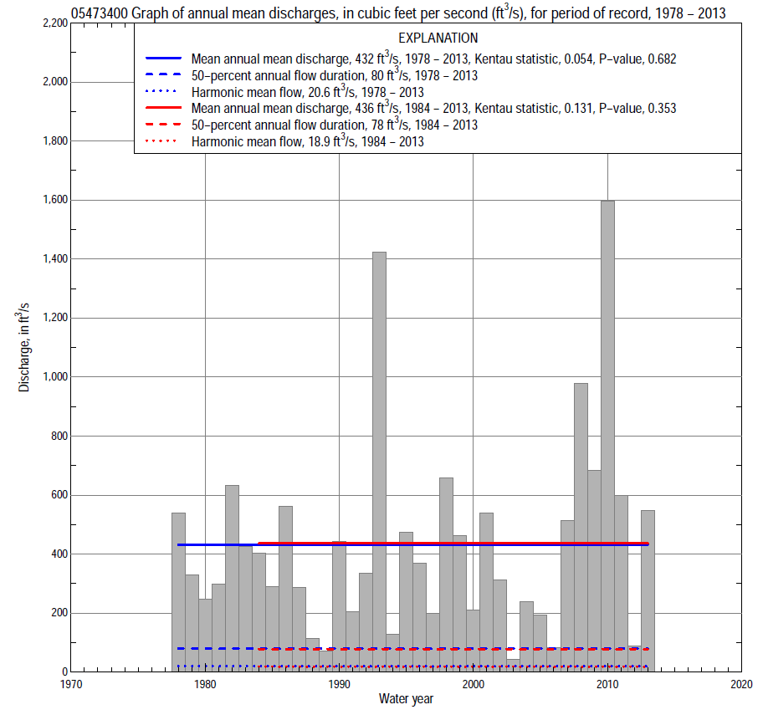

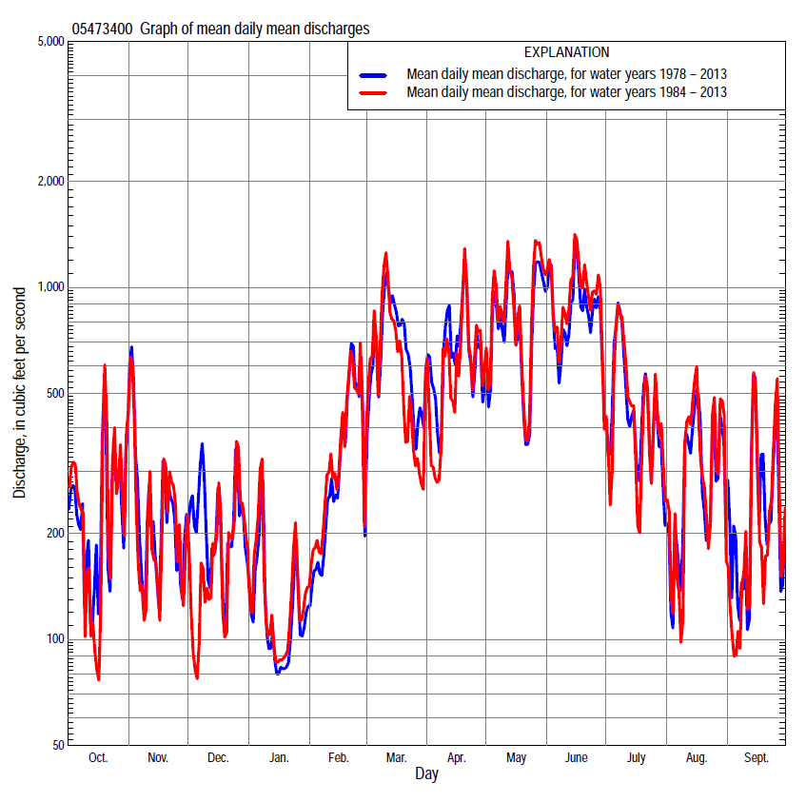

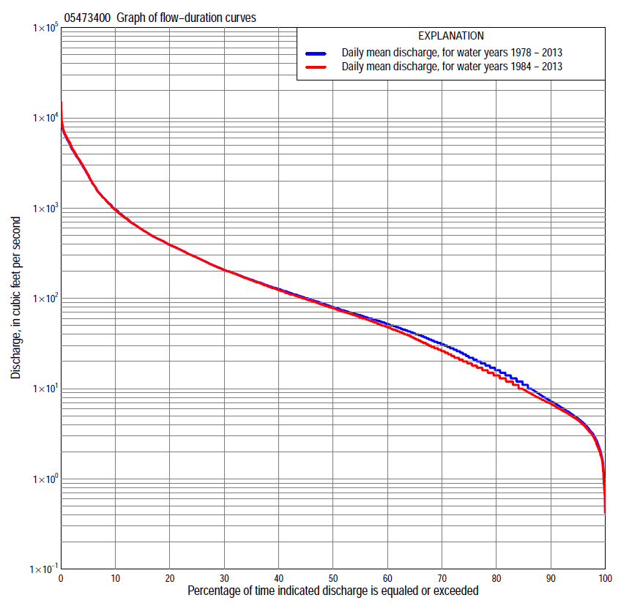

Statistics Based on the Entire Streamflow Period of Record
05473400 Monthly and annual flow durations, based on 1978–2013 period of record (36 years)
Percentage of days discharge equaled or exceeded |  |  |  |  | Discharge (cubic feet per second) |  |  |  |  |  |  |  |  | Annual flow durations
 | Oct | Nov | Dec | Jan | Feb | Mar | Apr | May | June | July | Aug | Sept | Annual | Kentau statistic | P-value
99 | 1.2 | 2.7 | 3.3 | 5.0 | 4.6 | 5.9 | 7.3 | 13 | 8.9 | 2.9 | 1.3 | 0.84 | 2.1 | -0.024 | 0.847
98 | 1.5 | 3.7 | 3.5 | 5.8 | 5.2 | 13 | 12 | 17 | 12 | 3.5 | 2.3 | 1.5 | 3.0 | -0.025 | 0.836
95 | 2.0 | 5.3 | 4.8 | 7.0 | 8.7 | 24 | 19 | 27 | 17 | 5.2 | 3.3 | 2.4 | 4.7 | -0.062 | 0.601
90 | 3.0 | 6.8 | 6.4 | 9.0 | 19 | 47 | 49 | 42 | 22 | 9.7 | 4.8 | 3.4 | 7.3 | -0.103 | 0.382
85 | 4.1 | 9.1 | 10 | 13 | 27 | 68 | 66 | 51 | 31 | 13 | 6.6 | 4.2 | 11 | -0.106 | 0.368
80 | 5.3 | 14 | 15 | 18 | 34 | 82 | 78 | 66 | 42 | 17 | 8.4 | 4.8 | 16 | -0.057 | 0.633
75 | 6.7 | 19 | 22 | 24 | 39 | 98 | 96 | 86 | 58 | 20 | 10 | 5.9 | 22 | -0.076 | 0.522
70 | 8.6 | 29 | 31 | 29 | 49 | 119 | 114 | 108 | 81 | 26 | 12 | 6.7 | 31 | -0.063 | 0.595
65 | 11 | 34 | 40 | 33 | 55 | 140 | 136 | 130 | 109 | 33 | 14 | 7.7 | 41 | -0.060 | 0.614
60 | 14 | 42 | 51 | 39 | 62 | 163 | 168 | 152 | 136 | 40 | 16 | 9.3 | 52 | -0.040 | 0.744
55 | 17 | 48 | 62 | 45 | 75 | 190 | 200 | 185 | 172 | 47 | 19 | 12 | 65 | -0.037 | 0.764
50 | 21 | 60 | 70 | 54 | 97 | 218 | 242 | 223 | 219 | 56 | 22 | 14 | 80 | -0.054 | 0.653
45 | 32 | 72 | 81 | 59 | 120 | 263 | 290 | 263 | 265 | 71 | 27 | 16 | 100 | -0.054 | 0.653
40 | 49 | 86 | 96 | 65 | 146 | 329 | 331 | 324 | 341 | 86 | 33 | 22 | 127 | -0.035 | 0.775
35 | 62 | 99 | 110 | 77 | 185 | 393 | 399 | 401 | 429 | 116 | 39 | 31 | 161 | -0.017 | 0.892
30 | 82 | 123 | 132 | 91 | 238 | 476 | 470 | 507 | 556 | 158 | 49 | 50 | 206 | -0.006 | 0.967
25 | 106 | 147 | 161 | 110 | 321 | 597 | 557 | 669 | 752 | 216 | 65 | 82 | 282 | -0.005 | 0.978
20 | 162 | 190 | 200 | 135 | 400 | 787 | 750 | 909 | 1,050 | 341 | 101 | 124 | 390 | 0.005 | 0.978
15 | 238 | 267 | 262 | 170 | 535 | 1,140 | 972 | 1,320 | 1,550 | 606 | 173 | 214 | 571 | -0.013 | 0.924
10 | 387 | 430 | 375 | 227 | 755 | 1,730 | 1,480 | 2,150 | 2,830 | 1,200 | 442 | 438 | 971 | -0.003 | 0.989
5 | 1,020 | 1,090 | 840 | 425 | 1,420 | 3,080 | 3,420 | 4,370 | 4,570 | 3,510 | 1,300 | 1,090 | 2,310 | 0.048 | 0.693
2 | 3,060 | 2,600 | 1,760 | 824 | 2,800 | 5,000 | 4,940 | 6,690 | 6,460 | 4,990 | 4,000 | 3,140 | 4,570 | 0.168 | 0.153
1 | 5,000 | 4,320 | 3,570 | 1,490 | 4,090 | 6,510 | 6,270 | 7,830 | 7,250 | 6,060 | 6,640 | 3,810 | 6,010 | 0.143 | 0.225

05473400 Annual exceedance probability of instantaneous peak discharges, in cubic feet per second (ft³/s), based on the Weighted Independent Estimates method,
Annual exceed-ance probability | Recur-rence interval (years) | Discharge (ft³/s) | 95-percent lower confi-dence interval (ft³/s) | 95-percent upper confi-dence interval (ft³/s)
0.500 | 2 | 7,220 | 6,250 | 8,340
0.200 | 5 | 10,900 | 9,370 | 12,600
0.100 | 10 | 13,600 | 11,500 | 16,000
0.040 | 25 | 17,500 | 14,500 | 21,200
0.020 | 50 | 20,400 | 16,400 | 25,300
0.010 | 100 | 23,200 | 18,100 | 29,700
0.005 | 200 | 27,000 | 20,400 | 35,800
0.002 | 500 | 30,100 | 21,800 | 41,600
and based on the expected moments algorithm/multiple Grubbs-Beck analysis computed using a historical period length of 49 years (1965–2013)
0.500 | 2 | 7,240 | 6,080 | 8,550
0.200 | 5 | 10,900 | 9,220 | 13,300
0.100 | 10 | 13,500 | 11,200 | 17,000
0.040 | 25 | 16,800 | 13,700 | 22,600
0.020 | 50 | 19,300 | 15,400 | 27,700
0.010 | 100 | 21,800 | 17,000 | 33,600
0.005 | 200 | 24,300 | 18,500 | 40,500
0.002 | 500 | 27,800 | 20,300 | 51,500
Kentau statistic |  | 0.183
P-value |  | 0.125
Begin year |  | 1979
End year |  | 2013
Number of peaks |  | 35

05473400 Annual exceedance probability of high discharges, based on 1978–2013 period of record (36 years)
Annual exceedance probability | Recur-rence interval (years) | Maximum average discharge (ft³/s) for indicated number of consecutive days
 |  | 1 | 3 | 7 | 15 | 30
0.990 | 1.01 | 1,280 | 778 | 456 | 282 | 185
0.950 | 1.05 | 2,320 | 1,590 | 935 | 586 | 386
0.900 | 1.11 | 3,060 | 2,220 | 1,320 | 831 | 549
0.800 | 1.25 | 4,130 | 3,180 | 1,920 | 1,220 | 813
0.500 | 2 | 6,630 | 5,580 | 3,550 | 2,300 | 1,560
0.200 | 5 | 9,450 | 8,440 | 5,770 | 3,780 | 2,660
0.100 | 10 | 10,900 | 9,920 | 7,090 | 4,670 | 3,360
0.040 | 25 | 12,300 | 11,400 | 8,540 | 5,660 | 4,170
0.020 | 50 | 13,100 | 12,200 | 9,470 | 6,300 | 4,720
0.010 | 100 | 13,800 | 12,900 | 10,300 | 6,870 | 5,220
0.005 | 200 | 14,300 | 13,500 | 11,000 | 7,360 | 5,670
0.002 | 500 | 14,900 | 14,000 | 11,800 | 7,930 | 6,210
Kentau statistic |  | 0.152 | 0.143 | 0.108 | 0.086 | 0.102
P-value |  | 0.196 | 0.225 | 0.361 | 0.470 | 0.391

 | 05473400 Annual nonexceedance probability of low discharges, based on April 1978 to March 2013 period of record (35 years)
Annual nonexceed-ance probability | Recur-rence interval (years) | Minimum average discharge (cubic feet per second) for indicated number of consecutive days
 |  | 1 | 3 | 7 | 14 | 30 | 60 | 90 | 120 | 183
0.01 | 100 | 0.36 | 0.44 | 0.55 | 0.68 | 1.4 | 1.8 | 1.9 | 2.2 | 3.3
0.02 | 50 | 0.49 | 0.59 | 0.73 | 0.89 | 1.7 | 2.3 | 2.4 | 3.0 | 4.8
0.05 | 20 | 0.78 | 0.91 | 1.1 | 1.3 | 2.4 | 3.5 | 3.8 | 4.9 | 8.5
0.10 | 10 | 1.2 | 1.3 | 1.6 | 1.9 | 3.2 | 5.1 | 5.9 | 7.7 | 14
0.20 | 5 | 1.9 | 2.1 | 2.5 | 3.0 | 4.9 | 8.2 | 10 | 14 | 26
0.50 | 2 | 4.8 | 5.2 | 6.1 | 7.4 | 11 | 22 | 30 | 41 | 78
0.80 | 1.25 | 12 | 13 | 15 | 19 | 29 | 61 | 98 | 133 | 233
0.90 | 1.11 | 19 | 20 | 23 | 31 | 49 | 109 | 187 | 251 | 405
0.96 | 1.04 | 31 | 34 | 38 | 54 | 87 | 206 | 382 | 502 | 725
0.98 | 1.02 | 42 | 46 | 53 | 79 | 129 | 317 | 616 | 795 | 1,050
0.99 | 1.01 | 55 | 62 | 71 | 110 | 186 | 471 | 954 | 1,210 | 1,460
Kentau statistic |  | 0.096 | 0.092 | 0.082 | 0.039 | 0.018 | -0.039 | -0.099 | -0.123 | -0.143
P-value |  | 0.426 | 0.443 | 0.495 | 0.755 | 0.887 | 0.755 | 0.410 | 0.307 | 0.233

05473400 Annual nonexceedance probability of seasonal low discharges, based on July 1977 to September 2013 period of record (36–37 years)
Annual nonexceed-ance probability | Recur-rence interval (years) | Minimum average discharge (cubic feet per second) for indicated number of consecutive days
 |  | 1 | 7 | 14 | 30 |  | 1 | 7 | 14 | 30
 |  | January-February-March |  |  |  |  | April-May-June
0.01 | 100 | 1.7 | 2.0 | 2.7 | 3.9 |  | 2.7 | 3.5 | 3.8 | 7.0
0.02 | 50 | 2.4 | 2.9 | 3.7 | 5.3 |  | 3.9 | 5.0 | 5.6 | 10
0.05 | 20 | 4.0 | 4.8 | 6.0 | 8.4 |  | 6.7 | 8.6 | 10 | 18
0.10 | 10 | 6.1 | 7.4 | 9.1 | 13 |  | 11 | 14 | 17 | 30
0.20 | 5 | 10 | 12 | 15 | 20 |  | 18 | 23 | 30 | 53
0.50 | 2 | 25 | 29 | 34 | 47 |  | 45 | 58 | 81 | 154
0.80 | 1.25 | 55 | 64 | 74 | 105 |  | 105 | 135 | 195 | 425
0.90 | 1.11 | 80 | 93 | 106 | 158 |  | 158 | 203 | 297 | 707
0.96 | 1.04 | 116 | 135 | 154 | 239 |  | 238 | 304 | 448 | 1,200
0.98 | 1.02 | 146 | 169 | 193 | 311 |  | 306 | 389 | 576 | 1,670
0.99 | 1.01 | 178 | 206 | 235 | 391 |  | 380 | 482 | 712 | 2,250
Kentau statistic |  | -0.073 | -0.010 | 0.006 | 0.022 |  | 0.148 | 0.165 | 0.203 | 0.244
P-value |  | 0.540 | 0.946 | 0.967 | 0.859 |  | 0.210 | 0.161 | 0.084 | 0.037
 |  | July-August-September |  |  |  |  | October-November-December
0.01 | 100 | 0.54 | 0.98 | 1.5 | 1.8 |  | 0.37 | 0.40 | 0.50 | 0.99
0.02 | 50 | 0.66 | 1.1 | 1.6 | 2.2 |  | 0.52 | 0.59 | 0.73 | 1.5
0.05 | 20 | 0.90 | 1.4 | 1.9 | 2.9 |  | 0.89 | 1.1 | 1.3 | 2.7
0.10 | 10 | 1.2 | 1.9 | 2.4 | 3.8 |  | 1.4 | 1.8 | 2.2 | 4.5
0.20 | 5 | 1.9 | 2.7 | 3.3 | 5.8 |  | 2.6 | 3.3 | 4.1 | 8.3
0.50 | 2 | 4.8 | 6.4 | 7.9 | 16 |  | 8.4 | 11 | 14 | 26
0.80 | 1.25 | 15 | 20 | 29 | 56 |  | 28 | 36 | 46 | 81
0.90 | 1.11 | 29 | 39 | 67 | 122 |  | 54 | 68 | 85 | 143
0.96 | 1.04 | 62 | 90 | 191 | 309 |  | 109 | 132 | 167 | 260
0.98 | 1.02 | 106 | 162 | 407 | 596 |  | 173 | 203 | 258 | 380
0.99 | 1.01 | 174 | 283 | 850 | 1,120 |  | 263 | 300 | 381 | 534
Kentau statistic |  | 0.093 | 0.047 | 0.027 | -0.084 |  | -0.071 | -0.041 | -0.070 | -0.133
P-value |  | 0.425 | 0.695 | 0.824 | 0.472 |  | 0.549 | 0.733 | 0.558 | 0.258

Statistics Based on the 1984–2013 Streamflow Period of Record
05473400 Monthly and annual flow durations, based on 1984–2013 period of record (30 years)
Percentage of days discharge equaled or exceeded |  |  |  |  | Discharge (cubic feet per second) |  |  |  |  |  |  |  |  | Annual flow durations
 | Oct | Nov | Dec | Jan | Feb | Mar | Apr | May | June | July | Aug | Sept | Annual | Kentau statistic | P-value
99 | 0.97 | 2.4 | 3.3 | 4.9 | 4.5 | 5.3 | 6.8 | 13 | 8.2 | 2.5 | 1.2 | 0.75 | 2.0 | 0.078 | 0.550
98 | 1.4 | 3.3 | 3.5 | 5.7 | 5.0 | 12 | 9.6 | 16 | 12 | 3.3 | 2.2 | 1.3 | 2.8 | 0.071 | 0.587
95 | 1.8 | 4.9 | 4.6 | 7.0 | 7.5 | 22 | 17 | 24 | 16 | 5.0 | 3.3 | 2.2 | 4.5 | 0.044 | 0.745
90 | 2.7 | 6.2 | 5.7 | 8.5 | 19 | 45 | 46 | 39 | 20 | 9.3 | 4.8 | 3.2 | 6.8 | 0.044 | 0.747
85 | 3.7 | 7.6 | 7.9 | 11 | 28 | 67 | 61 | 49 | 27 | 12 | 6.5 | 4.0 | 9.8 | 0.046 | 0.734
80 | 4.9 | 11 | 12 | 16 | 36 | 80 | 71 | 62 | 35 | 16 | 7.9 | 4.6 | 14 | 0.071 | 0.592
75 | 6.0 | 15 | 18 | 21 | 45 | 95 | 84 | 79 | 55 | 19 | 9.6 | 5.4 | 19 | 0.025 | 0.858
70 | 7.4 | 19 | 25 | 25 | 54 | 116 | 102 | 103 | 82 | 22 | 11 | 6.3 | 26 | 0.023 | 0.872
65 | 9.0 | 28 | 33 | 30 | 62 | 139 | 116 | 134 | 113 | 28 | 13 | 7.2 | 36 | 0.002 | 1.000
60 | 11 | 36 | 43 | 36 | 73 | 161 | 137 | 164 | 152 | 36 | 15 | 8.2 | 48 | 0.030 | 0.830
55 | 14 | 44 | 54 | 45 | 89 | 190 | 166 | 204 | 205 | 43 | 17 | 10 | 62 | 0.044 | 0.748
50 | 17 | 55 | 64 | 54 | 114 | 212 | 197 | 250 | 250 | 51 | 21 | 12 | 78 | 0.011 | 0.943
45 | 21 | 66 | 78 | 61 | 130 | 250 | 246 | 315 | 311 | 64 | 24 | 14 | 98 | 0.000 | 1.000
40 | 31 | 78 | 90 | 75 | 160 | 304 | 294 | 381 | 414 | 78 | 29 | 19 | 123 | 0.025 | 0.858
35 | 50 | 89 | 105 | 91 | 200 | 376 | 345 | 476 | 520 | 98 | 36 | 25 | 159 | 0.041 | 0.762
30 | 73 | 105 | 122 | 105 | 270 | 442 | 423 | 583 | 669 | 136 | 44 | 39 | 206 | 0.039 | 0.775
25 | 106 | 131 | 147 | 125 | 333 | 531 | 500 | 754 | 882 | 194 | 59 | 68 | 284 | 0.051 | 0.708
20 | 163 | 167 | 181 | 152 | 400 | 704 | 665 | 1,010 | 1,310 | 289 | 95 | 110 | 392 | 0.048 | 0.721
15 | 243 | 250 | 225 | 188 | 535 | 981 | 885 | 1,550 | 2,050 | 479 | 176 | 197 | 575 | 0.053 | 0.695
10 | 435 | 419 | 315 | 269 | 730 | 1,410 | 1,300 | 2,580 | 3,190 | 929 | 505 | 378 | 954 | 0.080 | 0.544
5 | 1,020 | 965 | 720 | 450 | 1,450 | 2,700 | 2,900 | 4,720 | 5,150 | 3,450 | 1,400 | 1,000 | 2,340 | 0.131 | 0.318
2 | 3,710 | 2,600 | 1,300 | 851 | 2,830 | 4,970 | 4,580 | 6,760 | 6,560 | 5,340 | 4,170 | 2,990 | 4,720 | 0.214 | 0.101
1 | 5,300 | 4,090 | 2,140 | 1,510 | 4,270 | 6,600 | 5,970 | 8,050 | 7,470 | 6,280 | 6,800 | 3,810 | 6,180 | 0.172 | 0.187

05473400 Annual exceedance probability of high discharges, based on 1984–2013 period of record (30 years)
Annual exceedance probability | Recur-rence interval (years) | Maximum average discharge (ft³/s) for indicated number of consecutive days
 |  | 1 | 3 | 7 | 15 | 30
0.990 | 1.01 | 1,150 | 687 | 402 | 249 | 163
0.950 | 1.05 | 2,120 | 1,430 | 836 | 525 | 346
0.900 | 1.11 | 2,840 | 2,030 | 1,190 | 754 | 500
0.800 | 1.25 | 3,910 | 2,970 | 1,770 | 1,130 | 755
0.500 | 2 | 6,550 | 5,450 | 3,440 | 2,220 | 1,520
0.200 | 5 | 9,760 | 8,690 | 5,930 | 3,860 | 2,730
0.100 | 10 | 11,500 | 10,500 | 7,540 | 4,930 | 3,560
0.040 | 25 | 13,400 | 12,500 | 9,440 | 6,200 | 4,580
0.020 | 50 | 14,500 | 13,700 | 10,700 | 7,070 | 5,300
0.010 | 100 | 15,400 | 14,700 | 11,900 | 7,870 | 5,990
0.005 | 200 | 16,200 | 15,500 | 13,000 | 8,620 | 6,640
0.002 | 500 | 17,100 | 16,500 | 14,400 | 9,520 | 7,450
Kentau statistic |  | 0.186 | 0.168 | 0.168 | 0.145 | 0.154
P-value |  | 0.154 | 0.199 | 0.199 | 0.269 | 0.239

 | 05473400 Annual nonexceedance probability of low discharges, based on April 1983 to March 2013 period of record (30 years)
Annual nonexceed-ance probability | Recur-rence interval (years) | Minimum average discharge (cubic feet per second) for indicated number of consecutive days
 |  | 1 | 3 | 7 | 14 | 30 | 60 | 90 | 120 | 183
0.01 | 100 | 0.35 | 0.43 | 0.54 | 0.69 | 1.5 | 1.9 | 1.9 | 2.4 | 3.2
0.02 | 50 | 0.46 | 0.56 | 0.70 | 0.87 | 1.8 | 2.3 | 2.4 | 3.1 | 4.5
0.05 | 20 | 0.71 | 0.84 | 1.0 | 1.3 | 2.4 | 3.3 | 3.6 | 4.6 | 7.7
0.10 | 10 | 1.1 | 1.2 | 1.5 | 1.8 | 3.1 | 4.6 | 5.2 | 6.8 | 12
0.20 | 5 | 1.7 | 1.9 | 2.3 | 2.7 | 4.5 | 7.1 | 8.5 | 11 | 22
0.50 | 2 | 4.2 | 4.7 | 5.5 | 6.5 | 9.9 | 18 | 25 | 33 | 67
0.80 | 1.25 | 11 | 12 | 14 | 17 | 25 | 52 | 83 | 108 | 211
0.90 | 1.11 | 18 | 19 | 22 | 30 | 44 | 96 | 167 | 214 | 385
0.96 | 1.04 | 31 | 34 | 38 | 54 | 81 | 192 | 373 | 463 | 736
0.98 | 1.02 | 44 | 48 | 55 | 81 | 125 | 310 | 646 | 781 | 1,120
0.99 | 1.01 | 60 | 67 | 76 | 118 | 186 | 484 | 1,080 | 1,270 | 1,650
Kentau statistic |  | 0.262 | 0.255 | 0.228 | 0.168 | 0.149 | 0.113 | 0.016 | -0.002 | -0.099
P-value |  | 0.044 | 0.050 | 0.080 | 0.199 | 0.254 | 0.392 | 0.915 | 1.000 | 0.454

05473400 Annual nonexceedance probability of seasonal low discharges, based on October 1983 to September 2013 period of record (30 years)
Annual nonexceed-ance probability | Recur-rence interval (years) | Minimum average discharge (cubic feet per second) for indicated number of consecutive days
 |  | 1 | 7 | 14 | 30 |  | 1 | 7 | 14 | 30
 |  | January-February-March |  |  |  |  | April-May-June
0.01 | 100 | 1.5 | 1.9 | 2.3 | 3.1 |  | 2.2 | 2.9 | 3.0 | 5.3
0.02 | 50 | 2.2 | 2.7 | 3.3 | 4.4 |  | 3.3 | 4.3 | 4.7 | 8.3
0.05 | 20 | 3.7 | 4.5 | 5.4 | 7.4 |  | 5.8 | 7.5 | 8.8 | 16
0.10 | 10 | 5.7 | 7.0 | 8.4 | 11 |  | 9.4 | 12 | 15 | 27
0.20 | 5 | 9.6 | 12 | 14 | 19 |  | 17 | 21 | 28 | 52
0.50 | 2 | 24 | 29 | 35 | 49 |  | 45 | 58 | 82 | 165
0.80 | 1.25 | 56 | 67 | 78 | 116 |  | 111 | 143 | 210 | 485
0.90 | 1.11 | 84 | 99 | 116 | 178 |  | 172 | 220 | 329 | 825
0.96 | 1.04 | 126 | 148 | 172 | 276 |  | 267 | 338 | 511 | 1,420
0.98 | 1.02 | 162 | 189 | 219 | 363 |  | 350 | 441 | 667 | 1,990
0.99 | 1.01 | 202 | 234 | 270 | 461 |  | 442 | 554 | 836 | 2,660
Kentau statistic |  | -0.094 | -0.053 | -0.044 | -0.030 |  | 0.228 | 0.241 | 0.251 | 0.297
P-value |  | 0.475 | 0.695 | 0.748 | 0.830 |  | 0.080 | 0.064 | 0.054 | 0.022
 |  | July-August-September |  |  |  |  | October-November-December
0.01 | 100 | 0.61 | 0.90 | 1.4 | 1.8 |  | 0.40 | 0.43 | 0.53 | 1.0
0.02 | 50 | 0.73 | 1.0 | 1.5 | 2.1 |  | 0.53 | 0.60 | 0.74 | 1.4
0.05 | 20 | 0.96 | 1.3 | 1.8 | 2.6 |  | 0.84 | 0.99 | 1.2 | 2.3
0.10 | 10 | 1.3 | 1.7 | 2.2 | 3.4 |  | 1.3 | 1.6 | 2.0 | 3.7
0.20 | 5 | 1.9 | 2.5 | 3.0 | 5.0 |  | 2.2 | 2.8 | 3.5 | 6.6
0.50 | 2 | 4.8 | 6.2 | 7.5 | 14 |  | 6.6 | 8.8 | 11 | 21
0.80 | 1.25 | 15 | 20 | 29 | 52 |  | 23 | 30 | 38 | 66
0.90 | 1.11 | 31 | 43 | 72 | 124 |  | 45 | 59 | 74 | 124
0.96 | 1.04 | 71 | 105 | 225 | 354 |  | 99 | 124 | 154 | 246
0.98 | 1.02 | 127 | 198 | 515 | 750 |  | 167 | 204 | 250 | 387
0.99 | 1.01 | 220 | 364 | 1,150 | 1,550 |  | 270 | 320 | 391 | 582
Kentau statistic |  | 0.136 | 0.115 | 0.080 | 0.021 |  | 0.074 | 0.076 | 0.053 | -0.002
P-value |  | 0.301 | 0.382 | 0.544 | 0.887 |  | 0.580 | 0.568 | 0.695 | 1.000

