LOCATION.--Lat 41°00'25", long 91°33'05" referenced to North American Datum of 1927, in SE 1/4 NW 1/4 SE 1/4 sec.28, T.72 N., R.6 W., Henry County, IA, Hydrologic Unit 07080107, on right bank 20 ft upstream from bridge on Old U.S. Highway 218 (business route), 2.0 mi north of Mount Pleasant, 1.6 mi upstream from Brandy Wine Creek, 2.3 mi upstream from Lynn Creek, and 27.4 mi upstream from mouth.

DRAINAGE AREA.--58 mi².

PERIOD OF RECORD.--Occasional low-flow measurements, water years 1957-1977; discharge records from October 1997 to current year. Prior to October 2008, published as "near Mt. Pleasant".

GAGE.--Water-stage recorder. Datum of gage is 643.00 ft above National Geodetic Vertical Datum of 1929.

EXTREMES OUTSIDE PERIOD OF RECORD.--Flood of April 21, 1973, discharge 9,580 ft³/s, on basis of contracted-opening measurement.

A summary of all available data for this streamgage is provided through the USGS National Water Information System web interface (NWISWeb). The following link provides access to current/historical observations, daily data, daily statistics, monthly statistics, annual statistics, peak streamflow, field measurements, field/lab water-quality samples, and the latest water-year summaries. Data can be filtered by parameter and/or dates, and can be output in various tabular and graphical formats.
http://waterdata.usgs.gov/nwis/inventory/?site_no=05473450

The USGS WaterWatch Toolkit is available at:
http://waterwatch.usgs.gov/?id=ww_toolkit
Tools for summarizing streamflow information include the duration hydrograph builder, the cumulative streamflow hydrograph builder, the streamgage statistics retrieval tool, the rating curve builder, the flood tracking chart builder, the National Weather Service Advanced Hydrologic Prediction Service (AHPS) river forecast hydrograph builder, and the raster-hydrograph builder. Entering the above number for this streamgage into these toolkit webpages will provide streamflow information specific to this streamgage.

A description of the statistics presented for this streamgage is available in the main body of the report at:
http://dx.doi.org/10.3133/ofr20151214
A link to other streamgages included in this report, a map showing the location of the streamgages, information on the programs used to compute the statistical analyses, and references are included in the main body of the report.

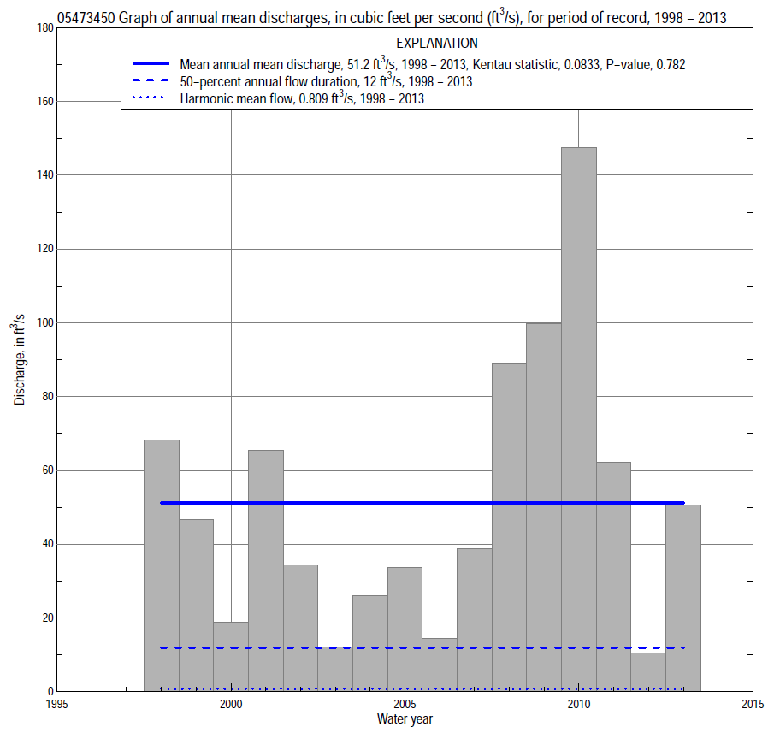

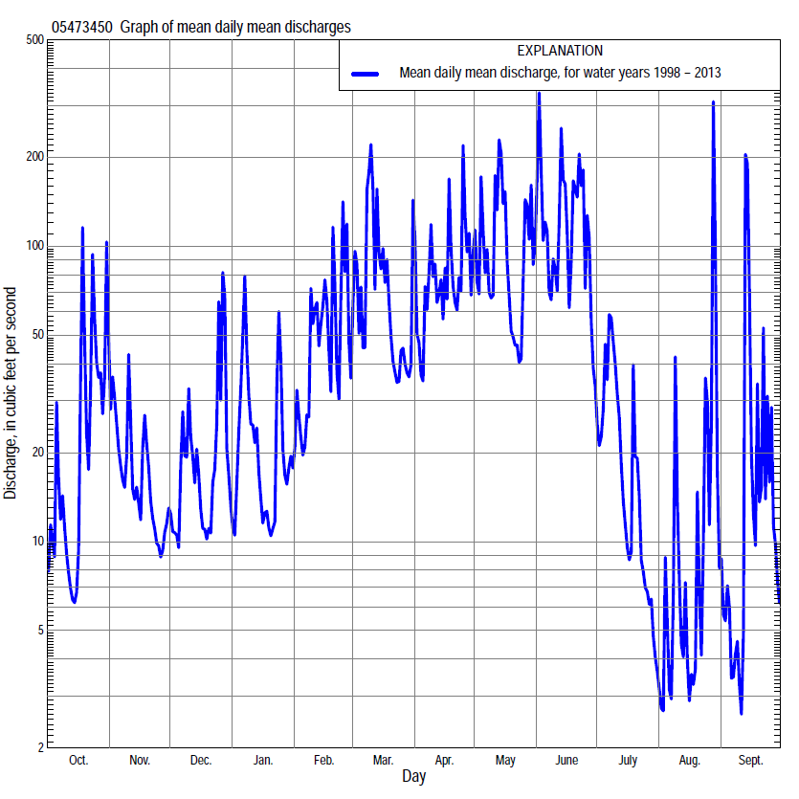

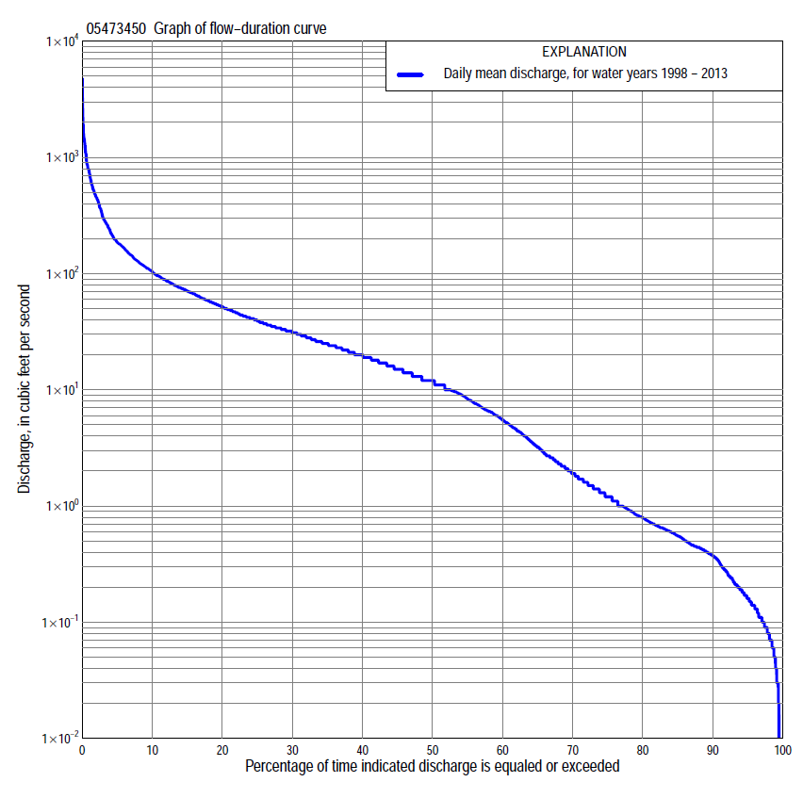

Statistics Based on the Entire Streamflow Period of Record
05473450 Monthly and annual flow durations, based on 1998–2013 period of record (16 years)
Percentage of days discharge equaled or exceeded |  |  |  |  | Discharge (cubic feet per second) |  |  |  |  |  |  |  |  | Annual flow durations
 | Oct | Nov | Dec | Jan | Feb | Mar | Apr | May | June | July | Aug | Sept | Annual | Kentau statistic | P-value
99 | 0.00 | 0.08 | 0.10 | 0.14 | 0.39 | 0.79 | 2.0 | 7.9 | 1.7 | 0.09 | 0.02 | 0.00 | 0.04 | 0.192 | 0.141
98 | 0.01 | 0.09 | 0.14 | 0.17 | 0.41 | 1.0 | 2.3 | 9.4 | 1.9 | 0.11 | 0.04 | 0.00 | 0.08 | 0.183 | 0.161
95 | 0.04 | 0.14 | 0.27 | 0.25 | 0.57 | 2.1 | 3.4 | 12 | 3.0 | 0.40 | 0.08 | 0.05 | 0.16 | 0.183 | 0.161
90 | 0.09 | 0.34 | 0.45 | 0.38 | 0.85 | 5.5 | 4.8 | 15 | 6.5 | 0.67 | 0.14 | 0.09 | 0.37 | 0.050 | 0.782
85 | 0.14 | 0.44 | 0.54 | 0.45 | 1.1 | 8.3 | 11 | 18 | 9.4 | 0.94 | 0.21 | 0.13 | 0.56 | 0.083 | 0.650
80 | 0.18 | 0.58 | 0.67 | 0.65 | 1.5 | 12 | 16 | 22 | 12 | 1.2 | 0.32 | 0.17 | 0.80 | 0.025 | 0.925
75 | 0.25 | 0.63 | 0.83 | 0.90 | 2.7 | 14 | 19 | 24 | 17 | 1.6 | 0.43 | 0.21 | 1.2 | -0.025 | 0.926
70 | 0.35 | 0.71 | 1.1 | 1.7 | 4.7 | 16 | 21 | 29 | 22 | 2.2 | 0.52 | 0.26 | 1.9 | 0.000 | 1.000
65 | 0.45 | 0.82 | 1.5 | 2.4 | 6.4 | 19 | 24 | 32 | 27 | 3.0 | 0.64 | 0.38 | 3.2 | 0.033 | 0.891
60 | 0.66 | 1.1 | 2.4 | 3.0 | 9.4 | 23 | 27 | 34 | 32 | 4.3 | 0.79 | 0.46 | 5.5 | 0.050 | 0.820
55 | 0.97 | 2.7 | 4.0 | 4.6 | 12 | 26 | 31 | 39 | 37 | 5.2 | 0.93 | 0.56 | 8.4 | 0.042 | 0.856
50 | 1.4 | 4.0 | 6.4 | 7.0 | 16 | 32 | 35 | 46 | 43 | 6.6 | 1.1 | 0.67 | 12 | -0.033 | 0.892
45 | 2.1 | 6.2 | 8.5 | 9.0 | 21 | 36 | 41 | 52 | 52 | 8.3 | 1.3 | 0.95 | 15 | -0.042 | 0.856
40 | 4.1 | 8.7 | 10 | 11 | 28 | 43 | 48 | 61 | 62 | 11 | 1.5 | 1.3 | 20 | -0.117 | 0.558
35 | 9.6 | 10 | 12 | 13 | 34 | 52 | 57 | 68 | 72 | 14 | 1.8 | 1.5 | 25 | -0.083 | 0.685
30 | 16 | 12 | 15 | 16 | 42 | 60 | 73 | 79 | 84 | 17 | 2.3 | 2.0 | 31 | -0.083 | 0.685
25 | 20 | 16 | 20 | 20 | 50 | 73 | 86 | 95 | 108 | 21 | 3.1 | 3.1 | 39 | -0.083 | 0.685
20 | 28 | 23 | 25 | 24 | 64 | 84 | 100 | 118 | 134 | 27 | 5.0 | 5.5 | 52 | -0.083 | 0.685
15 | 38 | 30 | 32 | 33 | 84 | 108 | 127 | 148 | 186 | 34 | 8.1 | 8.9 | 71 | 0.000 | 1.000
10 | 55 | 45 | 41 | 41 | 109 | 144 | 171 | 194 | 263 | 47 | 13 | 18 | 104 | 0.017 | 0.964
5 | 119 | 74 | 67 | 88 | 206 | 288 | 291 | 365 | 561 | 67 | 33 | 55 | 186 | 0.117 | 0.558
2 | 273 | 141 | 144 | 190 | 484 | 768 | 531 | 739 | 1,030 | 139 | 114 | 175 | 454 | 0.167 | 0.392
1 | 486 | 181 | 196 | 362 | 675 | 883 | 710 | 1,090 | 1,490 | 320 | 292 | 434 | 750 | 0.167 | 0.392

05473450 Annual exceedance probability of instantaneous peak discharges, in cubic feet per second (ft³/s), based on the Weighted Independent Estimates method,
Annual exceed-ance probability | Recur-rence interval (years) | Discharge (ft³/s) | 95-percent lower confi-dence interval (ft³/s) | 95-percent upper confi-dence interval (ft³/s)
0.500 | 2 | 1,600 | 1,260 | 2,040
0.200 | 5 | 3,430 | 2,730 | 4,310
0.100 | 10 | 5,030 | 3,980 | 6,360
0.040 | 25 | 7,480 | 5,790 | 9,660
0.020 | 50 | 9,310 | 7,010 | 12,400
0.010 | 100 | 11,100 | 8,100 | 15,300
0.005 | 200 | 13,900 | 9,680 | 20,000
0.002 | 500 | 15,900 | 10,500 | 24,100
and based on the expected moments algorithm/multiple Grubbs-Beck analysis computed using a historical period length of 58 years (1956–2013)
0.500 | 2 | 1,590 | 933 | 2,490
0.200 | 5 | 3,360 | 2,110 | 5,200
0.100 | 10 | 4,860 | 3,020 | 7,650
0.040 | 25 | 7,060 | 4,250 | 11,900
0.020 | 50 | 8,890 | 5,200 | 16,200
0.010 | 100 | 10,900 | 6,160 | 22,000
0.005 | 200 | 13,000 | 7,110 | 29,500
0.002 | 500 | 16,000 | 8,320 | 43,100
Kentau statistic |  | 0.217
P-value |  | 0.260
Begin year |  | 1998
End year |  | 2013
Number of peaks |  | 16

05473450 Annual exceedance probability of high discharges, based on 1998–2013 period of record (16 years)
Annual exceedance probability | Recur-rence interval (years) | Maximum average discharge (ft³/s) for indicated number of consecutive days
 |  | 1 | 3 | 7 | 15 | 30
0.990 | 1.01 | 157 | 116 | 94 | 70 | 50
0.950 | 1.05 | 266 | 183 | 136 | 99 | 70
0.900 | 1.11 | 356 | 236 | 167 | 121 | 84
0.800 | 1.25 | 509 | 325 | 217 | 154 | 105
0.500 | 2 | 1,030 | 616 | 371 | 249 | 168
0.200 | 5 | 2,160 | 1,220 | 660 | 412 | 279
0.100 | 10 | 3,220 | 1,760 | 907 | 541 | 369
0.040 | 25 | 4,980 | 2,660 | 1,290 | 729 | 504
0.020 | 50 | 6,640 | 3,480 | 1,630 | 887 | 619
0.010 | 100 | 8,620 | 4,470 | 2,020 | 1,060 | 749
0.005 | 200 | 11,000 | 5,640 | 2,480 | 1,250 | 895
0.002 | 500 | 14,800 | 7,500 | 3,180 | 1,540 | 1,120
Kentau statistic |  | 0.133 | 0.117 | 0.133 | 0.067 | 0.100
P-value |  | 0.499 | 0.558 | 0.499 | 0.753 | 0.620

 | 05473450 Annual nonexceedance probability of low discharges, based on April 1998 to March 2013 period of record (15 years)
Annual nonexceed-ance probability | Recur-rence interval (years) | Minimum average discharge (cubic feet per second) for indicated number of consecutive days
 |  | 1 | 3 | 7 | 14 | 30 | 60 | 90 | 120 | 183
0.01 | 100 | 0.00 | 0.00 | 0.00 | 0.00 | 0.02 | 0.04 | 0.05 | 0.06 | 0.07
0.02 | 50 | 0.00 | 0.00 | 0.00 | 0.00 | 0.03 | 0.06 | 0.09 | 0.09 | 0.12
0.05 | 20 | 0.00 | 0.00 | 0.00 | 0.01 | 0.04 | 0.10 | 0.15 | 0.17 | 0.26
0.10 | 10 | 0.00 | 0.00 | 0.01 | 0.02 | 0.08 | 0.17 | 0.24 | 0.32 | 0.51
0.20 | 5 | 0.00 | 0.01 | 0.04 | 0.06 | 0.15 | 0.34 | 0.47 | 0.67 | 1.2
0.50 | 2 | 0.22 | 0.23 | 0.28 | 0.36 | 0.61 | 1.4 | 2.0 | 3.1 | 5.7
0.80 | 1.25 | 1.3 | 1.4 | 1.5 | 1.9 | 2.8 | 6.9 | 10 | 15 | 28
0.90 | 1.11 | 2.7 | 3.1 | 3.4 | 4.2 | 6.5 | 17 | 26 | 37 | 62
0.96 | 1.04 | 5.5 | 6.7 | 7.9 | 9.6 | 17 | 46 | 78 | 98 | 148
0.98 | 1.02 | 8.3 | 11 | 14 | 16 | 32 | 91 | 164 | 186 | 258
0.99 | 1.01 | 12 | 16 | 22 | 25 | 57 | 171 | 329 | 336 | 425
Kentau statistic |  | 0.076 | 0.095 | 0.105 | 0.067 | 0.010 | -0.048 | 0.010 | 0.029 | 0.048
P-value |  | 0.727 | 0.656 | 0.621 | 0.767 | 1.000 | 0.843 | 1.000 | 0.921 | 0.843

05473450 Annual nonexceedance probability of seasonal low discharges, based on October 1997 to September 2013 period of record (16 years)
Annual nonexceed-ance probability | Recur-rence interval (years) | Minimum average discharge (cubic feet per second) for indicated number of consecutive days
 |  | 1 | 7 | 14 | 30 |  | 1 | 7 | 14 | 30
 |  | January-February-March |  |  |  |  | April-May-June
0.01 | 100 | 0.02 | 0.03 | 0.04 | 0.10 |  | 0.51 | 0.68 | 0.79 | 1.3
0.02 | 50 | 0.04 | 0.06 | 0.08 | 0.17 |  | 0.76 | 1.0 | 1.2 | 2.1
0.05 | 20 | 0.10 | 0.13 | 0.18 | 0.36 |  | 1.3 | 1.8 | 2.3 | 4.3
0.10 | 10 | 0.20 | 0.27 | 0.36 | 0.69 |  | 2.1 | 2.9 | 3.8 | 7.5
0.20 | 5 | 0.44 | 0.61 | 0.81 | 1.5 |  | 3.6 | 4.9 | 6.6 | 14
0.50 | 2 | 1.8 | 2.5 | 3.3 | 5.5 |  | 8.9 | 12 | 17 | 37
0.80 | 1.25 | 6.2 | 8.6 | 12 | 18 |  | 19 | 24 | 34 | 78
0.90 | 1.11 | 11 | 15 | 21 | 32 |  | 26 | 32 | 46 | 105
0.96 | 1.04 | 20 | 27 | 38 | 55 |  | 36 | 42 | 60 | 136
0.98 | 1.02 | 28 | 38 | 54 | 77 |  | 43 | 50 | 70 | 156
0.99 | 1.01 | 37 | 51 | 73 | 104 |  | 50 | 57 | 79 | 174
Kentau statistic |  | -0.125 | -0.117 | -0.083 | -0.167 |  | -0.042 | -0.017 | -0.033 | 0.133
P-value |  | 0.528 | 0.558 | 0.685 | 0.392 |  | 0.857 | 0.964 | 0.893 | 0.499
 |  | July-August-September |  |  |  |  | October-November-December
0.01 | 100 | 0.00 | 0.00 | 0.00 | 0.01 |  | 0.00 | 0.00 | 0.00 | 0.02
0.02 | 50 | 0.00 | 0.00 | 0.00 | 0.02 |  | 0.00 | 0.00 | 0.00 | 0.03
0.05 | 20 | 0.00 | 0.00 | 0.01 | 0.04 |  | 0.00 | 0.00 | 0.02 | 0.07
0.10 | 10 | 0.00 | 0.01 | 0.02 | 0.08 |  | 0.02 | 0.02 | 0.04 | 0.15
0.20 | 5 | 0.01 | 0.05 | 0.07 | 0.17 |  | 0.08 | 0.10 | 0.13 | 0.37
0.50 | 2 | 0.22 | 0.29 | 0.43 | 0.71 |  | 0.50 | 0.71 | 1.0 | 2.1
0.80 | 1.25 | 1.1 | 1.4 | 1.9 | 3.0 |  | 3.1 | 4.6 | 6.2 | 12
0.90 | 1.11 | 2.4 | 3.0 | 3.8 | 6.6 |  | 8.1 | 12 | 15 | 30
0.96 | 1.04 | 5.0 | 6.8 | 7.2 | 15 |  | 23 | 34 | 38 | 79
0.98 | 1.02 | 7.9 | 11 | 13 | 26 |  | 47 | 66 | 70 | 146
0.99 | 1.01 | 12 | 18 | 20 | 43 |  | 88 | 121 | 140 | 253
Kentau statistic |  | -0.050 | 0.000 | 0.000 | 0.033 |  | 0.042 | 0.000 | 0.000 | -0.050
P-value |  | 0.821 | 1.000 | 1.000 | 0.893 |  | 0.857 | 1.000 | 1.000 | 0.822

