LOCATION.--Lat 41°00'57", long 91°34'49" referenced to North American Datum of 1927, in NW 1/4 NW 1/4 sec.29, T.72 N., R.6 W., Henry County, IA, Hydrologic Unit 07080107, on left bank 10 ft downstream from bridge on Hickory Avenue, 2.8 mi north of Mount Pleasant, 100 ft downstream from Lynn Creek, and 24.2 mi upstream from mouth.

DRAINAGE AREA.--106 mi².

PERIOD OF RECORD.--Discharge records from October 1955 to October 1979.

GAGE.--Water-stage recorder and concrete control. Datum of gage is 630.53 ft above National Geodetic Vertical Datum of 1929.

EXTREMES OUTSIDE PERIOD OF RECORD.--Flood of August 3, 1948, reached a stage of about 27 ft, from floodmarks established by local residents, discharge not determined.

A summary of all available data for this streamgage is provided through the USGS National Water Information System web interface (NWISWeb). The following link provides access to current/historical observations, daily data, daily statistics, monthly statistics, annual statistics, peak streamflow, field measurements, field/lab water-quality samples, and the latest water-year summaries. Data can be filtered by parameter and/or dates, and can be output in various tabular and graphical formats.
http://waterdata.usgs.gov/nwis/inventory/?site_no=05473500

The USGS WaterWatch Toolkit is available at:
http://waterwatch.usgs.gov/?id=ww_toolkit
Tools for summarizing streamflow information include the duration hydrograph builder, the cumulative streamflow hydrograph builder, the streamgage statistics retrieval tool, the rating curve builder, the flood tracking chart builder, the National Weather Service Advanced Hydrologic Prediction Service (AHPS) river forecast hydrograph builder, and the raster-hydrograph builder. Entering the above number for this streamgage into these toolkit webpages will provide streamflow information specific to this streamgage.

A description of the statistics presented for this streamgage is available in the main body of the report at:
http://dx.doi.org/10.3133/ofr20151214
A link to other streamgages included in this report, a map showing the location of the streamgages, information on the programs used to compute the statistical analyses, and references are included in the main body of the report.

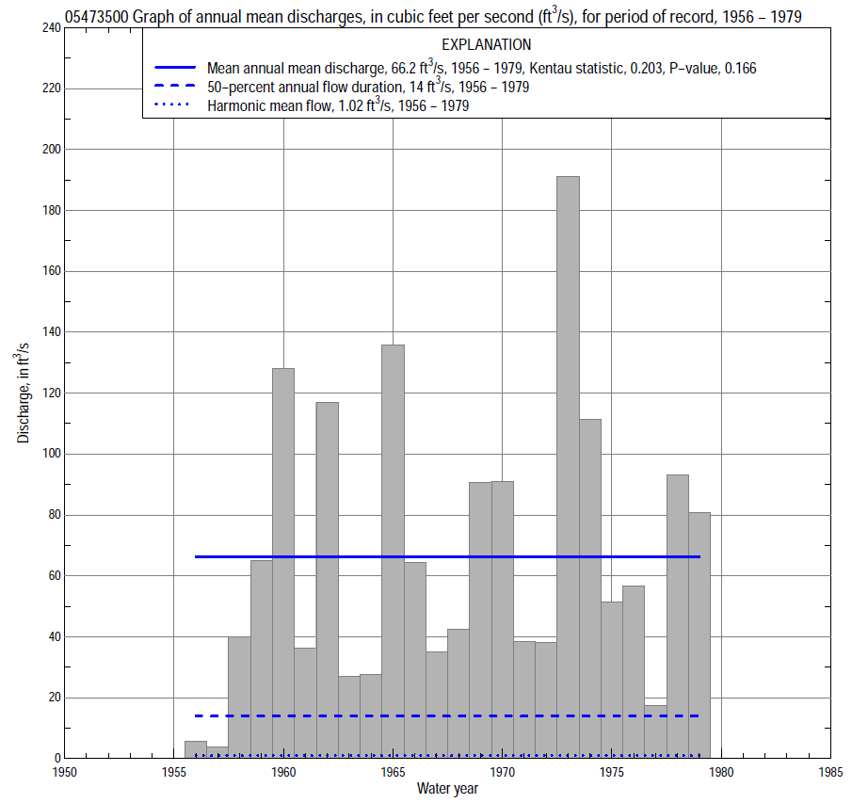

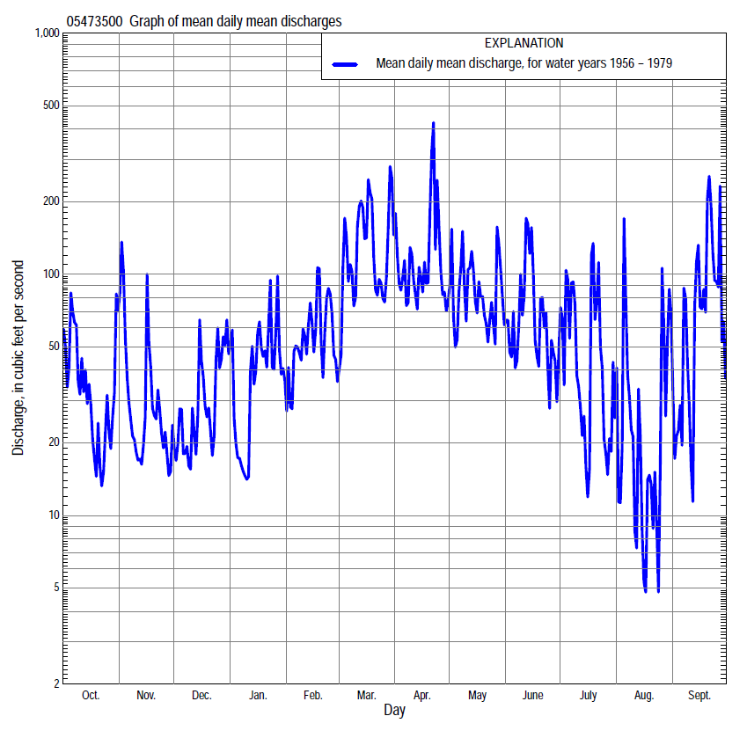

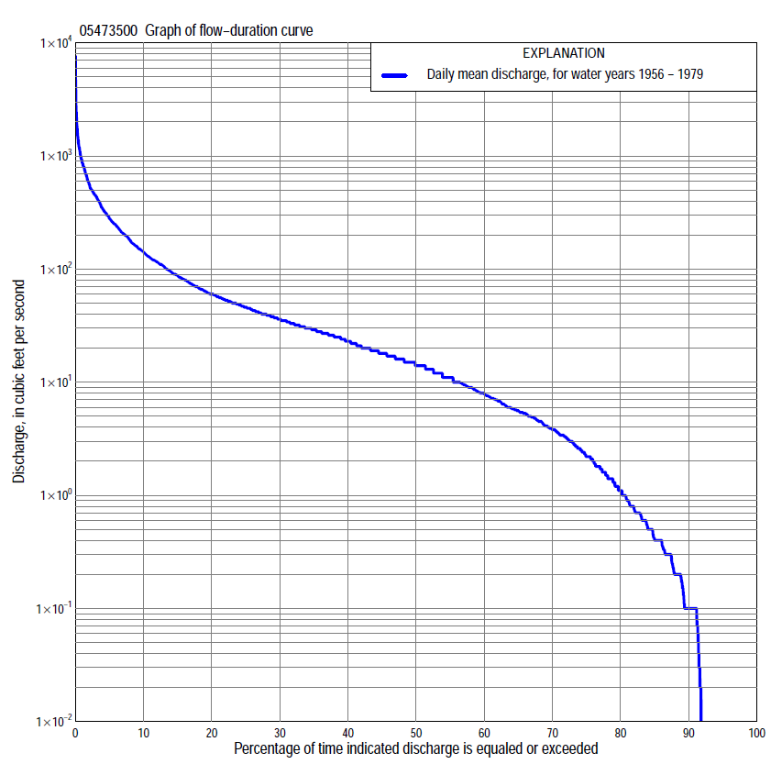

Statistics Based on the Entire Streamflow Period of Record
05473500 Monthly and annual flow durations, based on 1956–79 period of record (24 years)
[ND, not determined]
Percentage of days discharge equaled or exceeded |  |  |  |  | Discharge (cubic feet per second) |  |  |  |  |  |  |  |  | Annual flow durations
 | Oct | Nov | Dec | Jan | Feb | Mar | Apr | May | June | July | Aug | Sept | Annual | Kentau statistic | P-value
99 | 0.00 | 0.00 | 0.00 | 0.00 | 0.00 | 0.10 | 0.00 | 0.00 | 0.00 | 0.00 | 0.00 | 0.00 | 0.00 | 0.000 | ND
98 | 0.00 | 0.00 | 0.00 | 0.00 | 0.00 | 0.10 | 0.00 | 0.00 | 0.00 | 0.00 | 0.00 | 0.00 | 0.00 | 0.000 | ND
95 | 0.00 | 0.00 | 0.00 | 0.00 | 0.20 | 0.20 | 4.8 | 2.4 | 0.49 | 0.04 | 0.00 | 0.00 | 0.00 | 0.170 | 0.105
90 | 0.00 | 0.00 | 0.10 | 0.01 | 1.6 | 5.0 | 12 | 7.6 | 1.2 | 0.40 | 0.00 | 0.00 | 0.10 | 0.297 | 0.024
85 | 0.00 | 0.33 | 0.20 | 0.30 | 3.4 | 8.0 | 16 | 11 | 3.9 | 1.1 | 0.07 | 0.00 | 0.42 | 0.373 | 0.008
80 | 0.10 | 0.50 | 0.35 | 0.80 | 4.6 | 11 | 19 | 14 | 5.7 | 1.9 | 0.16 | 0.00 | 1.1 | 0.319 | 0.028
75 | 0.20 | 1.1 | 0.50 | 2.2 | 6.0 | 15 | 23 | 17 | 8.2 | 2.9 | 0.31 | 0.19 | 2.2 | 0.279 | 0.057
70 | 0.40 | 1.6 | 1.2 | 2.9 | 7.8 | 18 | 30 | 19 | 11 | 4.2 | 0.71 | 0.40 | 3.8 | 0.290 | 0.049
65 | 0.79 | 2.7 | 2.9 | 4.8 | 9.1 | 23 | 36 | 22 | 15 | 5.4 | 1.1 | 0.66 | 5.6 | 0.293 | 0.046
60 | 1.7 | 4.0 | 4.8 | 7.0 | 10 | 28 | 42 | 26 | 17 | 6.8 | 1.6 | 0.90 | 8.0 | 0.301 | 0.041
55 | 2.5 | 5.3 | 7.2 | 8.2 | 12 | 31 | 47 | 30 | 20 | 8.3 | 2.2 | 1.3 | 11 | 0.308 | 0.037
50 | 3.4 | 6.0 | 11 | 11 | 15 | 38 | 52 | 34 | 24 | 10 | 3.1 | 1.7 | 14 | 0.319 | 0.031
45 | 5.3 | 9.0 | 15 | 14 | 20 | 49 | 59 | 38 | 29 | 12 | 3.8 | 2.3 | 18 | 0.319 | 0.031
40 | 6.0 | 12 | 18 | 16 | 26 | 58 | 67 | 43 | 34 | 15 | 4.5 | 3.3 | 23 | 0.333 | 0.024
35 | 12 | 17 | 21 | 18 | 32 | 73 | 80 | 51 | 40 | 18 | 5.6 | 4.5 | 29 | 0.250 | 0.091
30 | 19 | 23 | 25 | 22 | 42 | 95 | 93 | 59 | 49 | 24 | 7.1 | 6.4 | 36 | 0.217 | 0.143
25 | 27 | 29 | 29 | 27 | 50 | 126 | 115 | 71 | 62 | 31 | 9.9 | 11 | 46 | 0.228 | 0.124
20 | 40 | 33 | 33 | 35 | 65 | 170 | 138 | 96 | 78 | 40 | 14 | 25 | 60 | 0.196 | 0.188
15 | 51 | 40 | 44 | 46 | 92 | 250 | 172 | 132 | 108 | 56 | 19 | 49 | 87 | 0.170 | 0.253
10 | 80 | 60 | 66 | 63 | 130 | 369 | 249 | 209 | 162 | 107 | 35 | 124 | 142 | 0.170 | 0.254
5 | 173 | 133 | 133 | 160 | 250 | 595 | 400 | 335 | 314 | 213 | 108 | 333 | 280 | 0.149 | 0.321
2 | 316 | 297 | 319 | 500 | 450 | 1,020 | 794 | 586 | 518 | 478 | 262 | 955 | 573 | 0.134 | 0.372
1 | 806 | 651 | 406 | 660 | 600 | 1,300 | 1,010 | 776 | 822 | 874 | 683 | 1,760 | 874 | 0.207 | 0.165

05473500 Annual exceedance probability of instantaneous peak discharges, in cubic feet per second (ft³/s), based on the Weighted Independent Estimates method,
Annual exceed-ance probability | Recur-rence interval (years) | Discharge (ft³/s) | 95-percent lower confi-dence interval (ft³/s) | 95-percent upper confi-dence interval (ft³/s)
0.500 | 2 | 2,190 | 1,630 | 2,940
0.200 | 5 | 4,530 | 3,460 | 5,930
0.100 | 10 | 6,620 | 5,070 | 8,650
0.040 | 25 | 9,830 | 7,410 | 13,000
0.020 | 50 | 12,100 | 8,930 | 16,500
0.010 | 100 | 14,400 | 10,200 | 20,300
0.005 | 200 | 18,000 | 12,200 | 26,400
0.002 | 500 | 20,300 | 13,100 | 31,500
and based on the expected moments algorithm/multiple Grubbs-Beck analysis computed using a historical period length of 32 years (1948–1979)
0.500 | 2 | 2,150 | 1,460 | 3,060
0.200 | 5 | 4,320 | 3,030 | 6,420
0.100 | 10 | 6,070 | 4,210 | 9,730
0.040 | 25 | 8,570 | 5,720 | 15,700
0.020 | 50 | 10,600 | 6,800 | 21,700
0.010 | 100 | 12,800 | 7,800 | 29,300
0.005 | 200 | 15,000 | 8,730 | 39,100
0.002 | 500 | 18,200 | 9,850 | 56,000
Kentau statistic |  | 0.167
P-value |  | 0.264
Begin year |  | 1956
End year |  | 1979
Number of peaks |  | 24

05473500 Annual exceedance probability of high discharges, based on 1956–79 period of record (24 years)
Annual exceedance probability | Recur-rence interval (years) | Maximum average discharge (ft³/s) for indicated number of consecutive days
 |  | 1 | 3 | 7 | 15 | 30
0.990 | 1.01 | 131 | 73 | 40 | 29 | 18
0.950 | 1.05 | 275 | 169 | 100 | 70 | 45
0.900 | 1.11 | 401 | 256 | 157 | 108 | 68
0.800 | 1.25 | 623 | 412 | 256 | 174 | 110
0.500 | 2 | 1,370 | 932 | 574 | 381 | 246
0.200 | 5 | 2,840 | 1,880 | 1,090 | 713 | 478
0.100 | 10 | 4,060 | 2,600 | 1,440 | 932 | 641
0.040 | 25 | 5,820 | 3,560 | 1,860 | 1,190 | 845
0.020 | 50 | 7,270 | 4,290 | 2,150 | 1,370 | 991
0.010 | 100 | 8,830 | 5,010 | 2,410 | 1,530 | 1,130
0.005 | 200 | 10,500 | 5,740 | 2,650 | 1,680 | 1,260
0.002 | 500 | 12,800 | 6,690 | 2,940 | 1,850 | 1,420
Kentau statistic |  | 0.221 | 0.188 | 0.203 | 0.225 | 0.232
P-value |  | 0.137 | 0.206 | 0.172 | 0.130 | 0.118

 | 05473500 Annual nonexceedance probability of low discharges, based on April 1956 to March 1979 period of record (23 years)
Annual nonexceed-ance probability | Recur-rence interval (years) | Minimum average discharge (cubic feet per second) for indicated number of consecutive days
 |  | 1 | 3 | 7 | 14 | 30 | 60 | 90 | 120 | 183
0.01 | 100 | 0.00 | 0.00 | 0.00 | 0.00 | 0.00 | 0.00 | 0.00 | 0.00 | 0.25
0.02 | 50 | 0.00 | 0.00 | 0.00 | 0.00 | 0.00 | 0.00 | 0.00 | 0.00 | 0.41
0.05 | 20 | 0.00 | 0.00 | 0.00 | 0.00 | 0.00 | 0.01 | 0.09 | 0.16 | 0.83
0.10 | 10 | 0.00 | 0.00 | 0.00 | 0.00 | 0.01 | 0.08 | 0.44 | 0.74 | 1.5
0.20 | 5 | 0.00 | 0.00 | 0.00 | 0.00 | 0.05 | 0.31 | 1.1 | 1.9 | 3.1
0.50 | 2 | 0.00 | 0.02 | 0.06 | 0.20 | 0.52 | 2.0 | 4.6 | 7.2 | 11
0.80 | 1.25 | 0.54 | 0.57 | 0.76 | 1.1 | 3.2 | 8.9 | 15 | 23 | 36
0.90 | 1.11 | 1.1 | 1.2 | 1.8 | 2.4 | 6.8 | 18 | 27 | 40 | 64
0.96 | 1.04 | 2.0 | 2.2 | 4.1 | 5.4 | 13 | 35 | 48 | 71 | 115
0.98 | 1.02 | 2.6 | 3.1 | 6.5 | 8.9 | 20 | 53 | 69 | 100 | 165
0.99 | 1.01 | 3.2 | 4.2 | 9.6 | 14 | 27 | 75 | 93 | 136 | 226
Kentau statistic |  | 0.170 | 0.166 | 0.162 | 0.130 | 0.249 | 0.233 | 0.225 | 0.225 | 0.265
P-value |  | 0.229 | 0.250 | 0.275 | 0.387 | 0.102 | 0.126 | 0.139 | 0.139 | 0.081

05473500 Annual nonexceedance probability of seasonal low discharges, based on October 1955 to September 1979 period of record (24 years)
Annual nonexceed-ance probability | Recur-rence interval (years) | Minimum average discharge (cubic feet per second) for indicated number of consecutive days
 |  | 1 | 7 | 14 | 30 |  | 1 | 7 | 14 | 30
 |  | January-February-March |  |  |  |  | April-May-June
0.01 | 100 | 0.00 | 0.00 | 0.00 | 0.00 |  | 0.00 | 0.00 | 0.00 | 0.00
0.02 | 50 | 0.00 | 0.00 | 0.00 | 0.00 |  | 0.00 | 0.00 | 0.00 | 0.00
0.05 | 20 | 0.00 | 0.00 | 0.00 | 0.00 |  | 0.03 | 0.08 | 0.16 | 1.0
0.10 | 10 | 0.00 | 0.00 | 0.00 | 0.13 |  | 0.31 | 0.58 | 1.0 | 3.8
0.20 | 5 | 0.33 | 0.42 | 0.62 | 1.3 |  | 1.1 | 1.9 | 3.0 | 8.3
0.50 | 2 | 3.3 | 4.1 | 4.9 | 9.3 |  | 6.1 | 8.6 | 12 | 25
0.80 | 1.25 | 12 | 15 | 16 | 30 |  | 20 | 26 | 33 | 56
0.90 | 1.11 | 21 | 24 | 27 | 46 |  | 31 | 40 | 48 | 80
0.96 | 1.04 | 33 | 36 | 41 | 68 |  | 46 | 60 | 67 | 111
0.98 | 1.02 | 43 | 45 | 52 | 83 |  | 57 | 74 | 80 | 134
0.99 | 1.01 | 52 | 54 | 63 | 96 |  | 67 | 88 | 92 | 157
Kentau statistic |  | 0.290 | 0.322 | 0.293 | 0.283 |  | 0.344 | 0.341 | 0.384 | 0.196
P-value |  | 0.050 | 0.029 | 0.047 | 0.056 |  | 0.020 | 0.021 | 0.009 | 0.189
 |  | July-August-September |  |  |  |  | October-November-December
0.01 | 100 | 0.00 | 0.00 | 0.00 | 0.00 |  | 0.00 | 0.00 | 0.00 | 0.00
0.02 | 50 | 0.00 | 0.00 | 0.00 | 0.00 |  | 0.00 | 0.00 | 0.00 | 0.00
0.05 | 20 | 0.00 | 0.00 | 0.00 | 0.00 |  | 0.00 | 0.00 | 0.00 | 0.00
0.10 | 10 | 0.00 | 0.00 | 0.00 | 0.01 |  | 0.00 | 0.00 | 0.00 | 0.00
0.20 | 5 | 0.00 | 0.00 | 0.00 | 0.27 |  | 0.00 | 0.00 | 0.00 | 0.19
0.50 | 2 | 0.00 | 0.09 | 0.26 | 1.1 |  | 0.74 | 1.2 | 2.0 | 3.1
0.80 | 1.25 | 0.50 | 0.96 | 1.4 | 3.7 |  | 6.0 | 9.1 | 12 | 15
0.90 | 1.11 | 0.90 | 2.0 | 2.7 | 6.5 |  | 15 | 20 | 26 | 31
0.96 | 1.04 | 1.7 | 3.8 | 5.2 | 12 |  | 36 | 44 | 51 | 60
0.98 | 1.02 | 2.8 | 5.0 | 7.7 | 17 |  | 61 | 69 | 75 | 90
0.99 | 1.01 | 4.3 | 6.7 | 11 | 23 |  | 101 | 103 | 104 | 128
Kentau statistic |  | 0.076 | 0.072 | 0.058 | 0.188 |  | 0.272 | 0.243 | 0.283 | 0.312
P-value |  | 0.595 | 0.628 | 0.706 | 0.206 |  | 0.063 | 0.097 | 0.055 | 0.035

