LOCATION.--Lat 40°45'13", long 91°16'37.0" referenced to North American Datum of 1927, in NE 1/4 NE 1/4 NE 1/4 sec.26, T.69 N., R.4 W., Des Moines County, IA, Hydrologic Unit 07080107, on left bank on downstream side of bridge on County Highway X38 in Augusta, 2.0 mi upstream from Long Creek, and 10.4 mi upstream from mouth.

DRAINAGE AREA.--4,312 mi².

PERIOD OF RECORD.--Discharge records from September to November 1913, October 1914 to current year. Prior to June 1915, monthly mean discharge for some periods published in WSP 1308.

GAGE.--Water-stage recorder. Datum of gage is 521.24 ft above National Geodetic Vertical Datum of 1929. September 30 to November 15, 1913, non-recording gage at site 400 ft upstream at datum 0.73 ft higher; October 1, 1914, to January 14, 1935, non-recording gage at site 400 ft upstream at same datum.

EXTREMES OUTSIDE PERIOD OF RECORD.--Since at least 1851, no flood outside the period of record exceeded the April 23, 1973, stage of 27.05 ft, discharge 66,800 ft³/s. Flood of June 1, 1903, reached a stage of about 21.0 ft, discharge about 45,000 ft³/s, at datum in use in 1913.

A summary of all available data for this streamgage is provided through the USGS National Water Information System web interface (NWISWeb). The following link provides access to current/historical observations, daily data, daily statistics, monthly statistics, annual statistics, peak streamflow, field measurements, field/lab water-quality samples, and the latest water-year summaries. Data can be filtered by parameter and/or dates, and can be output in various tabular and graphical formats.
http://waterdata.usgs.gov/nwis/inventory/?site_no=05474000

The USGS WaterWatch Toolkit is available at:
http://waterwatch.usgs.gov/?id=ww_toolkit
Tools for summarizing streamflow information include the duration hydrograph builder, the cumulative streamflow hydrograph builder, the streamgage statistics retrieval tool, the rating curve builder, the flood tracking chart builder, the National Weather Service Advanced Hydrologic Prediction Service (AHPS) river forecast hydrograph builder, and the raster-hydrograph builder. Entering the above number for this streamgage into these toolkit webpages will provide streamflow information specific to this streamgage.

A description of the statistics presented for this streamgage is available in the main body of the report at:
http://dx.doi.org/10.3133/ofr20151214
A link to other streamgages included in this report, a map showing the location of the streamgages, information on the programs used to compute the statistical analyses, and references are included in the main body of the report.

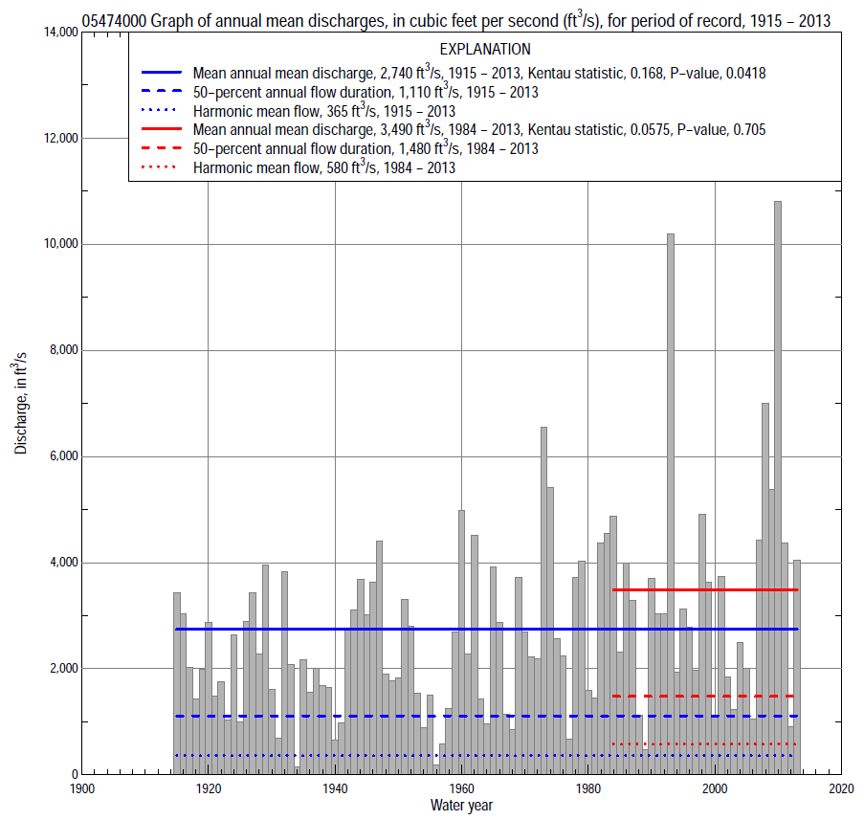

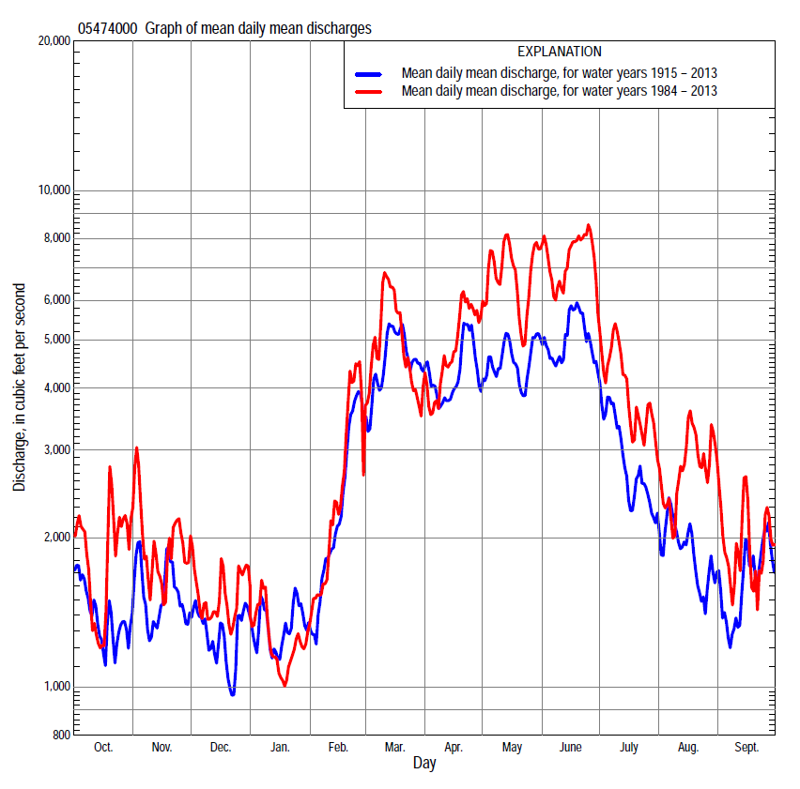

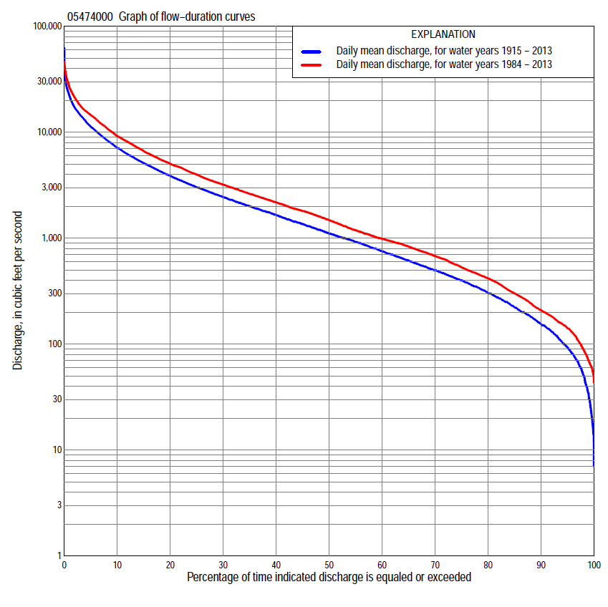

Statistics Based on the Entire Streamflow Period of Record
05474000 Monthly and annual flow durations, based on 1915–2013 period of record (99 years)
Percentage of days discharge equaled or exceeded |  |  |  |  | Discharge (cubic feet per second) |  |  |  |  |  |  |  |  | Annual flow durations
 | Oct | Nov | Dec | Jan | Feb | Mar | Apr | May | June | July | Aug | Sept | Annual | Kentau statistic | P-value
99 | 18 | 30 | 20 | 17 | 24 | 119 | 111 | 95 | 90 | 82 | 52 | 42 | 33 | 0.181 | 0.008
98 | 39 | 42 | 30 | 22 | 45 | 142 | 171 | 134 | 140 | 103 | 75 | 52 | 51 | 0.165 | 0.016
95 | 68 | 65 | 50 | 37 | 91 | 294 | 407 | 325 | 344 | 184 | 120 | 78 | 93 | 0.157 | 0.021
90 | 96 | 109 | 80 | 80 | 150 | 508 | 658 | 529 | 505 | 324 | 189 | 122 | 155 | 0.171 | 0.012
85 | 129 | 142 | 110 | 140 | 220 | 681 | 915 | 711 | 667 | 435 | 242 | 163 | 225 | 0.175 | 0.010
80 | 152 | 192 | 155 | 180 | 300 | 933 | 1,120 | 904 | 851 | 542 | 297 | 196 | 307 | 0.152 | 0.026
75 | 179 | 252 | 200 | 223 | 400 | 1,150 | 1,300 | 1,130 | 1,090 | 659 | 349 | 228 | 400 | 0.150 | 0.028
70 | 205 | 325 | 267 | 260 | 510 | 1,380 | 1,440 | 1,390 | 1,370 | 781 | 400 | 265 | 500 | 0.145 | 0.034
65 | 252 | 415 | 330 | 326 | 600 | 1,670 | 1,680 | 1,660 | 1,660 | 936 | 455 | 300 | 620 | 0.134 | 0.050
60 | 314 | 506 | 392 | 380 | 730 | 1,980 | 1,900 | 2,010 | 1,970 | 1,070 | 518 | 350 | 757 | 0.139 | 0.042
55 | 387 | 605 | 474 | 450 | 960 | 2,270 | 2,160 | 2,300 | 2,320 | 1,240 | 582 | 408 | 923 | 0.153 | 0.025
50 | 455 | 709 | 553 | 553 | 1,110 | 2,610 | 2,510 | 2,670 | 2,730 | 1,430 | 668 | 468 | 1,110 | 0.164 | 0.016
45 | 566 | 812 | 697 | 650 | 1,370 | 2,980 | 2,900 | 3,120 | 3,120 | 1,650 | 792 | 558 | 1,360 | 0.167 | 0.014
40 | 713 | 949 | 820 | 780 | 1,740 | 3,510 | 3,330 | 3,590 | 3,720 | 1,870 | 913 | 681 | 1,660 | 0.167 | 0.014
35 | 907 | 1,120 | 1,010 | 900 | 2,100 | 4,160 | 3,930 | 4,240 | 4,520 | 2,170 | 1,050 | 805 | 2,000 | 0.167 | 0.015
30 | 1,140 | 1,330 | 1,220 | 1,100 | 2,590 | 5,000 | 4,530 | 4,920 | 5,360 | 2,570 | 1,240 | 950 | 2,450 | 0.178 | 0.009
25 | 1,510 | 1,630 | 1,520 | 1,400 | 3,160 | 6,140 | 5,220 | 5,810 | 6,360 | 3,150 | 1,490 | 1,140 | 3,020 | 0.179 | 0.009
20 | 1,970 | 2,020 | 1,890 | 1,740 | 4,000 | 7,270 | 6,080 | 6,970 | 7,740 | 3,880 | 1,890 | 1,540 | 3,880 | 0.184 | 0.007
15 | 2,570 | 2,620 | 2,350 | 2,110 | 4,930 | 9,020 | 7,760 | 8,290 | 9,680 | 5,170 | 2,530 | 2,300 | 5,110 | 0.179 | 0.009
10 | 3,640 | 3,520 | 3,120 | 2,900 | 6,240 | 11,200 | 10,300 | 10,800 | 12,800 | 7,060 | 3,740 | 3,710 | 7,160 | 0.163 | 0.017
5 | 5,920 | 5,770 | 4,500 | 5,100 | 9,370 | 15,400 | 14,500 | 15,800 | 17,900 | 11,600 | 7,990 | 8,460 | 11,300 | 0.144 | 0.035
2 | 9,620 | 11,100 | 7,840 | 9,630 | 12,900 | 21,100 | 19,600 | 22,000 | 25,500 | 16,400 | 16,200 | 14,500 | 17,000 | 0.114 | 0.095
1 | 13,200 | 14,500 | 10,600 | 13,500 | 15,000 | 25,000 | 25,800 | 25,800 | 30,000 | 21,600 | 23,500 | 18,500 | 21,800 | 0.095 | 0.166

05474000 Annual exceedance probability of instantaneous peak discharges, in cubic feet per second (ft³/s), based on the Weighted Independent Estimates method,
Annual exceed-ance probability | Recur-rence interval (years) | Discharge (ft³/s) | 95-percent lower confi-dence interval (ft³/s) | 95-percent upper confi-dence interval (ft³/s)
0.500 | 2 | 21,400 | 19,700 | 23,100
0.200 | 5 | 31,200 | 28,900 | 33,700
0.100 | 10 | 37,300 | 34,300 | 40,500
0.040 | 25 | 44,700 | 40,400 | 49,500
0.020 | 50 | 49,800 | 44,100 | 56,300
0.010 | 100 | 54,600 | 47,300 | 63,100
0.005 | 200 | 60,100 | 50,800 | 71,100
0.002 | 500 | 65,300 | 53,400 | 79,900
and based on the expected moments algorithm/multiple Grubbs-Beck analysis computed using a historical period length of 162 years (1852–2013)
0.500 | 2 | 21,400 | 19,300 | 23,600
0.200 | 5 | 31,300 | 28,500 | 34,400
0.100 | 10 | 37,500 | 34,100 | 41,400
0.040 | 25 | 44,800 | 40,400 | 50,600
0.020 | 50 | 50,000 | 44,600 | 57,800
0.010 | 100 | 54,800 | 48,100 | 65,300
0.005 | 200 | 59,400 | 51,200 | 73,200
0.002 | 500 | 65,200 | 54,700 | 84,200
Kentau statistic |  | 0.081
P-value |  | 0.238
Begin year |  | 1915
End year |  | 2013
Number of peaks |  | 99

05474000 Annual exceedance probability of high discharges, based on 1915–2013 period of record (99 years)
[ND, not determined]
Annual exceed-ance probability | Recur-rence interval (years) | Maximum average discharge (ft³/s) for indicated number of consecutive days
 |  | 1 | 3 | 7 | 15 | 30
0.990 | 1.01 | ND | 2,460 | 1,710 | 1,040 | 749
0.950 | 1.05 | ND | 5,290 | 3,960 | 2,710 | 1,980
0.900 | 1.11 | ND | 7,520 | 5,820 | 4,170 | 3,060
0.800 | 1.25 | ND | 11,000 | 8,750 | 6,530 | 4,830
0.500 | 2 | ND | 19,600 | 16,200 | 12,500 | 9,330
0.200 | 5 | ND | 29,600 | 24,600 | 18,900 | 14,100
0.100 | 10 | ND | 34,500 | 28,600 | 21,700 | 16,200
0.040 | 25 | ND | 39,300 | 32,200 | 23,900 | 17,900
0.020 | 50 | ND | 41,900 | 34,100 | 25,000 | 18,700
0.010 | 100 | ND | 43,900 | 35,500 | 25,700 | 19,300
0.005 | 200 | ND | 45,500 | 36,600 | 26,200 | 19,600
0.002 | 500 | ND | 47,100 | 37,600 | 26,600 | 19,900
Kentau statistic |  | 0.097 | 0.102 | 0.100 | 0.129 | 0.157
P-value |  | 0.155 | 0.134 | 0.144 | 0.058 | 0.021

 | 05474000 Annual nonexceedance probability of low discharges, based on April 1915 to March 2013 period of record (98 years)
Annual nonexceed-ance probability | Recur-rence interval (years) | Minimum average discharge (ft³/s) for indicated number of consecutive days
 |  | 1 | 3 | 7 | 14 | 30 | 60 | 90 | 120 | 183
0.01 | 100 | 7.7 | 8.6 | 9.0 | 11 | 13 | 20 | 24 | 27 | 52
0.02 | 50 | 11 | 13 | 13 | 16 | 19 | 29 | 35 | 40 | 73
0.05 | 20 | 19 | 22 | 24 | 28 | 33 | 50 | 61 | 73 | 121
0.10 | 10 | 31 | 35 | 38 | 44 | 53 | 78 | 99 | 119 | 186
0.20 | 5 | 53 | 59 | 65 | 74 | 91 | 132 | 171 | 211 | 306
0.50 | 2 | 137 | 151 | 167 | 187 | 235 | 334 | 452 | 566 | 752
0.80 | 1.25 | 322 | 343 | 376 | 420 | 540 | 777 | 1,070 | 1,340 | 1,720
0.90 | 1.11 | 486 | 505 | 548 | 617 | 799 | 1,170 | 1,620 | 2,000 | 2,570
0.96 | 1.04 | 734 | 739 | 792 | 899 | 1,170 | 1,760 | 2,450 | 2,950 | 3,860
0.98 | 1.02 | 929 | 930 | 987 | 1,130 | 1,480 | 2,260 | 3,150 | 3,740 | 4,970
0.99 | 1.01 | 1,120 | 1,130 | 1,190 | 1,370 | 1,810 | 2,810 | 3,900 | 4,560 | 6,190
Kentau statistic |  | 0.273 | 0.241 | 0.209 | 0.201 | 0.168 | 0.131 | 0.124 | 0.113 | 0.126
P-value |  | 0.000 | 0.000 | 0.002 | 0.003 | 0.014 | 0.055 | 0.069 | 0.099 | 0.065

05474000 Annual nonexceedance probability of seasonal low discharges, based on October 1914 to September 2013 period of record (99 years)
Annual nonexceed-ance probability | Recur-rence interval (years) | Minimum average discharge (cubic feet per second) for indicated number of consecutive days
 |  | 1 | 7 | 14 | 30 |  | 1 | 7 | 14 | 30
 |  | January-February-March |  |  |  |  | April-May-June
0.01 | 100 | 10 | 11 | 12 | 19 |  | 51 | 73 | 86 | 108
0.02 | 50 | 16 | 18 | 19 | 29 |  | 74 | 102 | 121 | 156
0.05 | 20 | 29 | 33 | 37 | 56 |  | 127 | 165 | 197 | 264
0.10 | 10 | 50 | 56 | 64 | 95 |  | 198 | 250 | 298 | 412
0.20 | 5 | 91 | 103 | 119 | 176 |  | 329 | 402 | 482 | 687
0.50 | 2 | 266 | 302 | 355 | 521 |  | 796 | 937 | 1,130 | 1,680
0.80 | 1.25 | 696 | 789 | 912 | 1,350 |  | 1,720 | 2,010 | 2,460 | 3,720
0.90 | 1.11 | 1,100 | 1,250 | 1,410 | 2,130 |  | 2,450 | 2,890 | 3,560 | 5,410
0.96 | 1.04 | 1,750 | 1,970 | 2,170 | 3,320 |  | 3,470 | 4,160 | 5,170 | 7,840
0.98 | 1.02 | 2,320 | 2,600 | 2,800 | 4,350 |  | 4,280 | 5,200 | 6,500 | 9,810
0.99 | 1.01 | 2,960 | 3,300 | 3,470 | 5,480 |  | 5,110 | 6,300 | 7,910 | 11,900
Kentau statistic |  | 0.170 | 0.171 | 0.158 | 0.123 |  | 0.251 | 0.235 | 0.259 | 0.225
P-value |  | 0.013 | 0.012 | 0.021 | 0.072 |  | 0.000 | 0.001 | 0.000 | 0.001
 |  | July-August-September |  |  |  |  | October-November-December
0.01 | 100 | 17 | 23 | 33 | 54 |  | 9.8 | 14 | 16 | 19
0.02 | 50 | 23 | 30 | 42 | 66 |  | 15 | 19 | 22 | 28
0.05 | 20 | 36 | 47 | 60 | 90 |  | 25 | 33 | 38 | 49
0.10 | 10 | 53 | 68 | 83 | 121 |  | 41 | 53 | 60 | 79
0.20 | 5 | 85 | 107 | 126 | 177 |  | 73 | 90 | 103 | 138
0.50 | 2 | 207 | 250 | 283 | 388 |  | 206 | 243 | 278 | 382
0.80 | 1.25 | 485 | 574 | 665 | 921 |  | 540 | 614 | 707 | 981
0.90 | 1.11 | 748 | 880 | 1,060 | 1,500 |  | 870 | 973 | 1,120 | 1,560
0.96 | 1.04 | 1,180 | 1,380 | 1,750 | 2,570 |  | 1,420 | 1,560 | 1,810 | 2,510
0.98 | 1.02 | 1,570 | 1,840 | 2,440 | 3,710 |  | 1,920 | 2,100 | 2,450 | 3,370
0.99 | 1.01 | 2,020 | 2,370 | 3,300 | 5,200 |  | 2,510 | 2,720 | 3,190 | 4,360
Kentau statistic |  | 0.189 | 0.149 | 0.126 | 0.106 |  | 0.142 | 0.109 | 0.108 | 0.111
P-value |  | 0.006 | 0.029 | 0.065 | 0.120 |  | 0.037 | 0.110 | 0.115 | 0.105

Statistics Based on the 1984–2013 Streamflow Period of Record
05474000 Monthly and annual flow durations, based on 1984–2013 period of record (30 years)
Percentage of days discharge equaled or exceeded |  |  |  |  | Discharge (cubic feet per second) |  |  |  |  |  |  |  |  | Annual flow durations
 | Oct | Nov | Dec | Jan | Feb | Mar | Apr | May | June | July | Aug | Sept | Annual | Kentau statistic | P-value
99 | 52 | 72 | 59 | 70 | 76 | 163 | 156 | 179 | 216 | 108 | 74 | 60 | 68 | 0.041 | 0.762
98 | 55 | 104 | 65 | 83 | 82 | 281 | 207 | 432 | 257 | 124 | 82 | 64 | 89 | 0.053 | 0.695
95 | 130 | 134 | 86 | 104 | 105 | 450 | 446 | 560 | 450 | 176 | 123 | 106 | 149 | 0.034 | 0.803
90 | 152 | 182 | 138 | 150 | 264 | 713 | 799 | 802 | 653 | 319 | 194 | 158 | 219 | 0.011 | 0.943
85 | 180 | 214 | 164 | 193 | 406 | 960 | 1,010 | 1,230 | 861 | 565 | 311 | 200 | 315 | 0.044 | 0.748
80 | 196 | 308 | 228 | 273 | 514 | 1,170 | 1,190 | 1,680 | 1,150 | 747 | 382 | 222 | 433 | 0.037 | 0.789
75 | 219 | 423 | 302 | 352 | 627 | 1,490 | 1,400 | 2,060 | 1,640 | 930 | 420 | 253 | 554 | 0.021 | 0.887
70 | 260 | 482 | 476 | 430 | 779 | 1,830 | 1,760 | 2,500 | 2,220 | 1,080 | 487 | 279 | 700 | -0.023 | 0.872
65 | 307 | 582 | 600 | 490 | 943 | 2,030 | 2,110 | 3,090 | 2,660 | 1,230 | 558 | 309 | 850 | -0.021 | 0.887
60 | 374 | 709 | 701 | 572 | 1,040 | 2,270 | 2,580 | 3,570 | 3,340 | 1,440 | 625 | 352 | 1,000 | -0.062 | 0.643
55 | 424 | 819 | 826 | 670 | 1,200 | 2,640 | 2,930 | 4,340 | 3,990 | 1,650 | 688 | 406 | 1,200 | -0.067 | 0.617
50 | 546 | 920 | 980 | 780 | 1,450 | 3,000 | 3,300 | 4,770 | 4,690 | 1,880 | 781 | 473 | 1,500 | -0.023 | 0.872
45 | 729 | 1,090 | 1,130 | 919 | 1,780 | 3,380 | 3,780 | 5,350 | 5,350 | 2,180 | 876 | 573 | 1,820 | 0.005 | 0.986
40 | 853 | 1,290 | 1,390 | 1,020 | 2,080 | 3,910 | 4,320 | 6,030 | 6,160 | 2,600 | 981 | 703 | 2,190 | 0.011 | 0.943
35 | 1,000 | 1,550 | 1,620 | 1,340 | 2,450 | 4,580 | 4,940 | 6,980 | 7,080 | 3,090 | 1,130 | 861 | 2,630 | -0.002 | 1.000
30 | 1,260 | 1,810 | 1,780 | 1,500 | 2,900 | 5,390 | 5,510 | 7,800 | 8,270 | 3,610 | 1,350 | 1,040 | 3,200 | 0.021 | 0.887
25 | 1,880 | 2,120 | 2,040 | 1,700 | 3,310 | 6,310 | 6,140 | 8,840 | 9,670 | 4,370 | 1,680 | 1,340 | 3,970 | 0.041 | 0.762
20 | 2,530 | 2,680 | 2,340 | 1,940 | 3,890 | 7,550 | 7,120 | 10,100 | 12,000 | 5,340 | 2,230 | 2,040 | 5,000 | 0.080 | 0.544
15 | 3,350 | 3,190 | 2,760 | 2,300 | 4,660 | 8,960 | 8,490 | 12,700 | 14,800 | 7,200 | 3,280 | 2,940 | 6,580 | 0.055 | 0.682
10 | 4,440 | 4,320 | 3,370 | 2,610 | 5,790 | 11,600 | 11,500 | 15,900 | 18,100 | 11,200 | 7,740 | 5,420 | 9,110 | 0.122 | 0.354
5 | 7,950 | 7,250 | 4,480 | 3,300 | 10,700 | 15,900 | 15,200 | 21,000 | 24,000 | 14,800 | 15,200 | 10,600 | 14,400 | 0.131 | 0.318
2 | 14,900 | 13,200 | 7,410 | 5,650 | 14,000 | 24,200 | 18,700 | 26,300 | 32,400 | 22,900 | 25,600 | 14,700 | 20,500 | 0.069 | 0.605
1 | 17,500 | 19,200 | 10,600 | 8,530 | 16,800 | 28,900 | 22,400 | 32,000 | 37,500 | 29,900 | 30,800 | 17,600 | 25,600 | 0.103 | 0.432

05474000 Annual exceedance probability of high discharges, based on 1984–2013 period of record (30 years)
Annual exceed-ance probability | Recur-rence interval (years) | Maximum average discharge (ft³/s) for indicated number of consecutive days
 |  | 1 | 3 | 7 | 15 | 30
0.990 | 1.01 | 5,500 | 4,700 | 3,880 | 2,520 | 1,800
0.950 | 1.05 | 8,820 | 7,740 | 6,240 | 4,350 | 3,210
0.900 | 1.11 | 11,100 | 9,900 | 7,940 | 5,700 | 4,270
0.800 | 1.25 | 14,500 | 13,100 | 10,500 | 7,780 | 5,910
0.500 | 2 | 23,000 | 21,200 | 17,200 | 13,400 | 10,300
0.200 | 5 | 34,100 | 32,300 | 27,100 | 21,400 | 16,600
0.100 | 10 | 40,900 | 39,100 | 33,700 | 26,800 | 20,700
0.040 | 25 | 48,800 | 47,200 | 42,000 | 33,300 | 25,500
0.020 | 50 | 54,200 | 52,800 | 48,100 | 37,900 | 28,900
0.010 | 100 | 59,300 | 58,100 | 54,100 | 42,400 | 32,200
0.005 | 200 | 64,000 | 63,000 | 60,000 | 46,700 | 35,200
0.002 | 500 | 69,800 | 69,100 | 67,800 | 52,200 | 39,000
Kentau statistic |  | 0.122 | 0.126 | 0.083 | 0.094 | 0.085
P-value |  | 0.353 | 0.335 | 0.532 | 0.475 | 0.521

 | 05474000 Annual nonexceedance probability of low discharges, based on April 1983 to March 2013 period of record (30 years)
Annual nonexceed-ance probability | Recur-rence interval (years) | Minimum average discharge (ft³/s) for indicated number of consecutive days
 |  | 1 | 3 | 7 | 14 | 30 | 60 | 90 | 120 | 183
0.01 | 100 | 23 | 25 | 27 | 28 | 34 | 49 | 54 | 56 | 68
0.02 | 50 | 30 | 33 | 35 | 38 | 45 | 63 | 71 | 76 | 95
0.05 | 20 | 47 | 50 | 52 | 57 | 69 | 91 | 107 | 119 | 157
0.10 | 10 | 67 | 71 | 75 | 82 | 98 | 127 | 153 | 177 | 240
0.20 | 5 | 103 | 108 | 113 | 125 | 151 | 191 | 238 | 285 | 395
0.50 | 2 | 224 | 231 | 243 | 274 | 332 | 425 | 555 | 692 | 975
0.80 | 1.25 | 461 | 474 | 505 | 576 | 707 | 961 | 1,300 | 1,630 | 2,250
0.90 | 1.11 | 658 | 678 | 730 | 836 | 1,040 | 1,490 | 2,020 | 2,540 | 3,390
0.96 | 1.04 | 947 | 982 | 1,070 | 1,230 | 1,540 | 2,380 | 3,250 | 4,020 | 5,140
0.98 | 1.02 | 1,190 | 1,240 | 1,360 | 1,560 | 1,980 | 3,230 | 4,420 | 5,390 | 6,670
0.99 | 1.01 | 1,450 | 1,520 | 1,680 | 1,940 | 2,480 | 4,270 | 5,830 | 6,990 | 8,370
Kentau statistic |  | 0.044 | 0.034 | 0.039 | 0.025 | -0.007 | 0.007 | -0.011 | -0.025 | -0.076
P-value |  | 0.748 | 0.803 | 0.775 | 0.858 | 0.972 | 0.972 | 0.943 | 0.858 | 0.568

05474000 Annual nonexceedance probability of seasonal low discharges, based on October 1983 to September 2013 period of record (30 years)
Annual nonexceed-ance probability | Recur-rence interval (years) | Minimum average discharge (cubic feet per second) for indicated number of consecutive days
 |  | 1 | 7 | 14 | 30 |  | 1 | 7 | 14 | 30
 |  | January-February-March |  |  |  |  | April-May-June
0.01 | 100 | 21 | 27 | 34 | 50 |  | 81 | 90 | 91 | 135
0.02 | 50 | 31 | 40 | 49 | 70 |  | 118 | 133 | 137 | 200
0.05 | 20 | 56 | 70 | 85 | 114 |  | 203 | 229 | 249 | 352
0.10 | 10 | 91 | 112 | 134 | 175 |  | 319 | 359 | 409 | 566
0.20 | 5 | 160 | 194 | 226 | 287 |  | 530 | 598 | 713 | 974
0.50 | 2 | 426 | 499 | 560 | 694 |  | 1,260 | 1,430 | 1,810 | 2,500
0.80 | 1.25 | 1,010 | 1,140 | 1,240 | 1,560 |  | 2,620 | 3,000 | 3,920 | 5,690
0.90 | 1.11 | 1,510 | 1,670 | 1,800 | 2,310 |  | 3,650 | 4,210 | 5,520 | 8,340
0.96 | 1.04 | 2,250 | 2,430 | 2,590 | 3,440 |  | 5,020 | 5,820 | 7,610 | 12,100
0.98 | 1.02 | 2,860 | 3,040 | 3,220 | 4,390 |  | 6,040 | 7,050 | 9,170 | 15,200
0.99 | 1.01 | 3,510 | 3,680 | 3,880 | 5,430 |  | 7,050 | 8,280 | 10,700 | 18,300
Kentau statistic |  | -0.002 | 0.030 | 0.025 | 0.016 |  | 0.149 | 0.154 | 0.195 | 0.223
P-value |  | 1.000 | 0.830 | 0.858 | 0.915 |  | 0.254 | 0.239 | 0.134 | 0.087
 |  | July-August-September |  |  |  |  | October-November-December
0.01 | 100 | 57 | 59 | 67 | 81 |  | 24 | 28 | 29 | 35
0.02 | 50 | 63 | 67 | 74 | 92 |  | 32 | 37 | 40 | 50
0.05 | 20 | 77 | 82 | 91 | 115 |  | 50 | 57 | 62 | 82
0.10 | 10 | 94 | 102 | 113 | 145 |  | 74 | 84 | 92 | 126
0.20 | 5 | 126 | 139 | 154 | 202 |  | 119 | 133 | 147 | 209
0.50 | 2 | 257 | 292 | 330 | 455 |  | 288 | 318 | 356 | 521
0.80 | 1.25 | 652 | 770 | 908 | 1,310 |  | 688 | 749 | 837 | 1,220
0.90 | 1.11 | 1,160 | 1,410 | 1,710 | 2,540 |  | 1,080 | 1,170 | 1,300 | 1,850
0.96 | 1.04 | 2,330 | 2,880 | 3,670 | 5,600 |  | 1,730 | 1,860 | 2,050 | 2,840
0.98 | 1.02 | 3,800 | 4,790 | 6,310 | 9,800 |  | 2,340 | 2,520 | 2,740 | 3,700
0.99 | 1.01 | 6,080 | 7,770 | 10,600 | 16,700 |  | 3,070 | 3,300 | 3,560 | 4,670
Kentau statistic |  | 0.062 | 0.048 | 0.021 | 0.023 |  | -0.002 | -0.011 | 0.007 | -0.067
P-value |  | 0.643 | 0.721 | 0.887 | 0.872 |  | 1.000 | 0.943 | 0.972 | 0.617

