LOCATION.--Lat 40°23'37", long 91°22'27" referenced to North American Datum of 1927, in SE 1/4 SW 1/4 sec.30, T.65 N., R.4 W., Lee County, IA, Hydrologic Unit 07080104, near right bank in tailwater of dam and power plant of AmerenUE in Keokuk, 0.2 mi upstream from bridge on U.S. Highway 136, 2.7 mi upstream from Des Moines River, and 364.2 mi upstream from Ohio River.

DRAINAGE AREA.--119,000 mi².

PERIOD OF RECORD.--Discharge records from January 1878 to current year.

GAGE.--Datum of gage is 477.41 ft above National Geodetic Vertical Datum of 1929 (levels by U.S. Army Corps of Engineers). January 1, 1878, to May 1913, non-recording gage at Galland (formerly Nashville), 8 mi upstream, with datum of gage set to low-water mark of 1864, or 496.94 ft above Mean Sea Level, general adjustment of 1912.

COOPERATION.--Records provided by AmerenUE (formerly Union Electric Company).

REMARKS.--Discharge computed from records of operation of turbines in power plant and spillway gates at dam. Minor flow regulation caused by power plant since 1913 and navigation dams. Records for May 1913 to September 1937 adjusted for change in contents in Keokuk Reservoir, those after September 1937 unadjusted.

EXTREMES OUTSIDE PERIOD OF RECORD.--Flood of June 6, 1851, reached a stage of 21.0 ft, at current site and datum, estimated as 13.5 ft at Galland, discharge 360,000 ft³/s.

A summary of all available data for this streamgage is provided through the USGS National Water Information System web interface (NWISWeb). The following link provides access to current/historical observations, daily data, daily statistics, monthly statistics, annual statistics, peak streamflow, field measurements, field/lab water-quality samples, and the latest water-year summaries. Data can be filtered by parameter and/or dates, and can be output in various tabular and graphical formats.
http://waterdata.usgs.gov/nwis/inventory/?site_no=05474500

The USGS WaterWatch Toolkit is available at:
http://waterwatch.usgs.gov/?id=ww_toolkit
Tools for summarizing streamflow information include the duration hydrograph builder, the cumulative streamflow hydrograph builder, the streamgage statistics retrieval tool, the rating curve builder, the flood tracking chart builder, the National Weather Service Advanced Hydrologic Prediction Service (AHPS) river forecast hydrograph builder, and the raster-hydrograph builder. Entering the above number for this streamgage into these toolkit webpages will provide streamflow information specific to this streamgage.

A description of the statistics presented for this streamgage is available in the main body of the report at:
http://dx.doi.org/10.3133/ofr20151214
A link to other streamgages included in this report, a map showing the location of the streamgages, information on the programs used to compute the statistical analyses, and references are included in the main body of the report.

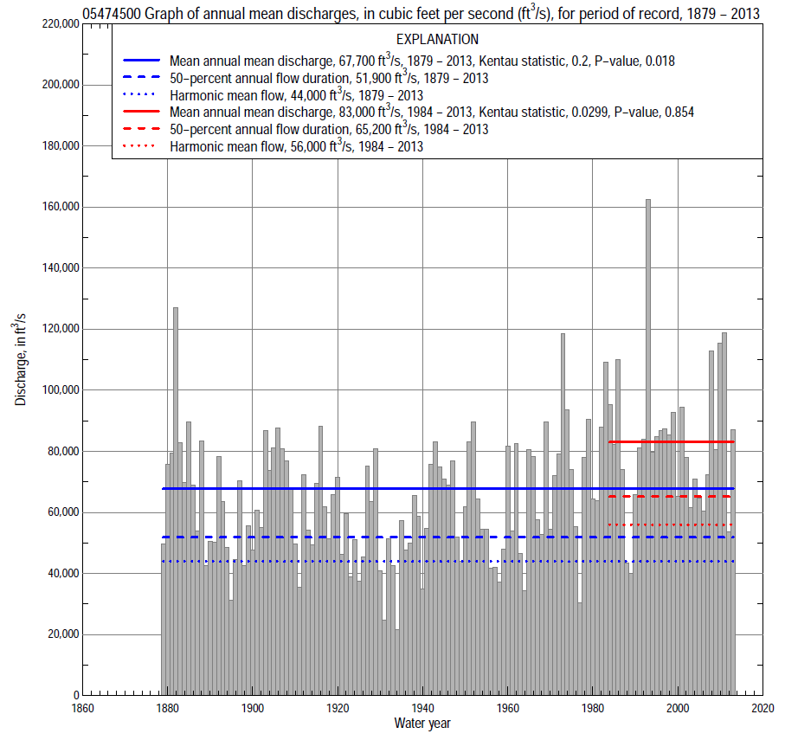

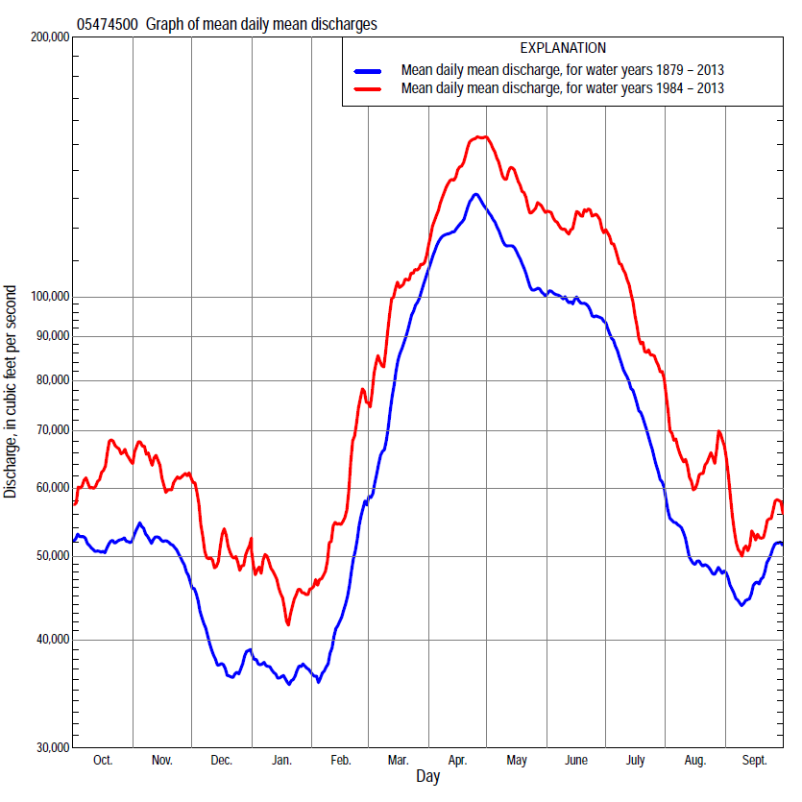

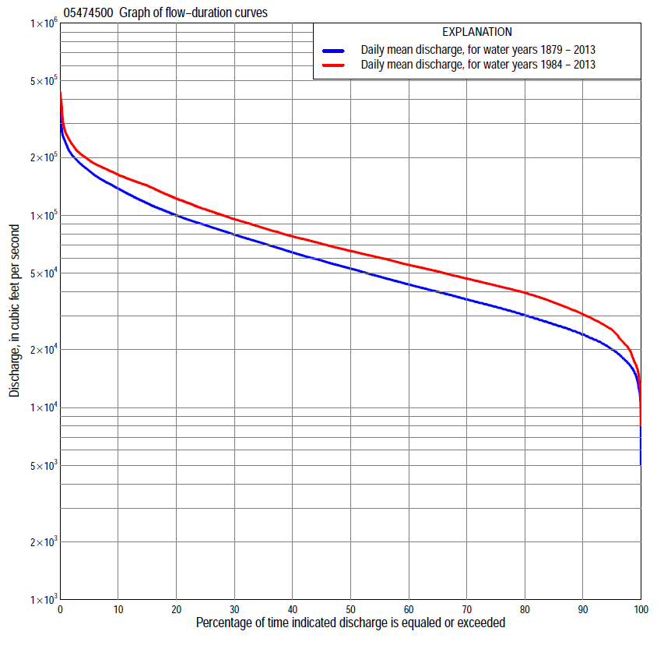

Statistics Based on the Entire Streamflow Period of Record
05474500 Monthly and annual flow durations, based on 1881–2013 period of record (133 years)
Percentage of days discharge equaled or exceeded |  |  |  |  | Discharge (cubic feet per second) |  |  |  |  |  |  |  |  | Annual flow durations
 | Oct | Nov | Dec | Jan | Feb | Mar | Apr | May | June | July | Aug | Sept | Annual | Kentau statistic | P-value
99 | 15,600 | 17,000 | 10,500 | 13,000 | 14,000 | 21,000 | 31,200 | 25,500 | 19,000 | 16,800 | 12,700 | 14,100 | 14,900 | 0.308 | 0.000
98 | 16,800 | 18,800 | 12,200 | 15,000 | 16,000 | 23,100 | 34,000 | 29,500 | 24,000 | 20,000 | 15,000 | 16,000 | 16,500 | 0.293 | 0.000
95 | 19,300 | 21,400 | 15,000 | 17,000 | 17,700 | 28,000 | 42,800 | 39,300 | 31,700 | 24,200 | 19,500 | 18,700 | 19,900 | 0.265 | 0.000
90 | 22,500 | 23,000 | 18,000 | 19,000 | 20,300 | 33,500 | 53,500 | 49,900 | 41,100 | 29,500 | 22,800 | 21,600 | 23,300 | 0.275 | 0.000
85 | 24,200 | 25,800 | 20,500 | 20,300 | 22,800 | 37,600 | 63,500 | 56,000 | 47,300 | 34,300 | 25,900 | 24,200 | 26,500 | 0.262 | 0.000
80 | 26,000 | 28,500 | 22,500 | 22,000 | 24,400 | 42,500 | 71,600 | 63,500 | 53,900 | 38,000 | 28,300 | 26,200 | 29,500 | 0.254 | 0.000
75 | 27,600 | 31,200 | 24,500 | 23,600 | 26,200 | 47,700 | 79,600 | 70,800 | 58,800 | 42,500 | 30,600 | 28,400 | 32,500 | 0.222 | 0.000
70 | 29,700 | 33,100 | 26,200 | 25,000 | 28,000 | 52,100 | 87,700 | 77,400 | 64,800 | 46,100 | 32,700 | 30,700 | 35,700 | 0.214 | 0.000
65 | 31,200 | 35,100 | 28,000 | 26,700 | 30,000 | 56,000 | 96,000 | 84,300 | 71,600 | 51,100 | 35,100 | 32,700 | 39,000 | 0.207 | 0.000
60 | 34,200 | 37,500 | 29,700 | 28,400 | 32,100 | 61,200 | 103,000 | 90,700 | 76,700 | 56,000 | 37,600 | 35,100 | 42,800 | 0.206 | 0.000
55 | 36,500 | 39,900 | 31,600 | 30,200 | 34,000 | 67,300 | 110,000 | 96,800 | 82,500 | 60,500 | 40,400 | 37,200 | 46,800 | 0.199 | 0.001
50 | 39,000 | 42,800 | 33,600 | 32,200 | 36,000 | 73,100 | 117,000 | 103,000 | 88,300 | 66,100 | 42,800 | 40,000 | 52,000 | 0.196 | 0.001
45 | 42,500 | 45,600 | 36,000 | 34,300 | 39,000 | 78,700 | 126,000 | 110,000 | 93,900 | 72,800 | 45,500 | 42,500 | 57,000 | 0.195 | 0.001
40 | 46,400 | 50,200 | 38,500 | 36,600 | 42,500 | 85,500 | 132,500 | 118,000 | 101,000 | 78,700 | 49,100 | 45,500 | 63,400 | 0.192 | 0.001
35 | 51,000 | 54,800 | 41,100 | 39,000 | 46,000 | 93,000 | 140,000 | 126,000 | 107,000 | 84,000 | 53,300 | 48,300 | 70,800 | 0.176 | 0.003
30 | 56,000 | 59,900 | 44,400 | 41,000 | 50,100 | 100,000 | 148,000 | 136,000 | 118,000 | 89,100 | 57,700 | 51,800 | 79,100 | 0.173 | 0.003
25 | 63,300 | 64,700 | 48,300 | 44,000 | 53,500 | 107,500 | 156,000 | 144,000 | 128,000 | 95,700 | 63,000 | 57,300 | 89,000 | 0.158 | 0.007
20 | 72,600 | 71,200 | 53,700 | 47,600 | 58,100 | 115,800 | 167,000 | 156,000 | 141,000 | 105,000 | 68,500 | 64,400 | 101,000 | 0.149 | 0.011
15 | 81,900 | 80,200 | 60,000 | 52,200 | 64,000 | 126,000 | 180,000 | 173,000 | 153,000 | 119,000 | 76,000 | 72,000 | 116,000 | 0.139 | 0.018
10 | 95,000 | 91,100 | 67,500 | 59,400 | 73,100 | 140,000 | 196,000 | 188,000 | 167,000 | 134,500 | 86,800 | 83,000 | 137,000 | 0.134 | 0.023
5 | 129,000 | 110,000 | 79,300 | 71,900 | 95,700 | 166,000 | 224,000 | 214,000 | 193,000 | 161,000 | 105,000 | 103,000 | 167,500 | 0.159 | 0.007
2 | 164,000 | 132,000 | 106,000 | 92,600 | 129,000 | 199,000 | 250,200 | 251,000 | 226,000 | 187,000 | 144,000 | 129,000 | 203,100 | 0.150 | 0.011
1 | 194,000 | 148,000 | 120,000 | 115,000 | 141,000 | 214,000 | 271,000 | 273,000 | 258,000 | 247,000 | 174,000 | 150,000 | 232,000 | 0.156 | 0.008

05474500 Annual exceedance probability of instantaneous peak discharges, in cubic feet per second (ft³/s), based on U.S. Army Corps of Engineers regulated flow frequency studyª, analysis computed using a systematic record length of 101 years (1898–1998)
USACE Regulated Flow Frequency Analysis
[ND, not determined]
Annual exceed-ance probability | Recurrence interval (years) | Discharge (ft³/s) | 95-percent lower confi-dence interval (ft³/s) | 95-percent upper confi-dence interval (ft³/s)
0.500 | 2 | 178,000 | ND | ND
0.200 | 5 | 228,000 | ND | ND
0.100 | 10 | 262,000 | ND | ND
0.040 | 25 | 298,000 | ND | ND
0.020 | 50 | 331,000 | ND | ND
0.010 | 100 | 366,000 | ND | ND
0.005 | 200 | 394,000 | ND | ND
0.002 | 500 | 429,000 | ND | ND
ªU.S. Army Corps of Engineers, 2004b, Upper Mississippi River System Flow Frequency Study, Hydrology and Hydraulics Appendix C Mississippi River, Rock Island District: U.S. Army Corps of Engineers, 50 p., acessed September 9, 2014, at http://www.mvr.usace.army.mil/Portals/48/docs/FRM/UpperMissFlowFreq/App.%20C%20Rock%20Island%20Dist.%20Mississippi%20River%20Hydrology_Hydraulics.pdf.
USGS Kendall's Tau Trend Analysis
Kentau statistic |  | 0.191 | 0.155 | -0.189 | 0.169
P-value |  | 0.005 | 0.007 | 0.034 | 0.031
Begin year |  | 1898 | ^{b}1878 | ^{c}1878 | ^{d}1938
End year |  | 1998 | ^{b}2013 | ^{c}1937 | ^{d}2013
Number of peaks |  | 101 | 136 | 60 | 76
^{b}Kendall's tau trend analysis computed using the entire period of record which is not the same period of record used to compute the above regulated flow frequency analysis
^{c}Kendall's tau trend analysis computed using the pre-regulated period of record which is not the same period of record used to compute the above regulated flow frequency analysis.
^{d}Kendall's tau trend analysis computed using the regulated period of record which is not the same period of record used to compute the above regulated flow frequency analysis.

05474500 Annual exceedance probability of high discharges, based on 1879–2013 period of record (135 years)
[ND, not determined]
Annual exceed-ance probability | Recur-rence interval (years) | Maximum average discharge (cubic feet per second) for indicated number of consecutive days
 |  | 1 | 3 | 7 | 15 | 30
0.990 | 1.01 | ND | ND | 60,400 | 56,000 | 49,000
0.950 | 1.05 | ND | ND | 87,900 | 81,300 | 71,800
0.900 | 1.11 | ND | ND | 105,000 | 97,300 | 86,500
0.800 | 1.25 | ND | ND | 129,000 | 119,000 | 106,000
0.500 | 2 | ND | ND | 180,000 | 167,000 | 150,000
0.200 | 5 | ND | ND | 236,000 | 219,000 | 199,000
0.100 | 10 | ND | ND | 266,000 | 248,000 | 225,000
0.040 | 25 | ND | ND | 297,000 | 278,000 | 253,000
0.020 | 50 | ND | ND | 317,000 | 296,000 | 270,000
0.010 | 100 | ND | ND | 333,000 | 313,000 | 285,000
0.005 | 200 | ND | ND | 348,000 | 327,000 | 298,000
0.002 | 500 | ND | ND | ª360,000 | ª339,000 | ª312,000
Kentau statistic |  | 0.151 | 0.151 | 0.143 | 0.136 | 0.134
P-value |  | 0.010 | 0.009 | 0.014 | 0.019 | 0.021
ªBased on 1881–2013 period of record (133 years).

 | 05474500 Annual nonexceedance probability of low discharges, based on April 1881 to March 2013, period of record (133 years)
Annual nonexceed-ance probability | Recur-rence interval (years) | Minimum average discharge (cubic feet per second) for indicated number of consecutive days
 |  | 1 | 3 | 7 | 14 | 30 | 60 | 90 | 120 | 183
0.01 | 100 | 6,330 | 6,860 | 7,820 | 9,410 | 11,300 | 12,800 | 13,900 | 14,700 | 15,700
0.02 | 50 | 7,280 | 7,840 | 8,840 | 10,400 | 12,500 | 14,000 | 15,200 | 16,100 | 17,300
0.05 | 20 | 8,900 | 9,510 | 10,600 | 12,200 | 14,400 | 16,000 | 17,400 | 18,700 | 20,200
0.10 | 10 | 10,600 | 11,200 | 12,300 | 14,000 | 16,300 | 18,100 | 19,700 | 21,300 | 23,200
0.20 | 5 | 12,900 | 13,600 | 14,800 | 16,500 | 19,100 | 21,100 | 23,000 | 25,000 | 27,500
0.50 | 2 | 18,100 | 19,100 | 20,600 | 22,500 | 25,700 | 28,600 | 31,300 | 34,400 | 38,700
0.80 | 1.25 | 24,600 | 26,100 | 28,200 | 30,600 | 34,700 | 39,400 | 43,200 | 47,800 | 55,100
0.90 | 1.11 | 28,500 | 30,400 | 33,000 | 35,800 | 40,600 | 46,800 | 51,500 | 57,100 | 66,800
0.96 | 1.04 | 32,900 | 35,300 | 38,800 | 42,200 | 48,100 | 56,600 | 62,300 | 69,200 | 82,300
0.98 | 1.02 | 35,900 | 38,800 | 42,900 | 46,900 | 53,700 | 64,100 | 70,800 | 78,600 | 94,500
0.99 | 1.01 | 38,700 | 42,000 | 46,800 | 51,600 | 59,300 | 71,800 | 79,400 | 88,100 | 107,000
Kentau statistic |  | 0.295 | 0.328 | 0.359 | 0.353 | 0.321 | 0.305 | 0.302 | 0.257 | 0.197
P-value |  | 0.000 | 0.000 | 0.000 | 0.000 | 0.000 | 0.000 | 0.000 | 0.000 | 0.001

05474500 Annual nonexceedance probability of seasonal low discharges, based on February 1880 to September 2013 period of record (133–134 years)
Annual nonexceed-ance probability | Recur-rence interval (years) | Minimum average discharge (cubic feet per second) for indicated number of consecutive days
 |  | 1 | 7 | 14 | 30 |  | 1 | 7 | 14 | 30
 |  | January-February-March |  |  |  |  | April-May-June
0.01 | 100 | 9,920 | 11,500 | 12,300 | 13,800 |  | 15,000 | 17,300 | 18,900 | 21,800
0.02 | 50 | 11,100 | 12,700 | 13,600 | 15,200 |  | 17,600 | 20,200 | 22,200 | 25,800
0.05 | 20 | 13,100 | 14,800 | 15,800 | 17,600 |  | 22,500 | 25,500 | 28,000 | 32,800
0.10 | 10 | 15,100 | 16,900 | 18,000 | 20,200 |  | 27,700 | 31,100 | 34,200 | 40,200
0.20 | 5 | 18,000 | 19,900 | 21,200 | 23,800 |  | 35,300 | 39,400 | 43,200 | 51,000
0.50 | 2 | 24,900 | 27,200 | 29,000 | 32,900 |  | 55,000 | 60,500 | 66,100 | 77,700
0.80 | 1.25 | 34,100 | 37,400 | 39,900 | 45,900 |  | 83,200 | 90,600 | 98,300 | 114,000
0.90 | 1.11 | 40,100 | 44,300 | 47,100 | 54,800 |  | 102,000 | 111,000 | 119,000 | 136,000
0.96 | 1.04 | 47,500 | 53,000 | 56,400 | 66,400 |  | 126,000 | 136,000 | 146,000 | 164,000
0.98 | 1.02 | 52,900 | 59,500 | 63,300 | 75,400 |  | 143,000 | 155,000 | 165,000 | 183,000
0.99 | 1.01 | 58,200 | 66,100 | 70,400 | 84,500 |  | 161,000 | 173,000 | 184,000 | 202,000
Kentau statistic |  | 0.333 | 0.364 | 0.369 | 0.352 |  | 0.054 | 0.074 | 0.090 | 0.092
P-value |  | 0.000 | 0.000 | 0.000 | 0.000 |  | 0.353 | 0.206 | 0.125 | 0.117
 |  | July-August-September |  |  |  |  | October-November-December
0.01 | 100 | 10,600 | 11,900 | 12,800 | 14,000 |  | 7,360 | 8,780 | 10,300 | 13,300
0.02 | 50 | 11,700 | 13,100 | 14,100 | 15,500 |  | 8,310 | 9,850 | 11,500 | 14,700
0.05 | 20 | 13,500 | 15,200 | 16,300 | 18,000 |  | 9,980 | 11,700 | 13,500 | 17,000
0.10 | 10 | 15,500 | 17,400 | 18,600 | 20,700 |  | 11,700 | 13,700 | 15,700 | 19,500
0.20 | 5 | 18,500 | 20,600 | 22,100 | 24,700 |  | 14,300 | 16,600 | 18,800 | 23,200
0.50 | 2 | 26,100 | 28,900 | 31,000 | 35,100 |  | 21,000 | 24,100 | 27,000 | 32,600
0.80 | 1.25 | 37,900 | 41,600 | 44,600 | 51,100 |  | 30,900 | 35,300 | 39,400 | 47,000
0.90 | 1.11 | 46,500 | 50,800 | 54,400 | 62,700 |  | 37,900 | 43,200 | 48,400 | 57,400
0.96 | 1.04 | 58,300 | 63,200 | 67,800 | 78,500 |  | 47,100 | 53,800 | 60,600 | 71,500
0.98 | 1.02 | 67,700 | 73,200 | 78,600 | 91,100 |  | 54,300 | 62,000 | 70,200 | 82,700
0.99 | 1.01 | 77,700 | 83,600 | 89,900 | 104,000 |  | 61,800 | 70,600 | 80,300 | 94,500
Kentau statistic |  | -0.097 | -0.009 | 0.022 | 0.072 |  | 0.326 | 0.372 | 0.372 | 0.299
P-value |  | 0.097 | 0.876 | 0.703 | 0.220 |  | 0.000 | 0.000 | 0.000 | 0.000

Statistics Based on the 1984–2013 Streamflow Period of Record
05474500 Monthly and annual flow durations, based on 1984–2013 period of record (30 years)
Percentage of days discharge equaled or exceeded |  |  |  |  | Discharge (cubic feet per second) |  |  |  |  |  |  |  |  | Annual flow durations
 | Oct | Nov | Dec | Jan | Feb | Mar | Apr | May | June | July | Aug | Sept | Annual | Kentau statistic | P-value
99 | 16,300 | 21,000 | 15,700 | 18,200 | 23,500 | 26,700 | 42,400 | 40,400 | 18,200 | 14,300 | 13,600 | 13,700 | 16,900 | -0.069 | 0.605
98 | 17,100 | 22,500 | 16,900 | 21,200 | 25,100 | 29,200 | 44,300 | 48,600 | 20,800 | 16,100 | 17,200 | 15,300 | 19,900 | -0.085 | 0.521
95 | 20,700 | 25,800 | 21,700 | 23,300 | 27,400 | 36,900 | 51,400 | 54,200 | 36,400 | 25,300 | 21,400 | 18,600 | 25,400 | -0.101 | 0.443
90 | 24,400 | 31,000 | 27,700 | 27,300 | 29,300 | 48,900 | 66,800 | 60,900 | 53,200 | 33,900 | 25,600 | 25,200 | 30,600 | -0.108 | 0.412
85 | 28,700 | 35,800 | 30,400 | 29,400 | 32,000 | 55,500 | 74,700 | 72,400 | 60,500 | 41,600 | 30,600 | 29,800 | 35,200 | -0.131 | 0.318
80 | 32,500 | 38,900 | 33,100 | 31,600 | 35,300 | 61,400 | 83,700 | 83,600 | 69,000 | 50,800 | 35,500 | 31,700 | 39,600 | -0.133 | 0.309
75 | 35,500 | 41,100 | 36,100 | 33,900 | 39,000 | 65,700 | 93,100 | 92,000 | 76,300 | 58,900 | 39,100 | 33,900 | 43,100 | -0.115 | 0.382
70 | 37,700 | 43,200 | 39,000 | 36,600 | 41,800 | 70,000 | 102,000 | 100,000 | 82,100 | 65,300 | 42,000 | 35,700 | 46,800 | -0.129 | 0.326
65 | 39,600 | 45,500 | 41,300 | 38,500 | 44,400 | 73,600 | 108,600 | 109,200 | 86,800 | 73,200 | 45,200 | 37,700 | 51,000 | -0.120 | 0.363
60 | 42,200 | 48,700 | 43,600 | 40,400 | 46,200 | 76,900 | 116,000 | 116,000 | 91,200 | 78,500 | 49,000 | 40,500 | 55,200 | -0.115 | 0.382
55 | 45,200 | 52,300 | 45,700 | 42,100 | 47,900 | 80,900 | 123,000 | 122,000 | 96,400 | 82,400 | 51,700 | 42,900 | 60,200 | -0.092 | 0.486
50 | 47,900 | 56,000 | 48,200 | 43,700 | 50,300 | 86,300 | 130,900 | 136,000 | 105,000 | 86,600 | 54,800 | 45,500 | 65,200 | -0.099 | 0.454
45 | 52,100 | 60,700 | 51,600 | 46,400 | 51,800 | 95,700 | 139,000 | 144,000 | 120,000 | 90,100 | 57,700 | 48,400 | 71,100 | -0.099 | 0.454
40 | 56,000 | 64,800 | 54,400 | 48,100 | 54,100 | 102,000 | 147,000 | 151,000 | 140,000 | 94,200 | 61,900 | 51,400 | 77,700 | -0.113 | 0.392
35 | 62,600 | 70,200 | 58,300 | 51,000 | 56,600 | 108,200 | 155,000 | 157,000 | 150,000 | 99,400 | 65,500 | 56,000 | 85,900 | -0.007 | 0.972
30 | 69,800 | 74,900 | 60,700 | 53,200 | 60,500 | 115,800 | 164,000 | 166,800 | 157,000 | 108,000 | 68,600 | 60,400 | 95,500 | 0.057 | 0.669
25 | 78,400 | 80,100 | 63,500 | 56,400 | 64,800 | 123,700 | 174,000 | 176,000 | 164,000 | 118,700 | 74,500 | 66,100 | 107,400 | 0.044 | 0.748
20 | 86,400 | 88,300 | 66,900 | 60,000 | 68,600 | 130,000 | 182,000 | 183,200 | 175,500 | 131,000 | 84,400 | 72,300 | 122,000 | 0.080 | 0.544
15 | 97,700 | 97,200 | 70,300 | 63,200 | 78,300 | 140,000 | 199,300 | 196,000 | 189,000 | 145,000 | 97,400 | 77,800 | 143,000 | 0.129 | 0.326
10 | 121,000 | 106,000 | 74,400 | 68,600 | 92,100 | 153,000 | 224,000 | 213,000 | 203,400 | 168,000 | 114,000 | 94,700 | 163,000 | 0.154 | 0.239
5 | 155,000 | 119,000 | 96,300 | 78,000 | 122,000 | 170,000 | 249,700 | 236,000 | 233,000 | 197,000 | 167,000 | 132,000 | 193,000 | 0.099 | 0.454
2 | 196,000 | 139,000 | 126,000 | 91,500 | 150,000 | 200,000 | 282,000 | 278,700 | 267,000 | 384,000 | 216,000 | 158,000 | 236,000 | 0.051 | 0.708
1 | 240,000 | 157,000 | 133,000 | 103,000 | 161,000 | 207,000 | 299,100 | 294,500 | 308,000 | 402,000 | 245,000 | 183,000 | 266,000 | 0.085 | 0.521

05474500 Annual exceedance probability of high discharges, based on 1984–2013 period of record (30 years)
[ND, not determined]
Annual exceed-ance probability | Recur-rence interval (years) | Maximum average discharge (cubic feet per second) for indicated number of consecutive days
 |  | 1 | 3 | 7 | 15 | 30
0.990 | 1.01 | ND | 101,000 | 99,900 | 96,700 | 85,000
0.950 | 1.05 | ND | 125,000 | 123,000 | 117,000 | 104,000
0.900 | 1.11 | ND | 140,000 | 137,000 | 130,000 | 117,000
0.800 | 1.25 | ND | 162,000 | 157,000 | 147,000 | 134,000
0.500 | 2 | ND | 213,000 | 205,000 | 190,000 | 174,000
0.200 | 5 | ND | 281,000 | 270,000 | 248,000 | 228,000
0.100 | 10 | ND | 326,000 | 312,000 | 287,000 | 262,000
0.040 | 25 | ND | 381,000 | 365,000 | 336,000 | 306,000
0.020 | 50 | ND | 423,000 | 405,000 | 373,000 | 338,000
0.010 | 100 | ND | 464,000 | 445,000 | 411,000 | 369,000
0.005 | 200 | ND | 505,000 | 486,000 | 448,000 | 401,000
0.002 | 500 | ND | 561,000 | 540,000 | 500,000 | 444,000
Kentau statistic |  | 0.113 | 0.106 | 0.080 | 0.039 | 0.094
P-value |  | 0.392 | 0.422 | 0.544 | 0.775 | 0.475

 | 05474500 Annual nonexceedance probability of low discharges, based on April 1983 to March 2013, period of record (30 years)
Annual nonexceed-ance probability | Recur-rence interval (years) | Minimum average discharge (cubic feet per second) for indicated number of consecutive days
 |  | 1 | 3 | 7 | 14 | 30 | 60 | 90 | 120 | 183
0.01 | 100 | 7,350 | 8,820 | 10,500 | 11,700 | 12,600 | 13,800 | 14,700 | 15,500 | 17,600
0.02 | 50 | 8,970 | 10,500 | 12,300 | 13,700 | 15,000 | 16,300 | 17,500 | 18,500 | 20,500
0.05 | 20 | 11,700 | 13,200 | 15,400 | 17,100 | 18,800 | 20,300 | 22,100 | 23,400 | 25,400
0.10 | 10 | 14,500 | 15,900 | 18,300 | 20,300 | 22,500 | 24,300 | 26,600 | 28,200 | 30,300
0.20 | 5 | 17,900 | 19,300 | 22,000 | 24,400 | 27,300 | 29,600 | 32,500 | 34,600 | 37,100
0.50 | 2 | 24,400 | 25,900 | 29,000 | 32,100 | 36,400 | 40,200 | 44,100 | 47,500 | 51,900
0.80 | 1.25 | 29,400 | 31,600 | 34,900 | 38,800 | 44,400 | 50,500 | 54,500 | 59,900 | 68,700
0.90 | 1.11 | 31,200 | 33,900 | 37,300 | 41,500 | 47,600 | 55,300 | 59,100 | 65,500 | 77,900
0.96 | 1.04 | 32,500 | 35,900 | 39,200 | 43,800 | 50,400 | 59,800 | 63,000 | 70,700 | 87,700
0.98 | 1.02 | 33,000 | 36,800 | 40,200 | 44,900 | 51,800 | 62,300 | 65,100 | 73,500 | 94,000
0.99 | 1.01 | 33,400 | 37,500 | 40,900 | 45,700 | 52,700 | 64,300 | 66,600 | 75,700 | 99,500
Kentau statistic |  | -0.090 | -0.097 | -0.166 | -0.159 | -0.177 | -0.108 | -0.126 | -0.168 | -0.182
P-value |  | 0.498 | 0.464 | 0.205 | 0.225 | 0.175 | 0.412 | 0.335 | 0.199 | 0.164

05474500 Annual nonexceedance probability of seasonal low discharges, based on October 1983 to September 2013 period of record (30 years)
Annual nonexceed-ance probability | Recur-rence interval (years) | Minimum average discharge (cubic feet per second) for indicated number of consecutive days
 |  | 1 | 7 | 14 | 30 |  | 1 | 7 | 14 | 30
 |  | January-February-March |  |  |  |  | April-May-June
0.01 | 100 | 13,400 | 15,900 | 17,500 | 18,900 |  | 13,700 | 17,100 | 18,000 | 23,300
0.02 | 50 | 15,000 | 17,800 | 19,500 | 21,100 |  | 16,900 | 20,900 | 22,200 | 28,200
0.05 | 20 | 17,600 | 20,800 | 22,700 | 24,700 |  | 23,000 | 27,800 | 29,800 | 37,100
0.10 | 10 | 20,100 | 23,700 | 25,700 | 28,100 |  | 29,600 | 35,300 | 38,100 | 46,700
0.20 | 5 | 23,500 | 27,500 | 29,600 | 32,500 |  | 39,400 | 46,000 | 50,000 | 60,600
0.50 | 2 | 30,700 | 35,200 | 37,600 | 41,500 |  | 63,900 | 72,000 | 79,000 | 94,400
0.80 | 1.25 | 39,000 | 43,200 | 45,900 | 50,700 |  | 95,800 | 104,000 | 115,000 | 138,000
0.90 | 1.11 | 43,600 | 47,400 | 50,300 | 55,400 |  | 115,000 | 123,000 | 136,000 | 164,000
0.96 | 1.04 | 48,600 | 51,700 | 54,800 | 60,200 |  | 137,000 | 144,000 | 159,000 | 193,000
0.98 | 1.02 | 52,000 | 54,400 | 57,600 | 63,100 |  | 151,000 | 158,000 | 174,000 | 213,000
0.99 | 1.01 | 55,000 | 56,700 | 60,000 | 65,700 |  | 164,000 | 170,000 | 187,000 | 231,000
Kentau statistic |  | -0.085 | -0.145 | -0.145 | -0.182 |  | 0.131 | 0.163 | 0.228 | 0.232
P-value |  | 0.521 | 0.269 | 0.269 | 0.164 |  | 0.318 | 0.212 | 0.080 | 0.074
 |  | July-August-September |  |  |  |  | October-November-December
0.01 | 100 | 10,600 | 12,200 | 14,300 | 16,100 |  | 7,760 | 12,300 | 13,200 | 15,100
0.02 | 50 | 11,600 | 13,500 | 15,600 | 17,700 |  | 9,470 | 14,100 | 15,300 | 17,600
0.05 | 20 | 13,500 | 15,800 | 18,100 | 20,500 |  | 12,400 | 17,100 | 18,800 | 21,700
0.10 | 10 | 15,600 | 18,400 | 20,700 | 23,700 |  | 15,500 | 20,100 | 22,300 | 25,800
0.20 | 5 | 18,700 | 22,100 | 24,700 | 28,400 |  | 19,500 | 24,100 | 27,000 | 31,300
0.50 | 2 | 28,000 | 32,600 | 35,700 | 41,400 |  | 27,700 | 32,500 | 36,900 | 43,300
0.80 | 1.25 | 44,100 | 49,900 | 54,000 | 63,300 |  | 35,400 | 41,600 | 47,600 | 56,300
0.90 | 1.11 | 57,400 | 63,400 | 68,200 | 80,500 |  | 38,900 | 46,300 | 53,100 | 63,300
0.96 | 1.04 | 77,400 | 82,700 | 88,800 | 105,000 |  | 41,900 | 51,200 | 58,800 | 70,500
0.98 | 1.02 | 94,900 | 99,000 | 106,000 | 127,000 |  | 43,400 | 54,300 | 62,300 | 74,900
0.99 | 1.01 | 115,000 | 117,000 | 125,000 | 150,000 |  | 44,600 | 56,900 | 65,200 | 78,800
Kentau statistic |  | -0.039 | -0.108 | -0.136 | -0.085 |  | -0.046 | -0.177 | -0.209 | -0.228
P-value |  | 0.775 | 0.412 | 0.301 | 0.521 |  | 0.735 | 0.175 | 0.108 | 0.080

