LOCATION.--Lat 43°23'51", long 94°50'38" referenced to North American Datum of 1927, in SW 1/4 NW 1/4 NE 1/4 sec.15, T.99 N., R.34 W., Emmet County, IA, Hydrologic Unit 07100002, on right bank 1,100 ft downstream from bridge on State Highway 9 in Estherville, 350 ft upstream from School Creek, 2.3 mi upstream from Brown Creek, and 404.2 mi upstream from mouth.

DRAINAGE AREA.--1,372 mi².

PERIOD OF RECORD.--Discharge records from October 1951 to May 1995; stage-only records from March 2009 to current year (no winter records). Prior to December 1951, monthly mean discharge for some periods published in WSP 1728.

GAGE.--Water-stage recorder and concrete control. Datum of gage is 1,247.55 ft above National Geodetic Vertical Datum of 1929.

A summary of all available data for this streamgage is provided through the USGS National Water Information System web interface (NWISWeb). The following link provides access to current/historical observations, daily data, daily statistics, monthly statistics, annual statistics, peak streamflow, field measurements, field/lab water-quality samples, and the latest water-year summaries. Data can be filtered by parameter and/or dates, and can be output in various tabular and graphical formats.
http://waterdata.usgs.gov/nwis/inventory/?site_no=05476500

The USGS WaterWatch Toolkit is available at:
http://waterwatch.usgs.gov/?id=ww_toolkit
Tools for summarizing streamflow information include the duration hydrograph builder, the cumulative streamflow hydrograph builder, the streamgage statistics retrieval tool, the rating curve builder, the flood tracking chart builder, the National Weather Service Advanced Hydrologic Prediction Service (AHPS) river forecast hydrograph builder, and the raster-hydrograph builder. Entering the above number for this streamgage into these toolkit webpages will provide streamflow information specific to this streamgage.

A description of the statistics presented for this streamgage is available in the main body of the report at:
http://dx.doi.org/10.3133/ofr20151214
A link to other streamgages included in this report, a map showing the location of the streamgages, information on the programs used to compute the statistical analyses, and references are included in the main body of the report.

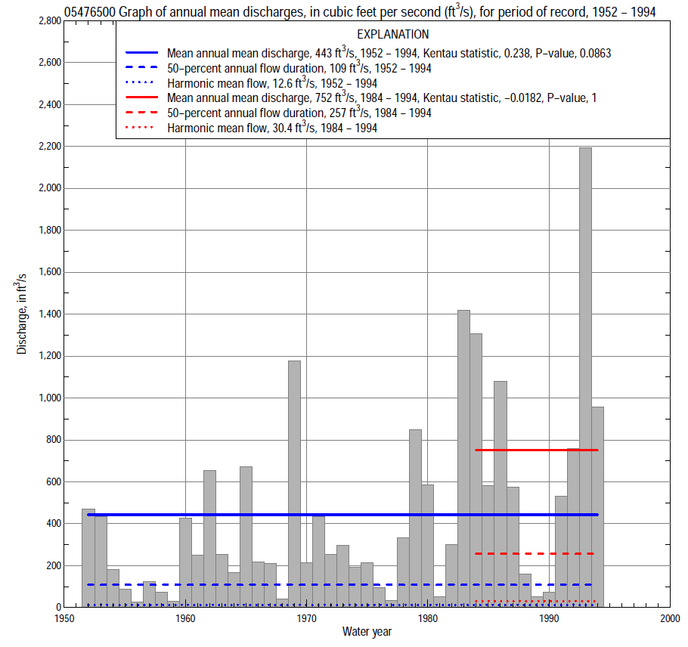

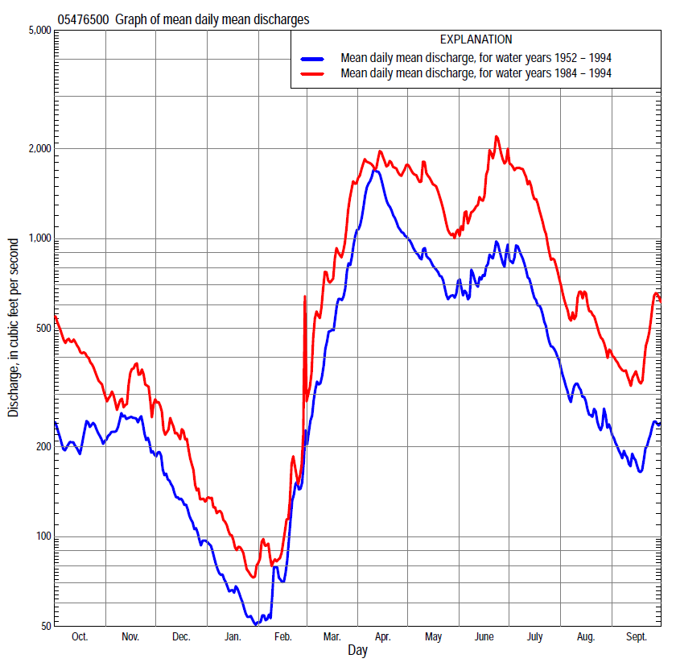

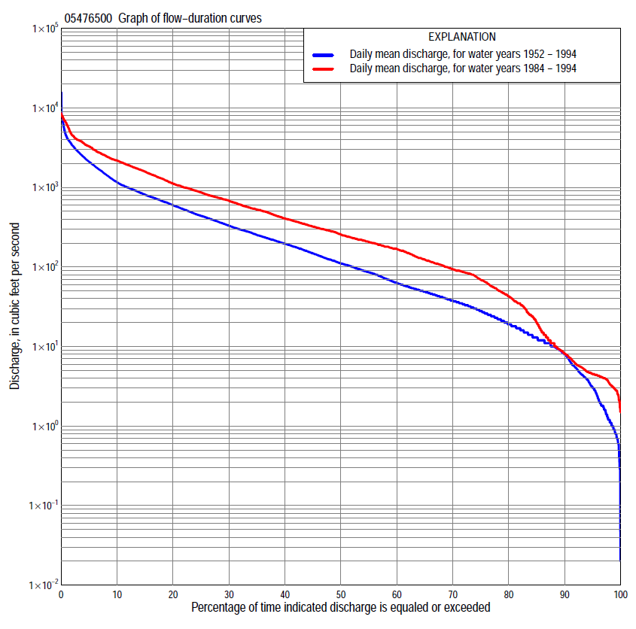

Statistics Based on the Entire Streamflow Period of Record
05476500 Monthly and annual flow durations, based on 1952–94 period of record (43 years)
Percentage of days discharge equaled or exceeded |  |  |  |  | Discharge (cubic feet per second) |  |  |  |  |  |  |  |  | Annual flow durations
 | Oct | Nov | Dec | Jan | Feb | Mar | Apr | May | June | July | Aug | Sept | Annual | Kentau statistic | P-value
99 | 0.67 | 1.6 | 1.0 | 0.30 | 0.60 | 3.3 | 10 | 14 | 9.3 | 2.0 | 0.81 | 0.50 | 0.80 | 0.261 | 0.014
98 | 0.80 | 1.8 | 1.1 | 0.70 | 0.80 | 4.4 | 17 | 15 | 11 | 2.7 | 1.3 | 0.70 | 1.2 | 0.255 | 0.016
95 | 1.3 | 2.8 | 1.8 | 1.0 | 1.2 | 7.4 | 30 | 25 | 17 | 8.2 | 2.6 | 1.3 | 3.0 | 0.252 | 0.017
90 | 2.9 | 9.0 | 5.8 | 2.4 | 3.8 | 15 | 55 | 42 | 38 | 15 | 5.4 | 4.0 | 7.8 | 0.270 | 0.011
85 | 7.9 | 12 | 8.8 | 3.9 | 4.5 | 21 | 90 | 58 | 61 | 25 | 13 | 6.9 | 12 | 0.288 | 0.007
80 | 12 | 17 | 12 | 4.8 | 5.8 | 32 | 170 | 87 | 104 | 40 | 24 | 12 | 19 | 0.281 | 0.008
75 | 15 | 27 | 15 | 7.6 | 11 | 44 | 238 | 141 | 150 | 61 | 34 | 18 | 27 | 0.271 | 0.011
70 | 21 | 33 | 21 | 11 | 12 | 63 | 299 | 229 | 202 | 90 | 44 | 23 | 37 | 0.269 | 0.011
65 | 29 | 37 | 30 | 13 | 14 | 103 | 377 | 291 | 242 | 121 | 52 | 30 | 48 | 0.265 | 0.013
60 | 37 | 46 | 37 | 17 | 18 | 140 | 437 | 342 | 285 | 153 | 62 | 36 | 61 | 0.264 | 0.013
55 | 45 | 58 | 42 | 23 | 22 | 173 | 536 | 399 | 350 | 192 | 74 | 43 | 84 | 0.241 | 0.023
50 | 55 | 75 | 48 | 27 | 26 | 220 | 650 | 458 | 402 | 242 | 90 | 50 | 109 | 0.267 | 0.012
45 | 64 | 89 | 57 | 35 | 31 | 275 | 756 | 571 | 491 | 297 | 110 | 62 | 145 | 0.276 | 0.009
40 | 80 | 106 | 73 | 43 | 42 | 335 | 860 | 674 | 565 | 376 | 136 | 77 | 192 | 0.291 | 0.006
35 | 100 | 116 | 100 | 52 | 60 | 430 | 996 | 750 | 674 | 450 | 168 | 96 | 250 | 0.277 | 0.009
30 | 124 | 150 | 132 | 75 | 83 | 540 | 1,170 | 850 | 784 | 559 | 198 | 117 | 328 | 0.275 | 0.010
25 | 167 | 222 | 182 | 94 | 106 | 648 | 1,590 | 981 | 896 | 711 | 241 | 149 | 437 | 0.279 | 0.009
20 | 237 | 327 | 218 | 114 | 150 | 850 | 2,300 | 1,220 | 1,030 | 918 | 310 | 211 | 597 | 0.275 | 0.010
15 | 436 | 456 | 260 | 150 | 181 | 1,160 | 2,960 | 1,620 | 1,270 | 1,200 | 417 | 289 | 805 | 0.276 | 0.009
10 | 627 | 724 | 345 | 203 | 230 | 1,700 | 3,550 | 2,050 | 1,780 | 1,700 | 736 | 480 | 1,150 | 0.251 | 0.018
5 | 874 | 1,050 | 570 | 272 | 397 | 2,200 | 4,600 | 2,640 | 3,160 | 2,470 | 1,580 | 1,020 | 2,090 | 0.193 | 0.070
2 | 1,750 | 1,600 | 757 | 339 | 540 | 2,890 | 6,870 | 3,610 | 4,760 | 4,720 | 2,250 | 1,610 | 3,400 | 0.168 | 0.114
1 | 2,660 | 1,930 | 960 | 406 | 1,160 | 3,620 | 8,160 | 3,950 | 6,210 | 6,650 | 2,530 | 2,210 | 4,340 | 0.147 | 0.167

05476500 Annual exceedance probability of instantaneous peak discharges, in cubic feet per second (ft³/s), based on the Weighted Independent Estimates method,
Annual exceed-ance probability | Recur-rence interval (years) | Discharge (ft³/s) | 95-percent lower confi-dence interval (ft³/s) | 95-percent upper confi-dence interval (ft³/s)
0.500 | 2 | 2,530 | 1,940 | 3,300
0.200 | 5 | 5,480 | 4,180 | 7,180
0.100 | 10 | 8,080 | 6,000 | 10,900
0.040 | 25 | 12,000 | 8,470 | 17,000
0.020 | 50 | 15,200 | 10,300 | 22,600
0.010 | 100 | 18,800 | 12,100 | 29,300
0.005 | 200 | 22,700 | 13,900 | 37,200
0.002 | 500 | 27,900 | 15,900 | 49,100
and based on the expected moments algorithm/multiple Grubbs-Beck analysis computed using a historical period length of 43 years (1952–1994)
0.500 | 2 | 2,320 | 1,730 | 3,090
0.200 | 5 | 4,880 | 3,660 | 6,850
0.100 | 10 | 7,110 | 5,230 | 10,800
0.040 | 25 | 10,500 | 7,400 | 18,400
0.020 | 50 | 13,500 | 9,070 | 26,600
0.010 | 100 | 16,800 | 10,700 | 37,400
0.005 | 200 | 20,400 | 12,400 | 51,600
0.002 | 500 | 25,800 | 14,500 | 77,400
Kentau statistic |  | 0.083
P-value |  | 0.439
Begin year |  | 1952
End year |  | 1994
Number of peaks |  | 43

05476500 Annual exceedance probability of high discharges, based on 1952–94 period of record (43 years)
[ND, not determined]
Annual exceedance probability | Recur-rence interval (years) | Maximum average discharge (ft³/s) for indicated number of consecutive days
 |  | 1 | 3 | 7 | 15 | 30
0.990 | 1.01 | ND | ND | ND | 122 | 79
0.950 | 1.05 | ND | ND | ND | 252 | 182
0.900 | 1.11 | ND | ND | ND | 369 | 278
0.800 | 1.25 | ND | ND | ND | 585 | 459
0.500 | 2 | ND | ND | ND | 1,390 | 1,140
0.200 | 5 | ND | ND | ND | 3,260 | 2,700
0.100 | 10 | ND | ND | ND | 5,050 | 4,130
0.040 | 25 | ND | ND | ND | 8,010 | 6,390
0.020 | 50 | ND | ND | ND | 10,800 | 8,410
0.010 | 100 | ND | ND | ND | 14,000 | 10,700
0.005 | 200 | ND | ND | ND | 17,800 | 13,300
0.002 | 500 | ND | ND | ND | 23,800 | 17,100
Kentau statistic |  | 0.078 | 0.084 | 0.124 | 0.152 | 0.169
P-value |  | 0.470 | 0.432 | 0.245 | 0.155 | 0.112

 | 05476500 Annual nonexceedance probability of low discharges, based on April 1952 to March 1995 period of record (43 years)
Annual nonexceed-ance probability | Recur-rence interval (years) | Minimum average discharge (cubic feet per second) for indicated number of consecutive days
 |  | 1 | 3 | 7 | 14 | 30 | 60 | 90 | 120 | 183
0.01 | 100 | 0.00 | 0.00 | 0.07 | 0.18 | 0.25 | 0.45 | 0.57 | 0.74 | 0.75
0.02 | 50 | 0.00 | 0.00 | 0.14 | 0.31 | 0.43 | 0.74 | 0.97 | 1.2 | 1.2
0.05 | 20 | 0.35 | 0.46 | 0.47 | 0.71 | 0.96 | 1.5 | 2.1 | 2.6 | 2.8
0.10 | 10 | 0.89 | 1.1 | 1.2 | 1.4 | 1.9 | 2.8 | 3.9 | 4.9 | 5.7
0.20 | 5 | 2.2 | 2.4 | 2.5 | 3.2 | 4.1 | 5.8 | 8.1 | 10 | 13
0.50 | 2 | 9.3 | 9.7 | 12 | 13 | 16 | 21 | 30 | 38 | 52
0.80 | 1.25 | 34 | 35 | 41 | 44 | 51 | 67 | 94 | 123 | 184
0.90 | 1.11 | 65 | 66 | 69 | 78 | 89 | 119 | 163 | 217 | 334
0.96 | 1.04 | 123 | 128 | 110 | 139 | 154 | 209 | 280 | 385 | 604
0.98 | 1.02 | 184 | 193 | 194 | 197 | 214 | 297 | 391 | 548 | 866
0.99 | 1.01 | 261 | 279 | 280 | 281 | 283 | 402 | 519 | 743 | 1,180
Kentau statistic |  | 0.267 | 0.267 | 0.260 | 0.267 | 0.256 | 0.256 | 0.260 | 0.271 | 0.249
P-value |  | 0.012 | 0.012 | 0.014 | 0.012 | 0.016 | 0.016 | 0.014 | 0.011 | 0.019

05476500 Annual nonexceedance probability of seasonal low discharges, based on October 1951 to April 1995 period of record (43–44 years)
Annual nonexceed-ance probability | Recur-rence interval (years) | Minimum average discharge (cubic feet per second) for indicated number of consecutive days
 |  | 1 | 7 | 14 | 30 |  | 1 | 7 | 14 | 30
 |  | January-February-March |  |  |  |  | April-May-June
0.01 | 100 | 0.00 | 0.07 | 0.18 | 0.25 |  | 2.3 | 2.8 | 3.4 | 5.2
0.02 | 50 | 0.00 | 0.16 | 0.34 | 0.46 |  | 3.9 | 4.8 | 5.8 | 8.8
0.05 | 20 | 0.65 | 0.70 | 0.84 | 1.1 |  | 8.3 | 10 | 13 | 18
0.10 | 10 | 1.6 | 1.7 | 1.8 | 2.3 |  | 16 | 19 | 24 | 34
0.20 | 5 | 3.9 | 4.0 | 4.2 | 5.2 |  | 34 | 41 | 50 | 71
0.50 | 2 | 16 | 19 | 18 | 22 |  | 126 | 149 | 183 | 247
0.80 | 1.25 | 52 | 61 | 62 | 74 |  | 411 | 475 | 563 | 739
0.90 | 1.11 | 92 | 97 | 109 | 130 |  | 722 | 823 | 953 | 1,240
0.96 | 1.04 | 163 | 170 | 187 | 226 |  | 1,270 | 1,420 | 1,600 | 2,050
0.98 | 1.02 | 231 | 240 | 256 | 313 |  | 1,790 | 1,980 | 2,180 | 2,780
0.99 | 1.01 | 311 | 320 | 333 | 413 |  | 2,400 | 2,620 | 2,830 | 3,610
Kentau statistic |  | 0.242 | 0.257 | 0.253 | 0.230 |  | 0.235 | 0.238 | 0.258 | 0.260
P-value |  | 0.021 | 0.014 | 0.016 | 0.028 |  | 0.027 | 0.025 | 0.015 | 0.014
 |  | July-August-September |  |  |  |  | October-November-December
0.01 | 100 | 0.11 | 0.26 | 0.32 | 0.45 |  | 0.15 | 0.30 | 0.38 | 0.42
0.02 | 50 | 0.22 | 0.47 | 0.58 | 0.83 |  | 0.29 | 0.55 | 0.68 | 0.78
0.05 | 20 | 0.61 | 1.1 | 1.4 | 2.0 |  | 0.78 | 1.3 | 1.6 | 1.9
0.10 | 10 | 1.4 | 2.3 | 2.8 | 4.2 |  | 1.8 | 2.8 | 3.3 | 4.0
0.20 | 5 | 3.8 | 5.3 | 6.6 | 9.9 |  | 4.5 | 6.4 | 7.6 | 9.3
0.50 | 2 | 21 | 25 | 31 | 45 |  | 22 | 28 | 33 | 42
0.80 | 1.25 | 96 | 107 | 125 | 173 |  | 84 | 102 | 123 | 160
0.90 | 1.11 | 195 | 218 | 250 | 329 |  | 154 | 187 | 230 | 301
0.96 | 1.04 | 396 | 453 | 504 | 624 |  | 276 | 340 | 428 | 564
0.98 | 1.02 | 609 | 713 | 779 | 922 |  | 389 | 487 | 625 | 826
0.99 | 1.01 | 877 | 1,060 | 1,140 | 1,290 |  | 517 | 662 | 864 | 1,140
Kentau statistic |  | 0.216 | 0.210 | 0.207 | 0.207 |  | 0.212 | 0.252 | 0.230 | 0.235
P-value |  | 0.042 | 0.048 | 0.052 | 0.052 |  | 0.043 | 0.017 | 0.028 | 0.025

Statistics Based on the 1984–2013 Streamflow Period of Record
05476500 Monthly and annual flow durations, based on 1984–94 period of record (11 years)
Percentage of days discharge equaled or exceeded |  |  |  |  | Discharge (cubic feet per second) |  |  |  |  |  |  |  |  | Annual flow durations
 | Oct | Nov | Dec | Jan | Feb | Mar | Apr | May | June | July | Aug | Sept | Annual | Kentau statistic | P-value
99 | 1.6 | 3.3 | 2.8 | 3.2 | 3.8 | 4.3 | 43 | 25 | 18 | 6.6 | 3.8 | 2.8 | 2.9 | 0.091 | 0.755
98 | 1.9 | 5.1 | 2.9 | 3.2 | 3.9 | 4.4 | 45 | 51 | 24 | 9.4 | 4.1 | 3.0 | 3.3 | 0.073 | 0.815
95 | 2.4 | 7.3 | 3.1 | 3.6 | 4.2 | 8.2 | 50 | 60 | 46 | 15 | 5.3 | 3.5 | 4.5 | 0.109 | 0.696
90 | 4.4 | 9.3 | 5.8 | 4.1 | 4.4 | 37 | 85 | 82 | 82 | 35 | 11 | 4.7 | 7.7 | 0.218 | 0.390
85 | 6.0 | 12 | 7.0 | 4.4 | 4.6 | 53 | 167 | 227 | 187 | 56 | 16 | 5.7 | 16 | 0.273 | 0.276
80 | 8.4 | 19 | 9.1 | 4.8 | 7.7 | 120 | 282 | 354 | 241 | 127 | 54 | 8.3 | 37 | 0.273 | 0.276
75 | 14 | 34 | 24 | 5.5 | 12 | 156 | 471 | 409 | 279 | 170 | 83 | 16 | 63 | 0.236 | 0.350
70 | 33 | 37 | 35 | 8.1 | 22 | 179 | 642 | 512 | 344 | 232 | 97 | 52 | 90 | 0.200 | 0.436
65 | 41 | 47 | 48 | 22 | 29 | 222 | 707 | 615 | 397 | 403 | 117 | 66 | 120 | 0.200 | 0.436
60 | 65 | 86 | 130 | 84 | 40 | 266 | 801 | 701 | 521 | 505 | 139 | 85 | 161 | 0.236 | 0.350
55 | 81 | 159 | 160 | 90 | 71 | 314 | 901 | 783 | 610 | 609 | 172 | 111 | 202 | 0.164 | 0.533
50 | 89 | 226 | 180 | 94 | 84 | 373 | 987 | 884 | 780 | 755 | 237 | 142 | 251 | 0.164 | 0.533
45 | 104 | 277 | 199 | 106 | 94 | 509 | 1,160 | 1,090 | 974 | 939 | 292 | 200 | 325 | 0.236 | 0.350
40 | 319 | 318 | 207 | 116 | 106 | 560 | 1,350 | 1,370 | 1,110 | 1,080 | 323 | 260 | 414 | 0.273 | 0.276
35 | 472 | 366 | 220 | 124 | 130 | 700 | 1,610 | 1,540 | 1,310 | 1,260 | 381 | 378 | 540 | 0.127 | 0.640
30 | 575 | 400 | 245 | 144 | 160 | 1,270 | 2,150 | 1,840 | 1,710 | 1,460 | 471 | 427 | 694 | 0.018 | 1.000
25 | 633 | 453 | 280 | 170 | 179 | 1,580 | 2,580 | 2,160 | 2,650 | 1,680 | 730 | 527 | 874 | -0.018 | 1.000
20 | 749 | 608 | 310 | 190 | 188 | 1,790 | 3,160 | 2,460 | 2,990 | 1,860 | 942 | 639 | 1,110 | 0.018 | 1.000
15 | 874 | 738 | 411 | 214 | 233 | 2,000 | 3,630 | 2,650 | 3,360 | 2,100 | 1,420 | 950 | 1,570 | 0.055 | 0.876
10 | 1,030 | 841 | 510 | 225 | 322 | 2,170 | 4,070 | 3,260 | 3,910 | 3,480 | 1,850 | 1,110 | 2,170 | 0.018 | 1.000
5 | 1,470 | 983 | 637 | 260 | 405 | 2,590 | 5,060 | 3,850 | 5,350 | 5,860 | 2,230 | 1,480 | 3,340 | -0.055 | 0.876
2 | 2,750 | 1,060 | 700 | 290 | 600 | 3,480 | 6,910 | 5,200 | 6,710 | 7,330 | 2,480 | 2,290 | 4,600 | -0.091 | 0.755
1 | 3,630 | 1,110 | 780 | 310 | 860 | 3,900 | 7,870 | 6,190 | 7,490 | 7,990 | 2,990 | 4,370 | 6,390 | -0.127 | 0.640

05476500 Annual exceedance probability of high discharges, based on 1984–94 period of record (11 years)
Annual exceed-ance probability | Recur-rence interval (years) | Maximum average discharge (ft³/s) for indicated number of consecutive days
 |  | 1 | 3 | 7 | 15 | 30
0.990 | 1.01 | 312 | 264 | 211 | 135 | 100
0.950 | 1.05 | 652 | 581 | 492 | 357 | 273
0.900 | 1.11 | 943 | 858 | 747 | 573 | 445
0.800 | 1.25 | 1,440 | 1,340 | 1,200 | 975 | 773
0.500 | 2 | 3,020 | 2,890 | 2,690 | 2,380 | 1,960
0.200 | 5 | 5,830 | 5,640 | 5,380 | 4,990 | 4,260
0.100 | 10 | 7,950 | 7,700 | 7,380 | 6,940 | 6,030
0.040 | 25 | 10,800 | 10,400 | 10,000 | 9,460 | 8,380
0.020 | 50 | 13,000 | 12,500 | 12,000 | 11,300 | 10,100
0.010 | 100 | 15,300 | 14,600 | 14,000 | 13,100 | 11,900
0.005 | 200 | 17,500 | 16,700 | 15,900 | 14,900 | 13,600
0.002 | 500 | 20,600 | 19,400 | 18,400 | 17,100 | 15,800
Kentau statistic |  | -0.164 | -0.200 | -0.164 | -0.091 | -0.055
P-value |  | 0.533 | 0.436 | 0.533 | 0.756 | 0.876

 | 05476500 Annual nonexceedance probability of low discharges, based on April 1983 to March 1995 period of record (12 years)
Annual nonexceed-ance probability | Recur-rence interval (years) | Minimum average discharge (cubic feet per second) for indicated number of consecutive days
 |  | 1 | 3 | 7 | 14 | 30 | 60 | 90 | 120 | 183
0.01 | 100 | 0.29 | 0.30 | 0.33 | 0.36 | 0.41 | 0.59 | 0.66 | 0.81 | 0.70
0.02 | 50 | 0.55 | 0.58 | 0.63 | 0.68 | 0.80 | 1.1 | 1.3 | 1.7 | 1.5
0.05 | 20 | 1.4 | 1.4 | 1.6 | 1.7 | 2.0 | 2.9 | 3.6 | 4.4 | 4.2
0.10 | 10 | 2.9 | 3.0 | 3.3 | 3.6 | 4.4 | 6.2 | 7.9 | 9.8 | 10
0.20 | 5 | 6.7 | 7.1 | 7.6 | 8.3 | 10 | 14 | 19 | 24 | 26
0.50 | 2 | 27 | 29 | 31 | 34 | 41 | 55 | 74 | 96 | 125
0.80 | 1.25 | 89 | 94 | 98 | 107 | 123 | 158 | 207 | 281 | 444
0.90 | 1.11 | 150 | 157 | 164 | 178 | 197 | 246 | 315 | 438 | 768
0.96 | 1.04 | 248 | 257 | 265 | 287 | 303 | 366 | 454 | 647 | 1,270
0.98 | 1.02 | 331 | 341 | 350 | 377 | 386 | 456 | 553 | 801 | 1,690
0.99 | 1.01 | 420 | 430 | 440 | 471 | 472 | 542 | 643 | 945 | 2,130
Kentau statistic |  | 0.061 | 0.061 | 0.000 | 0.030 | 0.000 | 0.182 | 0.121 | 0.212 | 0.152
P-value |  | 0.837 | 0.837 | 1.000 | 0.945 | 1.000 | 0.451 | 0.631 | 0.373 | 0.537

05476500 Annual nonexceedance probability of seasonal low discharges, based on October 1983 to March 1995 period of record (11–12 years)
Annual nonexceed-ance probability | Recur-rence interval (years) | Minimum average discharge (cubic feet per second) for indicated number of consecutive days
 |  | 1 | 7 | 14 | 30 |  | 1 | 7 | 14 | 30
 |  | January-February-March |  |  |  |  | April-May-June
0.01 | 100 | 0.49 | 0.52 | 0.53 | 0.54 |  | 4.5 | 6.0 | 6.3 | 9.8
0.02 | 50 | 0.88 | 0.93 | 0.94 | 0.97 |  | 7.8 | 10 | 11 | 17
0.05 | 20 | 2.0 | 2.1 | 2.2 | 2.4 |  | 17 | 22 | 26 | 38
0.10 | 10 | 4.0 | 4.2 | 4.4 | 4.9 |  | 34 | 42 | 51 | 74
0.20 | 5 | 8.6 | 9.2 | 9.8 | 11 |  | 73 | 88 | 109 | 157
0.50 | 2 | 33 | 35 | 38 | 45 |  | 280 | 320 | 400 | 551
0.80 | 1.25 | 103 | 111 | 121 | 141 |  | 902 | 992 | 1,180 | 1,570
0.90 | 1.11 | 174 | 187 | 204 | 233 |  | 1,560 | 1,690 | 1,920 | 2,500
0.96 | 1.04 | 290 | 310 | 337 | 374 |  | 2,680 | 2,840 | 3,050 | 3,890
0.98 | 1.02 | 392 | 419 | 452 | 493 |  | 3,700 | 3,890 | 4,000 | 5,020
0.99 | 1.01 | 505 | 538 | 577 | 617 |  | 4,870 | 4,920 | 4,990 | 6,210
Kentau statistic |  | 0.061 | 0.030 | 0.030 | 0.030 |  | -0.055 | -0.018 | -0.018 | -0.055
P-value |  | 0.837 | 0.945 | 0.945 | 0.945 |  | 0.876 | 1.000 | 1.000 | 0.876
 |  | July-August-September |  |  |  |  | October-November-December
0.01 | 100 | 0.27 | 0.32 | 0.35 | 0.63 |  | 0.26 | 0.35 | 0.39 | 0.40
0.02 | 50 | 0.56 | 0.65 | 0.71 | 1.2 |  | 0.55 | 0.75 | 0.82 | 0.89
0.05 | 20 | 1.6 | 1.8 | 2.0 | 3.3 |  | 1.6 | 2.1 | 2.4 | 2.7
0.10 | 10 | 3.7 | 4.3 | 4.7 | 7.6 |  | 3.8 | 5.1 | 5.6 | 6.7
0.20 | 5 | 10 | 12 | 13 | 20 |  | 10 | 13 | 15 | 18
0.50 | 2 | 59 | 68 | 75 | 107 |  | 49 | 61 | 70 | 93
0.80 | 1.25 | 286 | 328 | 369 | 485 |  | 174 | 205 | 243 | 336
0.90 | 1.11 | 605 | 698 | 789 | 996 |  | 299 | 341 | 415 | 580
0.96 | 1.04 | 1,270 | 1,480 | 1,680 | 2,040 |  | 489 | 541 | 674 | 951
0.98 | 1.02 | 2,010 | 2,350 | 2,680 | 3,150 |  | 645 | 699 | 885 | 1,250
0.99 | 1.01 | 2,960 | 3,480 | 3,990 | 4,590 |  | 805 | 856 | 1,100 | 1,560
Kentau statistic |  | 0.236 | 0.236 | 0.236 | 0.309 |  | 0.091 | 0.152 | 0.121 | 0.121
P-value |  | 0.350 | 0.350 | 0.350 | 0.213 |  | 0.732 | 0.537 | 0.631 | 0.631

