LOCATION.--Lat 42°43'10", long 94°13'13" referenced to North American Datum of 1927, in NW 1/4 SE 1/4 SW 1/4 sec.01, T.91 N., R.29 W., Humboldt County, IA, Hydrologic Unit 07100002, 700 ft downstream from the Humboldt Water Plant, 0.84 mi downstream from the Reasoner Dam, 3.2 mi upstream from Indian Creek, 4.1 mi upstream from East Fork Des Moines River, and 323.0 mi upstream from mouth.

DRAINAGE AREA.--2,256 mi².

PERIOD OF RECORD.--Discharge records from October 1964 to current year. Prior to October 1970, published as "West Fork Des Moines River at Humboldt".

GAGE.--Water-stage recorder. Datum of gage is 1,053.54 ft above National Geodetic Vertical Datum of 1929. Prior to October 3, 1966, non-recording gage at same site and datum.

REMARKS.--Daily non-recording gage-height readings available for period March 7, 1940, to September 30, 1964. Discharge not published for this period because of extreme regulation of streamflow by dam 700 ft upstream. Power generation and streamflow regulation discontinued August 1964. Low-flow discharges occasionally affected by minor regulation at Reasoner Dam, 0.84 mi upstream.

A summary of all available data for this streamgage is provided through the USGS National Water Information System web interface (NWISWeb). The following link provides access to current/historical observations, daily data, daily statistics, monthly statistics, annual statistics, peak streamflow, field measurements, field/lab water-quality samples, and the latest water-year summaries. Data can be filtered by parameter and/or dates, and can be output in various tabular and graphical formats.
http://waterdata.usgs.gov/nwis/inventory/?site_no=05476750

The USGS WaterWatch Toolkit is available at:
http://waterwatch.usgs.gov/?id=ww_toolkit
Tools for summarizing streamflow information include the duration hydrograph builder, the cumulative streamflow hydrograph builder, the streamgage statistics retrieval tool, the rating curve builder, the flood tracking chart builder, the National Weather Service Advanced Hydrologic Prediction Service (AHPS) river forecast hydrograph builder, and the raster-hydrograph builder. Entering the above number for this streamgage into these toolkit webpages will provide streamflow information specific to this streamgage.

A description of the statistics presented for this streamgage is available in the main body of the report at:
http://dx.doi.org/10.3133/ofr20151214
A link to other streamgages included in this report, a map showing the location of the streamgages, information on the programs used to compute the statistical analyses, and references are included in the main body of the report.

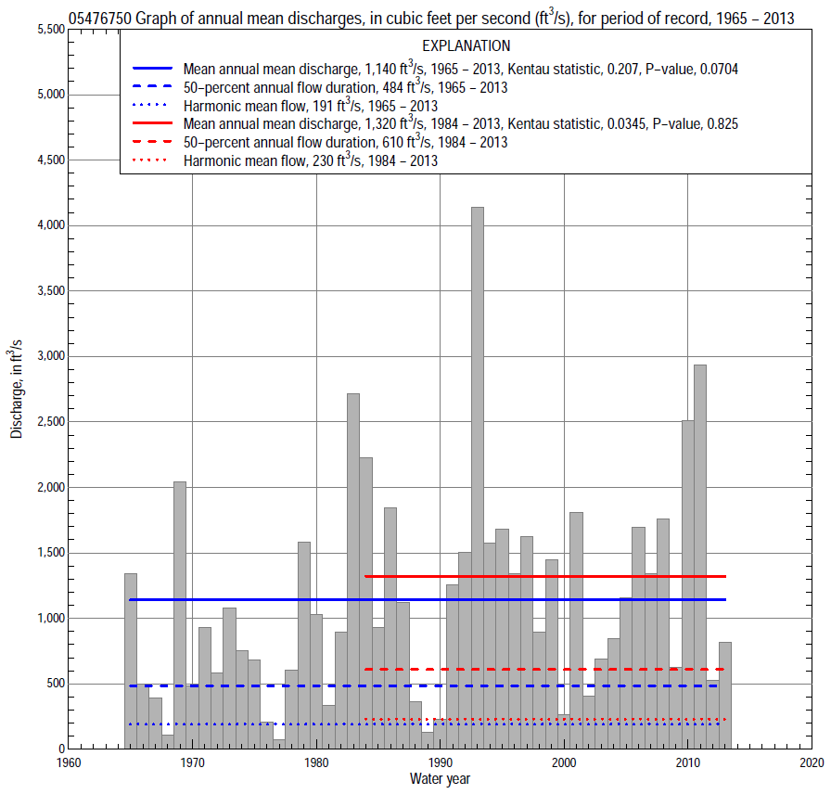

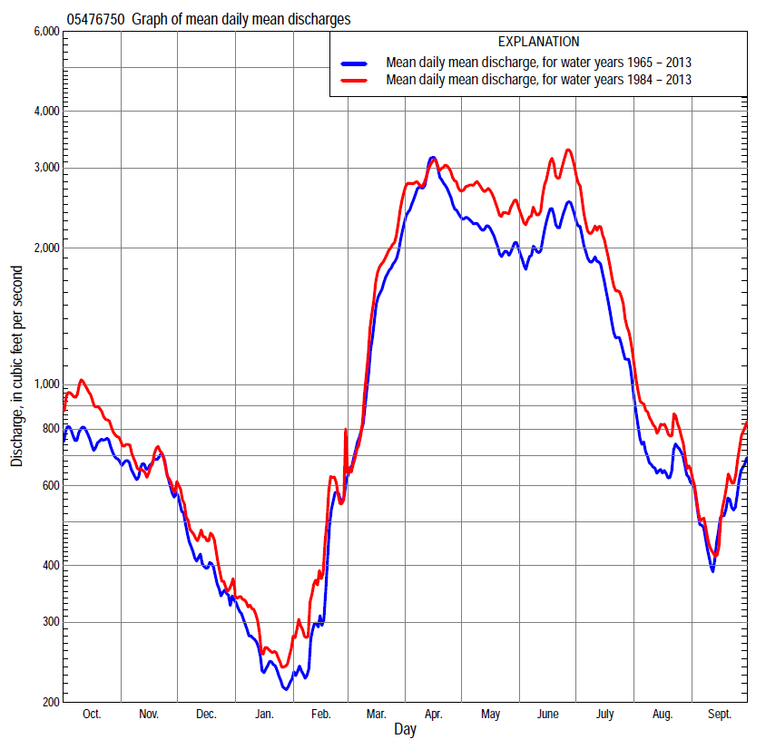

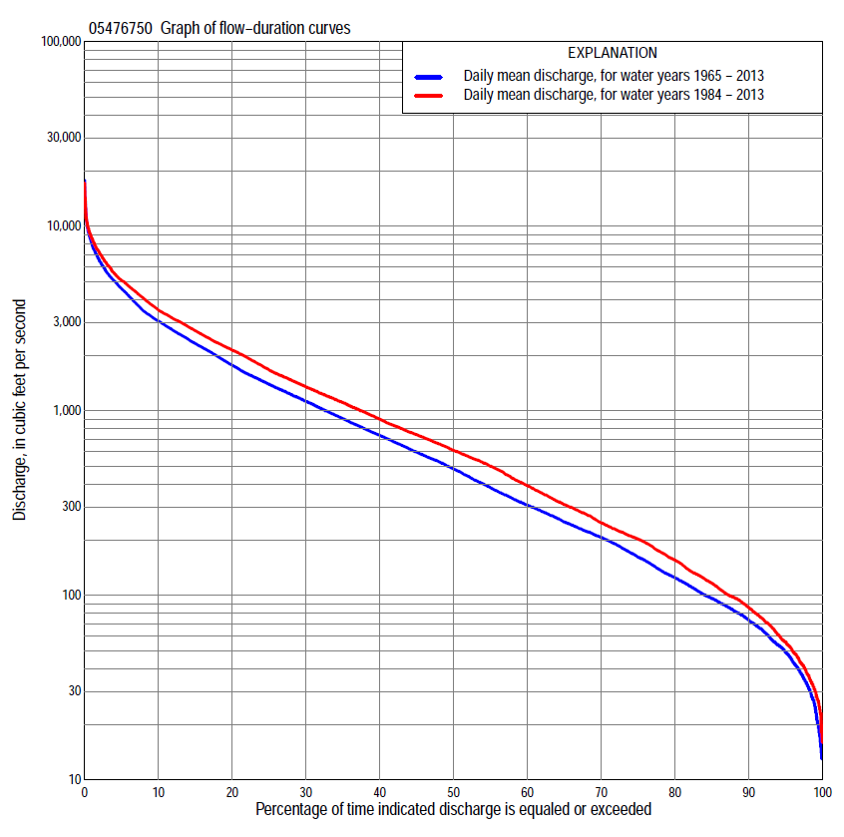

Statistics Based on the Entire Streamflow Period of Record
05476750 Monthly and annual flow durations, based on 1965–2013 period of record (49 years)
Percentage of days discharge equaled or exceeded |  |  |  |  | Discharge (cubic feet per second) |  |  |  |  |  |  |  |  | Annual flow durations
 | Oct | Nov | Dec | Jan | Feb | Mar | Apr | May | June | July | Aug | Sept | Annual | Kentau statistic | P-value
99 | 19 | 21 | 19 | 13 | 18 | 39 | 73 | 64 | 55 | 54 | 35 | 27 | 25 | 0.146 | 0.140
98 | 26 | 34 | 20 | 15 | 24 | 43 | 91 | 77 | 73 | 65 | 41 | 30 | 32 | 0.147 | 0.138
95 | 55 | 54 | 39 | 28 | 33 | 69 | 120 | 116 | 131 | 92 | 54 | 49 | 49 | 0.137 | 0.168
90 | 70 | 78 | 60 | 37 | 40 | 107 | 218 | 244 | 328 | 144 | 107 | 74 | 73 | 0.155 | 0.119
85 | 80 | 93 | 71 | 47 | 46 | 161 | 395 | 423 | 543 | 238 | 141 | 90 | 96 | 0.164 | 0.098
80 | 92 | 105 | 87 | 54 | 55 | 233 | 567 | 636 | 688 | 304 | 165 | 101 | 125 | 0.149 | 0.134
75 | 104 | 128 | 105 | 67 | 68 | 320 | 763 | 813 | 829 | 370 | 190 | 117 | 161 | 0.148 | 0.136
70 | 126 | 161 | 134 | 82 | 82 | 392 | 974 | 998 | 970 | 461 | 220 | 126 | 206 | 0.133 | 0.181
65 | 161 | 199 | 166 | 99 | 94 | 452 | 1,150 | 1,160 | 1,120 | 549 | 245 | 139 | 250 | 0.127 | 0.202
60 | 190 | 227 | 194 | 116 | 121 | 504 | 1,340 | 1,330 | 1,250 | 648 | 279 | 158 | 308 | 0.130 | 0.190
55 | 224 | 285 | 222 | 138 | 152 | 580 | 1,550 | 1,490 | 1,380 | 775 | 303 | 178 | 383 | 0.148 | 0.136
50 | 258 | 344 | 273 | 169 | 185 | 679 | 1,760 | 1,770 | 1,550 | 905 | 332 | 208 | 484 | 0.170 | 0.086
45 | 315 | 418 | 324 | 200 | 220 | 789 | 2,070 | 2,020 | 1,760 | 1,080 | 385 | 237 | 597 | 0.170 | 0.086
40 | 424 | 536 | 378 | 240 | 252 | 930 | 2,460 | 2,260 | 1,980 | 1,270 | 451 | 279 | 735 | 0.170 | 0.086
35 | 537 | 662 | 432 | 274 | 290 | 1,100 | 2,910 | 2,510 | 2,200 | 1,480 | 536 | 326 | 907 | 0.185 | 0.063
30 | 654 | 797 | 552 | 310 | 336 | 1,360 | 3,330 | 2,740 | 2,500 | 1,750 | 622 | 412 | 1,120 | 0.218 | 0.028
25 | 884 | 933 | 630 | 350 | 410 | 1,610 | 4,060 | 3,080 | 2,810 | 2,070 | 743 | 550 | 1,390 | 0.211 | 0.033
20 | 1,170 | 1,150 | 723 | 420 | 479 | 2,190 | 4,720 | 3,360 | 3,200 | 2,460 | 903 | 716 | 1,770 | 0.211 | 0.033
15 | 1,530 | 1,420 | 811 | 525 | 719 | 2,930 | 5,380 | 3,860 | 3,830 | 2,880 | 1,180 | 956 | 2,310 | 0.213 | 0.031
10 | 2,030 | 1,730 | 967 | 600 | 1,000 | 3,760 | 6,410 | 4,540 | 4,690 | 3,640 | 1,640 | 1,310 | 3,060 | 0.201 | 0.043
5 | 3,100 | 2,210 | 1,150 | 780 | 1,410 | 5,060 | 7,790 | 5,400 | 7,010 | 5,630 | 2,450 | 2,300 | 4,590 | 0.197 | 0.046
2 | 4,890 | 2,700 | 1,490 | 980 | 2,000 | 6,890 | 9,420 | 6,550 | 8,770 | 8,480 | 4,350 | 3,390 | 6,520 | 0.192 | 0.052
1 | 5,670 | 2,970 | 1,680 | 1,180 | 2,680 | 8,560 | 11,800 | 7,820 | 10,100 | 11,800 | 5,950 | 4,420 | 8,030 | 0.198 | 0.046

05476750 Annual exceedance probability of instantaneous peak discharges, in cubic feet per second (ft³/s), based on the Weighted Independent Estimates method,
Annual exceed-ance probability | Recur-rence interval (years) | Discharge (ft³/s) | 95-percent lower confi-dence interval (ft³/s) | 95-percent upper confi-dence interval (ft³/s)
0.500 | 2 | 4,960 | 4,250 | 5,770
0.200 | 5 | 8,440 | 7,240 | 9,840
0.100 | 10 | 11,000 | 9,280 | 13,000
0.040 | 25 | 14,500 | 11,800 | 17,700
0.020 | 50 | 17,100 | 13,500 | 21,800
0.010 | 100 | 20,000 | 15,100 | 26,400
0.005 | 200 | 22,900 | 16,700 | 31,500
0.002 | 500 | 26,800 | 18,500 | 38,800
and based on the expected moments algorithm/multiple Grubbs-Beck analysis computed using a historical period length of 74 years (1940–2013)
0.500 | 2 | 4,880 | 4,150 | 5,700
0.200 | 5 | 8,220 | 7,020 | 9,760
0.100 | 10 | 10,600 | 8,960 | 13,000
0.040 | 25 | 13,700 | 11,300 | 17,900
0.020 | 50 | 16,100 | 12,900 | 22,100
0.010 | 100 | 18,500 | 14,400 | 27,100
0.005 | 200 | 20,900 | 15,800 | 32,700
0.002 | 500 | 24,100 | 17,400 | 41,500
Kentau statistic |  | 0.147
P-value |  | 0.065
Begin year |  | 1940
End year |  | 2013
Number of peaks |  | 74

05476750 Annual exceedance probability of high discharges, based on 1965–2013 period of record (49 years)
[ND, not determined]
Annual exceed-ance probability | Recur-rence interval (years) | Maximum average discharge (ft³/s) for indicated number of consecutive days
 |  | 1 | 3 | 7 | 15 | 30
0.990 | 1.01 | ND | ND | 421 | 310 | 243
0.950 | 1.05 | ND | ND | 940 | 733 | 597
0.900 | 1.11 | ND | ND | 1,380 | 1,110 | 916
0.800 | 1.25 | ND | ND | 2,130 | 1,750 | 1,470
0.500 | 2 | ND | ND | 4,370 | 3,730 | 3,180
0.200 | 5 | ND | ND | 7,830 | 6,850 | 5,840
0.100 | 10 | ND | ND | 10,100 | 8,910 | 7,560
0.040 | 25 | ND | ND | 12,800 | 11,300 | 9,550
0.020 | 50 | ND | ND | 14,700 | 13,000 | 10,900
0.010 | 100 | ND | ND | 16,400 | 14,500 | 12,100
0.005 | 200 | ND | ND | 17,900 | 15,900 | 13,100
0.002 | 500 | ND | ND | 19,800 | 17,500 | 14,400
Kentau statistic |  | 0.177 | 0.180 | 0.192 | 0.179 | 0.187
P-value |  | 0.074 | 0.069 | 0.052 | 0.072 | 0.059

 | 05476750 Annual nonexceedance probability of low discharges, based on April 1965 to March 2013 period of record (48 years)
Annual nonexceed-ance probability | Recur-rence interval (years) | Minimum average discharge (cubic feet per second) for indicated number of consecutive days
 |  | 1 | 3 | 7 | 14 | 30 | 60 | 90 | 120 | 183
0.01 | 100 | 9.9 | 10 | 11 | 11 | 12 | 13 | 14 | 15 | 18
0.02 | 50 | 13 | 14 | 14 | 15 | 16 | 17 | 19 | 21 | 25
0.05 | 20 | 19 | 20 | 21 | 22 | 24 | 27 | 31 | 35 | 41
0.10 | 10 | 27 | 28 | 30 | 31 | 34 | 39 | 46 | 53 | 63
0.20 | 5 | 40 | 42 | 44 | 47 | 51 | 61 | 74 | 87 | 104
0.50 | 2 | 83 | 87 | 91 | 98 | 110 | 137 | 174 | 214 | 269
0.80 | 1.25 | 166 | 171 | 179 | 194 | 225 | 293 | 389 | 500 | 664
0.90 | 1.11 | 234 | 241 | 251 | 273 | 321 | 427 | 578 | 763 | 1,050
0.96 | 1.04 | 335 | 341 | 356 | 386 | 461 | 627 | 869 | 1,180 | 1,680
0.98 | 1.02 | 419 | 425 | 442 | 480 | 579 | 797 | 1,120 | 1,550 | 2,280
0.99 | 1.01 | 511 | 516 | 535 | 580 | 706 | 983 | 1,400 | 1,970 | 2,970
Kentau statistic |  | 0.146 | 0.154 | 0.150 | 0.167 | 0.147 | 0.142 | 0.142 | 0.163 | 0.165
P-value |  | 0.145 | 0.124 | 0.135 | 0.097 | 0.143 | 0.158 | 0.158 | 0.104 | 0.100

05476750 Annual nonexceedance probability of seasonal low discharges, based on October 1964 to September 2013 period of record (49 years)
Annual nonexceed-ance probability | Recur-rence interval (years) | Minimum average discharge (cubic feet per second) for indicated number of consecutive days
 |  | 1 | 7 | 14 | 30 |  | 1 | 7 | 14 | 30
 |  | January-February-March |  |  |  |  | April-May-June
0.01 | 100 | 9.6 | 11 | 11 | 12 |  | 18 | 26 | 29 | 37
0.02 | 50 | 13 | 14 | 15 | 16 |  | 29 | 41 | 47 | 59
0.05 | 20 | 20 | 21 | 22 | 24 |  | 60 | 79 | 91 | 116
0.10 | 10 | 29 | 31 | 32 | 35 |  | 107 | 135 | 158 | 203
0.20 | 5 | 45 | 48 | 51 | 56 |  | 204 | 246 | 290 | 375
0.50 | 2 | 104 | 110 | 117 | 131 |  | 590 | 671 | 797 | 1,030
0.80 | 1.25 | 230 | 246 | 260 | 301 |  | 1,380 | 1,520 | 1,800 | 2,280
0.90 | 1.11 | 344 | 370 | 391 | 460 |  | 1,980 | 2,190 | 2,560 | 3,220
0.96 | 1.04 | 522 | 568 | 599 | 717 |  | 2,750 | 3,070 | 3,540 | 4,390
0.98 | 1.02 | 680 | 747 | 786 | 953 |  | 3,320 | 3,730 | 4,260 | 5,230
0.99 | 1.01 | 859 | 953 | 1,000 | 1,230 |  | 3,850 | 4,370 | 4,940 | 6,020
Kentau statistic |  | 0.146 | 0.157 | 0.155 | 0.139 |  | 0.223 | 0.213 | 0.196 | 0.223
P-value |  | 0.140 | 0.113 | 0.119 | 0.160 |  | 0.024 | 0.032 | 0.047 | 0.024
 |  | July-August-September |  |  |  |  | October-November-December
0.01 | 100 | 24 | 29 | 31 | 36 |  | 12 | 13 | 15 | 17
0.02 | 50 | 28 | 33 | 36 | 42 |  | 16 | 18 | 21 | 24
0.05 | 20 | 37 | 42 | 46 | 54 |  | 24 | 29 | 33 | 38
0.10 | 10 | 47 | 53 | 58 | 69 |  | 36 | 43 | 49 | 56
0.20 | 5 | 66 | 73 | 79 | 96 |  | 56 | 68 | 77 | 91
0.50 | 2 | 132 | 144 | 158 | 194 |  | 130 | 158 | 179 | 220
0.80 | 1.25 | 293 | 322 | 355 | 443 |  | 290 | 352 | 400 | 513
0.90 | 1.11 | 464 | 515 | 571 | 714 |  | 433 | 524 | 598 | 785
0.96 | 1.04 | 782 | 884 | 988 | 1,240 |  | 658 | 792 | 905 | 1,220
0.98 | 1.02 | 1,120 | 1,280 | 1,440 | 1,800 |  | 856 | 1,030 | 1,180 | 1,620
0.99 | 1.01 | 1,550 | 1,820 | 2,060 | 2,560 |  | 1,080 | 1,290 | 1,480 | 2,070
Kentau statistic |  | 0.104 | 0.085 | 0.092 | 0.111 |  | 0.083 | 0.090 | 0.054 | 0.085
P-value |  | 0.297 | 0.393 | 0.356 | 0.266 |  | 0.403 | 0.365 | 0.587 | 0.393

Statistics Based on the 1984–2013 Streamflow Period of Record
05476750 Monthly and annual flow durations, based on 1984–2013 period of record (30 years)
Percentage of days discharge equaled or exceeded |  |  |  |  | Discharge (cubic feet per second) |  |  |  |  |  |  |  |  | Annual flow durations
 | Oct | Nov | Dec | Jan | Feb | Mar | Apr | May | June | July | Aug | Sept | Annual | Kentau statistic | P-value
99 | 29 | 36 | 20 | 18 | 24 | 40 | 90 | 61 | 102 | 74 | 48 | 28 | 30 | -0.034 | 0.803
98 | 37 | 41 | 28 | 25 | 27 | 46 | 96 | 98 | 129 | 88 | 53 | 46 | 37 | -0.037 | 0.789
95 | 57 | 71 | 42 | 32 | 35 | 86 | 117 | 227 | 353 | 114 | 69 | 57 | 56 | -0.037 | 0.789
90 | 73 | 84 | 63 | 43 | 42 | 136 | 299 | 477 | 591 | 220 | 133 | 86 | 86 | -0.007 | 0.972
85 | 86 | 96 | 76 | 52 | 50 | 227 | 434 | 821 | 746 | 321 | 184 | 106 | 116 | -0.014 | 0.929
80 | 99 | 107 | 97 | 61 | 65 | 331 | 701 | 1,070 | 915 | 415 | 224 | 122 | 155 | -0.048 | 0.721
75 | 112 | 132 | 128 | 75 | 86 | 397 | 857 | 1,250 | 1,090 | 539 | 254 | 133 | 202 | -0.046 | 0.735
70 | 141 | 158 | 164 | 98 | 117 | 455 | 1,110 | 1,380 | 1,230 | 647 | 282 | 149 | 247 | -0.039 | 0.775
65 | 161 | 201 | 198 | 132 | 141 | 504 | 1,310 | 1,560 | 1,410 | 778 | 305 | 164 | 310 | -0.037 | 0.789
60 | 186 | 227 | 221 | 160 | 180 | 580 | 1,560 | 1,800 | 1,650 | 962 | 338 | 180 | 393 | -0.018 | 0.901
55 | 215 | 325 | 301 | 200 | 209 | 665 | 1,900 | 2,010 | 1,860 | 1,140 | 388 | 204 | 500 | -0.009 | 0.957
50 | 254 | 484 | 380 | 232 | 239 | 783 | 2,250 | 2,230 | 2,110 | 1,290 | 452 | 230 | 610 | 0.016 | 0.915
45 | 358 | 568 | 430 | 270 | 260 | 880 | 2,620 | 2,430 | 2,300 | 1,490 | 520 | 260 | 742 | 0.023 | 0.872
40 | 488 | 671 | 520 | 300 | 290 | 1,050 | 3,070 | 2,700 | 2,560 | 1,710 | 601 | 294 | 900 | 0.005 | 0.986
35 | 640 | 785 | 600 | 325 | 340 | 1,330 | 3,330 | 3,010 | 2,840 | 1,980 | 695 | 347 | 1,110 | -0.009 | 0.957
30 | 932 | 876 | 650 | 360 | 399 | 1,490 | 3,770 | 3,270 | 3,200 | 2,250 | 803 | 500 | 1,350 | 0.025 | 0.858
25 | 1,170 | 1,010 | 715 | 413 | 494 | 1,780 | 4,390 | 3,600 | 3,570 | 2,500 | 940 | 633 | 1,660 | 0.016 | 0.915
20 | 1,440 | 1,200 | 767 | 490 | 690 | 2,410 | 5,010 | 4,030 | 4,140 | 2,800 | 1,170 | 822 | 2,130 | 0.016 | 0.915
15 | 1,800 | 1,440 | 840 | 541 | 878 | 3,010 | 5,820 | 4,570 | 4,800 | 3,160 | 1,490 | 1,060 | 2,710 | 0.044 | 0.748
10 | 2,610 | 1,640 | 984 | 613 | 1,170 | 3,840 | 6,660 | 5,200 | 6,100 | 4,040 | 1,960 | 1,370 | 3,520 | 0.057 | 0.669
5 | 3,780 | 2,040 | 1,100 | 752 | 1,520 | 5,330 | 7,650 | 6,090 | 8,170 | 6,030 | 2,700 | 2,400 | 5,090 | 0.071 | 0.592
2 | 5,600 | 2,260 | 1,240 | 950 | 2,070 | 8,230 | 8,820 | 7,190 | 9,740 | 10,200 | 4,510 | 3,500 | 7,190 | 0.064 | 0.630
1 | 6,960 | 2,530 | 1,360 | 983 | 2,390 | 9,410 | 9,420 | 8,410 | 10,800 | 13,700 | 5,640 | 4,420 | 8,570 | 0.094 | 0.475

05476750 Annual exceedance probability of high discharges, based on 1984–2013 period of record (30 years)
Annual exceed-ance probability | Recur-rence interval (years) | Maximum average discharge (ft³/s) for indicated number of consecutive days
 |  | 1 | 3 | 7 | 15 | 30
0.990 | 1.01 | 913 | 812 | 688 | 513 | 410
0.950 | 1.05 | 1,720 | 1,590 | 1,390 | 1,110 | 895
0.900 | 1.11 | 2,330 | 2,190 | 1,940 | 1,600 | 1,300
0.800 | 1.25 | 3,280 | 3,120 | 2,810 | 2,390 | 1,960
0.500 | 2 | 5,780 | 5,590 | 5,140 | 4,530 | 3,810
0.200 | 5 | 9,160 | 8,900 | 8,280 | 7,420 | 6,430
0.100 | 10 | 11,200 | 10,900 | 10,100 | 9,100 | 8,010
0.040 | 25 | 13,500 | 13,000 | 12,200 | 10,900 | 9,770
0.020 | 50 | 15,100 | 14,400 | 13,500 | 12,000 | 10,900
0.010 | 100 | 16,500 | 15,600 | 14,600 | 13,000 | 11,900
0.005 | 200 | 17,700 | 16,700 | 15,700 | 13,800 | 12,800
0.002 | 500 | 19,200 | 18,000 | 16,800 | 14,700 | 13,800
Kentau statistic |  | 0.090 | 0.085 | 0.085 | 0.039 | 0.076
P-value |  | 0.498 | 0.521 | 0.521 | 0.775 | 0.568

 | 05476750 Annual nonexceedance probability of low discharges, based on April 1983 to March 2013 period of record (30 years)
Annual nonexceed-ance probability | Recur-rence interval (years) | Minimum average discharge (cubic feet per second) for indicated number of consecutive days
 |  | 1 | 3 | 7 | 14 | 30 | 60 | 90 | 120 | 183
0.01 | 100 | 11 | 12 | 13 | 13 | 13 | 14 | 16 | 18 | 20
0.02 | 50 | 15 | 16 | 17 | 18 | 18 | 20 | 23 | 26 | 29
0.05 | 20 | 23 | 24 | 26 | 27 | 29 | 33 | 38 | 43 | 49
0.10 | 10 | 33 | 35 | 37 | 39 | 42 | 49 | 58 | 67 | 77
0.20 | 5 | 50 | 53 | 55 | 59 | 65 | 78 | 94 | 111 | 131
0.50 | 2 | 105 | 109 | 113 | 123 | 137 | 172 | 216 | 268 | 338
0.80 | 1.25 | 198 | 204 | 214 | 232 | 265 | 338 | 446 | 582 | 803
0.90 | 1.11 | 268 | 274 | 289 | 313 | 362 | 462 | 622 | 838 | 1,220
0.96 | 1.04 | 360 | 366 | 388 | 421 | 490 | 624 | 862 | 1,200 | 1,870
0.98 | 1.02 | 429 | 435 | 464 | 502 | 589 | 746 | 1,050 | 1,490 | 2,420
0.99 | 1.01 | 499 | 504 | 540 | 584 | 688 | 867 | 1,230 | 1,800 | 3,040
Kentau statistic |  | -0.110 | -0.099 | -0.101 | -0.067 | -0.048 | -0.021 | -0.030 | 0.007 | 0.011
P-value |  | 0.402 | 0.454 | 0.443 | 0.617 | 0.721 | 0.887 | 0.830 | 0.972 | 0.943

05476750 Annual nonexceedance probability of seasonal low discharges, based on October 1983 to September 2013 period of record (30 years)
Annual nonexceed-ance probability | Recur-rence interval (years) | Minimum average discharge (cubic feet per second) for indicated number of consecutive days
 |  | 1 | 7 | 14 | 30 |  | 1 | 7 | 14 | 30
 |  | January-February-March |  |  |  |  | April-May-June
0.01 | 100 | 10 | 11 | 12 | 13 |  | 17 | 29 | 33 | 45
0.02 | 50 | 14 | 16 | 16 | 18 |  | 30 | 48 | 55 | 75
0.05 | 20 | 23 | 25 | 26 | 29 |  | 68 | 96 | 113 | 152
0.10 | 10 | 35 | 37 | 39 | 43 |  | 132 | 170 | 200 | 271
0.20 | 5 | 56 | 59 | 63 | 69 |  | 268 | 320 | 377 | 507
0.50 | 2 | 129 | 138 | 146 | 161 |  | 813 | 891 | 1,040 | 1,370
0.80 | 1.25 | 280 | 303 | 318 | 357 |  | 1,830 | 1,980 | 2,290 | 2,880
0.90 | 1.11 | 407 | 445 | 466 | 529 |  | 2,510 | 2,780 | 3,180 | 3,880
0.96 | 1.04 | 593 | 658 | 687 | 790 |  | 3,280 | 3,760 | 4,260 | 5,030
0.98 | 1.02 | 748 | 840 | 874 | 1,010 |  | 3,770 | 4,450 | 4,990 | 5,770
0.99 | 1.01 | 915 | 1,040 | 1,080 | 1,260 |  | 4,190 | 5,080 | 5,660 | 6,420
Kentau statistic |  | 0.016 | 0.023 | 0.021 | 0.025 |  | 0.030 | 0.016 | 0.014 | 0.039
P-value |  | 0.915 | 0.872 | 0.887 | 0.858 |  | 0.830 | 0.915 | 0.929 | 0.775
 |  | July-August-September |  |  |  |  | October-November-December
0.01 | 100 | 26 | 32 | 36 | 45 |  | 12 | 13 | 16 | 18
0.02 | 50 | 31 | 37 | 41 | 51 |  | 17 | 19 | 22 | 26
0.05 | 20 | 40 | 47 | 52 | 65 |  | 27 | 31 | 36 | 42
0.10 | 10 | 52 | 59 | 66 | 81 |  | 41 | 48 | 54 | 65
0.20 | 5 | 73 | 81 | 90 | 111 |  | 66 | 78 | 87 | 106
0.50 | 2 | 152 | 164 | 179 | 222 |  | 151 | 183 | 202 | 254
0.80 | 1.25 | 347 | 378 | 411 | 512 |  | 314 | 383 | 431 | 559
0.90 | 1.11 | 559 | 618 | 672 | 842 |  | 444 | 541 | 620 | 817
0.96 | 1.04 | 961 | 1,090 | 1,190 | 1,500 |  | 626 | 759 | 891 | 1,190
0.98 | 1.02 | 1,390 | 1,610 | 1,750 | 2,240 |  | 772 | 929 | 1,110 | 1,510
0.99 | 1.01 | 1,960 | 2,320 | 2,540 | 3,260 |  | 922 | 1,100 | 1,350 | 1,840
Kentau statistic |  | -0.179 | -0.195 | -0.195 | -0.154 |  | -0.076 | -0.053 | -0.090 | -0.034
P-value |  | 0.169 | 0.134 | 0.134 | 0.239 |  | 0.568 | 0.695 | 0.498 | 0.803

