LOCATION.--Lat 42°43'25", long 94°11'35.7" referenced to North American Datum of 1927, in NE 1/4 NW 1/4 SE 1/4 sec.06, T.91 N., R.28 W., Humboldt County, IA, Hydrologic Unit 07100003, on right bank 50 ft upstream from old mill dam in city park, at eastern edge of Dakota City, 500 ft upstream from bridge on County Highway P56, 0.6 mi downstream from bridge on State Highway 3, 3.7 mi upstream from confluence with Des Moines River, and 322.6 mi upstream from mouth of Des Moines River.

DRAINAGE AREA.--1,308 mi².

PERIOD OF RECORD.--Discharge records from March 1940 to current year. Prior to October 1954, published as "near Hardy".

GAGE.--Water-stage recorder. Datum of gage is 1,038.71 ft above National Geodetic Vertical Datum of 1929. Prior to October 1, 1954, non-recording gage at site 8 mi upstream at datum 20.59 ft higher.

EXTREMES OUTSIDE PERIOD OF RECORD.--Flood of September 1938 reached a stage of 17.4 ft, discharge about 22,000 ft³/s, at site and datum in use from 1940-1954.

A summary of all available data for this streamgage is provided through the USGS National Water Information System web interface (NWISWeb). The following link provides access to current/historical observations, daily data, daily statistics, monthly statistics, annual statistics, peak streamflow, field measurements, field/lab water-quality samples, and the latest water-year summaries. Data can be filtered by parameter and/or dates, and can be output in various tabular and graphical formats.
http://waterdata.usgs.gov/nwis/inventory/?site_no=05479000

The USGS WaterWatch Toolkit is available at:
http://waterwatch.usgs.gov/?id=ww_toolkit
Tools for summarizing streamflow information include the duration hydrograph builder, the cumulative streamflow hydrograph builder, the streamgage statistics retrieval tool, the rating curve builder, the flood tracking chart builder, the National Weather Service Advanced Hydrologic Prediction Service (AHPS) river forecast hydrograph builder, and the raster-hydrograph builder. Entering the above number for this streamgage into these toolkit webpages will provide streamflow information specific to this streamgage.

A description of the statistics presented for this streamgage is available in the main body of the report at:
http://dx.doi.org/10.3133/ofr20151214
A link to other streamgages included in this report, a map showing the location of the streamgages, information on the programs used to compute the statistical analyses, and references are included in the main body of the report.

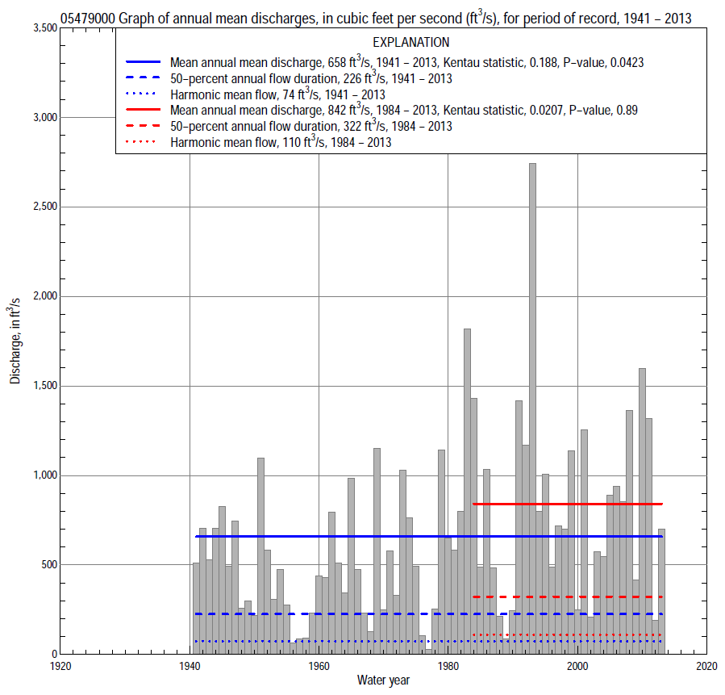

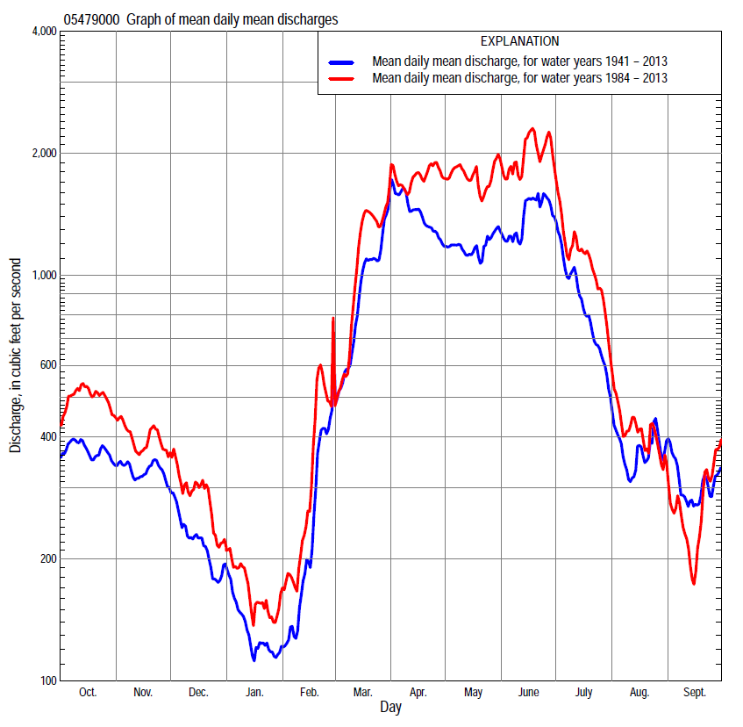

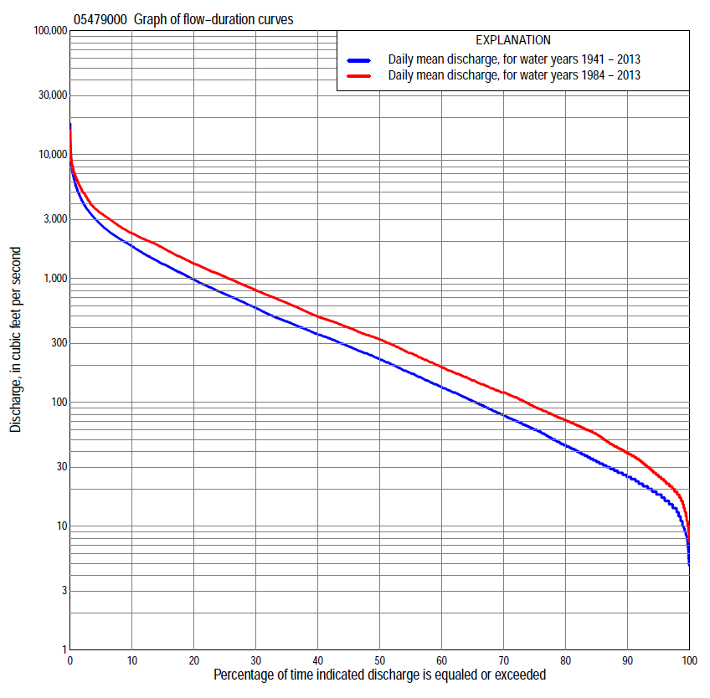

Statistics Based on the Entire Streamflow Period of Record
05479000 Monthly and annual flow durations, based on 1941–2013 period of record (73 years)
Percentage of days discharge equaled or exceeded |  |  |  |  | Discharge (cubic feet per second) |  |  |  |  |  |  |  |  | Annual flow durations
 | Oct | Nov | Dec | Jan | Feb | Mar | Apr | May | June | July | Aug | Sept | Annual | Kentau statistic | P-value
99 | 8.7 | 13 | 9.0 | 5.2 | 11 | 19 | 40 | 41 | 24 | 16 | 11 | 7.0 | 10 | 0.226 | 0.005
98 | 10 | 14 | 10 | 8.6 | 13 | 22 | 45 | 54 | 48 | 25 | 14 | 8.1 | 13 | 0.226 | 0.005
95 | 13 | 20 | 16 | 15 | 16 | 35 | 66 | 91 | 93 | 46 | 20 | 11 | 18 | 0.234 | 0.003
90 | 17 | 25 | 21 | 18 | 18 | 49 | 114 | 148 | 158 | 70 | 28 | 16 | 25 | 0.229 | 0.004
85 | 23 | 29 | 24 | 20 | 21 | 70 | 165 | 211 | 241 | 91 | 39 | 21 | 33 | 0.207 | 0.010
80 | 28 | 33 | 28 | 23 | 27 | 98 | 222 | 284 | 304 | 120 | 49 | 27 | 45 | 0.189 | 0.018
75 | 33 | 39 | 33 | 25 | 30 | 150 | 285 | 355 | 369 | 154 | 62 | 33 | 61 | 0.179 | 0.025
70 | 38 | 45 | 40 | 29 | 35 | 200 | 368 | 413 | 465 | 200 | 74 | 41 | 80 | 0.166 | 0.038
65 | 48 | 59 | 48 | 36 | 46 | 240 | 474 | 467 | 584 | 253 | 90 | 50 | 104 | 0.156 | 0.051
60 | 62 | 74 | 62 | 45 | 58 | 297 | 575 | 538 | 685 | 318 | 108 | 61 | 135 | 0.138 | 0.085
55 | 80 | 96 | 82 | 55 | 67 | 369 | 700 | 640 | 783 | 379 | 122 | 70 | 175 | 0.140 | 0.081
50 | 104 | 133 | 106 | 64 | 85 | 445 | 829 | 760 | 883 | 448 | 139 | 81 | 226 | 0.148 | 0.065
45 | 134 | 200 | 130 | 74 | 105 | 540 | 998 | 910 | 1,000 | 523 | 160 | 95 | 287 | 0.158 | 0.049
40 | 166 | 240 | 162 | 87 | 125 | 685 | 1,280 | 1,090 | 1,170 | 630 | 188 | 120 | 360 | 0.169 | 0.034
35 | 266 | 275 | 190 | 110 | 143 | 794 | 1,490 | 1,240 | 1,340 | 770 | 228 | 153 | 453 | 0.179 | 0.026
30 | 358 | 328 | 230 | 130 | 180 | 938 | 1,800 | 1,410 | 1,580 | 940 | 284 | 199 | 585 | 0.208 | 0.009
25 | 461 | 397 | 294 | 170 | 230 | 1,120 | 2,060 | 1,650 | 1,830 | 1,130 | 347 | 262 | 758 | 0.204 | 0.011
20 | 605 | 493 | 355 | 220 | 310 | 1,400 | 2,360 | 1,930 | 2,080 | 1,400 | 450 | 352 | 986 | 0.210 | 0.009
15 | 810 | 641 | 450 | 250 | 420 | 1,830 | 2,810 | 2,270 | 2,410 | 1,740 | 632 | 502 | 1,310 | 0.209 | 0.009
10 | 1,070 | 902 | 580 | 318 | 650 | 2,610 | 3,430 | 2,770 | 3,090 | 2,150 | 910 | 844 | 1,830 | 0.230 | 0.004
5 | 1,630 | 1,340 | 855 | 500 | 1,150 | 3,630 | 4,600 | 3,710 | 5,070 | 2,950 | 1,390 | 1,580 | 2,730 | 0.197 | 0.014
2 | 2,340 | 2,050 | 1,190 | 780 | 1,770 | 4,800 | 6,480 | 5,060 | 6,860 | 4,800 | 2,690 | 2,450 | 4,200 | 0.152 | 0.058
1 | 2,800 | 2,310 | 1,500 | 958 | 3,350 | 5,610 | 7,710 | 6,170 | 8,080 | 5,710 | 3,350 | 3,250 | 5,480 | 0.107 | 0.182

05479000 Annual exceedance probability of instantaneous peak discharges, in cubic feet per second (ft³/s), based on the Weighted Independent Estimates method,
Annual exceed-ance probability | Recur-rence interval (years) | Discharge (ft³/s) | 95-percent lower confi-dence interval (ft³/s) | 95-percent upper confi-dence interval (ft³/s)
0.500 | 2 | 4,290 | 3,550 | 5,180
0.200 | 5 | 8,170 | 6,780 | 9,840
0.100 | 10 | 11,100 | 9,070 | 13,600
0.040 | 25 | 15,100 | 11,800 | 19,200
0.020 | 50 | 18,000 | 13,600 | 24,000
0.010 | 100 | 21,100 | 15,200 | 29,300
0.005 | 200 | 24,200 | 16,600 | 35,200
0.002 | 500 | 28,200 | 18,200 | 43,500
and based on the expected moments algorithm/multiple Grubbs-Beck analysis computed using a historical period length of 76 years (1938–2013)
0.500 | 2 | 4,320 | 3,520 | 5,250
0.200 | 5 | 8,310 | 6,840 | 10,200
0.100 | 10 | 11,400 | 9,300 | 14,700
0.040 | 25 | 15,700 | 12,400 | 21,800
0.020 | 50 | 19,100 | 14,600 | 28,400
0.010 | 100 | 22,600 | 16,600 | 36,000
0.005 | 200 | 26,300 | 18,400 | 45,000
0.002 | 500 | 31,300 | 20,500 | 59,200
Kentau statistic |  | 0.097
P-value |  | 0.225
Begin year |  | 1940
End year |  | 2013
Number of peaks |  | 74

05479000 Annual exceedance probability of high discharges, based on 1941–2013 period of record (73 years)
Annual exceedance probability | Recur-rence interval (years) | Maximum average discharge (ft³/s) for indicated number of consecutive days
 |  | 1 | 3 | 7 | 15 | 30
0.990 | 1.01 | 417 | 376 | 286 | 192 | 141
0.950 | 1.05 | 905 | 835 | 686 | 504 | 383
0.900 | 1.11 | 1,320 | 1,230 | 1,040 | 793 | 610
0.800 | 1.25 | 2,030 | 1,900 | 1,650 | 1,300 | 1,010
0.500 | 2 | 4,210 | 3,940 | 3,480 | 2,810 | 2,200
0.200 | 5 | 7,780 | 7,210 | 6,260 | 5,000 | 3,890
0.100 | 10 | 10,300 | 9,430 | 8,020 | 6,300 | 4,850
0.040 | 25 | 13,400 | 12,200 | 10,000 | 7,690 | 5,850
0.020 | 50 | 15,700 | 14,100 | 11,300 | 8,540 | 6,450
0.010 | 100 | 17,900 | 15,900 | 12,500 | 9,250 | 6,930
0.005 | 200 | 20,000 | 17,600 | 13,600 | 9,840 | 7,330
0.002 | 500 | 22,600 | 19,700 | 14,800 | 10,500 | 7,740
Kentau statistic |  | 0.079 | 0.089 | 0.110 | 0.154 | 0.158
P-value |  | 0.327 | 0.269 | 0.170 | 0.054 | 0.048

 | 05479000 Annual nonexceedance probability of low discharges, based on April 1940 to March 2013 period of record (73 years)
Annual nonexceed-ance probability | Recur-rence interval (years) | Minimum average discharge (ft³/s) for indicated number of consecutive days
 |  | 1 | 3 | 7 | 14 | 30 | 60 | 90 | 120 | 183
0.01 | 100 | 3.7 | 4.0 | 4.3 | 4.7 | 5.4 | 6.1 | 6.4 | 6.5 | 6.6
0.02 | 50 | 4.8 | 5.2 | 5.5 | 6.0 | 6.9 | 7.8 | 8.3 | 8.4 | 8.5
0.05 | 20 | 6.9 | 7.4 | 7.9 | 8.6 | 10 | 11 | 13 | 13 | 15
0.10 | 10 | 10 | 10 | 11 | 12 | 13 | 16 | 18 | 20 | 23
0.20 | 5 | 14 | 15 | 16 | 17 | 19 | 24 | 28 | 33 | 41
0.50 | 2 | 29 | 30 | 32 | 34 | 39 | 53 | 68 | 86 | 119
0.80 | 1.25 | 57 | 59 | 63 | 68 | 80 | 117 | 167 | 226 | 332
0.90 | 1.11 | 80 | 83 | 88 | 96 | 116 | 178 | 270 | 377 | 561
0.96 | 1.04 | 116 | 119 | 126 | 139 | 172 | 278 | 452 | 653 | 972
0.98 | 1.02 | 146 | 149 | 159 | 176 | 221 | 372 | 634 | 935 | 1,380
0.99 | 1.01 | 179 | 181 | 194 | 217 | 277 | 484 | 862 | 1,290 | 1,880
Kentau statistic |  | 0.235 | 0.245 | 0.268 | 0.285 | 0.254 | 0.199 | 0.189 | 0.191 | 0.164
P-value |  | 0.003 | 0.002 | 0.001 | 0.000 | 0.001 | 0.013 | 0.018 | 0.017 | 0.041

05479000 Annual nonexceedance probability of seasonal low discharges, based on March 1940 to September 2013 period of record (73–74 years)
Annual nonexceed-ance probability | Recur-rence interval (years) | Minimum average discharge (cubic feet per second) for indicated number of consecutive days
 |  | 1 | 7 | 14 | 30 |  | 1 | 7 | 14 | 30
 |  | January-February-March |  |  |  |  | April-May-June
0.01 | 100 | 5.3 | 5.7 | 5.9 | 6.0 |  | 11 | 13 | 16 | 27
0.02 | 50 | 6.6 | 7.1 | 7.4 | 7.6 |  | 16 | 19 | 23 | 38
0.05 | 20 | 9.2 | 9.9 | 10 | 11 |  | 29 | 34 | 41 | 64
0.10 | 10 | 13 | 14 | 14 | 15 |  | 47 | 56 | 67 | 100
0.20 | 5 | 19 | 20 | 21 | 24 |  | 83 | 99 | 118 | 169
0.50 | 2 | 41 | 44 | 48 | 55 |  | 230 | 274 | 326 | 444
0.80 | 1.25 | 95 | 105 | 114 | 136 |  | 584 | 685 | 824 | 1,100
0.90 | 1.11 | 151 | 168 | 184 | 225 |  | 920 | 1,070 | 1,290 | 1,740
0.96 | 1.04 | 252 | 285 | 314 | 390 |  | 1,460 | 1,660 | 2,030 | 2,770
0.98 | 1.02 | 356 | 406 | 450 | 562 |  | 1,940 | 2,180 | 2,690 | 3,720
0.99 | 1.01 | 487 | 561 | 624 | 787 |  | 2,490 | 2,760 | 3,430 | 4,810
Kentau statistic |  | 0.185 | 0.211 | 0.228 | 0.197 |  | 0.245 | 0.239 | 0.242 | 0.245
P-value |  | 0.021 | 0.008 | 0.004 | 0.014 |  | 0.002 | 0.003 | 0.002 | 0.002
 |  | July-August-September |  |  |  |  | October-November-December
0.01 | 100 | 4.2 | 5.4 | 6.1 | 7.3 |  | 3.5 | 4.1 | 4.5 | 5.4
0.02 | 50 | 5.4 | 6.7 | 7.5 | 9.2 |  | 4.7 | 5.4 | 6.0 | 7.2
0.05 | 20 | 7.8 | 9.4 | 11 | 13 |  | 7.2 | 8.4 | 9.3 | 11
0.10 | 10 | 11 | 13 | 14 | 18 |  | 11 | 12 | 14 | 17
0.20 | 5 | 17 | 19 | 21 | 28 |  | 17 | 20 | 23 | 28
0.50 | 2 | 39 | 44 | 49 | 68 |  | 46 | 54 | 63 | 79
0.80 | 1.25 | 96 | 108 | 125 | 181 |  | 127 | 154 | 182 | 232
0.90 | 1.11 | 157 | 179 | 210 | 315 |  | 223 | 270 | 325 | 419
0.96 | 1.04 | 269 | 314 | 378 | 585 |  | 412 | 502 | 617 | 800
0.98 | 1.02 | 386 | 458 | 561 | 890 |  | 619 | 757 | 945 | 1,230
0.99 | 1.01 | 535 | 648 | 808 | 1,310 |  | 897 | 1,100 | 1,390 | 1,820
Kentau statistic |  | 0.117 | 0.107 | 0.096 | 0.072 |  | 0.183 | 0.203 | 0.194 | 0.190
P-value |  | 0.141 | 0.179 | 0.230 | 0.365 |  | 0.023 | 0.011 | 0.016 | 0.018

Statistics Based on the 1984–2013 Streamflow Period of Record
05479000 Monthly and annual flow durations, based on 1984–2013 period of record (30 years)
Percentage of days discharge equaled or exceeded |  |  |  |  | Discharge (cubic feet per second) |  |  |  |  |  |  |  |  | Annual flow durations
 | Oct | Nov | Dec | Jan | Feb | Mar | Apr | May | June | July | Aug | Sept | Annual | Kentau statistic | P-value
99 | 11 | 23 | 10 | 16 | 15 | 20 | 40 | 55 | 53 | 30 | 14 | 9.3 | 15 | -0.087 | 0.509
98 | 13 | 24 | 15 | 18 | 16 | 22 | 48 | 67 | 73 | 36 | 17 | 11 | 18 | -0.083 | 0.532
95 | 22 | 28 | 22 | 19 | 20 | 60 | 73 | 173 | 154 | 54 | 22 | 15 | 25 | -0.051 | 0.708
90 | 30 | 37 | 27 | 23 | 25 | 94 | 121 | 324 | 333 | 78 | 33 | 26 | 39 | -0.062 | 0.643
85 | 37 | 41 | 33 | 28 | 34 | 136 | 219 | 434 | 405 | 105 | 68 | 35 | 55 | -0.108 | 0.412
80 | 42 | 45 | 40 | 40 | 46 | 178 | 304 | 513 | 532 | 167 | 93 | 43 | 71 | -0.087 | 0.509
75 | 50 | 63 | 60 | 48 | 59 | 207 | 406 | 638 | 645 | 252 | 109 | 53 | 92 | -0.064 | 0.630
70 | 60 | 74 | 76 | 56 | 68 | 241 | 607 | 779 | 743 | 327 | 121 | 60 | 120 | -0.062 | 0.643
65 | 74 | 89 | 95 | 64 | 84 | 290 | 779 | 939 | 836 | 392 | 133 | 66 | 150 | -0.060 | 0.655
60 | 86 | 110 | 121 | 75 | 100 | 356 | 955 | 1,080 | 953 | 461 | 144 | 71 | 192 | -0.046 | 0.735
55 | 113 | 198 | 163 | 89 | 120 | 437 | 1,190 | 1,210 | 1,080 | 533 | 160 | 78 | 250 | -0.060 | 0.656
50 | 138 | 249 | 187 | 114 | 130 | 482 | 1,390 | 1,340 | 1,240 | 640 | 178 | 85 | 322 | -0.034 | 0.803
45 | 166 | 322 | 214 | 125 | 141 | 618 | 1,660 | 1,530 | 1,510 | 799 | 202 | 103 | 400 | -0.034 | 0.803
40 | 315 | 378 | 273 | 150 | 160 | 740 | 1,920 | 1,720 | 1,730 | 947 | 236 | 126 | 492 | -0.025 | 0.858
35 | 432 | 430 | 309 | 170 | 180 | 883 | 2,100 | 1,920 | 1,980 | 1,070 | 285 | 154 | 635 | -0.021 | 0.887
30 | 547 | 490 | 350 | 200 | 220 | 1,080 | 2,300 | 2,090 | 2,280 | 1,250 | 340 | 188 | 800 | 0.039 | 0.775
25 | 705 | 568 | 410 | 226 | 334 | 1,290 | 2,500 | 2,350 | 2,620 | 1,430 | 410 | 234 | 1,030 | 0.016 | 0.915
20 | 886 | 646 | 460 | 250 | 417 | 1,620 | 2,850 | 2,680 | 3,090 | 1,700 | 533 | 303 | 1,310 | 0.021 | 0.887
15 | 1,080 | 746 | 520 | 280 | 600 | 2,180 | 3,240 | 3,130 | 3,730 | 1,990 | 747 | 408 | 1,760 | 0.048 | 0.721
10 | 1,330 | 953 | 641 | 350 | 844 | 2,920 | 3,640 | 3,720 | 4,920 | 2,280 | 1,050 | 668 | 2,320 | 0.110 | 0.402
5 | 1,970 | 1,340 | 920 | 577 | 1,350 | 3,770 | 4,730 | 4,970 | 6,230 | 3,710 | 1,730 | 1,450 | 3,350 | 0.122 | 0.354
2 | 2,910 | 1,890 | 1,200 | 789 | 2,050 | 4,940 | 6,320 | 6,530 | 7,740 | 6,370 | 2,840 | 2,060 | 5,020 | 0.133 | 0.309
1 | 3,330 | 2,210 | 1,500 | 958 | 3,670 | 7,100 | 7,480 | 6,960 | 8,990 | 8,110 | 3,290 | 2,660 | 6,400 | 0.143 | 0.276

05479000 Annual exceedance probability of high discharges, based on 1984–2013 period of record (30 years)
Annual exceedance probability | Recur-rence interval (years) | Maximum average discharge (ft³/s) for indicated number of consecutive days
 |  | 1 | 3 | 7 | 15 | 30
0.990 | 1.01 | 821 | 716 | 537 | 357 | 282
0.950 | 1.05 | 1,380 | 1,250 | 1,030 | 777 | 615
0.900 | 1.11 | 1,810 | 1,670 | 1,430 | 1,130 | 892
0.800 | 1.25 | 2,490 | 2,330 | 2,060 | 1,690 | 1,350
0.500 | 2 | 4,500 | 4,270 | 3,890 | 3,310 | 2,640
0.200 | 5 | 7,870 | 7,460 | 6,740 | 5,610 | 4,490
0.100 | 10 | 10,400 | 9,810 | 8,700 | 7,020 | 5,640
0.040 | 25 | 14,000 | 13,000 | 11,100 | 8,600 | 6,930
0.020 | 50 | 16,800 | 15,400 | 12,900 | 9,630 | 7,770
0.010 | 100 | 19,700 | 18,000 | 14,600 | 10,500 | 8,520
0.005 | 200 | 22,800 | 20,500 | 16,300 | 11,400 | 9,190
0.002 | 500 | 27,100 | 24,100 | 18,400 | 12,300 | 9,960
Kentau statistic |  | 0.143 | 0.138 | 0.145 | 0.168 | 0.103
P-value |  | 0.276 | 0.292 | 0.269 | 0.199 | 0.432

 | 05479000 Annual nonexceedance probability of low discharges, based on April 1983 to March 2013 period of record (30 years)
Annual nonexceed-ance probability | Recur-rence interval (years) | Minimum average discharge (ft³/s) for indicated number of consecutive days
 |  | 1 | 3 | 7 | 14 | 30 | 60 | 90 | 120 | 183
0.01 | 100 | 5.4 | 6.0 | 6.3 | 6.8 | 8.3 | 8.6 | 8.9 | 9.0 | 9.1
0.02 | 50 | 7.1 | 7.8 | 8.3 | 8.9 | 11 | 12 | 12 | 13 | 14
0.05 | 20 | 10 | 12 | 12 | 13 | 16 | 18 | 20 | 22 | 23
0.10 | 10 | 15 | 16 | 17 | 19 | 22 | 25 | 29 | 34 | 38
0.20 | 5 | 21 | 23 | 25 | 27 | 31 | 38 | 47 | 57 | 68
0.50 | 2 | 42 | 45 | 49 | 54 | 61 | 80 | 105 | 140 | 188
0.80 | 1.25 | 78 | 81 | 88 | 97 | 112 | 154 | 217 | 310 | 462
0.90 | 1.11 | 104 | 108 | 116 | 128 | 150 | 211 | 308 | 454 | 705
0.96 | 1.04 | 141 | 142 | 152 | 169 | 202 | 289 | 435 | 660 | 1,070
0.98 | 1.02 | 167 | 168 | 179 | 200 | 243 | 350 | 538 | 829 | 1,370
0.99 | 1.01 | 193 | 194 | 205 | 230 | 286 | 412 | 645 | 1,010 | 1,700
Kentau statistic |  | -0.108 | -0.115 | -0.085 | -0.021 | -0.048 | -0.076 | -0.025 | -0.062 | -0.053
P-value |  | 0.411 | 0.382 | 0.521 | 0.887 | 0.721 | 0.568 | 0.858 | 0.643 | 0.695

05479000 Annual nonexceedance probability of seasonal low discharges, based on October 1983 to September 2013 period of record (30 years)
Annual nonexceed-ance probability | Recur-rence interval (years) | Minimum average discharge (cubic feet per second) for indicated number of consecutive days
 |  | 1 | 7 | 14 | 30 |  | 1 | 7 | 14 | 30
 |  | January-February-March |  |  |  |  | April-May-June
0.01 | 100 | 7.2 | 9.2 | 10 | 11 |  | 14 | 15 | 18 | 31
0.02 | 50 | 9.4 | 12 | 13 | 14 |  | 22 | 24 | 28 | 48
0.05 | 20 | 14 | 16 | 18 | 19 |  | 42 | 47 | 56 | 92
0.10 | 10 | 19 | 22 | 24 | 26 |  | 72 | 83 | 99 | 156
0.20 | 5 | 29 | 33 | 36 | 39 |  | 133 | 155 | 187 | 284
0.50 | 2 | 63 | 70 | 76 | 85 |  | 386 | 454 | 551 | 782
0.80 | 1.25 | 137 | 154 | 167 | 194 |  | 971 | 1,120 | 1,370 | 1,830
0.90 | 1.11 | 205 | 236 | 258 | 303 |  | 1,490 | 1,700 | 2,060 | 2,680
0.96 | 1.04 | 314 | 375 | 415 | 493 |  | 2,260 | 2,510 | 3,040 | 3,850
0.98 | 1.02 | 413 | 509 | 568 | 681 |  | 2,900 | 3,170 | 3,820 | 4,760
0.99 | 1.01 | 528 | 672 | 757 | 913 |  | 3,570 | 3,840 | 4,610 | 5,680
Kentau statistic |  | -0.154 | -0.136 | -0.099 | -0.090 |  | -0.005 | 0.016 | 0.025 | 0.030
P-value |  | 0.238 | 0.301 | 0.454 | 0.498 |  | 0.986 | 0.915 | 0.858 | 0.830
 |  | July-August-September |  |  |  |  | October-November-December
0.01 | 100 | 10 | 11 | 12 | 14 |  | 4.8 | 5.5 | 6.0 | 8.1
0.02 | 50 | 12 | 13 | 14 | 16 |  | 6.7 | 7.7 | 8.4 | 11
0.05 | 20 | 14 | 16 | 17 | 21 |  | 11 | 13 | 14 | 18
0.10 | 10 | 17 | 20 | 22 | 27 |  | 16 | 20 | 21 | 28
0.20 | 5 | 23 | 26 | 29 | 38 |  | 27 | 32 | 36 | 46
0.50 | 2 | 47 | 53 | 60 | 80 |  | 66 | 81 | 93 | 120
0.80 | 1.25 | 114 | 131 | 150 | 196 |  | 155 | 193 | 237 | 307
0.90 | 1.11 | 197 | 226 | 262 | 335 |  | 238 | 297 | 382 | 499
0.96 | 1.04 | 378 | 432 | 510 | 622 |  | 373 | 463 | 629 | 831
0.98 | 1.02 | 597 | 681 | 813 | 956 |  | 495 | 610 | 864 | 1,150
0.99 | 1.01 | 924 | 1,050 | 1,270 | 1,430 |  | 635 | 778 | 1,150 | 1,550
Kentau statistic |  | -0.152 | -0.172 | -0.154 | -0.163 |  | -0.002 | 0.039 | -0.011 | -0.067
P-value |  | 0.246 | 0.187 | 0.239 | 0.212 |  | 1.000 | 0.775 | 0.943 | 0.617

