LOCATION.--Lat 42°32'43", long 94°20'47" referenced to North American Datum of 1927, Webster County, IA, Hydrologic Unit 07100004, on right bank 20 ft downstream from bridge on 170th Street, 2.7 mi south of Clare, 3.9 mi downstream from Drainage Ditch 3, and 12.8 mi upstream from confluence with South Branch Lizard Creek.

DRAINAGE AREA.--257 mi².

PERIOD OF RECORD.--Discharge records from March 1940 to December 1981. Prior to April 1940, monthly mean discharge for some periods published in WSP 1308. Prior to October 1954, published as "North Lizard Creek."

GAGE.--Water-stage recorder and concrete control. Datum of gage is 1,079.30 ft above National Geodetic Vertical Datum of 1929. Prior to May 6, 1953, non-recording gage at same site and datum.

A summary of all available data for this streamgage is provided through the USGS National Water Information System web interface (NWISWeb). The following link provides access to current/historical observations, daily data, daily statistics, monthly statistics, annual statistics, peak streamflow, field measurements, field/lab water-quality samples, and the latest water-year summaries. Data can be filtered by parameter and/or dates, and can be output in various tabular and graphical formats.
http://waterdata.usgs.gov/nwis/inventory/?site_no=05480000

The USGS WaterWatch Toolkit is available at:
http://waterwatch.usgs.gov/?id=ww_toolkit
Tools for summarizing streamflow information include the duration hydrograph builder, the cumulative streamflow hydrograph builder, the streamgage statistics retrieval tool, the rating curve builder, the flood tracking chart builder, the National Weather Service Advanced Hydrologic Prediction Service (AHPS) river forecast hydrograph builder, and the raster-hydrograph builder. Entering the above number for this streamgage into these toolkit webpages will provide streamflow information specific to this streamgage.

A description of the statistics presented for this streamgage is available in the main body of the report at:
http://dx.doi.org/10.3133/ofr20151214
A link to other streamgages included in this report, a map showing the location of the streamgages, information on the programs used to compute the statistical analyses, and references are included in the main body of the report.

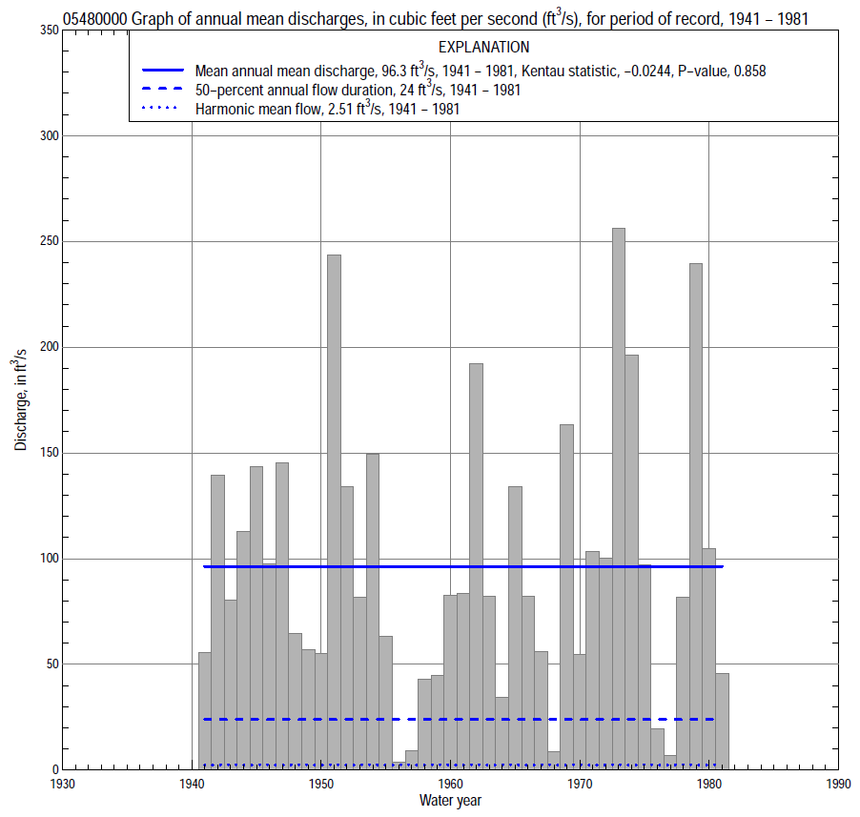

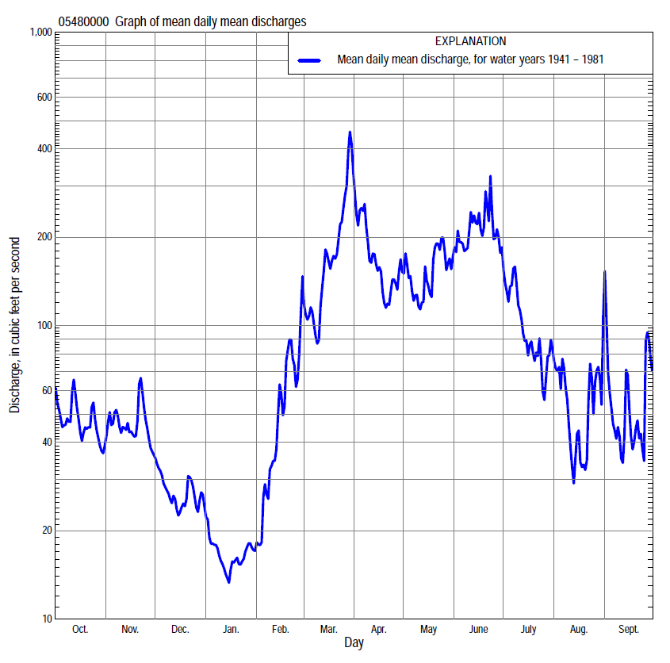

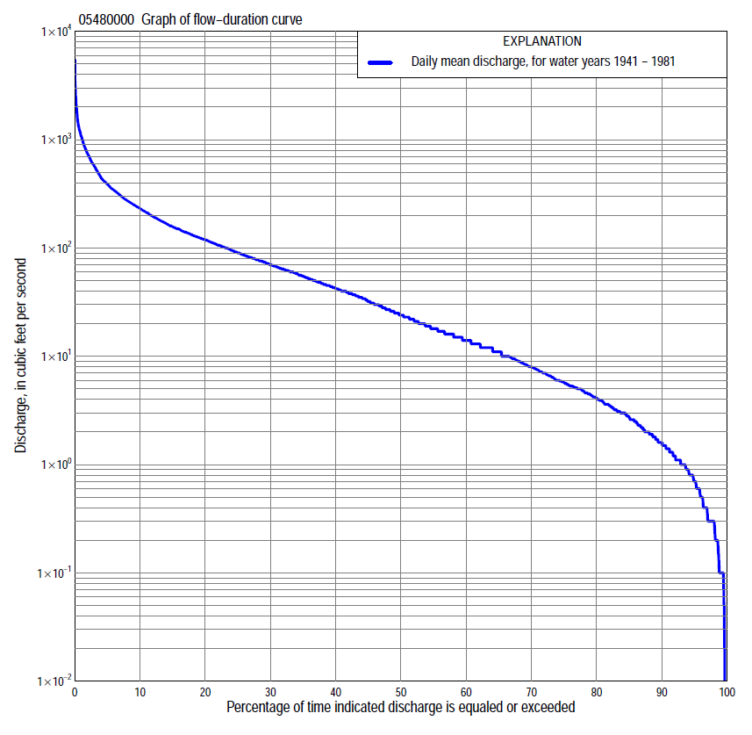

Statistics Based on the Entire Streamflow Period of Record
05480000 Monthly and annual flow durations, based on 1941–81 period of record (41 years)
Percentage of days discharge equaled or exceeded |  |  |  |  | Discharge (cubic feet per second) |  |  |  |  |  |  |  |  | Annual flow durations
 | Oct | Nov | Dec | Jan | Feb | Mar | Apr | May | June | July | Aug | Sept | Annual | Kentau statistic | P-value
99 | 0.12 | 0.70 | 0.05 | 0.00 | 0.03 | 1.4 | 2.0 | 1.6 | 0.46 | 0.20 | 0.10 | 0.10 | 0.10 | 0.078 | 0.448
98 | 0.37 | 1.1 | 0.13 | 0.00 | 0.10 | 1.9 | 3.3 | 3.2 | 0.80 | 0.36 | 0.20 | 0.10 | 0.29 | 0.155 | 0.139
95 | 0.70 | 1.5 | 0.60 | 0.30 | 0.30 | 5.0 | 7.0 | 7.5 | 3.0 | 1.6 | 0.60 | 0.20 | 0.70 | 0.137 | 0.198
90 | 1.1 | 2.1 | 0.90 | 0.40 | 0.40 | 8.0 | 13 | 13 | 18 | 5.9 | 1.6 | 0.90 | 1.5 | 0.088 | 0.418
85 | 1.8 | 2.8 | 1.2 | 0.70 | 0.94 | 12 | 20 | 27 | 29 | 10 | 3.1 | 1.5 | 2.6 | 0.115 | 0.293
80 | 2.4 | 3.5 | 1.7 | 1.0 | 1.6 | 14 | 30 | 36 | 39 | 14 | 4.6 | 2.3 | 4.0 | 0.105 | 0.337
75 | 2.9 | 4.2 | 2.4 | 1.3 | 2.0 | 18 | 39 | 44 | 48 | 18 | 6.4 | 2.9 | 5.6 | 0.093 | 0.398
70 | 3.5 | 5.3 | 3.6 | 1.8 | 3.0 | 22 | 46 | 52 | 58 | 23 | 7.6 | 3.6 | 7.9 | 0.078 | 0.478
65 | 4.4 | 7.6 | 5.0 | 2.5 | 3.6 | 31 | 55 | 60 | 68 | 27 | 8.7 | 4.6 | 11 | 0.074 | 0.500
60 | 5.3 | 10 | 5.5 | 4.0 | 4.8 | 40 | 67 | 71 | 75 | 33 | 10 | 5.8 | 14 | 0.062 | 0.574
55 | 7.2 | 11 | 7.0 | 4.8 | 5.7 | 50 | 78 | 82 | 86 | 40 | 12 | 7.0 | 18 | 0.033 | 0.770
50 | 10 | 14 | 9.0 | 5.3 | 7.0 | 68 | 91 | 94 | 97 | 46 | 14 | 8.5 | 24 | 0.007 | 0.955
45 | 13 | 16 | 12 | 6.0 | 10 | 86 | 106 | 106 | 114 | 54 | 17 | 10 | 33 | -0.045 | 0.686
40 | 16 | 20 | 14 | 8.0 | 14 | 106 | 124 | 118 | 130 | 64 | 20 | 13 | 43 | -0.065 | 0.559
35 | 20 | 26 | 17 | 9.8 | 19 | 128 | 139 | 132 | 152 | 76 | 24 | 17 | 56 | -0.065 | 0.559
30 | 26 | 32 | 20 | 12 | 28 | 152 | 165 | 148 | 181 | 91 | 30 | 22 | 72 | -0.065 | 0.559
25 | 42 | 41 | 24 | 13 | 42 | 188 | 202 | 168 | 226 | 114 | 39 | 30 | 92 | -0.056 | 0.613
20 | 60 | 55 | 33 | 22 | 55 | 235 | 261 | 198 | 280 | 150 | 50 | 46 | 121 | -0.061 | 0.582
15 | 93 | 70 | 45 | 34 | 80 | 300 | 328 | 245 | 376 | 192 | 72 | 67 | 160 | -0.028 | 0.805
10 | 141 | 108 | 73 | 53 | 150 | 485 | 425 | 323 | 550 | 250 | 112 | 106 | 235 | -0.043 | 0.703
5 | 222 | 213 | 120 | 72 | 290 | 830 | 633 | 456 | 820 | 353 | 225 | 230 | 394 | -0.028 | 0.805
2 | 340 | 404 | 200 | 120 | 447 | 1,470 | 1,010 | 896 | 1,220 | 650 | 482 | 560 | 745 | -0.044 | 0.694
1 | 429 | 499 | 266 | 150 | 700 | 2,110 | 1,210 | 1,400 | 1,700 | 920 | 850 | 1,060 | 1,080 | -0.067 | 0.544

05480000 Annual exceedance probability of instantaneous peak discharges, in cubic feet per second (ft³/s), based on the Weighted Independent Estimates method,
Annual exceed-ance probability | Recur-rence interval (years) | Discharge (ft³/s) | 95-percent lower confi-dence interval (ft³/s) | 95-percent upper confi-dence interval (ft³/s)
0.500 | 2 | 1,580 | 1,190 | 2,090
0.200 | 5 | 3,240 | 2,490 | 4,220
0.100 | 10 | 4,510 | 3,410 | 5,960
0.040 | 25 | 6,170 | 4,460 | 8,520
0.020 | 50 | 7,390 | 5,110 | 10,700
0.010 | 100 | 8,620 | 5,690 | 13,100
0.005 | 200 | 9,880 | 6,210 | 15,700
0.002 | 500 | 11,400 | 6,710 | 19,400
and based on the expected moments algorithm/multiple Grubbs-Beck analysis computed using a historical period length of 42 years (1940–1981)
0.500 | 2 | 1,590 | 1,150 | 2,150
0.200 | 5 | 3,350 | 2,500 | 4,580
0.100 | 10 | 4,710 | 3,520 | 6,870
0.040 | 25 | 6,560 | 4,740 | 10,700
0.020 | 50 | 7,990 | 5,530 | 14,300
0.010 | 100 | 9,430 | 6,190 | 18,600
0.005 | 200 | 10,900 | 6,730 | 23,700
0.002 | 500 | 12,800 | 7,320 | 32,000
Kentau statistic |  | 0.038
P-value |  | 0.729
Begin year |  | 1940
End year |  | 1981
Number of peaks |  | 42

05480000 Annual exceedance probability of high discharges, based on 1941–81 period of record (41 years)
Annual exceedance probability | Recur-rence interval (years) | Maximum average discharge (ft³/s) for indicated number of consecutive days
 |  | 1 | 3 | 7 | 15 | 30
0.990 | 1.01 | 66 | 44 | 28 | 22 | 15
0.950 | 1.05 | 190 | 141 | 97 | 69 | 49
0.900 | 1.11 | 315 | 244 | 171 | 119 | 85
0.800 | 1.25 | 547 | 441 | 314 | 213 | 153
0.500 | 2 | 1,350 | 1,120 | 801 | 530 | 374
0.200 | 5 | 2,730 | 2,230 | 1,560 | 1,030 | 703
0.100 | 10 | 3,680 | 2,940 | 2,000 | 1,340 | 892
0.040 | 25 | 4,830 | 3,720 | 2,470 | 1,670 | 1,080
0.020 | 50 | 5,600 | 4,200 | 2,740 | 1,870 | 1,190
0.010 | 100 | 6,310 | 4,620 | 2,950 | 2,030 | 1,280
0.005 | 200 | 6,950 | 4,960 | 3,130 | 2,170 | 1,350
0.002 | 500 | 7,710 | 5,340 | 3,300 | 2,320 | 1,410
Kentau statistic |  | -0.041 | -0.056 | -0.066 | -0.066 | -0.071
P-value |  | 0.711 | 0.613 | 0.552 | 0.552 | 0.522

 | 05480000 Annual nonexceedance probability of low discharges, based on April 1940 to March 1981 period of record (41 years)
Annual nonexceed-ance probability | Recur-rence interval (years) | Minimum average discharge (cubic feet per second) for indicated number of consecutive days
 |  | 1 | 3 | 7 | 14 | 30 | 60 | 90 | 120 | 183
0.01 | 100 | 0.00 | 0.00 | 0.00 | 0.00 | 0.00 | 0.02 | 0.15 | 0.32 | 0.45
0.02 | 50 | 0.00 | 0.00 | 0.00 | 0.00 | 0.00 | 0.04 | 0.23 | 0.46 | 0.65
0.05 | 20 | 0.00 | 0.01 | 0.05 | 0.08 | 0.12 | 0.25 | 0.45 | 0.78 | 1.1
0.10 | 10 | 0.01 | 0.07 | 0.12 | 0.18 | 0.27 | 0.49 | 0.81 | 1.3 | 1.9
0.20 | 5 | 0.21 | 0.22 | 0.28 | 0.40 | 0.59 | 1.0 | 1.6 | 2.3 | 3.4
0.50 | 2 | 1.0 | 1.1 | 1.3 | 1.6 | 2.3 | 3.5 | 5.7 | 7.5 | 11
0.80 | 1.25 | 4.3 | 5.0 | 5.4 | 6.0 | 8.4 | 12 | 18 | 25 | 37
0.90 | 1.11 | 9.4 | 11 | 11 | 12 | 16 | 22 | 33 | 48 | 71
0.96 | 1.04 | 22 | 23 | 25 | 26 | 33 | 44 | 59 | 96 | 143
0.98 | 1.02 | 37 | 37 | 41 | 42 | 52 | 68 | 86 | 152 | 227
0.99 | 1.01 | 57 | 57 | 63 | 64 | 79 | 101 | 120 | 231 | 344
Kentau statistic |  | 0.072 | 0.052 | 0.068 | 0.065 | 0.065 | 0.041 | -0.005 | 0.024 | 0.044
P-value |  | 0.514 | 0.637 | 0.537 | 0.559 | 0.559 | 0.711 | 0.973 | 0.831 | 0.694

05480000 Annual nonexceedance probability of seasonal low discharges, based on April 1940 to December 1981 period of record (41–42 years)
Annual nonexceed-ance probability | Recur-rence interval (years) | Minimum average discharge (cubic feet per second) for indicated number of consecutive days
 |  | 1 | 7 | 14 | 30 |  | 1 | 7 | 14 | 30
 |  | January-February-March |  |  |  |  | April-May-June
0.01 | 100 | 0.00 | 0.00 | 0.00 | 0.00 |  | 0.09 | 0.19 | 0.36 | 1.2
0.02 | 50 | 0.00 | 0.00 | 0.00 | 0.00 |  | 0.23 | 0.45 | 0.76 | 2.1
0.05 | 20 | 0.02 | 0.09 | 0.13 | 0.18 |  | 0.81 | 1.4 | 2.1 | 4.6
0.10 | 10 | 0.17 | 0.23 | 0.30 | 0.42 |  | 2.2 | 3.4 | 4.8 | 8.9
0.20 | 5 | 0.48 | 0.56 | 0.70 | 0.94 |  | 6.0 | 8.6 | 11 | 18
0.50 | 2 | 2.3 | 2.6 | 3.0 | 4.0 |  | 26 | 32 | 40 | 56
0.80 | 1.25 | 9.4 | 11 | 12 | 16 |  | 64 | 73 | 91 | 129
0.90 | 1.11 | 19 | 21 | 23 | 33 |  | 86 | 95 | 121 | 182
0.96 | 1.04 | 41 | 45 | 49 | 70 |  | 105 | 114 | 151 | 245
0.98 | 1.02 | 67 | 72 | 78 | 115 |  | 115 | 123 | 166 | 286
0.99 | 1.01 | 104 | 110 | 118 | 179 |  | 122 | 129 | 178 | 323
Kentau statistic |  | 0.050 | 0.040 | 0.020 | -0.044 |  | 0.123 | 0.065 | 0.034 | 0.013
P-value |  | 0.653 | 0.719 | 0.866 | 0.694 |  | 0.255 | 0.551 | 0.762 | 0.914
 |  | July-August-September |  |  |  |  | October-November-December
0.01 | 100 | 0.00 | 0.02 | 0.04 | 0.11 |  | 0.00 | 0.00 | 0.03 | 0.10
0.02 | 50 | 0.00 | 0.04 | 0.08 | 0.19 |  | 0.00 | 0.00 | 0.06 | 0.17
0.05 | 20 | 0.00 | 0.11 | 0.18 | 0.42 |  | 0.12 | 0.16 | 0.17 | 0.38
0.10 | 10 | 0.09 | 0.26 | 0.39 | 0.81 |  | 0.28 | 0.36 | 0.38 | 0.74
0.20 | 5 | 0.39 | 0.67 | 0.91 | 1.8 |  | 0.65 | 0.83 | 0.97 | 1.6
0.50 | 2 | 2.7 | 3.5 | 4.2 | 7.1 |  | 2.9 | 3.7 | 5.0 | 6.8
0.80 | 1.25 | 12 | 15 | 17 | 26 |  | 12 | 16 | 21 | 26
0.90 | 1.11 | 24 | 29 | 32 | 48 |  | 26 | 34 | 41 | 51
0.96 | 1.04 | 44 | 57 | 63 | 91 |  | 59 | 77 | 78 | 100
0.98 | 1.02 | 63 | 84 | 95 | 135 |  | 100 | 130 | 140 | 153
0.99 | 1.01 | 84 | 119 | 136 | 190 |  | 160 | 211 | 215 | 223
Kentau statistic |  | 0.128 | 0.150 | 0.149 | 0.122 |  | 0.120 | 0.121 | 0.151 | 0.148
P-value |  | 0.237 | 0.165 | 0.169 | 0.260 |  | 0.269 | 0.264 | 0.162 | 0.172

