LOCATION.--Lat 42°30'30", long 94°12'12" referenced to North American Datum of 1927, in SE 1/4 SW 1/4 NW 1/4 sec.19, T.89 N., R.28 W., Webster County, IA, Hydrologic Unit 07100004, on right bank 750 ft downstream from Illinois Central Railroad bridge in Fort Dodge, 1,100 ft downstream from Lizard Creek, 1,300 ft upstream from Soldier Creek, and 303.3 mi upstream from mouth.

DRAINAGE AREA.--4,190 mi².

PERIOD OF RECORD.--Discharge records from April 1905 to July 1906 (no winter records), October 1913 to September 1927 (published as "at Kalo"), October 1946 to current year. October 1913 to December 1949, monthly mean discharge for some periods published in WSP 1308.

GAGE.--Water-stage recorder. Datum of gage is 969.38 ft above National Geodetic Vertical Datum of 1929. April 22, 1905, to July 19, 1906, non-recording gage at bridge 0.8 mi downstream at different datum; October 18, 1913, to October 20, 1921, and June 20 to September 30, 1927, non-recording gage at site 8.2 mi downstream at Kalo at different datum; October 21, 1921, to June 19, 1927, water-stage recorder at site 8.2 mi downstream at Kalo at different datum; October 1, 1946, to December 7, 1949, non-recording gage at bridge 750 ft upstream at same datum; December 8, 1949, to July 14, 2009, at site 650 ft downstream at same datum.

REMARKS.--Occasional minor regulation caused by dam 0.8 mi upstream from gage.

A summary of all available data for this streamgage is provided through the USGS National Water Information System web interface (NWISWeb). The following link provides access to current/historical observations, daily data, daily statistics, monthly statistics, annual statistics, peak streamflow, field measurements, field/lab water-quality samples, and the latest water-year summaries. Data can be filtered by parameter and/or dates, and can be output in various tabular and graphical formats.
http://waterdata.usgs.gov/nwis/inventory/?site_no=05480500

The USGS WaterWatch Toolkit is available at:
http://waterwatch.usgs.gov/?id=ww_toolkit
Tools for summarizing streamflow information include the duration hydrograph builder, the cumulative streamflow hydrograph builder, the streamgage statistics retrieval tool, the rating curve builder, the flood tracking chart builder, the National Weather Service Advanced Hydrologic Prediction Service (AHPS) river forecast hydrograph builder, and the raster-hydrograph builder. Entering the above number for this streamgage into these toolkit webpages will provide streamflow information specific to this streamgage.

A description of the statistics presented for this streamgage is available in the main body of the report at:
http://dx.doi.org/10.3133/ofr20151214
A link to other streamgages included in this report, a map showing the location of the streamgages, information on the programs used to compute the statistical analyses, and references are included in the main body of the report.

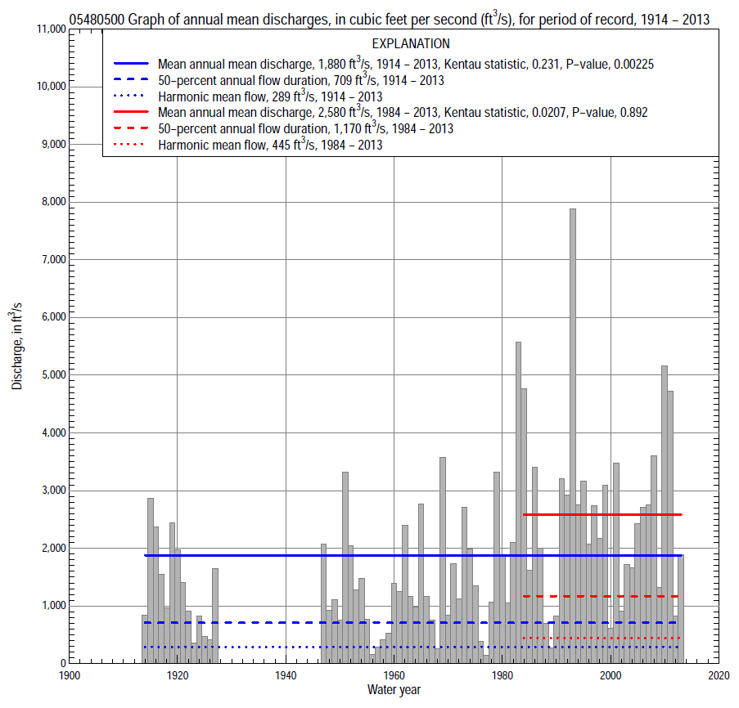

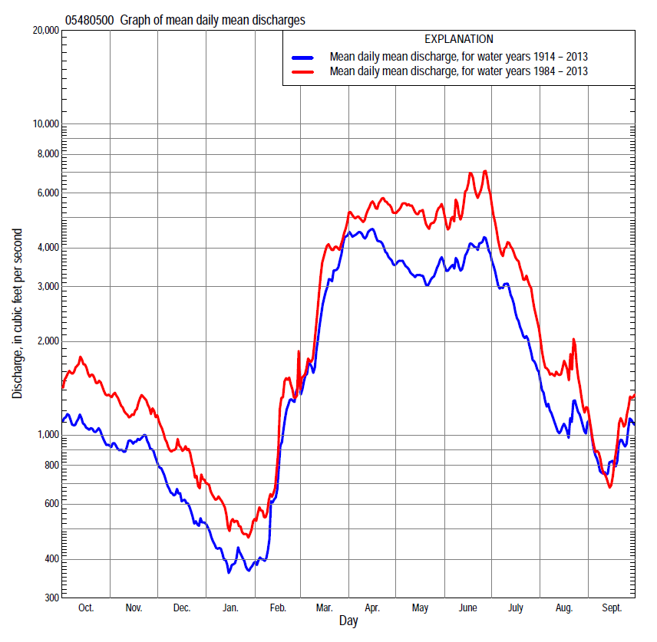

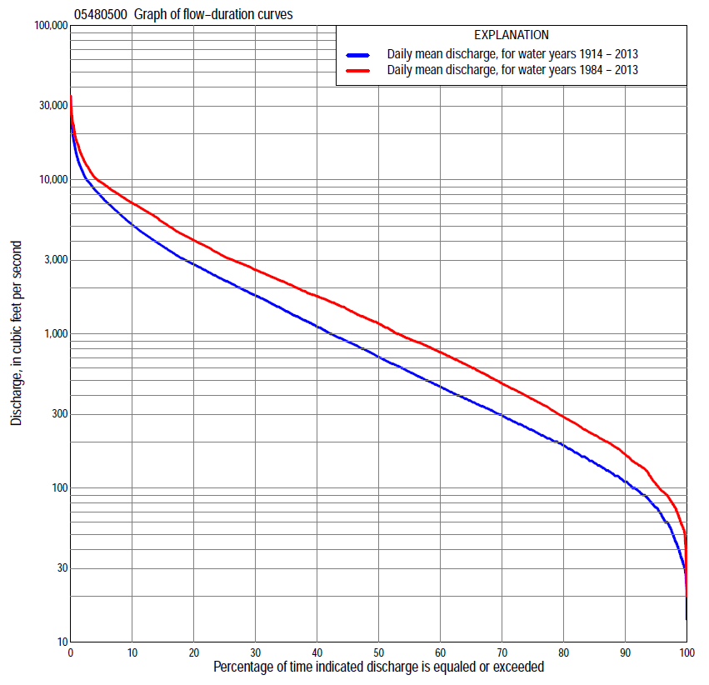

Statistics Based on the Entire Streamflow Period of Record
05480500 Monthly and annual flow durations, based on 1914–27, 1947–2013 period of record (81 years)
Percentage of days discharge equaled or exceeded |  |  |  |  | Discharge (cubic feet per second) |  |  |  |  |  |  |  |  | Annual flow durations
 | Oct | Nov | Dec | Jan | Feb | Mar | Apr | May | June | July | Aug | Sept | Annual | Kentau statistic | P-value
99 | 32 | 44 | 30 | 24 | 31 | 75 | 163 | 145 | 90 | 70 | 56 | 44 | 36 | 0.327 | 0.000
98 | 38 | 53 | 34 | 31 | 34 | 91 | 189 | 159 | 131 | 91 | 72 | 48 | 46 | 0.323 | 0.000
95 | 59 | 75 | 48 | 40 | 45 | 130 | 259 | 218 | 312 | 145 | 86 | 63 | 75 | 0.263 | 0.001
90 | 90 | 110 | 87 | 60 | 64 | 194 | 417 | 402 | 500 | 261 | 127 | 90 | 110 | 0.257 | 0.001
85 | 112 | 142 | 100 | 72 | 86 | 265 | 592 | 631 | 644 | 348 | 180 | 110 | 144 | 0.243 | 0.001
80 | 136 | 169 | 120 | 90 | 100 | 371 | 794 | 893 | 880 | 424 | 220 | 140 | 188 | 0.244 | 0.001
75 | 159 | 200 | 132 | 108 | 120 | 600 | 991 | 1,140 | 1,150 | 496 | 266 | 167 | 236 | 0.232 | 0.002
70 | 188 | 220 | 160 | 120 | 135 | 781 | 1,280 | 1,350 | 1,370 | 591 | 302 | 193 | 297 | 0.196 | 0.010
65 | 236 | 252 | 200 | 138 | 165 | 920 | 1,630 | 1,590 | 1,650 | 741 | 349 | 225 | 370 | 0.190 | 0.012
60 | 281 | 302 | 234 | 156 | 196 | 1,080 | 1,970 | 1,860 | 1,910 | 914 | 407 | 255 | 461 | 0.192 | 0.011
55 | 326 | 359 | 285 | 180 | 220 | 1,230 | 2,330 | 2,140 | 2,200 | 1,110 | 466 | 281 | 576 | 0.190 | 0.012
50 | 374 | 406 | 330 | 214 | 280 | 1,420 | 2,740 | 2,470 | 2,510 | 1,330 | 528 | 322 | 720 | 0.203 | 0.007
45 | 469 | 515 | 380 | 250 | 380 | 1,700 | 3,220 | 2,810 | 2,820 | 1,620 | 595 | 372 | 903 | 0.198 | 0.009
40 | 612 | 643 | 449 | 300 | 467 | 2,000 | 3,910 | 3,180 | 3,160 | 1,860 | 677 | 435 | 1,130 | 0.192 | 0.011
35 | 779 | 786 | 564 | 399 | 540 | 2,280 | 4,530 | 3,650 | 3,660 | 2,240 | 791 | 510 | 1,420 | 0.194 | 0.011
30 | 960 | 979 | 710 | 470 | 640 | 2,640 | 5,210 | 4,100 | 4,230 | 2,760 | 964 | 638 | 1,790 | 0.224 | 0.003
25 | 1,260 | 1,250 | 890 | 540 | 800 | 3,090 | 6,190 | 4,680 | 4,960 | 3,280 | 1,180 | 857 | 2,240 | 0.243 | 0.001
20 | 1,670 | 1,500 | 1,080 | 680 | 950 | 3,850 | 7,390 | 5,490 | 5,880 | 3,880 | 1,520 | 1,180 | 2,850 | 0.255 | 0.001
15 | 2,240 | 1,950 | 1,300 | 820 | 1,530 | 5,530 | 8,620 | 6,480 | 7,090 | 4,710 | 1,910 | 1,670 | 3,720 | 0.261 | 0.001
10 | 2,840 | 2,560 | 1,620 | 940 | 2,160 | 7,350 | 9,990 | 7,550 | 8,650 | 5,950 | 2,650 | 2,330 | 5,150 | 0.244 | 0.001
5 | 4,530 | 3,570 | 2,080 | 1,410 | 3,600 | 9,760 | 12,700 | 9,820 | 12,100 | 8,520 | 4,000 | 4,000 | 7,810 | 0.212 | 0.005
2 | 6,390 | 4,510 | 2,820 | 1,940 | 6,300 | 13,600 | 17,100 | 13,100 | 17,700 | 12,700 | 7,060 | 6,010 | 11,200 | 0.199 | 0.009
1 | 8,050 | 5,050 | 3,220 | 2,980 | 7,630 | 16,200 | 20,600 | 15,300 | 21,200 | 17,200 | 10,300 | 7,920 | 14,400 | 0.174 | 0.022

05480500 Annual exceedance probability of instantaneous peak discharges, in cubic feet per second (ft³/s), based on the Weighted Independent Estimates method,
Annual exceed-ance probability | Recur-rence interval (years) | Discharge (ft³/s) | 95-percent lower confi-dence interval (ft³/s) | 95-percent upper confi-dence interval (ft³/s)
0.500 | 2 | 11,300 | 9,890 | 12,900
0.200 | 5 | 19,100 | 16,800 | 21,700
0.100 | 10 | 24,500 | 21,300 | 28,100
0.040 | 25 | 31,300 | 26,400 | 37,100
0.020 | 50 | 36,300 | 29,700 | 44,400
0.010 | 100 | 41,300 | 32,600 | 52,300
0.005 | 200 | 46,300 | 35,200 | 60,900
0.002 | 500 | 52,600 | 38,000 | 72,800
and based on the expected moments algorithm/multiple Grubbs-Beck analysis computed using a historical period length of 109 years (1905–2013)
0.500 | 2 | 11,300 | 9,630 | 13,100
0.200 | 5 | 19,200 | 16,500 | 22,400
0.100 | 10 | 24,600 | 21,100 | 29,200
0.040 | 25 | 31,400 | 26,600 | 38,800
0.020 | 50 | 36,500 | 30,200 | 46,800
0.010 | 100 | 41,400 | 33,500 | 55,600
0.005 | 200 | 46,300 | 36,500 | 65,400
0.002 | 500 | 52,600 | 39,900 | 79,900
Kentau statistic |  | 0.177
P-value |  | 0.018
Begin year |  | 1905
End year |  | 2013
Number of peaks |  | 83

05480500 Annual exceedance probability of high discharges, based on 1914–27, 1947–2013 period of record (81 years)
Annual exceed-ance probability | Recur-rence interval (years) | Maximum average discharge (ft³/s) for indicated number of consecutive days
 |  | 1 | 3 | 7 | 15 | 30
0.990 | 1.01 | 1,270 | 1,060 | 828 | 603 | 464
0.950 | 1.05 | 2,600 | 2,290 | 1,880 | 1,440 | 1,100
0.900 | 1.11 | 3,700 | 3,320 | 2,780 | 2,170 | 1,670
0.800 | 1.25 | 5,490 | 5,020 | 4,300 | 3,430 | 2,640
0.500 | 2 | 10,700 | 10,000 | 8,790 | 7,150 | 5,580
0.200 | 5 | 18,700 | 17,600 | 15,500 | 12,700 | 10,100
0.100 | 10 | 24,100 | 22,500 | 19,800 | 16,200 | 13,000
0.040 | 25 | 30,600 | 28,300 | 24,800 | 20,000 | 16,300
0.020 | 50 | 35,200 | 32,300 | 28,000 | 22,600 | 18,500
0.010 | 100 | 39,500 | 35,900 | 31,000 | 24,800 | 20,500
0.005 | 200 | 43,600 | 39,300 | 33,700 | 26,800 | 22,300
0.002 | 500 | 48,600 | 43,300 | 36,800 | 29,000 | 24,300
Kentau statistic |  | 0.310 | 0.311 | 0.315 | 0.326 | 0.342
P-value |  | 0.000 | 0.000 | 0.000 | 0.000 | 0.000

 | 05480500 Annual nonexceedance probability of low discharges, based on April 1914 to March 1927, April 1947 to March 2013 period of record (79 years)
Annual nonexceed-ance probability | Recur-rence interval (years) | Minimum average discharge (ft³/s) for indicated number of consecutive days
 |  | 1 | 3 | 7 | 14 | 30 | 60 | 90 | 120 | 183
0.01 | 100 | 10 | 13 | 16 | 19 | 21 | 25 | 26 | 29 | 31
0.02 | 50 | 13 | 17 | 20 | 24 | 27 | 31 | 34 | 38 | 41
0.05 | 20 | 20 | 25 | 29 | 34 | 39 | 45 | 51 | 57 | 65
0.10 | 10 | 29 | 35 | 40 | 46 | 53 | 63 | 72 | 82 | 98
0.20 | 5 | 46 | 54 | 60 | 67 | 77 | 93 | 110 | 128 | 159
0.50 | 2 | 105 | 118 | 126 | 137 | 159 | 201 | 251 | 304 | 400
0.80 | 1.25 | 235 | 250 | 263 | 282 | 331 | 439 | 582 | 734 | 993
0.90 | 1.11 | 355 | 367 | 384 | 410 | 484 | 662 | 907 | 1,170 | 1,590
0.96 | 1.04 | 544 | 548 | 575 | 612 | 728 | 1,030 | 1,460 | 1,940 | 2,620
0.98 | 1.02 | 706 | 707 | 745 | 794 | 949 | 1,370 | 2,000 | 2,690 | 3,600
0.99 | 1.01 | 885 | 886 | 940 | 1,000 | 1,200 | 1,780 | 2,650 | 3,620 | 4,800
Kentau statistic |  | 0.467 | 0.464 | 0.467 | 0.465 | 0.446 | 0.423 | 0.418 | 0.409 | 0.401
P-value |  | 0.000 | 0.000 | 0.000 | 0.000 | 0.000 | 0.000 | 0.000 | 0.000 | 0.000

05480500 Annual nonexceedance probability of seasonal low discharges, based on April 1906 to June 1906, October 1913 to September 1927, October 1946 to September 2013 period of record (81–82 years)
Annual nonexceed-ance probability | Recur-rence interval (years) | Minimum average discharge (cubic feet per second) for indicated number of consecutive days
 |  | 1 | 7 | 14 | 30 |  | 1 | 7 | 14 | 30
 |  | January-February-March |  |  |  |  | April-May-June
0.01 | 100 | 13 | 17 | 20 | 22 |  | 32 | 52 | 61 | 86
0.02 | 50 | 18 | 22 | 25 | 28 |  | 51 | 77 | 90 | 124
0.05 | 20 | 26 | 32 | 36 | 40 |  | 97 | 135 | 157 | 213
0.10 | 10 | 38 | 44 | 49 | 56 |  | 166 | 217 | 253 | 337
0.20 | 5 | 59 | 67 | 74 | 84 |  | 302 | 375 | 436 | 572
0.50 | 2 | 140 | 154 | 165 | 191 |  | 835 | 967 | 1,130 | 1,460
0.80 | 1.25 | 338 | 367 | 390 | 461 |  | 1,950 | 2,210 | 2,590 | 3,370
0.90 | 1.11 | 538 | 587 | 623 | 747 |  | 2,860 | 3,240 | 3,830 | 5,030
0.96 | 1.04 | 888 | 979 | 1,040 | 1,270 |  | 4,110 | 4,720 | 5,620 | 7,490
0.98 | 1.02 | 1,230 | 1,370 | 1,470 | 1,810 |  | 5,070 | 5,920 | 7,090 | 9,570
0.99 | 1.01 | 1,650 | 1,870 | 2,000 | 2,510 |  | 6,040 | 7,170 | 8,640 | 11,800
Kentau statistic |  | 0.247 | 0.256 | 0.246 | 0.208 |  | 0.267 | 0.261 | 0.258 | 0.251
P-value |  | 0.001 | 0.001 | 0.001 | 0.006 |  | 0.000 | 0.001 | 0.001 | 0.001
 |  | July-August-September |  |  |  |  | October-November-December
0.01 | 100 | 19 | 33 | 38 | 42 |  | 12 | 21 | 23 | 26
0.02 | 50 | 25 | 40 | 45 | 51 |  | 16 | 28 | 30 | 34
0.05 | 20 | 37 | 54 | 60 | 70 |  | 26 | 41 | 45 | 52
0.10 | 10 | 52 | 71 | 79 | 93 |  | 39 | 59 | 65 | 75
0.20 | 5 | 80 | 101 | 111 | 135 |  | 64 | 91 | 100 | 117
0.50 | 2 | 184 | 211 | 230 | 292 |  | 162 | 210 | 235 | 283
0.80 | 1.25 | 426 | 471 | 522 | 691 |  | 408 | 493 | 563 | 703
0.90 | 1.11 | 663 | 739 | 832 | 1,120 |  | 657 | 773 | 895 | 1,140
0.96 | 1.04 | 1,060 | 1,220 | 1,400 | 1,940 |  | 1,090 | 1,250 | 1,470 | 1,940
0.98 | 1.02 | 1,450 | 1,710 | 2,010 | 2,800 |  | 1,500 | 1,720 | 2,050 | 2,740
0.99 | 1.01 | 1,920 | 2,330 | 2,790 | 3,930 |  | 2,000 | 2,280 | 2,750 | 3,750
Kentau statistic |  | 0.159 | 0.132 | 0.139 | 0.124 |  | 0.251 | 0.231 | 0.224 | 0.228
P-value |  | 0.034 | 0.079 | 0.066 | 0.101 |  | 0.001 | 0.002 | 0.003 | 0.003

Statistics Based on the 1984–2013 Streamflow Period of Record
05480500 Monthly and annual flow durations, based on 1984–2013 period of record (30 years)
Percentage of days discharge equaled or exceeded |  |  |  |  | Discharge (cubic feet per second) |  |  |  |  |  |  |  |  | Annual flow durations
 | Oct | Nov | Dec | Jan | Feb | Mar | Apr | May | June | July | Aug | Sept | Annual | Kentau statistic | P-value
99 | 57 | 67 | 31 | 43 | 52 | 81 | 178 | 171 | 210 | 132 | 78 | 63 | 60 | -0.085 | 0.521
98 | 59 | 70 | 55 | 52 | 58 | 94 | 202 | 231 | 276 | 157 | 83 | 74 | 75 | -0.087 | 0.509
95 | 92 | 93 | 88 | 72 | 78 | 197 | 267 | 556 | 556 | 235 | 111 | 90 | 105 | -0.083 | 0.532
90 | 135 | 139 | 113 | 102 | 95 | 309 | 504 | 1,270 | 1,180 | 384 | 230 | 139 | 165 | -0.053 | 0.695
85 | 150 | 179 | 146 | 125 | 127 | 580 | 919 | 1,740 | 1,550 | 500 | 333 | 167 | 221 | -0.097 | 0.464
80 | 185 | 204 | 180 | 145 | 175 | 675 | 1,260 | 2,140 | 1,820 | 753 | 400 | 208 | 289 | -0.067 | 0.617
75 | 211 | 237 | 221 | 180 | 200 | 824 | 1,730 | 2,410 | 2,120 | 1,080 | 461 | 243 | 377 | -0.110 | 0.402
70 | 243 | 295 | 340 | 223 | 225 | 941 | 2,180 | 2,780 | 2,490 | 1,320 | 521 | 267 | 477 | -0.097 | 0.464
65 | 286 | 355 | 385 | 260 | 328 | 1,030 | 2,590 | 3,100 | 2,840 | 1,600 | 584 | 282 | 607 | -0.074 | 0.580
60 | 316 | 503 | 497 | 330 | 380 | 1,200 | 3,000 | 3,500 | 3,130 | 1,820 | 644 | 304 | 760 | -0.048 | 0.721
55 | 363 | 732 | 618 | 418 | 439 | 1,310 | 3,540 | 3,870 | 3,620 | 2,090 | 720 | 330 | 928 | -0.060 | 0.656
50 | 440 | 859 | 730 | 470 | 470 | 1,590 | 4,320 | 4,270 | 4,080 | 2,390 | 805 | 374 | 1,170 | -0.021 | 0.887
45 | 677 | 1,110 | 850 | 520 | 511 | 1,900 | 5,080 | 4,730 | 4,560 | 2,760 | 933 | 438 | 1,440 | -0.034 | 0.803
40 | 888 | 1,270 | 980 | 580 | 573 | 2,250 | 5,750 | 5,380 | 5,310 | 3,160 | 1,090 | 504 | 1,750 | -0.030 | 0.830
35 | 1,360 | 1,440 | 1,080 | 650 | 680 | 2,720 | 6,520 | 6,060 | 6,140 | 3,670 | 1,290 | 615 | 2,140 | -0.025 | 0.858
30 | 1,790 | 1,620 | 1,150 | 710 | 800 | 3,300 | 7,330 | 6,540 | 6,900 | 4,000 | 1,500 | 782 | 2,600 | 0.002 | 1.000
25 | 2,220 | 1,890 | 1,300 | 774 | 941 | 3,940 | 8,170 | 7,010 | 7,790 | 4,460 | 1,730 | 1,010 | 3,170 | 0.002 | 1.000
20 | 2,580 | 2,270 | 1,480 | 840 | 1,400 | 4,840 | 9,010 | 7,780 | 8,650 | 5,060 | 2,040 | 1,300 | 4,050 | 0.016 | 0.915
15 | 3,090 | 2,570 | 1,670 | 908 | 1,900 | 6,320 | 9,730 | 8,920 | 10,200 | 5,970 | 2,530 | 1,720 | 5,300 | 0.044 | 0.748
10 | 4,280 | 2,910 | 1,900 | 1,050 | 2,500 | 7,700 | 10,900 | 10,000 | 13,000 | 7,300 | 3,280 | 2,340 | 7,050 | 0.085 | 0.521
5 | 6,370 | 3,710 | 2,300 | 1,600 | 3,510 | 9,760 | 13,100 | 12,500 | 17,500 | 10,600 | 6,110 | 4,530 | 9,610 | 0.126 | 0.335
2 | 8,730 | 4,300 | 2,700 | 1,970 | 5,780 | 14,900 | 16,800 | 15,500 | 21,400 | 20,100 | 9,480 | 6,470 | 13,800 | 0.168 | 0.199
1 | 9,610 | 4,750 | 2,910 | 2,490 | 8,240 | 21,500 | 19,200 | 18,900 | 24,100 | 26,200 | 12,900 | 7,620 | 17,600 | 0.143 | 0.276

05480500 Annual exceedance probability of high discharges, based on 1984–2013 period of record (30 years)
Annual exceed-ance probability | Recur-rence interval (years) | Maximum average discharge (ft³/s) for indicated number of consecutive days
 |  | 1 | 3 | 7 | 15 | 30
0.990 | 1.01 | 2,170 | 1,800 | 1,310 | 971 | 847
0.950 | 1.05 | 3,880 | 3,440 | 2,800 | 2,230 | 1,890
0.900 | 1.11 | 5,180 | 4,720 | 4,010 | 3,280 | 2,740
0.800 | 1.25 | 7,230 | 6,730 | 5,940 | 4,980 | 4,120
0.500 | 2 | 12,900 | 12,300 | 11,200 | 9,520 | 7,810
0.200 | 5 | 21,600 | 20,300 | 18,300 | 15,200 | 12,600
0.100 | 10 | 27,400 | 25,400 | 22,500 | 18,300 | 15,200
0.040 | 25 | 34,800 | 31,500 | 27,000 | 21,400 | 17,900
0.020 | 50 | 40,200 | 35,700 | 29,800 | 23,100 | 19,500
0.010 | 100 | 45,400 | 39,600 | 32,200 | 24,500 | 20,800
0.005 | 200 | 50,500 | 43,200 | 34,300 | 25,700 | 21,900
0.002 | 500 | 57,100 | 47,700 | 36,700 | 26,900 | 23,000
Kentau statistic |  | 0.124 | 0.122 | 0.145 | 0.168 | 0.154
P-value |  | 0.344 | 0.354 | 0.269 | 0.199 | 0.239

 | 05480500 Annual nonexceedance probability of low discharges, based on April 1983 to March 2013 period of record (30 years)
Annual nonexceed-ance probability | Recur-rence interval (years) | Minimum average discharge (ft³/s) for indicated number of consecutive days
 |  | 1 | 3 | 7 | 14 | 30 | 60 | 90 | 120 | 183
0.01 | 100 | 20 | 22 | 23 | 26 | 31 | 33 | 34 | 35 | 36
0.02 | 50 | 28 | 30 | 33 | 35 | 42 | 46 | 48 | 49 | 53
0.05 | 20 | 46 | 49 | 52 | 56 | 64 | 73 | 79 | 84 | 93
0.10 | 10 | 68 | 72 | 77 | 81 | 93 | 108 | 120 | 132 | 150
0.20 | 5 | 104 | 111 | 117 | 123 | 139 | 166 | 192 | 221 | 258
0.50 | 2 | 210 | 221 | 232 | 245 | 275 | 342 | 428 | 529 | 661
0.80 | 1.25 | 362 | 377 | 399 | 427 | 483 | 616 | 835 | 1,100 | 1,500
0.90 | 1.11 | 455 | 471 | 501 | 543 | 620 | 798 | 1,130 | 1,540 | 2,190
0.96 | 1.04 | 559 | 576 | 616 | 677 | 785 | 1,020 | 1,500 | 2,120 | 3,180
0.98 | 1.02 | 626 | 642 | 691 | 768 | 900 | 1,170 | 1,780 | 2,550 | 3,970
0.99 | 1.01 | 684 | 700 | 758 | 850 | 1,010 | 1,300 | 2,040 | 2,980 | 4,790
Kentau statistic |  | -0.126 | -0.131 | -0.108 | -0.113 | -0.103 | -0.080 | -0.080 | -0.080 | -0.057
P-value |  | 0.335 | 0.318 | 0.412 | 0.392 | 0.432 | 0.544 | 0.544 | 0.544 | 0.669

05480500 Annual nonexceedance probability of seasonal low discharges, based on October 1983 to September 2013 period of record (30 years)
Annual nonexceed-ance probability | Recur-rence interval (years) | Minimum average discharge (cubic feet per second) for indicated number of consecutive days
 |  | 1 | 7 | 14 | 30 |  | 1 | 7 | 14 | 30
 |  | January-February-March |  |  |  |  | April-May-June
0.01 | 100 | 24 | 31 | 34 | 34 |  | 61 | 72 | 82 | 111
0.02 | 50 | 33 | 41 | 44 | 45 |  | 96 | 113 | 130 | 176
0.05 | 20 | 51 | 60 | 64 | 68 |  | 183 | 213 | 247 | 338
0.10 | 10 | 75 | 85 | 90 | 97 |  | 310 | 360 | 419 | 574
0.20 | 5 | 116 | 128 | 135 | 148 |  | 557 | 644 | 753 | 1,030
0.50 | 2 | 255 | 275 | 290 | 323 |  | 1,470 | 1,690 | 1,980 | 2,660
0.80 | 1.25 | 515 | 578 | 613 | 685 |  | 3,240 | 3,670 | 4,300 | 5,600
0.90 | 1.11 | 721 | 844 | 900 | 1,000 |  | 4,560 | 5,150 | 6,010 | 7,660
0.96 | 1.04 | 1,010 | 1,250 | 1,350 | 1,490 |  | 6,260 | 7,030 | 8,190 | 10,200
0.98 | 1.02 | 1,240 | 1,610 | 1,750 | 1,910 |  | 7,490 | 8,390 | 9,750 | 11,900
0.99 | 1.01 | 1,480 | 2,020 | 2,200 | 2,390 |  | 8,670 | 9,690 | 11,200 | 13,400
Kentau statistic |  | -0.069 | -0.064 | -0.062 | -0.057 |  | 0.034 | 0.034 | 0.034 | 0.039
P-value |  | 0.605 | 0.630 | 0.643 | 0.669 |  | 0.803 | 0.803 | 0.803 | 0.775
 |  | July-August-September |  |  |  |  | October-November-December
0.01 | 100 | 63 | 65 | 68 | 77 |  | 18 | 21 | 24 | 31
0.02 | 50 | 70 | 73 | 76 | 89 |  | 27 | 32 | 35 | 44
0.05 | 20 | 84 | 89 | 94 | 112 |  | 47 | 56 | 60 | 75
0.10 | 10 | 101 | 108 | 115 | 140 |  | 75 | 89 | 95 | 116
0.20 | 5 | 131 | 142 | 153 | 189 |  | 125 | 151 | 160 | 194
0.50 | 2 | 241 | 267 | 292 | 373 |  | 296 | 360 | 393 | 479
0.80 | 1.25 | 524 | 587 | 654 | 841 |  | 606 | 733 | 852 | 1,070
0.90 | 1.11 | 843 | 949 | 1,060 | 1,360 |  | 835 | 1,000 | 1,220 | 1,570
0.96 | 1.04 | 1,480 | 1,670 | 1,880 | 2,380 |  | 1,130 | 1,340 | 1,730 | 2,310
0.98 | 1.02 | 2,200 | 2,480 | 2,800 | 3,500 |  | 1,350 | 1,580 | 2,130 | 2,910
0.99 | 1.01 | 3,210 | 3,600 | 4,090 | 5,040 |  | 1,560 | 1,810 | 2,530 | 3,550
Kentau statistic |  | -0.198 | -0.191 | -0.177 | -0.149 |  | -0.032 | -0.021 | -0.051 | -0.048
P-value |  | 0.129 | 0.143 | 0.175 | 0.254 |  | 0.817 | 0.887 | 0.708 | 0.721

