LOCATION.--Lat 42°25'57", long 93°48'20" referenced to North American Datum of 1927, in SW 1/4 NW 1/4 SE 1/4 sec.18, T.88 N., R.25 W., Hamilton County, IA, Hydrologic Unit 07100005, on left bank 50 ft upstream from bridge on State Highway 17, 2.5 mi south of Webster City, 3.2 mi downstream from Brewers Creek, and 21.2 mi upstream from mouth.

DRAINAGE AREA.--844 mi².

PERIOD OF RECORD.--Discharge records from March 1940 to current year.

GAGE.--Water-stage recorder. Datum of gage is 989.57 ft above National Geodetic Vertical Datum of 1929. Prior to June 26, 1940, non-recording gage at same site and datum.

EXTREMES OUTSIDE PERIOD OF RECORD.--Since at least 1896, no flood outside the period of record exceeded the June 10, 1918, stage of about 19.1 ft, from high-water mark, from information by local resident, discharge 21,500 ft³/s. Flood of June 18, 1932, reached a stage of 16.0 ft, discharge 15,000 ft³/s.

A summary of all available data for this streamgage is provided through the USGS National Water Information System web interface (NWISWeb). The following link provides access to current/historical observations, daily data, daily statistics, monthly statistics, annual statistics, peak streamflow, field measurements, field/lab water-quality samples, and the latest water-year summaries. Data can be filtered by parameter and/or dates, and can be output in various tabular and graphical formats.
http://waterdata.usgs.gov/nwis/inventory/?site_no=05481000

The USGS WaterWatch Toolkit is available at:
http://waterwatch.usgs.gov/?id=ww_toolkit
Tools for summarizing streamflow information include the duration hydrograph builder, the cumulative streamflow hydrograph builder, the streamgage statistics retrieval tool, the rating curve builder, the flood tracking chart builder, the National Weather Service Advanced Hydrologic Prediction Service (AHPS) river forecast hydrograph builder, and the raster-hydrograph builder. Entering the above number for this streamgage into these toolkit webpages will provide streamflow information specific to this streamgage.

A description of the statistics presented for this streamgage is available in the main body of the report at:
http://dx.doi.org/10.3133/ofr20151214
A link to other streamgages included in this report, a map showing the location of the streamgages, information on the programs used to compute the statistical analyses, and references are included in the main body of the report.

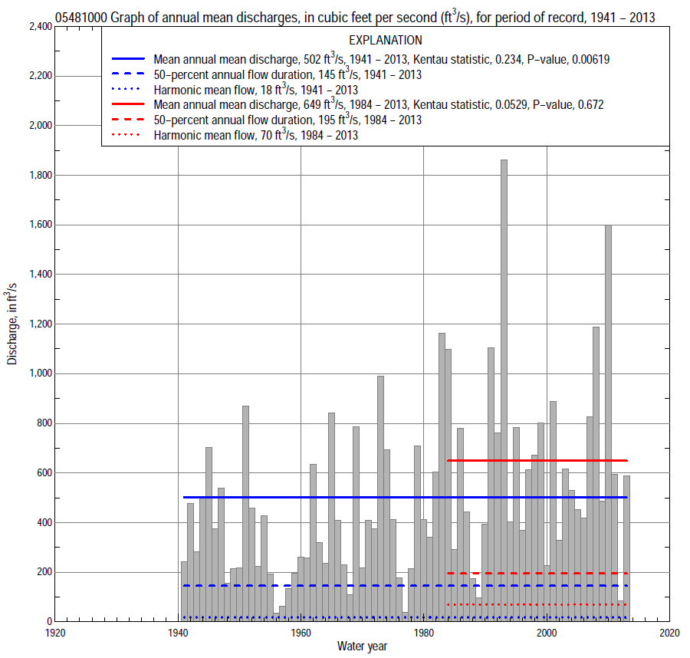

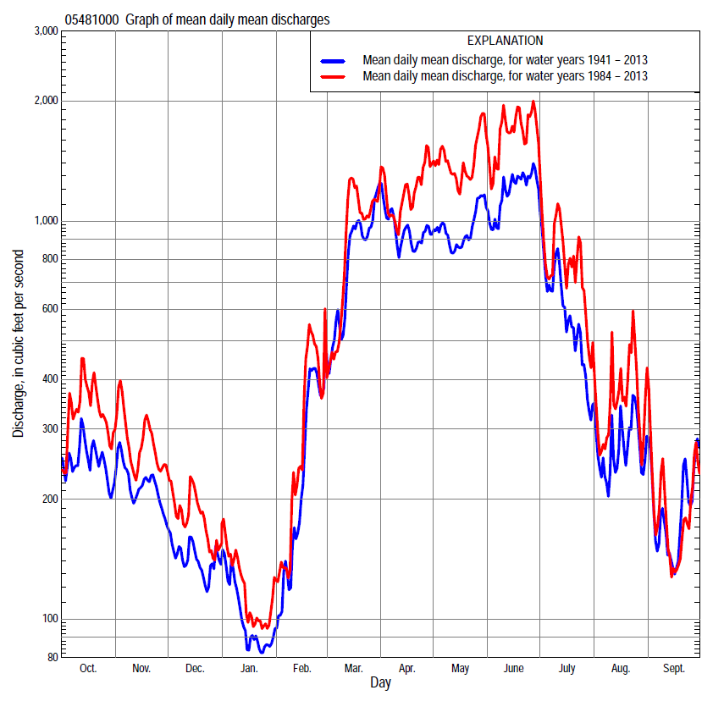

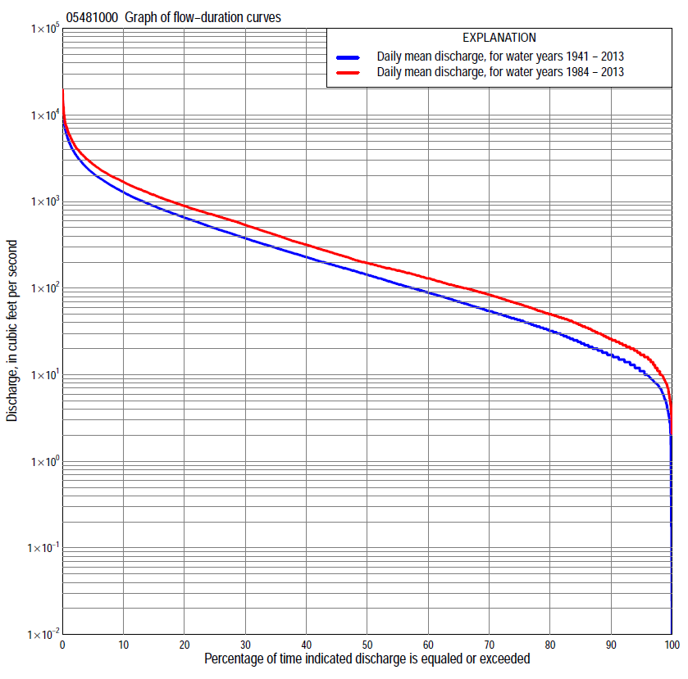

Statistics Based on the Entire Streamflow Period of Record
05481000 Monthly and annual flow durations, based on 1941–2013 period of record (73 years)
Percentage of days discharge equaled or exceeded |  |  |  |  | Discharge (cubic feet per second) |  |  |  |  |  |  |  |  | Annual flow durations
 | Oct | Nov | Dec | Jan | Feb | Mar | Apr | May | June | July | Aug | Sept | Annual | Kentau statistic | P-value
99 | 4.0 | 9.7 | 5.6 | 0.47 | 3.2 | 15 | 26 | 28 | 15 | 7.2 | 5.7 | 3.3 | 5.0 | 0.244 | 0.002
98 | 5.8 | 11 | 7.1 | 3.8 | 3.8 | 24 | 31 | 33 | 31 | 14 | 7.0 | 4.4 | 7.1 | 0.247 | 0.002
95 | 8.3 | 13 | 9.2 | 6.5 | 7.6 | 35 | 47 | 50 | 54 | 26 | 11 | 7.5 | 11 | 0.241 | 0.003
90 | 11 | 16 | 13 | 9.2 | 13 | 46 | 86 | 96 | 105 | 41 | 17 | 12 | 17 | 0.240 | 0.003
85 | 14 | 20 | 16 | 12 | 16 | 59 | 133 | 155 | 157 | 58 | 23 | 15 | 24 | 0.251 | 0.002
80 | 17 | 27 | 19 | 16 | 19 | 79 | 185 | 205 | 205 | 79 | 29 | 19 | 33 | 0.229 | 0.004
75 | 20 | 35 | 25 | 19 | 23 | 103 | 234 | 258 | 255 | 100 | 36 | 22 | 43 | 0.219 | 0.006
70 | 27 | 42 | 31 | 21 | 30 | 150 | 273 | 310 | 318 | 125 | 44 | 26 | 55 | 0.213 | 0.008
65 | 37 | 53 | 39 | 25 | 37 | 197 | 317 | 365 | 385 | 148 | 50 | 32 | 70 | 0.199 | 0.013
60 | 43 | 65 | 45 | 30 | 46 | 239 | 372 | 420 | 452 | 177 | 58 | 37 | 90 | 0.180 | 0.025
55 | 55 | 76 | 56 | 35 | 55 | 284 | 447 | 496 | 518 | 210 | 66 | 45 | 113 | 0.163 | 0.042
50 | 70 | 93 | 70 | 46 | 71 | 349 | 519 | 569 | 605 | 248 | 77 | 51 | 145 | 0.180 | 0.025
45 | 89 | 111 | 89 | 58 | 87 | 423 | 634 | 646 | 715 | 297 | 88 | 59 | 182 | 0.197 | 0.014
40 | 110 | 136 | 104 | 70 | 104 | 506 | 745 | 738 | 831 | 355 | 101 | 70 | 231 | 0.205 | 0.010
35 | 136 | 171 | 122 | 82 | 130 | 611 | 870 | 855 | 966 | 423 | 115 | 85 | 295 | 0.212 | 0.008
30 | 174 | 211 | 145 | 98 | 160 | 760 | 1,020 | 970 | 1,100 | 515 | 137 | 103 | 381 | 0.234 | 0.003
25 | 235 | 255 | 170 | 115 | 200 | 951 | 1,170 | 1,140 | 1,340 | 638 | 169 | 134 | 499 | 0.254 | 0.001
20 | 348 | 316 | 198 | 141 | 270 | 1,210 | 1,430 | 1,400 | 1,650 | 790 | 218 | 188 | 661 | 0.252 | 0.002
15 | 467 | 387 | 234 | 168 | 375 | 1,520 | 1,830 | 1,710 | 2,020 | 1,060 | 313 | 271 | 895 | 0.252 | 0.002
10 | 661 | 570 | 341 | 233 | 630 | 2,150 | 2,330 | 2,210 | 2,760 | 1,470 | 527 | 438 | 1,300 | 0.251 | 0.002
5 | 1,080 | 832 | 490 | 397 | 1,250 | 3,280 | 3,240 | 3,440 | 4,270 | 2,260 | 1,200 | 773 | 2,150 | 0.237 | 0.003
2 | 1,830 | 1,390 | 773 | 680 | 2,000 | 4,870 | 4,760 | 4,900 | 7,130 | 4,180 | 2,490 | 1,600 | 3,670 | 0.198 | 0.013
1 | 2,480 | 1,720 | 1,050 | 900 | 2,710 | 6,240 | 5,780 | 6,480 | 9,300 | 5,900 | 3,760 | 2,840 | 5,080 | 0.190 | 0.018

05481000 Annual exceedance probability of instantaneous peak discharges, in cubic feet per second (ft³/s), based on the Weighted Independent Estimates method,
Annual exceed-ance probability | Recur-rence interval (years) | Discharge (ft³/s) | 95-percent lower confi-dence interval (ft³/s) | 95-percent upper confi-dence interval (ft³/s)
0.500 | 2 | 5,460 | 4,800 | 6,210
0.200 | 5 | 9,380 | 8,260 | 10,700
0.100 | 10 | 12,200 | 10,600 | 14,000
0.040 | 25 | 15,800 | 13,300 | 18,800
0.020 | 50 | 18,600 | 15,100 | 22,800
0.010 | 100 | 21,300 | 16,800 | 27,100
0.005 | 200 | 24,100 | 18,300 | 31,900
0.002 | 500 | 27,800 | 20,000 | 38,600
and based on the expected moments algorithm/multiple Grubbs-Beck analysis computed using a historical period length of 118 years (1896–2013)
0.500 | 2 | 5,520 | 4,670 | 6,460
0.200 | 5 | 9,520 | 8,150 | 11,100
0.100 | 10 | 12,400 | 10,600 | 14,700
0.040 | 25 | 16,200 | 13,600 | 20,100
0.020 | 50 | 19,100 | 15,700 | 24,900
0.010 | 100 | 22,000 | 17,500 | 30,200
0.005 | 200 | 24,900 | 19,200 | 36,100
0.002 | 500 | 28,900 | 21,200 | 45,000
Kentau statistic |  | 0.115
P-value |  | 0.150
Begin year |  | 1941
End year |  | 2013
Number of peaks |  | 73

05481000 Annual exceedance probability of high discharges, based on 1941–2013 period of record (73 years)
Annual exceedance probability | Recur-rence interval (years) | Maximum average discharge (ft³/s) for indicated number of consecutive days
 |  | 1 | 3 | 7 | 15 | 30
0.990 | 1.01 | 789 | 607 | 377 | 239 | 155
0.950 | 1.05 | 1,420 | 1,140 | 780 | 524 | 363
0.900 | 1.11 | 1,920 | 1,570 | 1,110 | 766 | 545
0.800 | 1.25 | 2,710 | 2,270 | 1,670 | 1,170 | 850
0.500 | 2 | 5,030 | 4,340 | 3,320 | 2,380 | 1,740
0.200 | 5 | 8,800 | 7,740 | 5,970 | 4,270 | 3,040
0.100 | 10 | 11,500 | 10,200 | 7,800 | 5,530 | 3,840
0.040 | 25 | 15,200 | 13,400 | 10,100 | 7,040 | 4,730
0.020 | 50 | 17,900 | 15,900 | 11,700 | 8,100 | 5,300
0.010 | 100 | 20,700 | 18,300 | 13,300 | 9,070 | 5,800
0.005 | 200 | 23,500 | 20,800 | 14,900 | 9,980 | 6,230
0.002 | 500 | 27,300 | 24,000 | 16,800 | 11,100 | 6,730
Kentau statistic |  | 0.136 | 0.165 | 0.185 | 0.207 | 0.221
P-value |  | 0.090 | 0.039 | 0.021 | 0.010 | 0.006

 | 05481000 Annual nonexceedance probability of low discharges, based on April 1940 to March 2013 period of record (73 years)
Annual nonexceed-ance probability | Recur-rence interval (years) | Minimum average discharge (ft³/s) for indicated number of consecutive days
 |  | 1 | 3 | 7 | 14 | 30 | 60 | 90 | 120 | 183
0.01 | 100 | 0.07 | 0.08 | 0.12 | 0.18 | 0.44 | 1.7 | 3.4 | 4.2 | 4.2
0.02 | 50 | 0.2 | 0.24 | 0.34 | 0.45 | 0.91 | 2.6 | 4.7 | 5.8 | 6.1
0.05 | 20 | 0.9 | 1.0 | 1.3 | 1.5 | 2.4 | 4.7 | 7.6 | 9.2 | 11
0.10 | 10 | 2.8 | 2.9 | 3.3 | 3.7 | 4.9 | 7.9 | 12 | 14 | 17
0.20 | 5 | 7.7 | 7.8 | 8.2 | 8.9 | 11 | 14 | 19 | 23 | 31
0.50 | 2 | 22 | 23 | 24 | 26 | 30 | 36 | 47 | 59 | 87
0.80 | 1.25 | 32 | 33 | 37 | 43 | 56 | 80 | 111 | 146 | 230
0.90 | 1.11 | 33 | 34 | 39 | 47 | 67 | 114 | 171 | 232 | 374
0.96 | 1.04 | 34 | 35 | 40 | 49 | 76 | 158 | 268 | 379 | 618
0.98 | 1.02 | 34 | 35 | 41 | 49 | 80 | 191 | 356 | 519 | 846
0.99 | 1.01 | 34 | 35 | 41 | 49 | 82 | 224 | 458 | 685 | 1,120
Kentau statistic |  | 0.242 | 0.245 | 0.270 | 0.267 | 0.251 | 0.228 | 0.190 | 0.186 | 0.145
P-value |  | 0.003 | 0.002 | 0.001 | 0.001 | 0.002 | 0.004 | 0.017 | 0.020 | 0.071

05481000 Annual nonexceedance probability of seasonal low discharges, based on April 1940 to September 2013 period of record (73–74 years)
Annual nonexceed-ance probability | Recur-rence interval (years) | Minimum average discharge (cubic feet per second) for indicated number of consecutive days
 |  | 1 | 7 | 14 | 30 |  | 1 | 7 | 14 | 30
 |  | January-February-March |  |  |  |  | April-May-June
0.01 | 100 | 0.00 | 0.15 | 0.22 | 0.53 |  | 6.1 | 8.0 | 9.8 | 15
0.02 | 50 | 0.4 | 0.43 | 0.56 | 1.1 |  | 9.6 | 12 | 15 | 22
0.05 | 20 | 1.4 | 1.6 | 1.9 | 2.8 |  | 18 | 23 | 28 | 42
0.10 | 10 | 4.0 | 4.4 | 4.8 | 6.1 |  | 31 | 39 | 48 | 70
0.20 | 5 | 9.8 | 12 | 12 | 14 |  | 56 | 69 | 86 | 125
0.50 | 2 | 26 | 43 | 44 | 49 |  | 151 | 185 | 232 | 346
0.80 | 1.25 | 66 | 80 | 90 | 120 |  | 342 | 421 | 536 | 826
0.90 | 1.11 | 90 | 92 | 109 | 169 |  | 490 | 609 | 782 | 1,230
0.96 | 1.04 | 97 | 99 | 122 | 223 |  | 687 | 866 | 1,120 | 1,820
0.98 | 1.02 | 100 | 101 | 128 | 257 |  | 834 | 1,060 | 1,380 | 2,300
0.99 | 1.01 | 101 | 102 | 131 | 286 |  | 977 | 1,260 | 1,650 | 2,790
Kentau statistic |  | 0.169 | 0.201 | 0.207 | 0.170 |  | 0.294 | 0.283 | 0.294 | 0.291
P-value |  | 0.035 | 0.012 | 0.010 | 0.034 |  | 0.000 | 0.000 | 0.000 | 0.000
 |  | July-August-September |  |  |  |  | October-November-December
0.01 | 100 | 1.6 | 2.0 | 2.5 | 5.1 |  | 1.3 | 1.5 | 1.9 | 3.2
0.02 | 50 | 2.2 | 2.7 | 3.4 | 6.3 |  | 1.9 | 2.2 | 2.8 | 4.4
0.05 | 20 | 3.5 | 4.3 | 5.3 | 8.7 |  | 3.4 | 4.0 | 4.9 | 7.0
0.10 | 10 | 5.4 | 6.5 | 7.7 | 12 |  | 5.5 | 6.5 | 7.8 | 11
0.20 | 5 | 8.9 | 10 | 12 | 18 |  | 9.9 | 12 | 14 | 18
0.50 | 2 | 22 | 26 | 30 | 40 |  | 28 | 33 | 39 | 49
0.80 | 1.25 | 53 | 61 | 71 | 103 |  | 71 | 89 | 105 | 133
0.90 | 1.11 | 82 | 96 | 111 | 176 |  | 112 | 145 | 174 | 225
0.96 | 1.04 | 128 | 154 | 179 | 320 |  | 176 | 241 | 291 | 397
0.98 | 1.02 | 169 | 208 | 244 | 481 |  | 234 | 332 | 404 | 573
0.99 | 1.01 | 217 | 272 | 322 | 702 |  | 298 | 438 | 540 | 797
Kentau statistic |  | 0.137 | 0.137 | 0.144 | 0.089 |  | 0.183 | 0.179 | 0.188 | 0.202
P-value |  | 0.084 | 0.086 | 0.069 | 0.263 |  | 0.022 | 0.025 | 0.019 | 0.012

Statistics Based on the 1984–2013 Streamflow Period of Record
05481000 Monthly and annual flow durations, based on 1984–2013 period of record (30 years)
Percentage of days discharge equaled or exceeded |  |  |  |  | Discharge (cubic feet per second) |  |  |  |  |  |  |  |  | Annual flow durations
 | Oct | Nov | Dec | Jan | Feb | Mar | Apr | May | June | July | Aug | Sept | Annual | Kentau statistic | P-value
99 | 5.5 | 10 | 7.1 | 5.0 | 10 | 25 | 34 | 54 | 53 | 11 | 5.9 | 3.6 | 8.1 | -0.080 | 0.543
98 | 9.1 | 12 | 8.3 | 6.9 | 12 | 35 | 39 | 64 | 64 | 15 | 7.9 | 6.0 | 11 | -0.078 | 0.555
95 | 14 | 17 | 13 | 12 | 17 | 46 | 78 | 150 | 92 | 27 | 12 | 10 | 17 | -0.071 | 0.592
90 | 17 | 25 | 19 | 16 | 22 | 70 | 137 | 252 | 138 | 46 | 23 | 17 | 26 | -0.060 | 0.655
85 | 21 | 33 | 24 | 20 | 27 | 98 | 212 | 311 | 213 | 65 | 32 | 21 | 37 | -0.094 | 0.475
80 | 27 | 39 | 30 | 24 | 40 | 141 | 270 | 408 | 303 | 97 | 40 | 25 | 50 | -0.159 | 0.225
75 | 36 | 54 | 42 | 32 | 49 | 177 | 324 | 506 | 424 | 130 | 48 | 29 | 65 | -0.172 | 0.186
70 | 42 | 65 | 60 | 44 | 62 | 213 | 398 | 581 | 505 | 165 | 55 | 32 | 84 | -0.177 | 0.175
65 | 48 | 74 | 78 | 55 | 79 | 258 | 502 | 643 | 593 | 201 | 62 | 37 | 104 | -0.177 | 0.175
60 | 63 | 94 | 99 | 65 | 89 | 290 | 600 | 706 | 706 | 247 | 71 | 44 | 130 | -0.179 | 0.169
55 | 71 | 109 | 116 | 80 | 100 | 331 | 695 | 785 | 826 | 298 | 82 | 49 | 160 | -0.179 | 0.169
50 | 90 | 137 | 135 | 93 | 110 | 400 | 776 | 894 | 942 | 351 | 93 | 53 | 195 | -0.115 | 0.382
45 | 114 | 180 | 150 | 102 | 130 | 467 | 887 | 981 | 1,040 | 410 | 104 | 61 | 247 | -0.090 | 0.498
40 | 146 | 213 | 165 | 110 | 150 | 570 | 998 | 1,150 | 1,210 | 483 | 118 | 74 | 318 | -0.097 | 0.464
35 | 189 | 251 | 175 | 125 | 165 | 690 | 1,140 | 1,310 | 1,400 | 576 | 138 | 89 | 412 | -0.103 | 0.432
30 | 262 | 309 | 190 | 135 | 190 | 826 | 1,330 | 1,510 | 1,650 | 699 | 167 | 107 | 537 | -0.048 | 0.721
25 | 354 | 349 | 206 | 150 | 230 | 1,070 | 1,610 | 1,720 | 1,930 | 797 | 204 | 147 | 695 | 0.016 | 0.915
20 | 462 | 404 | 230 | 162 | 306 | 1,320 | 1,870 | 2,050 | 2,300 | 1,050 | 277 | 233 | 893 | 0.048 | 0.721
15 | 661 | 515 | 295 | 180 | 444 | 1,600 | 2,220 | 2,470 | 2,930 | 1,320 | 425 | 382 | 1,200 | 0.067 | 0.617
10 | 960 | 683 | 401 | 239 | 800 | 2,250 | 2,830 | 3,220 | 3,990 | 1,780 | 856 | 541 | 1,700 | 0.092 | 0.486
5 | 1,490 | 977 | 597 | 325 | 1,350 | 3,270 | 3,700 | 4,430 | 5,800 | 2,850 | 1,840 | 777 | 2,700 | 0.122 | 0.354
2 | 2,190 | 1,450 | 815 | 595 | 1,950 | 4,810 | 5,350 | 6,860 | 8,690 | 5,770 | 3,320 | 1,220 | 4,450 | 0.182 | 0.164
1 | 3,060 | 2,020 | 1,000 | 885 | 2,710 | 6,930 | 5,800 | 8,220 | 12,700 | 7,750 | 5,240 | 2,080 | 6,160 | 0.122 | 0.354

05481000 Annual exceedance probability of high discharges, based on 1984–2013 period of record (30 years)
Annual exceedance probability | Recur-rence interval (years) | Maximum average discharge (ft³/s) for indicated number of consecutive days
 |  | 1 | 3 | 7 | 15 | 30
0.990 | 1.01 | 883 | 773 | 623 | 426 | 269
0.950 | 1.05 | 1,590 | 1,390 | 1,110 | 788 | 548
0.900 | 1.11 | 2,140 | 1,870 | 1,490 | 1,070 | 773
0.800 | 1.25 | 3,030 | 2,660 | 2,100 | 1,540 | 1,140
0.500 | 2 | 5,670 | 5,000 | 3,940 | 2,900 | 2,170
0.200 | 5 | 10,100 | 8,960 | 7,050 | 5,130 | 3,710
0.100 | 10 | 13,300 | 11,900 | 9,410 | 6,740 | 4,710
0.040 | 25 | 17,700 | 16,000 | 12,600 | 8,870 | 5,890
0.020 | 50 | 21,000 | 19,100 | 15,200 | 10,500 | 6,700
0.010 | 100 | 24,500 | 22,400 | 17,800 | 12,100 | 7,450
0.005 | 200 | 28,000 | 25,800 | 20,600 | 13,700 | 8,140
0.002 | 500 | 32,800 | 30,400 | 24,300 | 15,900 | 8,990
Kentau statistic |  | 0.131 | 0.131 | 0.103 | 0.103 | 0.108
P-value |  | 0.318 | 0.318 | 0.432 | 0.432 | 0.412

 | 05481000 Annual nonexceedance probability of low discharges, based on April 1983 to March 2013 period of record (30 years)
Annual nonexceed-ance probability | Recur-rence interval (years) | Minimum average discharge (ft³/s) for indicated number of consecutive days
 |  | 1 | 3 | 7 | 14 | 30 | 60 | 90 | 120 | 183
0.01 | 100 | 1.2 | 1.8 | 2.5 | 3.2 | 4.7 | 5.4 | 5.5 | 5.8 | 5.8
0.02 | 50 | 2.0 | 2.6 | 3.6 | 4.4 | 6.2 | 7.4 | 7.9 | 8.5 | 8.9
0.05 | 20 | 3.7 | 4.6 | 5.9 | 7.0 | 9.3 | 12 | 13 | 15 | 16
0.10 | 10 | 6.2 | 7.3 | 8.8 | 10 | 13 | 17 | 20 | 23 | 27
0.20 | 5 | 11 | 12 | 14 | 16 | 19 | 26 | 33 | 39 | 49
0.50 | 2 | 25 | 26 | 28 | 31 | 38 | 54 | 74 | 92 | 133
0.80 | 1.25 | 44 | 45 | 49 | 56 | 69 | 100 | 145 | 190 | 311
0.90 | 1.11 | 55 | 57 | 61 | 72 | 91 | 134 | 197 | 264 | 459
0.96 | 1.04 | 66 | 69 | 75 | 91 | 119 | 177 | 262 | 360 | 667
0.98 | 1.02 | 72 | 76 | 84 | 104 | 140 | 208 | 310 | 432 | 833
0.99 | 1.01 | 77 | 82 | 91 | 116 | 161 | 239 | 356 | 502 | 1,000
Kentau statistic |  | -0.175 | -0.166 | -0.140 | -0.133 | -0.131 | -0.122 | -0.136 | -0.140 | -0.191
P-value |  | 0.181 | 0.205 | 0.284 | 0.309 | 0.318 | 0.354 | 0.301 | 0.284 | 0.143

05481000 Annual nonexceedance probability of seasonal low discharges, based on October 1983 to September 2013 period of record (30 years)
Annual nonexceed-ance probability | Recur-rence interval (years) | Minimum average discharge (cubic feet per second) for indicated number of consecutive days
 |  | 1 | 7 | 14 | 30 |  | 1 | 7 | 14 | 30
 |  | January-February-March |  |  |  |  | April-May-June
0.01 | 100 | 1.3 | 3.5 | 4.0 | 5.5 |  | 15 | 17 | 20 | 40
0.02 | 50 | 2.2 | 5.0 | 5.7 | 7.5 |  | 22 | 25 | 31 | 57
0.05 | 20 | 4.4 | 8.3 | 9.4 | 12 |  | 38 | 44 | 56 | 96
0.10 | 10 | 7.9 | 13 | 14 | 18 |  | 59 | 70 | 91 | 148
0.20 | 5 | 15 | 21 | 24 | 28 |  | 99 | 119 | 155 | 242
0.50 | 2 | 43 | 51 | 56 | 65 |  | 234 | 286 | 379 | 575
0.80 | 1.25 | 101 | 111 | 122 | 139 |  | 484 | 596 | 777 | 1,220
0.90 | 1.11 | 146 | 160 | 176 | 203 |  | 672 | 828 | 1,060 | 1,740
0.96 | 1.04 | 204 | 229 | 254 | 297 |  | 918 | 1,130 | 1,420 | 2,460
0.98 | 1.02 | 246 | 285 | 318 | 376 |  | 1,100 | 1,360 | 1,670 | 3,030
0.99 | 1.01 | 287 | 344 | 385 | 463 |  | 1,290 | 1,570 | 1,900 | 3,620
Kentau statistic |  | -0.260 | -0.246 | -0.246 | -0.200 |  | 0.021 | 0.016 | 0.062 | 0.149
P-value |  | 0.046 | 0.059 | 0.059 | 0.125 |  | 0.887 | 0.915 | 0.643 | 0.254
 |  | July-August-September |  |  |  |  | October-November-December
0.01 | 100 | 3.1 | 4.7 | 6.1 | 9.3 |  | 2.5 | 2.8 | 3.7 | 4.8
0.02 | 50 | 3.9 | 5.7 | 7.2 | 11 |  | 3.6 | 4.0 | 5.3 | 6.9
0.05 | 20 | 5.7 | 7.6 | 9.4 | 13 |  | 6.1 | 7.0 | 8.9 | 12
0.10 | 10 | 7.9 | 10 | 12 | 16 |  | 9.6 | 11 | 14 | 18
0.20 | 5 | 12 | 15 | 17 | 22 |  | 16 | 19 | 23 | 30
0.50 | 2 | 27 | 31 | 35 | 45 |  | 40 | 49 | 59 | 76
0.80 | 1.25 | 62 | 71 | 80 | 112 |  | 91 | 111 | 134 | 177
0.90 | 1.11 | 97 | 113 | 129 | 198 |  | 133 | 163 | 200 | 265
0.96 | 1.04 | 157 | 193 | 222 | 387 |  | 194 | 240 | 298 | 400
0.98 | 1.02 | 215 | 276 | 320 | 620 |  | 244 | 302 | 381 | 514
0.99 | 1.01 | 286 | 384 | 452 | 972 |  | 296 | 368 | 470 | 640
Kentau statistic |  | -0.216 | -0.198 | -0.175 | -0.207 |  | -0.138 | -0.099 | -0.122 | -0.131
P-value |  | 0.097 | 0.129 | 0.181 | 0.112 |  | 0.292 | 0.454 | 0.354 | 0.318

