LOCATION.--Lat 42°15'07", long 93°59'48" referenced to North American Datum of 1927, in NE 1/4 NW 1/4 NE 1/4 sec.21, T.86 N., R.27 W., Webster County, IA, Hydrologic Unit 07100004, on right downstream side of bridge on State Highway 175, 4.0 mi southwest of Stratford, 0.1 mi downstream from Skillet Creek, 7.3 mi downstream from Boone River, and 265.0 mi upstream from mouth.

DRAINAGE AREA.--5,452 mi².

PERIOD OF RECORD.--Discharge records from October 1967 to current year. April 1920 to September 1968, at site 18.5 mi downstream published as "near Boone" (station 05481500). Records are not equivalent because of difference in drainage area.

GAGE.--Water-stage recorder. Datum of gage is 894.00 ft above National Geodetic Vertical Datum of 1929.

REMARKS.--Occasional minor regulation caused by dam at Fort Dodge.

A summary of all available data for this streamgage is provided through the USGS National Water Information System web interface (NWISWeb). The following link provides access to current/historical observations, daily data, daily statistics, monthly statistics, annual statistics, peak streamflow, field measurements, field/lab water-quality samples, and the latest water-year summaries. Data can be filtered by parameter and/or dates, and can be output in various tabular and graphical formats.
http://waterdata.usgs.gov/nwis/inventory/?site_no=05481300

The USGS WaterWatch Toolkit is available at:
http://waterwatch.usgs.gov/?id=ww_toolkit
Tools for summarizing streamflow information include the duration hydrograph builder, the cumulative streamflow hydrograph builder, the streamgage statistics retrieval tool, the rating curve builder, the flood tracking chart builder, the National Weather Service Advanced Hydrologic Prediction Service (AHPS) river forecast hydrograph builder, and the raster-hydrograph builder. Entering the above number for this streamgage into these toolkit webpages will provide streamflow information specific to this streamgage.

A description of the statistics presented for this streamgage is available in the main body of the report at:
http://dx.doi.org/10.3133/ofr20151214
A link to other streamgages included in this report, a map showing the location of the streamgages, information on the programs used to compute the statistical analyses, and references are included in the main body of the report.

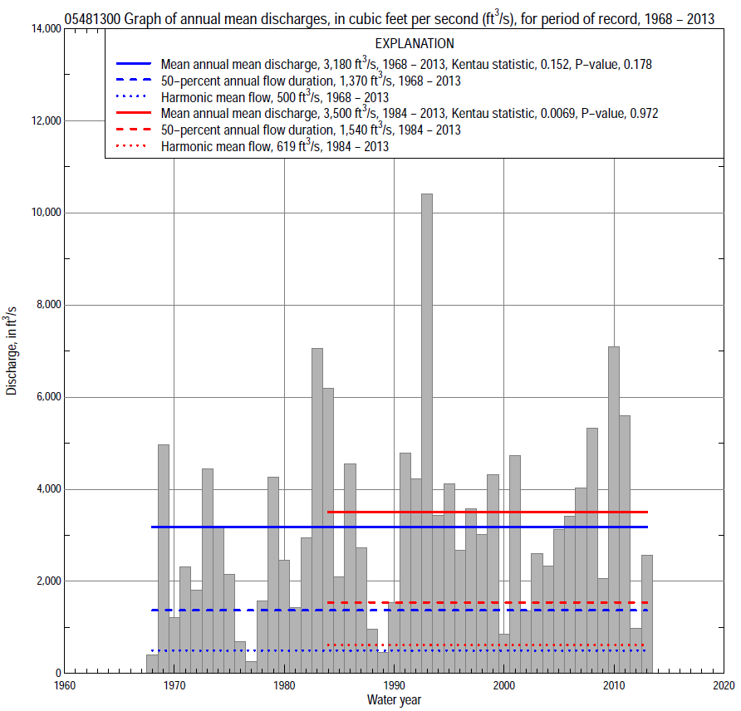

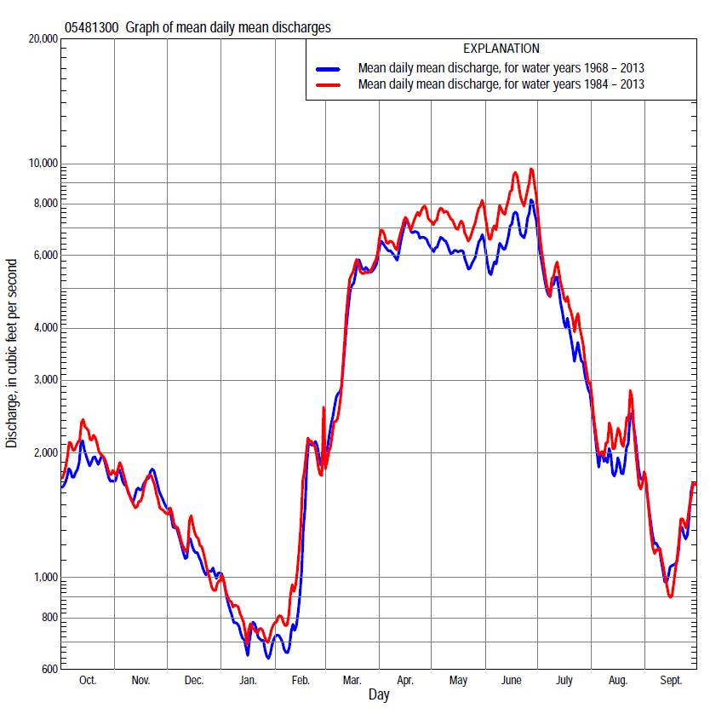

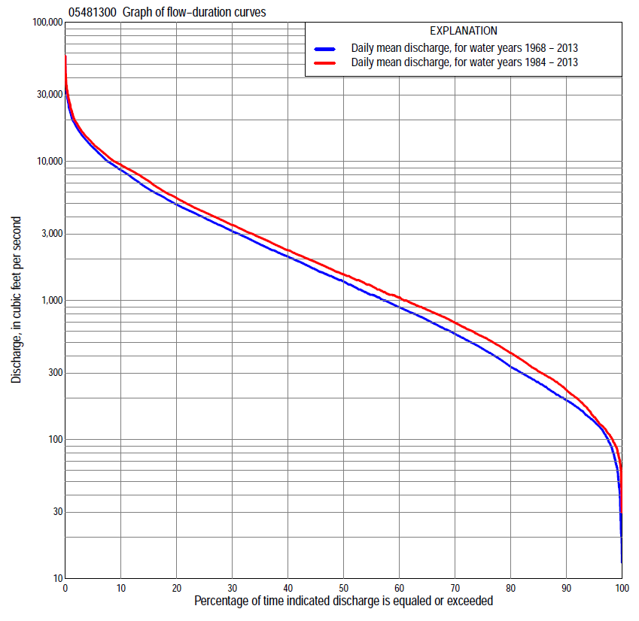

Statistics Based on the Entire Streamflow Period of Record
05481300 Monthly and annual flow durations, based on 1968–2013 period of record (46 years)
Percentage of days discharge equaled or exceeded |  |  |  |  | Discharge (cubic feet per second) |  |  |  |  |  |  |  |  | Annual flow durations
 | Oct | Nov | Dec | Jan | Feb | Mar | Apr | May | June | July | Aug | Sept | Annual | Kentau statistic | P-value
99 | 63 | 82 | 35 | 19 | 30 | 136 | 216 | 240 | 146 | 136 | 91 | 63 | 65 | 0.146 | 0.156
98 | 87 | 114 | 46 | 22 | 74 | 165 | 279 | 276 | 217 | 156 | 115 | 84 | 90 | 0.142 | 0.167
95 | 115 | 130 | 88 | 72 | 94 | 216 | 396 | 400 | 579 | 252 | 140 | 122 | 135 | 0.134 | 0.191
90 | 145 | 181 | 146 | 119 | 120 | 322 | 653 | 1,160 | 1,160 | 474 | 246 | 180 | 192 | 0.134 | 0.191
85 | 172 | 228 | 182 | 142 | 157 | 475 | 985 | 1,530 | 1,680 | 607 | 344 | 209 | 256 | 0.124 | 0.229
80 | 200 | 270 | 235 | 168 | 185 | 769 | 1,430 | 1,900 | 2,020 | 819 | 424 | 240 | 333 | 0.102 | 0.320
75 | 258 | 314 | 280 | 206 | 200 | 1,010 | 2,050 | 2,310 | 2,390 | 1,130 | 486 | 293 | 449 | 0.105 | 0.306
70 | 309 | 439 | 350 | 245 | 222 | 1,190 | 2,480 | 3,010 | 2,740 | 1,430 | 556 | 328 | 576 | 0.075 | 0.466
65 | 414 | 536 | 500 | 285 | 260 | 1,400 | 2,940 | 3,470 | 3,190 | 1,680 | 630 | 363 | 723 | 0.071 | 0.495
60 | 483 | 705 | 600 | 330 | 344 | 1,620 | 3,420 | 3,950 | 3,630 | 2,000 | 720 | 391 | 896 | 0.061 | 0.557
55 | 534 | 825 | 710 | 400 | 530 | 2,000 | 4,000 | 4,400 | 4,160 | 2,300 | 824 | 437 | 1,100 | 0.062 | 0.551
50 | 632 | 1,010 | 810 | 492 | 600 | 2,350 | 4,680 | 4,830 | 4,590 | 2,680 | 908 | 499 | 1,370 | 0.084 | 0.415
45 | 801 | 1,250 | 900 | 594 | 666 | 2,650 | 5,850 | 5,310 | 5,050 | 3,130 | 1,000 | 599 | 1,670 | 0.088 | 0.394
40 | 1,050 | 1,480 | 1,100 | 690 | 769 | 3,050 | 6,540 | 5,990 | 5,760 | 3,590 | 1,170 | 694 | 2,070 | 0.102 | 0.320
35 | 1,420 | 1,640 | 1,300 | 800 | 900 | 3,500 | 7,510 | 6,720 | 6,520 | 4,140 | 1,380 | 843 | 2,530 | 0.097 | 0.349
30 | 1,990 | 1,970 | 1,400 | 940 | 1,060 | 4,130 | 8,580 | 7,800 | 7,520 | 4,700 | 1,610 | 1,010 | 3,150 | 0.125 | 0.226
25 | 2,530 | 2,350 | 1,550 | 1,050 | 1,140 | 5,290 | 9,620 | 8,620 | 8,640 | 5,430 | 1,900 | 1,350 | 3,920 | 0.167 | 0.103
20 | 3,220 | 2,810 | 1,830 | 1,140 | 1,500 | 7,000 | 11,200 | 9,610 | 9,870 | 6,310 | 2,290 | 1,700 | 4,890 | 0.155 | 0.132
15 | 4,050 | 3,330 | 2,030 | 1,310 | 2,200 | 9,340 | 12,700 | 11,100 | 11,900 | 7,540 | 2,970 | 2,160 | 6,320 | 0.169 | 0.099
10 | 5,100 | 4,310 | 2,450 | 1,610 | 3,340 | 11,900 | 14,500 | 12,800 | 15,500 | 9,240 | 3,990 | 3,090 | 8,670 | 0.190 | 0.063
5 | 7,310 | 5,510 | 3,500 | 2,330 | 4,700 | 15,400 | 17,500 | 16,100 | 19,800 | 14,600 | 7,910 | 5,560 | 12,500 | 0.200 | 0.051
2 | 9,710 | 6,650 | 4,710 | 3,500 | 8,850 | 19,700 | 22,300 | 20,300 | 26,700 | 22,000 | 14,000 | 8,020 | 17,700 | 0.224 | 0.029
1 | 12,200 | 7,990 | 6,410 | 4,050 | 13,600 | 23,200 | 24,100 | 26,300 | 32,100 | 30,500 | 20,300 | 10,100 | 22,100 | 0.197 | 0.055

05481300 Annual exceedance probability of instantaneous peak discharges, in cubic feet per second (ft³/s), based on the Weighted Independent Estimates method,
Annual exceed-ance probability | Recur-rence interval (years) | Discharge (ft³/s) | 95-percent lower confi-dence interval (ft³/s) | 95-percent upper confi-dence interval (ft³/s)
0.500 | 2 | 15,300 | 13,400 | 17,500
0.200 | 5 | 26,200 | 23,000 | 29,900
0.100 | 10 | 33,900 | 29,400 | 39,100
0.040 | 25 | 43,800 | 36,800 | 52,200
0.020 | 50 | 51,100 | 41,500 | 62,900
0.010 | 100 | 58,400 | 45,800 | 74,500
0.005 | 200 | 65,800 | 49,700 | 87,100
0.002 | 500 | 75,200 | 54,000 | 105,000
and based on the expected moments algorithm/multiple Grubbs-Beck analysis computed using a historical period length of 111 years (1903–2013)ª
0.500 | 2 | 15,400 | 13,400 | 17,700
0.200 | 5 | 26,500 | 23,200 | 30,500
0.100 | 10 | 34,300 | 29,800 | 40,400
0.040 | 25 | 44,500 | 37,900 | 55,200
0.020 | 50 | 52,200 | 43,300 | 67,800
0.010 | 100 | 59,900 | 48,200 | 81,700
0.005 | 200 | 67,500 | 52,600 | 97,100
0.002 | 500 | 77,700 | 57,700 | 120,000
Kentau statistic |  | 0.153
P-value |  | 0.019
Begin year |  | 1905
End year |  | 2013
Number of peaks |  | 107
ªAnalysis includes annual peak discharges (1903, 1905–29, 1931, 1933–67) from streamgage 05481500 Des Moines River near Boone.

05481300 Annual exceedance probability of high discharges, based on 1968–2013 period of record (46 years)
[ND, not determined]
Annual exceed-ance probability | Recur-rence interval (years) | Maximum average discharge (ft³/s) for indicated number of consecutive days
 |  | 1 | 3 | 7 | 15 | 30
0.990 | 1.01 | ND | ND | 1,460 | 1,050 | 719
0.950 | 1.05 | ND | ND | 3,280 | 2,490 | 1,860
0.900 | 1.11 | ND | ND | 4,810 | 3,730 | 2,890
0.800 | 1.25 | ND | ND | 7,300 | 5,780 | 4,620
0.500 | 2 | ND | ND | 14,300 | 11,500 | 9,480
0.200 | 5 | ND | ND | 23,800 | 19,300 | 15,700
0.100 | 10 | ND | ND | 29,400 | 23,600 | 19,100
0.040 | 25 | ND | ND | 35,400 | 28,200 | 22,300
0.020 | 50 | ND | ND | 39,200 | 30,900 | 24,100
0.010 | 100 | ND | ND | 42,400 | 33,200 | 25,500
0.005 | 200 | ND | ND | 45,100 | 35,000 | 26,600
0.002 | 500 | ND | ND | 48,200 | 37,000 | 27,700
Kentau statistic |  | 0.214 | 0.202 | 0.212 | 0.258 | 0.221
P-value |  | 0.037 | 0.049 | 0.039 | 0.012 | 0.031

 | 05481300 Annual nonexceedance probability of low discharges, based on April 1968 to March 2013 period of record (45 years)
Annual nonexceed-ance probability | Recur-rence interval (years) | Minimum average discharge (cubic feet per second) for indicated number of consecutive days
 |  | 1 | 3 | 7 | 14 | 30 | 60 | 90 | 120 | 183
0.01 | 100 | 16 | 17 | 18 | 21 | 25 | 30 | 36 | 43 | 49
0.02 | 50 | 24 | 25 | 27 | 30 | 36 | 43 | 51 | 61 | 70
0.05 | 20 | 42 | 44 | 47 | 52 | 60 | 71 | 86 | 102 | 120
0.10 | 10 | 66 | 70 | 74 | 80 | 91 | 108 | 133 | 158 | 189
0.20 | 5 | 109 | 115 | 121 | 128 | 147 | 175 | 219 | 262 | 320
0.50 | 2 | 242 | 253 | 265 | 280 | 320 | 398 | 520 | 639 | 809
0.80 | 1.25 | 443 | 457 | 481 | 520 | 602 | 794 | 1,110 | 1,420 | 1,850
0.90 | 1.11 | 566 | 581 | 615 | 675 | 791 | 1,090 | 1,570 | 2,080 | 2,750
0.96 | 1.04 | 703 | 715 | 763 | 856 | 1,020 | 1,470 | 2,220 | 3,030 | 4,080
0.98 | 1.02 | 789 | 799 | 857 | 977 | 1,180 | 1,750 | 2,730 | 3,820 | 5,180
0.99 | 1.01 | 864 | 870 | 938 | 1,090 | 1,320 | 2,030 | 3,250 | 4,660 | 6,370
Kentau statistic |  | 0.088 | 0.097 | 0.099 | 0.090 | 0.077 | 0.055 | 0.030 | 0.026 | 0.046
P-value |  | 0.400 | 0.353 | 0.343 | 0.389 | 0.463 | 0.604 | 0.777 | 0.807 | 0.660

05481300 Annual nonexceedance probability of seasonal low discharges, based on October 1967 to September 2013 period of record (46 years)
Annual nonexceed-ance probability | Recur-rence interval (years) | Minimum average discharge (cubic feet per second) for indicated number of consecutive days
 |  | 1 | 7 | 14 | 30 |  | 1 | 7 | 14 | 30
 |  | January-February-March |  |  |  |  | April-May-June
0.01 | 100 | 17 | 19 | 21 | 25 |  | 73 | 85 | 98 | 150
0.02 | 50 | 26 | 28 | 31 | 36 |  | 114 | 133 | 155 | 229
0.05 | 20 | 45 | 49 | 53 | 60 |  | 214 | 252 | 294 | 417
0.10 | 10 | 73 | 79 | 84 | 93 |  | 359 | 425 | 496 | 683
0.20 | 5 | 127 | 136 | 141 | 157 |  | 637 | 755 | 887 | 1,190
0.50 | 2 | 322 | 343 | 357 | 395 |  | 1,640 | 1,930 | 2,290 | 2,980
0.80 | 1.25 | 712 | 761 | 815 | 916 |  | 3,500 | 4,070 | 4,870 | 6,330
0.90 | 1.11 | 1,020 | 1,100 | 1,210 | 1,380 |  | 4,850 | 5,580 | 6,720 | 8,820
0.96 | 1.04 | 1,450 | 1,570 | 1,780 | 2,080 |  | 6,540 | 7,430 | 9,010 | 12,000
0.98 | 1.02 | 1,780 | 1,940 | 2,260 | 2,670 |  | 7,750 | 8,720 | 10,600 | 14,400
0.99 | 1.01 | 2,120 | 2,320 | 2,770 | 3,330 |  | 8,880 | 9,910 | 12,100 | 16,600
Kentau statistic |  | 0.072 | 0.107 | 0.097 | 0.100 |  | 0.151 | 0.159 | 0.161 | 0.198
P-value |  | 0.483 | 0.298 | 0.349 | 0.334 |  | 0.142 | 0.120 | 0.116 | 0.053
 |  | July-August-September |  |  |  |  | October-November-December
0.01 | 100 | 54 | 62 | 69 | 78 |  | 20 | 23 | 27 | 35
0.02 | 50 | 65 | 74 | 81 | 93 |  | 30 | 34 | 39 | 50
0.05 | 20 | 85 | 96 | 105 | 124 |  | 51 | 59 | 67 | 83
0.10 | 10 | 111 | 123 | 135 | 161 |  | 81 | 93 | 106 | 130
0.20 | 5 | 154 | 170 | 186 | 227 |  | 137 | 159 | 179 | 218
0.50 | 2 | 304 | 333 | 369 | 468 |  | 346 | 408 | 462 | 560
0.80 | 1.25 | 644 | 711 | 801 | 1,060 |  | 776 | 947 | 1,090 | 1,350
0.90 | 1.11 | 980 | 1,090 | 1,250 | 1,680 |  | 1,130 | 1,420 | 1,660 | 2,090
0.96 | 1.04 | 1,570 | 1,770 | 2,060 | 2,830 |  | 1,650 | 2,110 | 2,520 | 3,280
0.98 | 1.02 | 2,150 | 2,460 | 2,900 | 4,040 |  | 2,060 | 2,700 | 3,270 | 4,340
0.99 | 1.01 | 2,870 | 3,340 | 3,980 | 5,620 |  | 2,490 | 3,330 | 4,080 | 5,540
Kentau statistic |  | 0.035 | 0.021 | 0.007 | -0.005 |  | 0.074 | 0.094 | 0.063 | 0.051
P-value |  | 0.740 | 0.842 | 0.955 | 0.970 |  | 0.472 | 0.363 | 0.545 | 0.622

Statistics Based on the 1984–2013 Streamflow Period of Record
05481300 Monthly and annual flow durations, based on 1984–2013 period of record (30 years)
Percentage of days discharge equaled or exceeded |  |  |  |  | Discharge (cubic feet per second) |  |  |  |  |  |  |  |  | Annual flow durations
 | Oct | Nov | Dec | Jan | Feb | Mar | Apr | May | June | July | Aug | Sept | Annual | Kentau statistic | P-value
99 | 89 | 121 | 44 | 63 | 77 | 138 | 303 | 297 | 373 | 201 | 110 | 94 | 88 | -0.090 | 0.498
98 | 105 | 124 | 60 | 71 | 88 | 150 | 369 | 341 | 484 | 247 | 121 | 102 | 104 | -0.085 | 0.521
95 | 119 | 133 | 115 | 87 | 100 | 322 | 471 | 770 | 950 | 337 | 145 | 125 | 145 | -0.094 | 0.475
90 | 166 | 195 | 150 | 127 | 118 | 610 | 768 | 1,650 | 1,750 | 527 | 298 | 192 | 227 | -0.108 | 0.412
85 | 191 | 240 | 208 | 170 | 164 | 828 | 1,230 | 2,270 | 2,160 | 692 | 408 | 227 | 310 | -0.092 | 0.486
80 | 247 | 270 | 245 | 215 | 226 | 1,020 | 1,780 | 2,990 | 2,500 | 1,050 | 508 | 281 | 420 | -0.083 | 0.532
75 | 286 | 298 | 330 | 280 | 279 | 1,160 | 2,330 | 3,460 | 2,950 | 1,420 | 581 | 323 | 549 | -0.067 | 0.617
70 | 314 | 418 | 509 | 340 | 340 | 1,310 | 2,860 | 3,880 | 3,380 | 1,690 | 650 | 353 | 692 | -0.085 | 0.521
65 | 414 | 534 | 630 | 400 | 547 | 1,500 | 3,440 | 4,280 | 3,910 | 2,040 | 750 | 376 | 857 | -0.085 | 0.521
60 | 474 | 812 | 770 | 500 | 603 | 1,680 | 4,080 | 4,730 | 4,490 | 2,360 | 840 | 405 | 1,050 | -0.078 | 0.556
55 | 516 | 1,050 | 849 | 590 | 645 | 2,090 | 4,680 | 5,170 | 4,970 | 2,820 | 919 | 446 | 1,270 | -0.097 | 0.464
50 | 589 | 1,260 | 960 | 660 | 732 | 2,410 | 5,850 | 5,770 | 5,640 | 3,230 | 1,010 | 503 | 1,540 | -0.062 | 0.643
45 | 832 | 1,450 | 1,120 | 730 | 818 | 2,740 | 6,570 | 6,460 | 6,470 | 3,680 | 1,170 | 609 | 1,880 | -0.057 | 0.669
40 | 1,240 | 1,580 | 1,300 | 820 | 902 | 3,140 | 7,600 | 7,380 | 7,450 | 4,170 | 1,380 | 711 | 2,300 | -0.039 | 0.775
35 | 1,780 | 1,820 | 1,390 | 900 | 1,000 | 3,560 | 8,540 | 8,290 | 8,350 | 4,640 | 1,590 | 851 | 2,840 | -0.039 | 0.775
30 | 2,370 | 2,020 | 1,500 | 1,000 | 1,100 | 4,200 | 9,330 | 8,970 | 9,210 | 5,250 | 1,820 | 974 | 3,500 | -0.011 | 0.943
25 | 2,850 | 2,290 | 1,600 | 1,080 | 1,300 | 5,250 | 10,600 | 9,770 | 10,300 | 5,820 | 2,110 | 1,330 | 4,330 | 0.030 | 0.830
20 | 3,440 | 2,650 | 1,820 | 1,110 | 1,830 | 6,640 | 11,800 | 11,000 | 12,200 | 6,650 | 2,490 | 1,730 | 5,450 | 0.023 | 0.872
15 | 4,170 | 3,090 | 1,990 | 1,290 | 2,440 | 8,570 | 12,900 | 12,400 | 14,900 | 7,800 | 3,160 | 2,140 | 7,210 | 0.064 | 0.630
10 | 5,430 | 3,800 | 2,300 | 1,510 | 3,470 | 10,700 | 14,600 | 14,700 | 18,000 | 9,270 | 4,050 | 3,070 | 9,460 | 0.087 | 0.509
5 | 8,080 | 4,870 | 2,980 | 2,110 | 4,640 | 14,100 | 17,400 | 17,800 | 22,700 | 14,200 | 8,880 | 5,580 | 13,400 | 0.110 | 0.402
2 | 10,100 | 5,840 | 4,140 | 3,300 | 8,270 | 19,500 | 22,100 | 23,500 | 30,300 | 27,900 | 14,100 | 7,300 | 19,000 | 0.163 | 0.212
1 | 13,600 | 6,900 | 5,400 | 4,000 | 12,400 | 26,000 | 24,600 | 27,600 | 35,700 | 33,100 | 20,300 | 8,790 | 24,000 | 0.108 | 0.412

05481300 Annual exceedance probability of high discharges, based on 1984–2013 period of record (30 years)
Annual exceed-ance probability | Recur-rence interval (years) | Maximum average discharge (ft³/s) for indicated number of consecutive days
 |  | 1 | 3 | 7 | 15 | 30
0.990 | 1.01 | 3,330 | 2,880 | 2,180 | 1,800 | 1,270
0.950 | 1.05 | 5,870 | 5,280 | 4,300 | 3,570 | 2,730
0.900 | 1.11 | 7,800 | 7,120 | 5,970 | 4,960 | 3,900
0.800 | 1.25 | 10,800 | 10,000 | 8,620 | 7,140 | 5,760
0.500 | 2 | 19,200 | 18,000 | 15,900 | 13,000 | 10,700
0.200 | 5 | 31,900 | 29,900 | 26,100 | 20,800 | 16,900
0.100 | 10 | 40,600 | 37,700 | 32,400 | 25,500 | 20,300
0.040 | 25 | 51,600 | 47,300 | 39,700 | 30,700 | 23,800
0.020 | 50 | 59,700 | 54,200 | 44,600 | 34,000 | 25,900
0.010 | 100 | 67,700 | 60,700 | 49,000 | 37,000 | 27,700
0.005 | 200 | 75,400 | 67,000 | 53,000 | 39,600 | 29,100
0.002 | 500 | 85,500 | 74,900 | 57,800 | 42,600 | 30,700
Kentau statistic |  | 0.143 | 0.117 | 0.117 | 0.182 | 0.149
P-value |  | 0.276 | 0.372 | 0.372 | 0.164 | 0.254

 | 05481300 Annual nonexceedance probability of low discharges, based on April 1983 to March 2013 period of record (30 years)
Annual nonexceed-ance probability | Recur-rence interval (years) | Minimum average discharge (cubic feet per second) for indicated number of consecutive days
 |  | 1 | 3 | 7 | 14 | 30 | 60 | 90 | 120 | 183
0.01 | 100 | 26 | 27 | 29 | 32 | 38 | 42 | 43 | 46 | 53
0.02 | 50 | 36 | 38 | 41 | 44 | 52 | 59 | 63 | 67 | 78
0.05 | 20 | 59 | 62 | 66 | 71 | 82 | 96 | 106 | 117 | 136
0.10 | 10 | 87 | 93 | 97 | 103 | 118 | 142 | 164 | 184 | 216
0.20 | 5 | 135 | 143 | 150 | 158 | 179 | 221 | 266 | 307 | 367
0.50 | 2 | 274 | 289 | 303 | 320 | 361 | 460 | 598 | 726 | 913
0.80 | 1.25 | 480 | 498 | 526 | 570 | 643 | 836 | 1,160 | 1,480 | 2,000
0.90 | 1.11 | 609 | 624 | 664 | 733 | 832 | 1,090 | 1,550 | 2,030 | 2,880
0.96 | 1.04 | 754 | 764 | 819 | 927 | 1,060 | 1,390 | 2,030 | 2,740 | 4,110
0.98 | 1.02 | 849 | 853 | 920 | 1,060 | 1,220 | 1,590 | 2,380 | 3,260 | 5,070
0.99 | 1.01 | 929 | 930 | 1,010 | 1,180 | 1,370 | 1,790 | 2,700 | 3,750 | 6,060
Kentau statistic |  | -0.120 | -0.126 | -0.122 | -0.131 | -0.117 | -0.117 | -0.126 | -0.076 | -0.085
P-value |  | 0.363 | 0.335 | 0.354 | 0.318 | 0.372 | 0.372 | 0.335 | 0.568 | 0.521

05481300 Annual nonexceedance probability of seasonal low discharges, based on October 1983 to September 2013 period of record (30 years)
Annual nonexceed-ance probability | Recur-rence interval (years) | Minimum average discharge (cubic feet per second) for indicated number of consecutive days
 |  | 1 | 7 | 14 | 30 |  | 1 | 7 | 14 | 30
 |  | January-February-March |  |  |  |  | April-May-June
0.01 | 100 | 29 | 35 | 39 | 42 |  | 118 | 131 | 158 | 240
0.02 | 50 | 41 | 48 | 53 | 57 |  | 172 | 194 | 233 | 350
0.05 | 20 | 67 | 76 | 82 | 90 |  | 295 | 339 | 407 | 597
0.10 | 10 | 101 | 113 | 119 | 132 |  | 464 | 541 | 646 | 931
0.20 | 5 | 162 | 179 | 187 | 207 |  | 776 | 914 | 1,090 | 1,540
0.50 | 2 | 374 | 404 | 424 | 470 |  | 1,890 | 2,230 | 2,650 | 3,620
0.80 | 1.25 | 782 | 844 | 913 | 1,000 |  | 4,090 | 4,740 | 5,630 | 7,440
0.90 | 1.11 | 1,110 | 1,210 | 1,340 | 1,460 |  | 5,860 | 6,660 | 7,920 | 10,300
0.96 | 1.04 | 1,570 | 1,720 | 1,980 | 2,130 |  | 8,300 | 9,230 | 11,000 | 14,100
0.98 | 1.02 | 1,940 | 2,150 | 2,540 | 2,710 |  | 10,200 | 11,200 | 13,300 | 16,900
0.99 | 1.01 | 2,320 | 2,600 | 3,150 | 3,330 |  | 12,200 | 13,100 | 15,600 | 19,700
Kentau statistic |  | -0.115 | -0.076 | -0.090 | -0.080 |  | 0.030 | 0.030 | 0.044 | 0.053
P-value |  | 0.382 | 0.568 | 0.498 | 0.544 |  | 0.830 | 0.830 | 0.748 | 0.695
 |  | July-August-September |  |  |  |  | October-November-December
0.01 | 100 | 93 | 98 | 99 | 108 |  | 24 | 26 | 30 | 42
0.02 | 50 | 101 | 108 | 110 | 123 |  | 35 | 40 | 44 | 60
0.05 | 20 | 119 | 127 | 132 | 152 |  | 61 | 70 | 77 | 100
0.10 | 10 | 141 | 151 | 160 | 187 |  | 96 | 112 | 121 | 155
0.20 | 5 | 179 | 193 | 207 | 250 |  | 162 | 191 | 206 | 256
0.50 | 2 | 319 | 348 | 384 | 482 |  | 390 | 464 | 511 | 623
0.80 | 1.25 | 680 | 751 | 837 | 1,080 |  | 817 | 967 | 1,120 | 1,370
0.90 | 1.11 | 1,090 | 1,210 | 1,350 | 1,740 |  | 1,140 | 1,340 | 1,620 | 2,000
0.96 | 1.04 | 1,910 | 2,140 | 2,370 | 3,060 |  | 1,570 | 1,820 | 2,300 | 2,910
0.98 | 1.02 | 2,840 | 3,200 | 3,530 | 4,540 |  | 1,890 | 2,170 | 2,850 | 3,650
0.99 | 1.01 | 4,150 | 4,700 | 5,140 | 6,570 |  | 2,200 | 2,510 | 3,410 | 4,430
Kentau statistic |  | -0.168 | -0.159 | -0.154 | -0.177 |  | -0.074 | -0.025 | -0.039 | -0.048
P-value |  | 0.199 | 0.225 | 0.239 | 0.175 |  | 0.580 | 0.858 | 0.775 | 0.721

