LOCATION.--Lat 42°04'38", long 93°56'06" referenced to North American Datum of 1927, in NW 1/4 NE 1/4 NE 1/4 sec.24, T.84 N., R.27 W., Boone County, IA, Hydrologic Unit 07100004, on left bank 30 ft upstream from dam, 0.2 mi downstream from bridge on County Highway E26, 1.2 mi northwest of Boone, 2.2 mi upstream from Bluff Creek, and 258.8 mi upstream from mouth.

DRAINAGE AREA.--5,511 mi².

PERIOD OF RECORD.--Discharge records from April 1920 to September 1968. Monthly discharge only for some periods published in WSP 1308. Fragmentary gage height records during periods of high water from December 1904 to April 1920 in reports of the U.W. Weather Bureau.

GAGE.--Water-stage recorder. Concrete control since October 20, 1932. Datum of gage is 872.16 ft above National Geodetic Vertical Datum of 1929 (levels by U.S. Army Corps of Engineers). Prior to May 1, 1920, non-recording gage at site 2.5 mi downstream at datum 7.87 ft lower; April 9, 1920, to September 13, 1924, non-recording gage at site 1.3 mi upstream at datum 1.65 ft lower; October 9, 1924, to January 10, 1933, non-recording gage at site 0.3 mi upstream at datum 6.69 ft lower; January 11, 1933, to September 30, 1934, non-recording gage at same site at datum 0.41 ft lower; October 1, 1934, to February 6, 1935, non-recording gage at same site and datum.

REMARKS.--Slight diurnal fluctuation at low stages caused by power plant at Fort Dodge. Municipal water supply for the city of Boone pumped from surficial aquifer wells in vicinity of gage. Net effect of pumping on Des Moines River flow is unknown.

EXTREMES OUTSIDE PERIOD OF RECORD.--Flood of May 30, 1903, reached a stage of 25.4 ft, from high-water mark, discharge 43,600 ft³/sec, at site and datum then in use.

A summary of all available data for this streamgage is provided through the USGS National Water Information System web interface (NWISWeb). The following link provides access to current/historical observations, daily data, daily statistics, monthly statistics, annual statistics, peak streamflow, field measurements, field/lab water-quality samples, and the latest water-year summaries. Data can be filtered by parameter and/or dates, and can be output in various tabular and graphical formats.
http://waterdata.usgs.gov/nwis/inventory/?site_no=05481500

The USGS WaterWatch Toolkit is available at:
http://waterwatch.usgs.gov/?id=ww_toolkit
Tools for summarizing streamflow information include the duration hydrograph builder, the cumulative streamflow hydrograph builder, the streamgage statistics retrieval tool, the rating curve builder, the flood tracking chart builder, the National Weather Service Advanced Hydrologic Prediction Service (AHPS) river forecast hydrograph builder, and the raster-hydrograph builder. Entering the above number for this streamgage into these toolkit webpages will provide streamflow information specific to this streamgage.

A description of the statistics presented for this streamgage is available in the main body of the report at:
http://dx.doi.org/10.3133/ofr20151214
A link to other streamgages included in this report, a map showing the location of the streamgages, information on the programs used to compute the statistical analyses, and references are included in the main body of the report.

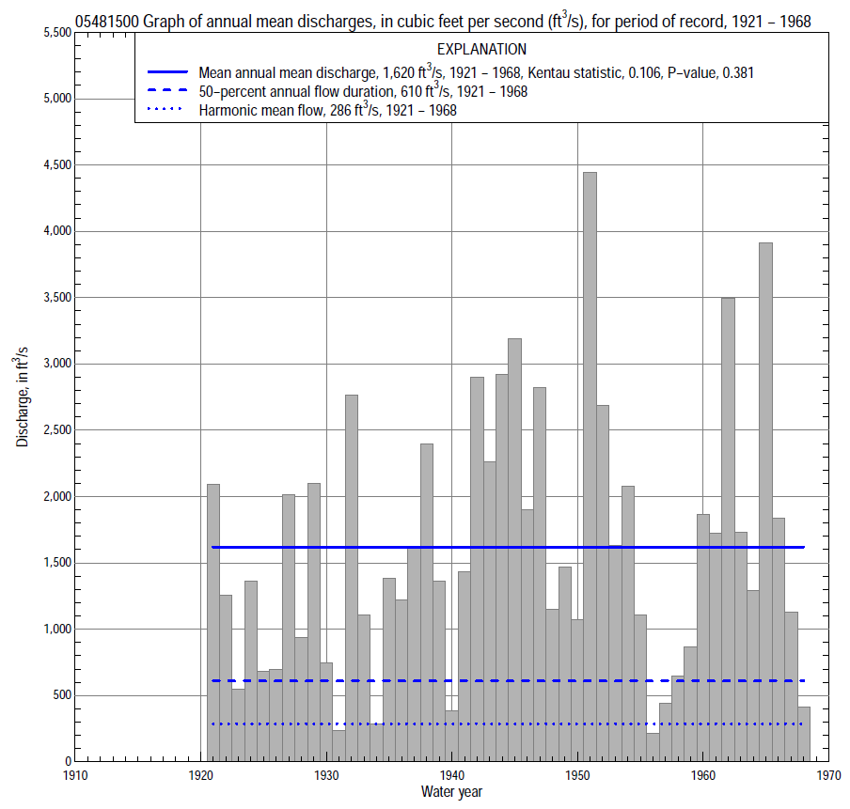

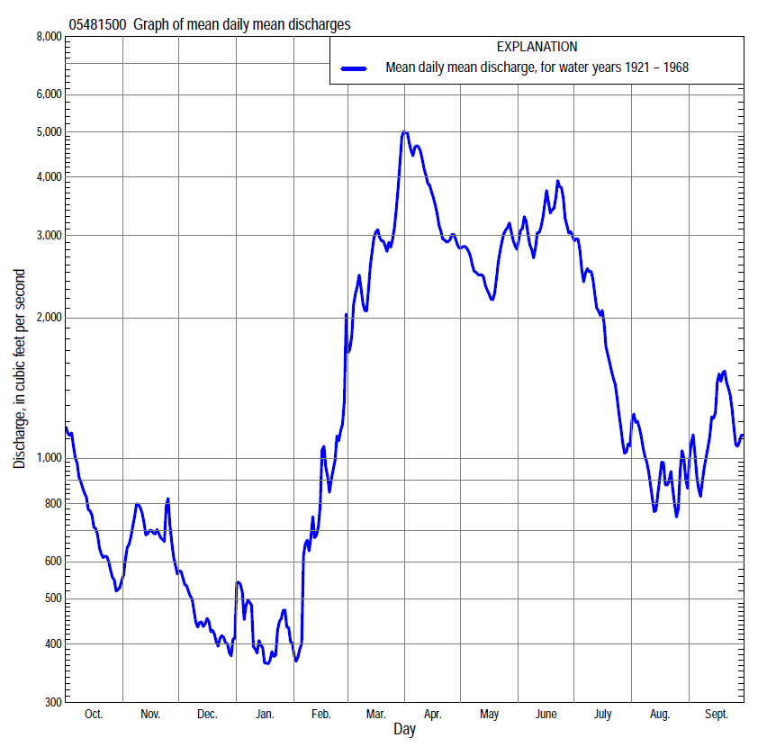

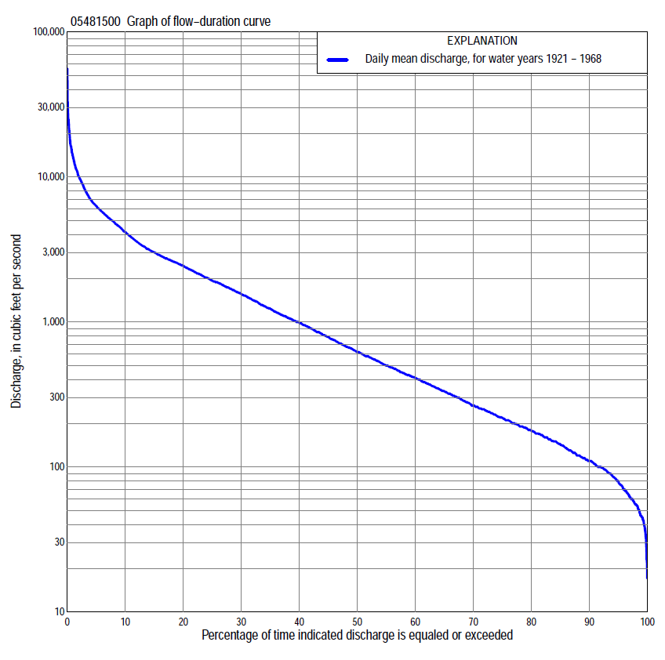

Statistics Based on the Entire Streamflow Period of Record
05481500 Monthly and annual flow durations, based on 1921–68 period of record (48 years)
Percentage of days discharge equaled or exceeded |  |  |  |  | Discharge (cubic feet per second) |  |  |  |  |  |  |  |  | Annual flow durations
 | Oct | Nov | Dec | Jan | Feb | Mar | Apr | May | June | July | Aug | Sept | Annual | Kentau statistic | P-value
99 | 43 | 62 | 46 | 22 | 33 | 90 | 176 | 112 | 118 | 64 | 51 | 50 | 45 | 0.009 | 0.936
98 | 54 | 68 | 51 | 35 | 38 | 104 | 210 | 162 | 125 | 77 | 61 | 60 | 55 | -0.020 | 0.845
95 | 74 | 91 | 60 | 45 | 51 | 146 | 288 | 200 | 203 | 132 | 86 | 73 | 78 | -0.059 | 0.557
90 | 95 | 115 | 82 | 58 | 62 | 210 | 440 | 301 | 362 | 222 | 123 | 96 | 110 | -0.039 | 0.702
85 | 115 | 141 | 100 | 80 | 86 | 285 | 728 | 450 | 534 | 285 | 166 | 113 | 142 | -0.066 | 0.516
80 | 133 | 160 | 115 | 98 | 109 | 400 | 890 | 628 | 622 | 365 | 204 | 142 | 176 | -0.062 | 0.540
75 | 155 | 187 | 130 | 100 | 120 | 565 | 1,070 | 847 | 795 | 474 | 235 | 169 | 215 | -0.052 | 0.606
70 | 174 | 220 | 150 | 110 | 145 | 760 | 1,250 | 1,020 | 950 | 580 | 265 | 200 | 261 | -0.029 | 0.776
65 | 192 | 250 | 165 | 120 | 170 | 980 | 1,460 | 1,200 | 1,110 | 655 | 293 | 222 | 327 | -0.036 | 0.722
60 | 235 | 277 | 185 | 142 | 200 | 1,290 | 1,700 | 1,400 | 1,430 | 729 | 334 | 260 | 402 | -0.027 | 0.790
55 | 298 | 306 | 215 | 160 | 240 | 1,590 | 1,900 | 1,620 | 1,700 | 849 | 375 | 306 | 490 | -0.039 | 0.702
50 | 347 | 340 | 250 | 185 | 310 | 1,800 | 2,160 | 1,840 | 1,930 | 960 | 421 | 370 | 610 | -0.026 | 0.803
45 | 402 | 380 | 300 | 200 | 415 | 2,160 | 2,440 | 2,080 | 2,260 | 1,140 | 482 | 418 | 760 | 0.004 | 0.972
40 | 525 | 430 | 340 | 240 | 485 | 2,440 | 2,660 | 2,360 | 2,650 | 1,340 | 556 | 485 | 958 | 0.013 | 0.901
35 | 622 | 540 | 400 | 280 | 580 | 2,680 | 3,020 | 2,600 | 3,040 | 1,600 | 660 | 590 | 1,180 | 0.019 | 0.859
30 | 790 | 640 | 450 | 347 | 749 | 3,010 | 3,360 | 2,900 | 3,660 | 1,880 | 811 | 735 | 1,520 | 0.059 | 0.563
25 | 1,000 | 802 | 540 | 425 | 980 | 3,470 | 4,200 | 3,320 | 4,160 | 2,180 | 1,030 | 951 | 1,880 | 0.082 | 0.419
20 | 1,240 | 970 | 642 | 500 | 1,140 | 4,160 | 5,150 | 3,870 | 4,980 | 2,620 | 1,330 | 1,260 | 2,360 | 0.104 | 0.302
15 | 1,580 | 1,150 | 814 | 650 | 1,410 | 5,180 | 6,290 | 4,730 | 5,900 | 3,270 | 1,750 | 1,850 | 2,940 | 0.110 | 0.274
10 | 1,960 | 1,500 | 1,120 | 900 | 2,010 | 6,260 | 8,900 | 5,620 | 7,510 | 4,340 | 2,410 | 2,760 | 4,070 | 0.093 | 0.355
5 | 2,570 | 2,200 | 1,730 | 1,520 | 3,200 | 9,500 | 12,700 | 7,040 | 10,300 | 6,530 | 3,320 | 4,690 | 6,200 | 0.113 | 0.259
2 | 3,770 | 4,480 | 2,160 | 2,900 | 5,770 | 13,600 | 19,400 | 10,500 | 14,500 | 8,900 | 4,720 | 8,440 | 9,970 | 0.140 | 0.163
1 | 4,610 | 5,810 | 2,460 | 4,600 | 6,600 | 19,500 | 26,500 | 14,800 | 17,700 | 10,100 | 6,330 | 13,800 | 13,600 | 0.134 | 0.182

05481500 Annual exceedance probability of instantaneous peak discharges, in cubic feet per second (ft³/s), based on the Weighted Independent Estimates method,
Annual exceed-ance probability | Recur-rence interval (years) | Discharge (ft³/s) | 95-percent lower confi-dence interval (ft³/s) | 95-percent upper confi-dence interval (ft³/s)
0.500 | 2 | 15,300 | 13,400 | 17,500
0.200 | 5 | 26,200 | 23,000 | 29,800
0.100 | 10 | 33,800 | 29,300 | 39,000
0.040 | 25 | 43,500 | 36,500 | 51,900
0.020 | 50 | 50,700 | 41,200 | 62,500
0.010 | 100 | 57,900 | 45,400 | 73,800
0.005 | 200 | 65,100 | 49,200 | 86,200
0.002 | 500 | 74,400 | 53,400 | 104,000
and based on the expected moments algorithm/multiple Grubbs-Beck analysis computed using a historical period length of 111 years (1903–2013)ª
0.500 | 2 | 15,400 | 13,400 | 17,700
0.200 | 5 | 26,500 | 23,200 | 30,500
0.100 | 10 | 34,300 | 29,800 | 40,500
0.040 | 25 | 44,500 | 37,900 | 55,200
0.020 | 50 | 52,200 | 43,300 | 67,800
0.010 | 100 | 59,800 | 48,200 | 81,700
0.005 | 200 | 67,500 | 52,500 | 97,000
0.002 | 500 | 77,700 | 57,700 | 120,000
Kentau statistic |  | 0.153
P-value |  | 0.019
Begin year |  | 1905
End year |  | 2013
Number of peaks |  | 107
ªAnalysis includes annual peak discharges (1969–2013) from streamgage 05481300 Des Moines River near Stratford.

05481500 Annual exceedance probability of high discharges, based on 1921–68 period of record (48 years)
[ND, not determined]
Annual exceed-ance probability | Recur-rence interval (years) | Maximum average discharge (ft³/s) for indicated number of consecutive days
 |  | 1 | 3 | 7 | 15 | 30
0.990 | 1.01 | ND | ND | 1,080 | 809 | 546
0.950 | 1.05 | ND | ND | 2,150 | 1,640 | 1,170
0.900 | 1.11 | ND | ND | 3,030 | 2,330 | 1,700
0.800 | 1.25 | ND | ND | 4,510 | 3,480 | 2,580
0.500 | 2 | ND | ND | 9,120 | 7,040 | 5,290
0.200 | 5 | ND | ND | 17,200 | 13,100 | 9,690
0.100 | 10 | ND | ND | 23,300 | 17,600 | 12,800
0.040 | 25 | ND | ND | 31,500 | 23,400 | 16,600
0.020 | 50 | ND | ND | 38,000 | 27,900 | 19,400
0.010 | 100 | ND | ND | 44,500 | 32,400 | 22,000
0.005 | 200 | ND | ND | 51,200 | 36,800 | 24,600
0.002 | 500 | ND | ND | 60,300 | 42,800 | 27,800
Kentau statistic |  | 0.166 | 0.159 | 0.140 | 0.119 | 0.131
P-value |  | 0.098 | 0.114 | 0.163 | 0.237 | 0.191

 | 05481500 Annual nonexceedance probability of low discharges, based on April 1920 to March 1968 period of record (48 years)
Annual nonexceed-ance probability | Recur-rence interval (years) | Minimum average discharge (cubic feet per second) for indicated number of consecutive days
 |  | 1 | 3 | 7 | 14 | 30 | 60 | 90 | 120 | 183
0.01 | 100 | 19 | 21 | 22 | 25 | 28 | 34 | 38 | 43 | 43
0.02 | 50 | 22 | 24 | 26 | 28 | 32 | 40 | 46 | 52 | 55
0.05 | 20 | 27 | 30 | 32 | 36 | 41 | 51 | 61 | 70 | 80
0.10 | 10 | 34 | 37 | 40 | 44 | 52 | 65 | 79 | 92 | 112
0.20 | 5 | 45 | 49 | 52 | 58 | 69 | 89 | 109 | 129 | 169
0.50 | 2 | 79 | 86 | 93 | 103 | 126 | 165 | 211 | 255 | 369
0.80 | 1.25 | 149 | 162 | 176 | 195 | 240 | 327 | 428 | 521 | 809
0.90 | 1.11 | 214 | 232 | 253 | 279 | 345 | 478 | 631 | 769 | 1,220
0.96 | 1.04 | 321 | 347 | 378 | 416 | 516 | 730 | 969 | 1,180 | 1,890
0.98 | 1.02 | 421 | 456 | 498 | 546 | 676 | 970 | 1,290 | 1,560 | 2,520
0.99 | 1.01 | 542 | 586 | 641 | 701 | 867 | 1,260 | 1,680 | 2,020 | 3,250
Kentau statistic |  | 0.031 | 0.023 | 0.021 | -0.001 | -0.014 | -0.041 | -0.078 | -0.106 | -0.075
P-value |  | 0.762 | 0.824 | 0.838 | 1.000 | 0.894 | 0.689 | 0.439 | 0.290 | 0.455

05481500 Annual nonexceedance probability of seasonal low discharges, based on April 1920 to September 1968 period of record (48–49 years)
Annual nonexceed-ance probability | Recur-rence interval (years) | Minimum average discharge (cubic feet per second) for indicated number of consecutive days
 |  | 1 | 7 | 14 | 30 |  | 1 | 7 | 14 | 30
 |  | January-February-March |  |  |  |  | April-May-June
0.01 | 100 | 22 | 23 | 24 | 26 |  | 41 | 49 | 57 | 85
0.02 | 50 | 25 | 27 | 29 | 31 |  | 60 | 71 | 82 | 120
0.05 | 20 | 32 | 36 | 38 | 42 |  | 101 | 120 | 139 | 198
0.10 | 10 | 41 | 46 | 50 | 55 |  | 158 | 188 | 217 | 302
0.20 | 5 | 56 | 64 | 69 | 79 |  | 263 | 313 | 361 | 491
0.50 | 2 | 110 | 128 | 140 | 168 |  | 641 | 755 | 874 | 1,160
0.80 | 1.25 | 245 | 278 | 305 | 394 |  | 1,400 | 1,620 | 1,880 | 2,510
0.90 | 1.11 | 392 | 431 | 473 | 637 |  | 2,030 | 2,310 | 2,690 | 3,630
0.96 | 1.04 | 670 | 707 | 774 | 1,100 |  | 2,920 | 3,260 | 3,810 | 5,230
0.98 | 1.02 | 970 | 988 | 1,080 | 1,580 |  | 3,630 | 4,020 | 4,700 | 6,540
0.99 | 1.01 | 1,350 | 1,350 | 1,470 | 2,220 |  | 4,380 | 4,780 | 5,610 | 7,920
Kentau statistic |  | -0.100 | -0.112 | -0.113 | -0.096 |  | 0.111 | 0.138 | 0.126 | 0.124
P-value |  | 0.319 | 0.267 | 0.259 | 0.342 |  | 0.266 | 0.165 | 0.205 | 0.211
 |  | July-August-September |  |  |  |  | October-November-December
0.01 | 100 | 21 | 29 | 34 | 44 |  | 25 | 30 | 34 | 40
0.02 | 50 | 26 | 35 | 40 | 52 |  | 30 | 35 | 40 | 47
0.05 | 20 | 36 | 46 | 53 | 68 |  | 39 | 45 | 51 | 61
0.10 | 10 | 48 | 60 | 68 | 89 |  | 50 | 58 | 65 | 78
0.20 | 5 | 70 | 85 | 96 | 125 |  | 68 | 79 | 89 | 108
0.50 | 2 | 154 | 179 | 202 | 268 |  | 126 | 155 | 174 | 214
0.80 | 1.25 | 372 | 421 | 474 | 655 |  | 243 | 332 | 379 | 467
0.90 | 1.11 | 612 | 689 | 777 | 1,110 |  | 348 | 513 | 594 | 731
0.96 | 1.04 | 1,070 | 1,200 | 1,370 | 2,030 |  | 517 | 840 | 992 | 1,210
0.98 | 1.02 | 1,560 | 1,760 | 2,010 | 3,070 |  | 673 | 1,180 | 1,410 | 1,710
0.99 | 1.01 | 2,220 | 2,520 | 2,880 | 4,530 |  | 856 | 1,610 | 1,960 | 2,360
Kentau statistic |  | 0.129 | 0.124 | 0.131 | 0.100 |  | -0.049 | -0.044 | -0.041 | -0.067
P-value |  | 0.193 | 0.211 | 0.187 | 0.313 |  | 0.631 | 0.663 | 0.689 | 0.505

