LOCATION.--Lat 41°40'50", long 93°40'05" referenced to North American Datum of 1927, in SW 1/4 NE 1/4 NE 1/4 sec.05, T.79 N., R.24 W., Polk County, IA, Hydrologic Unit 07100004, on left bank 5 ft upstream from Fisher Bridge on County Highway R6F, 2.0 mi west of Saylorville, 2.1 mi downstream from Rock Creek, 2.3 mi downstream from Saylorville Dam, 2.2 mi upstream from Beaver Creek, and 203.0 mi upstream from mouth.

DRAINAGE AREA.--5,841 mi².

PERIOD OF RECORD.--Discharge records from October 1961 to current year.

GAGE.--Water-stage recorder. Datum of gage is 787.42 ft above National Geodetic Vertical Datum of 1929 (levels by U.S. Army Corps of Engineers). Prior to August 6, 1970, non-recording gage at same site and datum.

REMARKS.--Flow regulated by Saylorville Lake (station 05481630), 2.3 mi upstream, since April 12, 1977.

EXTREMES OUTSIDE PERIOD OF RECORD.--Since at least 1893, no flood outside the period of record exceeded the June 24, 1954, stage of 24.50 ft, from high-water mark, discharge 60,000 ft³/s.

A summary of all available data for this streamgage is provided through the USGS National Water Information System web interface (NWISWeb). The following link provides access to current/historical observations, daily data, daily statistics, monthly statistics, annual statistics, peak streamflow, field measurements, field/lab water-quality samples, and the latest water-year summaries. Data can be filtered by parameter and/or dates, and can be output in various tabular and graphical formats.
http://waterdata.usgs.gov/nwis/inventory/?site_no=05481650

The USGS WaterWatch Toolkit is available at:
http://waterwatch.usgs.gov/?id=ww_toolkit
Tools for summarizing streamflow information include the duration hydrograph builder, the cumulative streamflow hydrograph builder, the streamgage statistics retrieval tool, the rating curve builder, the flood tracking chart builder, the National Weather Service Advanced Hydrologic Prediction Service (AHPS) river forecast hydrograph builder, and the raster-hydrograph builder. Entering the above number for this streamgage into these toolkit webpages will provide streamflow information specific to this streamgage.

A description of the statistics presented for this streamgage is available in the main body of the report at:
http://dx.doi.org/10.3133/ofr20151214
A link to other streamgages included in this report, a map showing the location of the streamgages, information on the programs used to compute the statistical analyses, and references are included in the main body of the report.

Statistics Based on the Pre-regulated Streamflow Period of Record

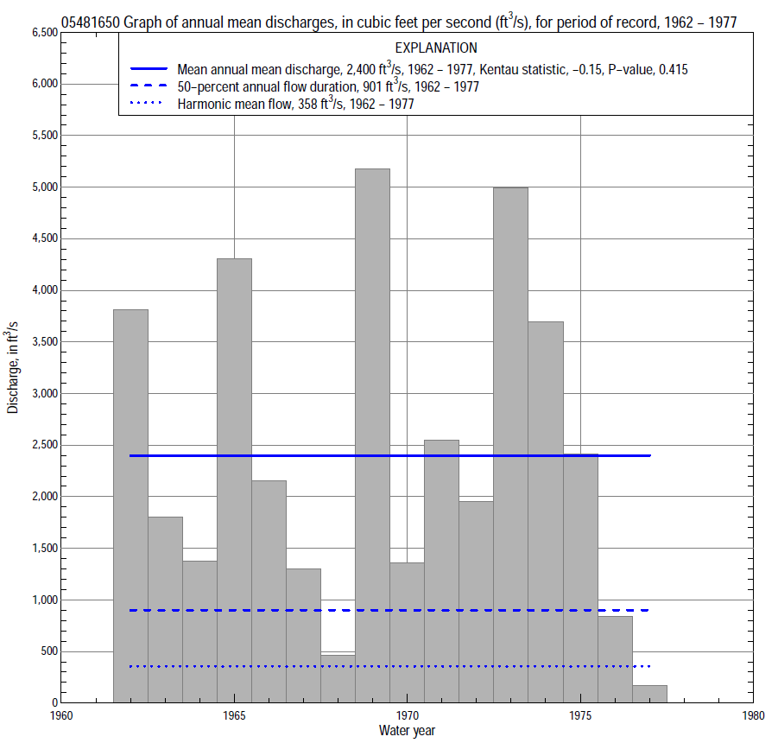

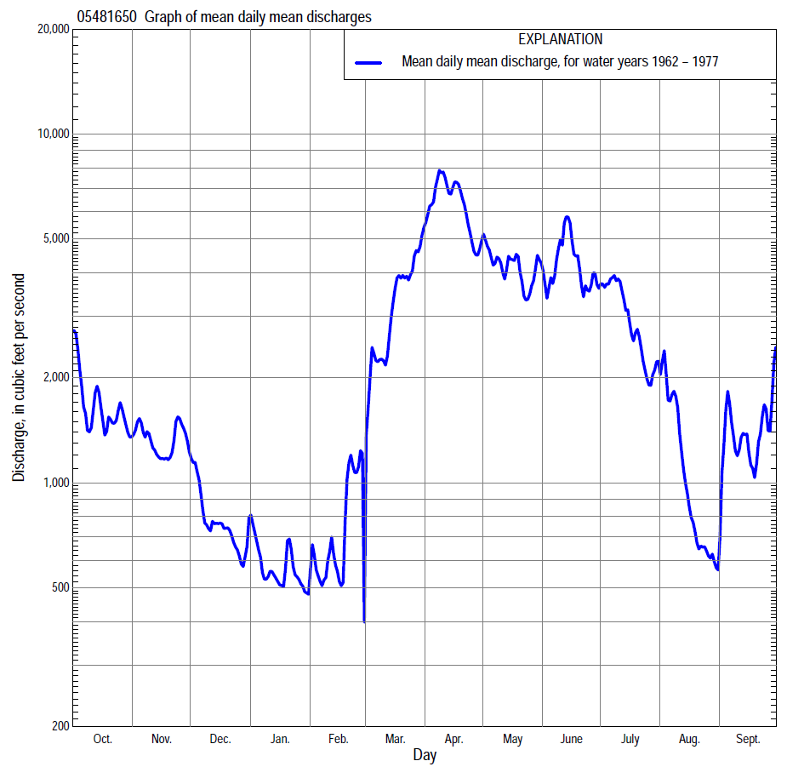

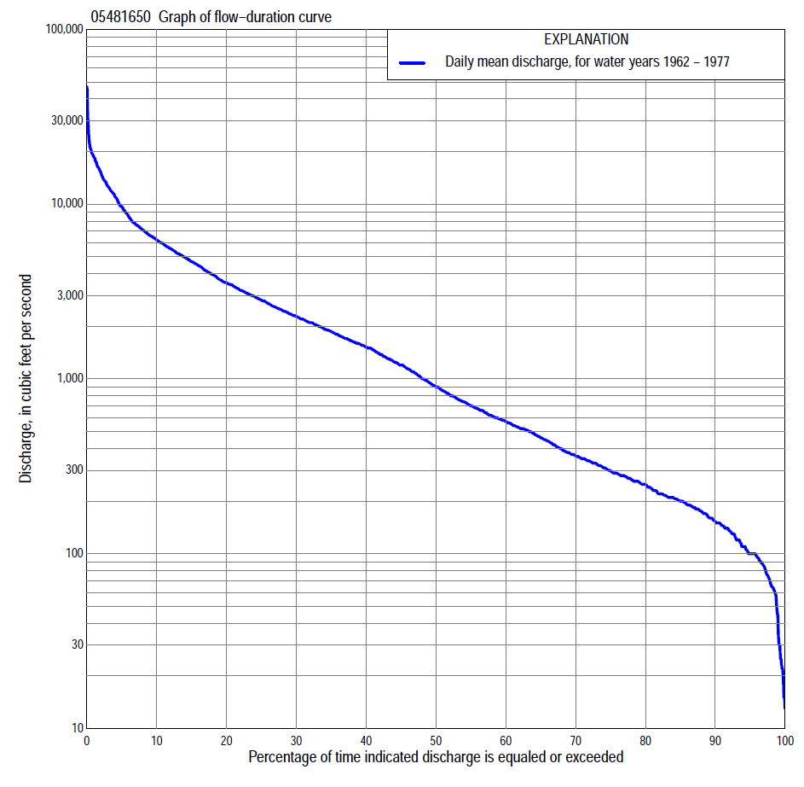

Statistics Based on the Pre-regulated Streamflow Period of Record
05481650 Monthly and annual flow durations, based on 1962–77 pre-regulated period of record (16 years)
Percentage of days discharge equaled or exceeded |  |  |  |  | Discharge (cubic feet per second) |  |  |  |  |  |  |  |  | Annual flow durations
 | Oct | Nov | Dec | Jan | Feb | Mar | Apr | May | June | July | Aug | Sept | Annual | Kentau statistic | P-value
99 | 64 | 75 | 29 | 15 | 19 | 110 | 195 | 175 | 100 | 100 | 76 | 60 | 37 | -0.183 | 0.344
98 | 68 | 86 | 37 | 17 | 30 | 160 | 200 | 185 | 100 | 100 | 82 | 64 | 66 | -0.133 | 0.499
95 | 82 | 119 | 65 | 23 | 85 | 210 | 216 | 215 | 198 | 100 | 96 | 89 | 100 | -0.183 | 0.344
90 | 136 | 152 | 104 | 70 | 105 | 260 | 456 | 340 | 570 | 363 | 176 | 160 | 152 | -0.225 | 0.241
85 | 154 | 184 | 120 | 110 | 130 | 292 | 980 | 630 | 1,240 | 562 | 280 | 184 | 200 | -0.200 | 0.300
80 | 176 | 214 | 150 | 130 | 170 | 405 | 1,200 | 1,270 | 1,490 | 686 | 321 | 211 | 249 | -0.150 | 0.444
75 | 196 | 291 | 210 | 145 | 190 | 470 | 1,380 | 1,910 | 1,850 | 830 | 374 | 239 | 298 | -0.142 | 0.471
70 | 219 | 324 | 265 | 170 | 210 | 580 | 1,630 | 2,250 | 2,080 | 926 | 410 | 268 | 364 | -0.192 | 0.321
65 | 274 | 361 | 314 | 200 | 220 | 740 | 1,920 | 2,440 | 2,270 | 1,080 | 453 | 288 | 460 | -0.150 | 0.444
60 | 343 | 560 | 368 | 250 | 230 | 1,070 | 2,570 | 2,740 | 2,510 | 1,250 | 510 | 322 | 570 | -0.133 | 0.499
55 | 452 | 703 | 440 | 270 | 240 | 1,430 | 2,970 | 3,160 | 2,840 | 1,510 | 550 | 364 | 702 | -0.117 | 0.558
50 | 626 | 797 | 510 | 310 | 260 | 1,650 | 3,210 | 3,540 | 3,210 | 1,750 | 590 | 389 | 901 | -0.108 | 0.589
45 | 767 | 900 | 562 | 330 | 306 | 1,900 | 3,590 | 4,050 | 3,580 | 1,940 | 642 | 466 | 1,200 | -0.200 | 0.300
40 | 1,150 | 968 | 616 | 350 | 380 | 2,200 | 4,890 | 4,500 | 4,080 | 2,130 | 708 | 542 | 1,520 | -0.233 | 0.224
35 | 1,420 | 1,100 | 700 | 380 | 490 | 2,630 | 5,990 | 4,860 | 4,490 | 2,430 | 800 | 680 | 1,870 | -0.183 | 0.344
30 | 1,770 | 1,380 | 780 | 440 | 530 | 3,060 | 7,000 | 5,340 | 4,990 | 3,010 | 994 | 800 | 2,280 | -0.083 | 0.685
25 | 2,140 | 1,590 | 900 | 540 | 640 | 3,560 | 7,800 | 5,980 | 5,450 | 3,720 | 1,170 | 1,010 | 2,820 | -0.067 | 0.753
20 | 2,570 | 1,850 | 1,230 | 640 | 1,000 | 4,420 | 10,300 | 6,410 | 6,070 | 4,370 | 1,400 | 1,380 | 3,550 | -0.100 | 0.620
15 | 3,110 | 2,430 | 1,600 | 900 | 1,450 | 5,910 | 12,900 | 7,060 | 7,590 | 5,360 | 1,840 | 2,010 | 4,690 | -0.133 | 0.499
10 | 4,100 | 3,460 | 1,990 | 1,650 | 1,900 | 10,200 | 16,400 | 7,920 | 9,050 | 6,570 | 2,520 | 4,060 | 6,240 | -0.133 | 0.499
5 | 6,900 | 5,060 | 2,450 | 2,350 | 3,700 | 13,600 | 21,000 | 10,600 | 12,100 | 9,690 | 4,160 | 6,570 | 9,680 | -0.117 | 0.558
2 | 10,200 | 7,130 | 3,000 | 3,000 | 5,600 | 18,300 | 28,600 | 13,700 | 14,800 | 18,300 | 6,730 | 11,600 | 15,200 | -0.192 | 0.321
1 | 12,000 | 8,200 | 4,500 | 3,500 | 6,000 | 20,000 | 36,900 | 15,700 | 18,000 | 19,500 | 9,230 | 14,000 | 18,700 | -0.233 | 0.224

05481650 Annual exceedance probability of instantaneous peak discharges, in cubic feet per second (ft³/s), for the pre-regulated period of record based on the expected moments algorithm/multiple Grubbs-Beck analysis computed using a historical period length of 74 years (1903–1976)ª
Annual exceed-ance probability | Recur-rence interval (years) | Discharge (ft³/s) | 95-percent lower confi-dence interval (ft³/s) | 95-percent upper confi-dence interval (ft³/s)
0.500 | 2 | 15,100 | 10,500 | 20,600
0.200 | 5 | 25,400 | 18,400 | 33,800
0.100 | 10 | 32,500 | 23,500 | 43,500
0.040 | 25 | 41,800 | 29,700 | 57,700
0.020 | 50 | 48,700 | 34,100 | 70,400
0.010 | 100 | 55,500 | 38,200 | 85,400
0.005 | 200 | 62,400 | 42,100 | 103,000
0.002 | 500 | 71,500 | 46,800 | 131,000
Kentau statistic |  | -0.124
P-value |  | 0.553
Begin year |  | 1962
End year |  | 1976
Number of peaks |  | 15
ªWeighted Independent Estimates were not computed because regional regression equations are not applicable due to size of drainage area.
Note: The above discharges are for the pre-regulated period of record and they are not applicable for flood-plain management regulation or for design purposes.

05481650 Annual exceedance probability of high discharges, based on 1962–77 pre-regulated period of record (16 years)
[ND, not determined]
Annual exceed-ance probability | Recur-rence interval (years) | Maximum average discharge (cubic feet per second) for indicated number of consecutive days
 |  | 1 | 3 | 7 | 15 | 30
0.990 | 1.01 | ND | 566 | 502 | 418 | 361
0.950 | 1.05 | ND | 1,910 | 1,630 | 1,320 | 1,100
0.900 | 1.11 | ND | 3,310 | 2,800 | 2,240 | 1,840
0.800 | 1.25 | ND | 5,920 | 4,990 | 3,970 | 3,220
0.500 | 2 | ND | 14,100 | 12,100 | 9,600 | 7,620
0.200 | 5 | ND | 25,100 | 22,400 | 18,100 | 14,200
0.100 | 10 | ND | 30,900 | 28,300 | 23,000 | 18,000
0.040 | 25 | ND | 36,200 | 34,100 | 28,100 | 22,000
0.020 | 50 | ND | 39,000 | 37,400 | 31,100 | 24,400
0.010 | 100 | ND | 41,000 | 40,000 | 33,600 | 26,400
0.005 | 200 | ND | 42,500 | 42,100 | 35,500 | 27,900
0.002 | 500 | ND | 43,900 | 44,100 | 37,500 | 29,600
Kentau statistic |  | -0.217 | -0.233 | -0.233 | -0.200 | -0.167
P-value |  | 0.260 | 0.224 | 0.224 | 0.300 | 0.392
Note: The above discharges are for the pre-regulated period of record and they are not applicable for flood-plain management regulation or for design purposes.

 | 05481650 Annual nonexceedance probability of low discharges, based on April 1962 to March 1977 pre-regulated period of record (15 years)
Annual nonexceed-ance probability | Recur-rence interval (years) | Minimum average discharge (cubic feet per second) for indicated number of consecutive days
 |  | 1 | 3 | 7 | 14 | 30 | 60 | 90 | 120 | 183
0.01 | 100 | 8.7 | 9.1 | 9.9 | 11 | 13 | 18 | 28 | 37 | 36
0.02 | 50 | 13 | 14 | 15 | 16 | 20 | 26 | 37 | 48 | 49
0.05 | 20 | 24 | 25 | 27 | 29 | 35 | 44 | 57 | 72 | 79
0.10 | 10 | 39 | 41 | 44 | 47 | 55 | 68 | 83 | 103 | 120
0.20 | 5 | 67 | 71 | 76 | 79 | 94 | 112 | 133 | 161 | 198
0.50 | 2 | 164 | 172 | 182 | 192 | 225 | 274 | 331 | 398 | 518
0.80 | 1.25 | 332 | 344 | 368 | 395 | 462 | 613 | 831 | 1,040 | 1,350
0.90 | 1.11 | 451 | 461 | 497 | 541 | 637 | 903 | 1,350 | 1,750 | 2,240
0.96 | 1.04 | 595 | 602 | 654 | 725 | 859 | 1,330 | 2,270 | 3,100 | 3,810
0.98 | 1.02 | 695 | 698 | 763 | 858 | 1,020 | 1,690 | 3,190 | 4,530 | 5,390
0.99 | 1.01 | 788 | 788 | 864 | 983 | 1,180 | 2,070 | 4,330 | 6,410 | 7,350
Kentau statistic |  | -0.105 | -0.086 | -0.029 | -0.029 | -0.067 | -0.086 | -0.086 | -0.067 | -0.162
P-value |  | 0.621 | 0.692 | 0.921 | 0.921 | 0.767 | 0.692 | 0.692 | 0.767 | 0.428

05481650 Annual nonexceedance probability of seasonal low discharges, based on October 1961 to September 1977 pre-regulated period of record (16 years)
Annual nonexceed-ance probability | Recur-rence interval (years) | Minimum average discharge (cubic feet per second) for indicated number of consecutive days
 |  | 1 | 7 | 14 | 30 |  | 1 | 7 | 14 | 30
 |  | January-February-March |  |  |  |  | April-May-June
0.01 | 100 | 9.8 | 11 | 12 | 16 |  | 44 | 44 | 46 | 69
0.02 | 50 | 15 | 16 | 18 | 22 |  | 74 | 78 | 83 | 118
0.05 | 20 | 26 | 29 | 31 | 37 |  | 152 | 172 | 184 | 251
0.10 | 10 | 42 | 46 | 49 | 59 |  | 270 | 319 | 344 | 457
0.20 | 5 | 74 | 81 | 86 | 100 |  | 499 | 613 | 670 | 869
0.50 | 2 | 203 | 217 | 231 | 268 |  | 1,270 | 1,610 | 1,820 | 2,340
0.80 | 1.25 | 503 | 531 | 568 | 694 |  | 2,450 | 3,010 | 3,590 | 4,750
0.90 | 1.11 | 778 | 817 | 879 | 1,120 |  | 3,140 | 3,750 | 4,580 | 6,230
0.96 | 1.04 | 1,210 | 1,260 | 1,370 | 1,850 |  | 3,830 | 4,420 | 5,540 | 7,780
0.98 | 1.02 | 1,580 | 1,640 | 1,790 | 2,550 |  | 4,230 | 4,760 | 6,070 | 8,720
0.99 | 1.01 | 1,990 | 2,070 | 2,260 | 3,380 |  | 4,540 | 5,010 | 6,470 | 9,470
Kentau statistic |  | -0.075 | -0.050 | -0.050 | -0.083 |  | 0.033 | 0.000 | 0.108 | -0.050
P-value |  | 0.718 | 0.822 | 0.822 | 0.685 |  | 0.893 | 1.000 | 0.589 | 0.822
 |  | July-August-September |  |  |  |  | October-November-December
0.01 | 100 | 37 | 37 | 39 | 45 |  | 17 | 19 | 21 | 28
0.02 | 50 | 48 | 49 | 51 | 59 |  | 23 | 26 | 30 | 39
0.05 | 20 | 69 | 73 | 76 | 87 |  | 37 | 43 | 49 | 62
0.10 | 10 | 95 | 101 | 107 | 123 |  | 55 | 66 | 77 | 94
0.20 | 5 | 137 | 148 | 157 | 184 |  | 89 | 110 | 130 | 154
0.50 | 2 | 259 | 289 | 312 | 386 |  | 227 | 288 | 342 | 396
0.80 | 1.25 | 459 | 521 | 573 | 772 |  | 574 | 743 | 860 | 1,010
0.90 | 1.11 | 602 | 687 | 765 | 1,090 |  | 933 | 1,210 | 1,370 | 1,650
0.96 | 1.04 | 788 | 904 | 1,020 | 1,560 |  | 1,560 | 2,020 | 2,220 | 2,760
0.98 | 1.02 | 929 | 1,070 | 1,210 | 1,940 |  | 2,180 | 2,810 | 3,010 | 3,850
0.99 | 1.01 | 1,070 | 1,230 | 1,410 | 2,360 |  | 2,940 | 3,780 | 3,940 | 5,180
Kentau statistic |  | -0.317 | -0.333 | -0.367 | -0.350 |  | -0.075 | -0.133 | -0.050 | -0.117
P-value |  | 0.096 | 0.079 | 0.053 | 0.065 |  | 0.718 | 0.499 | 0.822 | 0.558

Statistics Based on the Regulated Streamflow Period of Record

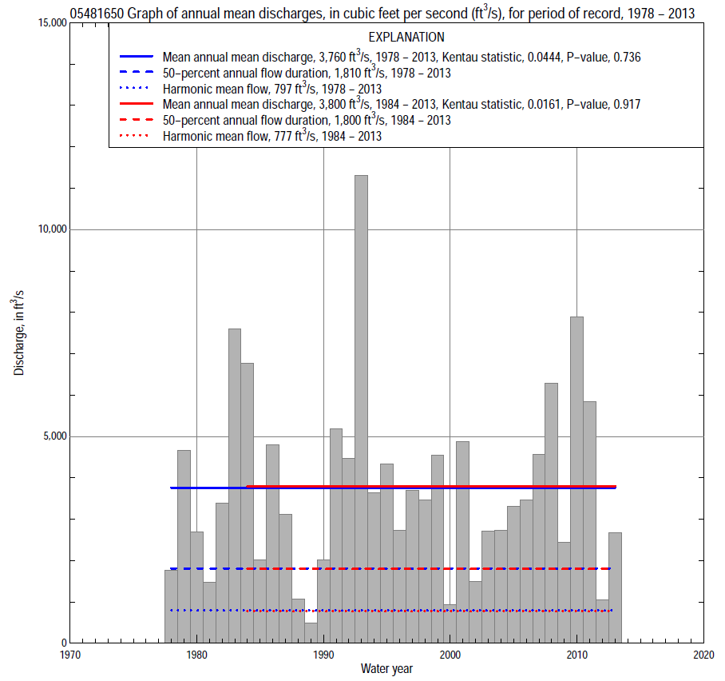

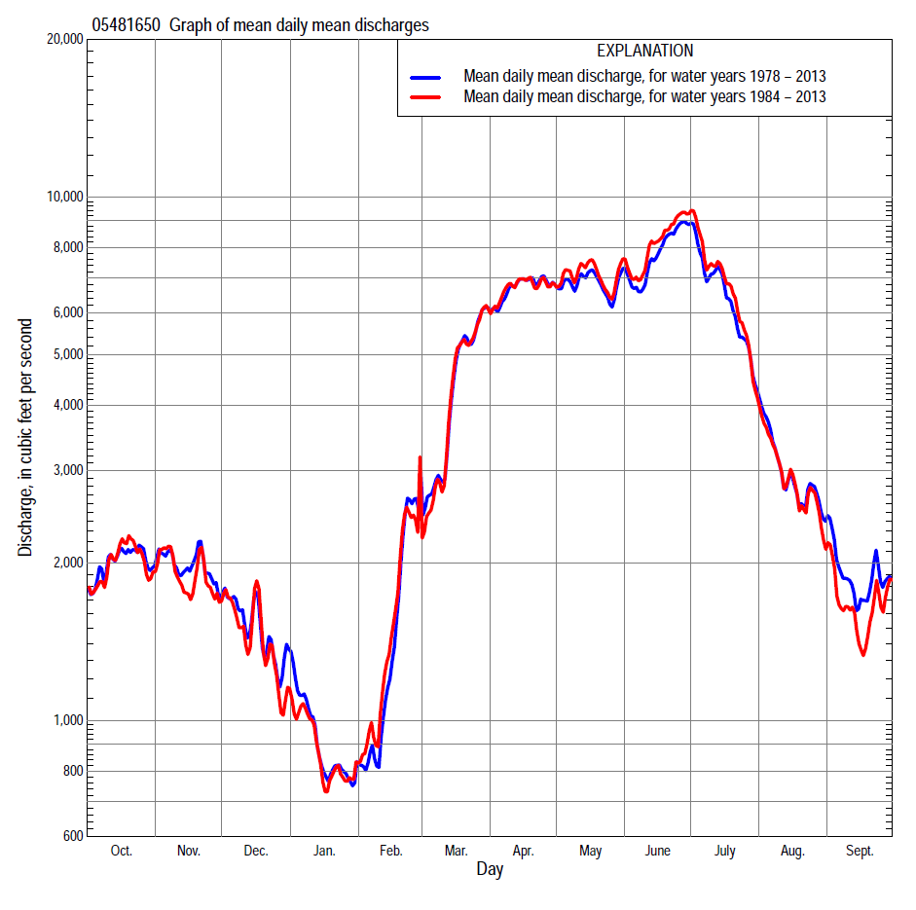

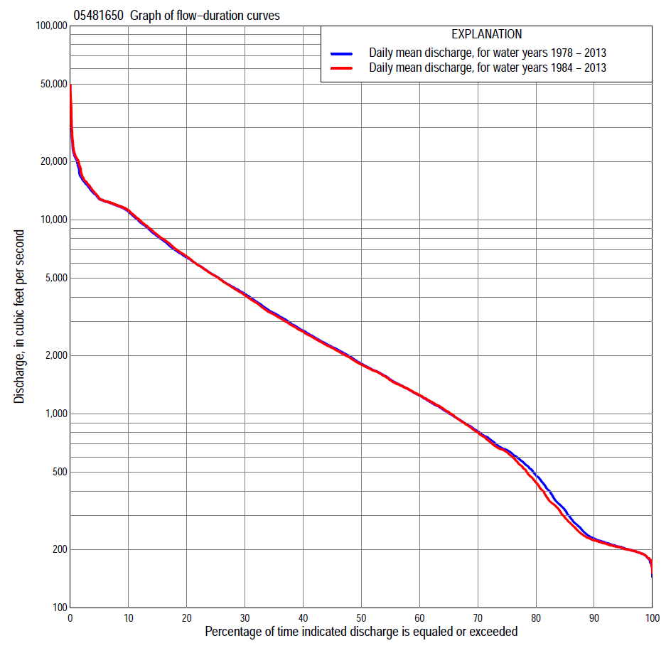

Statistics Based on the Regulated Streamflow Period of Record
05481650 Monthly and annual flow durations, based on 1978–2013 regulated period of record (36 years)
Percentage of days discharge equaled or exceeded |  |  |  |  | Discharge (cubic feet per second) |  |  |  |  |  |  |  |  | Annual flow durations
 | Oct | Nov | Dec | Jan | Feb | Mar | Apr | May | June | July | Aug | Sept | Annual | Kentau statistic | P-value
99 | 184 | 181 | 188 | 180 | 176 | 184 | 262 | 279 | 404 | 237 | 205 | 197 | 183 | -0.048 | 0.693
98 | 191 | 184 | 192 | 183 | 178 | 191 | 279 | 407 | 635 | 258 | 207 | 198 | 191 | -0.013 | 0.924
95 | 198 | 191 | 200 | 191 | 190 | 204 | 490 | 872 | 1,070 | 359 | 218 | 202 | 204 | -0.041 | 0.733
90 | 205 | 198 | 219 | 200 | 204 | 228 | 856 | 1,640 | 1,800 | 693 | 282 | 213 | 228 | -0.087 | 0.462
85 | 215 | 221 | 240 | 210 | 213 | 325 | 1,410 | 2,050 | 2,260 | 941 | 475 | 225 | 319 | -0.060 | 0.614
80 | 224 | 296 | 360 | 234 | 225 | 495 | 1,890 | 2,390 | 2,670 | 1,510 | 647 | 243 | 484 | -0.065 | 0.586
75 | 282 | 484 | 498 | 263 | 253 | 658 | 2,410 | 2,740 | 3,100 | 2,030 | 749 | 305 | 651 | -0.065 | 0.586
70 | 349 | 587 | 614 | 300 | 325 | 829 | 2,730 | 3,290 | 3,470 | 2,450 | 877 | 379 | 812 | -0.090 | 0.445
65 | 535 | 724 | 770 | 377 | 401 | 1,040 | 3,230 | 3,930 | 4,030 | 3,190 | 1,030 | 460 | 1,010 | -0.056 | 0.643
60 | 650 | 876 | 914 | 465 | 595 | 1,270 | 3,840 | 4,430 | 4,620 | 3,770 | 1,160 | 538 | 1,240 | -0.048 | 0.693
55 | 720 | 1,100 | 1,030 | 574 | 673 | 1,540 | 4,490 | 5,210 | 5,360 | 4,430 | 1,360 | 608 | 1,500 | -0.049 | 0.683
50 | 860 | 1,280 | 1,180 | 666 | 780 | 1,850 | 5,370 | 5,820 | 6,180 | 5,020 | 1,550 | 669 | 1,810 | -0.059 | 0.624
45 | 1,030 | 1,420 | 1,350 | 763 | 873 | 2,240 | 6,330 | 6,740 | 7,050 | 5,590 | 1,830 | 826 | 2,210 | -0.046 | 0.703
40 | 1,270 | 1,650 | 1,460 | 875 | 1,020 | 2,700 | 7,130 | 7,730 | 8,070 | 6,330 | 2,160 | 1,030 | 2,680 | -0.052 | 0.663
35 | 1,600 | 1,840 | 1,620 | 986 | 1,120 | 3,330 | 8,540 | 8,240 | 9,260 | 7,020 | 2,520 | 1,250 | 3,310 | -0.027 | 0.827
30 | 2,140 | 2,180 | 1,780 | 1,100 | 1,280 | 4,170 | 9,570 | 9,300 | 10,800 | 7,770 | 3,080 | 1,580 | 4,150 | 0.024 | 0.849
25 | 2,770 | 2,680 | 1,990 | 1,250 | 1,460 | 5,150 | 11,200 | 10,300 | 11,600 | 8,960 | 3,760 | 1,860 | 5,130 | 0.046 | 0.703
20 | 3,440 | 3,260 | 2,240 | 1,430 | 2,050 | 6,410 | 12,000 | 11,700 | 12,100 | 10,500 | 4,630 | 2,340 | 6,400 | 0.048 | 0.693
15 | 4,290 | 4,100 | 2,610 | 1,620 | 2,660 | 8,220 | 12,700 | 12,200 | 12,400 | 11,500 | 5,540 | 3,320 | 8,220 | 0.083 | 0.487
10 | 5,520 | 5,270 | 3,070 | 1,900 | 3,960 | 11,000 | 14,000 | 12,700 | 13,200 | 12,200 | 6,860 | 5,440 | 11,000 | 0.127 | 0.282
5 | 7,430 | 6,440 | 4,360 | 2,540 | 5,870 | 12,900 | 15,900 | 15,300 | 21,200 | 18,800 | 12,800 | 9,050 | 12,800 | 0.143 | 0.225
2 | 10,100 | 8,170 | 5,450 | 3,450 | 10,800 | 16,500 | 16,800 | 17,100 | 24,600 | 28,700 | 15,900 | 13,800 | 16,400 | 0.097 | 0.414
1 | 12,200 | 8,910 | 6,720 | 4,420 | 13,700 | 20,600 | 20,000 | 20,700 | 27,100 | 38,200 | 17,400 | 14,900 | 20,600 | 0.110 | 0.354

05481650 Annual exceedance probability of instantaneous peak discharges, in cubic feet per second (ft³/s), based on U.S. Army Corps of Engineers regulated flow frequency studyª, analysis computed using a record length of 92 years (1917–2008)
USACE Regulated Flow Frequency Analysis
[ND, not determined]
Annual exceedance probability | Recurrence interval (years) | Discharge (ft³/s) | 95-percent lower confdence interval (ft³/s) | 95-percent upper confidence interval (ft³/s)
0.500 | 2 | 12,300 | ND | ND
0.200 | 5 | ND | ND | ND
0.100 | 10 | 17,300 | ND | ND
0.040 | 25 | ND | ND | ND
0.020 | 50 | 45,200 | ND | ND
0.010 | 100 | 53,400 | ND | ND
0.005 | 200 | 61,900 | ND | ND
0.002 | 500 | 73,800 | ND | ND
ªU.S. Army Corps of Engineers, 2010, Des Moines River regulated flow frequency study: Rock Island District, 82 p., accessed September 9, 2014, at http://www.mvr.usace.army.mil/Portals/48/docs/FRM/DMRRFFS/DMRRFFS-FinalReport.pdf.
USGS Kendall's Tau Trend Analysis
Kentau statistic |  | 0.183
P-value |  | 0.113
Begin year |  | ^{b}1977
End year |  | ^{b}2013
Number of peaks |  | 37
^{b}Kendall's tau trend analysis computed using the regulated period of record which is not the same period of record used to compute the above regulated flow frequency analysis.

05481650 Annual exceedance probability of high discharges, based on 1978–2013 regulated period of recordª (36 years)
[ND, not determined]
Annual exceedance probability | Recur-rence interval (years) | Maximum average discharge (cubic feet per second) for indicated number of consecutive days
 |  | 1 | 3 | 7 | 15 | 30
0.990 | 1.01 | ND | ND | ND | ND | ND
0.950 | 1.05 | ND | ND | ND | ND | ND
0.900 | 1.11 | ND | ND | ND | ND | ND
0.800 | 1.25 | ND | ND | ND | ND | ND
0.500 | 2 | ND | ND | ND | ND | ND
0.200 | 5 | ND | ND | ND | ND | ND
0.100 | 10 | ND | ND | ND | ND | ND
0.040 | 25 | ND | ND | ND | ND | ND
0.020 | 50 | ND | ND | ND | ND | ND
0.010 | 100 | ND | ND | ND | ND | ND
0.005 | 200 | ND | ND | ND | ND | ND
0.002 | 500 | ND | ND | ND | ND | ND
Kentau statistic |  | 0.108 | 0.094 | 0.102 | 0.121 | 0.162
P-value |  | 0.361 | 0.429 | 0.391 | 0.307 | 0.169
ªContact the U.S. Army Corps of Engineers, Rock Island District, for the annual exceedance probability of high discharges.

 | 05481650 Annual nonexceedance probability of low discharges, based on April 1978 to March 2013 regulated period of record (35 years)
Annual nonexceed-ance probability | Recur-rence interval (years) | Minimum average discharge (cubic feet per second) for indicated number of consecutive days
 |  | 1 | 3 | 7 | 14 | 30 | 60 | 90 | 120 | 183
0.01 | 100 | 108 | 109 | 109 | 109 | 110 | 110 | 110 | 110 | 111
0.02 | 50 | 119 | 123 | 123 | 123 | 124 | 124 | 124 | 124 | 131
0.05 | 20 | 132 | 136 | 140 | 141 | 142 | 158 | 179 | 190 | 207
0.10 | 10 | 146 | 151 | 159 | 165 | 172 | 203 | 245 | 273 | 306
0.20 | 5 | 169 | 176 | 190 | 203 | 223 | 278 | 356 | 416 | 483
0.50 | 2 | 240 | 253 | 286 | 323 | 384 | 512 | 707 | 881 | 1,090
0.80 | 1.25 | 377 | 404 | 475 | 559 | 705 | 963 | 1,350 | 1,740 | 2,270
0.90 | 1.11 | 499 | 540 | 645 | 772 | 996 | 1,350 | 1,870 | 2,420 | 3,240
0.96 | 1.04 | 697 | 762 | 924 | 1,120 | 1,470 | 1,950 | 2,610 | 3,360 | 4,630
0.98 | 1.02 | 882 | 973 | 1,190 | 1,450 | 1,910 | 2,490 | 3,220 | 4,110 | 5,760
0.99 | 1.01 | 1,100 | 1,230 | 1,510 | 1,850 | 2,450 | 3,100 | 3,870 | 4,900 | 6,970
Kentau statistic |  | -0.101 | -0.118 | -0.052 | -0.096 | -0.089 | -0.153 | -0.116 | -0.072 | -0.079
P-value |  | 0.402 | 0.327 | 0.670 | 0.426 | 0.460 | 0.201 | 0.334 | 0.551 | 0.514

05481650 Annual nonexceedance probability of seasonal low discharges, based on October 1977 to September 2013 regulated period of record (36 years)
Annual nonexceed-ance probability | Recur-rence interval (years) | Minimum average discharge (cubic feet per second) for indicated number of consecutive days
 |  | 1 | 7 | 14 | 30 |  | 1 | 7 | 14 | 30
 |  | January-February-March |  |  |  |  | April-May-June
0.01 | 100 | 87 | 87 | 88 | 89 |  | 120 | 130 | 163 | 261
0.02 | 50 | 102 | 102 | 105 | 106 |  | 169 | 191 | 239 | 373
0.05 | 20 | 130 | 132 | 136 | 142 |  | 277 | 333 | 415 | 622
0.10 | 10 | 162 | 167 | 173 | 186 |  | 422 | 530 | 661 | 955
0.20 | 5 | 213 | 223 | 234 | 259 |  | 688 | 904 | 1,120 | 1,560
0.50 | 2 | 364 | 405 | 434 | 501 |  | 1,640 | 2,280 | 2,820 | 3,640
0.80 | 1.25 | 635 | 767 | 855 | 1,000 |  | 3,620 | 5,100 | 6,290 | 7,570
0.90 | 1.11 | 856 | 1,090 | 1,250 | 1,460 |  | 5,310 | 7,430 | 9,140 | 10,600
0.96 | 1.04 | 1,180 | 1,610 | 1,890 | 2,210 |  | 7,780 | 10,700 | 13,200 | 14,800
0.98 | 1.02 | 1,460 | 2,090 | 2,510 | 2,900 |  | 9,850 | 13,400 | 16,400 | 18,100
0.99 | 1.01 | 1,770 | 2,660 | 3,250 | 3,710 |  | 12,100 | 16,100 | 19,800 | 21,400
Kentau statistic |  | 0.022 | 0.067 | 0.051 | 0.022 |  | 0.040 | 0.063 | 0.089 | 0.102
P-value |  | 0.859 | 0.577 | 0.673 | 0.859 |  | 0.744 | 0.595 | 0.454 | 0.391
 |  | July-August-September |  |  |  |  | October-November-December
0.01 | 100 | 149 | 156 | 157 | 161 |  | 93 | 97 | 97 | 98
0.02 | 50 | 151 | 162 | 164 | 176 |  | 104 | 112 | 112 | 113
0.05 | 20 | 155 | 171 | 181 | 207 |  | 127 | 142 | 149 | 163
0.10 | 10 | 163 | 186 | 204 | 247 |  | 153 | 178 | 194 | 230
0.20 | 5 | 182 | 216 | 249 | 320 |  | 197 | 239 | 273 | 349
0.50 | 2 | 280 | 355 | 441 | 616 |  | 337 | 451 | 551 | 765
0.80 | 1.25 | 640 | 829 | 1,050 | 1,490 |  | 631 | 941 | 1,190 | 1,650
0.90 | 1.11 | 1,190 | 1,520 | 1,900 | 2,610 |  | 909 | 1,440 | 1,840 | 2,460
0.96 | 1.04 | 2,710 | 3,300 | 3,980 | 5,130 |  | 1,380 | 2,340 | 2,990 | 3,740
0.98 | 1.02 | 5,050 | 5,890 | 6,820 | 8,320 |  | 1,830 | 3,260 | 4,150 | 4,900
0.99 | 1.01 | 9,380 | 10,400 | 11,500 | 13,200 |  | 2,390 | 4,440 | 5,610 | 6,230
Kentau statistic |  | -0.108 | -0.179 | -0.203 | -0.219 |  | -0.100 | -0.137 | -0.184 | -0.117
P-value |  | 0.361 | 0.127 | 0.084 | 0.062 |  | 0.398 | 0.247 | 0.117 | 0.320

Statistics Based on the 1984–2013 Regulated Streamflow Period of Record
05481650 Monthly and annual flow durations, based on 1984–2013 regulated period of record (30 years)
Percentage of days discharge equaled or exceeded |  |  |  |  | Discharge (cubic feet per second) |  |  |  |  |  |  |  |  | Annual flow durations
 | Oct | Nov | Dec | Jan | Feb | Mar | Apr | May | June | July | Aug | Sept | Annual | Kentau statistic | P-value
99 | 178 | 181 | 185 | 180 | 177 | 179 | 251 | 215 | 402 | 223 | 203 | 196 | 185 | -0.154 | 0.239
98 | 190 | 184 | 191 | 180 | 180 | 201 | 275 | 404 | 517 | 253 | 207 | 197 | 191 | -0.152 | 0.246
95 | 196 | 190 | 199 | 190 | 191 | 222 | 445 | 853 | 1,070 | 307 | 212 | 201 | 203 | -0.145 | 0.269
90 | 203 | 196 | 211 | 199 | 207 | 407 | 848 | 1,980 | 1,810 | 667 | 254 | 211 | 223 | -0.145 | 0.269
85 | 211 | 209 | 224 | 208 | 223 | 881 | 1,420 | 2,370 | 2,260 | 872 | 374 | 217 | 291 | -0.094 | 0.475
80 | 218 | 225 | 299 | 239 | 269 | 1,140 | 1,830 | 2,720 | 2,670 | 1,320 | 589 | 230 | 443 | -0.083 | 0.532
75 | 228 | 349 | 470 | 272 | 325 | 1,330 | 2,360 | 3,230 | 3,060 | 1,880 | 699 | 260 | 635 | -0.080 | 0.544
70 | 282 | 515 | 653 | 328 | 370 | 1,560 | 2,700 | 3,770 | 3,430 | 2,490 | 823 | 311 | 802 | -0.101 | 0.443
65 | 338 | 661 | 823 | 422 | 534 | 1,720 | 3,230 | 4,240 | 4,030 | 3,250 | 954 | 368 | 1,020 | -0.069 | 0.605
60 | 519 | 993 | 959 | 547 | 629 | 1,940 | 3,870 | 4,780 | 4,600 | 3,880 | 1,130 | 444 | 1,250 | -0.062 | 0.643
55 | 634 | 1,210 | 1,100 | 654 | 760 | 2,290 | 4,550 | 5,460 | 5,410 | 4,770 | 1,290 | 512 | 1,490 | -0.062 | 0.643
50 | 668 | 1,350 | 1,260 | 716 | 840 | 2,670 | 5,520 | 6,200 | 6,530 | 5,300 | 1,480 | 605 | 1,800 | -0.037 | 0.789
45 | 883 | 1,480 | 1,360 | 809 | 995 | 3,050 | 6,610 | 7,140 | 7,670 | 5,910 | 1,720 | 655 | 2,190 | -0.037 | 0.789
40 | 1,260 | 1,700 | 1,490 | 914 | 1,050 | 3,440 | 7,660 | 7,860 | 8,600 | 6,550 | 2,070 | 821 | 2,650 | -0.037 | 0.789
35 | 1,660 | 1,850 | 1,650 | 1,020 | 1,180 | 4,000 | 8,720 | 8,430 | 10,600 | 7,240 | 2,400 | 1,030 | 3,250 | -0.025 | 0.858
30 | 2,200 | 2,130 | 1,770 | 1,100 | 1,320 | 4,410 | 9,590 | 9,310 | 11,500 | 8,210 | 2,860 | 1,200 | 4,080 | 0.011 | 0.943
25 | 2,740 | 2,500 | 1,940 | 1,240 | 1,570 | 5,250 | 10,800 | 10,300 | 11,900 | 9,370 | 3,520 | 1,560 | 5,110 | 0.023 | 0.872
20 | 3,380 | 2,990 | 2,190 | 1,370 | 2,160 | 6,750 | 11,800 | 11,700 | 12,300 | 10,700 | 4,540 | 1,930 | 6,490 | 0.021 | 0.886
15 | 4,280 | 3,590 | 2,400 | 1,540 | 2,750 | 9,070 | 12,600 | 12,200 | 12,500 | 11,600 | 5,330 | 2,550 | 8,360 | 0.062 | 0.643
10 | 5,520 | 5,020 | 2,820 | 1,740 | 4,020 | 11,600 | 13,700 | 12,800 | 15,100 | 12,300 | 6,520 | 5,070 | 11,200 | 0.115 | 0.382
5 | 8,320 | 6,320 | 3,670 | 2,190 | 5,800 | 14,000 | 15,700 | 15,500 | 21,900 | 20,500 | 13,100 | 7,430 | 12,900 | 0.117 | 0.372
2 | 10,200 | 8,260 | 5,150 | 3,310 | 8,090 | 16,000 | 17,300 | 17,600 | 25,500 | 30,700 | 16,100 | 13,200 | 17,000 | 0.046 | 0.734
1 | 12,500 | 8,710 | 5,770 | 3,470 | 13,400 | 20,200 | 20,200 | 20,800 | 28,400 | 39,500 | 18,800 | 15,100 | 21,000 | 0.071 | 0.592

05481650 Annual exceedance probability of high discharges, based on 1984–2013 regulated period of recordª (30 years)
[ND, not determined]
Annual exceedance probability | Recur-rence interval (years) | Maximum average discharge (cubic feet per second) for indicated number of consecutive days
 |  | 1 | 3 | 7 | 15 | 30
0.990 | 1.01 | ND | ND | ND | ND | ND
0.950 | 1.05 | ND | ND | ND | ND | ND
0.900 | 1.11 | ND | ND | ND | ND | ND
0.800 | 1.25 | ND | ND | ND | ND | ND
0.500 | 2 | ND | ND | ND | ND | ND
0.200 | 5 | ND | ND | ND | ND | ND
0.100 | 10 | ND | ND | ND | ND | ND
0.040 | 25 | ND | ND | ND | ND | ND
0.020 | 50 | ND | ND | ND | ND | ND
0.010 | 100 | ND | ND | ND | ND | ND
0.005 | 200 | ND | ND | ND | ND | ND
0.002 | 500 | ND | ND | ND | ND | ND
Kentau statistic |  | 0.085 | 0.069 | 0.053 | 0.085 | 0.149
P-value |  | 0.520 | 0.605 | 0.695 | 0.521 | 0.254
ªContact the U.S. Army Corps of Engineers, Rock Island District, for the annual exceedance probability of high discharges.

 | 05481650 Annual nonexceedance probability of low discharges, based on April 1983 to March 2013 regulated period of record (30 years)
Annual nonexceed-ance probability | Recur-rence interval (years) | Minimum average discharge (cubic feet per second) for indicated number of consecutive days
 |  | 1 | 3 | 7 | 14 | 30 | 60 | 90 | 120 | 183
0.01 | 100 | 93 | 95 | 97 | 99 | 101 | 103 | 105 | 107 | 109
0.02 | 50 | 108 | 110 | 112 | 114 | 116 | 118 | 120 | 122 | 124
0.05 | 20 | 134 | 139 | 145 | 148 | 152 | 159 | 173 | 181 | 192
0.10 | 10 | 147 | 153 | 164 | 169 | 178 | 208 | 243 | 267 | 288
0.20 | 5 | 168 | 175 | 193 | 207 | 230 | 288 | 359 | 413 | 461
0.50 | 2 | 234 | 247 | 283 | 322 | 386 | 521 | 711 | 882 | 1,060
0.80 | 1.25 | 363 | 390 | 454 | 540 | 675 | 913 | 1,300 | 1,700 | 2,220
0.90 | 1.11 | 478 | 520 | 605 | 730 | 918 | 1,210 | 1,740 | 2,300 | 3,150
0.96 | 1.04 | 665 | 735 | 847 | 1,030 | 1,290 | 1,620 | 2,310 | 3,090 | 4,480
0.98 | 1.02 | 841 | 940 | 1,070 | 1,310 | 1,620 | 1,950 | 2,750 | 3,680 | 5,550
0.99 | 1.01 | 1,050 | 1,190 | 1,340 | 1,640 | 1,990 | 2,290 | 3,180 | 4,270 | 6,660
Kentau statistic |  | -0.078 | -0.136 | -0.076 | -0.131 | -0.103 | -0.172 | -0.131 | -0.080 | -0.080
P-value |  | 0.556 | 0.301 | 0.568 | 0.318 | 0.432 | 0.187 | 0.318 | 0.544 | 0.544

05481650 Annual nonexceedance probability of seasonal low discharges, based on October 1983 to September 2013 regulated period of record (30 years)
Annual nonexceed-ance probability | Recur-rence interval (years) | Minimum average discharge (cubic feet per second) for indicated number of consecutive days
 |  | 1 | 7 | 14 | 30 |  | 1 | 7 | 14 | 30
 |  | January-February-March |  |  |  |  | April-May-June
0.01 | 100 | 90 | 93 | 96 | 97 |  | 110 | 111 | 141 | 239
0.02 | 50 | 107 | 110 | 113 | 116 |  | 158 | 168 | 213 | 352
0.05 | 20 | 138 | 142 | 147 | 156 |  | 263 | 305 | 385 | 610
0.10 | 10 | 173 | 180 | 188 | 204 |  | 408 | 503 | 631 | 963
0.20 | 5 | 228 | 242 | 254 | 284 |  | 679 | 888 | 1,110 | 1,610
0.50 | 2 | 385 | 436 | 469 | 540 |  | 1,690 | 2,360 | 2,900 | 3,840
0.80 | 1.25 | 653 | 812 | 905 | 1,040 |  | 3,850 | 5,460 | 6,600 | 7,950
0.90 | 1.11 | 860 | 1,140 | 1,300 | 1,480 |  | 5,750 | 8,030 | 9,640 | 11,000
0.96 | 1.04 | 1,150 | 1,650 | 1,940 | 2,160 |  | 8,610 | 11,700 | 13,900 | 15,000
0.98 | 1.02 | 1,400 | 2,120 | 2,530 | 2,760 |  | 11,000 | 14,600 | 17,200 | 18,000
0.99 | 1.01 | 1,660 | 2,650 | 3,240 | 3,450 |  | 13,700 | 17,600 | 20,600 | 20,900
Kentau statistic |  | -0.083 | -0.062 | -0.067 | -0.080 |  | 0.030 | 0.039 | 0.085 | 0.067
P-value |  | 0.532 | 0.643 | 0.617 | 0.544 |  | 0.830 | 0.775 | 0.521 | 0.617
 |  | July-August-September |  |  |  |  | October-November-December
0.01 | 100 | 153 | 163 | 164 | 169 |  | 84 | 85 | 88 | 92
0.02 | 50 | 154 | 167 | 168 | 179 |  | 101 | 103 | 104 | 109
0.05 | 20 | 156 | 174 | 179 | 202 |  | 130 | 133 | 138 | 147
0.10 | 10 | 161 | 182 | 196 | 232 |  | 155 | 169 | 180 | 212
0.20 | 5 | 174 | 203 | 229 | 289 |  | 197 | 228 | 254 | 325
0.50 | 2 | 253 | 312 | 385 | 530 |  | 326 | 428 | 509 | 717
0.80 | 1.25 | 569 | 713 | 921 | 1,290 |  | 585 | 860 | 1,080 | 1,520
0.90 | 1.11 | 1,080 | 1,330 | 1,710 | 2,330 |  | 819 | 1,280 | 1,640 | 2,220
0.96 | 1.04 | 2,550 | 3,040 | 3,770 | 4,840 |  | 1,200 | 1,980 | 2,590 | 3,280
0.98 | 1.02 | 4,930 | 5,680 | 6,800 | 8,240 |  | 1,560 | 2,670 | 3,530 | 4,200
0.99 | 1.01 | 9,580 | 10,600 | 12,200 | 13,800 |  | 2,000 | 3,520 | 4,690 | 5,220
Kentau statistic |  | 0.062 | -0.064 | -0.103 | -0.122 |  | -0.097 | -0.085 | -0.126 | -0.080
P-value |  | 0.643 | 0.630 | 0.432 | 0.354 |  | 0.464 | 0.521 | 0.335 | 0.544

