LOCATION.--Lat 41°41'18", long 93°44'07" referenced to North American Datum of 1927, in SW 1/4 SW 1/4 SW 1/4 sec.35, T.80 N., R.25 W., Polk County, IA, Hydrologic Unit 07100004, on left bank 10 ft upstream from bridge on Northwest 70th Avenue in Johnston, 2.5 mi east of Grimes, 0.5 mi downstream from Little Beaver Creek, and 6.3 mi upstream from mouth.

DRAINAGE AREA.--358 mi².

PERIOD OF RECORD.--Discharge records from April 1960 to current year.

GAGE.--Water-stage recorder. Datum of gage is 806.98 ft above National Geodetic Vertical Datum of 1929. Prior to August 31, 1966, non-recording gage at same site and datum.

A summary of all available data for this streamgage is provided through the USGS National Water Information System web interface (NWISWeb). The following link provides access to current/historical observations, daily data, daily statistics, monthly statistics, annual statistics, peak streamflow, field measurements, field/lab water-quality samples, and the latest water-year summaries. Data can be filtered by parameter and/or dates, and can be output in various tabular and graphical formats.
http://waterdata.usgs.gov/nwis/inventory/?site_no=05481950

The USGS WaterWatch Toolkit is available at:
http://waterwatch.usgs.gov/?id=ww_toolkit
Tools for summarizing streamflow information include the duration hydrograph builder, the cumulative streamflow hydrograph builder, the streamgage statistics retrieval tool, the rating curve builder, the flood tracking chart builder, the National Weather Service Advanced Hydrologic Prediction Service (AHPS) river forecast hydrograph builder, and the raster-hydrograph builder. Entering the above number for this streamgage into these toolkit webpages will provide streamflow information specific to this streamgage.

A description of the statistics presented for this streamgage is available in the main body of the report at:
http://dx.doi.org/10.3133/ofr20151214
A link to other streamgages included in this report, a map showing the location of the streamgages, information on the programs used to compute the statistical analyses, and references are included in the main body of the report.

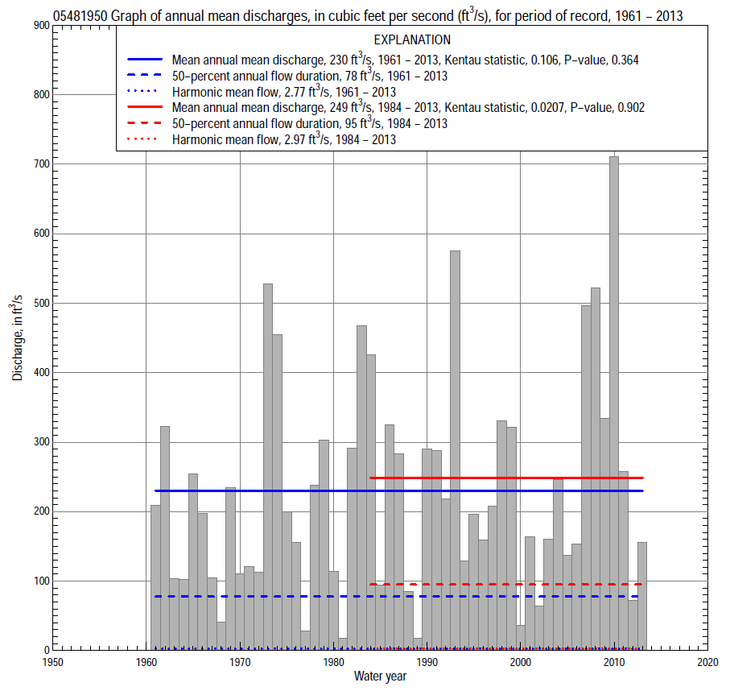

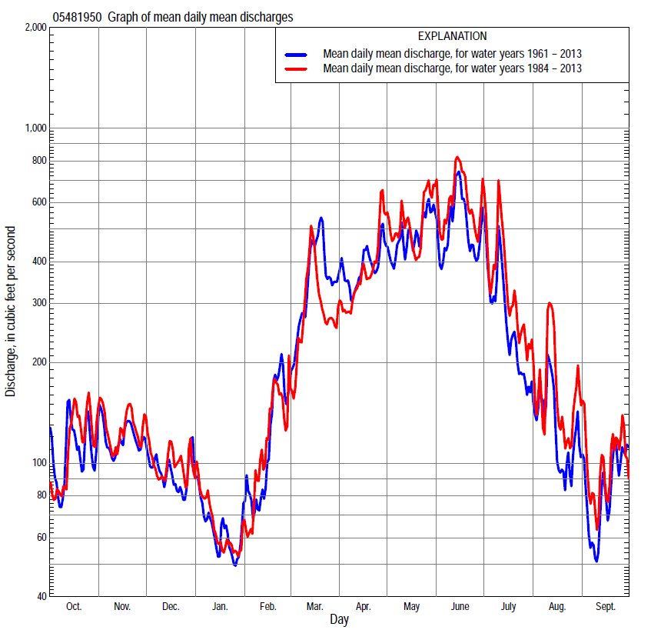

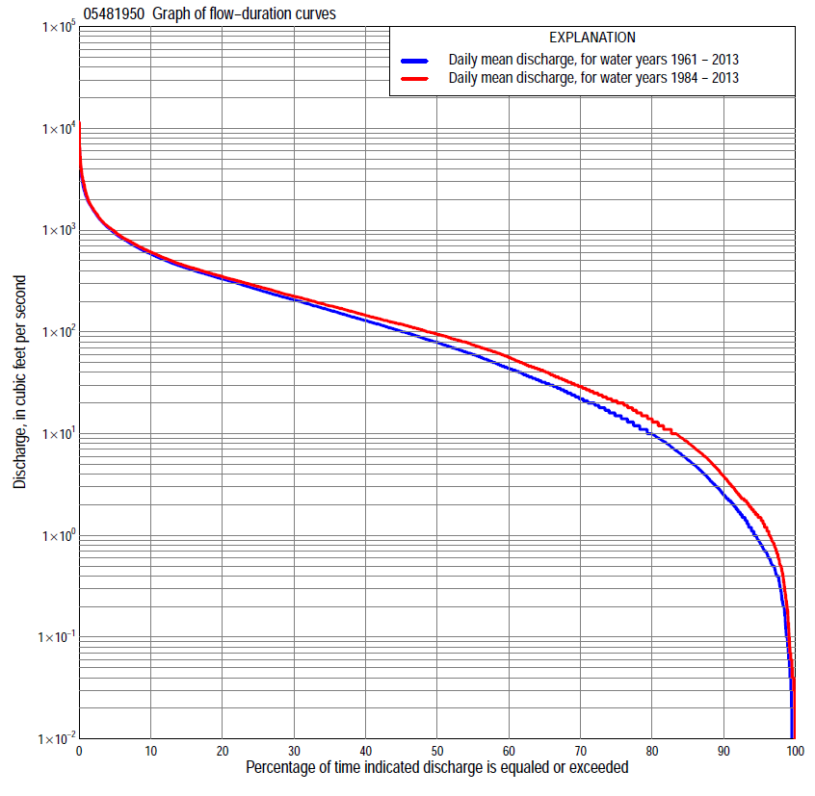

Statistics Based on the Entire Streamflow Period of Record
05481950 Monthly and annual flow durations, based on 1961–2013 period of record (53 years)
Percentage of days discharge equaled or exceeded |  |  |  |  | Discharge (cubic feet per second) |  |  |  |  |  |  |  |  | Annual flow durations
 | Oct | Nov | Dec | Jan | Feb | Mar | Apr | May | June | July | Aug | Sept | Annual | Kentau statistic | P-value
99 | 0.03 | 0.40 | 0.17 | 0.00 | 0.06 | 2.2 | 3.1 | 0.61 | 0.16 | 0.00 | 0.02 | 0.05 | 0.07 | 0.155 | 0.089
98 | 0.04 | 0.54 | 0.50 | 0.06 | 0.40 | 2.8 | 3.9 | 2.3 | 0.59 | 0.31 | 0.06 | 0.10 | 0.28 | 0.171 | 0.061
95 | 0.25 | 1.2 | 0.73 | 0.60 | 0.99 | 7.2 | 7.4 | 5.6 | 16 | 3.1 | 0.66 | 0.26 | 0.85 | 0.162 | 0.082
90 | 0.73 | 3.0 | 1.6 | 1.1 | 2.2 | 16 | 26 | 31 | 52 | 11 | 1.6 | 0.53 | 2.5 | 0.176 | 0.063
85 | 1.5 | 5.0 | 2.3 | 2.1 | 5.2 | 31 | 47 | 64 | 75 | 19 | 3.6 | 0.98 | 5.5 | 0.112 | 0.236
80 | 2.8 | 7.6 | 4.9 | 3.5 | 10 | 45 | 74 | 98 | 99 | 29 | 5.5 | 1.6 | 9.8 | 0.101 | 0.289
75 | 4.6 | 10 | 10 | 5.9 | 15 | 64 | 89 | 147 | 123 | 41 | 7.8 | 2.6 | 15 | 0.095 | 0.318
70 | 6.4 | 14 | 14 | 9.0 | 20 | 87 | 110 | 180 | 156 | 51 | 10 | 4.5 | 22 | 0.104 | 0.276
65 | 9.3 | 17 | 19 | 14 | 24 | 110 | 134 | 208 | 190 | 62 | 13 | 6.0 | 31 | 0.105 | 0.269
60 | 12 | 24 | 23 | 19 | 30 | 137 | 164 | 231 | 220 | 77 | 16 | 7.9 | 43 | 0.114 | 0.231
55 | 15 | 37 | 30 | 22 | 35 | 160 | 200 | 268 | 265 | 95 | 22 | 11 | 60 | 0.118 | 0.214
50 | 19 | 49 | 40 | 29 | 44 | 180 | 244 | 310 | 309 | 112 | 30 | 14 | 78 | 0.120 | 0.208
45 | 26 | 64 | 54 | 34 | 56 | 203 | 283 | 336 | 358 | 135 | 39 | 20 | 100 | 0.128 | 0.179
40 | 36 | 81 | 69 | 42 | 68 | 234 | 321 | 374 | 410 | 166 | 49 | 25 | 128 | 0.137 | 0.149
35 | 53 | 109 | 87 | 54 | 88 | 274 | 365 | 413 | 466 | 204 | 63 | 31 | 161 | 0.114 | 0.231
30 | 71 | 139 | 108 | 72 | 105 | 338 | 420 | 467 | 524 | 245 | 79 | 42 | 205 | 0.126 | 0.187
25 | 103 | 165 | 130 | 85 | 125 | 410 | 480 | 548 | 607 | 308 | 101 | 53 | 258 | 0.139 | 0.145
20 | 153 | 197 | 155 | 104 | 160 | 514 | 562 | 668 | 724 | 359 | 135 | 74 | 329 | 0.136 | 0.154
15 | 250 | 245 | 200 | 125 | 210 | 643 | 673 | 840 | 908 | 461 | 188 | 119 | 421 | 0.110 | 0.247
10 | 329 | 317 | 251 | 158 | 331 | 850 | 846 | 1,100 | 1,160 | 681 | 289 | 218 | 582 | 0.116 | 0.223
5 | 467 | 467 | 341 | 236 | 517 | 1,280 | 1,250 | 1,590 | 1,770 | 1,100 | 583 | 420 | 925 | 0.066 | 0.490
2 | 825 | 682 | 493 | 400 | 850 | 2,150 | 1,950 | 2,230 | 2,820 | 1,660 | 984 | 857 | 1,540 | 0.041 | 0.668
1 | 1,230 | 812 | 672 | 491 | 1,100 | 2,660 | 2,620 | 2,870 | 3,720 | 2,270 | 1,680 | 1,250 | 2,120 | 0.038 | 0.690

05481950 Annual exceedance probability of instantaneous peak discharges, in cubic feet per second (ft³/s), based on the Weighted Independent Estimates method,
Annual exceed-ance probability | Recur-rence interval (years) | Discharge (ft³/s) | 95-percent lower confi-dence interval (ft³/s) | 95-percent upper confi-dence interval (ft³/s)
0.500 | 2 | 2,810 | 2,320 | 3,390
0.200 | 5 | 5,030 | 4,140 | 6,100
0.100 | 10 | 6,750 | 5,440 | 8,370
0.040 | 25 | 9,170 | 7,080 | 11,900
0.020 | 50 | 11,100 | 8,230 | 15,000
0.010 | 100 | 13,200 | 9,370 | 18,600
0.005 | 200 | 15,400 | 10,400 | 22,600
0.002 | 500 | 18,300 | 11,700 | 28,700
and based on the expected moments algorithm/multiple Grubbs-Beck analysis computed using a historical period length of 54 years (1960–2013)
0.500 | 2 | 2,770 | 2,260 | 3,370
0.200 | 5 | 4,890 | 4,010 | 6,100
0.100 | 10 | 6,480 | 5,250 | 8,480
0.040 | 25 | 8,650 | 6,800 | 12,300
0.020 | 50 | 10,400 | 7,890 | 15,900
0.010 | 100 | 12,200 | 8,900 | 20,100
0.005 | 200 | 14,000 | 9,840 | 25,100
0.002 | 500 | 16,600 | 11,000 | 33,000
Kentau statistic |  | -0.031
P-value |  | 0.748
Begin year |  | 1960
End year |  | 2013
Number of peaks |  | 54

05481950 Annual exceedance probability of high discharges, based on 1961–2013 period of record (53 years)
Annual exceedance probability | Recur-rence interval (years) | Maximum average discharge (ft³/s) for indicated number of consecutive days
 |  | 1 | 3 | 7 | 15 | 30
0.990 | 1.01 | 369 | 276 | 189 | 139 | 97
0.950 | 1.05 | 650 | 517 | 374 | 274 | 199
0.900 | 1.11 | 871 | 712 | 526 | 384 | 282
0.800 | 1.25 | 1,230 | 1,030 | 778 | 563 | 416
0.500 | 2 | 2,330 | 2,010 | 1,540 | 1,090 | 800
0.200 | 5 | 4,270 | 3,710 | 2,810 | 1,930 | 1,370
0.100 | 10 | 5,790 | 5,000 | 3,720 | 2,510 | 1,740
0.040 | 25 | 7,940 | 6,760 | 4,920 | 3,250 | 2,180
0.020 | 50 | 9,680 | 8,140 | 5,820 | 3,790 | 2,480
0.010 | 100 | 11,500 | 9,580 | 6,720 | 4,320 | 2,760
0.005 | 200 | 13,500 | 11,100 | 7,610 | 4,830 | 3,020
0.002 | 500 | 16,300 | 13,100 | 8,780 | 5,490 | 3,330
Kentau statistic |  | 0.006 | 0.007 | 0.050 | 0.046 | 0.061
P-value |  | 0.957 | 0.945 | 0.602 | 0.629 | 0.524

 | 05481950 Annual nonexceedance probability of low discharges, based on April 1961 to March 2013 period of record (52 years)
Annual nonexceed-ance probability | Recur-rence interval (years) | Minimum average discharge (ft³/s) for indicated number of consecutive days
 |  | 1 | 3 | 7 | 14 | 30 | 60 | 90 | 120 | 183
0.01 | 100 | 0.00 | 0.00 | 0.00 | 0.00 | 0.00 | 0.05 | 0.11 | 0.22 | 0.29
0.02 | 50 | 0.00 | 0.00 | 0.00 | 0.00 | 0.00 | 0.10 | 0.22 | 0.41 | 0.55
0.05 | 20 | 0.00 | 0.00 | 0.00 | 0.01 | 0.10 | 0.29 | 0.60 | 1.0 | 1.4
0.10 | 10 | 0.02 | 0.03 | 0.07 | 0.10 | 0.32 | 0.69 | 1.4 | 2.2 | 3.1
0.20 | 5 | 0.19 | 0.25 | 0.39 | 0.50 | 1.0 | 1.9 | 3.5 | 5.4 | 7.6
0.50 | 2 | 2.2 | 2.6 | 3.2 | 4.5 | 6.3 | 11 | 18 | 25 | 35
0.80 | 1.25 | 13 | 14 | 16 | 22 | 29 | 47 | 69 | 91 | 130
0.90 | 1.11 | 28 | 30 | 34 | 43 | 60 | 94 | 129 | 166 | 237
0.96 | 1.04 | 58 | 62 | 68 | 78 | 120 | 185 | 235 | 300 | 424
0.98 | 1.02 | 87 | 93 | 103 | 109 | 182 | 277 | 335 | 428 | 597
0.99 | 1.01 | 121 | 132 | 146 | 150 | 258 | 389 | 451 | 576 | 796
Kentau statistic |  | 0.222 | 0.219 | 0.196 | 0.200 | 0.148 | 0.142 | 0.112 | 0.103 | 0.101
P-value |  | 0.020 | 0.023 | 0.041 | 0.037 | 0.124 | 0.140 | 0.246 | 0.287 | 0.294

05481950 Annual nonexceedance probability of seasonal low discharges, based on July 1960 to September 2013 period of record (53–54 years)
Annual nonexceed-ance probability | Recur-rence interval (years) | Minimum average discharge (cubic feet per second) for indicated number of consecutive days
 |  | 1 | 7 | 14 | 30 |  | 1 | 7 | 14 | 30
 |  | January-February-March |  |  |  |  | April-May-June
0.01 | 100 | 0.00 | 0.00 | 0.00 | 0.00 |  | 0.00 | 0.04 | 0.14 | 0.89
0.02 | 50 | 0.00 | 0.01 | 0.02 | 0.04 |  | 0.01 | 0.20 | 0.49 | 2.2
0.05 | 20 | 0.08 | 0.21 | 0.42 | 0.69 |  | 1.2 | 1.4 | 2.5 | 7.2
0.10 | 10 | 0.39 | 0.73 | 1.2 | 1.9 |  | 5.3 | 6.0 | 8.7 | 18
0.20 | 5 | 1.6 | 2.4 | 3.3 | 4.8 |  | 19 | 24 | 30 | 47
0.50 | 2 | 12 | 15 | 16 | 22 |  | 90 | 125 | 143 | 185
0.80 | 1.25 | 51 | 58 | 61 | 78 |  | 212 | 240 | 305 | 428
0.90 | 1.11 | 88 | 104 | 112 | 138 |  | 264 | 267 | 363 | 559
0.96 | 1.04 | 139 | 177 | 201 | 240 |  | 276 | 278 | 395 | 673
0.98 | 1.02 | 175 | 238 | 284 | 334 |  | 279 | 280 | 405 | 728
0.99 | 1.01 | 207 | 302 | 378 | 440 |  | 280 | 281 | 410 | 764
Kentau statistic |  | 0.085 | 0.122 | 0.144 | 0.137 |  | 0.165 | 0.137 | 0.151 | 0.164
P-value |  | 0.373 | 0.200 | 0.131 | 0.149 |  | 0.082 | 0.149 | 0.112 | 0.084
 |  | July-August-September |  |  |  |  | October-November-December
0.01 | 100 | 0.00 | 0.00 | 0.00 | 0.07 |  | 0.00 | 0.00 | 0.01 | 0.06
0.02 | 50 | 0.00 | 0.00 | 0.01 | 0.14 |  | 0.00 | 0.00 | 0.02 | 0.14
0.05 | 20 | 0.00 | 0.06 | 0.10 | 0.36 |  | 0.02 | 0.08 | 0.11 | 0.42
0.10 | 10 | 0.06 | 0.19 | 0.31 | 0.81 |  | 0.17 | 0.32 | 0.38 | 1.1
0.20 | 5 | 0.34 | 0.62 | 0.98 | 2.1 |  | 0.73 | 1.2 | 1.5 | 3.1
0.50 | 2 | 3.1 | 4.4 | 6.3 | 11 |  | 6.3 | 8.9 | 13 | 19
0.80 | 1.25 | 19 | 24 | 32 | 53 |  | 36 | 47 | 64 | 85
0.90 | 1.11 | 44 | 55 | 69 | 111 |  | 79 | 98 | 118 | 167
0.96 | 1.04 | 102 | 122 | 149 | 237 |  | 171 | 199 | 255 | 317
0.98 | 1.02 | 169 | 198 | 238 | 379 |  | 271 | 302 | 382 | 461
0.99 | 1.01 | 261 | 301 | 355 | 569 |  | 398 | 426 | 527 | 629
Kentau statistic |  | 0.151 | 0.135 | 0.126 | 0.062 |  | 0.072 | 0.091 | 0.075 | 0.044
P-value |  | 0.109 | 0.152 | 0.179 | 0.511 |  | 0.452 | 0.338 | 0.434 | 0.651

Statistics Based on the 1984–2013 Streamflow Period of Record
05481950 Monthly and annual flow durations, based on 1984–2013 period of record (30 years)
Percentage of days discharge equaled or exceeded |  |  |  |  | Discharge (cubic feet per second) |  |  |  |  |  |  |  |  | Annual flow durations
 | Oct | Nov | Dec | Jan | Feb | Mar | Apr | May | June | July | Aug | Sept | Annual | Kentau statistic | P-value
99 | 0.04 | 0.19 | 0.06 | 0.08 | 1.2 | 2.5 | 4.0 | 4.7 | 9.4 | 0.39 | 0.02 | 0.06 | 0.15 | 0.117 | 0.359
98 | 0.04 | 1.1 | 0.40 | 0.45 | 1.7 | 3.5 | 6.8 | 14 | 17 | 0.75 | 0.04 | 0.18 | 0.50 | 0.133 | 0.299
95 | 0.68 | 1.8 | 1.4 | 1.7 | 2.5 | 17 | 23 | 32 | 39 | 2.7 | 0.51 | 0.35 | 1.5 | 0.147 | 0.255
90 | 1.2 | 4.3 | 2.1 | 2.5 | 5.5 | 32 | 42 | 66 | 65 | 11 | 1.2 | 0.73 | 3.8 | 0.140 | 0.283
85 | 2.4 | 7.8 | 2.9 | 5.2 | 10 | 40 | 74 | 105 | 84 | 23 | 2.7 | 1.2 | 8.2 | 0.101 | 0.442
80 | 4.1 | 11 | 9.1 | 7.6 | 15 | 50 | 88 | 160 | 109 | 35 | 5.0 | 1.8 | 14 | 0.087 | 0.509
75 | 5.9 | 14 | 14 | 11 | 21 | 73 | 107 | 195 | 145 | 47 | 8.8 | 2.9 | 21 | 0.085 | 0.520
70 | 7.4 | 16 | 19 | 18 | 25 | 94 | 130 | 220 | 190 | 62 | 12 | 4.7 | 29 | 0.041 | 0.762
65 | 10 | 20 | 22 | 21 | 31 | 113 | 157 | 254 | 230 | 79 | 15 | 6.2 | 41 | 0.016 | 0.915
60 | 12 | 27 | 28 | 25 | 43 | 132 | 190 | 299 | 279 | 99 | 22 | 8.5 | 56 | 0.011 | 0.943
55 | 16 | 38 | 36 | 32 | 52 | 151 | 222 | 333 | 326 | 120 | 32 | 12 | 74 | -0.002 | 1.000
50 | 21 | 50 | 51 | 40 | 64 | 167 | 253 | 367 | 375 | 143 | 42 | 15 | 95 | -0.048 | 0.721
45 | 28 | 73 | 69 | 49 | 78 | 182 | 283 | 403 | 426 | 178 | 54 | 22 | 119 | -0.041 | 0.762
40 | 37 | 105 | 94 | 60 | 91 | 204 | 318 | 438 | 473 | 213 | 69 | 28 | 146 | -0.021 | 0.887
35 | 51 | 135 | 109 | 74 | 103 | 232 | 358 | 489 | 528 | 252 | 83 | 34 | 180 | -0.018 | 0.901
30 | 78 | 161 | 126 | 84 | 114 | 260 | 412 | 562 | 600 | 312 | 103 | 47 | 224 | -0.007 | 0.972
25 | 124 | 185 | 141 | 98 | 130 | 308 | 465 | 649 | 680 | 361 | 134 | 59 | 280 | 0.044 | 0.748
20 | 187 | 222 | 170 | 112 | 155 | 373 | 550 | 759 | 830 | 448 | 171 | 79 | 351 | 0.041 | 0.762
15 | 280 | 261 | 211 | 125 | 184 | 495 | 647 | 918 | 1,040 | 613 | 241 | 155 | 442 | 0.016 | 0.915
10 | 343 | 316 | 257 | 145 | 268 | 643 | 792 | 1,150 | 1,390 | 871 | 369 | 303 | 611 | 0.030 | 0.830
5 | 472 | 431 | 331 | 190 | 440 | 901 | 1,110 | 1,630 | 2,120 | 1,270 | 679 | 538 | 964 | 0.087 | 0.509
2 | 741 | 697 | 471 | 284 | 782 | 1,580 | 1,690 | 2,310 | 3,360 | 1,930 | 1,290 | 1,040 | 1,590 | 0.080 | 0.544
1 | 1,230 | 829 | 608 | 430 | 880 | 2,350 | 2,320 | 3,080 | 4,260 | 3,620 | 2,100 | 1,310 | 2,240 | 0.113 | 0.392

05481950 Annual exceedance probability of high discharges, based on 1984–2013 period of record (30 years)
Annual exceedance probability | Recur-rence interval (years) | Maximum average discharge (ft³/s) for indicated number of consecutive days
 |  | 1 | 3 | 7 | 15 | 30
0.990 | 1.01 | 289 | 219 | 160 | 118 | 85
0.950 | 1.05 | 537 | 431 | 326 | 240 | 181
0.900 | 1.11 | 743 | 610 | 467 | 344 | 263
0.800 | 1.25 | 1,100 | 920 | 712 | 519 | 399
0.500 | 2 | 2,270 | 1,960 | 1,510 | 1,080 | 808
0.200 | 5 | 4,620 | 3,990 | 3,010 | 2,060 | 1,460
0.100 | 10 | 6,650 | 5,700 | 4,210 | 2,820 | 1,900
0.040 | 25 | 9,740 | 8,230 | 5,910 | 3,840 | 2,450
0.020 | 50 | 12,400 | 10,400 | 7,290 | 4,630 | 2,840
0.010 | 100 | 15,400 | 12,700 | 8,740 | 5,450 | 3,210
0.005 | 200 | 18,800 | 15,300 | 10,300 | 6,280 | 3,550
0.002 | 500 | 23,800 | 19,000 | 12,400 | 7,400 | 3,990
Kentau statistic |  | 0.076 | 0.090 | 0.131 | 0.136 | 0.131
P-value |  | 0.568 | 0.498 | 0.318 | 0.301 | 0.318

 | 05481950 Annual nonexceedance probability of low discharges, based on April 1983 to March 2013 period of record (30 years)
Annual nonexceed-ance probability | Recur-rence interval (years) | Minimum average discharge (ft³/s) for indicated number of consecutive days
 |  | 1 | 3 | 7 | 14 | 30 | 60 | 90 | 120 | 183
0.01 | 100 | 0.00 | 0.01 | 0.01 | 0.02 | 0.03 | 0.10 | 0.15 | 0.30 | 0.36
0.02 | 50 | 0.01 | 0.02 | 0.02 | 0.04 | 0.07 | 0.21 | 0.32 | 0.58 | 0.72
0.05 | 20 | 0.05 | 0.06 | 0.09 | 0.15 | 0.23 | 0.59 | 0.93 | 1.5 | 1.9
0.10 | 10 | 0.15 | 0.19 | 0.26 | 0.40 | 0.60 | 1.4 | 2.2 | 3.2 | 4.3
0.20 | 5 | 0.54 | 0.64 | 0.83 | 1.2 | 1.7 | 3.4 | 5.8 | 7.7 | 10
0.50 | 2 | 4.3 | 4.7 | 5.6 | 7.4 | 10 | 16 | 26 | 32 | 46
0.80 | 1.25 | 21 | 23 | 25 | 30 | 39 | 57 | 81 | 103 | 151
0.90 | 1.11 | 41 | 44 | 47 | 53 | 70 | 99 | 127 | 171 | 256
0.96 | 1.04 | 74 | 81 | 82 | 88 | 119 | 166 | 189 | 274 | 415
0.98 | 1.02 | 101 | 112 | 114 | 116 | 160 | 223 | 233 | 358 | 548
0.99 | 1.01 | 130 | 136 | 140 | 144 | 204 | 283 | 285 | 446 | 686
Kentau statistic |  | 0.092 | 0.085 | 0.071 | 0.062 | 0.034 | 0.057 | -0.011 | 0.016 | -0.002
P-value |  | 0.486 | 0.521 | 0.592 | 0.643 | 0.803 | 0.669 | 0.943 | 0.915 | 1.000

05481950 Annual nonexceedance probability of seasonal low discharges, based on October 1983 to September 2013 period of record (30 years)
Annual nonexceed-ance probability | Recur-rence interval (years) | Minimum average discharge (cubic feet per second) for indicated number of consecutive days
 |  | 1 | 7 | 14 | 30 |  | 1 | 7 | 14 | 30
 |  | January-February-March |  |  |  |  | April-May-June
0.01 | 100 | 0.03 | 0.04 | 0.26 | 0.48 |  | 0.83 | 1.7 | 3.0 | 5.1
0.02 | 50 | 0.09 | 0.12 | 0.50 | 0.90 |  | 1.8 | 3.3 | 5.4 | 9.0
0.05 | 20 | 0.35 | 0.47 | 1.3 | 2.1 |  | 5.4 | 8.4 | 12 | 19
0.10 | 10 | 1.0 | 1.4 | 2.7 | 4.3 |  | 13 | 17 | 23 | 36
0.20 | 5 | 3.1 | 4.3 | 6.2 | 9.2 |  | 30 | 37 | 47 | 71
0.50 | 2 | 17 | 23 | 24 | 32 |  | 106 | 118 | 144 | 210
0.80 | 1.25 | 56 | 69 | 70 | 83 |  | 231 | 259 | 327 | 470
0.90 | 1.11 | 87 | 100 | 110 | 124 |  | 297 | 344 | 452 | 652
0.96 | 1.04 | 122 | 132 | 164 | 177 |  | 355 | 430 | 596 | 865
0.98 | 1.02 | 144 | 150 | 205 | 215 |  | 383 | 479 | 688 | 1,010
0.99 | 1.01 | 162 | 163 | 245 | 250 |  | 402 | 516 | 768 | 1,130
Kentau statistic |  | -0.094 | -0.039 | -0.016 | -0.005 |  | 0.041 | 0.044 | 0.057 | 0.103
P-value |  | 0.475 | 0.775 | 0.915 | 0.986 |  | 0.762 | 0.748 | 0.669 | 0.432
 |  | July-August-September |  |  |  |  | October-November-December
0.01 | 100 | 0.00 | 0.01 | 0.03 | 0.08 |  | 0.01 | 0.02 | 0.02 | 0.05
0.02 | 50 | 0.01 | 0.03 | 0.06 | 0.16 |  | 0.03 | 0.04 | 0.05 | 0.13
0.05 | 20 | 0.04 | 0.10 | 0.18 | 0.41 |  | 0.11 | 0.16 | 0.21 | 0.46
0.10 | 10 | 0.14 | 0.28 | 0.46 | 0.93 |  | 0.31 | 0.49 | 0.66 | 1.3
0.20 | 5 | 0.52 | 0.89 | 1.3 | 2.4 |  | 1.0 | 1.7 | 2.2 | 3.9
0.50 | 2 | 4.9 | 6.6 | 8.7 | 14 |  | 7.6 | 12 | 16 | 24
0.80 | 1.25 | 32 | 38 | 45 | 67 |  | 41 | 56 | 71 | 94
0.90 | 1.11 | 76 | 83 | 99 | 147 |  | 87 | 108 | 131 | 165
0.96 | 1.04 | 174 | 181 | 214 | 330 |  | 179 | 194 | 225 | 271
0.98 | 1.02 | 283 | 288 | 342 | 546 |  | 266 | 267 | 301 | 355
0.99 | 1.01 | 424 | 425 | 510 | 846 |  | 344 | 345 | 377 | 437
Kentau statistic |  | 0.071 | 0.053 | 0.048 | 0.021 |  | 0.030 | 0.057 | 0.030 | -0.048
P-value |  | 0.592 | 0.695 | 0.721 | 0.887 |  | 0.830 | 0.669 | 0.830 | 0.721

