LOCATION.--Lat 41°36'45", long 93°37'15" referenced to North American Datum of 1927, in SE 1/4 NE 1/4 NE 1/4 sec.34, T.79 N., R.24 W., Polk County, IA, Hydrologic Unit 07100004, on right bank 5 ft upstream from bridge on State Highway 60 (2nd Avenue) in Des Moines, 1.8 mi upstream from Center Street dam, 2.8 mi upstream from Raccoon River, 4.5 mi downstream from Beaver Creek, and 195.9 mi upstream from mouth.

DRAINAGE AREA.--6,245 mi².

PERIOD OF RECORD.--Gage heights and discharge measurements, October 1902 to August 1903, October 1914 to February 1915; discharge records from March 1915 to September 1961, October 1996 to current year.

GAGE.--Water-stage recorder. Datum of gage is 773.74 ft above National Geodetic Vertical Datum of 1929, and 0.10 ft below City of Des Moines datum (revised). October 2, 1902, to August 3, 1903, non-recording gage at site 2.1 mi downstream at Walnut Street bridge at datum 0.10 ft higher; May 24, 1905, to July 20, 1906, non-recording gage at site 1.9 mi upstream at Interurban Trail bridge at datum 0.10 ft higher; January 1912 to September 30, 1927, water-stage recorder at site 2.1 mi downstream at Walnut Street bridge at datum 0.10 ft higher; October 1, 1932, to September 30, 1938, water-stage recorder at site 2.1 mi downstream at Walnut Street bridge at same datum; October 1, 1938, to August 29, 1939, non-recording gage at site 1.8 mi downstream at Center Street dam at same datum (used as auxiliary gage from February 13, 1934, to September 30, 1938); August 30, 1939, to August 20, 1941, water-stage recorder at site 1.8 mi downstream at Center Street dam at same datum.

REMARKS.--Flow regulated by Saylorville Lake (station 05481630), 6.8 mi upstream, since April 12, 1977.

A summary of all available data for this streamgage is provided through the USGS National Water Information System web interface (NWISWeb). The following link provides access to current/historical observations, daily data, daily statistics, monthly statistics, annual statistics, peak streamflow, field measurements, field/lab water-quality samples, and the latest water-year summaries. Data can be filtered by parameter and/or dates, and can be output in various tabular and graphical formats.
http://waterdata.usgs.gov/nwis/inventory/?site_no=05482000

The USGS WaterWatch Toolkit is available at:
http://waterwatch.usgs.gov/?id=ww_toolkit
Tools for summarizing streamflow information include the duration hydrograph builder, the cumulative streamflow hydrograph builder, the streamgage statistics retrieval tool, the rating curve builder, the flood tracking chart builder, the National Weather Service Advanced Hydrologic Prediction Service (AHPS) river forecast hydrograph builder, and the raster-hydrograph builder. Entering the above number for this streamgage into these toolkit webpages will provide streamflow information specific to this streamgage.

A description of the statistics presented for this streamgage is available in the main body of the report at:
http://dx.doi.org/10.3133/ofr20151214
A link to other streamgages included in this report, a map showing the location of the streamgages, information on the programs used to compute the statistical analyses, and references are included in the main body of the report.

Statistics Based on the Pre-regulated Streamflow Period of Record

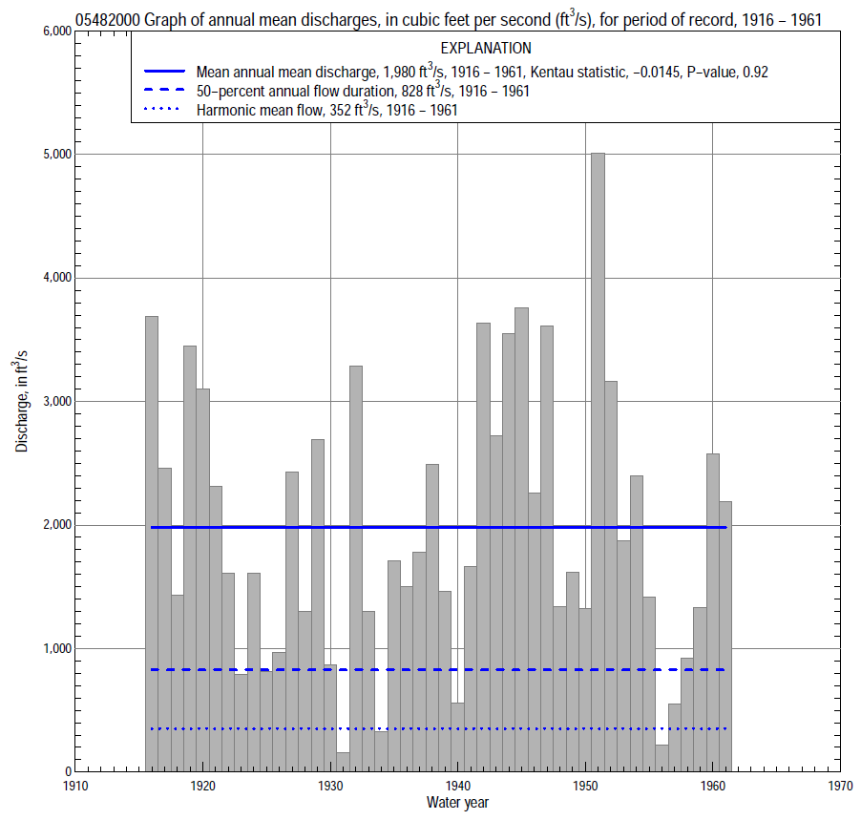

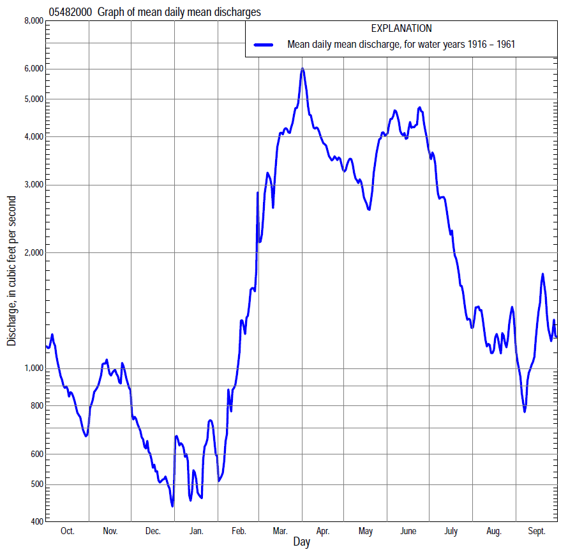

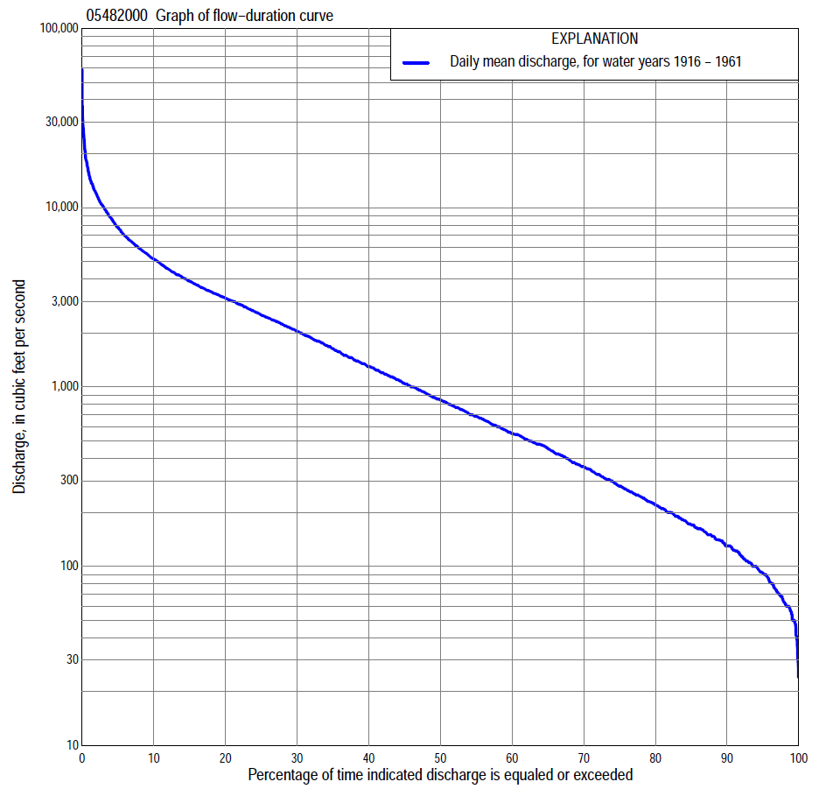

Statistics Based on the Pre-regulated Streamflow Period of Record
05482000 Monthly and annual flow durations, based on 1916–61 pre-regulated period of record (46 years)
Percentage of days discharge equaled or exceeded |  |  |  |  | Discharge (cubic feet per second) |  |  |  |  |  |  |  |  | Annual flow durations
 | Oct | Nov | Dec | Jan | Feb | Mar | Apr | May | June | July | Aug | Sept | Annual | Kentau statistic | P-value
99 | 62 | 72 | 57 | 30 | 38 | 107 | 186 | 141 | 98 | 80 | 50 | 50 | 54 | -0.137 | 0.182
98 | 68 | 81 | 60 | 47 | 47 | 123 | 246 | 162 | 141 | 94 | 67 | 57 | 63 | -0.167 | 0.103
95 | 93 | 97 | 74 | 55 | 64 | 165 | 413 | 264 | 264 | 157 | 87 | 70 | 91 | -0.146 | 0.155
90 | 121 | 128 | 93 | 66 | 88 | 315 | 675 | 420 | 534 | 262 | 150 | 110 | 130 | -0.142 | 0.167
85 | 142 | 150 | 116 | 90 | 107 | 498 | 885 | 645 | 688 | 347 | 210 | 156 | 170 | -0.146 | 0.155
80 | 167 | 182 | 140 | 100 | 139 | 769 | 1,070 | 907 | 860 | 466 | 255 | 198 | 218 | -0.156 | 0.130
75 | 186 | 212 | 150 | 115 | 170 | 945 | 1,340 | 1,130 | 1,110 | 599 | 305 | 237 | 276 | -0.148 | 0.150
70 | 210 | 262 | 170 | 130 | 200 | 1,240 | 1,640 | 1,340 | 1,300 | 743 | 350 | 265 | 352 | -0.157 | 0.127
65 | 234 | 305 | 199 | 145 | 250 | 1,500 | 1,880 | 1,490 | 1,580 | 860 | 398 | 294 | 442 | -0.171 | 0.096
60 | 270 | 348 | 230 | 170 | 336 | 1,940 | 2,140 | 1,760 | 1,920 | 985 | 448 | 325 | 544 | -0.179 | 0.081
55 | 325 | 414 | 270 | 197 | 420 | 2,190 | 2,430 | 2,040 | 2,230 | 1,130 | 500 | 368 | 670 | -0.133 | 0.195
50 | 410 | 479 | 348 | 220 | 505 | 2,500 | 2,700 | 2,320 | 2,620 | 1,260 | 560 | 442 | 828 | -0.105 | 0.306
45 | 490 | 522 | 400 | 266 | 628 | 2,850 | 3,090 | 2,580 | 3,020 | 1,470 | 641 | 532 | 1,020 | -0.098 | 0.344
40 | 572 | 570 | 459 | 318 | 753 | 3,110 | 3,450 | 2,900 | 3,370 | 1,750 | 735 | 615 | 1,260 | -0.069 | 0.507
35 | 688 | 685 | 502 | 380 | 955 | 3,500 | 3,850 | 3,290 | 3,880 | 2,090 | 855 | 748 | 1,570 | -0.064 | 0.538
30 | 863 | 830 | 595 | 484 | 1,140 | 4,000 | 4,440 | 3,710 | 4,570 | 2,380 | 1,040 | 915 | 1,970 | -0.057 | 0.583
25 | 1,120 | 1,020 | 700 | 613 | 1,390 | 4,660 | 5,170 | 4,210 | 5,300 | 2,800 | 1,300 | 1,120 | 2,430 | -0.044 | 0.670
20 | 1,410 | 1,370 | 856 | 750 | 1,650 | 5,650 | 5,860 | 4,800 | 6,200 | 3,260 | 1,730 | 1,400 | 3,030 | -0.035 | 0.740
15 | 1,820 | 1,680 | 1,130 | 928 | 2,040 | 6,600 | 7,030 | 5,670 | 7,690 | 4,020 | 2,270 | 1,910 | 3,760 | -0.001 | 1.000
10 | 2,430 | 2,300 | 1,460 | 1,240 | 2,800 | 8,830 | 9,000 | 6,790 | 9,540 | 4,870 | 3,040 | 2,800 | 5,040 | 0.011 | 0.925
5 | 3,580 | 3,560 | 2,160 | 2,100 | 3,950 | 12,400 | 12,400 | 9,000 | 13,000 | 7,220 | 4,100 | 4,030 | 7,530 | 0.024 | 0.820
2 | 4,730 | 5,930 | 2,890 | 5,100 | 6,650 | 15,300 | 17,800 | 13,200 | 18,700 | 11,900 | 5,380 | 7,040 | 11,800 | 0.037 | 0.726
1 | 5,380 | 7,300 | 3,190 | 5,920 | 9,400 | 18,400 | 23,600 | 16,800 | 25,500 | 15,900 | 6,840 | 9,000 | 14,900 | 0.046 | 0.656

05482000 Annual exceedance probability of instantaneous peak discharges, in cubic feet per second (ft³/s), for the pre-regulated period of record based on the expected moments algorithm/multiple Grubbs-Beck analysis computed using a historical period length of 75 years (1902–1976)ª
Annual exceed-ance probability | Recur-rence interval (years) | Discharge (ft³/s) | 95-percent lower confi-dence interval (ft³/s) | 95-percent upper confi-dence interval (ft³/s)
0.500 | 2 | 14,400 | 11,800 | 17,100
0.200 | 5 | 24,100 | 20,100 | 28,800
0.100 | 10 | 31,000 | 25,800 | 38,000
0.040 | 25 | 40,100 | 32,800 | 52,100
0.020 | 50 | 47,000 | 37,700 | 64,700
0.010 | 100 | 53,900 | 42,100 | 79,300
0.005 | 200 | 60,900 | 46,200 | 96,000
0.002 | 500 | 70,300 | 51,100 | 122,000
Kentau statistic |  | 0.037
P-value |  | 0.721
Begin year |  | 1915
End year |  | 1961
Number of peaks |  | 47
ªWeighted Independent Estimates were not computed because regional regression equations are not applicable due to size of drainage area.
Note: The above discharges are for the pre-regulated period of record and they are not applicable for flood-plain management regulation or for design purposes.

05482000 Annual exceedance probability of high discharges, based on 1916–61 pre-regulated period of record (46 years)
Annual exceed-ance probability | Recur-rence interval (years) | Maximum average discharge (cubic feet per second) for indicated number of consecutive days
 |  | 1 | 3 | 7 | 15 | 30
0.990 | 1.01 | 1,440 | 1,290 | 1,110 | 799 | 501
0.950 | 1.05 | 3,170 | 2,910 | 2,540 | 1,940 | 1,360
0.900 | 1.11 | 4,630 | 4,280 | 3,770 | 2,920 | 2,130
0.800 | 1.25 | 7,030 | 6,560 | 5,790 | 4,560 | 3,430
0.500 | 2 | 14,000 | 13,200 | 11,500 | 9,100 | 6,980
0.200 | 5 | 24,100 | 22,800 | 19,500 | 15,000 | 11,200
0.100 | 10 | 30,400 | 28,800 | 24,200 | 18,300 | 13,300
0.040 | 25 | 37,600 | 35,600 | 29,300 | 21,600 | 15,100
0.020 | 50 | 42,400 | 40,100 | 32,500 | 23,500 | 16,100
0.010 | 100 | 46,600 | 44,000 | 35,300 | 25,100 | 16,800
0.005 | 200 | 50,400 | 47,600 | 37,600 | 26,300 | 17,300
0.002 | 500 | 54,800 | 51,600 | 40,200 | 27,600 | 17,700
Kentau statistic |  | 0.094 | 0.090 | 0.051 | 0.033 | 0.040
P-value |  | 0.363 | 0.384 | 0.622 | 0.755 | 0.705
Note: The above discharges are for the pre-regulated period of record and they are not applicable for flood-plain management regulation or for design purposes.

 | 05482000 Annual nonexceedance probability of low discharges, based on April 1915 to March 1961 pre-regulated period of record (46 years)
Annual nonexceed-ance probability | Recur-rence interval (years) | Minimum average discharge (cubic feet per second) for indicated number of consecutive days
 |  | 1 | 3 | 7 | 14 | 30 | 60 | 90 | 120 | 183
0.01 | 100 | 22 | 23 | 25 | 27 | 30 | 38 | 44 | 48 | 52
0.02 | 50 | 25 | 27 | 29 | 32 | 36 | 44 | 53 | 59 | 67
0.05 | 20 | 32 | 34 | 36 | 40 | 46 | 58 | 71 | 81 | 98
0.10 | 10 | 40 | 42 | 45 | 51 | 59 | 75 | 93 | 109 | 138
0.20 | 5 | 54 | 57 | 61 | 68 | 80 | 103 | 132 | 157 | 210
0.50 | 2 | 102 | 107 | 115 | 128 | 154 | 203 | 266 | 326 | 468
0.80 | 1.25 | 212 | 221 | 238 | 262 | 320 | 435 | 569 | 708 | 1,040
0.90 | 1.11 | 323 | 338 | 363 | 396 | 486 | 668 | 866 | 1,080 | 1,590
0.96 | 1.04 | 521 | 547 | 587 | 633 | 779 | 1,080 | 1,380 | 1,730 | 2,490
0.98 | 1.02 | 722 | 762 | 816 | 870 | 1,070 | 1,510 | 1,890 | 2,360 | 3,340
0.99 | 1.01 | 979 | 1,040 | 1,110 | 1,170 | 1,440 | 2,040 | 2,510 | 3,130 | 4,330
Kentau statistic |  | -0.089 | -0.104 | -0.104 | -0.111 | -0.106 | -0.132 | -0.167 | -0.198 | -0.167
P-value |  | 0.389 | 0.311 | 0.311 | 0.280 | 0.302 | 0.198 | 0.103 | 0.053 | 0.103

05482000 Annual nonexceedance probability of seasonal low discharges, based on April 1915 to September 1961 pre-regulated period of record (46–47 years)
Annual nonexceed-ance probability | Recur-rence interval (years) | Minimum average discharge (cubic feet per second) for indicated number of consecutive days
 |  | 1 | 7 | 14 | 30 |  | 1 | 7 | 14 | 30
 |  | January-February-March |  |  |  |  | April-May-June
0.01 | 100 | 21 | 23 | 25 | 28 |  | 48 | 58 | 66 | 101
0.02 | 50 | 25 | 28 | 31 | 34 |  | 73 | 88 | 100 | 148
0.05 | 20 | 35 | 39 | 42 | 47 |  | 133 | 157 | 179 | 254
0.10 | 10 | 46 | 52 | 57 | 63 |  | 217 | 253 | 289 | 399
0.20 | 5 | 67 | 76 | 82 | 94 |  | 375 | 431 | 493 | 663
0.50 | 2 | 144 | 164 | 178 | 214 |  | 922 | 1,040 | 1,200 | 1,570
0.80 | 1.25 | 330 | 377 | 418 | 549 |  | 1,890 | 2,120 | 2,470 | 3,260
0.90 | 1.11 | 524 | 598 | 674 | 939 |  | 2,570 | 2,890 | 3,400 | 4,520
0.96 | 1.04 | 876 | 998 | 1,150 | 1,720 |  | 3,410 | 3,850 | 4,570 | 6,190
0.98 | 1.02 | 1,240 | 1,410 | 1,640 | 2,610 |  | 3,990 | 4,530 | 5,400 | 7,440
0.99 | 1.01 | 1,700 | 1,930 | 2,290 | 3,830 |  | 4,540 | 5,170 | 6,200 | 8,670
Kentau statistic |  | -0.152 | -0.149 | -0.151 | -0.130 |  | -0.013 | -0.003 | 0.014 | 0.006
P-value |  | 0.139 | 0.147 | 0.142 | 0.205 |  | 0.905 | 0.985 | 0.898 | 0.956
 |  | July-August-September |  |  |  |  | October-November-December
0.01 | 100 | 32 | 33 | 35 | 41 |  | 28 | 40 | 45 | 48
0.02 | 50 | 38 | 40 | 44 | 52 |  | 33 | 46 | 51 | 57
0.05 | 20 | 51 | 55 | 61 | 75 |  | 43 | 58 | 64 | 74
0.10 | 10 | 68 | 75 | 84 | 104 |  | 56 | 72 | 80 | 95
0.20 | 5 | 98 | 110 | 125 | 158 |  | 77 | 97 | 107 | 131
0.50 | 2 | 214 | 246 | 282 | 370 |  | 150 | 183 | 204 | 264
0.80 | 1.25 | 520 | 596 | 687 | 922 |  | 314 | 383 | 436 | 592
0.90 | 1.11 | 863 | 981 | 1,130 | 1,530 |  | 474 | 589 | 679 | 942
0.96 | 1.04 | 1,530 | 1,710 | 1,960 | 2,670 |  | 752 | 964 | 1,130 | 1,600
0.98 | 1.02 | 2,270 | 2,490 | 2,830 | 3,870 |  | 1,030 | 1,350 | 1,610 | 2,300
0.99 | 1.01 | 3,260 | 3,530 | 3,980 | 5,440 |  | 1,370 | 1,860 | 2,230 | 3,220
Kentau statistic |  | -0.054 | -0.054 | -0.067 | -0.029 |  | -0.158 | -0.156 | -0.156 | -0.175
P-value |  | 0.601 | 0.601 | 0.515 | 0.783 |  | 0.123 | 0.130 | 0.130 | 0.088

Statistics Based on the Regulated Streamflow Period of Record

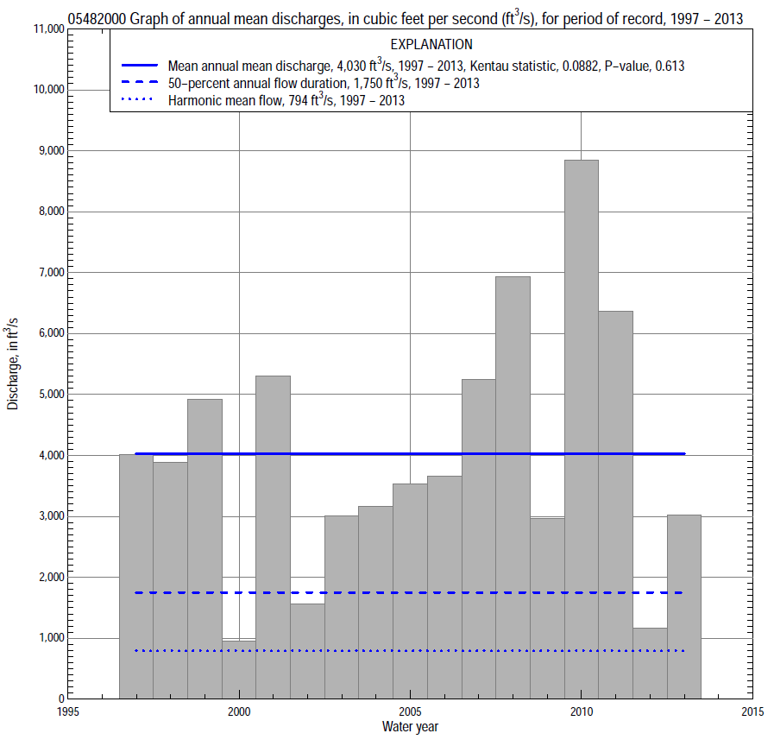

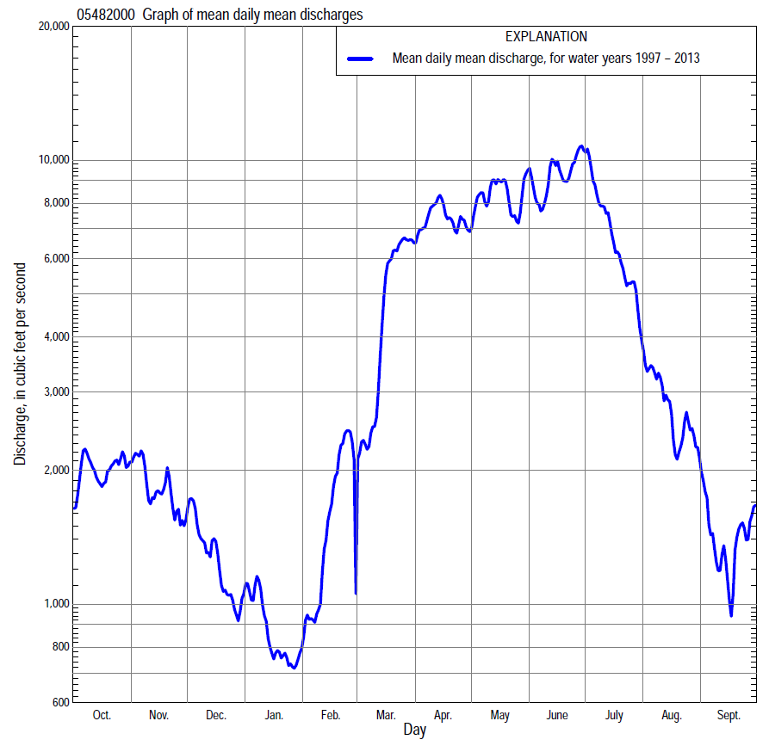

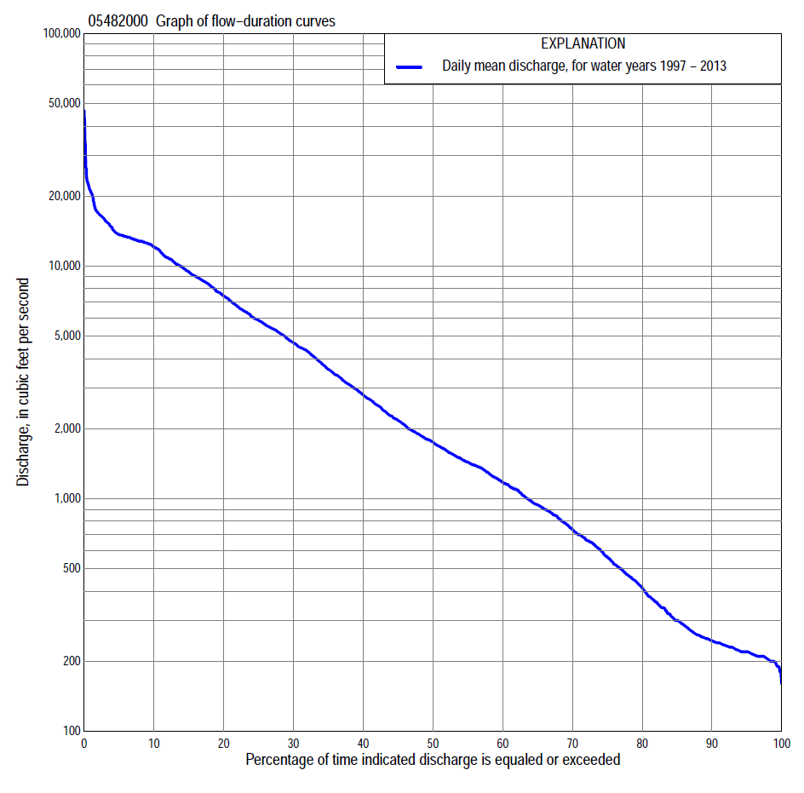
Statistics Based on the Regulated Streamflow Period of Record
05482000 Monthly and annual flow durations, based on 1997–2013 regulated period of record (17 years)
Percentage of days discharge equaled or exceeded |  |  |  |  | Discharge (cubic feet per second) |  |  |  |  |  |  |  |  | Annual flow durations
 | Oct | Nov | Dec | Jan | Feb | Mar | Apr | May | June | July | Aug | Sept | Annual | Kentau statistic | P-value
99 | 190 | 195 | 190 | 180 | 186 | 210 | 341 | 210 | 1,670 | 358 | 243 | 187 | 199 | 0.265 | 0.149
98 | 200 | 199 | 203 | 200 | 190 | 220 | 352 | 270 | 1,900 | 391 | 249 | 196 | 204 | 0.265 | 0.149
95 | 207 | 207 | 220 | 227 | 203 | 265 | 432 | 1,640 | 2,430 | 660 | 281 | 205 | 220 | 0.228 | 0.216
90 | 210 | 215 | 240 | 235 | 220 | 449 | 1,210 | 2,690 | 2,910 | 981 | 422 | 214 | 245 | 0.221 | 0.232
85 | 217 | 223 | 250 | 250 | 231 | 742 | 1,480 | 3,460 | 3,430 | 1,210 | 521 | 226 | 300 | 0.184 | 0.322
80 | 220 | 237 | 300 | 258 | 250 | 1,000 | 2,000 | 4,370 | 3,930 | 1,640 | 660 | 244 | 413 | 0.176 | 0.343
75 | 235 | 286 | 420 | 280 | 286 | 1,180 | 2,510 | 5,100 | 4,440 | 2,000 | 737 | 259 | 561 | 0.169 | 0.364
70 | 273 | 339 | 514 | 320 | 340 | 1,350 | 3,110 | 5,790 | 4,910 | 2,560 | 800 | 280 | 739 | 0.118 | 0.537
65 | 299 | 494 | 658 | 374 | 470 | 1,530 | 3,880 | 6,240 | 5,390 | 3,340 | 866 | 340 | 941 | 0.140 | 0.458
60 | 346 | 785 | 831 | 436 | 588 | 1,880 | 4,480 | 7,050 | 6,000 | 4,280 | 963 | 379 | 1,180 | 0.140 | 0.458
55 | 511 | 946 | 928 | 486 | 700 | 2,240 | 5,230 | 7,640 | 6,910 | 5,150 | 1,090 | 446 | 1,440 | 0.147 | 0.434
50 | 595 | 1,160 | 1,020 | 613 | 874 | 2,690 | 6,610 | 8,410 | 7,800 | 5,810 | 1,210 | 499 | 1,750 | 0.103 | 0.592
45 | 796 | 1,340 | 1,180 | 664 | 1,010 | 3,070 | 7,980 | 8,790 | 8,970 | 6,430 | 1,370 | 552 | 2,170 | 0.118 | 0.537
40 | 964 | 1,440 | 1,410 | 719 | 1,160 | 3,470 | 8,790 | 9,190 | 10,100 | 6,950 | 1,510 | 610 | 2,790 | 0.132 | 0.484
35 | 1,260 | 1,640 | 1,580 | 900 | 1,320 | 4,110 | 9,810 | 9,800 | 12,000 | 7,890 | 1,780 | 679 | 3,600 | 0.088 | 0.650
30 | 1,580 | 1,800 | 1,720 | 1,150 | 1,440 | 4,670 | 10,700 | 10,700 | 12,600 | 9,390 | 2,200 | 849 | 4,680 | 0.147 | 0.434
25 | 2,150 | 2,110 | 1,850 | 1,300 | 1,810 | 5,390 | 12,100 | 11,700 | 12,800 | 10,400 | 2,690 | 1,010 | 5,850 | 0.088 | 0.650
20 | 3,040 | 2,710 | 2,000 | 1,480 | 2,570 | 6,490 | 12,800 | 12,800 | 13,200 | 11,700 | 3,770 | 1,440 | 7,430 | -0.015 | 0.967
15 | 4,460 | 3,590 | 2,220 | 1,650 | 3,070 | 10,000 | 13,400 | 13,300 | 13,500 | 12,500 | 5,260 | 2,920 | 9,460 | 0.015 | 0.967
10 | 6,560 | 4,790 | 2,560 | 1,870 | 4,400 | 12,400 | 15,100 | 13,700 | 14,200 | 13,300 | 6,540 | 5,170 | 12,100 | 0.132 | 0.484
5 | 9,550 | 6,870 | 3,000 | 2,290 | 5,890 | 16,900 | 16,200 | 15,300 | 20,600 | 18,800 | 14,000 | 6,700 | 13,700 | 0.162 | 0.387
2 | 10,900 | 8,990 | 3,790 | 3,060 | 7,780 | 21,400 | 17,500 | 16,500 | 26,500 | 22,100 | 17,200 | 8,980 | 16,900 | 0.088 | 0.650
1 | 13,600 | 9,840 | 4,280 | 3,960 | 9,680 | 22,300 | 17,900 | 16,800 | 37,900 | 26,400 | 20,200 | 10,200 | 20,700 | 0.059 | 0.773

05482000 Annual exceedance probability of instantaneous peak discharges, in cubic feet per second (ft³/s), based on U.S. Army Corps of Engineers regulated flow frequency studyª, analysis computed using a record length of 92 years (1917–2008)
USACE Regulated Flow Frequency Analysis
[ND, not determined]
Annual exceedance probability | Recurrence interval (years) | Discharge (ft³/s) | 95-percent lower confidence interval (ft³/s) | 95-percent upper confidence interval (ft³/s)
0.500 | 2 | 13,100 | ND | ND
0.200 | 5 | ND | ND | ND
0.100 | 10 | 19,500 | ND | ND
0.040 | 25 | ND | ND | ND
0.020 | 50 | 48,500 | ND | ND
0.010 | 100 | 57,200 | ND | ND
0.005 | 200 | 66,200 | ND | ND
0.002 | 500 | 78,900 | ND | ND
ªU.S. Army Corps of Engineers, 2010, Des Moines River regulated flow frequency study: Rock Island District, 82 p., acessed September 9, 2014, at http://www.mvr.usace.army.mil/Portals/48/docs/FRM/DMRRFFS/DMRRFFS-FinalReport.pdf.
USGS Kendall's Tau Trend Analysis
Kentau statistic |  | 0.088
P-value |  | 0.650
Begin year |  | ^{b}1997
End year |  | ^{b}2013
Number of peaks |  | 17
^{b}Kendalls's tau trend analysis computed using the regulated period of record which is not the same period of record used to compute the above regulated flow frequency analysis

05482000 Annual exceedance probability of high discharges, based on 1997–2013 regulated period of recordª (17 years)
[ND, not determined]
Annual exceedance probability | Recur-rence interval (years) | Maximum average discharge (cubic feet per second) for indicated number of consecutive days
 |  | 1 | 3 | 7 | 15 | 30
0.990 | 1.01 | ND | ND | ND | ND | ND
0.950 | 1.05 | ND | ND | ND | ND | ND
0.900 | 1.11 | ND | ND | ND | ND | ND
0.800 | 1.25 | ND | ND | ND | ND | ND
0.500 | 2 | ND | ND | ND | ND | ND
0.200 | 5 | ND | ND | ND | ND | ND
0.100 | 10 | ND | ND | ND | ND | ND
0.040 | 25 | ND | ND | ND | ND | ND
0.020 | 50 | ND | ND | ND | ND | ND
0.010 | 100 | ND | ND | ND | ND | ND
0.005 | 200 | ND | ND | ND | ND | ND
0.002 | 500 | ND | ND | ND | ND | ND
Kentau statistic |  | 0.037 | 0.044 | 0.118 | 0.162 | 0.176
P-value |  | 0.869 | 0.837 | 0.537 | 0.387 | 0.343
ªContact the U.S. Army Corps of Engineers, Rock Island District, for the annual exceedance probability of high discharges.

 | 05482000 Annual nonexceedance probability of low discharges, based on April 1997 to March 2013 regulated period of record (16 years)
Annual nonexceed-ance probability | Recur-rence interval (years) | Minimum average discharge (cubic feet per second) for indicated number of consecutive days
 |  | 1 | 3 | 7 | 14 | 30 | 60 | 90 | 120 | 183
0.01 | 100 | 111 | 118 | 131 | 134 | 135 | 136 | 137 | 138 | 139
0.02 | 50 | 119 | 127 | 139 | 143 | 144 | 145 | 146 | 147 | 148
0.05 | 20 | 135 | 143 | 154 | 159 | 160 | 161 | 169 | 181 | 188
0.10 | 10 | 153 | 160 | 171 | 178 | 181 | 193 | 223 | 248 | 263
0.20 | 5 | 180 | 187 | 198 | 209 | 219 | 256 | 312 | 364 | 395
0.50 | 2 | 256 | 265 | 283 | 307 | 340 | 455 | 604 | 753 | 878
0.80 | 1.25 | 387 | 400 | 448 | 506 | 590 | 843 | 1,190 | 1,540 | 1,990
0.90 | 1.11 | 492 | 511 | 595 | 690 | 825 | 1,180 | 1,720 | 2,240 | 3,080
0.96 | 1.04 | 650 | 677 | 833 | 999 | 1,230 | 1,720 | 2,540 | 3,310 | 4,940
0.98 | 1.02 | 787 | 822 | 1,060 | 1,300 | 1,620 | 2,220 | 3,290 | 4,260 | 6,730
0.99 | 1.01 | 942 | 988 | 1,330 | 1,670 | 2,110 | 2,790 | 4,160 | 5,340 | 8,900
Kentau statistic |  | 0.300 | 0.300 | 0.267 | 0.250 | 0.233 | 0.183 | 0.117 | 0.200 | 0.217
P-value |  | 0.114 | 0.114 | 0.163 | 0.192 | 0.224 | 0.344 | 0.558 | 0.300 | 0.260

05482000 Annual nonexceedance probability of seasonal low discharges, based on October 1996 to September 2013 regulated period of record (17 years)
Annual nonexceed-ance probability | Recur-rence interval (years) | Minimum average discharge (cubic feet per second) for indicated number of consecutive days
 |  | 1 | 7 | 14 | 30 |  | 1 | 7 | 14 | 30
 |  | January-February-March |  |  |  |  | April-May-June
0.01 | 100 | 98 | 101 | 107 | 110 |  | 142 | 143 | 153 | 243
0.02 | 50 | 114 | 118 | 124 | 130 |  | 209 | 219 | 244 | 392
0.05 | 20 | 142 | 149 | 158 | 168 |  | 359 | 401 | 467 | 751
0.10 | 10 | 175 | 185 | 197 | 213 |  | 562 | 659 | 791 | 1,260
0.20 | 5 | 225 | 244 | 261 | 286 |  | 930 | 1,140 | 1,410 | 2,180
0.50 | 2 | 374 | 431 | 465 | 520 |  | 2,180 | 2,830 | 3,570 | 5,010
0.80 | 1.25 | 638 | 799 | 875 | 986 |  | 4,420 | 5,830 | 7,300 | 8,890
0.90 | 1.11 | 854 | 1,130 | 1,240 | 1,400 |  | 6,080 | 7,970 | 9,810 | 11,000
0.96 | 1.04 | 1,170 | 1,650 | 1,840 | 2,060 |  | 8,200 | 10,600 | 12,700 | 13,000
0.98 | 1.02 | 1,450 | 2,130 | 2,400 | 2,670 |  | 9,770 | 12,400 | 14,700 | 14,100
0.99 | 1.01 | 1,760 | 2,700 | 3,070 | 3,390 |  | 11,300 | 14,200 | 16,400 | 16,500
Kentau statistic |  | 0.059 | 0.000 | 0.000 | 0.015 |  | 0.118 | 0.118 | 0.103 | 0.059
P-value |  | 0.773 | 1.000 | 1.000 | 0.967 |  | 0.537 | 0.537 | 0.592 | 0.773
 |  | July-August-September |  |  |  |  | October-November-December
0.01 | 100 | 143 | 158 | 173 | 197 |  | 107 | 108 | 109 | 110
0.02 | 50 | 146 | 161 | 177 | 205 |  | 122 | 123 | 124 | 125
0.05 | 20 | 154 | 169 | 188 | 222 |  | 142 | 151 | 152 | 153
0.10 | 10 | 165 | 181 | 203 | 246 |  | 166 | 184 | 188 | 202
0.20 | 5 | 187 | 205 | 233 | 292 |  | 206 | 239 | 250 | 300
0.50 | 2 | 278 | 308 | 362 | 478 |  | 340 | 423 | 457 | 640
0.80 | 1.25 | 537 | 614 | 743 | 1,020 |  | 636 | 823 | 914 | 1,360
0.90 | 1.11 | 855 | 1,000 | 1,230 | 1,700 |  | 930 | 1,210 | 1,360 | 2,000
0.96 | 1.04 | 1,550 | 1,880 | 2,340 | 3,230 |  | 1,460 | 1,890 | 2,150 | 3,030
0.98 | 1.02 | 2,400 | 3,010 | 3,760 | 5,180 |  | 1,990 | 2,570 | 2,930 | 3,950
0.99 | 1.01 | 3,710 | 4,790 | 6,010 | 8,200 |  | 2,690 | 3,420 | 3,910 | 5,020
Kentau statistic |  | 0.169 | 0.132 | 0.088 | 0.059 |  | 0.184 | 0.221 | 0.221 | 0.324
P-value |  | 0.364 | 0.484 | 0.650 | 0.773 |  | 0.322 | 0.232 | 0.232 | 0.077

