LOCATION.--Lat 42°36'16", long 95°02'42" referenced to North American Datum of 1927, in NE 1/4 NW 1/4 sec.24, T.90 N., R.36 W., Buena Vista County, IA, Hydrologic Unit 07100006, on left bank 40 ft downstream from bridge on State Highway 7, 1.5 mi west of Newell, 0.7 mi upstream from Outlet Creek, and 165.5 mi upstream from mouth.

DRAINAGE AREA.--233 mi².

PERIOD OF RECORD.--Discharge records from October 1982 to October 1995.

GAGE.--Water-stage recorder. Datum of gage is 1,235.50 ft above National Geodetic Vertical Datum of 1929.

A summary of all available data for this streamgage is provided through the USGS National Water Information System web interface (NWISWeb). The following link provides access to current/historical observations, daily data, daily statistics, monthly statistics, annual statistics, peak streamflow, field measurements, field/lab water-quality samples, and the latest water-year summaries. Data can be filtered by parameter and/or dates, and can be output in various tabular and graphical formats.
http://waterdata.usgs.gov/nwis/inventory/?site_no=05482135

The USGS WaterWatch Toolkit is available at:
http://waterwatch.usgs.gov/?id=ww_toolkit
Tools for summarizing streamflow information include the duration hydrograph builder, the cumulative streamflow hydrograph builder, the streamgage statistics retrieval tool, the rating curve builder, the flood tracking chart builder, the National Weather Service Advanced Hydrologic Prediction Service (AHPS) river forecast hydrograph builder, and the raster-hydrograph builder. Entering the above number for this streamgage into these toolkit webpages will provide streamflow information specific to this streamgage.

A description of the statistics presented for this streamgage is available in the main body of the report at:
http://dx.doi.org/10.3133/ofr20151214
A link to other streamgages included in this report, a map showing the location of the streamgages, information on the programs used to compute the statistical analyses, and references are included in the main body of the report.

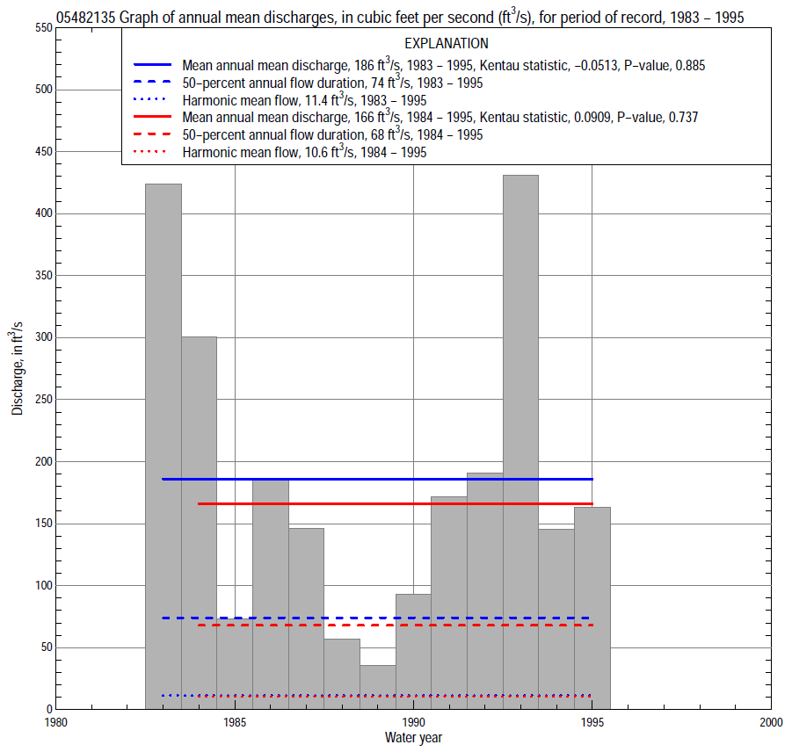

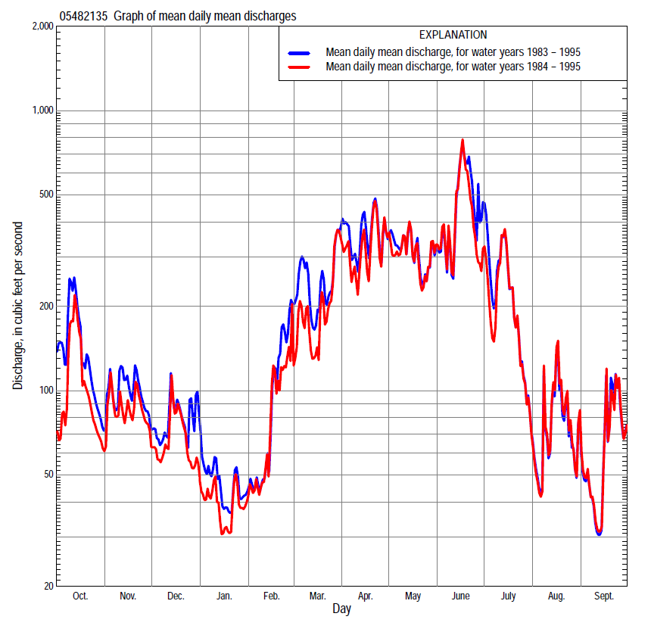

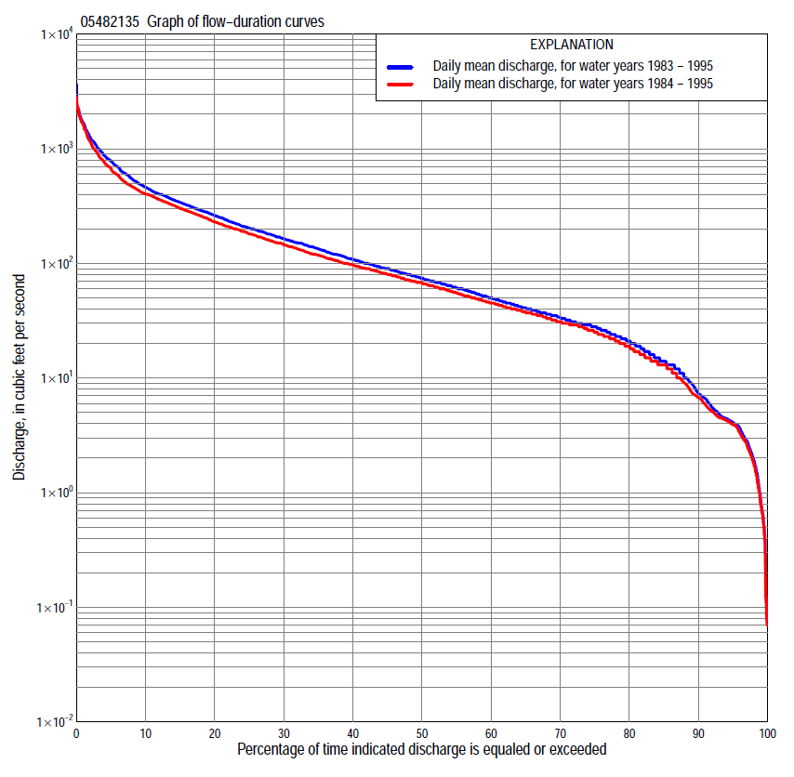

Statistics Based on the Entire Streamflow Period of Record
05482135 Monthly and annual flow durations, based on 1983–95 period of record (13 years)
Percentage of days discharge equaled or exceeded |  |  |  |  | Discharge (cubic feet per second) |  |  |  |  |  |  |  |  | Annual flow durations
 | Oct | Nov | Dec | Jan | Feb | Mar | Apr | May | June | July | Aug | Sept | Annual | Kentau statistic | P-value
99 | 3.2 | 1.0 | 0.08 | 0.43 | 1.7 | 3.8 | 9.0 | 6.5 | 17 | 3.5 | 1.2 | 3.9 | 0.85 | -0.038 | 0.902
98 | 3.7 | 1.6 | 0.11 | 0.61 | 1.9 | 8.6 | 12 | 12 | 21 | 4.0 | 1.4 | 3.9 | 1.9 | -0.064 | 0.806
95 | 3.9 | 3.0 | 0.52 | 1.0 | 2.3 | 19 | 16 | 30 | 27 | 6.7 | 2.2 | 5.1 | 4.1 | -0.128 | 0.582
90 | 4.2 | 4.7 | 5.3 | 3.3 | 5.6 | 30 | 41 | 63 | 48 | 11 | 3.2 | 6.0 | 7.3 | -0.103 | 0.668
85 | 4.4 | 6.1 | 18 | 4.6 | 11 | 45 | 60 | 78 | 64 | 19 | 7.2 | 6.8 | 14 | -0.103 | 0.669
80 | 5.1 | 15 | 26 | 16 | 13 | 55 | 84 | 92 | 82 | 27 | 9.8 | 7.3 | 21 | -0.064 | 0.807
75 | 18 | 24 | 29 | 20 | 14 | 64 | 95 | 108 | 98 | 34 | 13 | 8.9 | 28 | -0.013 | 1.000
70 | 26 | 36 | 35 | 24 | 16 | 77 | 130 | 133 | 115 | 45 | 18 | 10 | 33 | -0.013 | 1.000
65 | 30 | 39 | 38 | 27 | 24 | 87 | 156 | 152 | 134 | 57 | 21 | 13 | 40 | -0.026 | 0.951
60 | 42 | 43 | 45 | 29 | 30 | 96 | 176 | 185 | 158 | 70 | 26 | 16 | 50 | -0.128 | 0.583
55 | 52 | 58 | 56 | 31 | 34 | 110 | 200 | 224 | 178 | 83 | 29 | 19 | 60 | -0.128 | 0.583
50 | 59 | 64 | 60 | 32 | 38 | 121 | 226 | 252 | 210 | 99 | 34 | 21 | 74 | -0.128 | 0.583
45 | 78 | 70 | 68 | 34 | 44 | 150 | 274 | 275 | 277 | 114 | 40 | 24 | 90 | -0.103 | 0.669
40 | 92 | 74 | 74 | 36 | 49 | 178 | 310 | 303 | 339 | 133 | 44 | 29 | 108 | -0.103 | 0.669
35 | 106 | 82 | 80 | 39 | 55 | 220 | 351 | 331 | 394 | 161 | 49 | 35 | 133 | -0.115 | 0.625
30 | 125 | 110 | 88 | 42 | 61 | 254 | 413 | 363 | 450 | 187 | 56 | 50 | 163 | -0.154 | 0.502
25 | 156 | 141 | 99 | 47 | 75 | 300 | 491 | 401 | 571 | 227 | 69 | 86 | 202 | -0.128 | 0.583
20 | 189 | 177 | 118 | 52 | 130 | 350 | 597 | 466 | 703 | 280 | 91 | 106 | 260 | -0.128 | 0.583
15 | 230 | 200 | 136 | 80 | 210 | 418 | 710 | 550 | 915 | 354 | 126 | 125 | 340 | -0.077 | 0.760
10 | 330 | 257 | 150 | 110 | 283 | 540 | 875 | 706 | 1,380 | 540 | 170 | 174 | 460 | -0.051 | 0.855
5 | 600 | 322 | 198 | 165 | 450 | 938 | 1,180 | 885 | 1,800 | 1,080 | 281 | 261 | 781 | -0.026 | 0.951
2 | 1,000 | 420 | 402 | 210 | 640 | 1,370 | 1,420 | 1,200 | 2,270 | 1,770 | 592 | 411 | 1,260 | -0.128 | 0.583
1 | 1,190 | 500 | 538 | 235 | 800 | 1,920 | 1,680 | 1,420 | 2,400 | 1,930 | 826 | 580 | 1,680 | -0.205 | 0.360

05482135 Annual exceedance probability of instantaneous peak discharges, in cubic feet per second (ft³/s), based on the Weighted Independent Estimates method,
Annual exceed-ance probability | Recur-rence interval (years) | Discharge (ft³/s) | 95-percent lower confi-dence interval (ft³/s) | 95-percent upper confi-dence interval (ft³/s)
0.500 | 2 | 1,450 | 1,090 | 1,910
0.200 | 5 | 2,260 | 1,720 | 2,960
0.100 | 10 | 2,810 | 2,100 | 3,750
0.040 | 25 | 3,500 | 2,520 | 4,860
0.020 | 50 | 4,000 | 2,780 | 5,740
0.010 | 100 | 4,500 | 3,020 | 6,700
0.005 | 200 | 5,000 | 3,230 | 7,730
0.002 | 500 | 5,590 | 3,430 | 9,120
and based on the expected moments algorithm/multiple Grubbs-Beck analysis computed using a historical period length of 13 years (1983–1995)
0.500 | 2 | 1,520 | 1,050 | 2,040
0.200 | 5 | 2,320 | 1,720 | 3,340
0.100 | 10 | 2,820 | 2,110 | 4,490
0.040 | 25 | 3,430 | 2,520 | 6,320
0.020 | 50 | 3,850 | 2,770 | 7,960
0.010 | 100 | 4,240 | 2,970 | 9,860
0.005 | 200 | 4,620 | 3,140 | 12,000
0.002 | 500 | 5,090 | 3,320 | 15,500
Kentau statistic |  | -0.205
P-value |  | 0.360
Begin year |  | 1983
End year |  | 1995
Number of peaks |  | 13

05482135 Annual exceedance probability of high discharges, based on 1983–95 period of record (13 years)
[ND, not determined]
Annual exceedance probability | Recur-rence interval (years) | Maximum average discharge (ft³/s) for indicated number of consecutive days
 |  | 1 | 3 | 7 | 15 | 30
0.990 | 1.01 | ND | ND | 83 | 54 | 36
0.950 | 1.05 | ND | ND | 190 | 129 | 95
0.900 | 1.11 | ND | ND | 283 | 196 | 151
0.800 | 1.25 | ND | ND | 443 | 314 | 250
0.500 | 2 | ND | ND | 944 | 693 | 559
0.200 | 5 | ND | ND | 1,770 | 1,340 | 1,030
0.100 | 10 | ND | ND | 2,340 | 1,790 | 1,310
0.040 | 25 | ND | ND | 3,050 | 2,360 | 1,630
0.020 | 50 | ND | ND | 3,550 | 2,770 | 1,830
0.010 | 100 | ND | ND | 4,030 | 3,160 | 2,000
0.005 | 200 | ND | ND | 4,480 | 3,530 | 2,150
0.002 | 500 | ND | ND | 5,050 | 3,990 | 2,310
Kentau statistic |  | -0.179 | -0.179 | -0.128 | -0.103 | -0.026
P-value |  | 0.428 | 0.428 | 0.583 | 0.669 | 0.951

 | 05482135 Annual nonexceedance probability of low discharges, based on April 1983 to March 1995 period of record (12 years)
Annual nonexceed-ance probability | Recur-rence interval (years) | Minimum average discharge (cubic feet per second) for indicated number of consecutive days
 |  | 1 | 3 | 7 | 14 | 30 | 60 | 90 | 120 | 183
0.01 | 100 | 0.02 | 0.02 | 0.02 | 0.03 | 0.10 | 0.20 | 0.35 | 0.49 | 1.2
0.02 | 50 | 0.05 | 0.05 | 0.06 | 0.08 | 0.22 | 0.43 | 0.72 | 1.0 | 2.2
0.05 | 20 | 0.21 | 0.21 | 0.24 | 0.32 | 0.62 | 1.2 | 1.9 | 2.7 | 4.8
0.10 | 10 | 0.61 | 0.64 | 0.72 | 0.90 | 1.4 | 2.6 | 4.1 | 5.8 | 9.2
0.20 | 5 | 1.8 | 2.0 | 2.2 | 2.6 | 3.5 | 5.9 | 9.2 | 13 | 18
0.50 | 2 | 8.4 | 9.2 | 10 | 12 | 14 | 20 | 29 | 39 | 53
0.80 | 1.25 | 20 | 22 | 24 | 29 | 35 | 42 | 61 | 78 | 110
0.90 | 1.11 | 25 | 28 | 31 | 38 | 49 | 55 | 78 | 97 | 145
0.96 | 1.04 | 30 | 32 | 36 | 45 | 64 | 66 | 93 | 113 | 182
0.98 | 1.02 | 32 | 34 | 38 | 49 | 73 | 75 | 100 | 120 | 203
0.99 | 1.01 | 33 | 35 | 39 | 51 | 81 | 90 | 105 | 125 | 220
Kentau statistic |  | 0.045 | 0.091 | 0.076 | 0.061 | 0.061 | 0.121 | 0.061 | 0.030 | 0.152
P-value |  | 0.891 | 0.732 | 0.783 | 0.837 | 0.837 | 0.631 | 0.837 | 0.945 | 0.537

05482135 Annual nonexceedance probability of seasonal low discharges, based on October 1982 to September 1995 period of record (13 years)
Annual nonexceed-ance probability | Recur-rence interval (years) | Minimum average discharge (cubic feet per second) for indicated number of consecutive days
 |  | 1 | 7 | 14 | 30 |  | 1 | 7 | 14 | 30
 |  | January-February-March |  |  |  |  | April-May-June
0.01 | 100 | 0.04 | 0.12 | 0.19 | 0.37 |  | 2.4 | 3.0 | 5.3 | 7.3
0.02 | 50 | 0.11 | 0.30 | 0.43 | 0.72 |  | 3.9 | 4.8 | 8.1 | 11
0.05 | 20 | 0.51 | 0.99 | 1.2 | 1.8 |  | 7.9 | 9.4 | 15 | 21
0.10 | 10 | 1.6 | 2.5 | 2.9 | 3.7 |  | 14 | 16 | 24 | 36
0.20 | 5 | 5.1 | 6.4 | 6.9 | 8.2 |  | 26 | 30 | 41 | 63
0.50 | 2 | 23 | 24 | 26 | 28 |  | 70 | 81 | 101 | 158
0.80 | 1.25 | 51 | 54 | 60 | 67 |  | 153 | 180 | 216 | 323
0.90 | 1.11 | 61 | 69 | 81 | 94 |  | 212 | 253 | 303 | 436
0.96 | 1.04 | 68 | 81 | 101 | 125 |  | 285 | 347 | 415 | 571
0.98 | 1.02 | 70 | 87 | 111 | 145 |  | 335 | 414 | 499 | 663
0.99 | 1.01 | 72 | 90 | 119 | 162 |  | 380 | 477 | 581 | 747
Kentau statistic |  | -0.115 | -0.077 | 0.000 | -0.026 |  | -0.051 | -0.077 | -0.103 | -0.077
P-value |  | 0.623 | 0.760 | 1.000 | 0.951 |  | 0.855 | 0.760 | 0.669 | 0.760
 |  | July-August-September |  |  |  |  | October-November-December
0.01 | 100 | 0.58 | 0.71 | 0.93 | 0.94 |  | 0.02 | 0.02 | 0.03 | 0.11
0.02 | 50 | 0.78 | 0.96 | 1.2 | 1.3 |  | 0.06 | 0.07 | 0.10 | 0.28
0.05 | 20 | 1.2 | 1.5 | 1.9 | 2.2 |  | 0.34 | 0.38 | 0.51 | 1.0
0.10 | 10 | 1.9 | 2.3 | 2.8 | 3.4 |  | 1.2 | 1.5 | 1.7 | 2.9
0.20 | 5 | 3.1 | 3.8 | 4.5 | 5.9 |  | 4.5 | 5.4 | 6.1 | 8.2
0.50 | 2 | 8.6 | 10 | 12 | 17 |  | 25 | 30 | 33 | 38
0.80 | 1.25 | 25 | 29 | 35 | 51 |  | 56 | 69 | 83 | 96
0.90 | 1.11 | 44 | 51 | 63 | 91 |  | 69 | 85 | 106 | 130
0.96 | 1.04 | 82 | 94 | 119 | 169 |  | 76 | 93 | 123 | 161
0.98 | 1.02 | 124 | 140 | 183 | 255 |  | 78 | 96 | 130 | 176
0.99 | 1.01 | 181 | 203 | 271 | 369 |  | 79 | 98 | 134 | 186
Kentau statistic |  | 0.179 | 0.128 | 0.154 | 0.154 |  | -0.295 | -0.128 | -0.128 | -0.128
P-value |  | 0.428 | 0.583 | 0.502 | 0.502 |  | 0.179 | 0.583 | 0.583 | 0.583

Statistics Based on the 1984–2013 Streamflow Period of Record
05482135 Monthly and annual flow durations, based on 1984–1995 period of record (12 years)
Percentage of days discharge equaled or exceeded |  |  |  |  | Discharge (cubic feet per second) |  |  |  |  |  |  |  |  | Annual flow durations
 | Oct | Nov | Dec | Jan | Feb | Mar | Apr | May | June | July | Aug | Sept | Annual | Kentau statistic | P-value
99 | 3.2 | 1.0 | 0.08 | 0.43 | 1.7 | 3.8 | 9.0 | 6.5 | 17 | 3.5 | 1.2 | 3.9 | 0.78 | 0.091 | 0.730
98 | 3.7 | 1.5 | 0.10 | 0.55 | 1.8 | 8.5 | 12 | 10 | 20 | 4.0 | 1.4 | 3.9 | 1.8 | 0.091 | 0.730
95 | 3.9 | 2.9 | 0.50 | 1.0 | 2.2 | 17 | 15 | 30 | 27 | 6.4 | 2.2 | 5.1 | 3.9 | 0.030 | 0.945
90 | 4.1 | 4.5 | 5.1 | 3.0 | 4.5 | 24 | 39 | 57 | 43 | 10 | 3.1 | 5.9 | 6.7 | 0.061 | 0.836
85 | 4.4 | 5.2 | 15 | 4.5 | 10 | 42 | 53 | 76 | 60 | 16 | 6.1 | 6.7 | 13 | 0.061 | 0.837
80 | 4.7 | 13 | 25 | 13 | 13 | 50 | 76 | 87 | 72 | 24 | 9.0 | 7.0 | 19 | 0.106 | 0.680
75 | 14 | 19 | 29 | 18 | 14 | 61 | 91 | 100 | 91 | 31 | 12 | 8.3 | 25 | 0.167 | 0.492
70 | 22 | 30 | 32 | 22 | 15 | 71 | 110 | 119 | 104 | 40 | 15 | 9.5 | 31 | 0.167 | 0.492
65 | 28 | 38 | 36 | 26 | 18 | 80 | 144 | 144 | 121 | 51 | 20 | 12 | 37 | 0.152 | 0.537
60 | 37 | 40 | 41 | 28 | 26 | 90 | 163 | 165 | 138 | 62 | 23 | 15 | 45 | 0.030 | 0.945
55 | 44 | 45 | 48 | 29 | 30 | 100 | 183 | 194 | 169 | 72 | 27 | 17 | 55 | 0.030 | 0.945
50 | 55 | 60 | 58 | 31 | 35 | 115 | 207 | 230 | 205 | 85 | 33 | 20 | 66 | 0.030 | 0.945
45 | 65 | 64 | 64 | 32 | 39 | 130 | 232 | 266 | 253 | 101 | 38 | 22 | 80 | 0.061 | 0.837
40 | 78 | 70 | 68 | 34 | 44 | 152 | 274 | 294 | 321 | 116 | 44 | 24 | 96 | 0.061 | 0.837
35 | 92 | 74 | 74 | 36 | 49 | 178 | 316 | 325 | 380 | 141 | 49 | 32 | 117 | 0.045 | 0.891
30 | 104 | 82 | 80 | 39 | 54 | 215 | 361 | 354 | 420 | 166 | 56 | 46 | 145 | 0.000 | 1.000
25 | 121 | 103 | 88 | 42 | 64 | 249 | 425 | 397 | 486 | 203 | 74 | 87 | 180 | 0.030 | 0.945
20 | 148 | 137 | 95 | 46 | 99 | 297 | 503 | 466 | 619 | 260 | 102 | 106 | 229 | 0.030 | 0.945
15 | 178 | 179 | 111 | 52 | 200 | 333 | 607 | 539 | 791 | 320 | 133 | 131 | 300 | 0.091 | 0.732
10 | 209 | 228 | 137 | 67 | 240 | 391 | 756 | 706 | 1,190 | 484 | 185 | 177 | 401 | 0.091 | 0.732
5 | 313 | 288 | 161 | 132 | 390 | 522 | 1,050 | 885 | 1,700 | 930 | 285 | 278 | 666 | 0.121 | 0.631
2 | 701 | 381 | 220 | 210 | 520 | 956 | 1,580 | 1,260 | 2,040 | 1,700 | 610 | 430 | 1,150 | -0.030 | 0.945
1 | 951 | 444 | 293 | 225 | 540 | 1,920 | 1,680 | 1,420 | 2,300 | 1,910 | 826 | 580 | 1,590 | -0.121 | 0.631

05482135 Annual exceedance probability of high discharges, based on 1984–95 period of record (12 years)
Annual exceedance probability | Recur-rence interval (years) | Maximum average discharge (ft³/s) for indicated number of consecutive days
 |  | 1 | 3 | 7 | 15 | 30
0.990 | 1.01 | 228 | 136 | 84 | 54 | 35
0.950 | 1.05 | 412 | 282 | 182 | 124 | 90
0.900 | 1.11 | 551 | 401 | 268 | 185 | 142
0.800 | 1.25 | 763 | 593 | 413 | 292 | 232
0.500 | 2 | 1,320 | 1,140 | 863 | 630 | 513
0.200 | 5 | 2,100 | 1,930 | 1,610 | 1,200 | 941
0.100 | 10 | 2,580 | 2,440 | 2,140 | 1,600 | 1,210
0.040 | 25 | 3,140 | 3,030 | 2,810 | 2,100 | 1,510
0.020 | 50 | 3,520 | 3,430 | 3,300 | 2,460 | 1,700
0.010 | 100 | 3,870 | 3,800 | 3,660 | 2,800 | 1,870
0.005 | 200 | 4,190 | 4,130 | 3,990 | 3,130 | 2,010
0.002 | 500 | 4,590 | 4,520 | 4,380 | 3,540 | 2,180
Kentau statistic |  | -0.030 | -0.061 | 0.000 | 0.030 | 0.091
P-value |  | 0.945 | 0.837 | 1.000 | 0.945 | 0.732

 | 05482135 Annual nonexceedance probability of low discharges, based on April 1983 to March 1995 period of record (12 years)
Annual nonexceed-ance probability | Recur-rence interval (years) | Minimum average discharge (cubic feet per second) for indicated number of consecutive days
 |  | 1 | 3 | 7 | 14 | 30 | 60 | 90 | 120 | 183
0.01 | 100 | 0.02 | 0.02 | 0.02 | 0.03 | 0.10 | 0.20 | 0.35 | 0.49 | 1.2
0.02 | 50 | 0.05 | 0.05 | 0.06 | 0.08 | 0.22 | 0.43 | 0.72 | 1.0 | 2.2
0.05 | 20 | 0.21 | 0.21 | 0.24 | 0.32 | 0.62 | 1.2 | 1.9 | 2.7 | 4.8
0.10 | 10 | 0.61 | 0.64 | 0.72 | 0.90 | 1.4 | 2.6 | 4.1 | 5.8 | 9.2
0.20 | 5 | 1.8 | 2.0 | 2.2 | 2.6 | 3.5 | 5.9 | 9.2 | 13 | 18
0.50 | 2 | 8.4 | 9.2 | 10 | 12 | 14 | 20 | 29 | 39 | 53
0.80 | 1.25 | 20 | 22 | 24 | 29 | 35 | 42 | 61 | 78 | 110
0.90 | 1.11 | 25 | 28 | 31 | 38 | 49 | 55 | 78 | 97 | 145
0.96 | 1.04 | 30 | 32 | 36 | 45 | 64 | 66 | 93 | 113 | 182
0.98 | 1.02 | 32 | 34 | 38 | 49 | 73 | 72 | 100 | 120 | 203
0.99 | 1.01 | 33 | 35 | 39 | 51 | 81 | 76 | 105 | 125 | 220
Kentau statistic |  | 0.045 | 0.091 | 0.076 | 0.061 | 0.061 | 0.121 | 0.061 | 0.030 | 0.152
P-value |  | 0.891 | 0.732 | 0.783 | 0.837 | 0.837 | 0.631 | 0.837 | 0.945 | 0.537

05482135 Annual nonexceedance probability of seasonal low discharges, based on October 1983 to September 1995 period of record (12 years)
Annual nonexceed-ance probability | Recur-rence interval (years) | Minimum average discharge (cubic feet per second) for indicated number of consecutive days
 |  | 1 | 7 | 14 | 30 |  | 1 | 7 | 14 | 30
 |  | January-February-March |  |  |  |  | April-May-June
0.01 | 100 | 0.03 | 0.11 | 0.18 | 0.36 |  | 2.4 | 2.9 | 5.3 | 7.0
0.02 | 50 | 0.10 | 0.27 | 0.39 | 0.68 |  | 3.8 | 4.6 | 7.8 | 11
0.05 | 20 | 0.44 | 0.88 | 1.1 | 1.6 |  | 7.3 | 8.7 | 14 | 20
0.10 | 10 | 1.4 | 2.2 | 2.6 | 3.4 |  | 13 | 15 | 22 | 33
0.20 | 5 | 4.4 | 5.6 | 6.1 | 7.3 |  | 23 | 27 | 37 | 58
0.50 | 2 | 21 | 22 | 23 | 25 |  | 63 | 74 | 93 | 147
0.80 | 1.25 | 46 | 49 | 55 | 60 |  | 142 | 170 | 207 | 314
0.90 | 1.11 | 56 | 64 | 75 | 86 |  | 201 | 247 | 300 | 438
0.96 | 1.04 | 63 | 76 | 96 | 117 |  | 279 | 351 | 429 | 596
0.98 | 1.02 | 65 | 82 | 107 | 137 |  | 335 | 431 | 531 | 712
0.99 | 1.01 | 66 | 86 | 116 | 154 |  | 388 | 510 | 635 | 821
Kentau statistic |  | 0.015 | 0.061 | 0.152 | 0.121 |  | 0.061 | 0.030 | -0.030 | -0.030
P-value |  | 1.000 | 0.837 | 0.537 | 0.631 |  | 0.837 | 0.945 | 0.945 | 0.945
 |  | July-August-September |  |  |  |  | October-November-December
0.01 | 100 | 0.59 | 0.74 | 0.92 | 0.94 |  | 0.01 | 0.01 | 0.03 | 0.09
0.02 | 50 | 0.77 | 0.95 | 1.2 | 1.3 |  | 0.05 | 0.06 | 0.09 | 0.25
0.05 | 20 | 1.2 | 1.4 | 1.8 | 2.0 |  | 0.30 | 0.33 | 0.44 | 0.93
0.10 | 10 | 1.7 | 2.1 | 2.6 | 3.1 |  | 1.1 | 1.3 | 1.5 | 2.6
0.20 | 5 | 2.8 | 3.4 | 4.1 | 5.3 |  | 4.2 | 4.8 | 5.3 | 7.3
0.50 | 2 | 7.8 | 9.2 | 11 | 16 |  | 21 | 26 | 28 | 33
0.80 | 1.25 | 24 | 27 | 33 | 49 |  | 43 | 56 | 69 | 80
0.90 | 1.11 | 44 | 50 | 61 | 92 |  | 50 | 66 | 87 | 105
0.96 | 1.04 | 87 | 98 | 124 | 182 |  | 53 | 72 | 99 | 127
0.98 | 1.02 | 139 | 155 | 201 | 288 |  | 54 | 73 | 104 | 137
0.99 | 1.01 | 212 | 236 | 315 | 438 |  | 55 | 74 | 106 | 144
Kentau statistic |  | 0.303 | 0.273 | 0.303 | 0.242 |  | -0.167 | 0.030 | 0.030 | 0.030
P-value |  | 0.193 | 0.244 | 0.193 | 0.304 |  | 0.492 | 0.945 | 0.945 | 0.945

