LOCATION.--Lat 42°41'20", long 94°47'53" referenced to North American Datum of 1927, in NE 1/4 NE 1/4 sec.24, T.91 N., R.34 W., Pocahontas County, IA, Hydrologic Unit 07100006, on left bank on downstream side of bridge on County Highway N33, 5.5 mi northeast of Varina, 2.1 mi downstream from Drainage Ditch 21, 3.0 mi upstream Drainage Ditch 74, and 25.8 mi upstream from mouth.

DRAINAGE AREA.--80 mi².

PERIOD OF RECORD.--Discharge records from October 1959 to September 1991.

GAGE.--Water-stage recorder. Datum of gage is 1,225.12 ft above National Geodetic Vertical Datum of 1929.

A summary of all available data for this streamgage is provided through the USGS National Water Information System web interface (NWISWeb). The following link provides access to current/historical observations, daily data, daily statistics, monthly statistics, annual statistics, peak streamflow, field measurements, field/lab water-quality samples, and the latest water-year summaries. Data can be filtered by parameter and/or dates, and can be output in various tabular and graphical formats.
http://waterdata.usgs.gov/nwis/inventory/?site_no=05482170

The USGS WaterWatch Toolkit is available at:
http://waterwatch.usgs.gov/?id=ww_toolkit
Tools for summarizing streamflow information include the duration hydrograph builder, the cumulative streamflow hydrograph builder, the streamgage statistics retrieval tool, the rating curve builder, the flood tracking chart builder, the National Weather Service Advanced Hydrologic Prediction Service (AHPS) river forecast hydrograph builder, and the raster-hydrograph builder. Entering the above number for this streamgage into these toolkit webpages will provide streamflow information specific to this streamgage.

A description of the statistics presented for this streamgage is available in the main body of the report at:
http://dx.doi.org/10.3133/ofr20151214
A link to other streamgages included in this report, a map showing the location of the streamgages, information on the programs used to compute the statistical analyses, and references are included in the main body of the report.

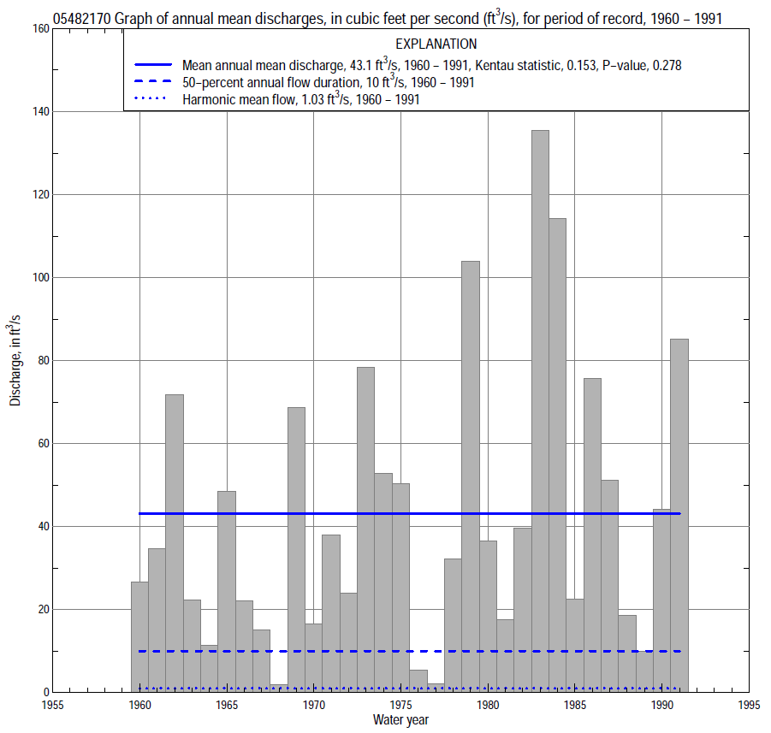

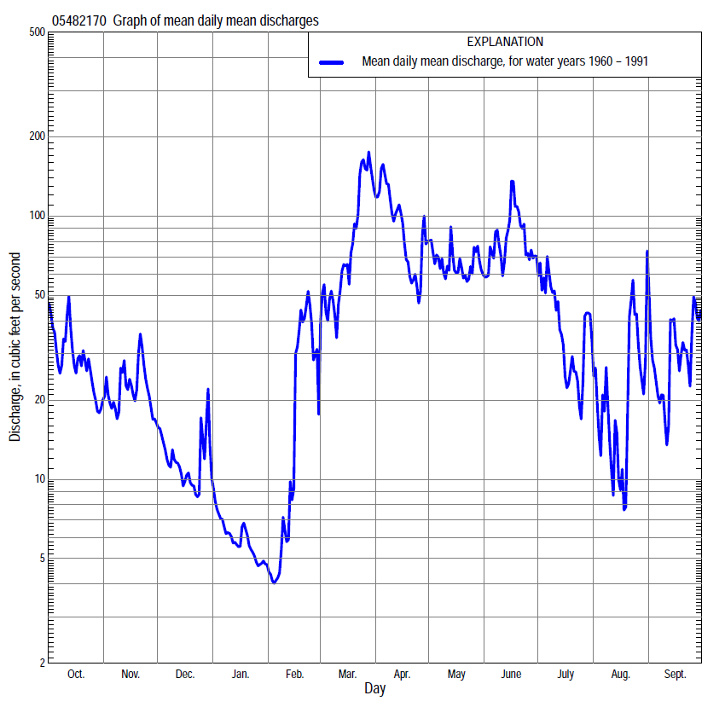

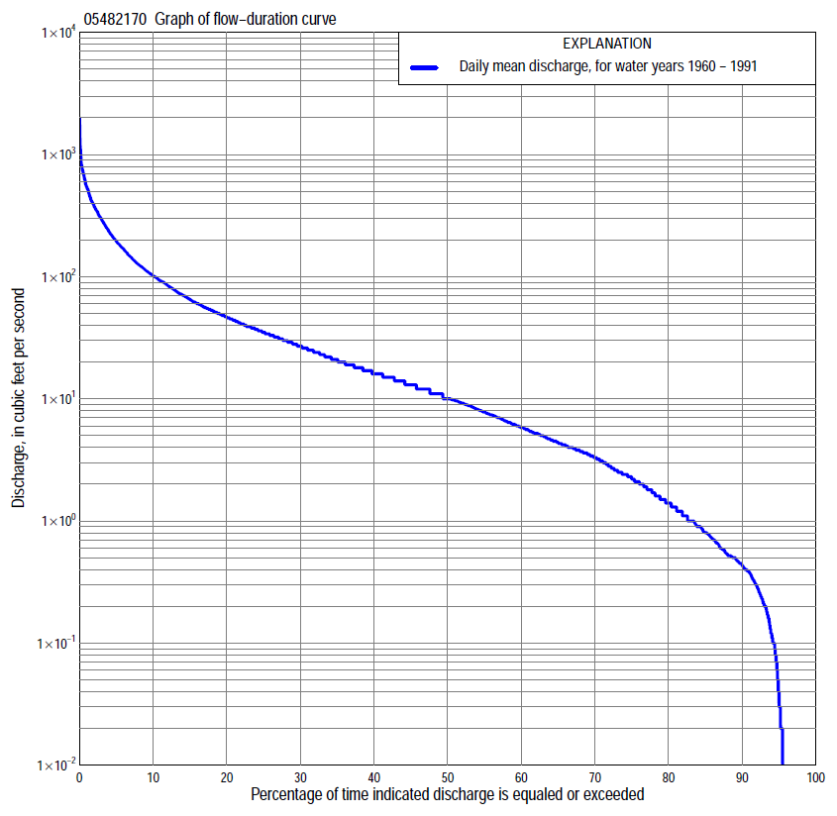

Statistics Based on the Entire Streamflow Period of Record
05482170 Monthly and annual flow durations, based on 1960–91 period of record (32 years)
Percentage of days discharge equaled or exceeded |  |  |  |  | Discharge (cubic feet per second) |  |  |  |  |  |  |  |  | Annual flow durations
 | Oct | Nov | Dec | Jan | Feb | Mar | Apr | May | June | July | Aug | Sept | Annual | Kentau statistic | P-value
99 | 0.21 | 0.05 | 0.00 | 0.00 | 0.00 | 0.00 | 0.39 | 0.37 | 0.23 | 0.18 | 0.10 | 0.23 | 0.00 | 0.099 | 0.340
98 | 0.23 | 0.09 | 0.00 | 0.00 | 0.00 | 0.00 | 0.52 | 0.45 | 0.27 | 0.24 | 0.16 | 0.29 | 0.00 | 0.069 | 0.524
95 | 0.37 | 0.24 | 0.00 | 0.00 | 0.00 | 0.28 | 1.1 | 0.90 | 1.3 | 1.1 | 0.36 | 0.40 | 0.04 | 0.075 | 0.489
90 | 0.48 | 0.49 | 0.01 | 0.00 | 0.00 | 1.4 | 3.5 | 5.6 | 7.9 | 2.3 | 0.69 | 0.52 | 0.43 | 0.113 | 0.337
85 | 0.54 | 0.71 | 0.28 | 0.00 | 0.00 | 2.4 | 7.1 | 9.0 | 11 | 3.2 | 1.1 | 0.64 | 0.80 | 0.171 | 0.157
80 | 0.73 | 1.2 | 0.60 | 0.00 | 0.02 | 3.8 | 9.6 | 13 | 14 | 4.2 | 1.4 | 0.82 | 1.4 | 0.157 | 0.203
75 | 1.2 | 1.8 | 1.1 | 0.06 | 0.13 | 4.5 | 12 | 16 | 16 | 5.1 | 1.8 | 1.2 | 2.2 | 0.183 | 0.140
70 | 1.8 | 2.5 | 1.9 | 0.30 | 0.50 | 6.2 | 15 | 19 | 18 | 6.2 | 2.3 | 1.6 | 3.3 | 0.218 | 0.080
65 | 2.4 | 3.6 | 2.6 | 0.74 | 1.1 | 8.7 | 23 | 22 | 21 | 7.5 | 2.6 | 2.1 | 4.4 | 0.206 | 0.100
60 | 3.3 | 4.5 | 3.4 | 0.90 | 1.5 | 12 | 29 | 26 | 24 | 9.2 | 3.1 | 2.6 | 5.8 | 0.248 | 0.047
55 | 4.6 | 5.7 | 4.2 | 1.3 | 2.3 | 15 | 36 | 31 | 27 | 10 | 3.7 | 3.3 | 7.8 | 0.232 | 0.063
50 | 6.4 | 7.0 | 5.2 | 2.2 | 3.4 | 20 | 44 | 36 | 30 | 13 | 4.3 | 4.0 | 10 | 0.202 | 0.108
45 | 11 | 10 | 6.2 | 3.4 | 4.2 | 26 | 53 | 42 | 34 | 16 | 5.1 | 4.9 | 13 | 0.218 | 0.082
40 | 16 | 14 | 8.1 | 4.0 | 5.1 | 32 | 62 | 47 | 40 | 19 | 6.5 | 6.5 | 16 | 0.208 | 0.098
35 | 20 | 16 | 10 | 5.7 | 6.0 | 38 | 73 | 55 | 49 | 23 | 8.0 | 9.0 | 21 | 0.188 | 0.135
30 | 24 | 19 | 12 | 6.8 | 7.8 | 48 | 89 | 66 | 59 | 29 | 9.8 | 12 | 27 | 0.198 | 0.115
25 | 29 | 22 | 14 | 8.6 | 9.4 | 63 | 106 | 82 | 72 | 36 | 12 | 16 | 35 | 0.234 | 0.062
20 | 36 | 31 | 16 | 10 | 11 | 88 | 135 | 99 | 94 | 46 | 16 | 25 | 47 | 0.190 | 0.131
15 | 50 | 45 | 20 | 13 | 16 | 134 | 176 | 121 | 128 | 60 | 26 | 42 | 65 | 0.196 | 0.119
10 | 80 | 59 | 31 | 17 | 25 | 211 | 264 | 158 | 206 | 100 | 43 | 67 | 102 | 0.145 | 0.249
5 | 127 | 95 | 44 | 22 | 70 | 395 | 389 | 233 | 371 | 173 | 94 | 164 | 195 | 0.093 | 0.466
2 | 228 | 139 | 64 | 36 | 285 | 769 | 560 | 367 | 572 | 315 | 259 | 303 | 377 | 0.050 | 0.697
1 | 288 | 191 | 85 | 47 | 580 | 1,060 | 702 | 442 | 766 | 468 | 349 | 444 | 541 | -0.002 | 1.000

05482170 Annual exceedance probability of instantaneous peak discharges, in cubic feet per second (ft³/s), based on the Weighted Independent Estimates method,
Annual exceed-ance probability | Recur-rence interval (years) | Discharge (ft³/s) | 95-percent lower confi-dence interval (ft³/s) | 95-percent upper confi-dence interval (ft³/s)
0.500 | 2 | 629 | 474 | 834
0.200 | 5 | 1,190 | 911 | 1,560
0.100 | 10 | 1,610 | 1,200 | 2,140
0.040 | 25 | 2,130 | 1,520 | 2,970
0.020 | 50 | 2,500 | 1,710 | 3,660
0.010 | 100 | 2,870 | 1,880 | 4,400
0.005 | 200 | 3,250 | 2,020 | 5,220
0.002 | 500 | 3,700 | 2,150 | 6,350
and based on the expected moments algorithm/multiple Grubbs-Beck analysis computed using a historical period length of 32 years (1960–1991)
0.500 | 2 | 665 | 272 | 854
0.200 | 5 | 1,280 | 960 | 1,870
0.100 | 10 | 1,750 | 1,300 | 2,960
0.040 | 25 | 2,370 | 1,670 | 5,410
0.020 | 50 | 2,840 | 1,920 | 8,500
0.010 | 100 | 3,310 | 2,140 | 12,500
0.005 | 200 | 3,790 | 2,350 | 16,800
0.002 | 500 | 4,420 | 2,590 | 23,900
Kentau statistic |  | -0.008
P-value |  | 0.961
Begin year |  | 1960
End year |  | 1991
Number of peaks |  | 32

05482170 Annual exceedance probability of high discharges, based on 1960–91 period of record (32 years)
Annual exceedance probability | Recur-rence interval (years) | Maximum average discharge (cubic feet per second) for indicated number of consecutive days
 |  | 1 | 3 | 7 | 15 | 30
0.990 | 1.01 | 26 | 16 | 11 | 7.2 | 4.5
0.950 | 1.05 | 75 | 50 | 34 | 23 | 15
0.900 | 1.11 | 124 | 86 | 60 | 39 | 27
0.800 | 1.25 | 216 | 157 | 110 | 73 | 50
0.500 | 2 | 529 | 413 | 301 | 200 | 138
0.200 | 5 | 1,060 | 878 | 661 | 453 | 305
0.100 | 10 | 1,420 | 1,200 | 921 | 646 | 424
0.040 | 25 | 1,840 | 1,600 | 1,240 | 896 | 570
0.020 | 50 | 2,120 | 1,870 | 1,470 | 1,080 | 671
0.010 | 100 | 2,370 | 2,110 | 1,670 | 1,250 | 763
0.005 | 200 | 2,600 | 2,330 | 1,860 | 1,420 | 846
0.002 | 500 | 2,860 | 2,590 | 2,090 | 1,620 | 944
Kentau statistic |  | -0.018 | -0.012 | -0.024 | -0.008 | 0.052
P-value |  | 0.897 | 0.935 | 0.858 | 0.961 | 0.685

 | 05482170 Annual nonexceedance probability of low discharges, based on April 1960 to March 1991 period of record (31 years)
Annual nonexceed-ance probability | Recur-rence interval (years) | Minimum average discharge (cubic feet per second) for indicated number of consecutive days
 |  | 1 | 3 | 7 | 14 | 30 | 60 | 90 | 120 | 183
0.01 | 100 | 0.00 | 0.00 | 0.00 | 0.00 | 0.00 | 0.00 | 0.00 | 0.01 | 0.06
0.02 | 50 | 0.00 | 0.00 | 0.00 | 0.00 | 0.00 | 0.00 | 0.00 | 0.03 | 0.10
0.05 | 20 | 0.00 | 0.00 | 0.00 | 0.00 | 0.00 | 0.00 | 0.00 | 0.08 | 0.24
0.10 | 10 | 0.00 | 0.00 | 0.00 | 0.00 | 0.00 | 0.01 | 0.04 | 0.21 | 0.51
0.20 | 5 | 0.00 | 0.00 | 0.00 | 0.00 | 0.00 | 0.10 | 0.43 | 0.61 | 1.2
0.50 | 2 | 0.43 | 0.48 | 0.55 | 0.75 | 0.93 | 1.2 | 3.0 | 3.6 | 5.6
0.80 | 1.25 | 2.3 | 2.6 | 2.8 | 3.3 | 4.8 | 7.0 | 12 | 15 | 22
0.90 | 1.11 | 4.2 | 4.5 | 4.9 | 5.6 | 8.4 | 16 | 20 | 28 | 43
0.96 | 1.04 | 7.2 | 7.5 | 8.0 | 8.7 | 13 | 30 | 37 | 50 | 83
0.98 | 1.02 | 9.7 | 9.9 | 11 | 11 | 16 | 47 | 55 | 70 | 125
0.99 | 1.01 | 12 | 12 | 13 | 14 | 19 | 68 | 77 | 92 | 177
Kentau statistic |  | 0.077 | 0.073 | 0.086 | 0.099 | 0.099 | 0.155 | 0.202 | 0.213 | 0.178
P-value |  | 0.542 | 0.565 | 0.497 | 0.433 | 0.441 | 0.227 | 0.114 | 0.096 | 0.163

05482170 Annual nonexceedance probability of seasonal low discharges, based on October 1959 to September 1991 period of record (32 years)
Annual nonexceed-ance probability | Recur-rence interval (years) | Minimum average discharge (cubic feet per second) for indicated number of consecutive days
 |  | 1 | 7 | 14 | 30 |  | 1 | 7 | 14 | 30
 |  | January-February-March |  |  |  |  | April-May-June
0.01 | 100 | 0.00 | 0.00 | 0.00 | 0.00 |  | 0.07 | 0.10 | 0.17 | 0.23
0.02 | 50 | 0.00 | 0.00 | 0.00 | 0.00 |  | 0.15 | 0.22 | 0.35 | 0.48
0.05 | 20 | 0.00 | 0.00 | 0.00 | 0.00 |  | 0.45 | 0.62 | 0.90 | 1.27
0.10 | 10 | 0.00 | 0.00 | 0.00 | 0.00 |  | 1.1 | 1.4 | 2.0 | 2.8
0.20 | 5 | 0.00 | 0.00 | 0.00 | 0.01 |  | 2.7 | 3.4 | 4.5 | 6.5
0.50 | 2 | 0.98 | 1.1 | 1.2 | 1.2 |  | 11 | 13 | 16 | 24
0.80 | 1.25 | 4.9 | 5.3 | 5.9 | 7.4 |  | 28 | 34 | 42 | 62
0.90 | 1.11 | 8.5 | 9.0 | 9.8 | 15 |  | 38 | 48 | 60 | 89
0.96 | 1.04 | 14 | 14 | 15 | 26 |  | 50 | 64 | 82 | 120
0.98 | 1.02 | 18 | 18 | 20 | 34 |  | 56 | 73 | 96 | 140
0.99 | 1.01 | 23 | 23 | 24 | 45 |  | 61 | 81 | 108 | 156
Kentau statistic |  | 0.069 | 0.087 | 0.091 | 0.087 |  | 0.139 | 0.175 | 0.141 | 0.121
P-value |  | 0.584 | 0.486 | 0.466 | 0.495 |  | 0.270 | 0.163 | 0.263 | 0.339
 |  | July-August-September |  |  |  |  | October-November-December
0.01 | 100 | 0.03 | 0.05 | 0.08 | 0.13 |  | 0.00 | 0.00 | 0.00 | 0.00
0.02 | 50 | 0.05 | 0.07 | 0.11 | 0.18 |  | 0.00 | 0.00 | 0.00 | 0.00
0.05 | 20 | 0.10 | 0.14 | 0.20 | 0.31 |  | 0.00 | 0.00 | 0.00 | 0.01
0.10 | 10 | 0.18 | 0.25 | 0.33 | 0.49 |  | 0.00 | 0.00 | 0.00 | 0.10
0.20 | 5 | 0.36 | 0.49 | 0.59 | 0.87 |  | 0.13 | 0.28 | 0.40 | 0.54
0.50 | 2 | 1.2 | 1.6 | 1.8 | 2.7 |  | 1.7 | 2.3 | 2.7 | 4.2
0.80 | 1.25 | 3.6 | 4.4 | 5.3 | 8.9 |  | 7.4 | 8.7 | 12 | 16
0.90 | 1.11 | 5.9 | 7.3 | 9.2 | 17 |  | 14 | 16 | 18 | 24
0.96 | 1.04 | 9.9 | 12 | 16 | 34 |  | 27 | 29 | 31 | 35
0.98 | 1.02 | 13 | 16 | 24 | 54 |  | 39 | 41 | 45 | 46
0.99 | 1.01 | 18 | 21 | 33 | 82 |  | 53 | 56 | 64 | 70
Kentau statistic |  | 0.000 | -0.008 | 0.028 | 0.020 |  | 0.181 | 0.183 | 0.192 | 0.198
P-value |  | 1.000 | 0.961 | 0.833 | 0.884 |  | 0.148 | 0.144 | 0.127 | 0.116

