LOCATION.--Lat 42°21'17.1", long 94°59'25.2" referenced to North American Datum of 1983, in NE 1/4 NW 1/4 NW 1/4 sec.13, T.87 N., R.36 W., Sac County, IA, Hydrologic Unit 07100006, on left bank 50 ft upstream from bridge on 300th Street, 4.6 mi south of Sac City, 2.1 mi upstream from Indian Creek, 0.3 mi upstream from Drainage Ditch 73, 135.9 mi upstream from mouth, and 166.4 mi upstream from mouth of Raccoon River.

DRAINAGE AREA.--700 mi².

PERIOD OF RECORD.--Discharge records from June 1958 to current year.

GAGE.--Water-stage recorder. Datum of gage is 1,146.03 ft above National Geodetic Vertical Datum of 1929. Prior to October 1, 1987, at site 1.7 mi downstream at datum 1.43 ft lower.

EXTREMES OUTSIDE PERIOD OF RECORD.--Flood of June 21, 1954, reached a stage of 15.61 ft, from high-water mark, discharge 7,000 ft³/s.

A summary of all available data for this streamgage is provided through the USGS National Water Information System web interface (NWISWeb). The following link provides access to current/historical observations, daily data, daily statistics, monthly statistics, annual statistics, peak streamflow, field measurements, field/lab water-quality samples, and the latest water-year summaries. Data can be filtered by parameter and/or dates, and can be output in various tabular and graphical formats.
http://waterdata.usgs.gov/nwis/inventory/?site_no=05482300

The USGS WaterWatch Toolkit is available at:
http://waterwatch.usgs.gov/?id=ww_toolkit
Tools for summarizing streamflow information include the duration hydrograph builder, the cumulative streamflow hydrograph builder, the streamgage statistics retrieval tool, the rating curve builder, the flood tracking chart builder, the National Weather Service Advanced Hydrologic Prediction Service (AHPS) river forecast hydrograph builder, and the raster-hydrograph builder. Entering the above number for this streamgage into these toolkit webpages will provide streamflow information specific to this streamgage.

A description of the statistics presented for this streamgage is available in the main body of the report at:
http://dx.doi.org/10.3133/ofr20151214
A link to other streamgages included in this report, a map showing the location of the streamgages, information on the programs used to compute the statistical analyses, and references are included in the main body of the report.

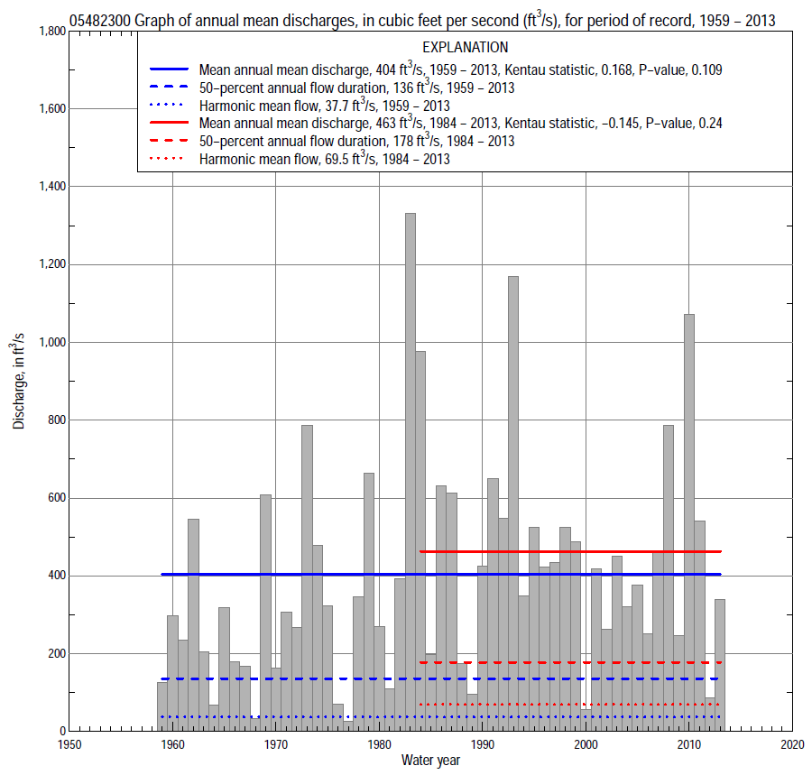

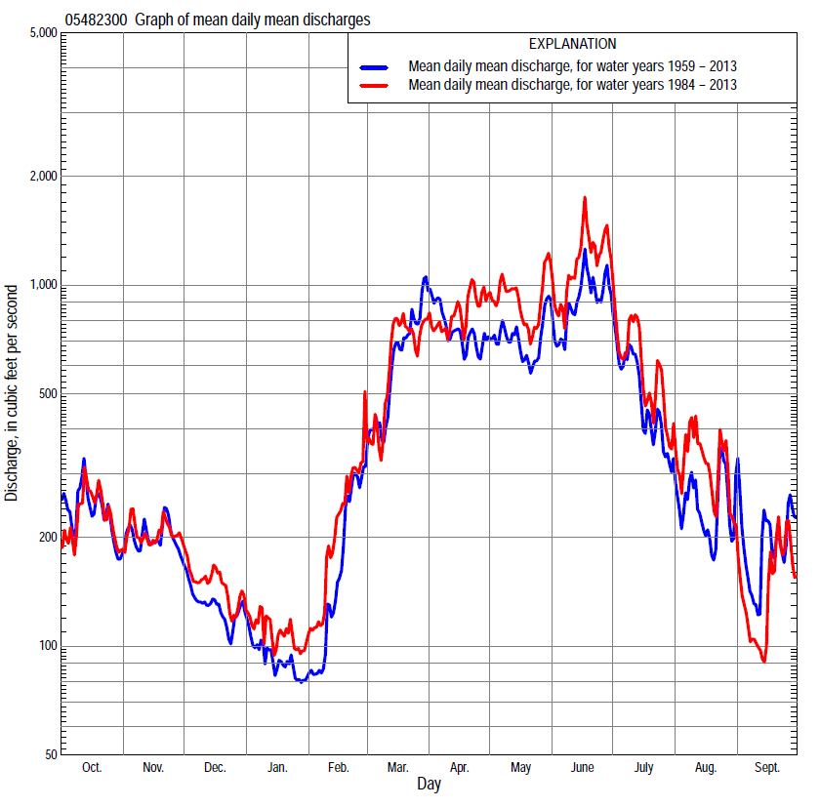

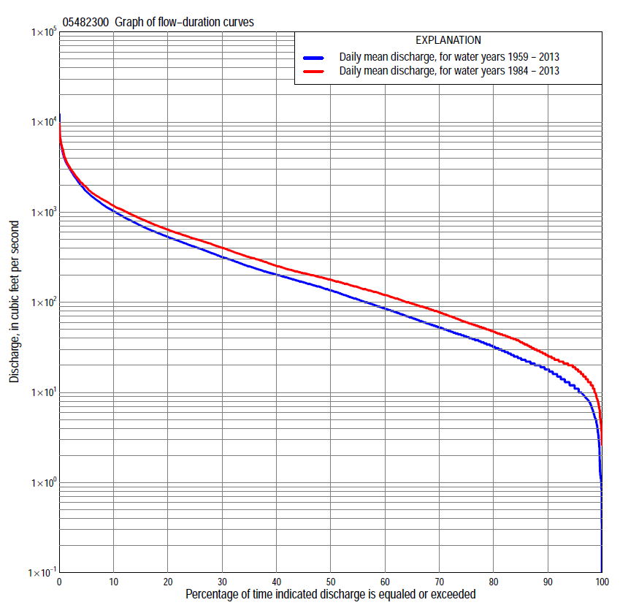

Statistics Based on the Entire Streamflow Period of Record
05482300 Monthly and annual flow durations, based on 1959–2013 period of record (55 years)
Percentage of days discharge equaled or exceeded |  |  |  |  | Discharge (cubic feet per second) |  |  |  |  |  |  |  |  | Annual flow durations
 | Oct | Nov | Dec | Jan | Feb | Mar | Apr | May | June | July | Aug | Sept | Annual | Kentau statistic | P-value
99 | 5.8 | 8.5 | 3.3 | 0.94 | 1.1 | 13 | 19 | 16 | 15 | 13 | 8.2 | 5.2 | 4.4 | 0.209 | 0.024
98 | 6.5 | 9.5 | 3.8 | 1.2 | 1.2 | 17 | 22 | 22 | 23 | 18 | 9.3 | 8.1 | 7.1 | 0.214 | 0.021
95 | 9.0 | 12 | 5.6 | 4.2 | 8.4 | 26 | 31 | 33 | 59 | 23 | 12 | 10 | 12 | 0.205 | 0.028
90 | 13 | 16 | 11 | 8.2 | 12 | 34 | 62 | 95 | 101 | 35 | 16 | 16 | 18 | 0.222 | 0.017
85 | 20 | 20 | 15 | 11 | 16 | 46 | 84 | 139 | 136 | 44 | 21 | 20 | 24 | 0.234 | 0.012
80 | 23 | 25 | 20 | 14 | 19 | 59 | 129 | 168 | 170 | 54 | 26 | 22 | 32 | 0.208 | 0.025
75 | 26 | 31 | 27 | 17 | 26 | 81 | 173 | 204 | 212 | 68 | 31 | 26 | 42 | 0.196 | 0.035
70 | 33 | 41 | 38 | 20 | 34 | 109 | 209 | 247 | 251 | 84 | 37 | 29 | 53 | 0.187 | 0.044
65 | 39 | 52 | 50 | 26 | 42 | 134 | 251 | 301 | 297 | 104 | 42 | 32 | 68 | 0.180 | 0.053
60 | 45 | 66 | 62 | 37 | 47 | 160 | 310 | 358 | 351 | 132 | 50 | 36 | 86 | 0.173 | 0.063
55 | 53 | 80 | 72 | 48 | 54 | 197 | 370 | 413 | 408 | 161 | 59 | 42 | 108 | 0.189 | 0.043
50 | 61 | 102 | 82 | 60 | 64 | 245 | 435 | 478 | 473 | 204 | 70 | 48 | 136 | 0.195 | 0.037
45 | 78 | 126 | 91 | 72 | 78 | 296 | 510 | 542 | 543 | 254 | 85 | 57 | 168 | 0.185 | 0.047
40 | 110 | 147 | 104 | 83 | 100 | 363 | 600 | 613 | 619 | 316 | 104 | 67 | 204 | 0.182 | 0.051
35 | 137 | 168 | 128 | 93 | 122 | 429 | 692 | 690 | 722 | 378 | 123 | 87 | 251 | 0.179 | 0.054
30 | 188 | 196 | 160 | 110 | 145 | 506 | 810 | 795 | 868 | 457 | 152 | 112 | 320 | 0.178 | 0.055
25 | 244 | 220 | 185 | 129 | 174 | 637 | 949 | 917 | 1,080 | 558 | 203 | 150 | 414 | 0.191 | 0.040
20 | 305 | 287 | 208 | 152 | 210 | 841 | 1,160 | 1,060 | 1,340 | 690 | 270 | 192 | 535 | 0.204 | 0.028
15 | 398 | 400 | 260 | 181 | 270 | 1,100 | 1,430 | 1,290 | 1,670 | 896 | 378 | 280 | 712 | 0.207 | 0.026
10 | 614 | 520 | 310 | 215 | 404 | 1,530 | 1,950 | 1,590 | 2,350 | 1,220 | 614 | 427 | 1,030 | 0.195 | 0.037
5 | 1,050 | 783 | 410 | 280 | 701 | 2,690 | 2,820 | 2,310 | 3,580 | 2,100 | 1,120 | 745 | 1,700 | 0.162 | 0.081
2 | 1,820 | 1,100 | 540 | 405 | 1,500 | 4,970 | 3,770 | 3,200 | 5,200 | 3,490 | 2,220 | 1,710 | 2,970 | 0.127 | 0.172
1 | 2,510 | 1,300 | 650 | 590 | 1,900 | 6,300 | 4,340 | 3,800 | 5,920 | 4,660 | 3,180 | 2,710 | 3,900 | 0.108 | 0.245

05482300 Annual exceedance probability of instantaneous peak discharges, in cubic feet per second (ft³/s), based on the Weighted Independent Estimates method,
Annual exceed-ance probability | Recur-rence interval (years) | Discharge (ft³/s) | 95-percent lower confi-dence interval (ft³/s) | 95-percent upper confi-dence interval (ft³/s)
0.500 | 2 | 4,650 | 4,060 | 5,330
0.200 | 5 | 6,990 | 6,120 | 7,990
0.100 | 10 | 8,500 | 7,350 | 9,830
0.040 | 25 | 10,300 | 8,660 | 12,300
0.020 | 50 | 11,600 | 9,460 | 14,300
0.010 | 100 | 12,900 | 10,200 | 16,300
0.005 | 200 | 14,100 | 10,800 | 18,600
0.002 | 500 | 15,700 | 11,400 | 21,600
and based on the expected moments algorithm/multiple Grubbs-Beck analysis computed using a historical period length of 60 years (1954–2013)
0.500 | 2 | 4,740 | 3,720 | 5,390
0.200 | 5 | 7,130 | 6,240 | 8,370
0.100 | 10 | 8,670 | 7,500 | 10,600
0.040 | 25 | 10,500 | 8,900 | 13,900
0.020 | 50 | 11,800 | 9,820 | 16,500
0.010 | 100 | 13,100 | 10,600 | 19,100
0.005 | 200 | 14,300 | 11,300 | 21,900
0.002 | 500 | 15,900 | 12,200 | 25,800
Kentau statistic |  | 0.116
P-value |  | 0.212
Begin year |  | 1959
End year |  | 2013
Number of peaks |  | 55

05482300 Annual exceedance probability of high discharges, based on 1959–2013 period of record (55 years)
[ND, not determined]
Annual exceedance probability | Recur-rence interval (years) | Maximum average discharge (ft³/s) for indicated number of consecutive days
 |  | 1 | 3 | 7 | 15 | 30
0.990 | 1.01 | ND | 186 | 143 | 95 | 71
0.950 | 1.05 | ND | 553 | 416 | 284 | 211
0.900 | 1.11 | ND | 913 | 682 | 471 | 351
0.800 | 1.25 | ND | 1,560 | 1,160 | 813 | 603
0.500 | 2 | ND | 3,510 | 2,650 | 1,900 | 1,390
0.200 | 5 | ND | 6,190 | 4,820 | 3,520 | 2,500
0.100 | 10 | ND | 7,640 | 6,070 | 4,470 | 3,120
0.040 | 25 | ND | 9,060 | 7,360 | 5,470 | 3,750
0.020 | 50 | ND | 9,860 | 8,120 | 6,060 | 4,100
0.010 | 100 | ND | 10,500 | 8,740 | 6,550 | 4,390
0.005 | 200 | ND | 10,900 | 9,240 | 6,940 | 4,610
0.002 | 500 | ND | 11,400 | 9,770 | 7,360 | 4,840
Kentau statistic |  | 0.106 | 0.090 | 0.100 | 0.121 | 0.162
P-value |  | 0.254 | 0.338 | 0.283 | 0.196 | 0.081

 | 05482300 Annual nonexceedance probability of low discharges, based on April 1959 to March 2013 period of record (54 years)
Annual nonexceed-ance probability | Recur-rence interval (years) | Minimum average discharge (ft³/s) for indicated number of consecutive days
 |  | 1 | 3 | 7 | 14 | 30 | 60 | 90 | 120 | 183
0.01 | 100 | 0.00 | 0.00 | 0.09 | 0.40 | 1.2 | 2.5 | 3.7 | 4.4 | 4.8
0.02 | 50 | 0.77 | 0.93 | 1.2 | 1.6 | 1.9 | 3.5 | 5.0 | 6.0 | 6.7
0.05 | 20 | 2.9 | 3.3 | 3.4 | 3.5 | 3.6 | 5.9 | 8.1 | 10 | 11
0.10 | 10 | 4.9 | 5.5 | 5.8 | 6.0 | 6.3 | 9.1 | 12 | 15 | 18
0.20 | 5 | 8.3 | 9.1 | 10 | 11 | 12 | 15 | 20 | 24 | 30
0.50 | 2 | 21 | 22 | 25 | 29 | 33 | 40 | 51 | 63 | 81
0.80 | 1.25 | 47 | 50 | 54 | 65 | 78 | 98 | 128 | 160 | 213
0.90 | 1.11 | 71 | 75 | 90 | 100 | 115 | 153 | 205 | 260 | 349
0.96 | 1.04 | 107 | 114 | 131 | 148 | 165 | 243 | 334 | 432 | 584
0.98 | 1.02 | 139 | 149 | 166 | 186 | 203 | 324 | 458 | 600 | 812
0.99 | 1.01 | 175 | 189 | 206 | 225 | 242 | 418 | 606 | 804 | 1,090
Kentau statistic |  | 0.138 | 0.171 | 0.190 | 0.210 | 0.189 | 0.161 | 0.160 | 0.153 | 0.117
P-value |  | 0.141 | 0.069 | 0.043 | 0.025 | 0.045 | 0.086 | 0.089 | 0.104 | 0.216

05482300 Annual nonexceedance probability of seasonal low discharges, based on July 1958 to September 2013 period of record (55–56 years)
Annual nonexceed-ance probability | Recur-rence interval (years) | Minimum average discharge (cubic feet per second) for indicated number of consecutive days
 |  | 1 | 7 | 14 | 30 |  | 1 | 7 | 14 | 30
 |  | January-February-March |  |  |  |  | April-May-June
0.01 | 100 | 0.00 | 0.08 | 0.31 | 0.77 |  | 6.5 | 7.6 | 8.8 | 14
0.02 | 50 | 0.26 | 0.38 | 0.69 | 1.4 |  | 10 | 12 | 14 | 21
0.05 | 20 | 1.1 | 1.2 | 2.0 | 3.2 |  | 18 | 21 | 26 | 39
0.10 | 10 | 3.8 | 4.7 | 4.9 | 6.3 |  | 31 | 35 | 43 | 64
0.20 | 5 | 9.9 | 11 | 12 | 13 |  | 54 | 62 | 77 | 112
0.50 | 2 | 30 | 42 | 44 | 46 |  | 141 | 164 | 206 | 288
0.80 | 1.25 | 76 | 92 | 107 | 121 |  | 315 | 373 | 465 | 635
0.90 | 1.11 | 116 | 120 | 147 | 183 |  | 451 | 542 | 669 | 904
0.96 | 1.04 | 173 | 175 | 188 | 266 |  | 634 | 774 | 943 | 1,260
0.98 | 1.02 | 195 | 200 | 212 | 329 |  | 774 | 954 | 1,150 | 1,540
0.99 | 1.01 | 210 | 220 | 230 | 389 |  | 912 | 1,140 | 1,350 | 1,810
Kentau statistic |  | 0.175 | 0.240 | 0.253 | 0.257 |  | 0.220 | 0.227 | 0.262 | 0.255
P-value |  | 0.060 | 0.010 | 0.007 | 0.006 |  | 0.018 | 0.015 | 0.005 | 0.006
 |  | July-August-September |  |  |  |  | October-November-December
0.01 | 100 | 3.5 | 4.1 | 4.7 | 5.3 |  | 1.4 | 1.7 | 2.0 | 2.8
0.02 | 50 | 4.3 | 5.0 | 5.7 | 6.5 |  | 2.1 | 2.5 | 2.9 | 4.2
0.05 | 20 | 5.9 | 6.8 | 7.7 | 9.1 |  | 3.7 | 4.6 | 5.3 | 7.3
0.10 | 10 | 8.0 | 9.1 | 10 | 13 |  | 6.1 | 7.6 | 8.8 | 12
0.20 | 5 | 12 | 13 | 15 | 19 |  | 11 | 14 | 16 | 21
0.50 | 2 | 26 | 29 | 33 | 44 |  | 32 | 40 | 46 | 59
0.80 | 1.25 | 62 | 70 | 80 | 115 |  | 89 | 106 | 123 | 156
0.90 | 1.11 | 101 | 116 | 133 | 199 |  | 148 | 171 | 198 | 253
0.96 | 1.04 | 176 | 205 | 236 | 368 |  | 249 | 279 | 320 | 417
0.98 | 1.02 | 256 | 301 | 350 | 559 |  | 345 | 379 | 432 | 571
0.99 | 1.01 | 361 | 430 | 504 | 822 |  | 459 | 493 | 560 | 752
Kentau statistic |  | 0.141 | 0.142 | 0.133 | 0.086 |  | 0.135 | 0.127 | 0.105 | 0.131
P-value |  | 0.127 | 0.123 | 0.149 | 0.351 |  | 0.148 | 0.175 | 0.260 | 0.159

Statistics Based on the 1984–2013 Streamflow Period of Record
05482300 Monthly and annual flow durations, based on 1984–2013 period of record (30 years)
Percentage of days discharge equaled or exceeded |  |  |  |  | Discharge (cubic feet per second) |  |  |  |  |  |  |  |  | Annual flow durations
 | Oct | Nov | Dec | Jan | Feb | Mar | Apr | May | June | July | Aug | Sept | Annual | Kentau statistic | P-value
99 | 9.9 | 12 | 3.8 | 4.5 | 11 | 20 | 22 | 21 | 44 | 20 | 8.6 | 7.8 | 8.7 | -0.214 | 0.101
98 | 12 | 14 | 5.0 | 5.2 | 13 | 28 | 23 | 25 | 53 | 22 | 11 | 10 | 12 | -0.218 | 0.093
95 | 16 | 17 | 12 | 8.6 | 17 | 36 | 45 | 75 | 77 | 29 | 13 | 14 | 19 | -0.216 | 0.097
90 | 21 | 21 | 19 | 16 | 25 | 64 | 94 | 193 | 148 | 40 | 21 | 20 | 26 | -0.207 | 0.112
85 | 23 | 25 | 25 | 21 | 36 | 89 | 158 | 247 | 193 | 55 | 27 | 23 | 36 | -0.207 | 0.112
80 | 27 | 34 | 35 | 33 | 45 | 118 | 201 | 300 | 257 | 79 | 34 | 27 | 47 | -0.216 | 0.097
75 | 38 | 43 | 44 | 50 | 49 | 134 | 230 | 360 | 321 | 104 | 41 | 30 | 60 | -0.223 | 0.086
70 | 40 | 51 | 60 | 59 | 58 | 157 | 298 | 417 | 392 | 132 | 51 | 32 | 78 | -0.198 | 0.129
65 | 48 | 66 | 80 | 70 | 70 | 180 | 345 | 481 | 453 | 157 | 59 | 36 | 97 | -0.189 | 0.148
60 | 54 | 80 | 89 | 79 | 82 | 216 | 439 | 536 | 512 | 201 | 70 | 42 | 120 | -0.179 | 0.169
55 | 59 | 112 | 97 | 84 | 98 | 254 | 510 | 585 | 583 | 245 | 83 | 46 | 147 | -0.168 | 0.199
50 | 70 | 134 | 110 | 90 | 115 | 294 | 582 | 642 | 651 | 293 | 99 | 52 | 178 | -0.152 | 0.246
45 | 99 | 151 | 140 | 98 | 130 | 341 | 657 | 718 | 768 | 344 | 114 | 60 | 210 | -0.149 | 0.254
40 | 125 | 178 | 160 | 108 | 147 | 410 | 729 | 807 | 887 | 395 | 136 | 68 | 253 | -0.177 | 0.175
35 | 158 | 201 | 176 | 120 | 165 | 489 | 835 | 905 | 1,080 | 467 | 173 | 86 | 317 | -0.186 | 0.153
30 | 202 | 218 | 190 | 130 | 190 | 577 | 970 | 1,010 | 1,240 | 552 | 233 | 105 | 402 | -0.205 | 0.116
25 | 256 | 247 | 208 | 150 | 219 | 700 | 1,130 | 1,150 | 1,430 | 662 | 298 | 140 | 505 | -0.161 | 0.218
20 | 309 | 309 | 232 | 170 | 259 | 870 | 1,340 | 1,340 | 1,710 | 812 | 394 | 174 | 641 | -0.168 | 0.199
15 | 379 | 398 | 280 | 190 | 360 | 1,060 | 1,580 | 1,550 | 2,200 | 984 | 557 | 230 | 844 | -0.122 | 0.353
10 | 553 | 494 | 313 | 210 | 495 | 1,320 | 2,050 | 1,980 | 2,870 | 1,390 | 821 | 395 | 1,180 | -0.092 | 0.486
5 | 927 | 680 | 391 | 240 | 876 | 2,030 | 2,630 | 2,820 | 4,300 | 2,380 | 1,440 | 549 | 1,890 | -0.046 | 0.734
2 | 1,580 | 982 | 500 | 320 | 1,440 | 4,030 | 3,350 | 3,580 | 5,590 | 3,900 | 2,660 | 1,130 | 3,070 | 0.037 | 0.789
1 | 2,130 | 1,250 | 559 | 590 | 1,850 | 5,720 | 3,990 | 4,350 | 6,460 | 5,110 | 3,300 | 1,490 | 4,060 | 0.097 | 0.464

05482300 Annual exceedance probability of high discharges, based on 1984–2013 period of record (30 years)
Annual exceedance probability | Recur-rence interval (years) | Maximum average discharge (ft³/s) for indicated number of consecutive days
 |  | 1 | 3 | 7 | 15 | 30
0.990 | 1.01 | 587 | 466 | 349 | 242 | 155
0.950 | 1.05 | 1,190 | 954 | 708 | 507 | 358
0.900 | 1.11 | 1,670 | 1,350 | 1,000 | 724 | 531
0.800 | 1.25 | 2,420 | 1,970 | 1,470 | 1,080 | 815
0.500 | 2 | 4,380 | 3,690 | 2,830 | 2,090 | 1,610
0.200 | 5 | 6,920 | 6,090 | 4,870 | 3,580 | 2,670
0.100 | 10 | 8,360 | 7,560 | 6,200 | 4,520 | 3,280
0.040 | 25 | 9,890 | 9,220 | 7,810 | 5,630 | 3,920
0.020 | 50 | 10,800 | 10,300 | 8,920 | 6,370 | 4,310
0.010 | 100 | 11,600 | 11,000 | 9,950 | 7,050 | 4,640
0.005 | 200 | 12,300 | 11,800 | 10,900 | 7,670 | 4,910
0.002 | 500 | 13,100 | 12,700 | 12,100 | 8,410 | 5,200
Kentau statistic |  | 0.186 | 0.145 | 0.131 | 0.094 | 0.062
P-value |  | 0.154 | 0.269 | 0.318 | 0.475 | 0.643

 | 05482300 Annual nonexceedance probability of low discharges, based on April 1983 to March 2013 period of record (30 years)
Annual nonexceed-ance probability | Recur-rence interval (years) | Minimum average discharge (ft³/s) for indicated number of consecutive days
 |  | 1 | 3 | 7 | 14 | 30 | 60 | 90 | 120 | 183
0.01 | 100 | 1.5 | 2.1 | 2.6 | 3.2 | 3.6 | 5.1 | 6.0 | 6.1 | 6.8
0.02 | 50 | 2.4 | 3.1 | 3.8 | 4.5 | 5.0 | 7.0 | 8.3 | 8.5 | 10
0.05 | 20 | 4.3 | 5.3 | 6.4 | 7.4 | 8.3 | 11 | 13 | 14 | 17
0.10 | 10 | 7.0 | 8.3 | 10 | 11 | 13 | 17 | 20 | 22 | 26
0.20 | 5 | 12 | 14 | 16 | 18 | 20 | 26 | 32 | 37 | 43
0.50 | 2 | 29 | 31 | 35 | 39 | 45 | 56 | 72 | 87 | 107
0.80 | 1.25 | 57 | 61 | 66 | 74 | 92 | 112 | 149 | 186 | 241
0.90 | 1.11 | 77 | 82 | 87 | 100 | 128 | 155 | 211 | 266 | 355
0.96 | 1.04 | 100 | 107 | 112 | 132 | 177 | 212 | 299 | 376 | 522
0.98 | 1.02 | 115 | 125 | 129 | 155 | 214 | 258 | 370 | 464 | 661
0.99 | 1.01 | 129 | 141 | 146 | 178 | 251 | 303 | 445 | 554 | 810
Kentau statistic |  | -0.234 | -0.193 | -0.202 | -0.186 | -0.218 | -0.274 | -0.218 | -0.195 | -0.209
P-value |  | 0.071 | 0.138 | 0.121 | 0.154 | 0.094 | 0.035 | 0.094 | 0.134 | 0.108

05482300 Annual nonexceedance probability of seasonal low discharges, based on October 1983 to September 2013 period of record (30 years)
Annual nonexceed-ance probability | Recur-rence interval (years) | Minimum average discharge (cubic feet per second) for indicated number of consecutive days
 |  | 1 | 7 | 14 | 30 |  | 1 | 7 | 14 | 30
 |  | January-February-March |  |  |  |  | April-May-June
0.01 | 100 | 1.7 | 2.8 | 3.0 | 4.2 |  | 12 | 14 | 15 | 21
0.02 | 50 | 2.8 | 4.4 | 4.8 | 6.3 |  | 18 | 20 | 23 | 33
0.05 | 20 | 5.6 | 8.3 | 9.0 | 11 |  | 31 | 36 | 43 | 62
0.10 | 10 | 9.7 | 14 | 15 | 18 |  | 50 | 57 | 71 | 103
0.20 | 5 | 18 | 24 | 26 | 31 |  | 84 | 96 | 123 | 180
0.50 | 2 | 46 | 58 | 65 | 74 |  | 200 | 233 | 301 | 433
0.80 | 1.25 | 93 | 113 | 131 | 148 |  | 404 | 485 | 608 | 840
0.90 | 1.11 | 124 | 149 | 174 | 200 |  | 549 | 673 | 819 | 1,100
0.96 | 1.04 | 160 | 189 | 223 | 263 |  | 730 | 916 | 1,070 | 1,390
0.98 | 1.02 | 182 | 215 | 256 | 307 |  | 858 | 1,100 | 1,240 | 1,570
0.99 | 1.01 | 202 | 238 | 285 | 347 |  | 978 | 1,270 | 1,390 | 1,730
Kentau statistic |  | -0.251 | -0.177 | -0.154 | -0.126 |  | -0.122 | -0.126 | -0.039 | -0.053
P-value |  | 0.054 | 0.175 | 0.239 | 0.335 |  | 0.354 | 0.335 | 0.775 | 0.695
 |  | July-August-September |  |  |  |  | October-November-December
0.01 | 100 | 6.0 | 6.5 | 7.3 | 7.6 |  | 1.6 | 2.6 | 3.4 | 4.9
0.02 | 50 | 7.0 | 7.6 | 8.5 | 9.1 |  | 2.6 | 3.9 | 5.0 | 7.0
0.05 | 20 | 8.9 | 9.7 | 11 | 12 |  | 5.2 | 7.2 | 8.7 | 12
0.10 | 10 | 11 | 12 | 14 | 16 |  | 9.0 | 12 | 14 | 18
0.20 | 5 | 16 | 17 | 19 | 23 |  | 17 | 21 | 24 | 31
0.50 | 2 | 32 | 36 | 40 | 51 |  | 46 | 54 | 61 | 76
0.80 | 1.25 | 76 | 86 | 97 | 129 |  | 104 | 119 | 138 | 172
0.90 | 1.11 | 126 | 145 | 164 | 223 |  | 148 | 168 | 202 | 255
0.96 | 1.04 | 226 | 264 | 302 | 418 |  | 205 | 234 | 295 | 378
0.98 | 1.02 | 339 | 399 | 461 | 644 |  | 247 | 283 | 370 | 480
0.99 | 1.01 | 494 | 590 | 686 | 966 |  | 287 | 332 | 448 | 590
Kentau statistic |  | -0.225 | -0.223 | -0.232 | -0.255 |  | -0.269 | -0.255 | -0.283 | -0.200
P-value |  | 0.083 | 0.087 | 0.074 | 0.050 |  | 0.038 | 0.050 | 0.030 | 0.125

