LOCATION.--Lat 41°59'17", long 94°22'36" referenced to North American Datum of 1927, in SW 1/4 SW 1/4 NW 1/4 sec.20, T.83 N., R.30 W., Greene County, IA, Hydrologic Unit 07100006, on right bank 20 ft downstream from bridge on State Highway 4, 1.9 mi south of Jefferson, 0.1 mi downstream from Drainage Ditch 33 and 40, 4.7 mi upstream from Hardin Creek, 62.6 mi upstream from mouth, and 92.6 mi upstream from mouth of Raccoon River.

DRAINAGE AREA.--1,619 mi².

PERIOD OF RECORD.--Discharge records from March 1940 to current year. Prior to October 1955, published as "Raccoon River near Jefferson."

GAGE.--Water-stage recorder. Datum of gage is 967.09 ft above National Geodetic Vertical Datum of 1929. Prior to April 22, 1946, non-recording gage at site 4.0 mi upstream at different datum; April 22 to June 25, 1946, non-recording gage, June 26, 1946, to September 30, 1955, water-stage recorder, and October 1, 1955, to April 30, 1958, non-recording gage, all at same site and datum.

A summary of all available data for this streamgage is provided through the USGS National Water Information System web interface (NWISWeb). The following link provides access to current/historical observations, daily data, daily statistics, monthly statistics, annual statistics, peak streamflow, field measurements, field/lab water-quality samples, and the latest water-year summaries. Data can be filtered by parameter and/or dates, and can be output in various tabular and graphical formats.
http://waterdata.usgs.gov/nwis/inventory/?site_no=05482500

The USGS WaterWatch Toolkit is available at:
http://waterwatch.usgs.gov/?id=ww_toolkit
Tools for summarizing streamflow information include the duration hydrograph builder, the cumulative streamflow hydrograph builder, the streamgage statistics retrieval tool, the rating curve builder, the flood tracking chart builder, the National Weather Service Advanced Hydrologic Prediction Service (AHPS) river forecast hydrograph builder, and the raster-hydrograph builder. Entering the above number for this streamgage into these toolkit webpages will provide streamflow information specific to this streamgage.

A description of the statistics presented for this streamgage is available in the main body of the report at:
http://dx.doi.org/10.3133/ofr20151214
A link to other streamgages included in this report, a map showing the location of the streamgages, information on the programs used to compute the statistical analyses, and references are included in the main body of the report.

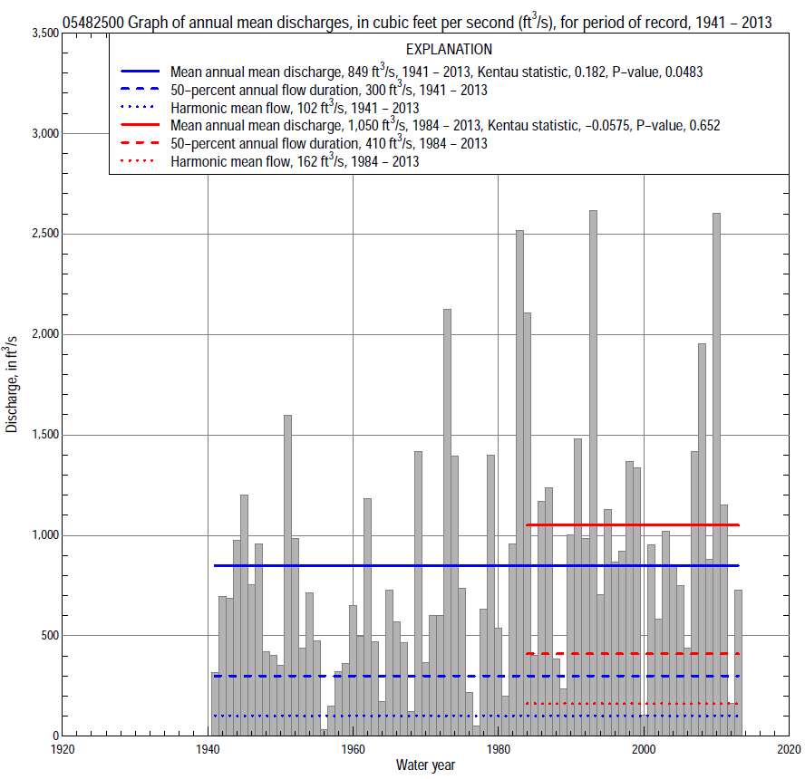

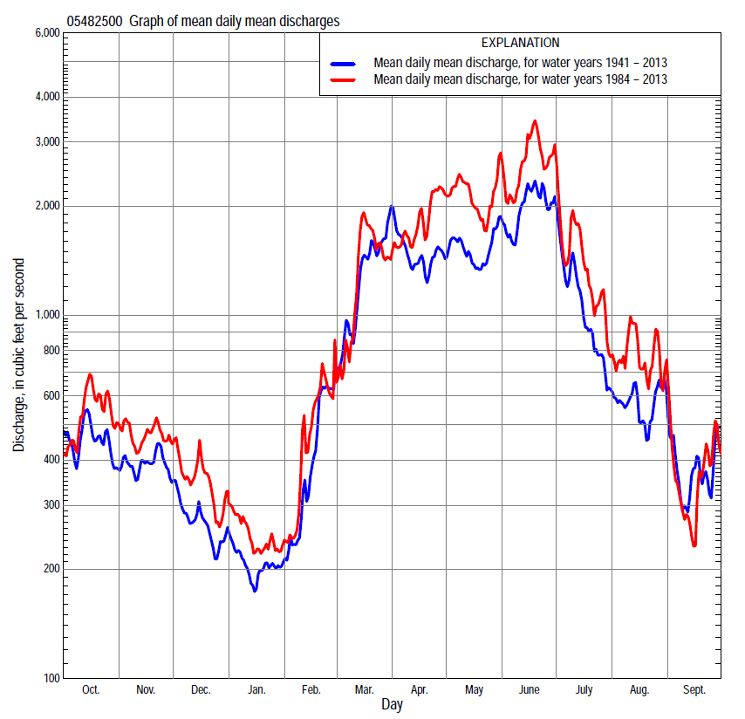

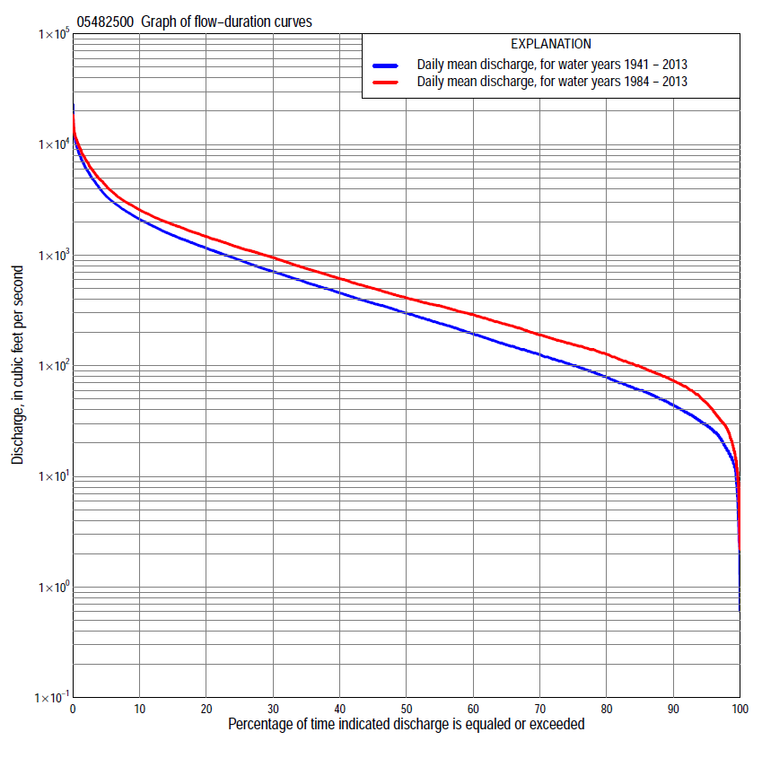

Statistics Based on the Entire Streamflow Period of Record
05482500 Monthly and annual flow durations, based on 1941–2013 period of record (73 years)
Percentage of days discharge equaled or exceeded |  |  |  |  | Discharge (cubic feet per second) |  |  |  |  |  |  |  |  | Annual flow durations
 | Oct | Nov | Dec | Jan | Feb | Mar | Apr | May | June | July | Aug | Sept | Annual | Kentau statistic | P-value
99 | 5.8 | 18 | 8.0 | 4.3 | 7.7 | 38 | 40 | 33 | 32 | 18 | 12 | 12 | 13 | 0.219 | 0.006
98 | 17 | 23 | 14 | 11 | 12 | 48 | 54 | 38 | 64 | 25 | 21 | 16 | 18 | 0.213 | 0.008
95 | 25 | 31 | 21 | 15 | 18 | 68 | 69 | 72 | 129 | 69 | 33 | 27 | 29 | 0.213 | 0.008
90 | 36 | 44 | 28 | 21 | 30 | 91 | 121 | 158 | 225 | 108 | 45 | 38 | 44 | 0.214 | 0.007
85 | 47 | 54 | 36 | 28 | 37 | 116 | 210 | 268 | 328 | 139 | 59 | 46 | 60 | 0.213 | 0.008
80 | 54 | 64 | 48 | 34 | 46 | 171 | 294 | 358 | 413 | 173 | 73 | 55 | 78 | 0.189 | 0.018
75 | 62 | 82 | 62 | 43 | 59 | 235 | 375 | 442 | 501 | 204 | 88 | 62 | 100 | 0.189 | 0.018
70 | 70 | 100 | 80 | 54 | 75 | 288 | 449 | 545 | 588 | 245 | 106 | 70 | 126 | 0.187 | 0.020
65 | 80 | 121 | 98 | 67 | 95 | 355 | 520 | 645 | 692 | 299 | 122 | 83 | 155 | 0.187 | 0.020
60 | 102 | 136 | 110 | 77 | 110 | 416 | 615 | 743 | 831 | 370 | 145 | 94 | 194 | 0.177 | 0.027
55 | 126 | 152 | 130 | 94 | 126 | 500 | 738 | 842 | 1,000 | 460 | 170 | 107 | 242 | 0.166 | 0.038
50 | 153 | 170 | 145 | 110 | 158 | 600 | 846 | 965 | 1,190 | 552 | 203 | 127 | 300 | 0.160 | 0.046
45 | 172 | 209 | 180 | 132 | 220 | 700 | 970 | 1,100 | 1,340 | 670 | 241 | 144 | 370 | 0.156 | 0.051
40 | 196 | 268 | 212 | 164 | 252 | 866 | 1,120 | 1,270 | 1,550 | 775 | 284 | 171 | 460 | 0.150 | 0.061
35 | 230 | 325 | 265 | 200 | 290 | 1,010 | 1,340 | 1,430 | 1,780 | 916 | 341 | 202 | 570 | 0.160 | 0.046
30 | 277 | 380 | 320 | 235 | 350 | 1,200 | 1,570 | 1,650 | 2,060 | 1,110 | 415 | 241 | 713 | 0.176 | 0.028
25 | 431 | 468 | 370 | 274 | 409 | 1,400 | 1,820 | 1,950 | 2,400 | 1,310 | 492 | 296 | 907 | 0.187 | 0.019
20 | 600 | 588 | 440 | 328 | 539 | 1,710 | 2,230 | 2,280 | 2,870 | 1,540 | 609 | 370 | 1,160 | 0.194 | 0.015
15 | 818 | 774 | 537 | 390 | 712 | 2,190 | 2,770 | 2,810 | 3,550 | 1,870 | 802 | 525 | 1,520 | 0.189 | 0.018
10 | 1,170 | 1,100 | 662 | 500 | 1,000 | 3,000 | 3,650 | 3,610 | 4,840 | 2,460 | 1,180 | 906 | 2,120 | 0.174 | 0.030
5 | 2,080 | 1,420 | 900 | 710 | 1,600 | 5,340 | 5,690 | 5,360 | 7,380 | 4,060 | 2,270 | 1,580 | 3,430 | 0.186 | 0.020
2 | 3,150 | 1,920 | 1,190 | 1,000 | 3,000 | 8,340 | 7,870 | 7,170 | 10,500 | 6,660 | 4,770 | 3,140 | 6,040 | 0.128 | 0.111
1 | 4,290 | 2,450 | 1,500 | 1,200 | 4,190 | 11,100 | 9,030 | 8,700 | 11,800 | 9,720 | 6,750 | 4,110 | 8,120 | 0.101 | 0.207

05482500 Annual exceedance probability of instantaneous peak discharges, in cubic feet per second (ft³/s), based on the Weighted Independent Estimates method,
Annual exceed-ance probability | Recur-rence interval (years) | Discharge (ft³/s) | 95-percent lower confi-dence interval (ft³/s) | 95-percent upper confi-dence interval (ft³/s)
0.500 | 2 | 7,970 | 6,920 | 9,170
0.200 | 5 | 12,800 | 11,100 | 14,700
0.100 | 10 | 16,000 | 13,800 | 18,700
0.040 | 25 | 20,100 | 16,700 | 24,200
0.020 | 50 | 23,100 | 18,600 | 28,700
0.010 | 100 | 26,100 | 20,300 | 33,600
0.005 | 200 | 29,200 | 21,900 | 38,900
0.002 | 500 | 33,000 | 23,500 | 46,300
and based on the expected moments algorithm/multiple Grubbs-Beck analysis computed using a historical period length of 74 years (1940–2013)
0.500 | 2 | 8,040 | 6,220 | 9,160
0.200 | 5 | 12,900 | 11,200 | 15,200
0.100 | 10 | 16,200 | 13,900 | 20,000
0.040 | 25 | 20,300 | 17,000 | 26,900
0.020 | 50 | 23,300 | 19,000 | 32,500
0.010 | 100 | 26,200 | 20,900 | 38,500
0.005 | 200 | 29,100 | 22,700 | 44,800
0.002 | 500 | 32,800 | 24,700 | 53,800
Kentau statistic |  | 0.095
P-value |  | 0.234
Begin year |  | 1940
End year |  | 2013
Number of peaks |  | 74

05482500 Annual exceedance probability of high discharges, based on 1941–2013 period of record (73 years)
[ND, not determined]
Annual exceedance probability | Recur-rence interval (years) | Maximum average discharge (ft³/s) for indicated number of consecutive days
 |  | 1 | 3 | 7 | 15 | 30
0.990 | 1.01 | ND | 314 | 230 | 171 | 137
0.950 | 1.05 | ND | 1,010 | 755 | 537 | 416
0.900 | 1.11 | ND | 1,710 | 1,300 | 910 | 696
0.800 | 1.25 | ND | 3,000 | 2,300 | 1,600 | 1,210
0.500 | 2 | ND | 6,890 | 5,430 | 3,800 | 2,810
0.200 | 5 | ND | 12,000 | 9,650 | 6,990 | 5,100
0.100 | 10 | ND | 14,600 | 11,900 | 8,810 | 6,390
0.040 | 25 | ND | 16,900 | 13,900 | 10,600 | 7,690
0.020 | 50 | ND | 18,200 | 15,000 | 11,700 | 8,440
0.010 | 100 | ND | 19,100 | 15,800 | 12,500 | 9,030
0.005 | 200 | ND | 19,700 | 16,400 | 13,200 | 9,490
0.002 | 500 | ND | 20,300 | 17,000 | 13,900 | 9,960
Kentau statistic |  | 0.082 | 0.078 | 0.093 | 0.126 | 0.132
P-value |  | 0.308 | 0.334 | 0.245 | 0.115 | 0.098

 | 05482500 Annual nonexceedance probability of low discharges, based on April 1940 to March 2013 period of record (73 years)
Annual nonexceed-ance probability | Recur-rence interval (years) | Minimum average discharge (ft³/s) for indicated number of consecutive days
 |  | 1 | 3 | 7 | 14 | 30 | 60 | 90 | 120 | 183
0.01 | 100 | 1.4 | 1.6 | 1.8 | 2.1 | 3.8 | 6.6 | 8.5 | 11 | 13
0.02 | 50 | 2.4 | 2.7 | 3.0 | 3.4 | 5.6 | 9.1 | 12 | 14 | 17
0.05 | 20 | 5.1 | 5.5 | 6.0 | 6.8 | 10 | 15 | 18 | 22 | 27
0.10 | 10 | 9.2 | 10 | 11 | 12 | 16 | 22 | 27 | 32 | 41
0.20 | 5 | 18 | 19 | 20 | 22 | 28 | 35 | 44 | 52 | 67
0.50 | 2 | 52 | 54 | 57 | 62 | 72 | 87 | 109 | 130 | 170
0.80 | 1.25 | 119 | 124 | 131 | 142 | 165 | 205 | 271 | 327 | 430
0.90 | 1.11 | 169 | 178 | 188 | 204 | 245 | 317 | 434 | 530 | 700
0.96 | 1.04 | 231 | 247 | 261 | 285 | 361 | 498 | 714 | 888 | 1,170
0.98 | 1.02 | 274 | 297 | 314 | 344 | 455 | 663 | 985 | 1,240 | 1,640
0.99 | 1.01 | 314 | 344 | 365 | 401 | 555 | 854 | 1,310 | 1,680 | 2,220
Kentau statistic |  | 0.217 | 0.222 | 0.236 | 0.247 | 0.235 | 0.206 | 0.206 | 0.190 | 0.137
P-value |  | 0.007 | 0.006 | 0.003 | 0.002 | 0.003 | 0.010 | 0.010 | 0.018 | 0.087

05482500 Annual nonexceedance probability of seasonal low discharges, based on March 1940 to September 2013 period of record (73–74 years)
Annual nonexceed-ance probability | Recur-rence interval (years) | Minimum average discharge (cubic feet per second) for indicated number of consecutive days
 |  | 1 | 7 | 14 | 30 |  | 1 | 7 | 14 | 30
 |  | January-February-March |  |  |  |  | April-May-June
0.01 | 100 | 3.4 | 3.8 | 4.2 | 5.0 |  | 14 | 17 | 19 | 28
0.02 | 50 | 5.0 | 5.6 | 6.1 | 7.2 |  | 22 | 26 | 29 | 42
0.05 | 20 | 8.8 | 9.8 | 11 | 13 |  | 41 | 48 | 54 | 77
0.10 | 10 | 14 | 16 | 17 | 20 |  | 69 | 79 | 91 | 126
0.20 | 5 | 25 | 28 | 30 | 35 |  | 123 | 139 | 164 | 222
0.50 | 2 | 67 | 75 | 82 | 98 |  | 322 | 365 | 437 | 593
0.80 | 1.25 | 168 | 189 | 208 | 255 |  | 708 | 814 | 985 | 1,380
0.90 | 1.11 | 263 | 297 | 329 | 410 |  | 1,000 | 1,170 | 1,420 | 2,040
0.96 | 1.04 | 414 | 468 | 526 | 667 |  | 1,390 | 1,650 | 1,990 | 2,990
0.98 | 1.02 | 547 | 622 | 704 | 906 |  | 1,670 | 2,010 | 2,430 | 3,750
0.99 | 1.01 | 697 | 795 | 907 | 1,190 |  | 1,950 | 2,370 | 2,870 | 4,550
Kentau statistic |  | 0.180 | 0.190 | 0.197 | 0.168 |  | 0.216 | 0.228 | 0.236 | 0.246
P-value |  | 0.025 | 0.018 | 0.014 | 0.036 |  | 0.007 | 0.004 | 0.003 | 0.002
 |  | July-August-September |  |  |  |  | October-November-December
0.01 | 100 | 3.6 | 7.2 | 9.4 | 14 |  | 1.7 | 2.2 | 3.9 | 6.6
0.02 | 50 | 5.5 | 9.6 | 12 | 17 |  | 3.0 | 3.8 | 6.0 | 9.4
0.05 | 20 | 10 | 15 | 18 | 24 |  | 6.5 | 7.9 | 11 | 16
0.10 | 10 | 16 | 22 | 25 | 33 |  | 12 | 15 | 19 | 25
0.20 | 5 | 29 | 34 | 39 | 50 |  | 25 | 29 | 35 | 44
0.50 | 2 | 78 | 83 | 90 | 114 |  | 77 | 90 | 101 | 121
0.80 | 1.25 | 184 | 196 | 216 | 284 |  | 183 | 224 | 258 | 318
0.90 | 1.11 | 274 | 308 | 347 | 474 |  | 261 | 334 | 402 | 519
0.96 | 1.04 | 404 | 496 | 579 | 839 |  | 359 | 481 | 621 | 864
0.98 | 1.02 | 510 | 675 | 812 | 1,230 |  | 427 | 592 | 808 | 1,190
0.99 | 1.01 | 621 | 889 | 1,100 | 1,760 |  | 490 | 700 | 1,010 | 1,590
Kentau statistic |  | 0.125 | 0.136 | 0.145 | 0.120 |  | 0.175 | 0.190 | 0.188 | 0.201
P-value |  | 0.117 | 0.087 | 0.069 | 0.131 |  | 0.029 | 0.018 | 0.019 | 0.012

Statistics Based on the 1984–2013 Streamflow Period of Record
05482500 Monthly and annual flow durations, based on 1984–2013 period of record (30 years)
Percentage of days discharge equaled or exceeded |  |  |  |  | Discharge (cubic feet per second) |  |  |  |  |  |  |  |  | Annual flow durations
 | Oct | Nov | Dec | Jan | Feb | Mar | Apr | May | June | July | Aug | Sept | Annual | Kentau statistic | P-value
99 | 26 | 18 | 3.2 | 9.2 | 19 | 42 | 56 | 29 | 115 | 35 | 20 | 18 | 18 | -0.143 | 0.276
98 | 30 | 27 | 8.2 | 11 | 30 | 65 | 65 | 41 | 138 | 58 | 22 | 24 | 27 | -0.156 | 0.232
95 | 49 | 48 | 28 | 19 | 36 | 100 | 132 | 187 | 208 | 89 | 31 | 35 | 46 | -0.138 | 0.292
90 | 62 | 77 | 46 | 40 | 50 | 150 | 225 | 438 | 362 | 132 | 61 | 51 | 73 | -0.115 | 0.382
85 | 73 | 92 | 67 | 55 | 70 | 199 | 352 | 611 | 467 | 169 | 81 | 66 | 98 | -0.129 | 0.326
80 | 82 | 112 | 86 | 70 | 94 | 252 | 441 | 742 | 613 | 222 | 106 | 82 | 127 | -0.133 | 0.309
75 | 97 | 129 | 104 | 81 | 112 | 309 | 519 | 861 | 784 | 298 | 132 | 92 | 155 | -0.159 | 0.225
70 | 118 | 141 | 120 | 101 | 132 | 363 | 660 | 967 | 974 | 369 | 167 | 103 | 190 | -0.149 | 0.254
65 | 147 | 159 | 140 | 134 | 181 | 414 | 803 | 1,080 | 1,120 | 466 | 205 | 112 | 236 | -0.136 | 0.301
60 | 162 | 170 | 158 | 155 | 218 | 498 | 901 | 1,200 | 1,260 | 558 | 241 | 128 | 290 | -0.154 | 0.239
55 | 175 | 196 | 191 | 190 | 242 | 591 | 1,010 | 1,370 | 1,460 | 670 | 276 | 141 | 348 | -0.122 | 0.354
50 | 195 | 268 | 275 | 220 | 260 | 664 | 1,170 | 1,520 | 1,630 | 757 | 312 | 151 | 410 | -0.120 | 0.363
45 | 221 | 332 | 320 | 239 | 290 | 790 | 1,360 | 1,670 | 1,840 | 876 | 351 | 171 | 500 | -0.108 | 0.412
40 | 240 | 370 | 357 | 260 | 309 | 965 | 1,520 | 1,890 | 2,030 | 1,050 | 409 | 190 | 612 | -0.101 | 0.443
35 | 297 | 422 | 397 | 300 | 350 | 1,090 | 1,710 | 2,110 | 2,320 | 1,220 | 463 | 222 | 755 | -0.083 | 0.532
30 | 443 | 534 | 445 | 330 | 391 | 1,280 | 1,930 | 2,370 | 2,660 | 1,450 | 523 | 268 | 951 | -0.064 | 0.630
25 | 549 | 634 | 520 | 360 | 500 | 1,440 | 2,290 | 2,690 | 3,120 | 1,620 | 632 | 312 | 1,170 | -0.057 | 0.669
20 | 708 | 772 | 604 | 397 | 590 | 1,770 | 2,790 | 3,110 | 3,820 | 1,870 | 793 | 377 | 1,470 | -0.048 | 0.721
15 | 876 | 1,070 | 664 | 432 | 761 | 2,180 | 3,350 | 3,780 | 4,970 | 2,290 | 1,070 | 565 | 1,890 | -0.067 | 0.617
10 | 1,280 | 1,260 | 768 | 500 | 1,050 | 2,840 | 4,460 | 4,750 | 6,650 | 2,910 | 1,820 | 1,030 | 2,570 | -0.030 | 0.830
5 | 2,300 | 1,490 | 987 | 635 | 1,500 | 4,270 | 6,050 | 6,820 | 9,490 | 5,020 | 3,250 | 1,540 | 4,220 | 0.041 | 0.762
2 | 3,280 | 1,820 | 1,300 | 800 | 3,100 | 7,640 | 8,000 | 8,700 | 11,500 | 9,720 | 6,730 | 2,770 | 7,170 | 0.071 | 0.592
1 | 5,800 | 2,150 | 1,500 | 900 | 4,100 | 10,200 | 9,120 | 10,700 | 13,100 | 11,500 | 8,290 | 3,420 | 9,440 | 0.106 | 0.422

05482500 Annual exceedance probability of high discharges, based on 1984–2013 period of record (30 years)
Annual exceed-ance probability | Recur-rence interval (years) | Maximum average discharge (ft³/s) for indicated number of consecutive days
 |  | 1 | 3 | 7 | 15 | 30
0.990 | 1.01 | 562 | 467 | 375 | 291 | 195
0.950 | 1.05 | 1,520 | 1,280 | 1,000 | 746 | 549
0.900 | 1.11 | 2,410 | 2,050 | 1,590 | 1,170 | 887
0.800 | 1.25 | 3,940 | 3,400 | 2,640 | 1,910 | 1,490
0.500 | 2 | 8,390 | 7,490 | 5,930 | 4,280 | 3,360
0.200 | 5 | 14,300 | 13,300 | 11,000 | 8,040 | 6,070
0.100 | 10 | 17,600 | 16,700 | 14,200 | 10,500 | 7,670
0.040 | 25 | 20,800 | 20,000 | 17,700 | 13,400 | 9,340
0.020 | 50 | 22,600 | 21,900 | 20,000 | 15,300 | 10,400
0.010 | 100 | 24,000 | 23,500 | 22,000 | 17,000 | 11,200
0.005 | 200 | 25,100 | 24,700 | 23,700 | 18,600 | 11,900
0.002 | 500 | 26,300 | 26,100 | 25,600 | 20,400 | 12,600
Kentau statistic |  | 0.120 | 0.117 | 0.094 | 0.080 | 0.071
P-value |  | 0.363 | 0.372 | 0.475 | 0.544 | 0.592

 | 05482500 Annual nonexceedance probability of low discharges, based on April 1983 to March 2013 period of record (30 years)
Annual nonexceed-ance probability | Recur-rence interval (years) | Minimum average discharge (ft³/s) for indicated number of consecutive days
 |  | 1 | 3 | 7 | 14 | 30 | 60 | 90 | 120 |  | 183
0.01 | 100 | 1.9 | 2.1 | 2.4 | 3.1 | 6.1 | 11 | 13 | 17 |  | 21
0.02 | 50 | 3.4 | 3.8 | 4.3 | 5.4 | 10 | 16 | 19 | 24 |  | 29
0.05 | 20 | 7.7 | 8.5 | 10 | 12 | 18 | 26 | 32 | 38 |  | 46
0.10 | 10 | 15 | 16 | 18 | 22 | 30 | 41 | 49 | 57 |  | 68
0.20 | 5 | 29 | 32 | 35 | 41 | 52 | 66 | 80 | 92 |  | 108
0.50 | 2 | 81 | 87 | 95 | 107 | 123 | 145 | 182 | 209 |  | 251
0.80 | 1.25 | 163 | 172 | 183 | 201 | 231 | 276 | 359 | 435 |  | 549
0.90 | 1.11 | 209 | 219 | 230 | 250 | 296 | 364 | 484 | 616 |  | 807
0.96 | 1.04 | 254 | 265 | 274 | 296 | 365 | 470 | 642 | 870 |  | 1,200
0.98 | 1.02 | 279 | 290 | 297 | 321 | 408 | 543 | 755 | 1,070 |  | 1,530
0.99 | 1.01 | 298 | 308 | 314 | 338 | 443 | 610 | 862 | 1,280 |  | 1,890
Kentau statistic |  | -0.198 | -0.198 | -0.177 | -0.186 | -0.202 | -0.218 | -0.154 | -0.145 |  | -0.163
P-value |  | 0.129 | 0.129 | 0.175 | 0.154 | 0.121 | 0.094 | 0.239 | 0.269 |  | 0.212

05482500 Annual nonexceedance probability of seasonal low discharges, based on October 1983 to September 2013 period of record (30 years)
Annual nonexceed-ance probability | Recur-rence interval (years) | Minimum average discharge (cubic feet per second) for indicated number of consecutive days
 |  | 1 | 7 | 14 | 30 |  | 1 | 7 | 14 | 30
 |  | January-February-March |  |  |  |  | April-May-June
0.01 | 100 | 3.3 | 5.4 | 6.8 | 9.0 |  | 20 | 23 | 28 | 39
0.02 | 50 | 5.6 | 8.5 | 11 | 14 |  | 33 | 38 | 46 | 63
0.05 | 20 | 12 | 16 | 20 | 25 |  | 65 | 75 | 91 | 126
0.10 | 10 | 22 | 28 | 33 | 40 |  | 113 | 129 | 157 | 219
0.20 | 5 | 41 | 50 | 58 | 69 |  | 204 | 232 | 284 | 398
0.50 | 2 | 114 | 130 | 144 | 166 |  | 512 | 589 | 715 | 1,020
0.80 | 1.25 | 242 | 272 | 299 | 334 |  | 992 | 1,180 | 1,400 | 2,020
0.90 | 1.11 | 326 | 371 | 408 | 452 |  | 1,280 | 1,560 | 1,810 | 2,650
0.96 | 1.04 | 421 | 489 | 542 | 596 |  | 1,590 | 1,980 | 2,260 | 3,340
0.98 | 1.02 | 481 | 571 | 636 | 696 |  | 1,770 | 2,250 | 2,530 | 3,770
0.99 | 1.01 | 532 | 644 | 722 | 788 |  | 1,920 | 2,480 | 2,750 | 4,130
Kentau statistic |  | -0.143 | -0.110 | -0.136 | -0.149 |  | -0.078 | -0.071 | -0.034 | -0.028
P-value |  | 0.276 | 0.402 | 0.301 | 0.254 |  | 0.556 | 0.592 | 0.803 | 0.844
 |  | July-August-September |  |  |  |  | October-November-December
0.01 | 100 | 8.2 | 13 | 17 | 25 |  | 2.0 | 2.4 | 3.8 | 11
0.02 | 50 | 11 | 16 | 20 | 29 |  | 3.8 | 4.6 | 6.8 | 16
0.05 | 20 | 16 | 23 | 28 | 38 |  | 9.0 | 11 | 15 | 27
0.10 | 10 | 24 | 31 | 37 | 49 |  | 18 | 23 | 29 | 43
0.20 | 5 | 38 | 46 | 54 | 69 |  | 37 | 47 | 57 | 73
0.50 | 2 | 92 | 103 | 116 | 145 |  | 109 | 140 | 162 | 187
0.80 | 1.25 | 225 | 244 | 270 | 346 |  | 229 | 284 | 344 | 428
0.90 | 1.11 | 362 | 392 | 433 | 574 |  | 298 | 362 | 457 | 633
0.96 | 1.04 | 605 | 659 | 733 | 1,020 |  | 367 | 435 | 579 | 931
0.98 | 1.02 | 844 | 933 | 1,050 | 1,520 |  | 405 | 472 | 652 | 1,180
0.99 | 1.01 | 1,140 | 1,280 | 1,450 | 2,210 |  | 434 | 499 | 712 | 1,440
Kentau statistic |  | -0.223 | -0.228 | -0.223 | -0.228 |  | -0.191 | -0.195 | -0.191 | -0.159
P-value |  | 0.087 | 0.080 | 0.087 | 0.080 |  | 0.143 | 0.134 | 0.143 | 0.225

