LOCATION.--Lat 42°06'27", long 94°22'12" referenced to North American Datum of 1927, in SE 1/4 SW 1/4 sec.05, T.84 N., R.30 N., Greene County, IA, Hydrologic Unit 07100006, on left bank 30 ft upstream from bridge on 170th Street, 5.5 mi southeast from Churdan, and 4.7 mi upstream from mouth.

DRAINAGE AREA.--24 mi².

PERIOD OF RECORD.--Discharge records from July 1952 to September 1991.

GAGE.--Water-stage recorder and concrete control. Datum of gage is 1,050.90 ft above National Geodetic Vertical Datum of 1929.

REMARKS.--Small diversion for irrigation upstream from station.

A summary of all available data for this streamgage is provided through the USGS National Water Information System web interface (NWISWeb). The following link provides access to current/historical observations, daily data, daily statistics, monthly statistics, annual statistics, peak streamflow, field measurements, field/lab water-quality samples, and the latest water-year summaries. Data can be filtered by parameter and/or dates, and can be output in various tabular and graphical formats.
http://waterdata.usgs.gov/nwis/inventory/?site_no=05483000

The USGS WaterWatch Toolkit is available at:
http://waterwatch.usgs.gov/?id=ww_toolkit
Tools for summarizing streamflow information include the duration hydrograph builder, the cumulative streamflow hydrograph builder, the streamgage statistics retrieval tool, the rating curve builder, the flood tracking chart builder, the National Weather Service Advanced Hydrologic Prediction Service (AHPS) river forecast hydrograph builder, and the raster-hydrograph builder. Entering the above number for this streamgage into these toolkit webpages will provide streamflow information specific to this streamgage.

A description of the statistics presented for this streamgage is available in the main body of the report at:
http://dx.doi.org/10.3133/ofr20151214
A link to other streamgages included in this report, a map showing the location of the streamgages, information on the programs used to compute the statistical analyses, and references are included in the main body of the report.

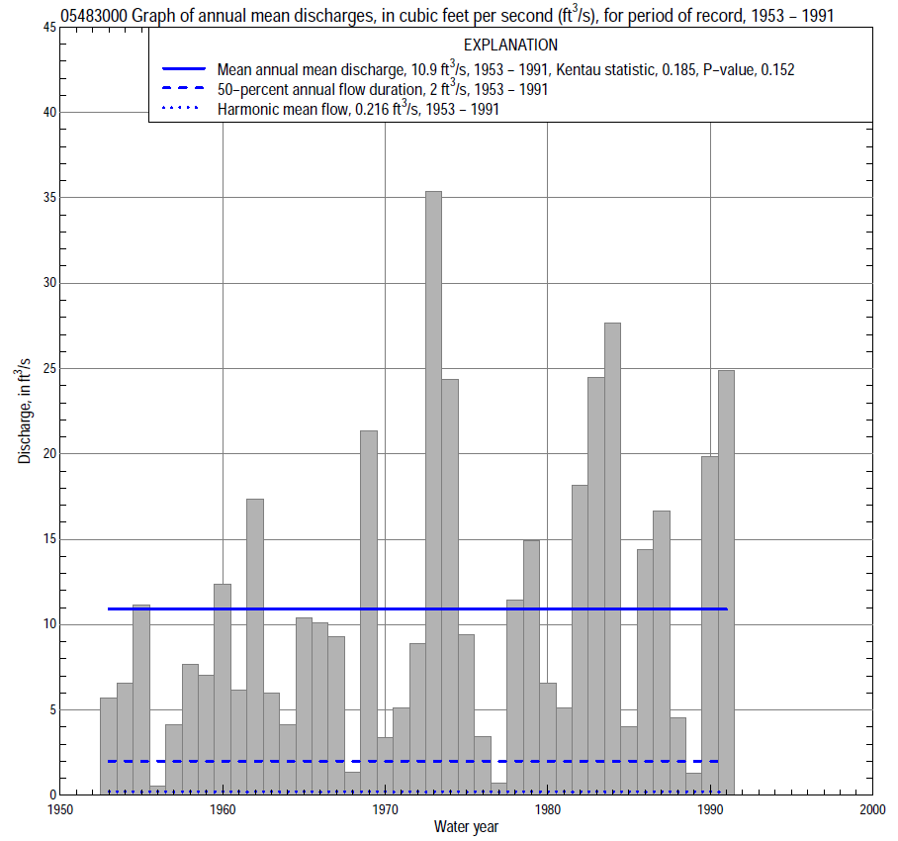

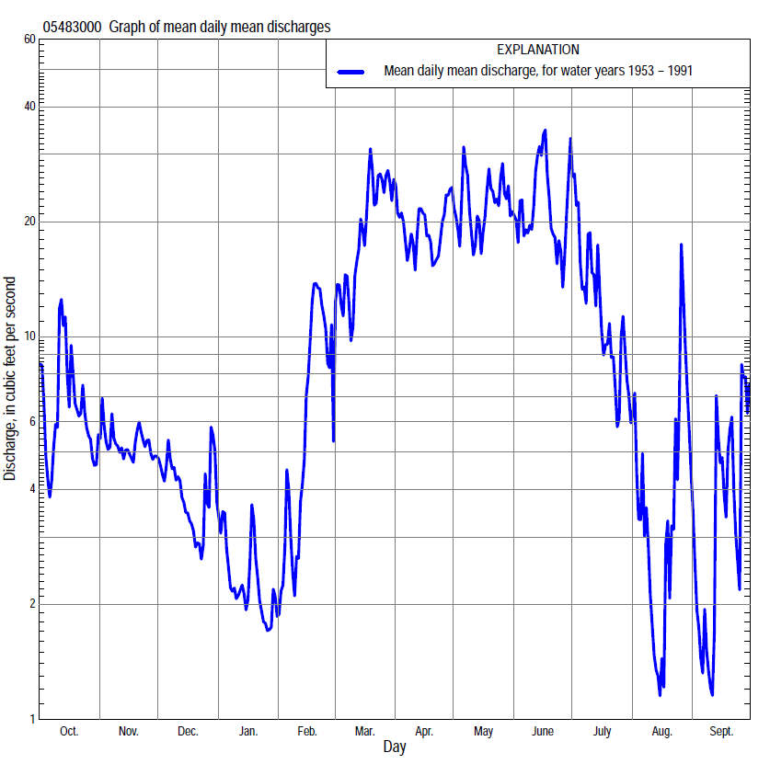

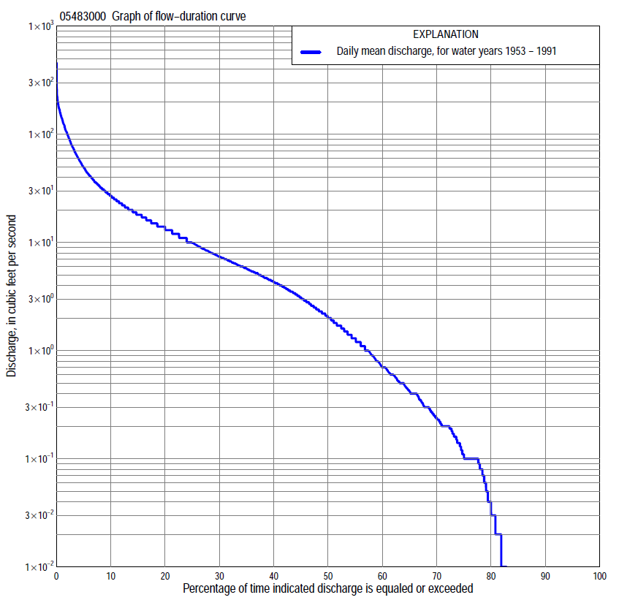

Statistics Based on the Entire Streamflow Period of Record
05483000 Monthly and annual flow durations, based on 1953–91 period of record (39 years)
Percentage of days discharge equaled or exceeded |  |  |  |  | Discharge (cubic feet per second) |  |  |  |  |  |  |  |  | Annual flow durations
 | Oct | Nov | Dec | Jan | Feb | Mar | Apr | May | June | July | Aug | Sept | Annual | Kentau statistic | P-value
99 | 0.00 | 0.00 | 0.00 | 0.00 | 0.00 | 0.00 | 0.00 | 0.00 | 0.00 | 0.00 | 0.00 | 0.00 | 0.00 | 0.003 | 0.965
98 | 0.00 | 0.00 | 0.00 | 0.00 | 0.00 | 0.00 | 0.00 | 0.00 | 0.00 | 0.00 | 0.00 | 0.00 | 0.00 | 0.042 | 0.340
95 | 0.00 | 0.00 | 0.00 | 0.00 | 0.00 | 0.00 | 0.00 | 0.01 | 0.40 | 0.00 | 0.00 | 0.00 | 0.00 | 0.042 | 0.340
90 | 0.00 | 0.00 | 0.00 | 0.00 | 0.00 | 0.10 | 0.10 | 0.33 | 1.4 | 0.32 | 0.00 | 0.00 | 0.00 | 0.012 | 0.853
85 | 0.00 | 0.00 | 0.00 | 0.00 | 0.00 | 0.20 | 0.27 | 1.5 | 2.2 | 0.50 | 0.00 | 0.00 | 0.00 | 0.040 | 0.574
80 | 0.00 | 0.00 | 0.00 | 0.00 | 0.00 | 0.35 | 1.2 | 2.5 | 3.4 | 0.71 | 0.05 | 0.00 | 0.03 | 0.069 | 0.456
75 | 0.00 | 0.04 | 0.00 | 0.00 | 0.00 | 0.70 | 2.5 | 3.8 | 4.7 | 1.0 | 0.10 | 0.00 | 0.10 | 0.124 | 0.206
70 | 0.02 | 0.10 | 0.02 | 0.00 | 0.10 | 1.6 | 4.2 | 4.9 | 5.6 | 1.3 | 0.14 | 0.01 | 0.23 | 0.167 | 0.094
65 | 0.10 | 0.11 | 0.10 | 0.00 | 0.20 | 2.6 | 5.1 | 6.0 | 6.5 | 1.6 | 0.20 | 0.03 | 0.42 | 0.194 | 0.055
60 | 0.14 | 0.23 | 0.14 | 0.02 | 0.30 | 3.7 | 6.0 | 7.1 | 7.8 | 2.0 | 0.29 | 0.10 | 0.70 | 0.194 | 0.055
55 | 0.28 | 0.40 | 0.23 | 0.10 | 0.43 | 4.5 | 7.3 | 8.5 | 8.9 | 2.4 | 0.34 | 0.10 | 1.3 | 0.217 | 0.037
50 | 0.48 | 0.77 | 0.50 | 0.23 | 0.62 | 5.8 | 8.5 | 11 | 10 | 3.0 | 0.40 | 0.20 | 2.0 | 0.250 | 0.020
45 | 0.69 | 1.2 | 1.1 | 0.43 | 1.1 | 7.4 | 11 | 13 | 12 | 3.9 | 0.52 | 0.27 | 3.1 | 0.228 | 0.037
40 | 0.92 | 3.0 | 2.5 | 0.72 | 1.7 | 9.7 | 13 | 15 | 14 | 5.0 | 0.79 | 0.40 | 4.3 | 0.238 | 0.032
35 | 2.1 | 4.5 | 3.4 | 1.6 | 2.1 | 12 | 15 | 17 | 17 | 6.3 | 1.0 | 0.53 | 5.8 | 0.242 | 0.029
30 | 4.0 | 5.6 | 4.4 | 2.3 | 3.0 | 15 | 18 | 20 | 20 | 8.0 | 1.4 | 0.70 | 7.4 | 0.215 | 0.054
25 | 6.1 | 7.2 | 5.6 | 2.9 | 4.2 | 20 | 21 | 24 | 24 | 11 | 1.8 | 1.1 | 9.9 | 0.227 | 0.043
20 | 8.1 | 9.7 | 6.9 | 3.5 | 6.0 | 25 | 26 | 31 | 29 | 14 | 2.8 | 1.7 | 14 | 0.209 | 0.062
15 | 11 | 12 | 8.5 | 4.6 | 10 | 35 | 35 | 41 | 36 | 19 | 4.4 | 3.5 | 18 | 0.217 | 0.053
10 | 20 | 15 | 12 | 7.0 | 19 | 50 | 50 | 56 | 52 | 29 | 7.7 | 6.1 | 27 | 0.188 | 0.095
5 | 32 | 23 | 17 | 10 | 36 | 97 | 83 | 92 | 92 | 62 | 17 | 17 | 50 | 0.193 | 0.086
2 | 52 | 32 | 22 | 17 | 78 | 160 | 134 | 146 | 144 | 120 | 50 | 54 | 101 | 0.078 | 0.490
1 | 105 | 38 | 31 | 21 | 110 | 178 | 156 | 179 | 183 | 151 | 83 | 85 | 141 | 0.062 | 0.586

05483000 Annual exceedance probability of instantaneous peak discharges, in cubic feet per second (ft³/s), based on the Weighted Independent Estimates method,
Annual exceed-ance probability | Recur-rence interval (years) | Discharge (ft³/s) | 95-percent lower confi-dence interval (ft³/s) | 95-percent upper confi-dence interval (ft³/s)
0.500 | 2 | 228 | 188 | 276
0.200 | 5 | 376 | 311 | 453
0.100 | 10 | 478 | 390 | 587
0.040 | 25 | 611 | 479 | 778
0.020 | 50 | 708 | 535 | 937
0.010 | 100 | 808 | 587 | 1,110
0.005 | 200 | 907 | 632 | 1,300
0.002 | 500 | 1,030 | 678 | 1,570
and based on the expected moments algorithm/multiple Grubbs-Beck analysis computed using a historical period length of 40 years (1952–1991)
0.500 | 2 | 228 | 184 | 277
0.200 | 5 | 369 | 304 | 458
0.100 | 10 | 463 | 380 | 602
0.040 | 25 | 580 | 466 | 814
0.020 | 50 | 665 | 521 | 996
0.010 | 100 | 747 | 568 | 1,200
0.005 | 200 | 827 | 608 | 1,430
0.002 | 500 | 930 | 654 | 1,770
Kentau statistic |  | 0.073
P-value |  | 0.514
Begin year |  | 1952
End year |  | 1991
Number of peaks |  | 40

05483000 Annual exceedance probability of high discharges, based on 1953–91 period of record (39 years)
Annual exceedance probability | Recur-rence interval (years) | Maximum average discharge (ft³/s) for indicated number of consecutive days
 |  | 1 | 3 | 7 | 15 | 30
0.990 | 1.01 | 29 | 15 | 7.9 | 4.9 | 3.6
0.950 | 1.05 | 53 | 31 | 18 | 12 | 8.5
0.900 | 1.11 | 71 | 45 | 27 | 18 | 13
0.800 | 1.25 | 99 | 67 | 43 | 29 | 20
0.500 | 2 | 172 | 129 | 89 | 61 | 42
0.200 | 5 | 270 | 214 | 158 | 109 | 76
0.100 | 10 | 328 | 266 | 203 | 141 | 98
0.040 | 25 | 395 | 323 | 254 | 176 | 123
0.020 | 50 | 439 | 359 | 289 | 200 | 139
0.010 | 100 | 478 | 391 | 320 | 221 | 154
0.005 | 200 | 514 | 418 | 347 | 240 | 168
0.002 | 500 | 556 | 450 | 380 | 262 | 183
Kentau statistic |  | 0.063 | 0.049 | 0.072 | 0.090 | 0.093
P-value |  | 0.578 | 0.672 | 0.529 | 0.425 | 0.411

 | 05483000 Annual nonexceedance probability of low discharges, based on April 1953 to March 1991 period of record (38 years)
Annual nonexceed-ance probability | Recur-rence interval (years) | Minimum average discharge (cubic feet per second) for indicated number of consecutive days
 |  | 1 | 3 | 7 | 14 | 30 | 60 | 90 | 120 | 183
0.01 | 100 | 0.00 | 0.00 | 0.00 | 0.00 | 0.00 | 0.00 | 0.00 | 0.00 | 0.00
0.02 | 50 | 0.00 | 0.00 | 0.00 | 0.00 | 0.00 | 0.00 | 0.00 | 0.00 | 0.00
0.05 | 20 | 0.00 | 0.00 | 0.00 | 0.00 | 0.00 | 0.00 | 0.00 | 0.00 | 0.00
0.10 | 10 | 0.00 | 0.00 | 0.00 | 0.00 | 0.00 | 0.00 | 0.00 | 0.00 | 0.01
0.20 | 5 | 0.00 | 0.00 | 0.00 | 0.00 | 0.00 | 0.00 | 0.01 | 0.02 | 0.05
0.50 | 2 | 0.00 | 0.00 | 0.00 | 0.00 | 0.02 | 0.08 | 0.19 | 0.31 | 0.67
0.80 | 1.25 | 0.14 | 0.17 | 0.21 | 0.25 | 0.45 | 0.89 | 1.7 | 2.8 | 5.2
0.90 | 1.11 | 0.47 | 0.53 | 0.64 | 0.77 | 1.3 | 2.4 | 4.7 | 7.4 | 13
0.96 | 1.04 | 1.2 | 1.3 | 1.5 | 2.0 | 3.4 | 6.0 | 13 | 19 | 31
0.98 | 1.02 | 2.0 | 2.1 | 2.5 | 3.5 | 6.0 | 10 | 25 | 34 | 51
0.99 | 1.01 | 3.0 | 3.2 | 3.6 | 5.6 | 9.6 | 17 | 45 | 54 | 78
Kentau statistic |  | 0.171 | 0.169 | 0.142 | 0.165 | 0.158 | 0.142 | 0.208 | 0.208 | 0.185
P-value |  | 0.076 | 0.078 | 0.149 | 0.112 | 0.150 | 0.209 | 0.068 | 0.068 | 0.105

05483000 Annual nonexceedance probability of seasonal low discharges, based on October 1952 to September 1991 period of record (39 years)
Annual nonexceed-ance probability | Recur-rence interval (years) | Minimum average discharge (cubic feet per second) for indicated number of consecutive days
 |  | 1 | 7 | 14 | 30 |  | 1 | 7 | 14 | 30
 |  | January-February-March |  |  |  |  | April-May-June
0.01 | 100 | 0.00 | 0.00 | 0.00 | 0.00 |  | 0.00 | 0.00 | 0.00 | 0.00
0.02 | 50 | 0.00 | 0.00 | 0.00 | 0.00 |  | 0.00 | 0.00 | 0.00 | 0.00
0.05 | 20 | 0.00 | 0.00 | 0.00 | 0.00 |  | 0.00 | 0.00 | 0.00 | 0.03
0.10 | 10 | 0.00 | 0.00 | 0.00 | 0.00 |  | 0.00 | 0.00 | 0.01 | 0.20
0.20 | 5 | 0.00 | 0.00 | 0.00 | 0.00 |  | 0.13 | 0.22 | 0.29 | 0.83
0.50 | 2 | 0.00 | 0.00 | 0.06 | 0.15 |  | 2.6 | 2.9 | 3.9 | 5.6
0.80 | 1.25 | 1.7 | 1.9 | 2.4 | 2.4 |  | 8.0 | 9.8 | 14 | 18
0.90 | 1.11 | 3.2 | 3.6 | 5.4 | 6.1 |  | 11 | 14 | 20 | 28
0.96 | 1.04 | 5.2 | 6.1 | 9.0 | 16 |  | 14 | 19 | 25 | 38
0.98 | 1.02 | 6.9 | 8.3 | 11 | 26 |  | 15 | 22 | 27 | 44
0.99 | 1.01 | 8.6 | 11 | 13 | 41 |  | 16 | 24 | 28 | 49
Kentau statistic |  | 0.147 | 0.153 | 0.221 | 0.224 |  | 0.167 | 0.148 | 0.148 | 0.120
P-value |  | 0.159 | 0.144 | 0.041 | 0.044 |  | 0.136 | 0.187 | 0.187 | 0.287
 |  | July-August-September |  |  |  |  | October-November-December
0.01 | 100 | 0.00 | 0.00 | 0.00 | 0.00 |  | 0.00 | 0.00 | 0.00 | 0.00
0.02 | 50 | 0.00 | 0.00 | 0.00 | 0.00 |  | 0.00 | 0.00 | 0.00 | 0.00
0.05 | 20 | 0.00 | 0.00 | 0.00 | 0.00 |  | 0.00 | 0.00 | 0.00 | 0.00
0.10 | 10 | 0.00 | 0.00 | 0.00 | 0.00 |  | 0.00 | 0.00 | 0.00 | 0.00
0.20 | 5 | 0.00 | 0.00 | 0.00 | 0.00 |  | 0.00 | 0.00 | 0.00 | 0.00
0.50 | 2 | 0.02 | 0.05 | 0.07 | 0.16 |  | 0.00 | 0.05 | 0.18 | 0.30
0.80 | 1.25 | 0.30 | 0.42 | 0.60 | 1.1 |  | 1.6 | 1.9 | 2.5 | 3.5
0.90 | 1.11 | 0.66 | 0.87 | 1.4 | 2.5 |  | 3.7 | 4.9 | 6.3 | 9.9
0.96 | 1.04 | 1.4 | 1.7 | 3.0 | 5.6 |  | 6.5 | 11 | 14 | 27
0.98 | 1.02 | 2.1 | 2.6 | 4.8 | 8.9 |  | 8.4 | 17 | 22 | 48
0.99 | 1.01 | 3.0 | 3.6 | 7.1 | 13 |  | 10 | 23 | 32 | 78
Kentau statistic |  | 0.011 | 0.003 | 0.028 | 0.055 |  | 0.158 | 0.158 | 0.155 | 0.178
P-value |  | 0.929 | 0.990 | 0.806 | 0.626 |  | 0.126 | 0.142 | 0.159 | 0.111

