LOCATION.--Lat 41°46'44.7", long 94°29'34.3" referenced to North American Datum of 1983, in SW 1/4 SW 1/4 SW 1/4 sec.32, T.81 N., R.31 W., Guthrie County, IA, Hydrologic Unit 07100007, on left bank 15 ft downstream from bridge on State Highway 25, 5.8 mi southeast of Bayard, 0.2 mi downstream from Battle Run Creek, 1.8 mi upstream from Springbrook Creek, 10.3 mi upstream from dam at Lake Panorama, 30.2 mi upstream from mouth, and 78.0 mi upstream from mouth of Raccoon River.

DRAINAGE AREA.--375 mi².

PERIOD OF RECORD.--Discharge records from March 1979 to current year; occasional low-flow measurements, water years 1976-1977.

GAGE.--Water-stage recorder. Datum of gage is 1,040.00 ft above National Geodetic Vertical Datum of 1929. Prior to June 23, 1979, non-recording gage at same site and datum.

EXTREMES OUTSIDE PERIOD OF RECORD.--Flood of July 3, 1973, reached a stage of 21.63 ft, from contracted-opening measurement, discharge 14,600 ft³/s.

A summary of all available data for this streamgage is provided through the USGS National Water Information System web interface (NWISWeb). The following link provides access to current/historical observations, daily data, daily statistics, monthly statistics, annual statistics, peak streamflow, field measurements, field/lab water-quality samples, and the latest water-year summaries. Data can be filtered by parameter and/or dates, and can be output in various tabular and graphical formats.
http://waterdata.usgs.gov/nwis/inventory/?site_no=05483450

The USGS WaterWatch Toolkit is available at:
http://waterwatch.usgs.gov/?id=ww_toolkit
Tools for summarizing streamflow information include the duration hydrograph builder, the cumulative streamflow hydrograph builder, the streamgage statistics retrieval tool, the rating curve builder, the flood tracking chart builder, the National Weather Service Advanced Hydrologic Prediction Service (AHPS) river forecast hydrograph builder, and the raster-hydrograph builder. Entering the above number for this streamgage into these toolkit webpages will provide streamflow information specific to this streamgage.

A description of the statistics presented for this streamgage is available in the main body of the report at:
http://dx.doi.org/10.3133/ofr20151214
A link to other streamgages included in this report, a map showing the location of the streamgages, information on the programs used to compute the statistical analyses, and references are included in the main body of the report.

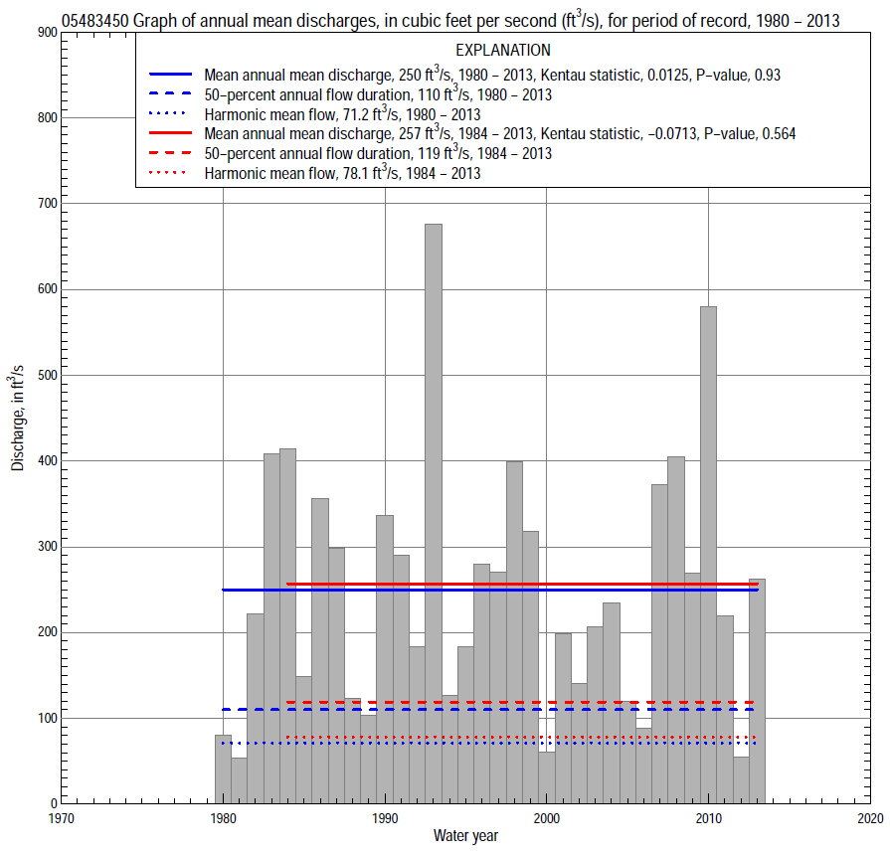

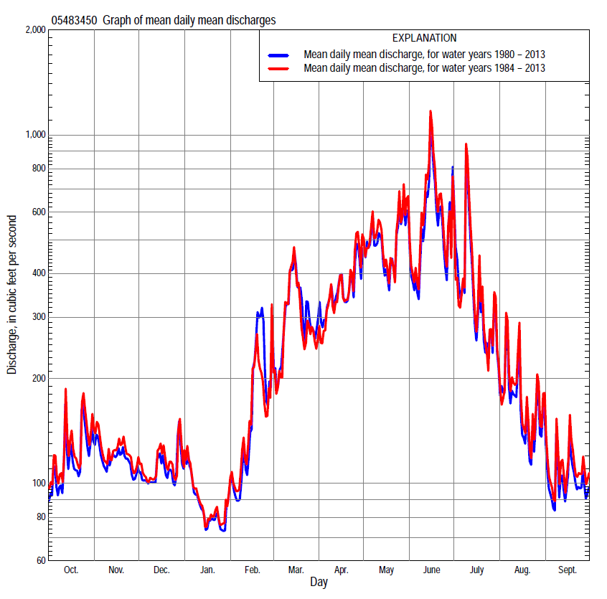

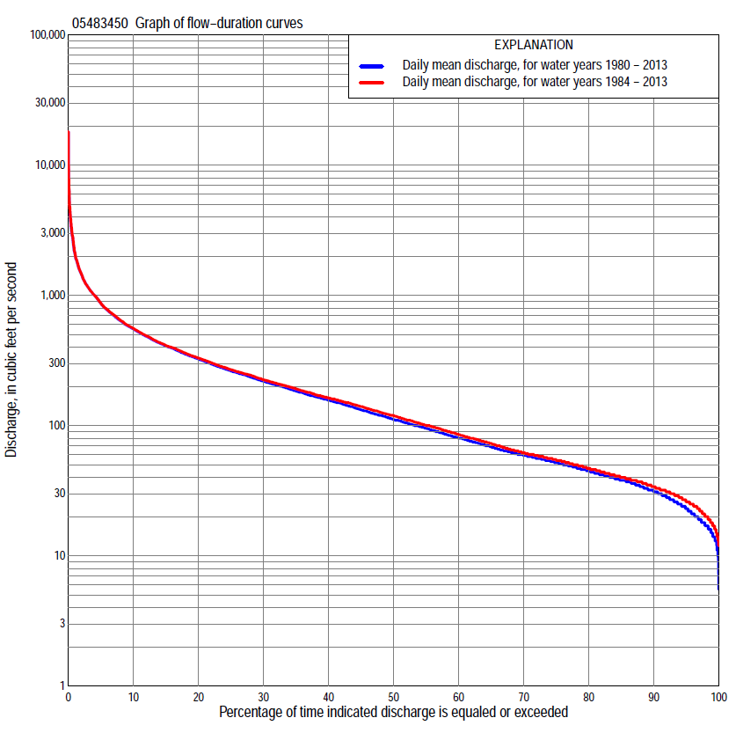

Statistics Based on the Entire Streamflow Period of Record
05483450 Monthly and annual flow durations, based on 1980–2013 period of record (34 years)
Percentage of days discharge equaled or exceeded |  |  |  |  | Discharge (cubic feet per second) |  |  |  |  |  |  |  |  | Annual flow durations
 | Oct | Nov | Dec | Jan | Feb | Mar | Apr | May | June | July | Aug | Sept | Annual | Kentau statistic | P-value
99 | 17 | 18 | 11 | 12 | 14 | 21 | 15 | 16 | 14 | 24 | 20 | 16 | 15 | 0.046 | 0.711
98 | 17 | 19 | 13 | 13 | 17 | 23 | 19 | 23 | 24 | 27 | 21 | 16 | 17 | 0.084 | 0.495
95 | 21 | 23 | 18 | 16 | 21 | 33 | 49 | 47 | 59 | 35 | 27 | 18 | 23 | 0.109 | 0.373
90 | 26 | 32 | 23 | 20 | 27 | 45 | 59 | 67 | 78 | 48 | 32 | 25 | 31 | 0.100 | 0.415
85 | 31 | 39 | 31 | 24 | 32 | 58 | 75 | 87 | 100 | 57 | 35 | 29 | 38 | 0.034 | 0.789
80 | 34 | 42 | 37 | 30 | 38 | 69 | 89 | 113 | 125 | 67 | 38 | 31 | 44 | 0.009 | 0.953
75 | 38 | 47 | 44 | 35 | 48 | 82 | 110 | 192 | 159 | 78 | 43 | 34 | 52 | 0.000 | 1.000
70 | 40 | 50 | 50 | 39 | 54 | 100 | 122 | 218 | 192 | 91 | 49 | 38 | 59 | -0.007 | 0.964
65 | 43 | 53 | 54 | 44 | 61 | 120 | 141 | 244 | 232 | 106 | 56 | 41 | 68 | -0.021 | 0.870
60 | 49 | 57 | 60 | 48 | 74 | 141 | 164 | 270 | 261 | 124 | 60 | 43 | 80 | -0.045 | 0.722
55 | 56 | 61 | 65 | 54 | 84 | 154 | 189 | 300 | 286 | 153 | 66 | 46 | 94 | -0.061 | 0.625
50 | 60 | 72 | 70 | 60 | 96 | 169 | 217 | 327 | 322 | 178 | 77 | 51 | 110 | -0.089 | 0.467
45 | 72 | 82 | 78 | 70 | 106 | 187 | 255 | 359 | 365 | 203 | 89 | 58 | 131 | -0.109 | 0.373
40 | 82 | 100 | 90 | 82 | 120 | 203 | 294 | 400 | 407 | 227 | 103 | 65 | 155 | -0.073 | 0.553
35 | 98 | 114 | 102 | 98 | 140 | 229 | 341 | 452 | 460 | 260 | 121 | 74 | 183 | -0.030 | 0.813
30 | 123 | 124 | 118 | 110 | 154 | 261 | 391 | 505 | 520 | 309 | 142 | 82 | 217 | -0.018 | 0.894
25 | 147 | 140 | 140 | 120 | 173 | 330 | 433 | 566 | 593 | 352 | 162 | 93 | 261 | 0.000 | 1.000
20 | 165 | 172 | 169 | 140 | 197 | 420 | 506 | 671 | 697 | 420 | 205 | 116 | 321 | 0.007 | 0.965
15 | 191 | 236 | 204 | 161 | 241 | 517 | 635 | 796 | 853 | 561 | 278 | 172 | 406 | 0.025 | 0.847
10 | 250 | 282 | 235 | 180 | 318 | 638 | 823 | 1,040 | 1,200 | 743 | 384 | 253 | 547 | 0.016 | 0.906
5 | 378 | 342 | 279 | 211 | 624 | 976 | 1,150 | 1,460 | 1,830 | 1,170 | 595 | 363 | 862 | 0.055 | 0.657
2 | 633 | 423 | 419 | 316 | 1,100 | 1,660 | 1,630 | 2,410 | 3,540 | 1,980 | 1,120 | 551 | 1,450 | 0.086 | 0.486
1 | 801 | 502 | 560 | 380 | 1,550 | 2,370 | 2,000 | 3,260 | 4,820 | 3,130 | 1,480 | 774 | 2,100 | 0.089 | 0.468

05483450 Annual exceedance probability of instantaneous peak discharges, in cubic feet per second (ft³/s), based on the Weighted Independent Estimates method,
Annual exceed-ance probability | Recur-rence interval (years) | Discharge (ft³/s) | 95-percent lower confi-dence interval (ft³/s) | 95-percent upper confi-dence interval (ft³/s)
0.500 | 2 | 3,680 | 3,160 | 4,300
0.200 | 5 | 7,240 | 6,230 | 8,420
0.100 | 10 | 10,000 | 8,510 | 11,900
0.040 | 25 | 14,000 | 11,400 | 17,100
0.020 | 50 | 17,100 | 13,400 | 21,800
0.010 | 100 | 20,400 | 15,400 | 27,100
0.005 | 200 | 23,900 | 17,200 | 33,100
0.002 | 500 | 28,500 | 19,400 | 41,900
and based on the expected moments algorithm/multiple Grubbs-Beck analysis computed using a historical period length of 128 years (1886–2013)
0.500 | 2 | 3,680 | 2,710 | 4,890
0.200 | 5 | 7,230 | 5,470 | 9,570
0.100 | 10 | 10,000 | 7,520 | 13,400
0.040 | 25 | 13,900 | 10,200 | 19,300
0.020 | 50 | 17,100 | 12,100 | 24,700
0.010 | 100 | 20,400 | 13,900 | 31,000
0.005 | 200 | 23,800 | 15,600 | 38,600
0.002 | 500 | 28,500 | 17,700 | 50,700
Kentau statistic |  | -0.012
P-value |  | 0.932
Begin year |  | 1979
End year |  | 2013
Number of peaks |  | 35

05483450 Annual exceedance probability of high discharges, based on 1980–2013 period of record (34 years)
[ND, not determined]
Annual exceedance probability | Recur-rence interval (years) | Maximum average discharge (ft³/s) for indicated number of consecutive days
 |  | 1 | 3 | 7 | 15 | 30
0.990 | 1.01 | ND | 196 | 146 | 99 | 74
0.950 | 1.05 | ND | 387 | 282 | 196 | 152
0.900 | 1.11 | ND | 552 | 398 | 280 | 219
0.800 | 1.25 | ND | 846 | 600 | 425 | 332
0.500 | 2 | ND | 1,880 | 1,300 | 914 | 698
0.200 | 5 | ND | 4,110 | 2,750 | 1,880 | 1,360
0.100 | 10 | ND | 6,120 | 4,030 | 2,680 | 1,880
0.040 | 25 | ND | 9,320 | 6,030 | 3,880 | 2,590
0.020 | 50 | ND | 12,200 | 7,800 | 4,890 | 3,150
0.010 | 100 | ND | 15,500 | 9,800 | 5,990 | 3,740
0.005 | 200 | ND | 19,200 | 12,100 | 7,180 | 4,340
0.002 | 500 | ND | 24,900 | 15,500 | 8,910 | 5,160
Kentau statistic |  | 0.048 | 0.087 | 0.091 | 0.102 | 0.123
P-value |  | 0.700 | 0.477 | 0.459 | 0.406 | 0.313

 | 05483450 Annual nonexceedance probability of low discharges, based on April 1979 to March 2013 period of record (34 years)
Annual nonexceed-ance probability | Recur-rence interval (years) | Minimum average discharge (cubic feet per second) for indicated number of consecutive days
 |  | 1 | 3 | 7 | 14 | 30 | 60 | 90 | 120 | 183
0.01 | 100 | 5.8 | 6.0 | 7.0 | 8.1 | 9.9 | 13 | 13 | 14 | 14
0.02 | 50 | 7.0 | 7.4 | 8.5 | 9.8 | 12 | 15 | 16 | 17 | 18
0.05 | 20 | 9.2 | 9.9 | 11 | 13 | 15 | 19 | 20 | 22 | 24
0.10 | 10 | 12 | 13 | 15 | 17 | 19 | 23 | 26 | 28 | 31
0.20 | 5 | 16 | 17 | 20 | 22 | 25 | 30 | 34 | 37 | 43
0.50 | 2 | 27 | 30 | 34 | 37 | 42 | 50 | 58 | 65 | 78
0.80 | 1.25 | 47 | 51 | 56 | 61 | 69 | 84 | 102 | 116 | 142
0.90 | 1.11 | 62 | 66 | 72 | 78 | 89 | 111 | 137 | 159 | 193
0.96 | 1.04 | 83 | 87 | 94 | 100 | 115 | 149 | 189 | 223 | 266
0.98 | 1.02 | 100 | 104 | 110 | 117 | 136 | 181 | 233 | 279 | 328
0.99 | 1.01 | 118 | 121 | 127 | 134 | 157 | 216 | 282 | 342 | 395
Kentau statistic |  | -0.089 | -0.037 | 0.004 | 0.041 | 0.020 | -0.030 | -0.020 | -0.009 | -0.012
P-value |  | 0.467 | 0.767 | 0.988 | 0.744 | 0.882 | 0.813 | 0.882 | 0.953 | 0.929

05483450 Annual nonexceedance probability of seasonal low discharges, based on April 1979 to September 2013 period of record (34–35 years)
Annual nonexceed-ance probability | Recur-rence interval (years) | Minimum average discharge (cubic feet per second) for indicated number of consecutive days
 |  | 1 | 7 | 14 | 30 |  | 1 | 7 | 14 | 30
 |  | January-February-March |  |  |  |  | April-May-June
0.01 | 100 | 6.5 | 8.2 | 8.7 | 9.1 |  | 7.5 | 9.4 | 13 | 20
0.02 | 50 | 7.9 | 10 | 11 | 11 |  | 11 | 14 | 18 | 27
0.05 | 20 | 11 | 14 | 15 | 16 |  | 20 | 23 | 29 | 42
0.10 | 10 | 14 | 18 | 19 | 22 |  | 32 | 36 | 44 | 61
0.20 | 5 | 19 | 25 | 27 | 31 |  | 52 | 58 | 69 | 93
0.50 | 2 | 35 | 45 | 50 | 59 |  | 116 | 131 | 150 | 194
0.80 | 1.25 | 66 | 81 | 91 | 108 |  | 212 | 251 | 288 | 366
0.90 | 1.11 | 93 | 110 | 124 | 147 |  | 271 | 334 | 387 | 491
0.96 | 1.04 | 134 | 153 | 172 | 200 |  | 336 | 435 | 511 | 654
0.98 | 1.02 | 169 | 188 | 211 | 243 |  | 378 | 506 | 602 | 776
0.99 | 1.01 | 210 | 226 | 254 | 289 |  | 413 | 572 | 689 | 897
Kentau statistic |  | -0.157 | -0.084 | -0.068 | -0.052 |  | -0.022 | -0.010 | 0.055 | 0.119
P-value |  | 0.197 | 0.495 | 0.583 | 0.678 |  | 0.865 | 0.943 | 0.650 | 0.320
 |  | July-August-September |  |  |  |  | October-November-December
0.01 | 100 | 14 | 15 | 16 | 19 |  | 8.1 | 8.8 | 9.9 | 11
0.02 | 50 | 15 | 16 | 17 | 20 |  | 9.4 | 11 | 12 | 14
0.05 | 20 | 17 | 18 | 19 | 22 |  | 12 | 14 | 16 | 18
0.10 | 10 | 19 | 21 | 22 | 25 |  | 15 | 18 | 20 | 23
0.20 | 5 | 23 | 25 | 27 | 30 |  | 20 | 24 | 27 | 32
0.50 | 2 | 36 | 39 | 43 | 49 |  | 35 | 44 | 49 | 60
0.80 | 1.25 | 69 | 73 | 80 | 95 |  | 65 | 81 | 90 | 115
0.90 | 1.11 | 103 | 109 | 118 | 146 |  | 92 | 111 | 124 | 164
0.96 | 1.04 | 167 | 177 | 188 | 243 |  | 134 | 158 | 176 | 241
0.98 | 1.02 | 237 | 249 | 262 | 351 |  | 172 | 199 | 221 | 311
0.99 | 1.01 | 331 | 347 | 359 | 500 |  | 218 | 245 | 272 | 393
Kentau statistic |  | 0.039 | 0.022 | 0.015 | -0.008 |  | -0.005 | 0.014 | 0.025 | 0.018
P-value |  | 0.754 | 0.865 | 0.910 | 0.955 |  | 0.976 | 0.917 | 0.847 | 0.894

Statistics Based on the 1984–2013 Streamflow Period of Record
05483450 Monthly and annual flow durations, based on 1984–2013 period of record (30 years)
Percentage of days discharge equaled or exceeded |  |  |  |  | Discharge (cubic feet per second) |  |  |  |  |  |  |  |  | Annual flow durations
 | Oct | Nov | Dec | Jan | Feb | Mar | Apr | May | June | July | Aug | Sept | Annual | Kentau statistic | P-value
99 | 18 | 20 | 15 | 13 | 18 | 28 | 38 | 34 | 52 | 24 | 20 | 16 | 18 | -0.069 | 0.604
98 | 19 | 23 | 16 | 14 | 20 | 32 | 46 | 44 | 56 | 29 | 21 | 17 | 20 | -0.028 | 0.844
95 | 24 | 26 | 21 | 17 | 25 | 38 | 55 | 65 | 64 | 42 | 27 | 20 | 26 | -0.007 | 0.971
90 | 29 | 36 | 25 | 23 | 29 | 52 | 62 | 86 | 86 | 52 | 32 | 27 | 34 | -0.025 | 0.858
85 | 32 | 41 | 33 | 28 | 35 | 63 | 80 | 106 | 111 | 60 | 35 | 30 | 40 | -0.097 | 0.464
80 | 37 | 43 | 38 | 34 | 40 | 72 | 98 | 181 | 136 | 72 | 38 | 32 | 47 | -0.101 | 0.443
75 | 39 | 48 | 44 | 38 | 50 | 89 | 115 | 210 | 171 | 82 | 43 | 35 | 54 | -0.108 | 0.412
70 | 43 | 50 | 49 | 41 | 58 | 104 | 129 | 230 | 204 | 93 | 49 | 39 | 62 | -0.122 | 0.353
65 | 47 | 53 | 54 | 46 | 68 | 124 | 147 | 254 | 241 | 109 | 56 | 41 | 73 | -0.143 | 0.276
60 | 54 | 58 | 59 | 50 | 78 | 143 | 173 | 277 | 268 | 124 | 60 | 45 | 85 | -0.163 | 0.212
55 | 59 | 63 | 65 | 56 | 88 | 155 | 202 | 307 | 304 | 153 | 68 | 48 | 100 | -0.172 | 0.187
50 | 66 | 75 | 70 | 64 | 100 | 167 | 232 | 330 | 339 | 178 | 80 | 56 | 119 | -0.207 | 0.112
45 | 79 | 90 | 78 | 75 | 110 | 184 | 276 | 361 | 396 | 207 | 94 | 64 | 140 | -0.211 | 0.104
40 | 96 | 106 | 93 | 86 | 128 | 199 | 309 | 402 | 435 | 234 | 112 | 71 | 163 | -0.149 | 0.254
35 | 115 | 120 | 109 | 100 | 143 | 220 | 355 | 456 | 488 | 272 | 131 | 79 | 192 | -0.113 | 0.392
30 | 140 | 130 | 130 | 110 | 157 | 250 | 392 | 509 | 554 | 316 | 152 | 88 | 225 | -0.097 | 0.464
25 | 157 | 150 | 150 | 124 | 173 | 301 | 433 | 579 | 631 | 369 | 175 | 102 | 269 | -0.083 | 0.532
20 | 171 | 202 | 180 | 142 | 193 | 387 | 497 | 678 | 729 | 441 | 226 | 137 | 330 | -0.083 | 0.532
15 | 206 | 251 | 209 | 163 | 228 | 493 | 611 | 799 | 928 | 581 | 297 | 194 | 413 | -0.060 | 0.656
10 | 261 | 292 | 242 | 182 | 282 | 628 | 799 | 1,040 | 1,280 | 756 | 403 | 285 | 558 | -0.053 | 0.695
5 | 412 | 354 | 283 | 214 | 500 | 954 | 1,080 | 1,520 | 1,890 | 1,170 | 630 | 392 | 870 | 0.002 | 1.000
2 | 663 | 428 | 450 | 316 | 920 | 1,660 | 1,620 | 2,520 | 3,590 | 1,920 | 1,120 | 570 | 1,460 | 0.032 | 0.817
1 | 854 | 509 | 600 | 400 | 1,200 | 2,760 | 2,000 | 3,820 | 4,860 | 3,850 | 1,770 | 827 | 2,130 | 0.037 | 0.789

05483450 Annual exceedance probability of high discharges, based on 1984–2013 period of record (30 years)
Annual exceedance probability | Recur-rence interval (years) | Maximum average discharge (ft³/s) for indicated number of consecutive days
 |  | 1 | 3 | 7 | 15 | 30
0.990 | 1.01 | 252 | 200 | 147 | 101 | 77
0.950 | 1.05 | 533 | 400 | 290 | 205 | 161
0.900 | 1.11 | 783 | 575 | 412 | 295 | 234
0.800 | 1.25 | 1,230 | 887 | 627 | 450 | 357
0.500 | 2 | 2,800 | 1,990 | 1,360 | 969 | 749
0.200 | 5 | 6,030 | 4,340 | 2,890 | 1,970 | 1,440
0.100 | 10 | 8,830 | 6,450 | 4,220 | 2,800 | 1,950
0.040 | 25 | 13,000 | 9,770 | 6,270 | 4,000 | 2,650
0.020 | 50 | 16,600 | 12,700 | 8,060 | 5,000 | 3,180
0.010 | 100 | 20,600 | 16,100 | 10,100 | 6,070 | 3,710
0.005 | 200 | 25,000 | 19,900 | 12,300 | 7,220 | 4,250
0.002 | 500 | 31,300 | 25,600 | 15,700 | 8,850 | 4,970
Kentau statistic |  | -0.016 | 0.021 | 0.030 | 0.034 | 0.048
P-value |  | 0.915 | 0.887 | 0.830 | 0.803 | 0.721

 | 05483450 Annual nonexceedance probability of low discharges, based on April 1983 to March 2013 period of record (30 years)
Annual nonexceed-ance probability | Recur-rence interval (years) | Minimum average discharge (cubic feet per second) for indicated number of consecutive days
 |  | 1 | 3 | 7 | 14 | 30 | 60 | 90 | 120 | 183
0.01 | 100 | 9.2 | 9.6 | 11 | 11 | 12 | 15 | 16 | 17 | 18
0.02 | 50 | 10 | 11 | 12 | 13 | 14 | 17 | 18 | 19 | 20
0.05 | 20 | 12 | 13 | 15 | 16 | 18 | 21 | 23 | 24 | 26
0.10 | 10 | 14 | 16 | 18 | 19 | 22 | 25 | 28 | 30 | 34
0.20 | 5 | 18 | 19 | 22 | 25 | 28 | 32 | 36 | 39 | 46
0.50 | 2 | 28 | 31 | 35 | 39 | 45 | 52 | 60 | 67 | 83
0.80 | 1.25 | 46 | 51 | 57 | 62 | 72 | 87 | 105 | 120 | 149
0.90 | 1.11 | 62 | 68 | 74 | 80 | 92 | 115 | 143 | 166 | 202
0.96 | 1.04 | 88 | 93 | 99 | 104 | 120 | 158 | 202 | 238 | 281
0.98 | 1.02 | 110 | 115 | 121 | 123 | 142 | 195 | 254 | 302 | 347
0.99 | 1.01 | 137 | 141 | 144 | 145 | 166 | 237 | 313 | 377 | 420
Kentau statistic |  | -0.214 | -0.154 | -0.115 | -0.080 | -0.094 | -0.122 | -0.090 | -0.080 | -0.117
P-value |  | 0.101 | 0.239 | 0.382 | 0.544 | 0.475 | 0.354 | 0.498 | 0.544 | 0.372

05483450 Annual nonexceedance probability of seasonal low discharges, based on October 1983 to September 2013 period of record (30 years)
Annual nonexceed-ance probability | Recur-rence interval (years) | Minimum average discharge (cubic feet per second) for indicated number of consecutive days
 |  | 1 | 7 | 14 | 30 |  | 1 | 7 | 14 | 30
 |  | January-February-March |  |  |  |  | April-May-June
0.01 | 100 | 7.2 | 10 | 11 | 11 |  | 20 | 21 | 24 | 30
0.02 | 50 | 8.6 | 12 | 13 | 14 |  | 25 | 26 | 30 | 38
0.05 | 20 | 11 | 16 | 17 | 19 |  | 33 | 36 | 42 | 54
0.10 | 10 | 15 | 20 | 22 | 24 |  | 43 | 47 | 56 | 74
0.20 | 5 | 20 | 27 | 29 | 34 |  | 59 | 67 | 79 | 106
0.50 | 2 | 36 | 46 | 52 | 62 |  | 109 | 128 | 152 | 205
0.80 | 1.25 | 68 | 82 | 92 | 110 |  | 203 | 247 | 289 | 377
0.90 | 1.11 | 95 | 111 | 125 | 147 |  | 281 | 348 | 403 | 509
0.96 | 1.04 | 137 | 154 | 172 | 198 |  | 398 | 503 | 574 | 692
0.98 | 1.02 | 174 | 190 | 212 | 239 |  | 500 | 639 | 720 | 838
0.99 | 1.01 | 217 | 231 | 255 | 282 |  | 613 | 791 | 882 | 991
Kentau statistic |  | -0.255 | -0.172 | -0.163 | -0.149 |  | -0.094 | -0.090 | -0.021 | 0.039
P-value |  | 0.050 | 0.187 | 0.212 | 0.254 |  | 0.475 | 0.498 | 0.887 | 0.775
 |  | July-August-September |  |  |  |  | October-November-December
0.01 | 100 | 14 | 15 | 16 | 18 |  | 9.0 | 10 | 12 | 14
0.02 | 50 | 15 | 16 | 17 | 20 |  | 10 | 12 | 14 | 16
0.05 | 20 | 17 | 18 | 20 | 22 |  | 13 | 15 | 18 | 20
0.10 | 10 | 20 | 21 | 23 | 26 |  | 16 | 19 | 22 | 26
0.20 | 5 | 24 | 26 | 28 | 31 |  | 21 | 26 | 29 | 35
0.50 | 2 | 39 | 42 | 46 | 52 |  | 37 | 46 | 52 | 63
0.80 | 1.25 | 74 | 80 | 86 | 103 |  | 68 | 85 | 95 | 121
0.90 | 1.11 | 112 | 119 | 128 | 159 |  | 96 | 117 | 131 | 173
0.96 | 1.04 | 184 | 194 | 206 | 269 |  | 142 | 168 | 187 | 258
0.98 | 1.02 | 261 | 274 | 287 | 391 |  | 185 | 212 | 236 | 337
0.99 | 1.01 | 366 | 382 | 395 | 562 |  | 236 | 263 | 292 | 432
Kentau statistic |  | -0.062 | -0.085 | -0.099 | -0.080 |  | -0.094 | -0.087 | -0.080 | -0.076
P-value |  | 0.642 | 0.521 | 0.454 | 0.544 |  | 0.475 | 0.509 | 0.544 | 0.568

