LOCATION.--Lat 41°41'14", long 94°22'15" referenced to North American Datum of 1927, in NW 1/4 NE 1/4 NW 1/4 sec.05, T.79 N., R.30 W., Guthrie County, IA, Hydrologic Unit 07100007, on right bank 10 ft upstream from bridge on Soldier Trail, at southwestern edge of Panora, 1.5 mi upstream from Andy's Branch, 1.6 mi downstream from Lake Panorama, 18.2 mi upstream from mouth, and 66.1 mi upstream from mouth of Raccoon River.

DRAINAGE AREA.--440 mi².

PERIOD OF RECORD.--Discharge records from June 1958 to current year.

GAGE.--Water-stage recorder and concrete control. Datum of gage is 991.20 ft above National Geodetic Vertical Datum of 1929. Prior to September 9, 2009, at site 25 ft downstream at same datum.

REMARKS.--Panora Water Department diverts approximately 100 acre-ft/yr upstream of station. Flow regulated by dam on Lake Panorama since August 1970.

EXTREMES OUTSIDE PERIOD OF RECORD.--Flood of June 10, 1953, reached a stage of 14.3 ft, from high-water mark, discharge about 14,000 ft³/s.

A summary of all available data for this streamgage is provided through the USGS National Water Information System web interface (NWISWeb). The following link provides access to current/historical observations, daily data, daily statistics, monthly statistics, annual statistics, peak streamflow, field measurements, field/lab water-quality samples, and the latest water-year summaries. Data can be filtered by parameter and/or dates, and can be output in various tabular and graphical formats.
http://waterdata.usgs.gov/nwis/inventory/?site_no=05483600

The USGS WaterWatch Toolkit is available at:
http://waterwatch.usgs.gov/?id=ww_toolkit
Tools for summarizing streamflow information include the duration hydrograph builder, the cumulative streamflow hydrograph builder, the streamgage statistics retrieval tool, the rating curve builder, the flood tracking chart builder, the National Weather Service Advanced Hydrologic Prediction Service (AHPS) river forecast hydrograph builder, and the raster-hydrograph builder. Entering the above number for this streamgage into these toolkit webpages will provide streamflow information specific to this streamgage.

A description of the statistics presented for this streamgage is available in the main body of the report at:
http://dx.doi.org/10.3133/ofr20151214
A link to other streamgages included in this report, a map showing the location of the streamgages, information on the programs used to compute the statistical analyses, and references are included in the main body of the report.

Statistics Based on the Pre-regulated Streamflow Period of Record

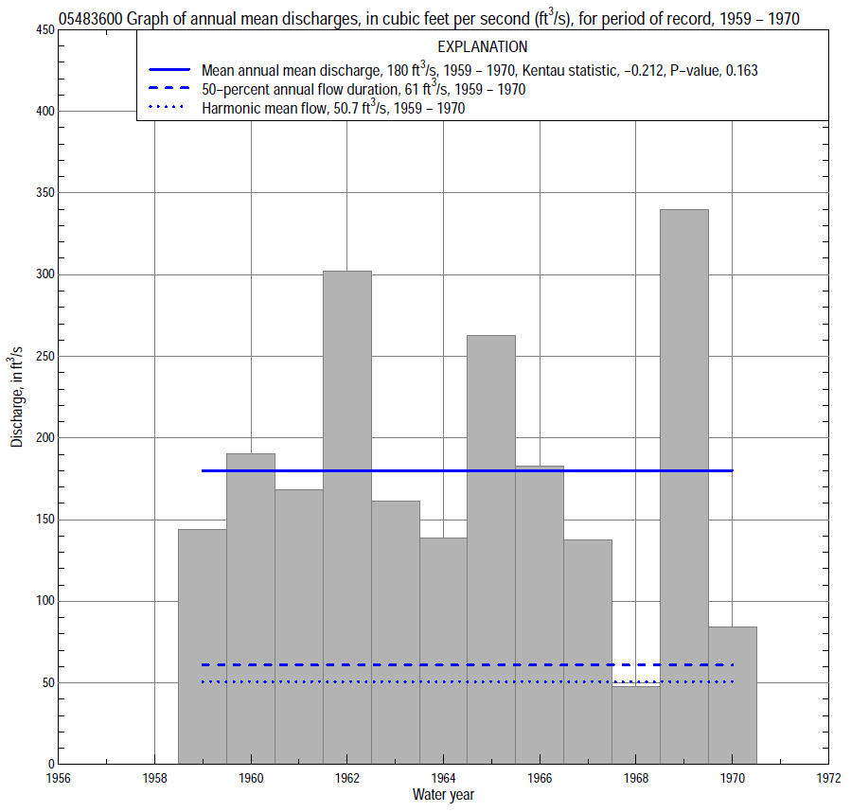

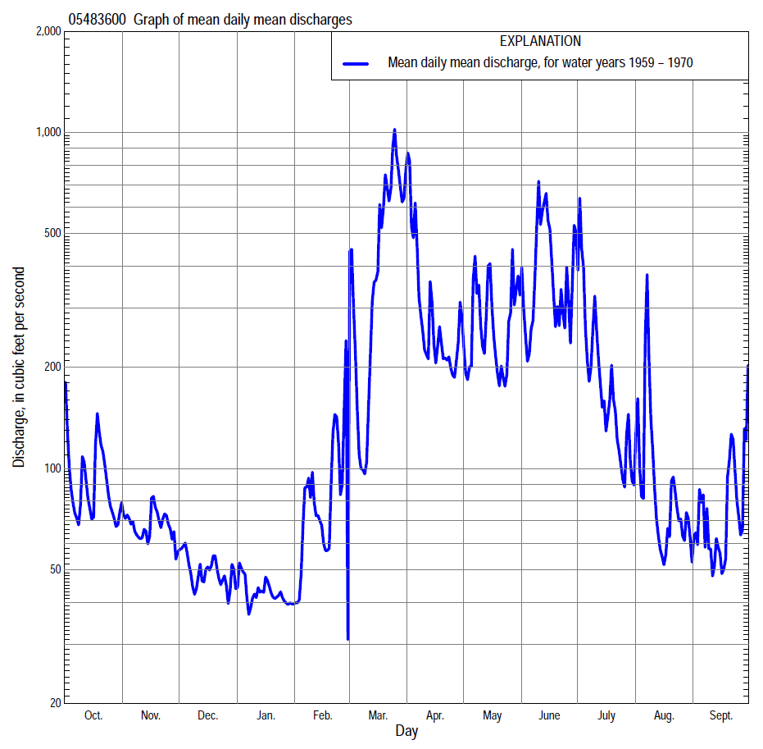

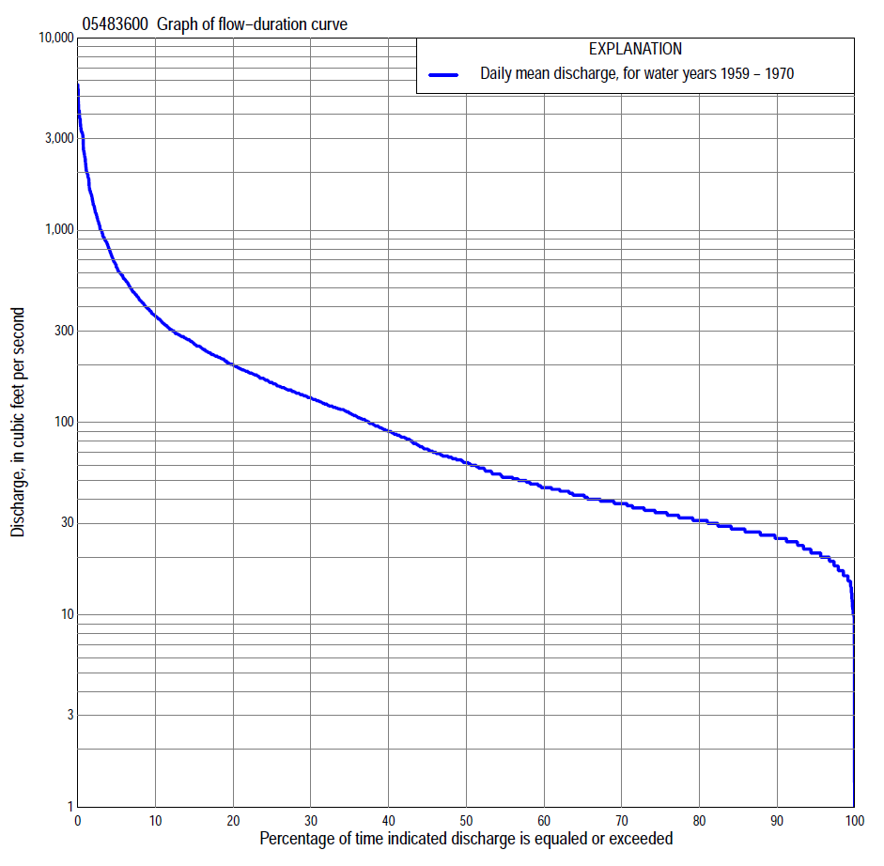

Statistics Based on the Pre-regulated Streamflow Period of Record
05483600 Monthly and annual flow durations, based on 1959–70 pre-regulated period of record (12 years)
Percentage of days discharge equaled or exceeded |  |  |  |  | Discharge (cubic feet per second) |  |  |  |  |  |  |  |  | Annual flow durations
 | Oct | Nov | Dec | Jan | Feb | Mar | Apr | May | June | July | Aug | Sept | Annual | Kentau statistic | P-value
99 | 19 | 16 | 15 | 10 | 15 | 27 | 26 | 20 | 22 | 31 | 20 | 19 | 16 | -0.015 | 1.000
98 | 21 | 19 | 16 | 10 | 15 | 28 | 27 | 20 | 24 | 32 | 20 | 19 | 17 | 0.015 | 1.000
95 | 22 | 25 | 18 | 15 | 17 | 31 | 32 | 27 | 30 | 33 | 22 | 21 | 21 | 0.000 | 1.000
90 | 26 | 27 | 20 | 17 | 19 | 32 | 35 | 35 | 41 | 37 | 24 | 23 | 25 | 0.015 | 1.000
85 | 27 | 28 | 22 | 20 | 23 | 36 | 62 | 45 | 70 | 42 | 27 | 25 | 28 | 0.030 | 0.945
80 | 30 | 29 | 24 | 21 | 27 | 40 | 74 | 74 | 99 | 51 | 29 | 27 | 31 | 0.015 | 1.000
75 | 32 | 31 | 25 | 24 | 30 | 46 | 94 | 106 | 115 | 60 | 32 | 30 | 34 | -0.015 | 1.000
70 | 34 | 34 | 26 | 26 | 33 | 58 | 110 | 125 | 130 | 66 | 35 | 35 | 38 | -0.045 | 0.890
65 | 36 | 38 | 27 | 27 | 36 | 77 | 122 | 145 | 142 | 71 | 39 | 39 | 40 | -0.076 | 0.783
60 | 38 | 39 | 28 | 28 | 39 | 93 | 138 | 154 | 155 | 76 | 43 | 42 | 46 | -0.091 | 0.730
55 | 39 | 39 | 29 | 30 | 43 | 103 | 160 | 166 | 170 | 84 | 46 | 45 | 52 | -0.076 | 0.783
50 | 41 | 42 | 31 | 32 | 46 | 120 | 192 | 182 | 189 | 93 | 50 | 47 | 61 | -0.015 | 1.000
45 | 44 | 44 | 33 | 34 | 49 | 137 | 222 | 197 | 215 | 105 | 54 | 51 | 72 | -0.045 | 0.891
40 | 47 | 46 | 35 | 36 | 53 | 174 | 250 | 209 | 240 | 120 | 58 | 54 | 90 | -0.106 | 0.680
35 | 51 | 51 | 39 | 39 | 62 | 240 | 280 | 231 | 276 | 140 | 62 | 56 | 111 | -0.121 | 0.631
30 | 57 | 52 | 45 | 45 | 70 | 304 | 300 | 255 | 328 | 158 | 69 | 62 | 133 | -0.091 | 0.732
25 | 66 | 73 | 56 | 56 | 82 | 375 | 325 | 290 | 402 | 186 | 82 | 67 | 159 | -0.258 | 0.271
20 | 135 | 126 | 72 | 64 | 102 | 525 | 379 | 356 | 477 | 215 | 94 | 73 | 197 | -0.303 | 0.193
15 | 177 | 143 | 110 | 80 | 135 | 678 | 476 | 426 | 613 | 250 | 111 | 84 | 254 | -0.288 | 0.216
10 | 218 | 162 | 122 | 85 | 200 | 1,300 | 596 | 584 | 1,010 | 345 | 143 | 99 | 356 | -0.394 | 0.086
5 | 335 | 185 | 137 | 94 | 300 | 3,000 | 1,000 | 848 | 1,800 | 590 | 231 | 185 | 641 | -0.091 | 0.732
2 | 578 | 216 | 152 | 118 | 555 | 4,070 | 1,950 | 1,340 | 2,350 | 871 | 552 | 676 | 1,350 | -0.030 | 0.945
1 | 725 | 222 | 155 | 140 | 730 | 4,200 | 3,190 | 1,850 | 2,510 | 1,120 | 902 | 1,010 | 2,120 | 0.030 | 0.945

05483600 Annual exceedance probability of instantaneous peak discharges, in cubic feet per second (ft³/s), based on the Weighted Independent Estimates method,
Annual exceed-ance probability | Recur-rence interval (years) | Discharge (ft³/s) | 95-percent lower confi-dence interval (ft³/s) | 95-percent upper confi-dence interval (ft³/s)
0.500 | 2 | 4,730 | 4,200 | 5,330
0.200 | 5 | 7,340 | 6,500 | 8,290
0.100 | 10 | 9,150 | 7,990 | 10,500
0.040 | 25 | 11,500 | 9,750 | 13,600
0.020 | 50 | 13,300 | 10,900 | 16,200
0.010 | 100 | 15,200 | 12,100 | 19,100
0.005 | 200 | 17,100 | 13,200 | 22,300
0.002 | 500 | 19,700 | 14,400 | 26,800
and based on the expected moments algorithm/multiple Grubbs-Beck analysis computed using a pre-regulated historical period length of 85 years (1886–1970)
0.500 | 2 | 4,740 | 3,180 | 6,430
0.200 | 5 | 7,310 | 5,360 | 10,200
0.100 | 10 | 9,050 | 6,540 | 13,200
0.040 | 25 | 11,300 | 7,910 | 17,600
0.020 | 50 | 12,900 | 8,860 | 21,400
0.010 | 100 | 14,500 | 9,740 | 25,600
0.005 | 200 | 16,200 | 10,600 | 30,200
0.002 | 500 | 18,300 | 11,500 | 36,900
Kentau statistic |  | -0.077
P-value |  | 0.760
Begin year |  | 1958
End year |  | 1970
Number of peaks |  | 13

05483600 Annual exceedance probability of high discharges, based on 1959–70 pre-regulated period of record (12 years)
Annual exceedance probability | Recur-rence interval (years) | Maximum average discharge (cubic feet per second) for indicated number of consecutive days
 |  | 1 | 3 | 7 | 15 | 30
0.990 | 1.01 | 703 | 401 | 358 | 205 | 113
0.950 | 1.05 | 1,190 | 773 | 568 | 334 | 213
0.900 | 1.11 | 1,520 | 1,050 | 723 | 430 | 291
0.800 | 1.25 | 1,990 | 1,470 | 963 | 582 | 412
0.500 | 2 | 3,090 | 2,490 | 1,650 | 1,020 | 742
0.200 | 5 | 4,350 | 3,710 | 2,760 | 1,770 | 1,220
0.100 | 10 | 5,010 | 4,350 | 3,390 | 2,330 | 1,520
0.040 | 25 | 5,680 | 4,990 | 4,030 | 3,120 | 1,870
0.020 | 50 | 6,090 | 5,370 | 4,540 | 3,760 | 2,120
0.010 | 100 | 6,430 | 5,680 | 5,080 | 4,430 | 2,340
0.005 | 200 | 6,720 | 5,940 | 5,580 | 5,140 | 2,550
0.002 | 500 | 7,040 | 6,210 | 6,170 | 6,140 | 2,810
Kentau statistic |  | -0.106 | -0.030 | -0.030 | -0.061 | 0.000
P-value |  | 0.680 | 0.945 | 0.945 | 0.837 | 1.000

 | 05483600 Annual nonexceedance probability of low discharges, based on April 1959 to March 1970 pre-regulated period of record (11 years)
Annual nonexceed-ance probability | Recur-rence interval (years) | Minimum average discharge (cubic feet per second) for indicated number of consecutive days
 |  | 1 | 3 | 7 | 14 | 30 | 60 | 90 | 120 | 183
0.01 | 100 | 0.39 | 9.6 | 11 | 12 | 17 | 21 | 20 | 18 | 20
0.02 | 50 | 0.80 | 10 | 11 | 12 | 17 | 21 | 20 | 19 | 21
0.05 | 20 | 2.1 | 12 | 12 | 14 | 17 | 22 | 21 | 21 | 23
0.10 | 10 | 4.1 | 13 | 14 | 15 | 18 | 22 | 23 | 23 | 26
0.20 | 5 | 8.1 | 15 | 16 | 17 | 20 | 24 | 26 | 27 | 31
0.50 | 2 | 18 | 20 | 21 | 23 | 26 | 29 | 35 | 40 | 46
0.80 | 1.25 | 25 | 27 | 30 | 33 | 38 | 43 | 56 | 68 | 80
0.90 | 1.11 | 26 | 32 | 38 | 41 | 50 | 57 | 76 | 96 | 114
0.96 | 1.04 | 27 | 39 | 50 | 53 | 71 | 82 | 111 | 145 | 176
0.98 | 1.02 | 27 | 44 | 60 | 63 | 92 | 107 | 146 | 195 | 240
0.99 | 1.01 | 27 | 49 | 71 | 75 | 118 | 141 | 192 | 260 | 324
Kentau statistic |  | -0.255 | 0.200 | 0.127 | 0.127 | 0.018 | 0.091 | 0.055 | -0.018 | -0.018
P-value |  | 0.310 | 0.436 | 0.640 | 0.640 | 1.000 | 0.756 | 0.876 | 1.000 | 1.000

05483600 Annual nonexceedance probability of seasonal low discharges, based on July 1958 to September 1970 pre-regulated period of record (12–13 years)
Annual nonexceed-ance probability | Recur-rence interval (years) | Minimum average discharge (cubic feet per second) for indicated number of consecutive days
 |  | 1 | 7 | 14 | 30 |  | 1 | 7 | 14 | 30
 |  | January-February-March |  |  |  |  | April-May-June
0.01 | 100 | 8.2 | 8.2 | 8.8 | 12 |  | 0.27 | 9.4 | 10 | 12
0.02 | 50 | 9.2 | 9.2 | 9.9 | 13 |  | 0.66 | 13 | 14 | 17
0.05 | 20 | 11 | 11 | 12 | 15 |  | 2.2 | 20 | 23 | 29
0.10 | 10 | 13 | 13 | 14 | 17 |  | 5.6 | 28 | 33 | 45
0.20 | 5 | 16 | 16 | 18 | 21 |  | 15 | 41 | 50 | 70
0.50 | 2 | 24 | 26 | 28 | 31 |  | 56 | 78 | 97 | 136
0.80 | 1.25 | 39 | 44 | 46 | 51 |  | 125 | 129 | 159 | 213
0.90 | 1.11 | 52 | 58 | 61 | 67 |  | 159 | 160 | 194 | 249
0.96 | 1.04 | 73 | 80 | 84 | 92 |  | 188 | 193 | 232 | 282
0.98 | 1.02 | 91 | 100 | 103 | 114 |  | 201 | 215 | 255 | 298
0.99 | 1.01 | 114 | 122 | 126 | 140 |  | 209 | 234 | 275 | 310
Kentau statistic |  | 0.076 | 0.000 | 0.030 | 0.061 |  | -0.545 | -0.455 | -0.424 | -0.515
P-value |  | 0.782 | 1.000 | 0.945 | 0.837 |  | 0.016 | 0.047 | 0.064 | 0.024
 |  | July-August-September |  |  |  |  | October-November-December
0.01 | 100 | 3.9 | 14 | 15 | 15 |  | 8.8 | 14 | 14 | 15
0.02 | 50 | 5.4 | 15 | 16 | 17 |  | 9.2 | 15 | 15 | 16
0.05 | 20 | 8.6 | 18 | 19 | 21 |  | 10 | 15 | 16 | 18
0.10 | 10 | 12 | 20 | 21 | 25 |  | 11 | 16 | 17 | 20
0.20 | 5 | 18 | 23 | 25 | 30 |  | 12 | 18 | 20 | 23
0.50 | 2 | 30 | 32 | 34 | 45 |  | 17 | 26 | 30 | 35
0.80 | 1.25 | 42 | 43 | 47 | 65 |  | 28 | 44 | 55 | 62
0.90 | 1.11 | 47 | 51 | 56 | 79 |  | 38 | 63 | 82 | 90
0.96 | 1.04 | 50 | 61 | 66 | 97 |  | 56 | 101 | 132 | 144
0.98 | 1.02 | 52 | 69 | 74 | 110 |  | 73 | 142 | 188 | 201
0.99 | 1.01 | 53 | 77 | 83 | 123 |  | 95 | 200 | 263 | 277
Kentau statistic |  | -0.346 | -0.218 | -0.256 | -0.385 |  | -0.106 | 0.212 | 0.333 | 0.303
P-value |  | 0.109 | 0.328 | 0.246 | 0.077 |  | 0.678 | 0.373 | 0.150 | 0.193

Statistics Based on the Regulated Streamflow Period of Record

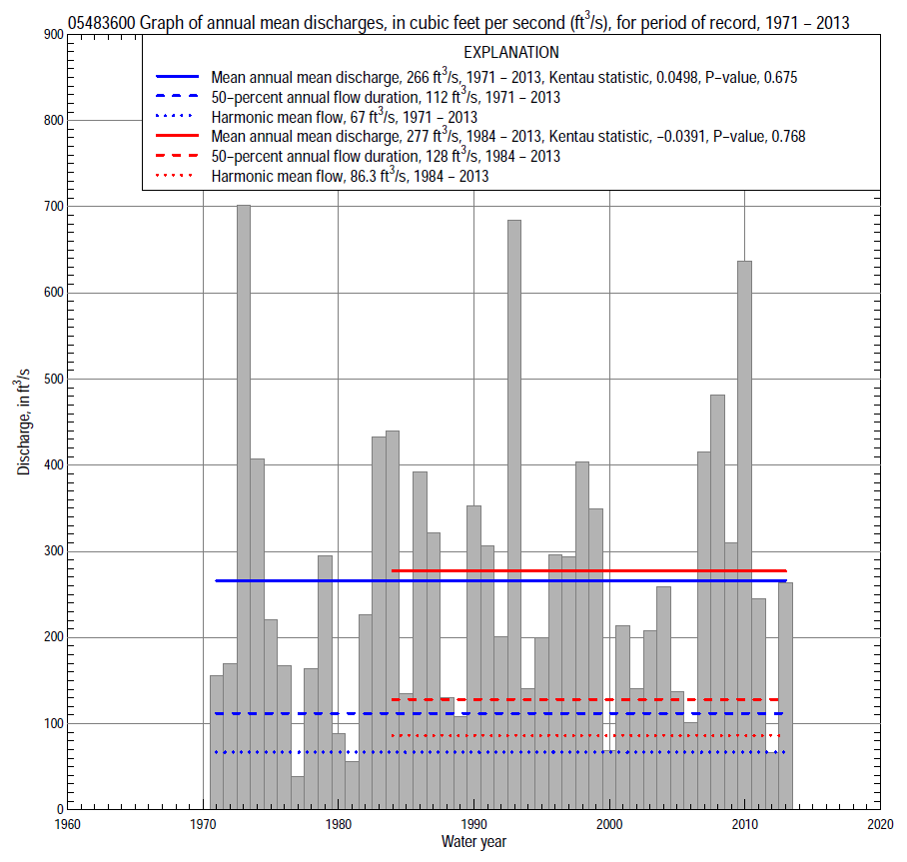

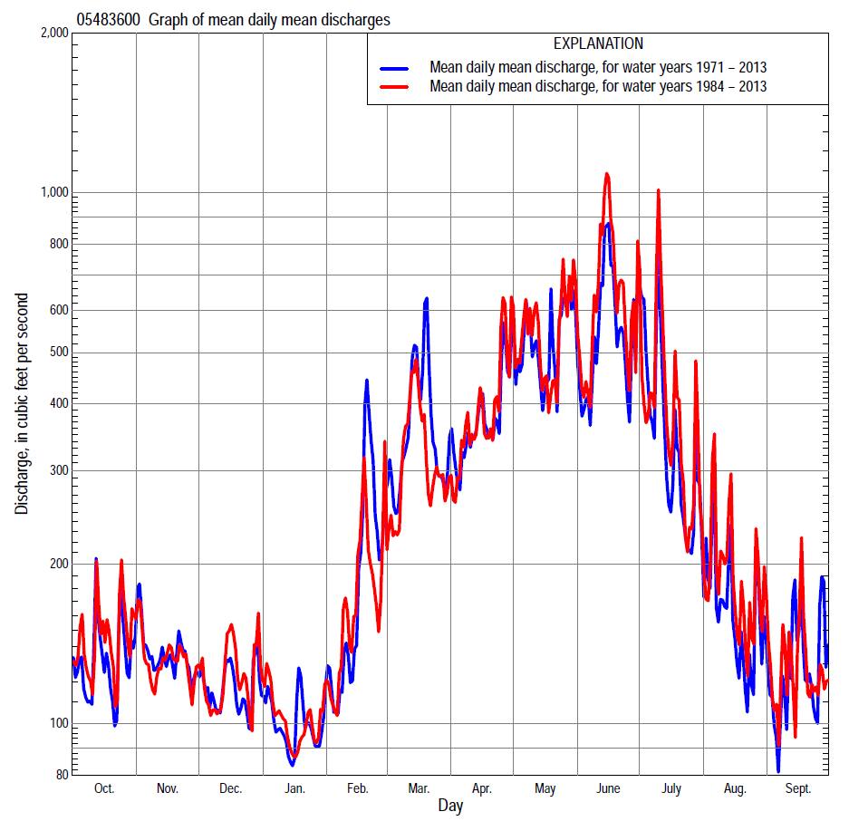

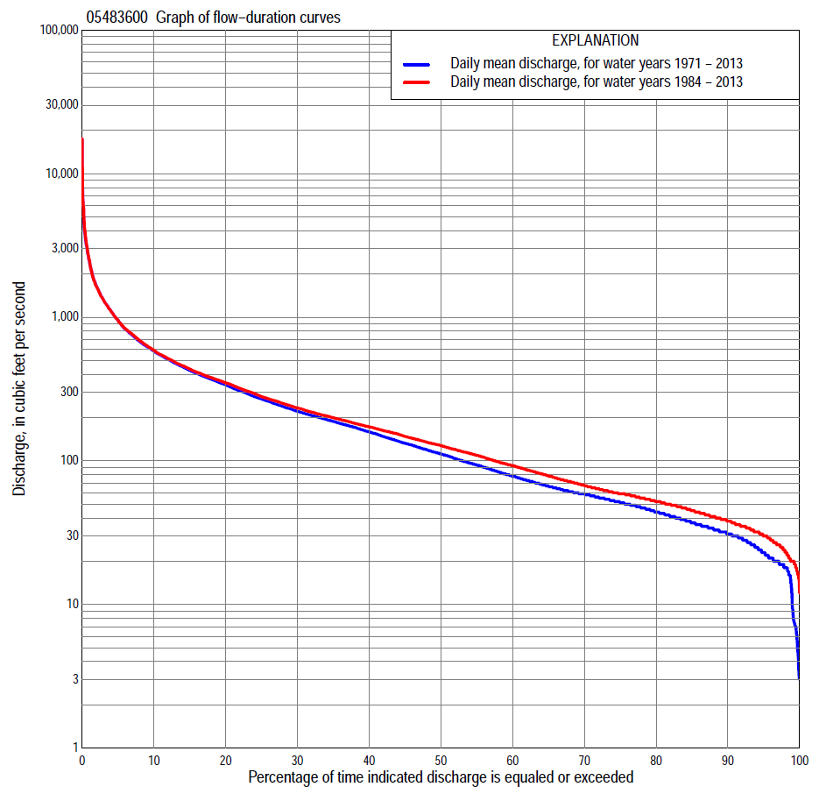

Statistics Based on the Regulated Streamflow Period of Record
05483600 Monthly and annual flow durations, based on 1971–2013 regulated period of record (43 years)
Percentage of days discharge equaled or exceeded |  |  |  |  | Discharge (cubic feet per second) |  |  |  |  |  |  |  |  | Annual flow durations
 | Oct | Nov | Dec | Jan | Feb | Mar | Apr | May | June | July | Aug | Sept | Annual | Kentau statistic | P-value
99 | 16 | 13 | 7.2 | 7.1 | 6.7 | 18 | 20 | 20 | 9.3 | 3.2 | 5.1 | 15 | 9.4 | 0.078 | 0.470
98 | 18 | 16 | 8.4 | 7.5 | 18 | 22 | 23 | 21 | 16 | 5.4 | 17 | 18 | 18 | 0.132 | 0.216
95 | 20 | 21 | 21 | 20 | 26 | 35 | 29 | 40 | 38 | 23 | 22 | 20 | 23 | 0.158 | 0.137
90 | 23 | 27 | 31 | 28 | 31 | 47 | 42 | 59 | 67 | 32 | 30 | 25 | 31 | 0.179 | 0.092
85 | 30 | 31 | 35 | 32 | 37 | 59 | 59 | 93 | 88 | 44 | 33 | 30 | 37 | 0.166 | 0.119
80 | 33 | 38 | 39 | 37 | 43 | 67 | 80 | 119 | 110 | 62 | 37 | 33 | 44 | 0.132 | 0.217
75 | 36 | 45 | 46 | 40 | 47 | 79 | 101 | 159 | 138 | 81 | 42 | 37 | 51 | 0.126 | 0.237
70 | 41 | 51 | 53 | 46 | 51 | 98 | 115 | 198 | 165 | 95 | 48 | 41 | 59 | 0.105 | 0.325
65 | 45 | 57 | 58 | 49 | 57 | 117 | 143 | 221 | 197 | 105 | 52 | 45 | 67 | 0.092 | 0.391
60 | 50 | 61 | 61 | 53 | 65 | 142 | 172 | 249 | 234 | 119 | 59 | 49 | 78 | 0.084 | 0.432
55 | 55 | 66 | 67 | 57 | 76 | 162 | 197 | 286 | 276 | 134 | 64 | 53 | 94 | 0.078 | 0.470
50 | 62 | 74 | 74 | 60 | 87 | 181 | 227 | 325 | 308 | 155 | 73 | 59 | 112 | 0.071 | 0.510
45 | 70 | 87 | 82 | 68 | 106 | 201 | 271 | 367 | 356 | 184 | 80 | 65 | 133 | 0.074 | 0.490
40 | 82 | 103 | 96 | 80 | 123 | 227 | 322 | 409 | 407 | 208 | 94 | 72 | 159 | 0.090 | 0.402
35 | 98 | 123 | 110 | 95 | 139 | 253 | 365 | 458 | 457 | 240 | 114 | 78 | 188 | 0.086 | 0.420
30 | 124 | 149 | 128 | 115 | 156 | 300 | 399 | 518 | 515 | 283 | 138 | 90 | 222 | 0.082 | 0.445
25 | 154 | 175 | 151 | 130 | 176 | 372 | 458 | 598 | 599 | 323 | 170 | 108 | 270 | 0.103 | 0.336
20 | 182 | 208 | 187 | 148 | 202 | 461 | 538 | 678 | 721 | 389 | 205 | 130 | 338 | 0.076 | 0.477
15 | 225 | 254 | 207 | 172 | 260 | 601 | 653 | 902 | 844 | 511 | 262 | 186 | 427 | 0.063 | 0.558
10 | 307 | 334 | 248 | 204 | 391 | 821 | 846 | 1,150 | 1,210 | 713 | 363 | 274 | 580 | 0.061 | 0.572
5 | 439 | 438 | 305 | 263 | 755 | 1,330 | 1,230 | 1,650 | 1,810 | 1,180 | 551 | 407 | 955 | 0.062 | 0.565
2 | 684 | 576 | 450 | 375 | 1,340 | 2,160 | 1,750 | 2,750 | 3,200 | 2,630 | 913 | 870 | 1,640 | 0.025 | 0.818
1 | 1,150 | 726 | 598 | 545 | 1,980 | 3,110 | 2,410 | 3,860 | 4,840 | 3,550 | 1,620 | 1,450 | 2,490 | -0.021 | 0.851

05483600 Annual exceedance probability of instantaneous peak discharges, in cubic feet per second (ft³/s), based on the expected moments algorithm/multiple Grubbs-Beck analysis computed using a regulated period length of 43 years (1971–2013)ª
Annual exceed-ance probability | Recur-rence interval (years) | Discharge (ft³/s) | 95-percent lower confi-dence interval (ft³/s) | 95-percent upper confi-dence interval (ft³/s)
0.500 | 2 | 5,010 | 4,060 | 6,170
0.200 | 5 | 8,650 | 6,990 | 11,200
0.100 | 10 | 11,500 | 9,110 | 15,800
0.040 | 25 | 15,500 | 11,900 | 23,800
0.020 | 50 | 18,700 | 13,900 | 31,700
0.010 | 100 | 22,200 | 15,900 | 41,500
0.005 | 200 | 25,900 | 17,800 | 53,700
0.002 | 500 | 31,300 | 20,200 | 74,300
Kentau statistic |  | -0.075
P-value |  | 0.483
Begin year |  | 1971
End year |  | 2013
Number of peaks |  | 43
ªWeighted Independent Estimates were not computed because regional regression equations are not applicable due to regulation of streamflow.

05483600 Annual exceedance probability of high discharges, based on 1971–2013 regulated period of record (43 years)
[ND, not determined]
Annual exceedance probability | Recur-rence interval (years) | Maximum average discharge (cubic feet per second) for indicated number of consecutive days
 |  | 1 | 3 | 7 | 15 | 30
0.990 | 1.01 | ND | ND | 164 | 117 | 89.4
0.950 | 1.05 | ND | ND | 333 | 234 | 179
0.900 | 1.11 | ND | ND | 478 | 333 | 253
0.800 | 1.25 | ND | ND | 729 | 503 | 379
0.500 | 2 | ND | ND | 1,570 | 1,060 | 772
0.200 | 5 | ND | ND | 3,180 | 2,090 | 1,460
0.100 | 10 | ND | ND | 4,490 | 2,920 | 1,980
0.040 | 25 | ND | ND | 6,400 | 4,110 | 2,690
0.020 | 50 | ND | ND | 7,980 | 5,070 | 3,240
0.010 | 100 | ND | ND | 9,660 | 6,100 | 3,800
0.005 | 200 | ND | ND | 11,500 | 7,180 | 4,380
0.002 | 500 | ND | ND | 14,000 | 8,700 | 5,160
Kentau statistic |  | -0.073 | -0.063 | -0.034 | 0.019 | 0.056
P-value |  | 0.496 | 0.558 | 0.754 | 0.867 | 0.601

 | 05483600 Annual nonexceedance probability of low discharges, based on April 1971 to March 2013 regulated period of record (42 years)
Annual nonexceed-ance probability | Recur-rence interval (years) | Minimum average discharge (cubic feet per second) for indicated number of consecutive days
 |  | 1 | 3 | 7 | 14 | 30 | 60 | 90 | 120 | 183
0.01 | 100 | 0.00 | 4.5 | 5.1 | 5.7 | 5.8 | 8.1 | 9.6 | 11 | 17
0.02 | 50 | 0.00 | 6.1 | 6.8 | 7.6 | 8.1 | 10 | 12 | 14 | 20
0.05 | 20 | 9.4 | 9.4 | 10 | 12 | 13 | 15 | 17 | 20 | 27
0.10 | 10 | 13 | 13 | 14 | 16 | 18 | 21 | 24 | 26 | 35
0.20 | 5 | 18 | 19 | 21 | 23 | 27 | 30 | 34 | 37 | 47
0.50 | 2 | 27 | 32 | 37 | 43 | 50 | 57 | 65 | 71 | 86
0.80 | 1.25 | 38 | 46 | 57 | 67 | 79 | 102 | 119 | 132 | 160
0.90 | 1.11 | 46 | 52 | 68 | 82 | 95 | 136 | 162 | 182 | 222
0.96 | 1.04 | 55 | 57 | 80 | 97 | 112 | 180 | 222 | 253 | 317
0.98 | 1.02 | 61 | 60 | 87 | 106 | 122 | 214 | 270 | 312 | 399
0.99 | 1.01 | 62 | 62 | 92 | 114 | 130 | 248 | 321 | 376 | 492
Kentau statistic |  | 0.035 | 0.081 | 0.142 | 0.125 | 0.087 | 0.057 | 0.043 | 0.020 | 0.010
P-value |  | 0.753 | 0.455 | 0.190 | 0.246 | 0.423 | 0.603 | 0.696 | 0.862 | 0.931

05483600 Annual nonexceedance probability of seasonal low discharges, based on October 1970 to September 2013 regulated period of record (43 years)
Annual nonexceed-ance probability | Recur-rence interval (years) | Minimum average discharge (cubic feet per second) for indicated number of consecutive days
 |  | 1 | 7 | 14 | 30 |  | 1 | 7 | 14 | 30
 |  | January-February-March |  |  |  |  | April-May-June
0.01 | 100 | 5.9 | 7.9 | 8.9 | 9.7 |  | 0.02 | 6.4 | 8.3 | 11
0.02 | 50 | 7.9 | 10 | 11 | 12 |  | 0.02 | 10 | 13 | 17
0.05 | 20 | 12 | 15 | 16 | 18 |  | 16 | 18 | 22 | 31
0.10 | 10 | 17 | 20 | 22 | 24 |  | 23 | 29 | 36 | 50
0.20 | 5 | 25 | 29 | 31 | 34 |  | 33 | 50 | 61 | 86
0.50 | 2 | 47 | 56 | 59 | 66 |  | 67 | 122 | 147 | 206
0.80 | 1.25 | 77 | 98 | 106 | 126 |  | 137 | 246 | 302 | 406
0.90 | 1.11 | 95 | 128 | 141 | 173 |  | 203 | 331 | 414 | 540
0.96 | 1.04 | 114 | 167 | 188 | 242 |  | 311 | 434 | 556 | 698
0.98 | 1.02 | 127 | 197 | 225 | 299 |  | 412 | 504 | 659 | 804
0.99 | 1.01 | 138 | 226 | 263 | 360 |  | 534 | 568 | 756 | 899
Kentau statistic |  | 0.071 | 0.058 | 0.076 | 0.070 |  | 0.308 | 0.154 | 0.158 | 0.141
P-value |  | 0.510 | 0.594 | 0.477 | 0.516 |  | 0.004 | 0.149 | 0.137 | 0.187
 |  | July-August-September |  |  |  |  | October-November-December
0.01 | 100 | 5.7 | 6.2 | 6.7 | 9.4 |  | 8.9 | 8.9 | 8.9 | 8.9
0.02 | 50 | 7.1 | 7.9 | 8.6 | 12 |  | 10 | 11 | 11 | 11
0.05 | 20 | 10 | 11 | 13 | 16 |  | 13 | 15 | 15 | 16
0.10 | 10 | 13 | 15 | 17 | 21 |  | 16 | 18 | 20 | 22
0.20 | 5 | 18 | 22 | 25 | 29 |  | 20 | 25 | 28 | 32
0.50 | 2 | 33 | 42 | 48 | 56 |  | 34 | 44 | 52 | 63
0.80 | 1.25 | 59 | 77 | 87 | 108 |  | 58 | 80 | 97 | 122
0.90 | 1.11 | 79 | 104 | 116 | 152 |  | 78 | 110 | 133 | 172
0.96 | 1.04 | 108 | 141 | 154 | 220 |  | 108 | 155 | 186 | 246
0.98 | 1.02 | 132 | 171 | 183 | 280 |  | 135 | 194 | 230 | 309
0.99 | 1.01 | 158 | 203 | 212 | 347 |  | 165 | 239 | 279 | 378
Kentau statistic |  | 0.125 | 0.141 | 0.138 | 0.103 |  | -0.076 | 0.024 | 0.070 | 0.072
P-value |  | 0.241 | 0.187 | 0.194 | 0.336 |  | 0.476 | 0.826 | 0.516 | 0.503

Statistics Based on the 1984–2013 Regulated Streamflow Period of Record
05483600 Monthly and annual flow durations, based on 1984–2013 regulated period of record (30 years)
Percentage of days discharge equaled or exceeded |  |  |  |  | Discharge (cubic feet per second) |  |  |  |  |  |  |  |  | Annual flow durations
 | Oct | Nov | Dec | Jan | Feb | Mar | Apr | May | June | July | Aug | Sept | Annual | Kentau statistic | P-value
99 | 17 | 21 | 18 | 19 | 30 | 37 | 41 | 41 | 39 | 20 | 20 | 16 | 20 | -0.044 | 0.748
98 | 19 | 23 | 21 | 26 | 32 | 41 | 43 | 44 | 55 | 24 | 23 | 18 | 23 | 0.032 | 0.816
95 | 21 | 26 | 28 | 31 | 36 | 49 | 53 | 56 | 65 | 37 | 28 | 21 | 30 | 0.053 | 0.694
90 | 28 | 28 | 34 | 38 | 41 | 59 | 64 | 94 | 86 | 52 | 34 | 27 | 38 | 0.032 | 0.816
85 | 35 | 32 | 37 | 40 | 46 | 65 | 88 | 119 | 109 | 70 | 37 | 31 | 45 | 0.009 | 0.957
80 | 40 | 38 | 43 | 45 | 49 | 74 | 104 | 159 | 137 | 85 | 41 | 35 | 52 | -0.069 | 0.605
75 | 44 | 46 | 50 | 49 | 57 | 88 | 118 | 203 | 165 | 96 | 47 | 40 | 59 | -0.085 | 0.521
70 | 47 | 54 | 55 | 52 | 65 | 107 | 141 | 223 | 202 | 106 | 52 | 45 | 67 | -0.115 | 0.382
65 | 52 | 58 | 59 | 56 | 75 | 122 | 165 | 255 | 239 | 120 | 60 | 49 | 79 | -0.131 | 0.317
60 | 56 | 63 | 63 | 59 | 81 | 144 | 188 | 286 | 276 | 133 | 67 | 53 | 93 | -0.140 | 0.284
55 | 66 | 68 | 71 | 62 | 94 | 162 | 215 | 316 | 316 | 154 | 73 | 59 | 109 | -0.152 | 0.246
50 | 74 | 75 | 82 | 72 | 107 | 178 | 241 | 352 | 365 | 178 | 81 | 65 | 128 | -0.170 | 0.193
45 | 85 | 89 | 95 | 84 | 121 | 192 | 285 | 382 | 416 | 205 | 94 | 71 | 148 | -0.149 | 0.253
40 | 107 | 111 | 109 | 94 | 133 | 215 | 332 | 427 | 466 | 237 | 116 | 77 | 173 | -0.103 | 0.432
35 | 135 | 128 | 125 | 108 | 144 | 238 | 366 | 478 | 516 | 279 | 138 | 87 | 200 | -0.094 | 0.475
30 | 156 | 153 | 139 | 121 | 157 | 260 | 397 | 537 | 588 | 312 | 165 | 99 | 234 | -0.087 | 0.509
25 | 177 | 175 | 166 | 132 | 173 | 307 | 455 | 605 | 706 | 371 | 194 | 117 | 280 | -0.048 | 0.721
20 | 204 | 200 | 192 | 147 | 193 | 386 | 533 | 703 | 799 | 456 | 239 | 145 | 350 | -0.051 | 0.708
15 | 246 | 238 | 207 | 163 | 226 | 506 | 646 | 893 | 1,010 | 598 | 321 | 223 | 437 | -0.032 | 0.817
10 | 313 | 313 | 244 | 187 | 320 | 689 | 830 | 1,140 | 1,350 | 819 | 406 | 290 | 588 | -0.016 | 0.915
5 | 448 | 406 | 290 | 233 | 599 | 1,040 | 1,150 | 1,640 | 2,210 | 1,300 | 635 | 408 | 951 | 0.014 | 0.929
2 | 706 | 477 | 462 | 348 | 928 | 1,940 | 1,700 | 2,750 | 3,880 | 2,700 | 1,270 | 674 | 1,640 | 0.060 | 0.656
1 | 1,130 | 585 | 729 | 545 | 1,310 | 2,870 | 2,490 | 4,020 | 5,890 | 4,120 | 1,910 | 1,170 | 2,500 | 0.014 | 0.929

05483600 Annual exceedance probability of high discharges, based on 1984–2013 regulated period of record (30 years)
Annual exceedance probability | Recur-rence interval (years) | Maximum average discharge (cubic feet per second) for indicated number of consecutive days
 |  | 1 | 3 | 7 | 15 | 30
0.990 | 1.01 | 389 | 272 | 176 | 119 | 92.9
0.950 | 1.05 | 733 | 519 | 340 | 233 | 184
0.900 | 1.11 | 1,020 | 726 | 478 | 329 | 260
0.800 | 1.25 | 1,510 | 1,080 | 718 | 496 | 388
0.500 | 2 | 3,110 | 2,290 | 1,520 | 1,050 | 795
0.200 | 5 | 6,210 | 4,720 | 3,120 | 2,140 | 1,530
0.100 | 10 | 8,810 | 6,820 | 4,480 | 3,040 | 2,100
0.040 | 25 | 12,700 | 10,000 | 6,530 | 4,390 | 2,890
0.020 | 50 | 16,000 | 12,800 | 8,290 | 5,510 | 3,520
0.010 | 100 | 19,600 | 15,900 | 10,200 | 6,750 | 4,170
0.005 | 200 | 23,500 | 19,300 | 12,400 | 8,090 | 4,850
0.002 | 500 | 29,300 | 24,500 | 15,500 | 10,000 | 5,780
Kentau statistic |  | -0.041 | -0.021 | 0.030 | 0.057 | 0.080
P-value |  | 0.762 | 0.887 | 0.830 | 0.669 | 0.544

 | 05483600 Annual nonexceedance probability of low discharges, based on April 1983 to March 2013 regulated period of record (30 years)
Annual nonexceed-ance probability | Recur-rence interval (years) | Minimum average discharge (cubic feet per second) for indicated number of consecutive days
 |  | 1 | 3 | 7 | 14 | 30 | 60 | 90 | 120 | 183
0.01 | 100 | 11 | 13 | 14 | 14 | 14 | 16 | 17 | 17 | 18
0.02 | 50 | 12 | 14 | 15 | 16 | 17 | 18 | 20 | 20 | 22
0.05 | 20 | 14 | 16 | 18 | 19 | 21 | 23 | 25 | 26 | 30
0.10 | 10 | 17 | 18 | 21 | 23 | 25 | 28 | 31 | 33 | 38
0.20 | 5 | 20 | 22 | 25 | 28 | 32 | 36 | 41 | 44 | 52
0.50 | 2 | 28 | 31 | 37 | 44 | 51 | 60 | 69 | 76 | 93
0.80 | 1.25 | 40 | 45 | 58 | 69 | 81 | 101 | 119 | 134 | 163
0.90 | 1.11 | 48 | 56 | 74 | 88 | 103 | 135 | 159 | 181 | 218
0.96 | 1.04 | 57 | 71 | 98 | 115 | 132 | 183 | 217 | 252 | 295
0.98 | 1.02 | 65 | 84 | 119 | 138 | 156 | 225 | 267 | 313 | 358
0.99 | 1.01 | 72 | 97 | 142 | 162 | 181 | 271 | 322 | 381 | 426
Kentau statistic |  | -0.129 | -0.099 | -0.051 | -0.055 | -0.062 | -0.094 | -0.090 | -0.099 | -0.099
P-value |  | 0.326 | 0.454 | 0.708 | 0.682 | 0.643 | 0.475 | 0.498 | 0.454 | 0.454

05483600 Annual nonexceedance probability of seasonal low discharges, based on October 1983 to September 2013 regulated period of record (30 years)
Annual nonexceed-ance probability | Recur-rence interval (years) | Minimum average discharge (cubic feet per second) for indicated number of consecutive days
 |  | 1 | 7 | 14 | 30 |  | 1 | 7 | 14 | 30
 |  | January-February-March |  |  |  |  | April-May-June
0.01 | 100 | 11 | 15 | 18 | 21 |  | 17 | 25 | 26 | 31
0.02 | 50 | 14 | 18 | 21 | 24 |  | 20 | 30 | 33 | 40
0.05 | 20 | 18 | 23 | 26 | 30 |  | 26 | 40 | 46 | 57
0.10 | 10 | 23 | 28 | 31 | 36 |  | 33 | 52 | 61 | 79
0.20 | 5 | 30 | 37 | 40 | 46 |  | 45 | 72 | 86 | 113
0.50 | 2 | 49 | 60 | 63 | 73 |  | 82 | 133 | 165 | 221
0.80 | 1.25 | 77 | 95 | 102 | 119 |  | 156 | 250 | 309 | 411
0.90 | 1.11 | 95 | 121 | 131 | 155 |  | 222 | 348 | 426 | 557
0.96 | 1.04 | 118 | 156 | 171 | 207 |  | 327 | 498 | 596 | 760
0.98 | 1.02 | 134 | 183 | 204 | 251 |  | 424 | 628 | 739 | 922
0.99 | 1.01 | 150 | 211 | 239 | 299 |  | 536 | 775 | 894 | 1,090
Kentau statistic |  | -0.097 | -0.124 | -0.126 | -0.168 |  | 0.202 | 0.030 | 0.021 | 0.057
P-value |  | 0.464 | 0.344 | 0.335 | 0.199 |  | 0.120 | 0.830 | 0.887 | 0.669
 |  | July-August-September |  |  |  |  | October-November-December
0.01 | 100 | 12 | 16 | 16 | 17 |  | 11 | 11 | 12 | 12
0.02 | 50 | 13 | 17 | 18 | 19 |  | 13 | 14 | 14 | 15
0.05 | 20 | 15 | 19 | 21 | 23 |  | 15 | 18 | 19 | 21
0.10 | 10 | 17 | 22 | 25 | 28 |  | 18 | 22 | 24 | 27
0.20 | 5 | 21 | 27 | 30 | 35 |  | 22 | 28 | 32 | 38
0.50 | 2 | 34 | 43 | 50 | 61 |  | 34 | 47 | 58 | 70
0.80 | 1.25 | 62 | 81 | 91 | 118 |  | 58 | 84 | 104 | 130
0.90 | 1.11 | 91 | 119 | 131 | 176 |  | 78 | 115 | 142 | 180
0.96 | 1.04 | 143 | 189 | 202 | 280 |  | 108 | 164 | 197 | 255
0.98 | 1.02 | 196 | 263 | 272 | 387 |  | 136 | 209 | 244 | 319
0.99 | 1.01 | 265 | 360 | 361 | 526 |  | 169 | 260 | 296 | 390
Kentau statistic |  | -0.018 | 0.002 | -0.007 | -0.025 |  | -0.228 | -0.159 | -0.117 | -0.094
P-value |  | 0.901 | 1.000 | 0.972 | 0.858 |  | 0.080 | 0.225 | 0.372 | 0.475

