LOCATION.--Lat 41°35'22", long 94°09'04" referenced to North American Datum of 1927, in SE 1/4 SW 1/4 NE 1/4 sec.02, T.78 N., R.29 W., Dallas County, IA, Hydrologic Unit 07100007, on right bank 20 ft upstream from bridge on H Avenue, 3.4 mi downstream from bridge on U.S. Highway 6, 2.0 mi east of Redfield, 3.4 mi downstream from Middle Raccoon River, 14.3 mi upstream from mouth, and 44.6 mi upstream from mouth of Raccoon River.

DRAINAGE AREA.--994 mi².

PERIOD OF RECORD.--Discharge records from March 1940 to current year.

GAGE.--Water-stage recorder. Datum of gage is 888.88 ft above National Geodetic Vertical Datum of 1929. Prior to June 12, 1946, non-recording gage, and June 12, 1946, to September 30, 1986, water-stage recorder, both at site 2.4 mi upstream at datum 7.55 ft higher.

A summary of all available data for this streamgage is provided through the USGS National Water Information System web interface (NWISWeb). The following link provides access to current/historical observations, daily data, daily statistics, monthly statistics, annual statistics, peak streamflow, field measurements, field/lab water-quality samples, and the latest water-year summaries. Data can be filtered by parameter and/or dates, and can be output in various tabular and graphical formats.
http://waterdata.usgs.gov/nwis/inventory/?site_no=05484000

The USGS WaterWatch Toolkit is available at:
http://waterwatch.usgs.gov/?id=ww_toolkit
Tools for summarizing streamflow information include the duration hydrograph builder, the cumulative streamflow hydrograph builder, the streamgage statistics retrieval tool, the rating curve builder, the flood tracking chart builder, the National Weather Service Advanced Hydrologic Prediction Service (AHPS) river forecast hydrograph builder, and the raster-hydrograph builder. Entering the above number for this streamgage into these toolkit webpages will provide streamflow information specific to this streamgage.

A description of the statistics presented for this streamgage is available in the main body of the report at:
http://dx.doi.org/10.3133/ofr20151214
A link to other streamgages included in this report, a map showing the location of the streamgages, information on the programs used to compute the statistical analyses, and references are included in the main body of the report.

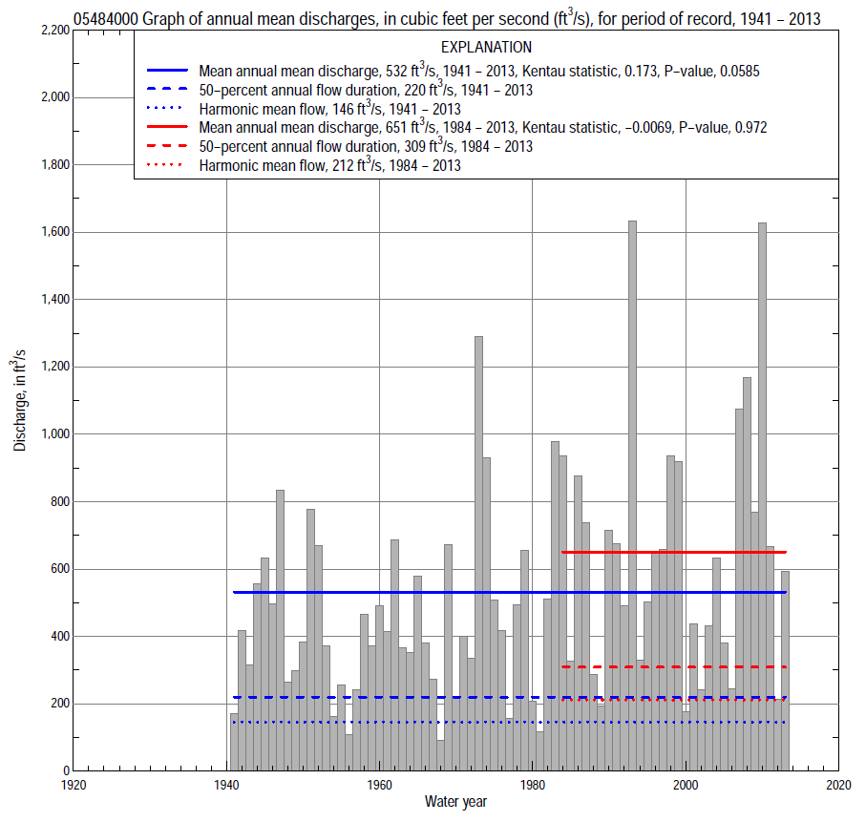

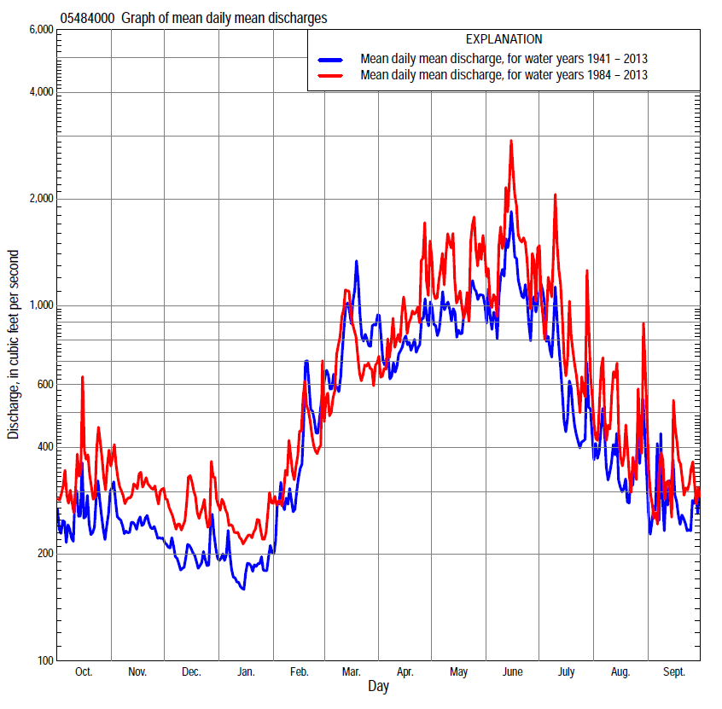

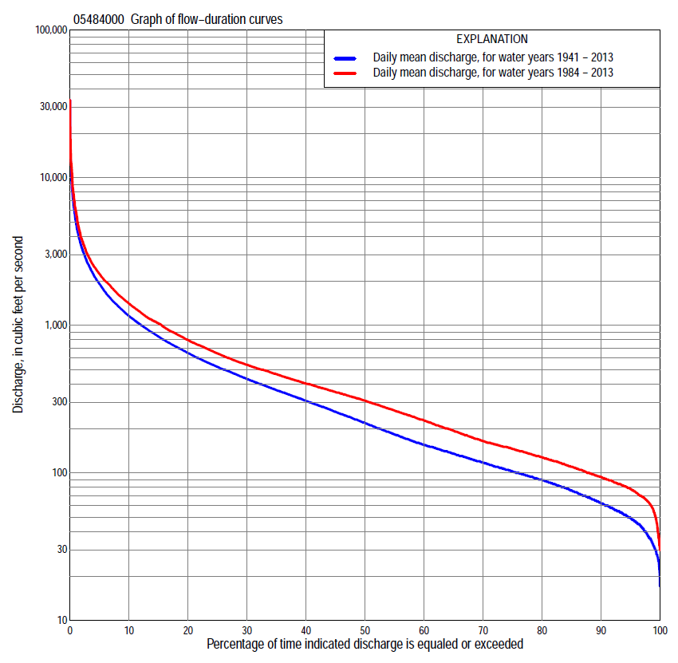

Statistics Based on the Entire Streamflow Period of Record
05484000 Monthly and annual flow durations, based on 1941–2013 period of record (73 years)
Percentage of days discharge equaled or exceeded |  |  |  |  | Discharge (cubic feet per second) |  |  |  |  |  |  |  |  | Annual flow durations
 | Oct | Nov | Dec | Jan | Feb | Mar | Apr | May | June | July | Aug | Sept | Annual | Kentau statistic | P-value
99 | 28 | 37 | 32 | 25 | 30 | 60 | 55 | 46 | 40 | 34 | 31 | 29 | 32 | 0.385 | 0.000
98 | 30 | 42 | 35 | 29 | 34 | 67 | 61 | 52 | 48 | 44 | 37 | 36 | 38 | 0.376 | 0.000
95 | 45 | 55 | 42 | 36 | 45 | 80 | 79 | 67 | 90 | 65 | 46 | 47 | 50 | 0.356 | 0.000
90 | 56 | 65 | 50 | 45 | 56 | 100 | 109 | 108 | 142 | 87 | 62 | 55 | 63 | 0.325 | 0.000
85 | 65 | 79 | 55 | 52 | 66 | 122 | 142 | 156 | 185 | 112 | 73 | 63 | 76 | 0.303 | 0.000
80 | 74 | 86 | 64 | 59 | 80 | 150 | 181 | 223 | 219 | 136 | 86 | 70 | 90 | 0.293 | 0.000
75 | 81 | 94 | 72 | 66 | 92 | 188 | 209 | 285 | 259 | 160 | 98 | 81 | 103 | 0.295 | 0.000
70 | 90 | 101 | 80 | 74 | 106 | 225 | 245 | 336 | 308 | 183 | 110 | 93 | 118 | 0.286 | 0.000
65 | 97 | 108 | 88 | 82 | 118 | 272 | 279 | 388 | 358 | 210 | 121 | 102 | 135 | 0.270 | 0.001
60 | 104 | 119 | 100 | 90 | 130 | 322 | 328 | 460 | 424 | 240 | 132 | 111 | 156 | 0.259 | 0.001
55 | 113 | 130 | 113 | 98 | 152 | 372 | 384 | 514 | 499 | 269 | 148 | 122 | 184 | 0.223 | 0.005
50 | 122 | 141 | 127 | 110 | 180 | 422 | 449 | 578 | 578 | 300 | 166 | 133 | 220 | 0.219 | 0.006
45 | 135 | 153 | 140 | 128 | 230 | 470 | 541 | 656 | 671 | 344 | 184 | 144 | 261 | 0.209 | 0.009
40 | 153 | 170 | 157 | 145 | 276 | 518 | 645 | 746 | 755 | 394 | 208 | 160 | 310 | 0.203 | 0.011
35 | 183 | 212 | 180 | 166 | 313 | 596 | 749 | 842 | 882 | 464 | 242 | 181 | 366 | 0.196 | 0.015
30 | 237 | 260 | 216 | 190 | 351 | 697 | 852 | 970 | 1,040 | 538 | 284 | 206 | 436 | 0.192 | 0.016
25 | 288 | 306 | 250 | 224 | 420 | 825 | 962 | 1,110 | 1,260 | 625 | 345 | 242 | 525 | 0.203 | 0.011
20 | 355 | 357 | 290 | 290 | 500 | 1,020 | 1,110 | 1,300 | 1,520 | 742 | 425 | 302 | 652 | 0.189 | 0.018
15 | 415 | 431 | 358 | 350 | 600 | 1,350 | 1,340 | 1,600 | 1,880 | 957 | 547 | 382 | 842 | 0.183 | 0.022
10 | 542 | 546 | 440 | 406 | 800 | 1,900 | 1,720 | 2,170 | 2,560 | 1,310 | 729 | 530 | 1,160 | 0.161 | 0.044
5 | 825 | 779 | 580 | 540 | 1,360 | 3,000 | 2,580 | 3,160 | 4,150 | 2,100 | 1,270 | 973 | 1,910 | 0.142 | 0.076
2 | 1,360 | 1,080 | 840 | 747 | 2,140 | 5,670 | 3,880 | 5,500 | 7,120 | 3,920 | 2,240 | 1,820 | 3,360 | 0.099 | 0.219
1 | 2,090 | 1,280 | 1,000 | 964 | 3,350 | 7,290 | 4,960 | 7,480 | 10,200 | 6,420 | 3,840 | 2,730 | 5,030 | 0.073 | 0.363

05484000 Annual exceedance probability of instantaneous peak discharges, in cubic feet per second (ft³/s), based on the Weighted Independent Estimates method,
Annual exceed-ance probability | Recur-rence interval (years) | Discharge (ft³/s) | 95-percent lower confi-dence interval (ft³/s) | 95-percent upper confi-dence interval (ft³/s)
0.500 | 2 | 10,900 | 9,290 | 12,700
0.200 | 5 | 18,100 | 15,600 | 21,000
0.100 | 10 | 22,600 | 19,300 | 26,500
0.040 | 25 | 28,900 | 24,000 | 34,700
0.020 | 50 | 33,300 | 27,000 | 41,200
0.010 | 100 | 37,700 | 29,600 | 48,000
0.005 | 200 | 43,700 | 33,100 | 57,700
0.002 | 500 | 48,400 | 35,000 | 66,900
and based on the expected moments algorithm/multiple Grubbs-Beck analysis computed using a historical period length of 74 years (1940–2013)
0.500 | 2 | 11,000 | 9,320 | 12,900
0.200 | 5 | 18,500 | 15,900 | 21,800
0.100 | 10 | 23,700 | 20,200 | 29,000
0.040 | 25 | 30,500 | 25,400 | 39,600
0.020 | 50 | 35,500 | 28,700 | 48,600
0.010 | 100 | 40,500 | 31,600 | 58,600
0.005 | 200 | 45,500 | 34,200 | 69,700
0.002 | 500 | 52,100 | 37,100 | 86,200
Kentau statistic |  | 0.111
P-value |  | 0.164
Begin year |  | 1940
End year |  | 2013
Number of peaks |  | 74

05484000 Annual exceedance probability of high discharges, based on 1941–2013 period of record (73 years)
Annual exceedance probability | Recur-rence interval (years) | Maximum average discharge (ft³/s) for indicated number of consecutive days
 |  | 1 | 3 | 7 | 15 | 30
0.990 | 1.01 | 896 | 658 | 497 | 322 | 237
0.950 | 1.05 | 1,860 | 1,350 | 941 | 614 | 449
0.900 | 1.11 | 2,650 | 1,920 | 1,300 | 849 | 618
0.800 | 1.25 | 3,960 | 2,860 | 1,870 | 1,230 | 891
0.500 | 2 | 7,800 | 5,620 | 3,560 | 2,350 | 1,690
0.200 | 5 | 13,800 | 9,910 | 6,310 | 4,170 | 2,950
0.100 | 10 | 17,800 | 12,800 | 8,270 | 5,470 | 3,830
0.040 | 25 | 22,700 | 16,400 | 10,800 | 7,140 | 4,960
0.020 | 50 | 26,100 | 18,900 | 12,700 | 8,390 | 5,800
0.010 | 100 | 29,300 | 21,300 | 14,600 | 9,630 | 6,610
0.005 | 200 | 32,400 | 23,600 | 16,500 | 10,900 | 7,420
0.002 | 500 | 36,200 | 26,500 | 18,900 | 12,500 | 8,460
Kentau statistic |  | 0.040 | 0.060 | 0.078 | 0.097 | 0.126
P-value |  | 0.624 | 0.458 | 0.329 | 0.225 | 0.115

 | 05484000 Annual nonexceedance probability of low discharges, based on April 1940 to March 2013 period of record (73 years)
Annual nonexceed-ance probability | Recur-rence interval (years) | Minimum average discharge (ft³/s) for indicated number of consecutive days
 |  | 1 | 3 | 7 | 14 | 30 | 60 | 90 | 120 | 183
0.01 | 100 | 14 | 15 | 17 | 18 | 22 | 28 | 32 | 35 | 36
0.02 | 50 | 16 | 17 | 19 | 21 | 25 | 31 | 36 | 39 | 43
0.05 | 20 | 20 | 22 | 24 | 26 | 31 | 38 | 43 | 47 | 55
0.10 | 10 | 25 | 27 | 29 | 31 | 37 | 45 | 52 | 57 | 68
0.20 | 5 | 33 | 35 | 37 | 40 | 48 | 57 | 66 | 73 | 91
0.50 | 2 | 55 | 58 | 63 | 68 | 79 | 96 | 110 | 123 | 161
0.80 | 1.25 | 97 | 103 | 111 | 121 | 138 | 173 | 202 | 227 | 296
0.90 | 1.11 | 133 | 141 | 152 | 166 | 188 | 245 | 289 | 324 | 414
0.96 | 1.04 | 188 | 200 | 218 | 236 | 265 | 363 | 435 | 484 | 598
0.98 | 1.02 | 237 | 252 | 277 | 299 | 335 | 476 | 577 | 639 | 764
0.99 | 1.01 | 293 | 313 | 346 | 372 | 415 | 613 | 752 | 827 | 956
Kentau statistic |  | 0.382 | 0.387 | 0.398 | 0.388 | 0.373 | 0.326 | 0.303 | 0.272 | 0.197
P-value |  | 0.000 | 0.000 | 0.000 | 0.000 | 0.000 | 0.000 | 0.000 | 0.001 | 0.014

05484000 Annual nonexceedance probability of seasonal low discharges, based on April 1940 to September 2013 period of record (73–74 years)
Annual nonexceed-ance probability | Recur-rence interval (years) | Minimum average discharge (cubic feet per second) for indicated number of consecutive days
 |  | 1 | 7 | 14 | 30 |  | 1 | 7 | 14 | 30
 |  | January-February-March |  |  |  |  | April-May-June
0.01 | 100 | 17 | 18 | 19 | 22 |  | 21 | 26 | 28 | 33
0.02 | 50 | 19 | 21 | 22 | 26 |  | 28 | 34 | 37 | 44
0.05 | 20 | 25 | 27 | 29 | 34 |  | 42 | 50 | 55 | 68
0.10 | 10 | 31 | 34 | 37 | 44 |  | 60 | 70 | 78 | 100
0.20 | 5 | 41 | 46 | 50 | 60 |  | 89 | 105 | 118 | 156
0.50 | 2 | 74 | 85 | 93 | 113 |  | 183 | 222 | 256 | 352
0.80 | 1.25 | 142 | 165 | 181 | 226 |  | 351 | 449 | 536 | 751
0.90 | 1.11 | 205 | 238 | 260 | 331 |  | 482 | 638 | 780 | 1,090
0.96 | 1.04 | 310 | 358 | 389 | 508 |  | 663 | 918 | 1,150 | 1,600
0.98 | 1.02 | 409 | 470 | 508 | 676 |  | 807 | 1,150 | 1,480 | 2,030
0.99 | 1.01 | 530 | 604 | 650 | 880 |  | 956 | 1,410 | 1,840 | 2,500
Kentau statistic |  | 0.296 | 0.291 | 0.292 | 0.235 |  | 0.235 | 0.217 | 0.227 | 0.209
P-value |  | 0.000 | 0.000 | 0.000 | 0.003 |  | 0.003 | 0.006 | 0.004 | 0.008
 |  | July-August-September |  |  |  |  | October-November-December
0.01 | 100 | 18 | 25 | 26 | 33 |  | 19 | 22 | 23 | 27
0.02 | 50 | 21 | 28 | 29 | 37 |  | 22 | 25 | 27 | 31
0.05 | 20 | 27 | 33 | 36 | 45 |  | 26 | 31 | 34 | 39
0.10 | 10 | 34 | 40 | 43 | 54 |  | 32 | 37 | 41 | 48
0.20 | 5 | 44 | 51 | 55 | 69 |  | 41 | 48 | 54 | 63
0.50 | 2 | 78 | 86 | 95 | 117 |  | 70 | 83 | 95 | 112
0.80 | 1.25 | 143 | 159 | 175 | 221 |  | 132 | 155 | 177 | 214
0.90 | 1.11 | 201 | 228 | 249 | 319 |  | 191 | 222 | 251 | 308
0.96 | 1.04 | 294 | 344 | 373 | 488 |  | 293 | 336 | 374 | 465
0.98 | 1.02 | 379 | 457 | 491 | 653 |  | 392 | 445 | 489 | 614
0.99 | 1.01 | 478 | 596 | 635 | 859 |  | 515 | 579 | 627 | 794
Kentau statistic |  | 0.350 | 0.323 | 0.285 | 0.181 |  | 0.339 | 0.329 | 0.320 | 0.306
P-value |  | 0.000 | 0.000 | 0.000 | 0.023 |  | 0.000 | 0.000 | 0.000 | 0.000

Statistics Based on the 1984–2013 Streamflow Period of Record
05484000 Monthly and annual flow durations, based on 1984–2013 period of record (30 years)
Percentage of days discharge equaled or exceeded |  |  |  |  | Discharge (cubic feet per second) |  |  |  |  |  |  |  |  | Annual flow durations
 | Oct | Nov | Dec | Jan | Feb | Mar | Apr | May | June | July | Aug | Sept | Annual | Kentau statistic | P-value
99 | 62 | 56 | 33 | 39 | 46 | 89 | 94 | 94 | 99 | 70 | 65 | 57 | 54 | -0.009 | 0.957
98 | 67 | 73 | 36 | 47 | 52 | 96 | 109 | 107 | 138 | 80 | 69 | 60 | 64 | -0.009 | 0.957
95 | 75 | 82 | 59 | 58 | 74 | 111 | 126 | 132 | 169 | 112 | 76 | 66 | 78 | 0.025 | 0.858
90 | 81 | 89 | 74 | 70 | 92 | 141 | 166 | 230 | 205 | 139 | 89 | 72 | 94 | 0.007 | 0.972
85 | 88 | 97 | 84 | 82 | 105 | 167 | 199 | 292 | 243 | 164 | 100 | 85 | 110 | -0.051 | 0.708
80 | 95 | 107 | 99 | 90 | 117 | 199 | 233 | 345 | 286 | 193 | 113 | 95 | 127 | -0.083 | 0.532
75 | 109 | 122 | 114 | 100 | 130 | 227 | 270 | 434 | 358 | 221 | 123 | 104 | 145 | -0.083 | 0.532
70 | 120 | 130 | 130 | 110 | 154 | 255 | 312 | 517 | 437 | 249 | 138 | 113 | 164 | -0.064 | 0.630
65 | 128 | 138 | 139 | 130 | 180 | 296 | 368 | 581 | 542 | 278 | 158 | 126 | 193 | -0.090 | 0.498
60 | 139 | 146 | 150 | 150 | 230 | 352 | 427 | 656 | 653 | 310 | 174 | 137 | 227 | -0.101 | 0.443
55 | 151 | 154 | 160 | 165 | 263 | 395 | 496 | 736 | 716 | 357 | 187 | 150 | 264 | -0.108 | 0.412
50 | 167 | 173 | 178 | 180 | 292 | 432 | 594 | 830 | 820 | 407 | 206 | 160 | 309 | -0.113 | 0.392
45 | 215 | 241 | 210 | 200 | 313 | 464 | 700 | 928 | 920 | 483 | 235 | 182 | 353 | -0.092 | 0.486
40 | 263 | 288 | 235 | 225 | 338 | 494 | 771 | 1,060 | 1,070 | 560 | 274 | 203 | 403 | -0.051 | 0.708
35 | 308 | 320 | 275 | 261 | 360 | 529 | 872 | 1,140 | 1,250 | 637 | 335 | 221 | 466 | -0.051 | 0.708
30 | 362 | 372 | 338 | 309 | 400 | 599 | 984 | 1,280 | 1,460 | 759 | 394 | 248 | 540 | -0.034 | 0.803
25 | 398 | 410 | 387 | 330 | 460 | 718 | 1,110 | 1,450 | 1,680 | 881 | 461 | 304 | 644 | -0.016 | 0.915
20 | 444 | 490 | 430 | 367 | 502 | 850 | 1,290 | 1,680 | 1,950 | 1,070 | 547 | 375 | 795 | -0.030 | 0.830
15 | 520 | 595 | 480 | 400 | 561 | 1,110 | 1,600 | 2,140 | 2,340 | 1,390 | 644 | 505 | 1,030 | -0.016 | 0.915
10 | 703 | 692 | 542 | 460 | 674 | 1,540 | 1,980 | 2,690 | 3,280 | 1,860 | 911 | 697 | 1,400 | 0.032 | 0.817
5 | 976 | 855 | 637 | 560 | 1,100 | 2,470 | 2,910 | 3,800 | 5,400 | 2,900 | 1,470 | 1,110 | 2,230 | 0.078 | 0.556
2 | 1,960 | 1,080 | 954 | 820 | 2,000 | 4,130 | 4,160 | 6,440 | 8,750 | 5,860 | 2,950 | 1,890 | 3,810 | 0.106 | 0.422
1 | 2,420 | 1,430 | 1,220 | 1,100 | 2,500 | 6,200 | 5,180 | 8,330 | 12,100 | 9,410 | 5,290 | 2,590 | 5,920 | 0.113 | 0.392

05484000 Annual exceedance probability of high discharges, based on 1984–2013 period of record (30 years)
Annual exceed-ance probability | Recur-rence interval (years) | Maximum average discharge (ft³/s) for indicated number of consecutive days
 |  | 1 | 3 | 7 | 15 | 30
0.990 | 1.01 | 764 | 680 | 491 | 342 | 258
0.950 | 1.05 | 1,670 | 1,350 | 923 | 641 | 484
0.900 | 1.11 | 2,470 | 1,910 | 1,280 | 884 | 667
0.800 | 1.25 | 3,840 | 2,860 | 1,870 | 1,290 | 968
0.500 | 2 | 8,270 | 5,860 | 3,760 | 2,560 | 1,890
0.200 | 5 | 16,100 | 11,200 | 7,240 | 4,870 | 3,510
0.100 | 10 | 21,900 | 15,400 | 10,000 | 6,680 | 4,740
0.040 | 25 | 29,600 | 21,100 | 14,000 | 9,250 | 6,430
0.020 | 50 | 35,500 | 25,600 | 17,200 | 11,300 | 7,770
0.010 | 100 | 41,400 | 30,300 | 20,700 | 13,500 | 9,150
0.005 | 200 | 47,200 | 35,100 | 24,400 | 15,900 | 10,600
0.002 | 500 | 54,900 | 41,700 | 29,700 | 19,200 | 12,600
Kentau statistic |  | 0.071 | 0.064 | 0.085 | 0.122 | 0.145
P-value |  | 0.592 | 0.630 | 0.521 | 0.354 | 0.269

 | 05484000 Annual nonexceedance probability of low discharges, based on April 1983 to March 2013 period of record (30 years)
Annual nonexceed-ance probability | Recur-rence interval (years) | Minimum average discharge (ft³/s) for indicated number of consecutive days
 |  | 1 | 3 | 7 | 14 | 30 | 60 | 90 | 120 | 183
0.01 | 100 | 23 | 25 | 26 | 28 | 35 | 41 | 45 | 46 | 47
0.02 | 50 | 26 | 29 | 31 | 33 | 40 | 47 | 51 | 53 | 56
0.05 | 20 | 33 | 36 | 39 | 42 | 50 | 58 | 63 | 66 | 73
0.10 | 10 | 41 | 44 | 48 | 52 | 61 | 70 | 77 | 81 | 93
0.20 | 5 | 53 | 56 | 61 | 67 | 77 | 88 | 98 | 105 | 124
0.50 | 2 | 85 | 90 | 98 | 107 | 121 | 141 | 160 | 176 | 217
0.80 | 1.25 | 136 | 145 | 158 | 172 | 191 | 233 | 273 | 306 | 381
0.90 | 1.11 | 175 | 186 | 202 | 218 | 242 | 306 | 366 | 416 | 514
0.96 | 1.04 | 228 | 243 | 262 | 281 | 311 | 413 | 506 | 583 | 708
0.98 | 1.02 | 271 | 288 | 311 | 331 | 366 | 503 | 629 | 732 | 872
0.99 | 1.01 | 316 | 336 | 362 | 383 | 424 | 604 | 766 | 901 | 1,050
Kentau statistic |  | -0.069 | -0.060 | -0.076 | -0.051 | -0.030 | -0.071 | -0.067 | -0.071 | -0.057
P-value |  | 0.605 | 0.656 | 0.568 | 0.708 | 0.830 | 0.592 | 0.617 | 0.592 | 0.669

05484000 Annual nonexceedance probability of seasonal low discharges, based on October 1983 to September 2013 period of record (30 years)
Annual nonexceed-ance probability | Recur-rence interval (years) | Minimum average discharge (cubic feet per second) for indicated number of consecutive days
 |  | 1 | 7 | 14 | 30 |  | 1 | 7 | 14 | 30
 |  | January-February-March |  |  |  |  | April-May-June
0.01 | 100 | 19 | 28 | 33 | 36 |  | 47 | 54 | 58 | 66
0.02 | 50 | 24 | 33 | 40 | 44 |  | 58 | 67 | 72 | 86
0.05 | 20 | 33 | 44 | 51 | 57 |  | 80 | 91 | 101 | 126
0.10 | 10 | 44 | 56 | 64 | 73 |  | 105 | 120 | 136 | 176
0.20 | 5 | 62 | 75 | 84 | 98 |  | 144 | 168 | 193 | 259
0.50 | 2 | 115 | 134 | 145 | 172 |  | 259 | 315 | 375 | 520
0.80 | 1.25 | 211 | 238 | 254 | 302 |  | 449 | 588 | 719 | 990
0.90 | 1.11 | 287 | 321 | 342 | 407 |  | 590 | 812 | 1,000 | 1,360
0.96 | 1.04 | 395 | 444 | 471 | 559 |  | 780 | 1,140 | 1,430 | 1,880
0.98 | 1.02 | 484 | 547 | 582 | 686 |  | 931 | 1,420 | 1,790 | 2,290
0.99 | 1.01 | 580 | 660 | 705 | 826 |  | 1,090 | 1,740 | 2,180 | 2,730
Kentau statistic |  | -0.205 | -0.163 | -0.131 | -0.136 |  | 0.039 | -0.011 | 0.021 | 0.062
P-value |  | 0.116 | 0.212 | 0.318 | 0.301 |  | 0.775 | 0.943 | 0.887 | 0.643
 |  | July-August-September |  |  |  |  | October-November-December
0.01 | 100 | 48 | 52 | 53 | 55 |  | 22 | 25 | 28 | 35
0.02 | 50 | 51 | 55 | 57 | 59 |  | 26 | 30 | 34 | 42
0.05 | 20 | 56 | 60 | 63 | 67 |  | 35 | 40 | 45 | 55
0.10 | 10 | 62 | 67 | 71 | 77 |  | 45 | 52 | 58 | 69
0.20 | 5 | 73 | 79 | 85 | 93 |  | 61 | 70 | 79 | 93
0.50 | 2 | 110 | 122 | 132 | 151 |  | 109 | 126 | 140 | 165
0.80 | 1.25 | 195 | 221 | 238 | 289 |  | 198 | 224 | 248 | 299
0.90 | 1.11 | 281 | 324 | 348 | 436 |  | 272 | 303 | 332 | 411
0.96 | 1.04 | 440 | 518 | 548 | 713 |  | 381 | 417 | 453 | 581
0.98 | 1.02 | 605 | 726 | 759 | 1,010 |  | 475 | 513 | 554 | 728
0.99 | 1.01 | 824 | 1,010 | 1,040 | 1,420 |  | 580 | 618 | 662 | 894
Kentau statistic |  | 0.039 | 0.025 | 0.011 | -0.039 |  | -0.048 | -0.057 | -0.062 | -0.030
P-value |  | 0.775 | 0.858 | 0.943 | 0.775 |  | 0.721 | 0.669 | 0.643 | 0.830

