LOCATION.--Lat 41°32'02", long 93°56'59" referenced to North American Datum of 1927, in SE 1/4 SW 1/4 SW 1/4 sec.22, T.78 N., R.27 W., Dallas County, IA, Hydrologic Unit 07100006, on right bank 160 ft downstream from bridge on County Highway R16, 0.3 mi northeast of Van Meter, 0.7 mi upstream from small left bank tributary, 1.2 mi downstream from confluence of North and South Raccoon Rivers, and 29.3 mi upstream from mouth.

DRAINAGE AREA.--3,441 mi².

PERIOD OF RECORD.--Discharge records from April 1915 to current year. Prior to October 1933, monthly mean discharge for some periods published in WSP 1308.

GAGE.--Water-stage recorder. Datum of gage is 841.16 ft above National Geodetic Vertical Datum of 1929. Prior to October 1, 1915, non-recording gage at same site at datum 2.00 ft higher. October 1, 1915, to May 30, 1923, non-recording gage, May 31, 1923, to September 30, 1927, water-stage recorder, and October 1, 1927, to August 8, 1934, non-recording gage, all at same site and datum.

A summary of all available data for this streamgage is provided through the USGS National Water Information System web interface (NWISWeb). The following link provides access to current/historical observations, daily data, daily statistics, monthly statistics, annual statistics, peak streamflow, field measurements, field/lab water-quality samples, and the latest water-year summaries. Data can be filtered by parameter and/or dates, and can be output in various tabular and graphical formats.
http://waterdata.usgs.gov/nwis/inventory/?site_no=05484500

The USGS WaterWatch Toolkit is available at:
http://waterwatch.usgs.gov/?id=ww_toolkit
Tools for summarizing streamflow information include the duration hydrograph builder, the cumulative streamflow hydrograph builder, the streamgage statistics retrieval tool, the rating curve builder, the flood tracking chart builder, the National Weather Service Advanced Hydrologic Prediction Service (AHPS) river forecast hydrograph builder, and the raster-hydrograph builder. Entering the above number for this streamgage into these toolkit webpages will provide streamflow information specific to this streamgage.

A description of the statistics presented for this streamgage is available in the main body of the report at:
http://dx.doi.org/10.3133/ofr20151214
A link to other streamgages included in this report, a map showing the location of the streamgages, information on the programs used to compute the statistical analyses, and references are included in the main body of the report.

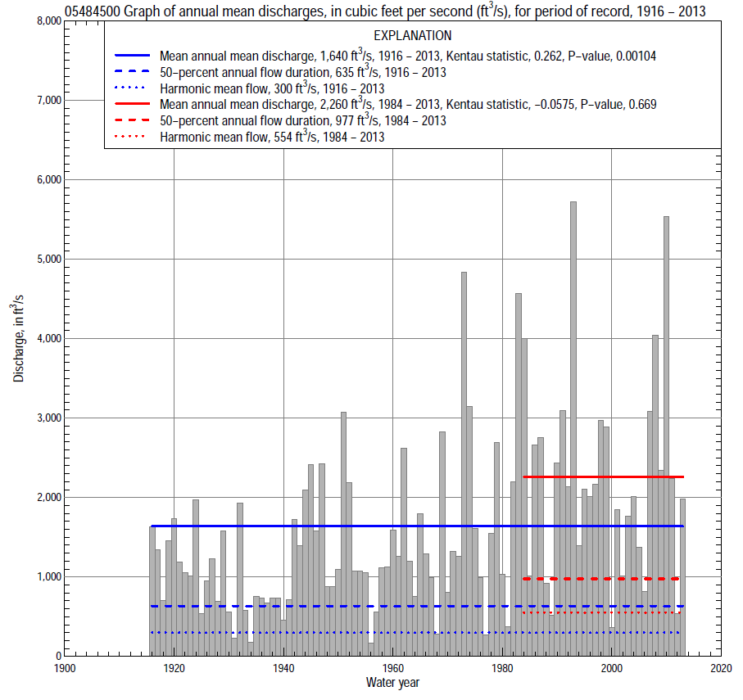

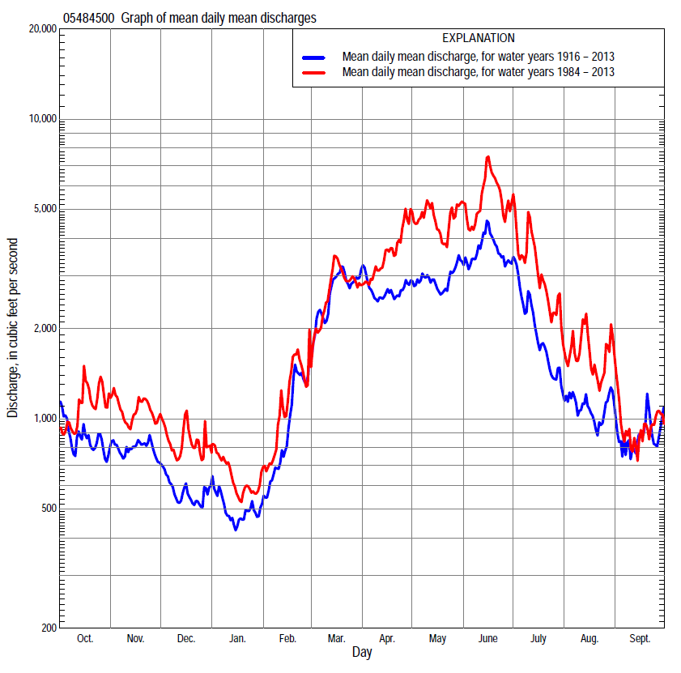

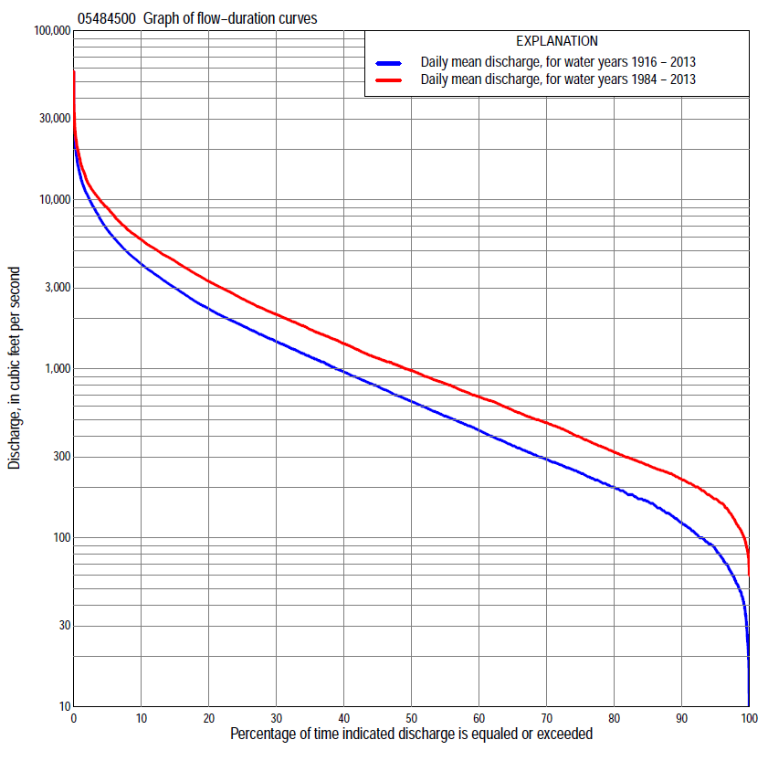

Statistics Based on the Entire Streamflow Period of Record
05484500 Monthly and annual flow durations, based on 1916–2013 period of record (98 years)
Percentage of days discharge equaled or exceeded |  |  |  |  | Discharge (cubic feet per second) |  |  |  |  |  |  |  |  | Annual flow durations
 | Oct | Nov | Dec | Jan | Feb | Mar | Apr | May | June | July | Aug | Sept | Annual | Kentau statistic | P-value
99 | 40 | 52 | 40 | 20 | 35 | 123 | 136 | 98 | 78 | 55 | 29 | 44 | 44 | 0.362 | 0.000
98 | 49 | 62 | 45 | 35 | 42 | 150 | 160 | 118 | 123 | 72 | 56 | 49 | 55 | 0.362 | 0.000
95 | 72 | 90 | 65 | 48 | 58 | 175 | 200 | 167 | 217 | 134 | 92 | 76 | 85 | 0.346 | 0.000
90 | 94 | 120 | 82 | 68 | 94 | 255 | 281 | 282 | 396 | 218 | 124 | 100 | 122 | 0.311 | 0.000
85 | 117 | 146 | 105 | 85 | 120 | 328 | 400 | 448 | 565 | 288 | 150 | 121 | 163 | 0.286 | 0.000
80 | 142 | 170 | 130 | 100 | 155 | 490 | 527 | 655 | 730 | 342 | 180 | 141 | 198 | 0.258 | 0.000
75 | 167 | 195 | 160 | 120 | 175 | 601 | 693 | 808 | 912 | 405 | 217 | 170 | 241 | 0.254 | 0.000
70 | 189 | 230 | 180 | 160 | 210 | 705 | 841 | 1,020 | 1,110 | 480 | 257 | 200 | 290 | 0.235 | 0.001
65 | 210 | 258 | 210 | 180 | 270 | 878 | 981 | 1,220 | 1,320 | 563 | 298 | 226 | 350 | 0.215 | 0.002
60 | 240 | 287 | 240 | 205 | 310 | 1,040 | 1,160 | 1,400 | 1,520 | 665 | 335 | 262 | 429 | 0.195 | 0.004
55 | 273 | 329 | 275 | 220 | 380 | 1,240 | 1,340 | 1,590 | 1,780 | 800 | 387 | 295 | 522 | 0.190 | 0.006
50 | 324 | 383 | 313 | 255 | 475 | 1,460 | 1,500 | 1,800 | 2,040 | 925 | 442 | 335 | 635 | 0.196 | 0.004
45 | 380 | 460 | 365 | 300 | 560 | 1,680 | 1,760 | 2,060 | 2,370 | 1,100 | 513 | 386 | 780 | 0.197 | 0.004
40 | 445 | 550 | 431 | 350 | 680 | 1,940 | 2,090 | 2,330 | 2,800 | 1,320 | 602 | 448 | 950 | 0.219 | 0.001
35 | 558 | 657 | 500 | 410 | 805 | 2,200 | 2,500 | 2,650 | 3,300 | 1,560 | 726 | 509 | 1,170 | 0.231 | 0.001
30 | 678 | 834 | 580 | 500 | 953 | 2,600 | 3,020 | 3,100 | 3,820 | 1,860 | 866 | 602 | 1,440 | 0.235 | 0.001
25 | 850 | 1,000 | 689 | 590 | 1,110 | 3,140 | 3,540 | 3,720 | 4,470 | 2,250 | 1,070 | 761 | 1,780 | 0.265 | 0.000
20 | 1,100 | 1,190 | 836 | 690 | 1,400 | 3,800 | 4,150 | 4,370 | 5,430 | 2,800 | 1,350 | 963 | 2,250 | 0.266 | 0.000
15 | 1,540 | 1,490 | 1,050 | 850 | 1,700 | 4,870 | 5,080 | 5,520 | 6,720 | 3,540 | 1,720 | 1,330 | 3,000 | 0.270 | 0.000
10 | 2,200 | 1,950 | 1,320 | 1,140 | 2,200 | 6,580 | 6,440 | 7,180 | 9,060 | 4,680 | 2,460 | 2,110 | 4,150 | 0.271 | 0.000
5 | 3,520 | 2,860 | 1,980 | 1,770 | 3,800 | 9,720 | 9,500 | 9,790 | 12,700 | 6,990 | 4,340 | 3,620 | 6,600 | 0.245 | 0.000
2 | 5,710 | 4,230 | 2,810 | 2,810 | 6,380 | 14,100 | 12,500 | 13,100 | 17,800 | 12,200 | 7,380 | 6,100 | 10,700 | 0.187 | 0.007
1 | 9,020 | 5,190 | 3,530 | 3,480 | 8,100 | 17,000 | 14,500 | 16,500 | 21,400 | 16,500 | 9,980 | 8,300 | 13,700 | 0.143 | 0.038

05484500 Annual exceedance probability of instantaneous peak discharges, in cubic feet per second (ft³/s), based on the Weighted Independent Estimates method,
Annual exceed-ance probability | Recur-rence interval (years) | Discharge (ft³/s) | 95-percent lower confi-dence interval (ft³/s) | 95-percent upper confi-dence interval (ft³/s)
0.500 | 2 | 15,100 | 13,200 | 17,200
0.200 | 5 | 25,300 | 22,200 | 28,800
0.100 | 10 | 31,900 | 27,700 | 36,800
0.040 | 25 | 41,200 | 34,800 | 48,800
0.020 | 50 | 47,900 | 39,300 | 58,300
0.010 | 100 | 54,500 | 43,400 | 68,400
0.005 | 200 | 63,100 | 48,600 | 81,900
0.002 | 500 | 70,600 | 51,900 | 95,900
and based on the expected moments algorithm/multiple Grubbs-Beck analysis computed using a historical period length of 99 years (1915–2013)
0.500 | 2 | 15,100 | 13,200 | 17,200
0.200 | 5 | 25,200 | 22,100 | 29,100
0.100 | 10 | 32,500 | 28,200 | 38,600
0.040 | 25 | 42,100 | 35,600 | 52,900
0.020 | 50 | 49,500 | 40,800 | 65,400
0.010 | 100 | 57,000 | 45,700 | 79,500
0.005 | 200 | 64,700 | 50,200 | 95,500
0.002 | 500 | 75,000 | 55,600 | 120,000
Kentau statistic |  | 0.163
P-value |  | 0.017
Begin year |  | 1915
End year |  | 2013
Number of peaks |  | 99

05484500 Annual exceedance probability of high discharges, based on 1916–2013 period of record (98 years)
Annual exceed-ance probability | Recur-rence interval (years) | Maximum average discharge (ft³/s) for indicated number of consecutive days
 |  | 1 | 3 | 7 | 15 | 30
0.990 | 1.01 | 2,250 | 1,750 | 1,220 | 797 | 585
0.950 | 1.05 | 3,950 | 3,240 | 2,430 | 1,660 | 1,210
0.900 | 1.11 | 5,250 | 4,390 | 3,400 | 2,370 | 1,730
0.800 | 1.25 | 7,310 | 6,230 | 4,970 | 3,530 | 2,570
0.500 | 2 | 13,200 | 11,500 | 9,420 | 6,880 | 5,020
0.200 | 5 | 22,400 | 19,500 | 16,100 | 11,900 | 8,750
0.100 | 10 | 29,000 | 25,100 | 20,400 | 15,200 | 11,200
0.040 | 25 | 37,500 | 32,100 | 25,700 | 19,100 | 14,200
0.020 | 50 | 43,900 | 37,200 | 29,400 | 21,800 | 16,200
0.010 | 100 | 50,300 | 42,200 | 32,800 | 24,300 | 18,200
0.005 | 200 | 56,800 | 47,000 | 36,000 | 26,600 | 20,000
0.002 | 500 | 65,300 | 53,300 | 40,000 | 29,300 | 22,200
Kentau statistic |  | 0.125 | 0.133 | 0.143 | 0.162 | 0.195
P-value |  | 0.069 | 0.052 | 0.038 | 0.018 | 0.004

 | 05484500 Annual nonexceedance probability of low discharges, based on April 1916 to March 2013 period of record (97 years)
Annual nonexceed-ance probability | Recur-rence interval (years) | Minimum average discharge (ft³/s) for indicated number of consecutive days
 |  | 1 | 3 | 7 | 14 | 30 | 60 | 90 | 120 | 183
0.01 | 100 | 15 | 16 | 16 | 17 | 21 | 30 | 38 | 42 | 48
0.02 | 50 | 19 | 20 | 21 | 22 | 26 | 37 | 46 | 52 | 61
0.05 | 20 | 27 | 29 | 30 | 32 | 38 | 51 | 64 | 73 | 89
0.10 | 10 | 37 | 39 | 42 | 45 | 53 | 69 | 86 | 99 | 124
0.20 | 5 | 54 | 58 | 62 | 67 | 79 | 101 | 125 | 144 | 185
0.50 | 2 | 112 | 121 | 130 | 142 | 167 | 208 | 259 | 304 | 406
0.80 | 1.25 | 231 | 251 | 271 | 297 | 350 | 440 | 557 | 666 | 895
0.90 | 1.11 | 339 | 366 | 397 | 433 | 512 | 657 | 843 | 1,020 | 1,360
0.96 | 1.04 | 509 | 548 | 594 | 645 | 767 | 1,020 | 1,320 | 1,610 | 2,130
0.98 | 1.02 | 663 | 711 | 771 | 832 | 994 | 1,350 | 1,790 | 2,190 | 2,850
0.99 | 1.01 | 840 | 897 | 972 | 1,040 | 1,250 | 1,750 | 2,350 | 2,890 | 3,700
Kentau statistic |  | 0.355 | 0.379 | 0.396 | 0.402 | 0.367 | 0.314 | 0.261 | 0.219 | 0.175
P-value |  | 0.000 | 0.000 | 0.000 | 0.000 | 0.000 | 0.000 | 0.000 | 0.002 | 0.011

05484500 Annual nonexceedance probability of seasonal low discharges, based on May 1915 to September 2013 period of record (98–99 years)
Annual nonexceed-ance probability | Recur-rence interval (years) | Minimum average discharge (cubic feet per second) for indicated number of consecutive days
 |  | 1 | 7 | 14 | 30 |  | 1 | 7 | 14 | 30
 |  | January-February-March |  |  |  |  | April-May-June
0.01 | 100 | 15 | 16 | 17 | 20 |  | 35 | 44 | 53 | 69
0.02 | 50 | 21 | 22 | 23 | 27 |  | 51 | 63 | 76 | 99
0.05 | 20 | 33 | 35 | 36 | 42 |  | 88 | 107 | 126 | 166
0.10 | 10 | 47 | 51 | 54 | 63 |  | 141 | 168 | 194 | 260
0.20 | 5 | 73 | 81 | 86 | 100 |  | 239 | 281 | 323 | 436
0.50 | 2 | 168 | 190 | 205 | 245 |  | 599 | 698 | 799 | 1,100
0.80 | 1.25 | 380 | 431 | 474 | 591 |  | 1,330 | 1,560 | 1,830 | 2,570
0.90 | 1.11 | 581 | 650 | 725 | 930 |  | 1,930 | 2,290 | 2,730 | 3,870
0.96 | 1.04 | 909 | 998 | 1,130 | 1,500 |  | 2,770 | 3,350 | 4,100 | 5,850
0.98 | 1.02 | 1,210 | 1,310 | 1,500 | 2,040 |  | 3,450 | 4,210 | 5,270 | 7,560
0.99 | 1.01 | 1,570 | 1,660 | 1,920 | 2,680 |  | 4,140 | 5,130 | 6,550 | 9,420
Kentau statistic |  | 0.233 | 0.276 | 0.283 | 0.231 |  | 0.283 | 0.279 | 0.271 | 0.277
P-value |  | 0.001 | 0.000 | 0.000 | 0.001 |  | 0.000 | 0.000 | 0.000 | 0.000
 |  | July-August-September |  |  |  |  | October-November-December
0.01 | 100 | 21 | 25 | 29 | 39 |  | 23 | 24 | 28 | 34
0.02 | 50 | 27 | 32 | 37 | 48 |  | 29 | 31 | 35 | 43
0.05 | 20 | 39 | 45 | 52 | 68 |  | 40 | 44 | 49 | 61
0.10 | 10 | 54 | 62 | 71 | 93 |  | 54 | 60 | 68 | 83
0.20 | 5 | 80 | 92 | 104 | 136 |  | 77 | 89 | 100 | 123
0.50 | 2 | 173 | 196 | 222 | 293 |  | 156 | 190 | 216 | 266
0.80 | 1.25 | 382 | 427 | 487 | 660 |  | 324 | 413 | 477 | 600
0.90 | 1.11 | 583 | 648 | 742 | 1,030 |  | 478 | 625 | 729 | 931
0.96 | 1.04 | 920 | 1,020 | 1,170 | 1,670 |  | 727 | 975 | 1,150 | 1,510
0.98 | 1.02 | 1,240 | 1,370 | 1,590 | 2,300 |  | 958 | 1,300 | 1,560 | 2,070
0.99 | 1.01 | 1,630 | 1,780 | 2,090 | 3,080 |  | 1,230 | 1,700 | 2,050 | 2,760
Kentau statistic |  | 0.265 | 0.244 | 0.221 | 0.181 |  | 0.238 | 0.263 | 0.267 | 0.234
P-value |  | 0.000 | 0.000 | 0.001 | 0.008 |  | 0.001 | 0.000 | 0.000 | 0.001

Statistics Based on the 1984–2013 Streamflow Period of Record
05484500 Monthly and annual flow durations, based on 1984–2013 period of record (30 years)
Percentage of days discharge equaled or exceeded |  |  |  |  | Discharge (cubic feet per second) |  |  |  |  |  |  |  |  | Annual flow durations
 | Oct | Nov | Dec | Jan | Feb | Mar | Apr | May | June | July | Aug | Sept | Annual | Kentau statistic | P-value
99 | 91 | 129 | 78 | 85 | 89 | 170 | 254 | 245 | 421 | 182 | 111 | 112 | 105 | 0.014 | 0.929
98 | 102 | 140 | 89 | 98 | 99 | 230 | 264 | 302 | 460 | 226 | 119 | 115 | 123 | 0.007 | 0.972
95 | 153 | 160 | 130 | 160 | 150 | 297 | 376 | 488 | 552 | 291 | 148 | 130 | 170 | 0.009 | 0.957
90 | 173 | 190 | 168 | 190 | 180 | 462 | 565 | 955 | 739 | 391 | 192 | 163 | 222 | -0.030 | 0.830
85 | 198 | 237 | 210 | 210 | 228 | 542 | 700 | 1,230 | 990 | 505 | 252 | 199 | 270 | -0.103 | 0.432
80 | 222 | 257 | 242 | 230 | 264 | 618 | 881 | 1,640 | 1,270 | 633 | 307 | 220 | 321 | -0.099 | 0.454
75 | 250 | 284 | 272 | 260 | 314 | 698 | 1,090 | 1,930 | 1,570 | 740 | 366 | 244 | 394 | -0.120 | 0.363
70 | 271 | 322 | 309 | 293 | 379 | 842 | 1,260 | 2,150 | 1,940 | 846 | 425 | 270 | 480 | -0.131 | 0.318
65 | 313 | 366 | 360 | 314 | 480 | 1,040 | 1,470 | 2,350 | 2,250 | 995 | 485 | 293 | 568 | -0.117 | 0.372
60 | 352 | 427 | 407 | 356 | 546 | 1,230 | 1,660 | 2,700 | 2,670 | 1,180 | 548 | 317 | 682 | -0.149 | 0.254
55 | 403 | 489 | 469 | 400 | 634 | 1,470 | 2,010 | 3,010 | 3,210 | 1,400 | 622 | 351 | 818 | -0.161 | 0.218
50 | 479 | 584 | 520 | 450 | 736 | 1,620 | 2,420 | 3,460 | 3,630 | 1,680 | 700 | 400 | 977 | -0.154 | 0.239
45 | 594 | 676 | 581 | 500 | 845 | 1,800 | 2,940 | 3,870 | 4,170 | 1,970 | 809 | 443 | 1,160 | -0.133 | 0.309
40 | 688 | 836 | 661 | 620 | 929 | 2,030 | 3,290 | 4,280 | 4,690 | 2,370 | 945 | 487 | 1,410 | -0.131 | 0.318
35 | 785 | 1,000 | 825 | 707 | 1,000 | 2,300 | 3,700 | 4,760 | 5,390 | 2,800 | 1,100 | 550 | 1,710 | -0.126 | 0.335
30 | 933 | 1,170 | 1,020 | 789 | 1,100 | 2,740 | 4,410 | 5,400 | 6,200 | 3,250 | 1,280 | 689 | 2,100 | -0.129 | 0.326
25 | 1,130 | 1,480 | 1,150 | 860 | 1,260 | 3,160 | 4,960 | 6,260 | 7,140 | 3,870 | 1,530 | 903 | 2,590 | -0.071 | 0.592
20 | 1,480 | 1,810 | 1,350 | 977 | 1,500 | 3,900 | 5,620 | 7,300 | 8,460 | 4,620 | 1,840 | 1,240 | 3,290 | -0.074 | 0.580
15 | 1,900 | 2,300 | 1,560 | 1,080 | 1,800 | 4,920 | 6,560 | 8,730 | 9,870 | 5,750 | 2,540 | 1,900 | 4,330 | -0.048 | 0.721
10 | 2,560 | 2,690 | 1,900 | 1,300 | 2,330 | 5,980 | 8,220 | 10,000 | 12,500 | 7,390 | 4,000 | 2,590 | 5,820 | 0.016 | 0.915
5 | 4,440 | 3,340 | 2,330 | 1,700 | 3,840 | 8,480 | 10,900 | 12,500 | 17,600 | 11,900 | 6,790 | 3,900 | 8,910 | 0.085 | 0.521
2 | 6,660 | 4,250 | 3,130 | 2,410 | 6,660 | 13,200 | 13,000 | 16,400 | 22,500 | 16,100 | 11,600 | 5,900 | 12,900 | 0.057 | 0.669
1 | 9,910 | 5,100 | 4,150 | 2,920 | 7,930 | 17,800 | 15,100 | 20,600 | 27,400 | 20,100 | 15,900 | 6,530 | 16,600 | 0.067 | 0.617

05484500 Annual exceedance probability of high discharges, based on 1984–2013 period of record (30 years)
Annual exceed-ance probability | Recur-rence interval (years) | Maximum average discharge (ft³/s) for indicated number of consecutive days
 |  | 1 | 3 | 7 | 15 | 30
0.990 | 1.01 | 2,370 | 1,550 | 1,140 | 831 | 651
0.950 | 1.05 | 4,200 | 3,130 | 2,430 | 1,810 | 1,420
0.900 | 1.11 | 5,630 | 4,430 | 3,530 | 2,640 | 2,070
0.800 | 1.25 | 7,950 | 6,600 | 5,370 | 4,050 | 3,170
0.500 | 2 | 14,900 | 13,100 | 10,900 | 8,340 | 6,460
0.200 | 5 | 26,700 | 23,800 | 19,900 | 15,200 | 11,700
0.100 | 10 | 35,700 | 31,500 | 26,000 | 20,000 | 15,200
0.040 | 25 | 48,100 | 41,300 | 33,700 | 25,800 | 19,400
0.020 | 50 | 57,900 | 48,600 | 39,100 | 30,000 | 22,400
0.010 | 100 | 68,100 | 55,800 | 44,300 | 34,000 | 25,200
0.005 | 200 | 78,700 | 62,800 | 49,300 | 37,700 | 27,900
0.002 | 500 | 93,400 | 71,900 | 55,500 | 42,400 | 31,100
Kentau statistic |  | 0.053 | 0.034 | 0.062 | 0.076 | 0.090
P-value |  | 0.695 | 0.803 | 0.643 | 0.568 | 0.498

 | 05484500 Annual nonexceedance probability of low discharges, based on April 1983 to March 2013 period of record (30 years)
Annual nonexceed-ance probability | Recur-rence interval (years) | Minimum average discharge (ft³/s) for indicated number of consecutive days
 |  | 1 | 3 | 7 | 14 | 30 | 60 | 90 | 120 | 183
0.01 | 100 | 44 | 50 | 56 | 61 | 68 | 75 | 82 | 80 | 84
0.02 | 50 | 52 | 60 | 67 | 73 | 81 | 91 | 100 | 101 | 106
0.05 | 20 | 67 | 78 | 87 | 95 | 106 | 120 | 135 | 137 | 152
0.10 | 10 | 85 | 99 | 110 | 120 | 135 | 154 | 175 | 183 | 208
0.20 | 5 | 113 | 132 | 146 | 160 | 180 | 208 | 240 | 259 | 304
0.50 | 2 | 199 | 229 | 251 | 276 | 314 | 368 | 440 | 504 | 618
0.80 | 1.25 | 358 | 398 | 434 | 477 | 548 | 653 | 802 | 981 | 1,240
0.90 | 1.11 | 492 | 532 | 577 | 637 | 734 | 880 | 1,100 | 1,390 | 1,770
0.96 | 1.04 | 696 | 724 | 782 | 866 | 1,000 | 1,210 | 1,530 | 2,020 | 2,590
0.98 | 1.02 | 874 | 885 | 953 | 1,060 | 1,220 | 1,480 | 1,890 | 2,570 | 3,300
0.99 | 1.01 | 1,080 | 1,100 | 1,140 | 1,260 | 1,460 | 1,780 | 2,290 | 3,190 | 4,100
Kentau statistic |  | -0.126 | -0.085 | -0.103 | -0.103 | -0.117 | -0.094 | -0.103 | -0.094 | -0.117
P-value |  | 0.335 | 0.521 | 0.432 | 0.432 | 0.372 | 0.475 | 0.432 | 0.475 | 0.372

05484500 Annual nonexceedance probability of seasonal low discharges, based on October 1983 to September 2013 period of record (30 years)
Annual nonexceed-ance probability | Recur-rence interval (years) | Minimum average discharge (cubic feet per second) for indicated number of consecutive days
 |  | 1 | 7 | 14 | 30 |  | 1 | 7 | 14 | 30
 |  | January-February-March |  |  |  |  | April-May-June
0.01 | 100 | 42 | 67 | 73 | 80 |  | 142 | 154 | 172 | 189
0.02 | 50 | 53 | 81 | 89 | 98 |  | 181 | 199 | 222 | 258
0.05 | 20 | 75 | 108 | 119 | 133 |  | 258 | 290 | 324 | 406
0.10 | 10 | 102 | 139 | 154 | 174 |  | 353 | 402 | 450 | 595
0.20 | 5 | 146 | 188 | 210 | 240 |  | 511 | 592 | 666 | 926
0.50 | 2 | 286 | 339 | 379 | 436 |  | 1,020 | 1,210 | 1,380 | 2,020
0.80 | 1.25 | 541 | 610 | 677 | 778 |  | 1,980 | 2,390 | 2,800 | 4,040
0.90 | 1.11 | 746 | 830 | 914 | 1,050 |  | 2,780 | 3,370 | 4,020 | 5,620
0.96 | 1.04 | 1,040 | 1,150 | 1,260 | 1,430 |  | 3,950 | 4,810 | 5,850 | 7,810
0.98 | 1.02 | 1,280 | 1,430 | 1,540 | 1,740 |  | 4,950 | 6,030 | 7,440 | 9,540
0.99 | 1.01 | 1,550 | 1,730 | 1,850 | 2,070 |  | 6,040 | 7,350 | 9,190 | 11,300
Kentau statistic |  | -0.193 | -0.122 | -0.126 | -0.149 |  | -0.062 | -0.076 | -0.048 | 0.025
P-value |  | 0.138 | 0.353 | 0.335 | 0.254 |  | 0.643 | 0.568 | 0.721 | 0.858
 |  | July-August-September |  |  |  |  | October-November-December
0.01 | 100 | 79 | 87 | 91 | 106 |  | 52 | 59 | 61 | 64
0.02 | 50 | 86 | 94 | 99 | 116 |  | 62 | 71 | 75 | 81
0.05 | 20 | 99 | 110 | 117 | 136 |  | 80 | 96 | 103 | 114
0.10 | 10 | 116 | 129 | 139 | 162 |  | 101 | 125 | 136 | 154
0.20 | 5 | 146 | 162 | 178 | 207 |  | 136 | 173 | 191 | 222
0.50 | 2 | 257 | 284 | 320 | 383 |  | 246 | 318 | 362 | 441
0.80 | 1.25 | 543 | 596 | 683 | 867 |  | 459 | 583 | 686 | 865
0.90 | 1.11 | 871 | 948 | 1,100 | 1,450 |  | 644 | 801 | 955 | 1,220
0.96 | 1.04 | 1,540 | 1,650 | 1,920 | 2,680 |  | 934 | 1,120 | 1,360 | 1,770
0.98 | 1.02 | 2,300 | 2,450 | 2,860 | 4,160 |  | 1,190 | 1,390 | 1,710 | 2,240
0.99 | 1.01 | 3,390 | 3,570 | 4,170 | 6,330 |  | 1,500 | 1,690 | 2,090 | 2,760
Kentau statistic |  | -0.048 | -0.071 | -0.076 | -0.092 |  | -0.115 | -0.103 | -0.113 | -0.117
P-value |  | 0.721 | 0.592 | 0.568 | 0.486 |  | 0.382 | 0.432 | 0.392 | 0.372

