LOCATION.--Lat 41°33'42", long 93°42'12" referenced to North American Datum of 1927, in NE 1/4 NE 1/4 SW 1/4 sec.14, T.78 N., R.25 W., Polk County, IA, Hydrologic Unit 07100006, on right bank 10 ft downstream from bridge on State Highway 28 in Des Moines, 2.9 mi upstream from Walnut Creek, and 8.6 mi upstream from mouth.

DRAINAGE AREA.--3,529 mi².

PERIOD OF RECORD.--Stage-only records from October 1991 to September 1996; discharge records from October 1996 to current year.

GAGE.--Water-stage recorder. Datum of gage is 773.91 ft above National Geodetic Vertical Datum of 1929.

EXTREMES FOR PERIOD OF RECORD.--Flood of July 11, 1993, reached a stage of 40.77 ft, discharge about 66,000 ft³/s, stage-only period of operation. Flood of June 13, 2008, reached a stage of 41.31 ft, discharge 52,000 ft³/s.

A summary of all available data for this streamgage is provided through the USGS National Water Information System web interface (NWISWeb). The following link provides access to current/historical observations, daily data, daily statistics, monthly statistics, annual statistics, peak streamflow, field measurements, field/lab water-quality samples, and the latest water-year summaries. Data can be filtered by parameter and/or dates, and can be output in various tabular and graphical formats.
http://waterdata.usgs.gov/nwis/inventory/?site_no=05484650

The USGS WaterWatch Toolkit is available at:
http://waterwatch.usgs.gov/?id=ww_toolkit
Tools for summarizing streamflow information include the duration hydrograph builder, the cumulative streamflow hydrograph builder, the streamgage statistics retrieval tool, the rating curve builder, the flood tracking chart builder, the National Weather Service Advanced Hydrologic Prediction Service (AHPS) river forecast hydrograph builder, and the raster-hydrograph builder. Entering the above number for this streamgage into these toolkit webpages will provide streamflow information specific to this streamgage.

A description of the statistics presented for this streamgage is available in the main body of the report at:
http://dx.doi.org/10.3133/ofr20151214
A link to other streamgages included in this report, a map showing the location of the streamgages, information on the programs used to compute the statistical analyses, and references are included in the main body of the report.

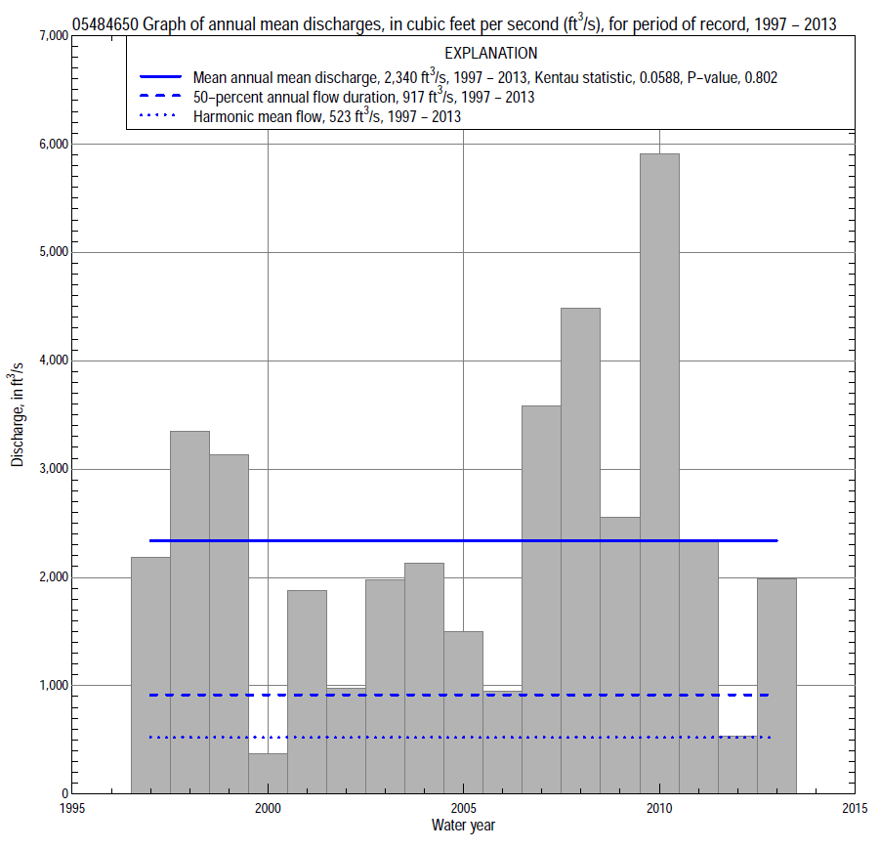

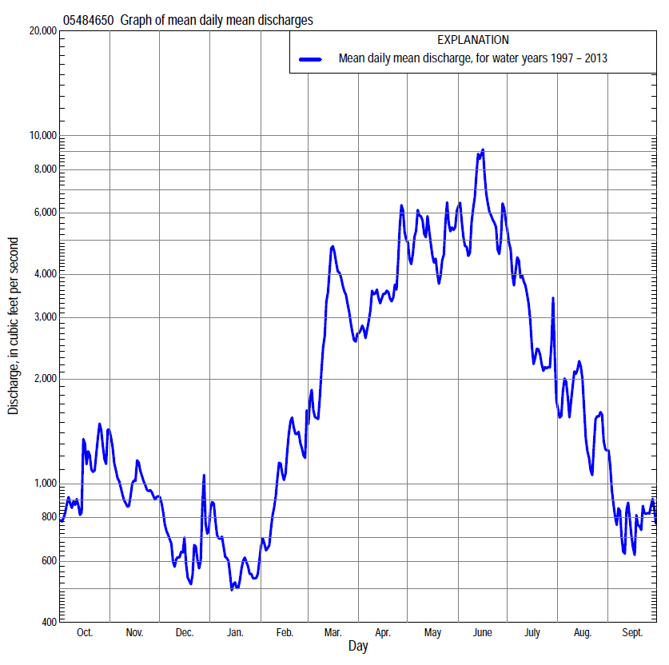

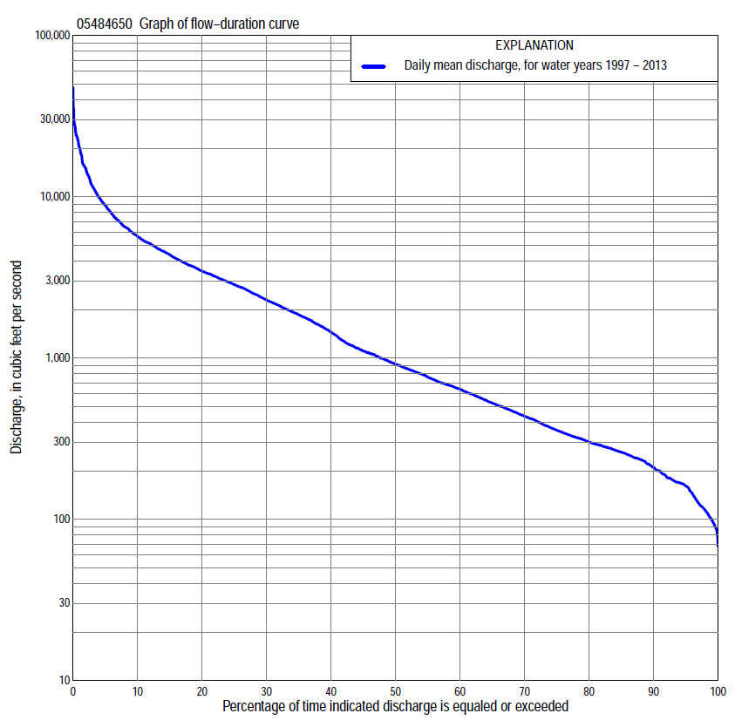

Statistics Based on the Entire Streamflow Period of Record
05484650 Monthly and annual flow durations, based on 1997–2013 period of record (17 years)
Percentage of days discharge equaled or exceeded |  |  |  |  | Discharge (cubic feet per second) |  |  |  |  |  |  |  |  | Annual flow durations
 | Oct | Nov | Dec | Jan | Feb | Mar | Apr | May | June | July | Aug | Sept | Annual | Kentau statistic | P-value
99 | 90 | 110 | 85 | 89 | 94 | 148 | 264 | 254 | 457 | 149 | 115 | 95 | 99 | 0.015 | 0.967
98 | 97 | 117 | 88 | 98 | 99 | 200 | 268 | 262 | 503 | 183 | 121 | 103 | 114 | -0.007 | 1.000
95 | 118 | 153 | 110 | 116 | 132 | 325 | 296 | 446 | 568 | 257 | 163 | 117 | 161 | -0.007 | 1.000
90 | 163 | 177 | 161 | 180 | 170 | 425 | 503 | 1,420 | 728 | 416 | 224 | 157 | 210 | -0.044 | 0.837
85 | 169 | 232 | 200 | 200 | 200 | 508 | 779 | 1,890 | 1,180 | 531 | 267 | 175 | 261 | -0.044 | 0.837
80 | 179 | 260 | 236 | 218 | 240 | 620 | 1,010 | 2,290 | 1,820 | 675 | 336 | 206 | 301 | 0.000 | 1.000
75 | 235 | 279 | 262 | 240 | 280 | 667 | 1,490 | 2,700 | 2,320 | 801 | 384 | 247 | 356 | -0.015 | 0.967
70 | 249 | 297 | 285 | 263 | 307 | 705 | 1,730 | 2,930 | 2,710 | 942 | 440 | 275 | 435 | 0.007 | 1.000
65 | 279 | 323 | 313 | 290 | 351 | 819 | 1,920 | 3,150 | 2,990 | 1,080 | 501 | 303 | 525 | 0.022 | 0.934
60 | 306 | 341 | 371 | 325 | 442 | 988 | 2,110 | 3,390 | 3,240 | 1,270 | 550 | 327 | 640 | 0.029 | 0.902
55 | 330 | 408 | 441 | 360 | 573 | 1,220 | 2,360 | 3,620 | 3,740 | 1,520 | 602 | 353 | 760 | 0.000 | 1.000
50 | 406 | 485 | 500 | 393 | 652 | 1,610 | 2,790 | 3,840 | 4,100 | 1,820 | 682 | 387 | 917 | 0.000 | 1.000
45 | 565 | 639 | 550 | 420 | 820 | 1,790 | 3,100 | 4,140 | 4,600 | 2,190 | 835 | 419 | 1,100 | -0.037 | 0.869
40 | 709 | 754 | 599 | 480 | 950 | 2,070 | 3,460 | 4,500 | 5,190 | 2,640 | 958 | 448 | 1,450 | 0.000 | 1.000
35 | 815 | 914 | 680 | 556 | 1,020 | 2,380 | 3,820 | 4,970 | 5,700 | 3,060 | 1,060 | 476 | 1,860 | 0.000 | 1.000
30 | 872 | 1,160 | 740 | 750 | 1,110 | 2,780 | 4,220 | 5,470 | 6,460 | 3,430 | 1,200 | 526 | 2,290 | -0.015 | 0.967
25 | 958 | 1,490 | 834 | 828 | 1,200 | 3,350 | 4,750 | 6,060 | 7,340 | 3,940 | 1,400 | 595 | 2,850 | 0.000 | 1.000
20 | 1,330 | 1,820 | 1,030 | 924 | 1,560 | 4,030 | 5,260 | 6,830 | 8,670 | 4,730 | 1,640 | 732 | 3,460 | 0.000 | 1.000
15 | 1,880 | 2,190 | 1,150 | 1,080 | 1,940 | 5,110 | 5,870 | 7,920 | 10,300 | 5,580 | 2,090 | 1,520 | 4,380 | 0.015 | 0.967
10 | 2,650 | 2,540 | 1,270 | 1,270 | 2,400 | 6,620 | 7,150 | 9,400 | 13,700 | 7,370 | 3,330 | 2,410 | 5,660 | 0.118 | 0.537
5 | 4,200 | 3,030 | 2,000 | 1,870 | 3,620 | 10,700 | 11,200 | 14,700 | 21,100 | 11,400 | 7,430 | 3,370 | 8,840 | 0.074 | 0.711
2 | 6,700 | 3,850 | 2,580 | 2,500 | 6,040 | 19,100 | 15,000 | 19,900 | 26,100 | 15,100 | 11,700 | 5,180 | 14,700 | 0.088 | 0.650
1 | 9,910 | 4,720 | 3,230 | 3,110 | 7,400 | 26,300 | 16,900 | 24,000 | 35,200 | 16,300 | 19,900 | 5,570 | 20,100 | 0.074 | 0.711

05484650 Annual exceedance probability of instantaneous peak discharges, in cubic feet per second (ft³/s), based on the Weighted Independent Estimates method,
Annual exceed-ance probability | Recur-rence interval (years) | Discharge (ft³/s) | 95-percent lower confi-dence interval (ft³/s) | 95-percent upper confi-dence interval (ft³/s)
0.500 | 2 | 16,800 | 14,700 | 19,200
0.200 | 5 | 27,800 | 24,500 | 31,600
0.100 | 10 | 34,600 | 30,100 | 39,600
0.040 | 25 | 43,600 | 37,000 | 51,200
0.020 | 50 | 49,900 | 41,300 | 60,300
0.010 | 100 | 55,900 | 44,900 | 69,600
0.005 | 200 | 63,800 | 49,500 | 82,200
0.002 | 500 | 70,300 | 52,200 | 94,800
and based on the expected moments algorithm/multiple Grubbs-Beck analysis computed using a historical period length of 99 years (1915–2013)
0.500 | 2 | 16,800 | 12,300 | 21,800
0.200 | 5 | 27,900 | 21,400 | 35,400
0.100 | 10 | 35,600 | 27,200 | 45,100
0.040 | 25 | 45,300 | 34,200 | 58,800
0.020 | 50 | 52,500 | 39,200 | 70,900
0.010 | 100 | 59,600 | 43,800 | 85,000
0.005 | 200 | 66,600 | 48,000 | 101,000
0.002 | 500 | 75,700 | 53,000 | 127,000
Kentau statistic |  | 0.021
P-value |  | 0.922
Begin year |  | 1993
End year |  | 2013
Number of peaks |  | 20

05484650 Annual exceedance probability of high discharges, based on 1997–2013 period of record (17 years)
[ND, not determined]
Annual exceed-ance probability | Recur-rence interval (years) | Maximum average discharge (ft³/s) for indicated number of consecutive days
 |  | 1 | 3 | 7 | 15 | 30
0.990 | 1.01 | ND | ND | 1,250 | 894 | 682
0.950 | 1.05 | ND | ND | 2,660 | 1,950 | 1,530
0.900 | 1.11 | ND | ND | 3,860 | 2,860 | 2,260
0.800 | 1.25 | ND | ND | 5,890 | 4,410 | 3,500
0.500 | 2 | ND | ND | 12,100 | 9,200 | 7,250
0.200 | 5 | ND | ND | 22,400 | 17,100 | 13,100
0.100 | 10 | ND | ND | 29,700 | 22,800 | 17,100
0.040 | 25 | ND | ND | 38,900 | 29,900 | 21,800
0.020 | 50 | ND | ND | 45,600 | 35,000 | 25,100
0.010 | 100 | ND | ND | 52,100 | 40,000 | 28,100
0.005 | 200 | ND | ND | 58,400 | 44,800 | 30,900
0.002 | 500 | ND | ND | 66,400 | 50,900 | 34,400
Kentau statistic |  | 0.044 | 0.029 | 0.103 | 0.118 | 0.088
P-value |  | 0.837 | 0.902 | 0.592 | 0.537 | 0.650

 | 05484650 Annual nonexceedance probability of low discharges, based on April 1997 to March 2013 period of record (16 years)
Annual nonexceed-ance probability | Recur-rence interval (years) | Minimum average discharge (cubic feet per second) for indicated number of consecutive days
 |  | 1 | 3 | 7 | 14 | 30 | 60 | 90 | 120 | 183
0.01 | 100 | 45 | 49 | 55 | 62 | 69 | 72 | 74 | 75 | 76
0.02 | 50 | 55 | 59 | 67 | 73 | 82 | 86 | 90 | 92 | 94
0.05 | 20 | 73 | 79 | 87 | 95 | 105 | 113 | 120 | 122 | 129
0.10 | 10 | 93 | 101 | 110 | 119 | 130 | 143 | 156 | 160 | 171
0.20 | 5 | 123 | 134 | 145 | 155 | 170 | 190 | 212 | 225 | 245
0.50 | 2 | 200 | 219 | 237 | 256 | 283 | 327 | 385 | 438 | 501
0.80 | 1.25 | 308 | 342 | 374 | 415 | 471 | 559 | 702 | 868 | 1,060
0.90 | 1.11 | 376 | 423 | 468 | 532 | 614 | 737 | 964 | 1,250 | 1,600
0.96 | 1.04 | 459 | 523 | 589 | 690 | 814 | 989 | 1,350 | 1,860 | 2,510
0.98 | 1.02 | 517 | 596 | 680 | 814 | 977 | 1,200 | 1,690 | 2,410 | 3,380
0.99 | 1.01 | 572 | 666 | 771 | 943 | 1,150 | 1,420 | 2,060 | 3,050 | 4,430
Kentau statistic |  | 0.083 | 0.100 | 0.100 | 0.067 | 0.050 | 0.167 | 0.150 | 0.167 | 0.133
P-value |  | 0.685 | 0.620 | 0.620 | 0.753 | 0.822 | 0.392 | 0.444 | 0.392 | 0.499

05484650 Annual nonexceedance probability of seasonal low discharges, based on October 1996 to September 2013 period of record (17 years)
Annual nonexceed-ance probability | Recur-rence interval (years) | Minimum average discharge (cubic feet per second) for indicated number of consecutive days
 |  | 1 | 7 | 14 | 30 |  | 1 | 7 | 14 | 30
 |  | January-February-March |  |  |  |  | April-May-June
0.01 | 100 | 46 | 65 | 68 | 72 |  | 112 | 140 | 150 | 167
0.02 | 50 | 56 | 77 | 82 | 88 |  | 154 | 190 | 206 | 249
0.05 | 20 | 75 | 101 | 109 | 118 |  | 242 | 295 | 324 | 434
0.10 | 10 | 97 | 130 | 141 | 154 |  | 353 | 427 | 474 | 678
0.20 | 5 | 136 | 175 | 193 | 213 |  | 544 | 649 | 734 | 1,100
0.50 | 2 | 261 | 317 | 351 | 397 |  | 1,140 | 1,340 | 1,570 | 2,390
0.80 | 1.25 | 517 | 588 | 645 | 747 |  | 2,160 | 2,500 | 3,030 | 4,260
0.90 | 1.11 | 748 | 819 | 888 | 1,040 |  | 2,900 | 3,330 | 4,130 | 5,390
0.96 | 1.04 | 1,120 | 1,170 | 1,250 | 1,490 |  | 3,860 | 4,410 | 5,600 | 6,600
0.98 | 1.02 | 1,460 | 1,490 | 1,560 | 1,870 |  | 4,570 | 5,210 | 6,710 | 7,350
0.99 | 1.01 | 1,840 | 1,850 | 1,910 | 2,310 |  | 5,270 | 5,990 | 7,830 | 7,980
Kentau statistic |  | 0.022 | 0.015 | 0.000 | -0.044 |  | -0.015 | -0.015 | -0.015 | 0.059
P-value |  | 0.934 | 0.967 | 1.000 | 0.837 |  | 0.967 | 0.967 | 0.967 | 0.773
 |  | July-August-September |  |  |  |  | October-November-December
0.01 | 100 | 104 | 108 | 112 | 122 |  | 50 | 52 | 57 | 60
0.02 | 50 | 108 | 112 | 118 | 130 |  | 61 | 65 | 71 | 75
0.05 | 20 | 116 | 123 | 131 | 146 |  | 83 | 92 | 100 | 106
0.10 | 10 | 128 | 137 | 148 | 167 |  | 108 | 123 | 133 | 144
0.20 | 5 | 149 | 162 | 177 | 204 |  | 147 | 172 | 187 | 207
0.50 | 2 | 232 | 255 | 284 | 341 |  | 258 | 319 | 348 | 411
0.80 | 1.25 | 454 | 497 | 555 | 689 |  | 433 | 565 | 623 | 804
0.90 | 1.11 | 713 | 773 | 856 | 1,080 |  | 560 | 748 | 831 | 1,130
0.96 | 1.04 | 1,250 | 1,330 | 1,460 | 1,870 |  | 727 | 997 | 1,120 | 1,630
0.98 | 1.02 | 1,890 | 1,980 | 2,130 | 2,770 |  | 856 | 1,190 | 1,350 | 2,060
0.99 | 1.01 | 2,830 | 2,910 | 3,090 | 4,050 |  | 987 | 1,390 | 1,580 | 2,530
Kentau statistic |  | -0.103 | -0.103 | -0.103 | -0.029 |  | -0.015 | 0.074 | 0.059 | 0.015
P-value |  | 0.592 | 0.592 | 0.592 | 0.902 |  | 0.967 | 0.711 | 0.773 | 0.967

