LOCATION.--Lat 41°35'14", long 93°42'11" referenced to North American Datum of 1927, in NW 1/4 SW 1/4 SE 1/4 sec.02, T.78 N., R.25 W., Polk County, IA, Hydrologic Unit 07100006, on left bank 25 ft downstream from bridge on 63rd Street in Des Moines, and 2.2 mi upstream from mouth.

DRAINAGE AREA.--78.4 mi².

PERIOD OF RECORD.--Discharge records from October 1971 to current year.

GAGE.--Water-stage recorder. Datum of gage is 801.04 ft above National Geodetic Vertical Datum of 1929 (levels by Iowa Natural Resources Council).

A summary of all available data for this streamgage is provided through the USGS National Water Information System web interface (NWISWeb). The following link provides access to current/historical observations, daily data, daily statistics, monthly statistics, annual statistics, peak streamflow, field measurements, field/lab water-quality samples, and the latest water-year summaries. Data can be filtered by parameter and/or dates, and can be output in various tabular and graphical formats.
http://waterdata.usgs.gov/nwis/inventory/?site_no=05484800

The USGS WaterWatch Toolkit is available at:
http://waterwatch.usgs.gov/?id=ww_toolkit
Tools for summarizing streamflow information include the duration hydrograph builder, the cumulative streamflow hydrograph builder, the streamgage statistics retrieval tool, the rating curve builder, the flood tracking chart builder, the National Weather Service Advanced Hydrologic Prediction Service (AHPS) river forecast hydrograph builder, and the raster-hydrograph builder. Entering the above number for this streamgage into these toolkit webpages will provide streamflow information specific to this streamgage.

A description of the statistics presented for this streamgage is available in the main body of the report at:
http://dx.doi.org/10.3133/ofr20151214
A link to other streamgages included in this report, a map showing the location of the streamgages, information on the programs used to compute the statistical analyses, and references are included in the main body of the report.

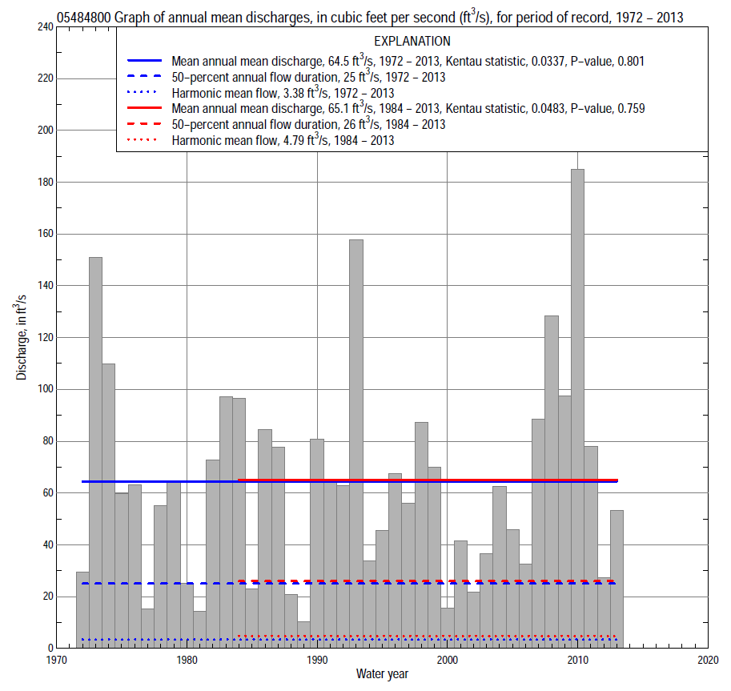

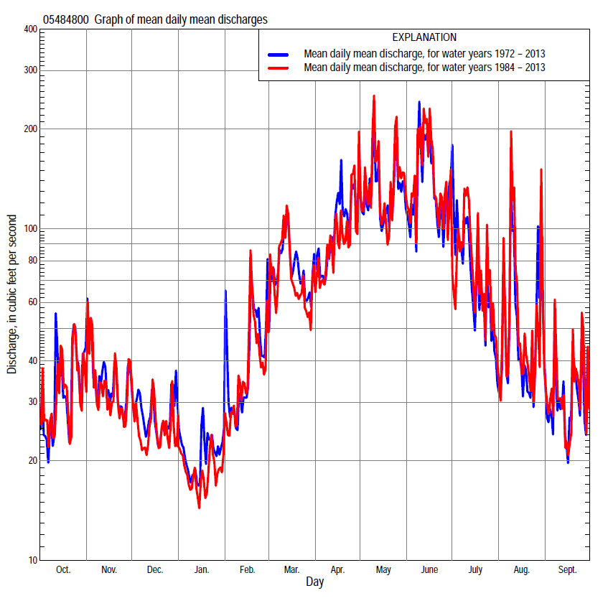

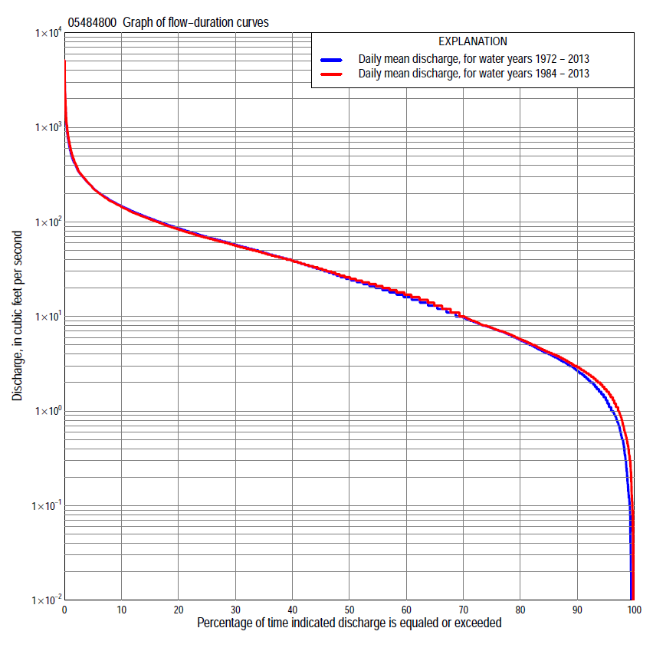

Statistics Based on the Entire Streamflow Period of Record
05484800 Monthly and annual flow durations, based on 1972–2013 period of record (42 years)
Percentage of days discharge equaled or exceeded |  |  |  |  | Discharge (cubic feet per second) |  |  |  |  |  |  |  |  | Annual flow durations
 | Oct | Nov | Dec | Jan | Feb | Mar | Apr | May | June | July | Aug | Sept | Annual | Kentau statistic | P-value
99 | 0.14 | 0.75 | 0.14 | 0.00 | 0.03 | 2.0 | 2.0 | 1.0 | 0.10 | 0.58 | 0.04 | 0.00 | 0.13 | 0.111 | 0.276
98 | 0.32 | 0.88 | 0.23 | 0.00 | 0.78 | 2.6 | 2.2 | 3.2 | 1.7 | 0.83 | 0.17 | 0.02 | 0.50 | 0.043 | 0.684
95 | 0.86 | 1.7 | 1.5 | 1.1 | 1.3 | 4.1 | 4.5 | 6.0 | 5.5 | 1.7 | 0.50 | 0.34 | 1.3 | 0.094 | 0.377
90 | 1.5 | 2.8 | 2.0 | 2.2 | 3.1 | 6.9 | 8.8 | 11 | 12 | 3.9 | 1.1 | 0.79 | 2.7 | 0.067 | 0.534
85 | 2.3 | 3.5 | 2.8 | 3.3 | 4.3 | 9.5 | 15 | 17 | 19 | 7.1 | 2.0 | 1.6 | 4.0 | 0.051 | 0.640
80 | 2.8 | 4.6 | 3.8 | 3.9 | 6.0 | 13 | 19 | 27 | 25 | 9.6 | 3.2 | 2.5 | 5.6 | 0.029 | 0.794
75 | 3.3 | 5.9 | 5.0 | 4.6 | 7.2 | 16 | 24 | 38 | 31 | 13 | 4.7 | 3.3 | 7.6 | 0.003 | 0.983
70 | 4.3 | 7.6 | 6.8 | 5.5 | 8.5 | 20 | 36 | 48 | 37 | 16 | 6.1 | 4.0 | 9.7 | -0.001 | 1.000
65 | 5.2 | 9.7 | 8.6 | 6.5 | 11 | 27 | 44 | 58 | 47 | 19 | 7.4 | 5.1 | 13 | -0.009 | 0.939
60 | 6.6 | 13 | 10 | 7.7 | 13 | 34 | 51 | 67 | 58 | 23 | 8.6 | 6.4 | 16 | -0.006 | 0.965
55 | 7.9 | 15 | 12 | 8.9 | 16 | 40 | 57 | 76 | 65 | 26 | 11 | 7.8 | 20 | -0.007 | 0.957
50 | 9.9 | 19 | 15 | 11 | 20 | 44 | 63 | 85 | 72 | 32 | 13 | 9.5 | 25 | -0.003 | 0.983
45 | 14 | 24 | 18 | 13 | 25 | 52 | 70 | 93 | 81 | 37 | 17 | 12 | 31 | 0.010 | 0.931
40 | 19 | 27 | 22 | 15 | 31 | 58 | 78 | 105 | 90 | 43 | 20 | 14 | 39 | 0.008 | 0.948
35 | 21 | 33 | 25 | 17 | 38 | 68 | 90 | 116 | 104 | 50 | 25 | 18 | 47 | 0.024 | 0.828
30 | 25 | 40 | 30 | 21 | 44 | 78 | 103 | 134 | 119 | 61 | 31 | 21 | 57 | 0.016 | 0.888
25 | 32 | 46 | 38 | 28 | 50 | 92 | 121 | 150 | 137 | 74 | 37 | 26 | 69 | 0.017 | 0.879
20 | 45 | 54 | 44 | 34 | 59 | 107 | 143 | 179 | 164 | 94 | 50 | 36 | 86 | 0.012 | 0.922
15 | 65 | 67 | 52 | 40 | 70 | 130 | 172 | 208 | 197 | 122 | 68 | 56 | 109 | 0.008 | 0.948
10 | 88 | 89 | 63 | 50 | 95 | 180 | 225 | 275 | 260 | 164 | 106 | 80 | 148 | -0.033 | 0.770
5 | 137 | 127 | 88 | 68 | 139 | 260 | 332 | 386 | 437 | 271 | 196 | 135 | 229 | 0.012 | 0.922
2 | 228 | 182 | 148 | 100 | 199 | 409 | 498 | 628 | 859 | 554 | 386 | 259 | 389 | 0.098 | 0.368
1 | 293 | 224 | 199 | 155 | 290 | 510 | 678 | 861 | 1,200 | 771 | 542 | 320 | 570 | 0.161 | 0.135

05484800 Annual exceedance probability of instantaneous peak discharges, in cubic feet per second (ft³/s), based on the expected moments algorithm/multiple Grubbs-Beck analysis computed using a historical period length of 42 years (1972–2013)ª
Annual exceed-ance probability | Recur-rence interval (years) | Discharge (ft³/s) | 95-percent lower confi-dence interval (ft³/s) | 95-percent upper confi-dence interval (ft³/s)
0.500 | 2 | 2,620 | 2,060 | 3,320
0.200 | 5 | 4,840 | 3,800 | 6,460
0.100 | 10 | 6,640 | 5,120 | 9,530
0.040 | 25 | 9,250 | 6,860 | 15,000
0.020 | 50 | 11,400 | 8,170 | 20,600
0.010 | 100 | 13,800 | 9,460 | 27,800
0.005 | 200 | 16,400 | 10,700 | 36,900
0.002 | 500 | 20,100 | 12,300 | 52,700
Kentau statistic |  | 0.132
P-value |  | 0.221
Begin year |  | 1972
End year |  | 2013
Number of peaks |  | 42
ªWeighted Independent Estimates were not computed because regional regression equations are not considered applicable due to urbanization.

05484800 Annual exceedance probability of high discharges, based on 1972–2013 period of record (42 years)
Annual exceedance probability | Recur-rence interval (years) | Maximum average discharge (ft³/s) for indicated number of consecutive days
 |  | 1 | 3 | 7 | 15 | 30
0.990 | 1.01 | 127 | 107 | 70 | 49 | 33
0.950 | 1.05 | 246 | 182 | 121 | 85 | 60
0.900 | 1.11 | 346 | 241 | 160 | 112 | 81
0.800 | 1.25 | 517 | 339 | 224 | 156 | 114
0.500 | 2 | 1,080 | 646 | 416 | 282 | 206
0.200 | 5 | 2,170 | 1,220 | 752 | 490 | 347
0.100 | 10 | 3,080 | 1,690 | 1,010 | 644 | 442
0.040 | 25 | 4,410 | 2,400 | 1,380 | 851 | 562
0.020 | 50 | 5,530 | 3,000 | 1,670 | 1,010 | 650
0.010 | 100 | 6,750 | 3,670 | 1,990 | 1,180 | 734
0.005 | 200 | 8,070 | 4,400 | 2,320 | 1,350 | 817
0.002 | 500 | 9,980 | 5,480 | 2,790 | 1,580 | 922
Kentau statistic |  | 0.114 | 0.134 | 0.117 | 0.115 | 0.131
P-value |  | 0.293 | 0.217 | 0.278 | 0.288 | 0.225

 | 05484800 Annual nonexceedance probability of low discharges, based on April 1972 to March 2013 period of record (41 years)
Annual nonexceed-ance probability | Recur-rence interval (years) | Minimum average discharge (cubic feet per second) for indicated number of consecutive days
 |  | 1 | 3 | 7 | 14 | 30 | 60 | 90 | 120 | 183
0.01 | 100 | 0.00 | 0.00 | 0.00 | 0.00 | 0.00 | 0.09 | 0.23 | 0.57 | 1.1
0.02 | 50 | 0.00 | 0.00 | 0.00 | 0.00 | 0.00 | 0.21 | 0.44 | 0.93 | 1.6
0.05 | 20 | 0.00 | 0.00 | 0.00 | 0.04 | 0.62 | 0.63 | 1.1 | 1.8 | 2.9
0.10 | 10 | 0.00 | 0.03 | 0.13 | 0.19 | 1.1 | 1.5 | 2.3 | 3.2 | 4.7
0.20 | 5 | 0.13 | 0.22 | 0.48 | 0.68 | 2.0 | 3.4 | 4.7 | 5.9 | 8.0
0.50 | 2 | 1.3 | 1.6 | 2.1 | 3.6 | 5.1 | 11 | 14 | 15 | 20
0.80 | 1.25 | 5.4 | 5.9 | 6.7 | 9.8 | 12 | 20 | 27 | 32 | 41
0.90 | 1.11 | 9.3 | 10 | 12 | 14 | 19 | 23 | 34 | 44 | 56
0.96 | 1.04 | 15 | 17 | 20 | 22 | 23 | 25 | 40 | 57 | 76
0.98 | 1.02 | 20 | 22 | 23 | 24 | 25 | 26 | 43 | 66 | 90
0.99 | 1.01 | 24 | 27 | 28 | 29 | 30 | 31 | 45 | 74 | 103
Kentau statistic |  | 0.072 | 0.055 | 0.057 | 0.054 | 0.080 | 0.039 | 0.029 | 0.010 | 0.007
P-value |  | 0.514 | 0.621 | 0.605 | 0.629 | 0.465 | 0.728 | 0.796 | 0.937 | 0.955

05484800 Annual nonexceedance probability of seasonal low discharges, based on October 1971 to September 2013 period of record (42 years)
Annual nonexceed-ance probability | Recur-rence interval (years) | Minimum average discharge (cubic feet per second) for indicated number of consecutive days
 |  | 1 | 7 | 14 | 30 |  | 1 | 7 | 14 | 30
 |  | January-February-March |  |  |  |  | April-May-June
0.01 | 100 | 0.00 | 0.00 | 0.00 | 0.00 |  | 0.00 | 0.00 | 0.05 | 1.1
0.02 | 50 | 0.00 | 0.00 | 0.00 | 0.00 |  | 0.00 | 0.00 | 0.18 | 2.1
0.05 | 20 | 0.48 | 0.71 | 0.83 | 1.2 |  | 0.92 | 1.4 | 2.4 | 4.8
0.10 | 10 | 0.93 | 1.3 | 1.6 | 2.3 |  | 2.5 | 3.7 | 5.7 | 9.4
0.20 | 5 | 1.7 | 2.4 | 2.9 | 4.1 |  | 5.8 | 8.4 | 13 | 19
0.50 | 2 | 4.9 | 6.4 | 7.8 | 11 |  | 19 | 26 | 44 | 56
0.80 | 1.25 | 13 | 16 | 19 | 26 |  | 45 | 55 | 85 | 115
0.90 | 1.11 | 20 | 25 | 29 | 39 |  | 63 | 74 | 111 | 149
0.96 | 1.04 | 33 | 40 | 45 | 60 |  | 84 | 93 | 138 | 183
0.98 | 1.02 | 45 | 54 | 59 | 79 |  | 97 | 105 | 145 | 202
0.99 | 1.01 | 59 | 69 | 75 | 99 |  | 108 | 115 | 166 | 217
Kentau statistic |  | -0.101 | -0.028 | -0.010 | 0.010 |  | 0.062 | 0.057 | 0.075 | 0.106
P-value |  | 0.351 | 0.803 | 0.931 | 0.931 |  | 0.573 | 0.603 | 0.488 | 0.329
 |  | July-August-September |  |  |  |  | October-November-December
0.01 | 100 | 0.00 | 0.00 | 0.03 | 0.45 |  | 0.02 | 0.07 | 0.13 | 0.27
0.02 | 50 | 0.00 | 0.00 | 0.06 | 0.63 |  | 0.04 | 0.12 | 0.23 | 0.45
0.05 | 20 | 0.00 | 0.09 | 0.17 | 1.1 |  | 0.10 | 0.27 | 0.51 | 0.93
0.10 | 10 | 0.00 | 0.22 | 0.42 | 1.7 |  | 0.23 | 0.53 | 0.99 | 1.7
0.20 | 5 | 0.12 | 0.53 | 1.1 | 3.0 |  | 0.59 | 1.2 | 2.0 | 3.3
0.50 | 2 | 1.4 | 2.4 | 5.0 | 8.4 |  | 2.9 | 4.4 | 6.8 | 10
0.80 | 1.25 | 8.0 | 10 | 17 | 24 |  | 11 | 14 | 19 | 25
0.90 | 1.11 | 17 | 21 | 30 | 40 |  | 19 | 24 | 30 | 38
0.96 | 1.04 | 36 | 45 | 57 | 69 |  | 32 | 41 | 46 | 55
0.98 | 1.02 | 56 | 74 | 86 | 99 |  | 44 | 55 | 60 | 69
0.99 | 1.01 | 82 | 115 | 125 | 135 |  | 56 | 72 | 76 | 82
Kentau statistic |  | 0.038 | 0.015 | 0.057 | 0.096 |  | 0.013 | -0.014 | 0.053 | 0.003
P-value |  | 0.729 | 0.897 | 0.603 | 0.374 |  | 0.914 | 0.905 | 0.626 | 0.983

Statistics Based on the 1984–2013 Streamflow Period of Record
05484800 Monthly and annual flow durations, based on 1984–2013 period of record (30 years)
Percentage of days discharge equaled or exceeded |  |  |  |  | Discharge (cubic feet per second) |  |  |  |  |  |  |  |  | Annual flow durations
 | Oct | Nov | Dec | Jan | Feb | Mar | Apr | May | June | July | Aug | Sept | Annual | Kentau statistic | P-value
99 | 0.32 | 1.4 | 0.90 | 0.96 | 0.90 | 1.9 | 2.2 | 3.8 | 3.3 | 0.55 | 0.05 | 0.00 | 0.40 | 0.110 | 0.378
98 | 0.40 | 1.8 | 1.3 | 1.4 | 1.2 | 2.8 | 3.0 | 5.7 | 4.6 | 0.75 | 0.14 | 0.07 | 0.72 | 0.085 | 0.502
95 | 1.2 | 2.5 | 1.7 | 2.0 | 2.0 | 5.2 | 6.7 | 9.1 | 7.8 | 1.3 | 0.50 | 0.34 | 1.7 | 0.113 | 0.385
90 | 1.9 | 3.1 | 2.2 | 2.7 | 3.9 | 7.1 | 13 | 14 | 13 | 3.5 | 0.87 | 0.80 | 2.9 | 0.057 | 0.667
85 | 2.5 | 3.9 | 2.7 | 3.6 | 4.9 | 9.6 | 16 | 23 | 20 | 6.4 | 1.7 | 1.6 | 4.2 | 0.090 | 0.495
80 | 2.9 | 4.8 | 3.6 | 4.2 | 6.2 | 15 | 20 | 34 | 26 | 9.6 | 2.9 | 2.6 | 5.8 | 0.071 | 0.591
75 | 3.5 | 6.0 | 4.6 | 5.0 | 7.2 | 18 | 26 | 41 | 33 | 13 | 4.2 | 3.3 | 7.6 | 0.051 | 0.707
70 | 4.2 | 7.7 | 6.4 | 5.8 | 9.0 | 22 | 38 | 52 | 39 | 17 | 5.9 | 4.0 | 10 | 0.034 | 0.802
65 | 5.0 | 9.7 | 8.0 | 6.7 | 11 | 27 | 44 | 61 | 49 | 21 | 7.5 | 4.8 | 13 | 0.018 | 0.900
60 | 5.8 | 13 | 10 | 8.0 | 14 | 33 | 50 | 69 | 58 | 24 | 8.8 | 5.9 | 17 | 0.016 | 0.915
55 | 7.2 | 15 | 12 | 8.9 | 18 | 38 | 55 | 79 | 66 | 29 | 12 | 7.2 | 21 | 0.000 | 1.000
50 | 9.1 | 19 | 15 | 11 | 22 | 42 | 62 | 86 | 73 | 34 | 15 | 8.9 | 26 | -0.007 | 0.972
45 | 13 | 24 | 18 | 13 | 26 | 46 | 68 | 95 | 82 | 39 | 18 | 11 | 32 | 0.011 | 0.943
40 | 19 | 27 | 22 | 15 | 31 | 53 | 76 | 107 | 91 | 45 | 22 | 15 | 39 | 0.028 | 0.844
35 | 21 | 31 | 25 | 18 | 35 | 58 | 86 | 118 | 106 | 53 | 27 | 18 | 47 | 0.053 | 0.695
30 | 25 | 39 | 29 | 21 | 42 | 68 | 100 | 136 | 123 | 63 | 33 | 21 | 56 | 0.067 | 0.617
25 | 32 | 45 | 35 | 27 | 49 | 78 | 114 | 152 | 140 | 77 | 40 | 25 | 68 | 0.053 | 0.694
20 | 48 | 53 | 41 | 31 | 57 | 92 | 134 | 180 | 168 | 102 | 52 | 36 | 83 | 0.037 | 0.789
15 | 65 | 64 | 49 | 37 | 70 | 109 | 162 | 217 | 201 | 133 | 72 | 63 | 107 | 0.037 | 0.789
10 | 88 | 82 | 59 | 44 | 90 | 161 | 203 | 301 | 294 | 179 | 113 | 89 | 144 | 0.007 | 0.972
5 | 130 | 113 | 74 | 56 | 130 | 253 | 293 | 422 | 529 | 272 | 200 | 152 | 227 | 0.032 | 0.817
2 | 224 | 178 | 107 | 70 | 179 | 425 | 430 | 687 | 1,020 | 563 | 397 | 270 | 402 | 0.131 | 0.318
1 | 293 | 228 | 153 | 81 | 249 | 614 | 624 | 1,020 | 1,490 | 771 | 575 | 341 | 614 | 0.209 | 0.108

05484800 Annual exceedance probability of high discharges, based on 1984–2013 period of record (30 years)
Annual exceedance probability | Recur-rence interval (years) | Maximum average discharge (ft³/s) for indicated number of consecutive days
 |  | 1 | 3 | 7 | 15 | 30
0.990 | 1.01 | 98 | 87 | 56 | 41 | 29
0.950 | 1.05 | 220 | 168 | 109 | 77 | 57
0.900 | 1.11 | 327 | 234 | 153 | 106 | 80
0.800 | 1.25 | 516 | 346 | 225 | 154 | 116
0.500 | 2 | 1,130 | 696 | 444 | 297 | 218
0.200 | 5 | 2,240 | 1,320 | 816 | 531 | 371
0.100 | 10 | 3,080 | 1,800 | 1,090 | 701 | 470
0.040 | 25 | 4,190 | 2,460 | 1,450 | 924 | 591
0.020 | 50 | 5,040 | 2,990 | 1,730 | 1,090 | 674
0.010 | 100 | 5,890 | 3,530 | 2,010 | 1,260 | 753
0.005 | 200 | 6,730 | 4,100 | 2,290 | 1,430 | 826
0.002 | 500 | 7,850 | 4,880 | 2,670 | 1,660 | 917
Kentau statistic |  | 0.193 | 0.186 | 0.182 | 0.149 | 0.154
P-value |  | 0.138 | 0.154 | 0.164 | 0.254 | 0.239

 | 05484800 Annual nonexceedance probability of low discharges, based on April 1983 to March 2013 period of record (30 years)
Annual nonexceed-ance probability | Recur-rence interval (years) | Minimum average discharge (cubic feet per second) for indicated number of consecutive days
 |  | 1 | 3 | 7 | 14 | 30 | 60 | 90 | 120 | 183
0.01 | 100 | 0.00 | 0.00 | 0.00 | 0.01 | 0.42 | 1.0 | 1.3 | 1.7 | 2.5
0.02 | 50 | 0.00 | 0.00 | 0.00 | 0.04 | 0.57 | 1.3 | 1.7 | 2.2 | 3.2
0.05 | 20 | 0.00 | 0.02 | 0.09 | 0.12 | 0.90 | 1.9 | 2.6 | 3.2 | 4.5
0.10 | 10 | 0.00 | 0.10 | 0.24 | 0.33 | 1.3 | 2.7 | 3.7 | 4.5 | 6.2
0.20 | 5 | 0.22 | 0.30 | 0.55 | 0.89 | 2.2 | 4.0 | 5.5 | 6.7 | 9.0
0.50 | 2 | 1.4 | 1.6 | 2.1 | 3.8 | 5.3 | 8.4 | 12 | 14 | 18
0.80 | 1.25 | 5.2 | 5.9 | 6.7 | 9.7 | 12 | 17 | 23 | 28 | 37
0.90 | 1.11 | 9.5 | 11 | 12 | 15 | 19 | 25 | 33 | 41 | 53
0.96 | 1.04 | 17 | 18 | 22 | 26 | 30 | 38 | 46 | 59 | 78
0.98 | 1.02 | 24 | 25 | 31 | 36 | 41 | 49 | 58 | 74 | 100
0.99 | 1.01 | 31 | 32 | 44 | 48 | 53 | 62 | 70 | 91 | 124
Kentau statistic |  | 0.055 | 0.034 | 0.062 | 0.011 | 0.080 | 0.057 | 0.067 | 0.044 | 0.044
P-value |  | 0.681 | 0.803 | 0.643 | 0.943 | 0.544 | 0.669 | 0.617 | 0.748 | 0.748

05484800 Annual nonexceedance probability of seasonal low discharges, based on October 1983 to September 2013 period of record (30 years)
Annual nonexceed-ance probability | Recur-rence interval (years) | Minimum average discharge (cubic feet per second) for indicated number of consecutive days
 |  | 1 | 7 | 14 | 30 |  | 1 | 7 | 14 | 30
 |  | January-February-March |  |  |  |  | April-May-June
0.01 | 100 | 0.23 | 0.39 | 0.49 | 0.85 |  | 0.58 | 1.1 | 1.5 | 4.0
0.02 | 50 | 0.35 | 0.57 | 0.71 | 1.2 |  | 0.95 | 1.7 | 2.4 | 5.7
0.05 | 20 | 0.62 | 0.99 | 1.2 | 2.0 |  | 1.9 | 3.1 | 4.6 | 9.6
0.10 | 10 | 1.0 | 1.6 | 1.9 | 3.0 |  | 3.3 | 5.3 | 7.8 | 15
0.20 | 5 | 1.8 | 2.6 | 3.2 | 4.8 |  | 6.3 | 9.4 | 14 | 24
0.50 | 2 | 4.7 | 6.5 | 7.9 | 11 |  | 18 | 24 | 35 | 55
0.80 | 1.25 | 11 | 15 | 17 | 24 |  | 43 | 53 | 70 | 109
0.90 | 1.11 | 17 | 21 | 25 | 34 |  | 63 | 74 | 94 | 148
0.96 | 1.04 | 24 | 31 | 35 | 49 |  | 89 | 101 | 121 | 198
0.98 | 1.02 | 31 | 38 | 43 | 60 |  | 110 | 120 | 138 | 234
0.99 | 1.01 | 37 | 46 | 51 | 73 |  | 129 | 139 | 154 | 269
Kentau statistic |  | -0.133 | -0.048 | -0.011 | -0.002 |  | 0.117 | 0.085 | 0.113 | 0.168
P-value |  | 0.309 | 0.721 | 0.943 | 1.000 |  | 0.372 | 0.521 | 0.392 | 0.199
 |  | July-August-September |  |  |  |  | October-November-December
0.01 | 100 | 0.00 | 0.00 | 0.02 | 0.46 |  | 0.04 | 0.22 | 0.66 | 0.87
0.02 | 50 | 0.00 | 0.00 | 0.04 | 0.64 |  | 0.07 | 0.30 | 0.84 | 1.1
0.05 | 20 | 0.00 | 0.07 | 0.13 | 1.1 |  | 0.16 | 0.50 | 1.2 | 1.7
0.10 | 10 | 0.00 | 0.21 | 0.35 | 1.7 |  | 0.33 | 0.79 | 1.7 | 2.5
0.20 | 5 | 0.18 | 0.53 | 1.0 | 3.0 |  | 0.73 | 1.4 | 2.6 | 3.8
0.50 | 2 | 1.6 | 2.5 | 5.5 | 8.7 |  | 2.9 | 4.0 | 6.1 | 8.9
0.80 | 1.25 | 9.0 | 11 | 19 | 26 |  | 9.2 | 12 | 15 | 21
0.90 | 1.11 | 21 | 25 | 36 | 47 |  | 16 | 21 | 24 | 33
0.96 | 1.04 | 48 | 59 | 74 | 89 |  | 26 | 39 | 42 | 52
0.98 | 1.02 | 80 | 103 | 116 | 135 |  | 34 | 58 | 59 | 71
0.99 | 1.01 | 127 | 170 | 182 | 195 |  | 43 | 80 | 82 | 94
Kentau statistic |  | -0.018 | -0.025 | 0.034 | 0.103 |  | 0.034 | 0.002 | 0.083 | 0.057
P-value |  | 0.901 | 0.858 | 0.803 | 0.432 |  | 0.803 | 1.000 | 0.532 | 0.669

