LOCATION.--Lat 41°34'54", long 93°38'34" referenced to North American Datum of 1927, in SW 1/4 NW 1/4 NE 1/4 sec.08, T.78 N., R.24 W., Polk County, IA, Hydrologic Unit 07100006, attached to handrail 465 ft from right edge on downstream side of bridge on Fleur Drive (Southwest 18th Street) in Des Moines, 3.0 mi downstream from Walnut Creek, and 2.6 mi upstream from mouth.

DRAINAGE AREA.--3,625 mi².

PERIOD OF RECORD.--Stage-only records from October 1995 to September 1996; discharge records from October 1996 to current year.

GAGE.--Water-stage recorder. Datum of gage is 780.70 ft above National Geodetic Vertical Datum of 1929.

REMARKS.--Discharges are affected by withdrawal by Des Moines Water Works.

EXTREMES FOR PERIOD OF RECORD.--Flood of July 11, 1993, reached a stage of 26.80 ft, discharge about 67,900 ft³/s, stage-only period of operation.

A summary of all available data for this streamgage is provided through the USGS National Water Information System web interface (NWISWeb). The following link provides access to current/historical observations, daily data, daily statistics, monthly statistics, annual statistics, peak streamflow, field measurements, field/lab water-quality samples, and the latest water-year summaries. Data can be filtered by parameter and/or dates, and can be output in various tabular and graphical formats.
http://waterdata.usgs.gov/nwis/inventory/?site_no=05484900

The USGS WaterWatch Toolkit is available at:
http://waterwatch.usgs.gov/?id=ww_toolkit
Tools for summarizing streamflow information include the duration hydrograph builder, the cumulative streamflow hydrograph builder, the streamgage statistics retrieval tool, the rating curve builder, the flood tracking chart builder, the National Weather Service Advanced Hydrologic Prediction Service (AHPS) river forecast hydrograph builder, and the raster-hydrograph builder. Entering the above number for this streamgage into these toolkit webpages will provide streamflow information specific to this streamgage.

A description of the statistics presented for this streamgage is available in the main body of the report at:
http://dx.doi.org/10.3133/ofr20151214
A link to other streamgages included in this report, a map showing the location of the streamgages, information on the programs used to compute the statistical analyses, and references are included in the main body of the report.

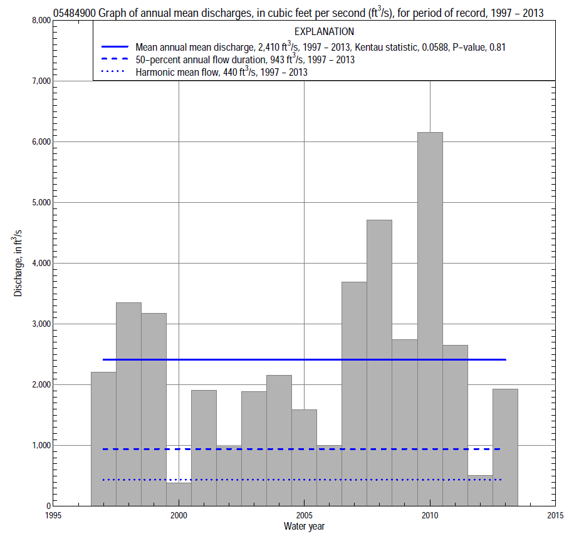

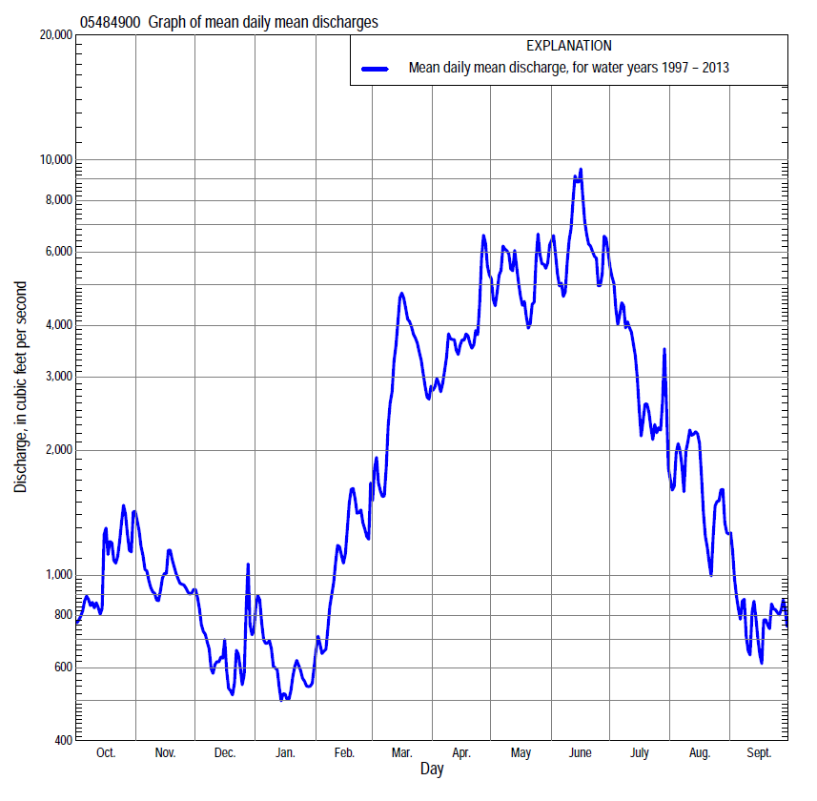

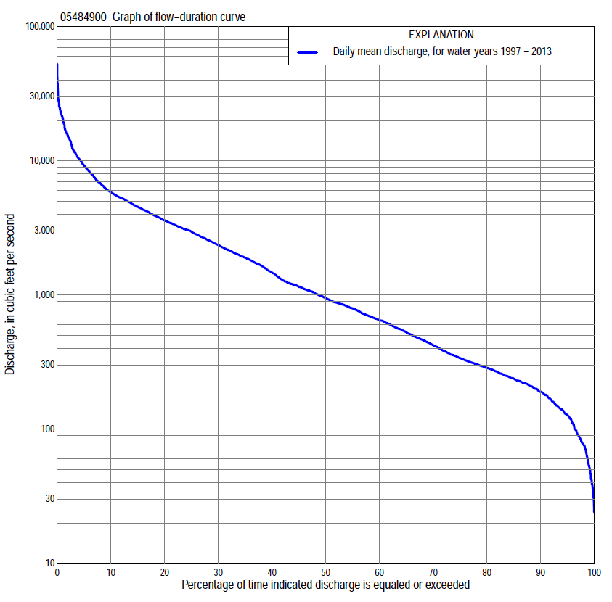

Statistics Based on the Entire Streamflow Period of Record
05484900 Monthly and annual flow durations, based on 1997–2013 period of record (17 years)
Percentage of days discharge equaled or exceeded |  |  |  |  | Discharge (cubic feet per second) |  |  |  |  |  |  |  |  | Annual flow durations
 | Oct | Nov | Dec | Jan | Feb | Mar | Apr | May | June | July | Aug | Sept | Annual | Kentau statistic | P-value
99 | 31 | 67 | 39 | 43 | 69 | 149 | 219 | 265 | 487 | 86 | 50 | 36 | 54 | 0.044 | 0.837
98 | 35 | 74 | 47 | 51 | 78 | 215 | 253 | 314 | 515 | 141 | 54 | 46 | 77 | 0.015 | 0.967
95 | 87 | 93 | 88 | 83 | 100 | 288 | 325 | 450 | 594 | 303 | 110 | 81 | 127 | 0.000 | 1.000
90 | 124 | 147 | 150 | 138 | 144 | 380 | 467 | 1,450 | 797 | 441 | 201 | 126 | 190 | 0.015 | 0.967
85 | 141 | 219 | 190 | 186 | 178 | 512 | 771 | 1,890 | 1,140 | 575 | 259 | 155 | 238 | 0.015 | 0.967
80 | 160 | 240 | 220 | 200 | 201 | 616 | 996 | 2,330 | 1,800 | 711 | 315 | 200 | 287 | 0.029 | 0.902
75 | 184 | 275 | 251 | 217 | 235 | 676 | 1,470 | 2,710 | 2,250 | 835 | 371 | 227 | 339 | 0.044 | 0.837
70 | 209 | 292 | 275 | 227 | 280 | 752 | 1,750 | 3,050 | 2,660 | 976 | 420 | 241 | 423 | 0.015 | 0.967
65 | 253 | 307 | 292 | 250 | 342 | 871 | 1,950 | 3,200 | 3,060 | 1,090 | 487 | 265 | 529 | 0.029 | 0.902
60 | 285 | 345 | 329 | 285 | 419 | 1,060 | 2,200 | 3,540 | 3,380 | 1,290 | 547 | 296 | 651 | 0.015 | 0.967
55 | 327 | 407 | 379 | 320 | 545 | 1,250 | 2,650 | 3,770 | 3,890 | 1,560 | 601 | 333 | 796 | 0.015 | 0.967
50 | 403 | 479 | 430 | 353 | 699 | 1,680 | 3,050 | 4,030 | 4,340 | 1,850 | 698 | 374 | 943 | -0.029 | 0.902
45 | 586 | 654 | 496 | 386 | 884 | 1,890 | 3,430 | 4,390 | 4,940 | 2,200 | 827 | 431 | 1,150 | -0.029 | 0.902
40 | 710 | 722 | 607 | 450 | 1,010 | 2,140 | 3,670 | 4,790 | 5,460 | 2,660 | 960 | 480 | 1,470 | 0.015 | 0.967
35 | 815 | 858 | 666 | 604 | 1,080 | 2,550 | 4,020 | 5,180 | 6,030 | 3,050 | 1,080 | 516 | 1,900 | 0.015 | 0.967
30 | 865 | 1,190 | 753 | 846 | 1,190 | 3,000 | 4,440 | 5,600 | 6,780 | 3,470 | 1,180 | 557 | 2,360 | 0.000 | 1.000
25 | 963 | 1,600 | 914 | 881 | 1,290 | 3,430 | 5,040 | 6,140 | 8,030 | 3,990 | 1,360 | 628 | 2,960 | -0.015 | 0.967
20 | 1,280 | 1,860 | 1,130 | 990 | 1,600 | 4,290 | 5,490 | 7,190 | 9,290 | 4,670 | 1,640 | 772 | 3,600 | 0.044 | 0.837
15 | 1,880 | 2,200 | 1,200 | 1,110 | 2,080 | 5,180 | 6,060 | 8,230 | 11,400 | 5,630 | 2,170 | 1,750 | 4,550 | 0.059 | 0.773
10 | 2,660 | 2,550 | 1,300 | 1,330 | 2,550 | 6,550 | 7,500 | 9,910 | 14,400 | 7,870 | 3,330 | 2,460 | 5,810 | 0.088 | 0.650
5 | 4,180 | 3,090 | 2,010 | 1,900 | 3,810 | 10,700 | 11,700 | 15,500 | 21,800 | 11,500 | 7,590 | 3,580 | 9,250 | 0.103 | 0.592
2 | 7,190 | 3,910 | 2,650 | 2,500 | 5,910 | 19,700 | 15,000 | 20,400 | 26,700 | 16,100 | 13,900 | 4,910 | 15,200 | 0.118 | 0.537
1 | 9,890 | 4,790 | 3,270 | 3,060 | 7,840 | 25,300 | 17,500 | 24,000 | 35,100 | 20,100 | 21,000 | 5,490 | 20,700 | 0.132 | 0.484

05484900 Annual exceedance probability of instantaneous peak discharges, in cubic feet per second (ft³/s), based on the Weighted Independent Estimates method,
Annual exceed-ance probability | Recur-rence interval (years) | Discharge (ft³/s) | 95-percent lower confi-dence interval (ft³/s) | 95-percent upper confi-dence interval (ft³/s)
0.500 | 2 | 15,400 | 13,100 | 18,100
0.200 | 5 | 28,300 | 24,300 | 32,900
0.100 | 10 | 36,200 | 30,900 | 42,500
0.040 | 25 | 46,900 | 38,900 | 56,500
0.020 | 50 | 54,100 | 43,600 | 67,200
0.010 | 100 | 61,000 | 47,500 | 78,400
0.005 | 200 | 70,700 | 53,000 | 94,300
0.002 | 500 | 77,700 | 55,400 | 109,000
and based on the expected moments algorithm/multiple Grubbs-Beck analysis computed using a historical period length of 99 years (1915–2013)
0.500 | 2 | 15,400 | 11,200 | 20,300
0.200 | 5 | 28,500 | 21,700 | 36,800
0.100 | 10 | 38,100 | 29,000 | 49,300
0.040 | 25 | 50,700 | 38,100 | 67,900
0.020 | 50 | 60,200 | 44,500 | 84,900
0.010 | 100 | 69,700 | 50,400 | 105,000
0.005 | 200 | 79,100 | 55,700 | 128,000
0.002 | 500 | 91,600 | 61,700 | 164,000
Kentau statistic |  | 0.015
P-value |  | 0.930
Begin year |  | 1984
End year |  | 2013
Number of peaks |  | 26

05484900 Annual exceedance probability of high discharges, based on 1997–2013 period of record (17 years)
[ND, not determined]
Annual exceed-ance probability | Recur-rence interval (years) | Maximum average discharge (ft³/s) for indicated number of consecutive days
 |  | 1 | 3 | 7 | 15 | 30
0.990 | 1.01 | ND | ND | 1,560 | 1,060 | 817
0.950 | 1.05 | ND | ND | 3,090 | 2,200 | 1,730
0.900 | 1.11 | ND | ND | 4,350 | 3,160 | 2,500
0.800 | 1.25 | ND | ND | 6,410 | 4,750 | 3,770
0.500 | 2 | ND | ND | 12,600 | 9,610 | 7,580
0.200 | 5 | ND | ND | 22,800 | 17,600 | 13,600
0.100 | 10 | ND | ND | 30,100 | 23,300 | 17,600
0.040 | 25 | ND | ND | 39,600 | 30,500 | 22,600
0.020 | 50 | ND | ND | 46,700 | 35,900 | 26,100
0.010 | 100 | ND | ND | 53,700 | 41,100 | 29,400
0.005 | 200 | ND | ND | 60,600 | 46,200 | 32,500
0.002 | 500 | ND | ND | 69,700 | 52,800 | 36,400
Kentau statistic |  | 0.074 | 0.059 | 0.132 | 0.132 | 0.118
P-value |  | 0.711 | 0.773 | 0.484 | 0.484 | 0.537

 | 05484900 Annual nonexceedance probability of low discharges, based on April 1997 to March 2013 period of record (16 years)
Annual nonexceed-ance probability | Recur-rence interval (years) | Minimum average discharge (cubic feet per second) for indicated number of consecutive days
 |  | 1 | 3 | 7 | 14 | 30 | 60 | 90 | 120 | 183
0.01 | 100 | 17 | 22 | 23 | 25 | 38 | 43 | 50 | 51 | 52
0.02 | 50 | 22 | 29 | 31 | 33 | 48 | 54 | 65 | 66 | 67
0.05 | 20 | 33 | 43 | 47 | 50 | 67 | 77 | 92 | 94 | 100
0.10 | 10 | 47 | 61 | 67 | 71 | 90 | 105 | 125 | 131 | 142
0.20 | 5 | 71 | 90 | 100 | 107 | 128 | 151 | 182 | 195 | 217
0.50 | 2 | 152 | 182 | 207 | 224 | 252 | 300 | 366 | 417 | 489
0.80 | 1.25 | 308 | 350 | 395 | 442 | 493 | 581 | 727 | 887 | 1,090
0.90 | 1.11 | 437 | 483 | 536 | 616 | 696 | 814 | 1,030 | 1,310 | 1,660
0.96 | 1.04 | 626 | 669 | 727 | 861 | 1,000 | 1,160 | 1,500 | 1,990 | 2,590
0.98 | 1.02 | 784 | 820 | 875 | 1,060 | 1,270 | 1,450 | 1,900 | 2,610 | 3,450
0.99 | 1.01 | 954 | 979 | 1,030 | 1,270 | 1,570 | 1,760 | 2,350 | 3,320 | 4,470
Kentau statistic |  | 0.167 | 0.183 | 0.133 | 0.150 | 0.150 | 0.183 | 0.150 | 0.183 | 0.167
P-value |  | 0.392 | 0.344 | 0.499 | 0.444 | 0.444 | 0.344 | 0.444 | 0.344 | 0.392

05484900 Annual nonexceedance probability of seasonal low discharges, based on October 1996 to September 2013 period of record (17 years)
Annual nonexceed-ance probability | Recur-rence interval (years) | Minimum average discharge (cubic feet per second) for indicated number of consecutive days
 |  | 1 | 7 | 14 | 30 |  | 1 | 7 | 14 | 30
 |  | January-February-March |  |  |  |  | April-May-June
0.01 | 100 | 19 | 30 | 39 | 43 |  | 108 | 125 | 149 | 168
0.02 | 50 | 25 | 40 | 51 | 56 |  | 148 | 174 | 206 | 251
0.05 | 20 | 39 | 62 | 75 | 83 |  | 236 | 280 | 326 | 438
0.10 | 10 | 58 | 89 | 105 | 118 |  | 348 | 416 | 480 | 688
0.20 | 5 | 93 | 138 | 157 | 179 |  | 543 | 653 | 748 | 1,120
0.50 | 2 | 225 | 302 | 331 | 384 |  | 1,180 | 1,410 | 1,620 | 2,460
0.80 | 1.25 | 533 | 629 | 677 | 796 |  | 2,310 | 2,700 | 3,210 | 4,430
0.90 | 1.11 | 831 | 904 | 973 | 1,150 |  | 3,170 | 3,640 | 4,410 | 5,630
0.96 | 1.04 | 1,310 | 1,310 | 1,420 | 1,680 |  | 4,310 | 4,840 | 6,040 | 6,930
0.98 | 1.02 | 1,650 | 1,650 | 1,800 | 2,150 |  | 5,190 | 5,730 | 7,310 | 7,750
0.99 | 1.01 | 2,020 | 2,020 | 2,230 | 2,660 |  | 6,080 | 6,600 | 8,450 | 8,450
Kentau statistic |  | 0.000 | 0.044 | 0.074 | 0.015 |  | 0.029 | 0.000 | 0.015 | 0.059
P-value |  | 1.000 | 0.837 | 0.711 | 0.967 |  | 0.902 | 1.000 | 0.967 | 0.773
 |  | July-August-September |  |  |  |  | October-November-December
0.01 | 100 | 28 | 41 | 52 | 61 |  | 19 | 22 | 32 | 40
0.02 | 50 | 35 | 50 | 61 | 73 |  | 26 | 31 | 43 | 52
0.05 | 20 | 50 | 68 | 81 | 96 |  | 41 | 50 | 66 | 79
0.10 | 10 | 69 | 90 | 104 | 124 |  | 62 | 77 | 95 | 112
0.20 | 5 | 103 | 127 | 144 | 174 |  | 98 | 124 | 145 | 171
0.50 | 2 | 228 | 261 | 287 | 350 |  | 221 | 286 | 313 | 378
0.80 | 1.25 | 522 | 566 | 618 | 765 |  | 451 | 588 | 636 | 811
0.90 | 1.11 | 815 | 871 | 955 | 1,190 |  | 631 | 821 | 900 | 1,200
0.96 | 1.04 | 1,320 | 1,400 | 1,560 | 1,960 |  | 878 | 1,140 | 1,280 | 1,790
0.98 | 1.02 | 1,830 | 1,930 | 2,170 | 2,740 |  | 1,070 | 1,380 | 1,590 | 2,320
0.99 | 1.01 | 2,440 | 2,590 | 2,950 | 3,750 |  | 1,270 | 1,630 | 1,920 | 2,920
Kentau statistic |  | -0.074 | -0.044 | -0.029 | -0.037 |  | 0.088 | 0.088 | 0.059 | 0.059
P-value |  | 0.711 | 0.837 | 0.902 | 0.869 |  | 0.650 | 0.650 | 0.773 | 0.773

