LOCATION.--Lat 41°34'40", long 93°36'19" referenced to North American Datum of 1927, in SW 1/4 SW 1/4 NE 1/4 sec.10, T.78 N., R.24 W., Polk County, IA, Hydrologic Unit 07100008, on left bank 40 ft downstream from bridge on Southeast 6th Street in Des Moines, 0.4 mi downstream from Raccoon River and Scott Street Dam, and 201.0 mi upstream from mouth.

DRAINAGE AREA.--9,879 mi².

PERIOD OF RECORD.--Discharge records from April 1940 to current year.

GAGE.--Water-stage recorder. Datum of gage is 762.52 ft above National Geodetic Vertical Datum of 1929. Prior to October 1, 1951, water-stage recorder upstream from Scott Street Dam (0.4 mi upstream from current site) at datum 11.16 ft higher; October 1, 1951, to September 30, 1953, water-stage recorder at Southeast 14th Street (0.5 mi downstream from current site) at current datum; October 1, 1953, to September 30, 1959, water-stage recorder upstream from Scott Street Dam at datum 11.16 ft higher; October 1, 1959, to September 30, 1961, non-recording gage at current site and datum; October 1, 1961, to April 24, 1997, water-stage recorder at Southeast 14th Street at current datum.

COOPERATION.--Average monthly pumpage from galleries provided by Des Moines Water Works.

REMARKS.--Des Moines municipal water supply is taken from infiltration galleries on Raccoon River, 3.5 mi upstream from station. At times, water is pumped from Raccoon River into recharge basins or into Des Moines Water Works reservoir, capacity 4,800 acre-ft. Effluent from sewage treatment plant enters the river 2.3 mi downstream from station. Net effect of diversions not known. Flow regulated by Saylorville Lake (station 05481630), 12.7 mi upstream, since April 12, 1977.

EXTREMES OUTSIDE PERIOD OF RECORD.--Flood of May 31, 1903, reached a stage of 20.9 ft, from flood profile, at Scott Street site and datum, from the office of the Des Moines City Engineer.

A summary of all available data for this streamgage is provided through the USGS National Water Information System web interface (NWISWeb). The following link provides access to current/historical observations, daily data, daily statistics, monthly statistics, annual statistics, peak streamflow, field measurements, field/lab water-quality samples, and the latest water-year summaries. Data can be filtered by parameter and/or dates, and can be output in various tabular and graphical formats.
http://waterdata.usgs.gov/nwis/inventory/?site_no=05485500

The USGS WaterWatch Toolkit is available at:
http://waterwatch.usgs.gov/?id=ww_toolkit
Tools for summarizing streamflow information include the duration hydrograph builder, the cumulative streamflow hydrograph builder, the streamgage statistics retrieval tool, the rating curve builder, the flood tracking chart builder, the National Weather Service Advanced Hydrologic Prediction Service (AHPS) river forecast hydrograph builder, and the raster-hydrograph builder. Entering the above number for this streamgage into these toolkit webpages will provide streamflow information specific to this streamgage.

A description of the statistics presented for this streamgage is available in the main body of the report at:
http://dx.doi.org/10.3133/ofr20151214
A link to other streamgages included in this report, a map showing the location of the streamgages, information on the programs used to compute the statistical analyses, and references are included in the main body of the report.

Statistics Based on the Pre-regulated Streamflow Period of Record
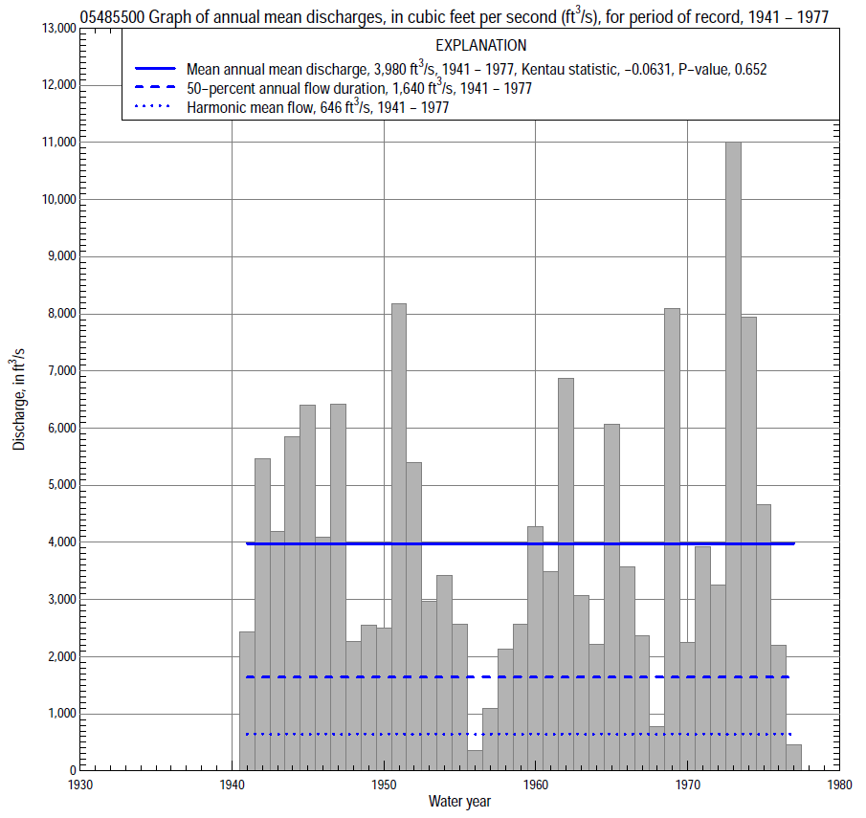

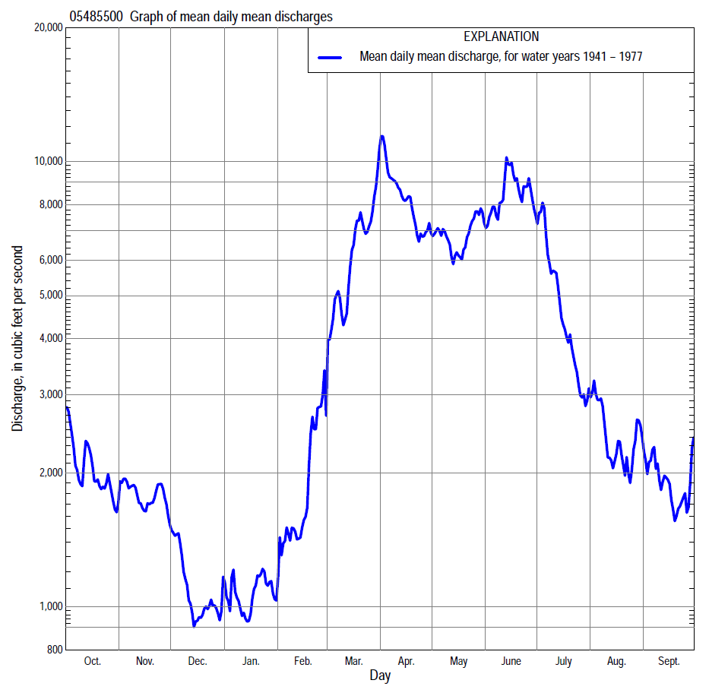

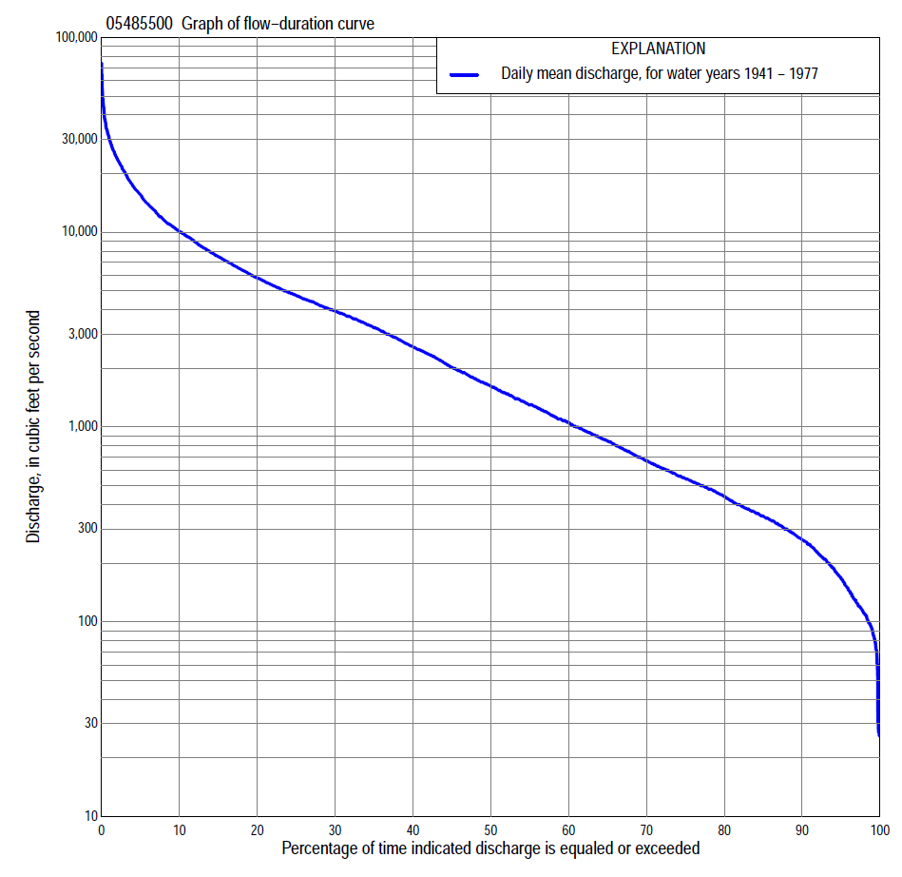

Statistics Based on the Pre-regulated Streamflow Period of Record
05485500 Monthly and annual flow durations, based on 1941–77 pre-regulated period of record (37 years)
Percentage of days discharge equaled or exceeded |  |  |  |  | Discharge (cubic feet per second) |  |  |  |  |  |  |  |  | Annual flow durations
 | Oct | Nov | Dec | Jan | Feb | Mar | Apr | May | June | July | Aug | Sept | Annual | Kentau statistic | P-value
99 | 71 | 113 | 78 | 26 | 63 | 235 | 285 | 313 | 170 | 92 | 163 | 102 | 91 | -0.083 | 0.480
98 | 90 | 124 | 85 | 29 | 106 | 300 | 362 | 340 | 227 | 144 | 194 | 117 | 110 | -0.075 | 0.522
95 | 152 | 173 | 110 | 96 | 116 | 390 | 492 | 492 | 488 | 406 | 284 | 171 | 168 | -0.063 | 0.592
90 | 197 | 250 | 170 | 115 | 150 | 570 | 1,230 | 803 | 1,240 | 826 | 392 | 236 | 264 | -0.071 | 0.547
85 | 255 | 285 | 200 | 140 | 220 | 705 | 1,540 | 1,400 | 1,950 | 1,050 | 478 | 306 | 348 | -0.059 | 0.619
80 | 294 | 330 | 230 | 185 | 290 | 1,100 | 1,810 | 2,170 | 2,600 | 1,320 | 560 | 367 | 440 | -0.099 | 0.395
75 | 334 | 406 | 290 | 240 | 330 | 1,390 | 2,300 | 2,720 | 3,300 | 1,520 | 650 | 436 | 541 | -0.114 | 0.327
70 | 369 | 489 | 350 | 324 | 370 | 1,900 | 2,890 | 3,210 | 3,760 | 1,770 | 750 | 492 | 670 | -0.099 | 0.395
65 | 401 | 566 | 417 | 365 | 447 | 2,350 | 3,530 | 3,700 | 4,260 | 2,000 | 824 | 544 | 848 | -0.089 | 0.448
60 | 474 | 632 | 500 | 410 | 500 | 2,880 | 4,000 | 4,030 | 4,760 | 2,340 | 929 | 628 | 1,060 | -0.098 | 0.402
55 | 562 | 733 | 587 | 480 | 580 | 3,460 | 4,420 | 4,550 | 5,310 | 2,640 | 1,030 | 730 | 1,310 | -0.116 | 0.320
50 | 704 | 852 | 672 | 530 | 786 | 4,070 | 4,860 | 5,030 | 5,840 | 3,160 | 1,190 | 875 | 1,640 | -0.155 | 0.182
45 | 918 | 972 | 760 | 580 | 970 | 4,510 | 5,750 | 5,640 | 6,670 | 3,700 | 1,360 | 1,060 | 2,060 | -0.156 | 0.178
40 | 1,080 | 1,100 | 860 | 638 | 1,200 | 5,050 | 6,740 | 6,290 | 7,560 | 4,150 | 1,540 | 1,280 | 2,610 | -0.144 | 0.214
35 | 1,350 | 1,400 | 957 | 760 | 1,650 | 5,870 | 7,770 | 6,930 | 8,450 | 4,710 | 1,900 | 1,510 | 3,290 | -0.114 | 0.327
30 | 1,730 | 1,590 | 1,100 | 976 | 2,050 | 6,800 | 9,650 | 7,600 | 9,630 | 5,300 | 2,260 | 1,740 | 3,970 | -0.048 | 0.685
25 | 2,480 | 2,110 | 1,300 | 1,150 | 2,700 | 8,300 | 11,400 | 8,440 | 10,900 | 6,150 | 2,780 | 2,060 | 4,780 | -0.038 | 0.754
20 | 3,110 | 2,660 | 1,610 | 1,300 | 3,250 | 9,630 | 13,500 | 9,870 | 12,800 | 7,090 | 3,570 | 2,610 | 5,880 | -0.033 | 0.784
15 | 3,920 | 3,110 | 2,000 | 1,640 | 3,800 | 11,200 | 16,000 | 11,900 | 15,900 | 8,750 | 4,420 | 3,250 | 7,570 | -0.032 | 0.794
10 | 4,940 | 4,070 | 2,600 | 2,410 | 4,860 | 15,300 | 20,100 | 15,400 | 18,900 | 10,600 | 5,730 | 4,520 | 10,200 | -0.038 | 0.754
5 | 7,800 | 7,630 | 3,680 | 5,000 | 7,750 | 22,000 | 27,400 | 21,600 | 26,100 | 16,500 | 8,350 | 7,070 | 15,700 | -0.024 | 0.844
2 | 12,500 | 11,000 | 5,200 | 6,500 | 11,400 | 31,000 | 38,500 | 31,100 | 33,800 | 25,000 | 13,000 | 12,300 | 24,000 | 0.026 | 0.834
1 | 20,500 | 13,300 | 6,350 | 9,000 | 13,200 | 35,100 | 48,600 | 38,000 | 43,800 | 30,400 | 15,000 | 16,800 | 30,300 | 0.005 | 0.979

05485500 Annual exceedance probability of instantaneous peak discharges, in cubic feet per second (ft³/s), for the pre-regulated period of record based on the expected moments algorithm/multiple Grubbs-Beck analysis computed using a historical period length of 85 years (1893–1977)ª
Annual exceed-ance probability | Recur-rence interval (years) | Discharge (ft³/s) | 95-percent lower confi-dence interval (ft³/s) | 95-percent upper confi-dence interval (ft³/s)
0.500 | 2 | 27,800 | 22,400 | 33,800
0.200 | 5 | 44,400 | 36,700 | 53,600
0.100 | 10 | 55,300 | 45,700 | 67,300
0.040 | 25 | 68,700 | 56,100 | 85,900
0.020 | 50 | 78,200 | 63,100 | 101,000
0.010 | 100 | 87,300 | 69,200 | 118,000
0.005 | 200 | 96,100 | 74,600 | 137,000
0.002 | 500 | 107,000 | 80,700 | 164,000
Kentau statistic |  | 0.040
P-value |  | 0.734
Begin year |  | 1940
End year |  | 1977
Number of peaks |  | 38
ªWeighted Independent Estimates were not computed because regional regression equations are not applicable due to size of drainage area.
Note: The above discharges are for the pre-regulated period of record and they are not applicable for flood-plain management regulation or for design purposes.

05485500 Annual exceedance probability of high discharges, based on 1941–77 pre-regulated period of record (37 years) [ND, not determined]
Annual exceedance probability | Recur-rence interval (years) | Maximum average discharge (cubic feet per second) for indicated number of consecutive days
 |  | 1 | 3 | 7 | 15 | 30
0.990 | 1.01 | ND | 2,990 | 1,810 | 1,370 | 1,010
0.950 | 1.05 | ND | 6,710 | 4,830 | 3,600 | 2,720
0.900 | 1.11 | ND | 9,770 | 7,530 | 5,590 | 4,260
0.800 | 1.25 | ND | 14,600 | 12,000 | 8,890 | 6,850
0.500 | 2 | ND | 27,500 | 23,800 | 17,800 | 13,900
0.200 | 5 | ND | 43,500 | 37,200 | 28,400 | 22,200
0.100 | 10 | ND | 52,100 | 43,400 | 33,500 | 26,100
0.040 | 25 | ND | 60,500 | 48,700 | 38,100 | 29,700
0.020 | 50 | ND | 65,400 | 51,300 | 40,500 | 31,500
0.010 | 100 | ND | 69,300 | 53,200 | 42,200 | 32,800
0.005 | 200 | ND | 72,400 | 54,500 | 43,500 | 33,700
0.002 | 500 | ND | 75,700 | 55,600 | 44,700 | 34,600
Kentau statistic |  | -0.011 | 0.005 | 0.000 | -0.012 | -0.024
P-value |  | 0.937 | 0.979 | 1.000 | 0.927 | 0.844
Note: The above discharges are for the pre-regulated period of record and they are not applicable for flood-plain management regulation or for design purposes.

 | 05485500 Annual nonexceedance probability of low discharges, based on April 1940 to March 1977 pre-regulated period of record (37 years)
Annual nonexceed-ance probability | Recur-rence interval (years) | Minimum average discharge (cubic feet per second) for indicated number of consecutive days
 |  | 1 | 3 | 7 | 14 | 30 | 60 | 90 | 120 | 183
0.01 | 100 | 26 | 28 | 29 | 30 | 32 | 51 | 69 | 77 | 87
0.02 | 50 | 35 | 37 | 38 | 39 | 44 | 65 | 86 | 97 | 114
0.05 | 20 | 51 | 55 | 57 | 60 | 69 | 95 | 120 | 138 | 172
0.10 | 10 | 72 | 77 | 80 | 86 | 102 | 132 | 163 | 190 | 248
0.20 | 5 | 108 | 116 | 121 | 132 | 159 | 198 | 239 | 284 | 385
0.50 | 2 | 225 | 244 | 260 | 290 | 354 | 431 | 526 | 633 | 892
0.80 | 1.25 | 453 | 489 | 544 | 606 | 732 | 944 | 1,230 | 1,470 | 2,060
0.90 | 1.11 | 643 | 692 | 791 | 875 | 1,040 | 1,430 | 1,980 | 2,320 | 3,180
0.96 | 1.04 | 923 | 987 | 1,170 | 1,280 | 1,480 | 2,210 | 3,330 | 3,830 | 5,060
0.98 | 1.02 | 1,160 | 1,230 | 1,500 | 1,620 | 1,840 | 2,950 | 4,730 | 5,340 | 6,820
0.99 | 1.01 | 1,420 | 1,500 | 1,870 | 1,990 | 2,220 | 3,820 | 6,530 | 7,230 | 8,910
Kentau statistic |  | 0.038 | 0.075 | 0.066 | 0.045 | 0.003 | -0.012 | -0.042 | -0.060 | -0.093
P-value |  | 0.754 | 0.522 | 0.574 | 0.704 | 0.990 | 0.927 | 0.724 | 0.610 | 0.425

05485500 Annual nonexceedance probability of seasonal low discharges, based on April 1940 to March 1977 pre-regulated period of record (37 years)
Annual nonexceed-ance probability | Recur-rence interval (years) | Minimum average discharge (cubic feet per second) for indicated number of consecutive days
 |  | 1 | 7 | 14 | 30 |  | 1 | 7 | 14 | 30
 |  | January-February-March |  |  |  |  | April-May-June
0.01 | 100 | 29 | 29 | 30 | 33 |  | 106 | 135 | 162 | 267
0.02 | 50 | 39 | 39 | 41 | 45 |  | 163 | 203 | 240 | 377
0.05 | 20 | 61 | 61 | 64 | 72 |  | 296 | 360 | 419 | 617
0.10 | 10 | 87 | 91 | 96 | 108 |  | 484 | 576 | 664 | 934
0.20 | 5 | 135 | 147 | 156 | 178 |  | 834 | 973 | 1,110 | 1,500
0.50 | 2 | 312 | 356 | 383 | 465 |  | 2,020 | 2,310 | 2,630 | 3,430
0.80 | 1.25 | 723 | 835 | 915 | 1,220 |  | 4,080 | 4,630 | 5,350 | 7,040
0.90 | 1.11 | 1,120 | 1,290 | 1,430 | 2,010 |  | 5,500 | 6,270 | 7,330 | 9,860
0.96 | 1.04 | 1,800 | 2,030 | 2,270 | 3,450 |  | 7,210 | 8,270 | 9,830 | 13,700
0.98 | 1.02 | 2,440 | 2,710 | 3,060 | 4,890 |  | 8,390 | 9,680 | 11,600 | 16,700
0.99 | 1.01 | 3,210 | 3,500 | 3,980 | 6,700 |  | 9,460 | 11,000 | 13,400 | 19,800
Kentau statistic |  | -0.072 | -0.096 | -0.087 | -0.105 |  | 0.108 | 0.153 | 0.159 | 0.126
P-value |  | 0.539 | 0.410 | 0.456 | 0.367 |  | 0.353 | 0.187 | 0.170 | 0.278
 |  | July-August-September |  |  |  |  | October-November-December
0.01 | 100 | 44 | 65 | 78 | 127 |  | 53 | 54 | 57 | 63
0.02 | 50 | 58 | 82 | 97 | 153 |  | 62 | 65 | 70 | 78
0.05 | 20 | 87 | 117 | 136 | 205 |  | 80 | 88 | 97 | 108
0.10 | 10 | 126 | 160 | 184 | 269 |  | 102 | 117 | 130 | 148
0.20 | 5 | 195 | 237 | 269 | 380 |  | 142 | 169 | 192 | 222
0.50 | 2 | 445 | 510 | 571 | 770 |  | 292 | 371 | 429 | 511
0.80 | 1.25 | 999 | 1,120 | 1,260 | 1,660 |  | 680 | 895 | 1,050 | 1,290
0.90 | 1.11 | 1,510 | 1,720 | 1,940 | 2,560 |  | 1,120 | 1,480 | 1,750 | 2,170
0.96 | 1.04 | 2,350 | 2,720 | 3,090 | 4,120 |  | 1,970 | 2,610 | 3,100 | 3,890
0.98 | 1.02 | 3,110 | 3,680 | 4,220 | 5,670 |  | 2,910 | 3,830 | 4,560 | 5,770
0.99 | 1.01 | 3,990 | 4,830 | 5,600 | 7,620 |  | 4,190 | 5,470 | 6,530 | 8,310
Kentau statistic |  | -0.021 | 0.024 | -0.003 | -0.063 |  | 0.012 | 0.012 | 0.039 | 0.054
P-value |  | 0.865 | 0.844 | 0.990 | 0.592 |  | 0.927 | 0.927 | 0.744 | 0.647

Statistics Based on the Regulated Streamflow Period of Record

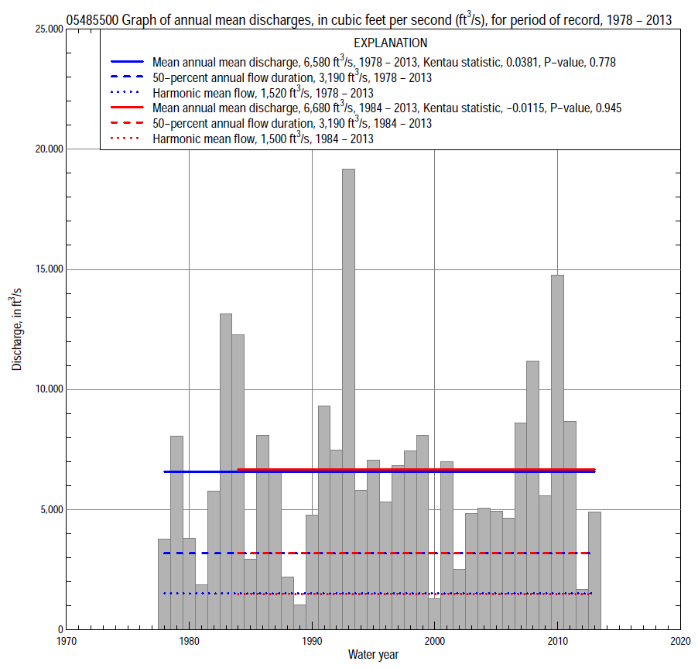

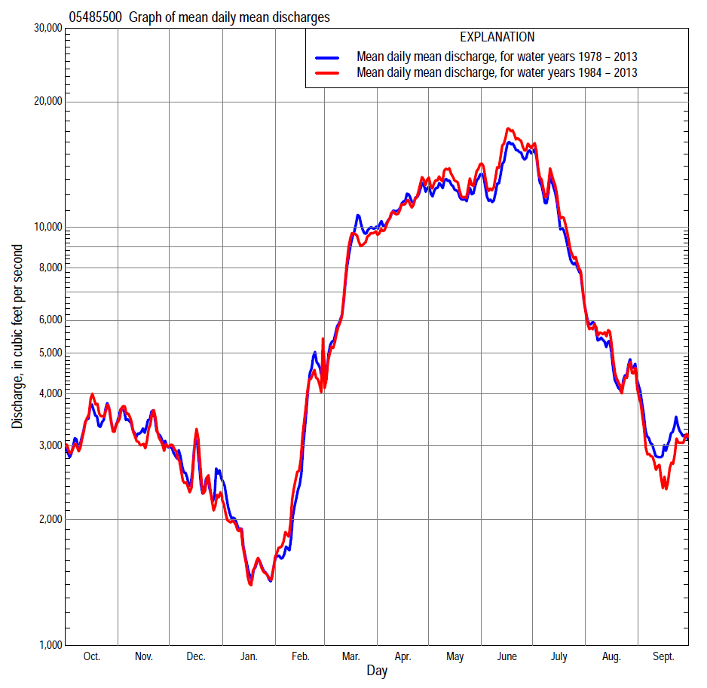

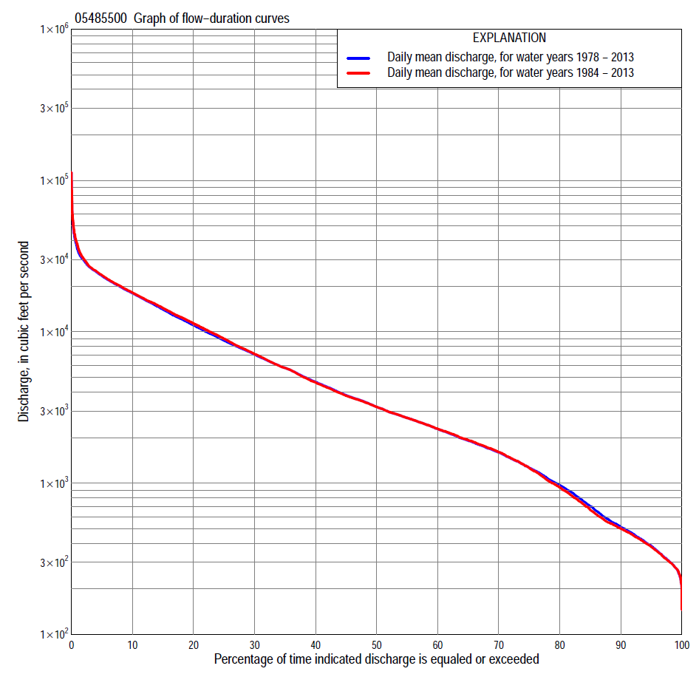
Statistics Based on the Regulated Streamflow Period of Record
05485500 Monthly and annual flow durations, based on 1978–2013 regulated period of record (36 years)
Percentage of days discharge equaled or exceeded |  |  |  |  | Discharge (cubic feet per second) |  |  |  |  |  |  |  |  | Annual flow durations
 | Oct | Nov | Dec | Jan | Feb | Mar | Apr | May | June | July | Aug | Sept | Annual | Kentau statistic | P-value
99 | 218 | 276 | 279 | 244 | 274 | 280 | 521 | 642 | 970 | 460 | 273 | 240 | 275 | -0.016 | 0.902
98 | 271 | 300 | 287 | 260 | 295 | 312 | 556 | 707 | 1,180 | 550 | 328 | 264 | 302 | -0.027 | 0.827
95 | 310 | 391 | 340 | 307 | 322 | 597 | 945 | 1,440 | 2,170 | 810 | 393 | 328 | 385 | -0.017 | 0.892
90 | 394 | 461 | 464 | 360 | 370 | 883 | 1,520 | 2,750 | 3,010 | 1,280 | 572 | 410 | 514 | -0.037 | 0.764
85 | 460 | 532 | 550 | 420 | 423 | 1,670 | 2,430 | 3,760 | 3,660 | 1,840 | 867 | 499 | 701 | -0.062 | 0.605
80 | 552 | 743 | 709 | 489 | 500 | 1,970 | 3,430 | 4,670 | 4,300 | 2,490 | 1,110 | 619 | 970 | -0.073 | 0.540
75 | 777 | 884 | 900 | 542 | 570 | 2,340 | 3,980 | 5,320 | 5,200 | 3,220 | 1,400 | 741 | 1,260 | -0.067 | 0.576
70 | 948 | 1,230 | 1,060 | 651 | 640 | 2,760 | 4,580 | 6,180 | 6,250 | 4,460 | 1,600 | 869 | 1,600 | -0.060 | 0.614
65 | 1,140 | 1,460 | 1,240 | 740 | 900 | 3,220 | 5,650 | 7,250 | 7,230 | 5,440 | 1,780 | 973 | 1,910 | -0.051 | 0.673
60 | 1,370 | 1,670 | 1,430 | 918 | 1,210 | 3,700 | 6,650 | 8,380 | 8,400 | 6,190 | 2,110 | 1,080 | 2,280 | -0.049 | 0.683
55 | 1,630 | 1,860 | 1,640 | 1,080 | 1,450 | 4,290 | 8,020 | 9,780 | 9,720 | 6,980 | 2,400 | 1,240 | 2,700 | -0.056 | 0.643
50 | 1,890 | 2,030 | 1,870 | 1,240 | 1,760 | 4,890 | 9,250 | 11,200 | 11,100 | 7,960 | 2,830 | 1,420 | 3,190 | -0.063 | 0.595
45 | 2,080 | 2,290 | 2,160 | 1,480 | 2,000 | 5,810 | 10,700 | 12,300 | 12,600 | 9,200 | 3,290 | 1,630 | 3,810 | -0.065 | 0.586
40 | 2,400 | 2,620 | 2,420 | 1,700 | 2,310 | 6,670 | 12,200 | 13,600 | 14,600 | 10,100 | 3,710 | 1,910 | 4,670 | -0.048 | 0.693
35 | 2,760 | 3,300 | 2,680 | 1,900 | 2,580 | 7,700 | 13,800 | 15,400 | 16,000 | 11,200 | 4,270 | 2,250 | 5,780 | -0.035 | 0.775
30 | 3,310 | 3,800 | 3,060 | 2,200 | 2,790 | 9,070 | 15,800 | 17,100 | 17,600 | 12,500 | 4,990 | 2,610 | 7,070 | 0.005 | 0.978
25 | 3,910 | 4,370 | 3,340 | 2,500 | 3,110 | 11,100 | 18,000 | 18,700 | 19,200 | 13,900 | 5,730 | 3,150 | 8,760 | 0.029 | 0.817
20 | 4,740 | 5,720 | 3,710 | 2,700 | 3,760 | 13,700 | 19,700 | 20,000 | 21,000 | 15,400 | 6,870 | 4,160 | 11,100 | 0.052 | 0.663
15 | 6,170 | 6,740 | 4,720 | 3,050 | 4,750 | 16,600 | 21,700 | 21,700 | 23,900 | 17,100 | 8,270 | 5,950 | 14,100 | 0.087 | 0.462
10 | 8,290 | 8,470 | 5,910 | 3,500 | 7,600 | 20,100 | 24,300 | 23,700 | 29,400 | 21,000 | 10,700 | 7,920 | 18,000 | 0.097 | 0.414
5 | 13,000 | 10,400 | 7,400 | 4,640 | 10,700 | 24,800 | 26,600 | 26,700 | 35,600 | 30,700 | 21,900 | 14,900 | 23,400 | 0.078 | 0.513
2 | 17,000 | 12,600 | 9,670 | 6,760 | 19,700 | 30,100 | 29,600 | 30,800 | 44,600 | 46,600 | 28,300 | 18,600 | 29,600 | 0.098 | 0.406
1 | 22,800 | 14,500 | 12,400 | 8,040 | 23,900 | 36,000 | 31,100 | 33,800 | 55,100 | 59,800 | 32,000 | 22,000 | 35,000 | 0.070 | 0.558

05485500 Annual exceedance probability of instantaneous peak discharges, in cubic feet per second (ft³/s), based on U.S. Army Corps of Engineers regulated flow frequency studyª, analysis computed using a record length of 92 years (1917–2008)
USACE Regulated Flow Frequency Analysis
[ND, not determined]
Annual exceedance probability | Recurrence interval (years) | Discharge (ft³/s) | 95-percent lower confidence interval (ft³/s) | 95-percent upper confidence interval (ft³/s)
0.500 | 2 | 26,300 | ND | ND
0.200 | 5 | ND | ND | ND
0.100 | 10 | 44,100 | ND | ND
0.040 | 25 | ND | ND | ND
0.020 | 50 | 83,300 | ND | ND
0.010 | 100 | 108,000 | ND | ND
0.005 | 200 | 122,000 | ND | ND
0.002 | 500 | 142,000 | ND | ND
ªU.S. Army Corps of Engineers, 2010, Des Moines River regulated flow frequency study: Rock Island District, 82 p., accessed September 9, 2014, at http://www.mvr.usace.army.mil/Portals/48/docs/FRM/DMRRFFS/DMRRFFS-FinalReport.pdf.
USGS Kendall's Tau Trend Analysis
Kentau statistic |  | 0.124
P-value |  | 0.294
Begin year |  | ^{b}1978
End year |  | ^{b}2013
Number of peaks |  | 36
^{b}Kendall's tau trend analysis computed using the regulated period of record which is not the same period of record used for the above regulated flow frequency analysis

05485500 Annual exceedance probability of high discharges, based on 1978–2013 regulated period of recordª (36 years)
[ND, not determined]
Annual exceedance probability | Recur-rence interval (years) | Maximum average discharge (cubic feet per second) for indicated number of consecutive days
 |  | 1 | 3 | 7 | 15 | 30
0.990 | 1.01 | ND | ND | ND | ND | ND
0.950 | 1.05 | ND | ND | ND | ND | ND
0.900 | 1.11 | ND | ND | ND | ND | ND
0.800 | 1.25 | ND | ND | ND | ND | ND
0.500 | 2 | ND | ND | ND | ND | ND
0.200 | 5 | ND | ND | ND | ND | ND
0.100 | 10 | ND | ND | ND | ND | ND
0.040 | 25 | ND | ND | ND | ND | ND
0.020 | 50 | ND | ND | ND | ND | ND
0.010 | 100 | ND | ND | ND | ND | ND
0.005 | 200 | ND | ND | ND | ND | ND
0.002 | 500 | ND | ND | ND | ND | ND
Kentau statistic |  | 0.106 | 0.084 | 0.089 | 0.073 | 0.092
P-value |  | 0.369 | 0.479 | 0.454 | 0.540 | 0.438
ªContact the U.S. Army Corps of Engineers, Rock Island District, for the annual exceedance probability of high discharges.

 | 05485500 Annual nonexceedance probability of low discharges, based on April 1978 to March 2013 regulated period of record (35 years)
Annual nonexceed-ance probability | Recur-rence interval (years) | Minimum average discharge (cubic feet per second) for indicated number of consecutive days
 |  | 1 | 3 | 7 | 14 | 30 | 60 | 90 | 120 | 183
0.01 | 100 | 121 | 144 | 151 | 152 | 160 | 165 | 174 | 175 | 186
0.02 | 50 | 147 | 171 | 179 | 180 | 193 | 208 | 232 | 233 | 254
0.05 | 20 | 195 | 220 | 230 | 235 | 256 | 292 | 341 | 354 | 398
0.10 | 10 | 251 | 275 | 288 | 299 | 330 | 392 | 468 | 506 | 583
0.20 | 5 | 337 | 360 | 380 | 401 | 450 | 554 | 678 | 766 | 905
0.50 | 2 | 584 | 606 | 651 | 710 | 822 | 1,050 | 1,330 | 1,610 | 1,970
0.80 | 1.25 | 990 | 1,020 | 1,130 | 1,270 | 1,510 | 1,920 | 2,490 | 3,150 | 3,970
0.90 | 1.11 | 1,290 | 1,340 | 1,510 | 1,730 | 2,090 | 2,610 | 3,400 | 4,370 | 5,540
0.96 | 1.04 | 1,710 | 1,790 | 2,080 | 2,410 | 2,960 | 3,570 | 4,680 | 6,080 | 7,730
0.98 | 1.02 | 2,040 | 2,170 | 2,560 | 2,990 | 3,720 | 4,360 | 5,710 | 7,450 | 9,480
0.99 | 1.01 | 2,380 | 2,570 | 3,080 | 3,630 | 4,560 | 5,190 | 6,790 | 8,880 | 11,300
Kentau statistic |  | -0.096 | -0.077 | -0.062 | -0.066 | -0.086 | -0.089 | -0.079 | -0.039 | -0.086
P-value |  | 0.426 | 0.523 | 0.609 | 0.589 | 0.478 | 0.460 | 0.514 | 0.755 | 0.478

05485500 Annual nonexceedance probability of seasonal low discharges, based on July 1977 to September 2013 regulated period of record (36–37 years)
Annual nonexceed-ance probability | Recur-rence interval (years) | Minimum average discharge (cubic feet per second) for indicated number of consecutive days
 |  | 1 | 7 | 14 | 30 |  | 1 | 7 | 14 | 30
 |  | January-February-March |  |  |  |  | April-May-June
0.01 | 100 | 120 | 132 | 140 | 145 |  | 216 | 290 | 353 | 478
0.02 | 50 | 149 | 163 | 172 | 182 |  | 316 | 416 | 501 | 682
0.05 | 20 | 205 | 222 | 236 | 255 |  | 544 | 697 | 830 | 1,130
0.10 | 10 | 272 | 295 | 314 | 345 |  | 860 | 1,080 | 1,270 | 1,740
0.20 | 5 | 383 | 416 | 447 | 498 |  | 1,450 | 1,780 | 2,080 | 2,820
0.50 | 2 | 737 | 816 | 888 | 1,010 |  | 3,610 | 4,240 | 4,950 | 6,480
0.80 | 1.25 | 1,420 | 1,630 | 1,800 | 2,040 |  | 7,980 | 9,130 | 10,700 | 13,200
0.90 | 1.11 | 2,000 | 2,360 | 2,630 | 2,960 |  | 11,600 | 13,100 | 15,400 | 18,400
0.96 | 1.04 | 2,880 | 3,510 | 3,970 | 4,400 |  | 16,600 | 18,600 | 22,100 | 25,300
0.98 | 1.02 | 3,640 | 4,550 | 5,200 | 5,700 |  | 20,700 | 23,100 | 27,600 | 30,600
0.99 | 1.01 | 4,500 | 5,770 | 6,640 | 7,180 |  | 24,900 | 27,700 | 33,300 | 35,800
Kentau statistic |  | 0.019 | 0.057 | 0.057 | 0.037 |  | 0.030 | 0.033 | 0.049 | 0.102
P-value |  | 0.881 | 0.634 | 0.634 | 0.764 |  | 0.806 | 0.785 | 0.683 | 0.391
 |  | July-August-September |  |  |  |  | October-November-December
0.01 | 100 | 127 | 151 | 168 | 172 |  | 124 | 154 | 165 | 166
0.02 | 50 | 147 | 172 | 194 | 209 |  | 154 | 191 | 207 | 208
0.05 | 20 | 186 | 215 | 246 | 283 |  | 213 | 264 | 289 | 306
0.10 | 10 | 235 | 269 | 311 | 377 |  | 283 | 351 | 389 | 438
0.20 | 5 | 324 | 367 | 428 | 547 |  | 398 | 495 | 557 | 665
0.50 | 2 | 666 | 751 | 883 | 1,190 |  | 757 | 953 | 1,100 | 1,420
0.80 | 1.25 | 1,600 | 1,830 | 2,130 | 2,880 |  | 1,420 | 1,830 | 2,170 | 2,860
0.90 | 1.11 | 2,690 | 3,140 | 3,610 | 4,750 |  | 1,960 | 2,570 | 3,100 | 4,050
0.96 | 1.04 | 4,940 | 5,900 | 6,660 | 8,360 |  | 2,750 | 3,680 | 4,500 | 5,760
0.98 | 1.02 | 7,540 | 9,180 | 10,200 | 12,300 |  | 3,420 | 4,640 | 5,740 | 7,180
0.99 | 1.01 | 11,200 | 14,000 | 15,300 | 17,500 |  | 4,150 | 5,720 | 7,120 | 8,710
Kentau statistic |  | -0.134 | -0.162 | -0.171 | -0.177 |  | -0.078 | -0.095 | -0.130 | -0.089
P-value |  | 0.250 | 0.162 | 0.139 | 0.126 |  | 0.513 | 0.422 | 0.270 | 0.454

Statistics Based on the 1984–2013 Regulated Streamflow Period of Record
05485500 Monthly and annual flow durations, based on 1984–2013 regulated period of record (30 years)
Percentage of days discharge equaled or exceeded |  |  |  |  | Discharge (cubic feet per second) |  |  |  |  |  |  |  |  | Annual flow durations
 | Oct | Nov | Dec | Jan | Feb | Mar | Apr | May | June | July | Aug | Sept | Annual | Kentau statistic | P-value
99 | 215 | 266 | 276 | 252 | 274 | 371 | 521 | 600 | 917 | 445 | 259 | 239 | 276 | -0.103 | 0.432
98 | 270 | 294 | 286 | 273 | 295 | 490 | 551 | 700 | 1,230 | 543 | 319 | 254 | 300 | -0.106 | 0.422
95 | 301 | 362 | 330 | 315 | 325 | 705 | 896 | 1,720 | 2,280 | 712 | 375 | 302 | 380 | -0.085 | 0.521
90 | 376 | 437 | 412 | 370 | 384 | 1,370 | 1,630 | 3,630 | 3,080 | 1,170 | 497 | 380 | 500 | -0.110 | 0.402
85 | 428 | 486 | 525 | 440 | 460 | 1,870 | 2,450 | 4,670 | 3,680 | 1,770 | 708 | 460 | 665 | -0.110 | 0.402
80 | 481 | 577 | 629 | 500 | 540 | 2,130 | 3,280 | 5,330 | 4,380 | 2,370 | 1,000 | 538 | 936 | -0.090 | 0.498
75 | 589 | 762 | 849 | 559 | 620 | 2,520 | 3,870 | 6,100 | 5,230 | 3,100 | 1,300 | 632 | 1,260 | -0.097 | 0.464
70 | 785 | 1,020 | 1,060 | 700 | 855 | 2,820 | 4,540 | 7,060 | 6,420 | 4,210 | 1,500 | 768 | 1,610 | -0.103 | 0.432
65 | 967 | 1,460 | 1,280 | 844 | 1,180 | 3,200 | 5,660 | 8,020 | 7,680 | 5,270 | 1,710 | 882 | 1,930 | -0.080 | 0.544
60 | 1,170 | 1,650 | 1,520 | 1,010 | 1,380 | 3,730 | 7,030 | 9,320 | 9,120 | 6,360 | 2,030 | 977 | 2,290 | -0.060 | 0.656
55 | 1,480 | 1,860 | 1,730 | 1,200 | 1,700 | 4,280 | 8,390 | 10,800 | 10,600 | 7,320 | 2,330 | 1,080 | 2,700 | -0.048 | 0.721
50 | 1,730 | 2,020 | 1,990 | 1,350 | 1,960 | 4,830 | 9,630 | 11,800 | 12,400 | 8,510 | 2,730 | 1,250 | 3,190 | -0.057 | 0.669
45 | 2,020 | 2,280 | 2,210 | 1,590 | 2,160 | 5,680 | 11,100 | 12,800 | 14,500 | 9,550 | 3,270 | 1,430 | 3,780 | -0.074 | 0.580
40 | 2,380 | 2,590 | 2,500 | 1,750 | 2,460 | 6,380 | 12,500 | 14,000 | 15,800 | 10,400 | 3,700 | 1,670 | 4,630 | -0.055 | 0.681
35 | 2,730 | 3,240 | 2,760 | 1,970 | 2,680 | 7,370 | 13,800 | 15,600 | 17,300 | 11,700 | 4,220 | 1,900 | 5,780 | -0.057 | 0.669
30 | 3,310 | 3,710 | 3,070 | 2,200 | 2,860 | 8,620 | 15,500 | 17,300 | 18,800 | 13,100 | 4,830 | 2,280 | 7,130 | -0.030 | 0.830
25 | 3,910 | 4,170 | 3,300 | 2,450 | 3,220 | 10,400 | 17,500 | 19,000 | 20,500 | 14,300 | 5,670 | 2,700 | 9,000 | -0.025 | 0.858
20 | 4,760 | 5,090 | 3,620 | 2,650 | 3,890 | 12,600 | 19,100 | 20,300 | 22,500 | 15,800 | 6,810 | 3,590 | 11,400 | 0.005 | 0.986
15 | 6,110 | 6,570 | 4,540 | 2,940 | 4,820 | 15,500 | 21,000 | 22,100 | 25,500 | 17,600 | 8,220 | 5,180 | 14,300 | 0.060 | 0.656
10 | 8,760 | 8,510 | 5,740 | 3,320 | 7,400 | 18,000 | 23,800 | 24,500 | 30,700 | 21,900 | 10,700 | 7,440 | 18,200 | 0.060 | 0.656
5 | 13,500 | 10,500 | 7,110 | 3,990 | 10,400 | 23,200 | 26,300 | 27,300 | 38,600 | 32,400 | 22,400 | 12,400 | 23,700 | 0.060 | 0.655
2 | 18,300 | 12,600 | 8,930 | 5,900 | 15,100 | 29,800 | 27,800 | 31,300 | 48,900 | 47,600 | 29,000 | 19,800 | 30,400 | 0.071 | 0.592
1 | 23,900 | 15,300 | 10,900 | 6,990 | 21,200 | 40,600 | 31,500 | 35,500 | 56,000 | 61,000 | 35,000 | 22,600 | 37,300 | 0.011 | 0.943

05485500 Annual exceedance probability of high discharges, based on 1984–2013 regulated period of recordª (30 years)
[ND, not determined]
Annual exceedance probability | Recur-rence interval (years) | Maximum average discharge (cubic feet per second) for indicated number of consecutive days
 |  | 1 | 3 | 7 | 15 | 30
0.990 | 1.01 | ND | ND | ND | ND | ND
0.950 | 1.05 | ND | ND | ND | ND | ND
0.900 | 1.11 | ND | ND | ND | ND | ND
0.800 | 1.25 | ND | ND | ND | ND | ND
0.500 | 2 | ND | ND | ND | ND | ND
0.200 | 5 | ND | ND | ND | ND | ND
0.100 | 10 | ND | ND | ND | ND | ND
0.040 | 25 | ND | ND | ND | ND | ND
0.020 | 50 | ND | ND | ND | ND | ND
0.010 | 100 | ND | ND | ND | ND | ND
0.005 | 200 | ND | ND | ND | ND | ND
0.002 | 500 | ND | ND | ND | ND | ND
Kentau statistic |  | 0.051 | 0.025 | 0.030 | 0.053 | 0.085
P-value |  | 0.708 | 0.858 | 0.830 | 0.695 | 0.521
ªContact the U.S. Army Corps of Engineers, Rock Island District, for the annual exceedance probability of high discharges.

 | 05485500 Annual nonexceedance probability of low discharges, based on April 1983 to March 2013 period of record (30 years)
Annual nonexceed-ance probability | Recur-rence interval (years) | Minimum average discharge (cubic feet per second) for indicated number of consecutive days
 |  | 1 | 3 | 7 | 14 | 30 | 60 | 90 | 120 | 183
0.01 | 100 | 122 | 150 | 155 | 156 | 163 | 165 | 170 | 171 | 172
0.02 | 50 | 148 | 176 | 185 | 187 | 198 | 205 | 223 | 226 | 237
0.05 | 20 | 197 | 225 | 238 | 244 | 265 | 294 | 332 | 341 | 375
0.10 | 10 | 252 | 280 | 296 | 310 | 342 | 400 | 464 | 496 | 555
0.20 | 5 | 338 | 364 | 388 | 414 | 465 | 570 | 683 | 763 | 872
0.50 | 2 | 579 | 601 | 650 | 715 | 831 | 1,070 | 1,350 | 1,620 | 1,930
0.80 | 1.25 | 965 | 992 | 1,090 | 1,230 | 1,470 | 1,880 | 2,460 | 3,140 | 3,910
0.90 | 1.11 | 1,250 | 1,290 | 1,430 | 1,630 | 1,980 | 2,470 | 3,270 | 4,300 | 5,480
0.96 | 1.04 | 1,620 | 1,700 | 1,910 | 2,190 | 2,700 | 3,230 | 4,340 | 5,860 | 7,650
0.98 | 1.02 | 1,910 | 2,040 | 2,310 | 2,660 | 3,290 | 3,820 | 5,150 | 7,070 | 9,380
0.99 | 1.01 | 2,210 | 2,390 | 2,730 | 3,160 | 3,930 | 4,400 | 5,970 | 8,290 | 11,200
Kentau statistic |  | -0.113 | -0.097 | -0.085 | -0.099 | -0.122 | -0.117 | -0.080 | -0.039 | -0.076
P-value |  | 0.392 | 0.464 | 0.521 | 0.454 | 0.354 | 0.372 | 0.544 | 0.775 | 0.568

05485500 Annual nonexceedance probability of seasonal low discharges, based on October 1983 to September 2013 regulated period of record (30 years)
Annual nonexceed-ance probability | Recur-rence interval (years) | Minimum average discharge (cubic feet per second) for indicated number of consecutive days
 |  | 1 | 7 | 14 | 30 |  | 1 | 7 | 14 | 30
 |  | January-February-March |  |  |  |  | April-May-June
0.01 | 100 | 139 | 151 | 161 | 162 |  | 224 | 273 | 330 | 470
0.02 | 50 | 171 | 185 | 198 | 203 |  | 326 | 398 | 479 | 686
0.05 | 20 | 232 | 250 | 269 | 286 |  | 559 | 682 | 814 | 1,170
0.10 | 10 | 303 | 328 | 355 | 387 |  | 883 | 1,070 | 1,270 | 1,830
0.20 | 5 | 420 | 458 | 496 | 554 |  | 1,490 | 1,800 | 2,130 | 3,020
0.50 | 2 | 780 | 872 | 955 | 1,090 |  | 3,700 | 4,400 | 5,180 | 7,010
0.80 | 1.25 | 1,440 | 1,680 | 1,860 | 2,100 |  | 8,250 | 9,550 | 11,300 | 14,100
0.90 | 1.11 | 1,980 | 2,390 | 2,650 | 2,950 |  | 12,000 | 13,700 | 16,200 | 19,300
0.96 | 1.04 | 2,770 | 3,480 | 3,890 | 4,200 |  | 17,400 | 19,400 | 23,100 | 25,900
0.98 | 1.02 | 3,430 | 4,450 | 4,990 | 5,270 |  | 21,700 | 24,000 | 28,700 | 30,700
0.99 | 1.01 | 4,170 | 5,550 | 6,250 | 6,460 |  | 26,300 | 28,600 | 34,400 | 35,400
Kentau statistic |  | -0.097 | -0.057 | -0.057 | -0.076 |  | 0.007 | -0.014 | 0.000 | 0.034
P-value |  | 0.464 | 0.669 | 0.669 | 0.568 |  | 0.972 | 0.929 | 1.000 | 0.803
 |  | July-August-September |  |  |  |  | October-November-December
0.01 | 100 | 237 | 250 | 251 | 273 |  | 118 | 138 | 147 | 148
0.02 | 50 | 246 | 261 | 265 | 300 |  | 148 | 175 | 187 | 189
0.05 | 20 | 266 | 286 | 301 | 356 |  | 206 | 248 | 267 | 279
0.10 | 10 | 295 | 320 | 348 | 427 |  | 275 | 336 | 365 | 406
0.20 | 5 | 352 | 386 | 435 | 556 |  | 388 | 482 | 529 | 626
0.50 | 2 | 598 | 671 | 795 | 1,070 |  | 738 | 934 | 1,060 | 1,350
0.80 | 1.25 | 1,390 | 1,580 | 1,890 | 2,550 |  | 1,380 | 1,750 | 2,070 | 2,720
0.90 | 1.11 | 2,480 | 2,840 | 3,320 | 4,410 |  | 1,890 | 2,400 | 2,910 | 3,820
0.96 | 1.04 | 5,150 | 5,910 | 6,670 | 8,510 |  | 2,640 | 3,320 | 4,160 | 5,360
0.98 | 1.02 | 8,840 | 10,100 | 11,000 | 13,600 |  | 3,270 | 4,080 | 5,220 | 6,600
0.99 | 1.01 | 15,000 | 17,100 | 18,000 | 21,300 |  | 3,940 | 4,890 | 6,380 | 7,910
Kentau statistic |  | -0.163 | -0.168 | -0.172 | -0.177 |  | -0.078 | -0.090 | -0.131 | -0.067
P-value |  | 0.212 | 0.199 | 0.187 | 0.175 |  | 0.556 | 0.498 | 0.318 | 0.617

