LOCATION.--Lat 41°43'02.6", long 93°34'11.7" referenced to North American Datum of 1927, in NW 1/4 NW 1/4 NE 1/4 sec.30, T.80 N., R.23 W., Polk County, IA, Hydrologic Unit 07100008, on right bank at bridge on Northeast 86th Avenue, 1.0 mi southeast of Ankeny, 1.4 mi downstream from Deer Creek, 6.0 mi upstream from Muchikinock Creek, and 15.6 mi upstream from mouth.

DRAINAGE AREA.--62 mi².

PERIOD OF RECORD.--Discharge records from June 2003 to current year.

GAGE.--Water-stage recorder. Datum of gage is 864.91 ft above National Geodetic Vertical Datum of 1929.

A summary of all available data for this streamgage is provided through the USGS National Water Information System web interface (NWISWeb). The following link provides access to current/historical observations, daily data, daily statistics, monthly statistics, annual statistics, peak streamflow, field measurements, field/lab water-quality samples, and the latest water-year summaries. Data can be filtered by parameter and/or dates, and can be output in various tabular and graphical formats.
http://waterdata.usgs.gov/nwis/inventory/?site_no=05485605

The USGS WaterWatch Toolkit is available at:
http://waterwatch.usgs.gov/?id=ww_toolkit
Tools for summarizing streamflow information include the duration hydrograph builder, the cumulative streamflow hydrograph builder, the streamgage statistics retrieval tool, the rating curve builder, the flood tracking chart builder, the National Weather Service Advanced Hydrologic Prediction Service (AHPS) river forecast hydrograph builder, and the raster-hydrograph builder. Entering the above number for this streamgage into these toolkit webpages will provide streamflow information specific to this streamgage.

A description of the statistics presented for this streamgage is available in the main body of the report at:
http://dx.doi.org/10.3133/ofr20151214
A link to other streamgages included in this report, a map showing the location of the streamgages, information on the programs used to compute the statistical analyses, and references are included in the main body of the report.

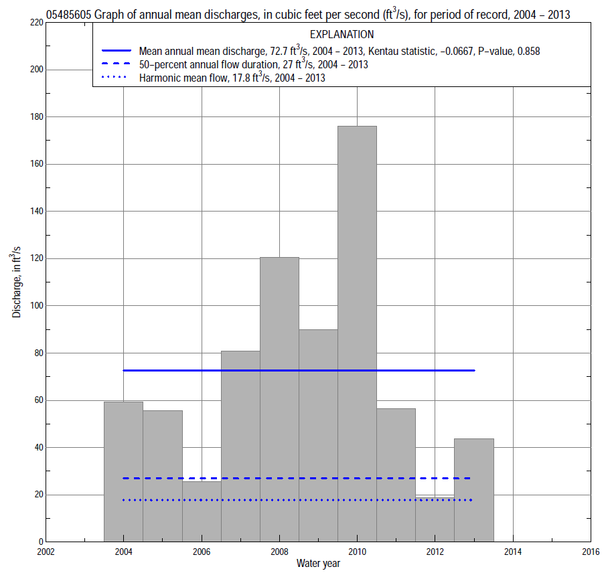

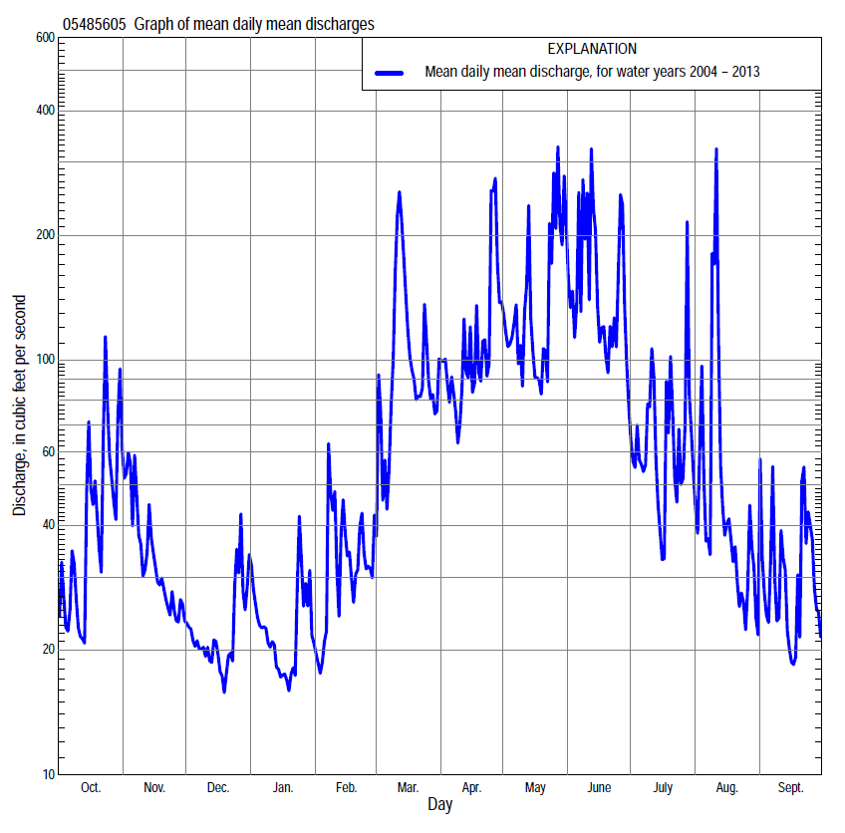

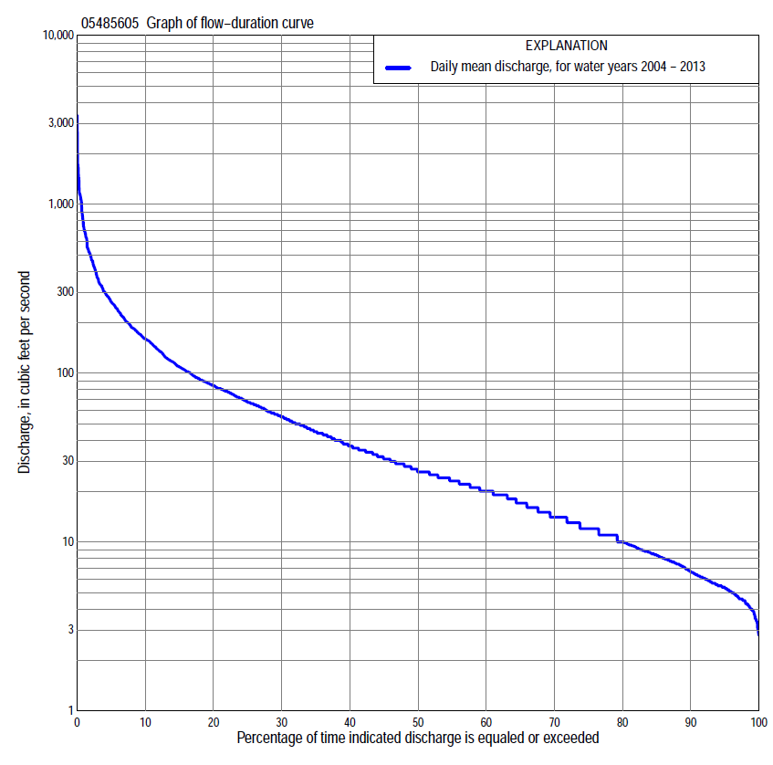

Statistics Based on the Entire Streamflow Period of Record
05485605 Monthly and annual flow durations, based on 2004–2013 period of record (10 years)
Percentage of days discharge equaled or exceeded |  |  |  |  | Discharge (cubic feet per second) |  |  |  |  |  |  |  |  | Annual flow durations
 | Oct | Nov | Dec | Jan | Feb | Mar | Apr | May | June | July | Aug | Sept | Annual | Kentau statistic | P-value
99 | 3.8 | 4.3 | 5.0 | 5.1 | 6.4 | 8.6 | 15 | 21 | 11 | 5.0 | 3.5 | 3.7 | 4.2 | 0.133 | 0.647
98 | 4.1 | 4.5 | 5.1 | 5.3 | 6.4 | 8.8 | 16 | 23 | 12 | 5.1 | 4.8 | 3.9 | 4.6 | 0.000 | 1.000
95 | 4.3 | 6.0 | 5.8 | 6.6 | 6.8 | 14 | 18 | 28 | 15 | 6.0 | 5.4 | 4.0 | 5.5 | 0.044 | 0.927
90 | 4.6 | 6.6 | 6.2 | 7.9 | 8.5 | 16 | 29 | 35 | 19 | 8.6 | 6.1 | 4.6 | 7.2 | 0.000 | 1.000
85 | 4.9 | 7.6 | 7.1 | 9.3 | 9.6 | 18 | 35 | 40 | 23 | 9.9 | 7.2 | 5.2 | 8.7 | -0.022 | 1.000
80 | 5.5 | 8.2 | 8.4 | 10 | 10 | 20 | 38 | 46 | 41 | 11 | 7.6 | 5.6 | 11 | -0.044 | 0.928
75 | 5.8 | 8.8 | 9.2 | 12 | 11 | 21 | 44 | 55 | 49 | 14 | 9.4 | 5.8 | 12 | -0.022 | 1.000
70 | 7.3 | 10 | 11 | 12 | 12 | 25 | 47 | 58 | 56 | 16 | 11 | 7.0 | 15 | 0.044 | 0.928
65 | 7.9 | 14 | 14 | 13 | 13 | 28 | 51 | 62 | 63 | 19 | 12 | 8.3 | 18 | 0.022 | 1.000
60 | 8.5 | 19 | 17 | 14 | 14 | 31 | 58 | 67 | 72 | 21 | 12 | 10 | 20 | 0.022 | 1.000
55 | 9.7 | 22 | 20 | 14 | 16 | 36 | 66 | 74 | 82 | 25 | 13 | 11 | 24 | 0.022 | 1.000
50 | 16 | 24 | 22 | 15 | 19 | 45 | 72 | 81 | 89 | 29 | 15 | 12 | 27 | -0.022 | 1.000
45 | 20 | 26 | 23 | 16 | 21 | 53 | 79 | 87 | 101 | 35 | 16 | 13 | 32 | -0.044 | 0.928
40 | 24 | 29 | 23 | 18 | 26 | 61 | 86 | 94 | 114 | 39 | 17 | 15 | 38 | -0.022 | 1.000
35 | 26 | 34 | 24 | 19 | 29 | 72 | 97 | 107 | 127 | 47 | 19 | 17 | 46 | 0.000 | 1.000
30 | 31 | 38 | 26 | 22 | 34 | 89 | 111 | 125 | 155 | 59 | 23 | 20 | 57 | 0.000 | 1.000
25 | 40 | 42 | 27 | 26 | 37 | 109 | 134 | 153 | 177 | 69 | 31 | 25 | 70 | -0.022 | 1.000
20 | 51 | 48 | 29 | 29 | 42 | 134 | 155 | 188 | 212 | 85 | 43 | 31 | 86 | -0.067 | 0.858
15 | 65 | 55 | 31 | 31 | 52 | 179 | 179 | 258 | 255 | 102 | 66 | 42 | 111 | -0.067 | 0.858
10 | 87 | 68 | 35 | 38 | 64 | 243 | 219 | 328 | 367 | 144 | 118 | 87 | 162 | -0.067 | 0.858
5 | 199 | 113 | 48 | 57 | 85 | 438 | 329 | 520 | 615 | 267 | 223 | 149 | 271 | -0.067 | 0.858
2 | 365 | 171 | 75 | 112 | 185 | 695 | 539 | 844 | 1,160 | 489 | 344 | 289 | 501 | -0.022 | 1.000
1 | 495 | 207 | 117 | 156 | 259 | 886 | 635 | 1,060 | 1,320 | 605 | 1,060 | 345 | 722 | -0.111 | 0.721

05485605 Annual exceedance probability of instantaneous peak discharges, in cubic feet per second (ft³/s), based on the Weighted Independent Estimates method,
Annual exceed-ance probability | Recur-rence interval (years) | Discharge (ft³/s) | 95-percent lower confi-dence interval (ft³/s) | 95-percent upper confi-dence interval (ft³/s)
0.500 | 2 | 1,800 | 1,570 | 2,070
0.200 | 5 | 2,590 | 2,250 | 2,980
0.100 | 10 | 3,110 | 2,660 | 3,630
0.040 | 25 | 3,740 | 3,100 | 4,510
0.020 | 50 | 4,200 | 3,380 | 5,220
0.010 | 100 | 4,670 | 3,640 | 5,990
0.005 | 200 | 5,130 | 3,870 | 6,810
0.002 | 500 | 5,730 | 4,120 | 7,960
and based on the expected moments algorithm/multiple Grubbs-Beck analysis computed using a historical period length of 42 years (1972–2013)
0.500 | 2 | 1,850 | 1,320 | 2,440
0.200 | 5 | 2,640 | 1,980 | 3,510
0.100 | 10 | 3,150 | 2,340 | 4,240
0.040 | 25 | 3,760 | 2,740 | 5,260
0.020 | 50 | 4,190 | 3,000 | 6,130
0.010 | 100 | 4,610 | 3,240 | 7,090
0.005 | 200 | 5,020 | 3,460 | 8,190
0.002 | 500 | 5,540 | 3,720 | 9,860
Kentau statistic |  | 0.111
P-value |  | 0.721
Begin year |  | 2004
End year |  | 2013
Number of peaks |  | 10

05485605 Annual exceedance probability of high discharges, based on 2004–2013 period of record (10 years)
Annual exceedance probability | Recur-rence interval (years) | Maximum average discharge (ft³/s) for indicated number of consecutive days
 |  | 1 | 3 | 7 | 15 | 30
0.990 | 1.01 | 167 | 119 | 75 | 51 | 41
0.950 | 1.05 | 340 | 226 | 148 | 98 | 77
0.900 | 1.11 | 479 | 309 | 206 | 135 | 103
0.800 | 1.25 | 699 | 442 | 298 | 194 | 144
0.500 | 2 | 1,300 | 818 | 552 | 356 | 249
0.200 | 5 | 2,130 | 1,390 | 921 | 590 | 388
0.100 | 10 | 2,640 | 1,770 | 1,160 | 740 | 471
0.040 | 25 | 3,210 | 2,240 | 1,430 | 917 | 562
0.020 | 50 | 3,570 | 2,580 | 1,620 | 1,040 | 621
0.010 | 100 | 3,900 | 2,910 | 1,790 | 1,150 | 674
0.005 | 200 | 4,190 | 3,220 | 1,950 | 1,250 | 721
0.002 | 500 | 4,530 | 3,610 | 2,150 | 1,380 | 776
Kentau statistic |  | -0.111 | -0.111 | -0.067 | -0.067 | -0.022
P-value |  | 0.721 | 0.721 | 0.858 | 0.858 | 1.000

(Annual nonexceedance probability of low discharges not determined because only 9 years of annual low-flow data were available for analysis.)

05485605 Annual nonexceedance probability of seasonal low discharges, based on July 2003 to September 2013 period of record (10-11 years)
Annual nonexceed-ance probability | Recur-rence interval (years) | Minimum average discharge (cubic feet per second) for indicated number of consecutive days
 |  | 1 | 7 | 14 | 30 |  | 1 | 7 | 14 | 30
 |  | January-February-March |  |  |  |  | April-May-June
0.01 | 100 | 3.9 | 3.9 | 5.1 | 5.1 |  | 6.4 | 7.4 | 7.8 | 9.3
0.02 | 50 | 4.3 | 4.3 | 5.6 | 5.6 |  | 7.6 | 8.7 | 9.9 | 12
0.05 | 20 | 5.0 | 5.2 | 6.5 | 6.6 |  | 9.8 | 11 | 14 | 18
0.10 | 10 | 5.8 | 6.2 | 7.3 | 7.6 |  | 12 | 14 | 18 | 25
0.20 | 5 | 7.0 | 7.6 | 8.5 | 9.2 |  | 16 | 18 | 25 | 36
0.50 | 2 | 10 | 11 | 12 | 14 |  | 26 | 30 | 42 | 67
0.80 | 1.25 | 16 | 17 | 18 | 21 |  | 43 | 47 | 62 | 112
0.90 | 1.11 | 20 | 21 | 22 | 27 |  | 55 | 60 | 74 | 141
0.96 | 1.04 | 25 | 26 | 29 | 35 |  | 71 | 76 | 86 | 174
0.98 | 1.02 | 30 | 31 | 34 | 42 |  | 84 | 89 | 94 | 198
0.99 | 1.01 | 35 | 36 | 40 | 50 |  | 98 | 102 | 103 | 219
Kentau statistic |  | -0.022 | -0.022 | -0.022 | -0.067 |  | 0.133 | 0.111 | -0.067 | 0.111
P-value |  | 1.000 | 1.000 | 1.000 | 0.858 |  | 0.653 | 0.721 | 0.858 | 0.721
 |  | July-August-September |  |  |  |  | October-November-December
0.01 | 100 | 2.9 | 3.2 | 3.2 | 3.2 |  | 1.7 | 1.7 | 1.9 | 2.1
0.02 | 50 | 2.9 | 3.3 | 3.4 | 3.4 |  | 2.1 | 2.2 | 2.4 | 2.7
0.05 | 20 | 3.1 | 3.4 | 3.6 | 3.8 |  | 2.8 | 3.0 | 3.3 | 3.7
0.10 | 10 | 3.3 | 3.6 | 3.9 | 4.4 |  | 3.6 | 4.0 | 4.4 | 4.9
0.20 | 5 | 3.8 | 4.1 | 4.5 | 5.5 |  | 5.0 | 5.7 | 6.2 | 7.0
0.50 | 2 | 5.9 | 6.4 | 7.2 | 10 |  | 9.3 | 11 | 12 | 13
0.80 | 1.25 | 13 | 15 | 17 | 25 |  | 17 | 20 | 22 | 25
0.90 | 1.11 | 22 | 26 | 30 | 45 |  | 23 | 28 | 30 | 35
0.96 | 1.04 | 44 | 58 | 66 | 94 |  | 33 | 38 | 42 | 49
0.98 | 1.02 | 75 | 104 | 117 | 161 |  | 40 | 47 | 51 | 61
0.99 | 1.01 | 126 | 185 | 208 | 272 |  | 49 | 57 | 62 | 74
Kentau statistic |  | 0.200 | 0.164 | 0.127 | -0.091 |  | 0.111 | 0.156 | 0.111 | 0.156
P-value |  | 0.433 | 0.533 | 0.640 | 0.756 |  | 0.721 | 0.592 | 0.721 | 0.592

