LOCATION.--Lat 41°36'50", long 93°32'43" referenced to North American Datum of 1927, in NW 1/4 NE 1/4 NE 1/4 sec.32, T.79 N., R.23 W., Polk County, IA, Hydrologic Unit 07100008, on right bank 20 ft downstream from bridge on Easton Boulevard in Des Moines, 4.4 mi downstream from Muchikinock Creek, and 5.2 mi upstream from mouth.

DRAINAGE AREA.--92.7 mi².

PERIOD OF RECORD.--Discharge records from October 1971 to current year.

GAGE.--Water-stage recorder. Datum of gage is 795.87 ft above National Geodetic Vertical Datum of 1929.

A summary of all available data for this streamgage is provided through the USGS National Water Information System web interface (NWISWeb). The following link provides access to current/historical observations, daily data, daily statistics, monthly statistics, annual statistics, peak streamflow, field measurements, field/lab water-quality samples, and the latest water-year summaries. Data can be filtered by parameter and/or dates, and can be output in various tabular and graphical formats.
http://waterdata.usgs.gov/nwis/inventory/?site_no=05485640

The USGS WaterWatch Toolkit is available at:
http://waterwatch.usgs.gov/?id=ww_toolkit
Tools for summarizing streamflow information include the duration hydrograph builder, the cumulative streamflow hydrograph builder, the streamgage statistics retrieval tool, the rating curve builder, the flood tracking chart builder, the National Weather Service Advanced Hydrologic Prediction Service (AHPS) river forecast hydrograph builder, and the raster-hydrograph builder. Entering the above number for this streamgage into these toolkit webpages will provide streamflow information specific to this streamgage.

A description of the statistics presented for this streamgage is available in the main body of the report at:
http://dx.doi.org/10.3133/ofr20151214
A link to other streamgages included in this report, a map showing the location of the streamgages, information on the programs used to compute the statistical analyses, and references are included in the main body of the report.

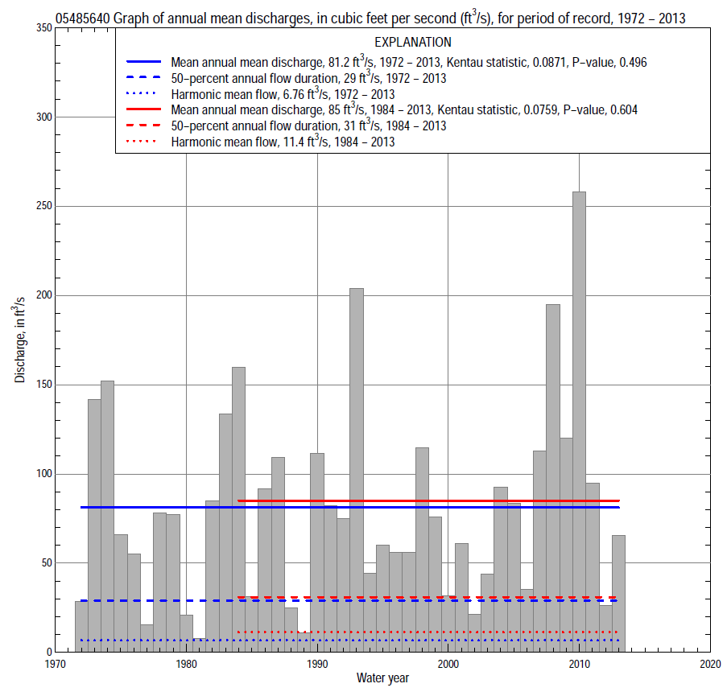

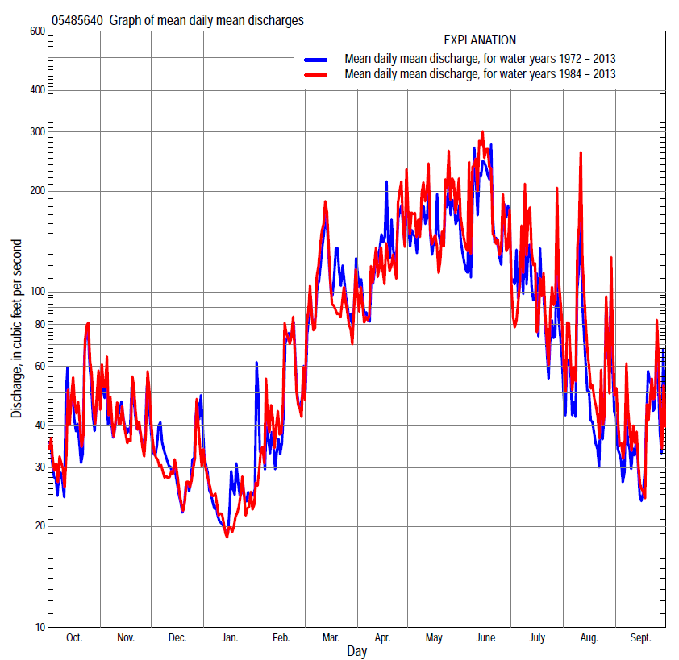

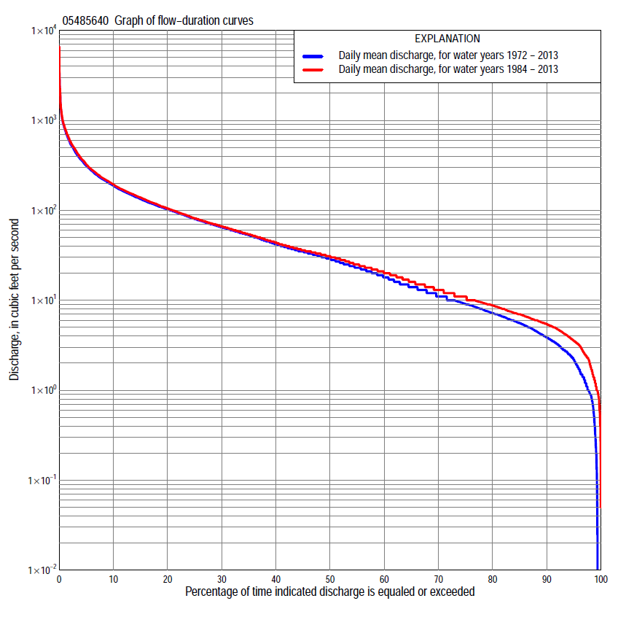

Statistics Based on the Entire Streamflow Period of Record
05485640 Monthly and annual flow durations, based on 1972–2013 period of record (42 years)
Percentage of days discharge equaled or exceeded |  |  |  |  | Discharge (cubic feet per second) |  |  |  |  |  |  |  |  | Annual flow durations
 | Oct | Nov | Dec | Jan | Feb | Mar | Apr | May | June | July | Aug | Sept | Annual | Kentau statistic | P-value
99 | 0.45 | 0.69 | 0.21 | 0.00 | 0.04 | 2.9 | 1.9 | 2.1 | 0.00 | 0.00 | 0.00 | 0.68 | 0.29 | 0.365 | 0.001
98 | 0.80 | 1.3 | 0.36 | 0.00 | 0.35 | 3.8 | 2.5 | 2.9 | 1.4 | 0.00 | 0.41 | 0.79 | 0.90 | 0.322 | 0.003
95 | 1.2 | 2.3 | 1.9 | 1.3 | 1.2 | 4.7 | 3.5 | 9.9 | 5.0 | 1.9 | 1.4 | 1.4 | 2.2 | 0.315 | 0.003
90 | 2.6 | 3.8 | 3.0 | 2.8 | 4.5 | 10 | 10 | 17 | 12 | 4.1 | 2.8 | 2.5 | 3.9 | 0.303 | 0.005
85 | 3.7 | 5.4 | 4.4 | 4.0 | 7.0 | 14 | 18 | 23 | 22 | 7.5 | 4.0 | 3.4 | 5.6 | 0.249 | 0.021
80 | 4.3 | 6.5 | 5.9 | 6.3 | 9.0 | 17 | 23 | 35 | 30 | 11 | 5.0 | 4.1 | 7.2 | 0.194 | 0.071
75 | 5.2 | 7.3 | 7.2 | 8.0 | 11 | 22 | 30 | 45 | 39 | 14 | 5.8 | 4.8 | 9.1 | 0.171 | 0.113
70 | 5.8 | 8.3 | 8.8 | 9.1 | 13 | 25 | 36 | 55 | 49 | 18 | 6.9 | 5.6 | 11 | 0.121 | 0.263
65 | 6.4 | 10 | 10 | 10 | 14 | 31 | 46 | 66 | 60 | 22 | 8.6 | 6.4 | 14 | 0.086 | 0.428
60 | 7.1 | 12 | 12 | 11 | 17 | 39 | 56 | 77 | 67 | 26 | 9.8 | 7.3 | 18 | 0.088 | 0.416
55 | 7.7 | 16 | 15 | 13 | 21 | 45 | 64 | 88 | 76 | 30 | 11 | 8.2 | 23 | 0.078 | 0.474
50 | 9.1 | 22 | 18 | 14 | 25 | 54 | 75 | 97 | 86 | 35 | 13 | 9.4 | 29 | 0.045 | 0.680
45 | 11 | 25 | 21 | 15 | 29 | 62 | 85 | 108 | 95 | 40 | 17 | 11 | 35 | 0.030 | 0.786
40 | 15 | 31 | 27 | 19 | 32 | 70 | 99 | 118 | 109 | 47 | 20 | 13 | 42 | 0.042 | 0.704
35 | 21 | 37 | 32 | 23 | 37 | 82 | 114 | 134 | 127 | 56 | 25 | 15 | 53 | 0.024 | 0.828
30 | 27 | 45 | 36 | 29 | 43 | 98 | 134 | 157 | 148 | 68 | 30 | 19 | 65 | 0.030 | 0.786
25 | 33 | 54 | 42 | 33 | 52 | 119 | 153 | 187 | 174 | 83 | 37 | 24 | 80 | 0.056 | 0.610
20 | 50 | 62 | 52 | 36 | 62 | 145 | 184 | 224 | 213 | 111 | 48 | 34 | 102 | 0.070 | 0.523
15 | 76 | 77 | 60 | 41 | 78 | 181 | 228 | 276 | 266 | 153 | 68 | 52 | 134 | 0.071 | 0.515
10 | 114 | 104 | 70 | 52 | 107 | 242 | 297 | 361 | 373 | 226 | 124 | 99 | 187 | 0.077 | 0.481
5 | 176 | 157 | 101 | 76 | 152 | 404 | 427 | 534 | 658 | 395 | 225 | 188 | 312 | 0.080 | 0.461
2 | 358 | 247 | 154 | 110 | 265 | 662 | 662 | 884 | 1,160 | 746 | 476 | 343 | 559 | 0.103 | 0.340
1 | 492 | 331 | 217 | 150 | 400 | 893 | 966 | 1,100 | 1,570 | 968 | 697 | 540 | 819 | 0.094 | 0.386

05485640 Annual exceedance probability of instantaneous peak discharges, in cubic feet per second (ft³/s), based on the Weighted Independent Estimates method,
Annual exceed-ance probability | Recur-rence interval (years) | Discharge (ft³/s) | 95-percent lower confi-dence interval (ft³/s) | 95-percent upper confi-dence interval (ft³/s)
0.500 | 2 | 2,260 | 1,830 | 2,780
0.200 | 5 | 3,920 | 3,170 | 4,850
0.100 | 10 | 5,160 | 4,080 | 6,520
0.040 | 25 | 6,820 | 5,170 | 9,010
0.020 | 50 | 8,120 | 5,900 | 11,200
0.010 | 100 | 9,470 | 6,600 | 13,600
0.005 | 200 | 10,900 | 7,250 | 16,400
0.002 | 500 | 12,800 | 7,980 | 20,400
and based on the expected moments algorithm/multiple Grubbs-Beck analysis computed using a historical period length of 42 years (1972–2013)
0.500 | 2 | 2,340 | 1,850 | 2,910
0.200 | 5 | 4,070 | 3,270 | 5,250
0.100 | 10 | 5,360 | 4,250 | 7,290
0.040 | 25 | 7,080 | 5,460 | 10,600
0.020 | 50 | 8,430 | 6,310 | 13,800
0.010 | 100 | 9,810 | 7,090 | 17,500
0.005 | 200 | 11,200 | 7,820 | 22,000
0.002 | 500 | 13,200 | 8,690 | 29,300
Kentau statistic |  | -0.002
P-value |  | 0.991
Begin year |  | 1972
End year |  | 2013
Number of peaks |  | 41

05485640 Annual exceedance probability of high discharges, based on 1972–2013 period of record (42 years)
Annual exceedance probability | Recur-rence interval (years) | Maximum average discharge (ft³/s) for indicated number of consecutive days
 |  | 1 | 3 | 7 | 15 | 30
0.990 | 1.01 | 136 | 79 | 46 | 37 | 26
0.950 | 1.05 | 283 | 172 | 110 | 82 | 59
0.900 | 1.11 | 408 | 252 | 167 | 121 | 88
0.800 | 1.25 | 622 | 389 | 266 | 187 | 135
0.500 | 2 | 1,300 | 826 | 576 | 387 | 274
0.200 | 5 | 2,490 | 1,590 | 1,080 | 699 | 481
0.100 | 10 | 3,390 | 2,150 | 1,420 | 907 | 612
0.040 | 25 | 4,590 | 2,880 | 1,830 | 1,160 | 763
0.020 | 50 | 5,510 | 3,440 | 2,110 | 1,330 | 863
0.010 | 100 | 6,450 | 3,990 | 2,380 | 1,490 | 953
0.005 | 200 | 7,400 | 4,540 | 2,620 | 1,640 | 1,030
0.002 | 500 | 8,660 | 5,250 | 2,920 | 1,820 | 1,130
Kentau statistic |  | 0.092 | 0.113 | 0.082 | 0.087 | 0.117
P-value |  | 0.398 | 0.298 | 0.448 | 0.423 | 0.278

 | 05485640 Annual nonexceedance probability of low discharges, based on April 1972 to March 2013 period of record (41 years)
Annual nonexceed-ance probability | Recur-rence interval (years) | Minimum average discharge (cubic feet per second) for indicated number of consecutive days
 |  | 1 | 3 | 7 | 14 | 30 | 60 | 90 | 120 | 183
0.01 | 100 | 0.00 | 0.00 | 0.00 | 0.00 | 0.00 | 0.06 | 0.26 | 0.71 | 1.0
0.02 | 50 | 0.00 | 0.00 | 0.00 | 0.00 | 0.00 | 0.15 | 0.47 | 1.1 | 1.5
0.05 | 20 | 0.02 | 0.04 | 0.09 | 0.29 | 0.37 | 0.49 | 1.1 | 2.0 | 2.7
0.10 | 10 | 0.32 | 0.46 | 0.67 | 1.1 | 1.6 | 1.8 | 2.1 | 3.3 | 4.4
0.20 | 5 | 0.90 | 1.1 | 1.4 | 2.0 | 2.9 | 3.1 | 4.3 | 5.9 | 7.7
0.50 | 2 | 3.2 | 3.6 | 4.0 | 5.0 | 6.9 | 11 | 13 | 16 | 20
0.80 | 1.25 | 7.9 | 8.5 | 9.3 | 11 | 15 | 23 | 28 | 36 | 47
0.90 | 1.11 | 11 | 12 | 14 | 17 | 21 | 28 | 38 | 52 | 70
0.96 | 1.04 | 15 | 17 | 20 | 26 | 31 | 38 | 49 | 75 | 103
0.98 | 1.02 | 18 | 21 | 25 | 35 | 39 | 45 | 56 | 93 | 130
0.99 | 1.01 | 21 | 24 | 31 | 45 | 47 | 54 | 62 | 111 | 159
Kentau statistic |  | 0.357 | 0.360 | 0.349 | 0.323 | 0.235 | 0.173 | 0.137 | 0.115 | 0.051
P-value |  | 0.001 | 0.001 | 0.001 | 0.003 | 0.031 | 0.113 | 0.212 | 0.296 | 0.645

05485640 Annual nonexceedance probability of seasonal low discharges, based on October 1971 to September 2013 period of record (42 years)
Annual nonexceed-ance probability | Recur-rence interval (years) | Minimum average discharge (cubic feet per second) for indicated number of consecutive days
 |  | 1 | 7 | 14 | 30 |  | 1 | 7 | 14 | 30
 |  | January-February-March |  |  |  |  | April-May-June
0.01 | 100 | 0.00 | 0.00 | 0.00 | 0.00 |  | 0.00 | 0.00 | 0.35 | 0.97
0.02 | 50 | 0.00 | 0.00 | 0.00 | 0.00 |  | 0.00 | 0.00 | 0.77 | 1.9
0.05 | 20 | 0.38 | 0.65 | 0.88 | 1.3 |  | 1.3 | 1.7 | 2.2 | 4.9
0.10 | 10 | 1.1 | 1.7 | 2.1 | 2.7 |  | 3.5 | 4.6 | 5.1 | 10
0.20 | 5 | 2.7 | 3.6 | 4.3 | 5.4 |  | 8.3 | 10 | 12 | 22
0.50 | 2 | 9.0 | 11 | 12 | 15 |  | 26 | 32 | 41 | 67
0.80 | 1.25 | 20 | 22 | 25 | 31 |  | 57 | 67 | 88 | 134
0.90 | 1.11 | 26 | 29 | 32 | 42 |  | 74 | 88 | 111 | 168
0.96 | 1.04 | 32 | 36 | 41 | 56 |  | 92 | 109 | 132 | 199
0.98 | 1.02 | 36 | 41 | 46 | 65 |  | 102 | 121 | 141 | 214
0.99 | 1.01 | 38 | 44 | 50 | 74 |  | 109 | 130 | 148 | 224
Kentau statistic |  | 0.163 | 0.148 | 0.152 | 0.117 |  | 0.128 | 0.091 | 0.138 | 0.189
P-value |  | 0.132 | 0.172 | 0.159 | 0.278 |  | 0.237 | 0.404 | 0.201 | 0.079
 |  | July-August-September |  |  |  |  | October-November-December
0.01 | 100 | 0.00 | 0.02 | 0.28 | 0.34 |  | 0.05 | 0.13 | 0.26 | 0.39
0.02 | 50 | 0.00 | 0.02 | 0.28 | 0.34 |  | 0.10 | 0.23 | 0.41 | 0.62
0.05 | 20 | 0.24 | 0.64 | 1.1 | 1.6 |  | 0.26 | 0.51 | 0.80 | 1.2
0.10 | 10 | 0.52 | 1.0 | 1.6 | 2.3 |  | 0.59 | 1.0 | 1.4 | 2.1
0.20 | 5 | 1.1 | 1.7 | 2.4 | 3.6 |  | 1.4 | 2.1 | 2.6 | 3.8
0.50 | 2 | 3.7 | 4.5 | 5.7 | 8.6 |  | 5.7 | 7.0 | 8.0 | 11
0.80 | 1.25 | 11 | 13 | 16 | 25 |  | 16 | 18 | 21 | 28
0.90 | 1.11 | 20 | 24 | 30 | 46 |  | 23 | 28 | 33 | 44
0.96 | 1.04 | 34 | 47 | 61 | 94 |  | 33 | 40 | 50 | 66
0.98 | 1.02 | 49 | 75 | 101 | 155 |  | 39 | 49 | 65 | 85
0.99 | 1.01 | 66 | 114 | 163 | 249 |  | 45 | 58 | 82 | 105
Kentau statistic |  | 0.293 | 0.260 | 0.213 | 0.145 |  | 0.201 | 0.192 | 0.201 | 0.087
P-value |  | 0.007 | 0.016 | 0.049 | 0.179 |  | 0.062 | 0.076 | 0.062 | 0.423

Statistics Based on the 1984–2013 Streamflow Period of Record
05485640 Monthly and annual flow durations, based on 1984–2013 period of record (30 years)
Percentage of days discharge equaled or exceeded |  |  |  |  | Discharge (cubic feet per second) |  |  |  |  |  |  |  |  | Annual flow durations
 | Oct | Nov | Dec | Jan | Feb | Mar | Apr | May | June | July | Aug | Sept | Annual | Kentau statistic | P-value
99 | 1.0 | 1.7 | 1.0 | 1.9 | 1.1 | 4.0 | 2.6 | 9.3 | 4.9 | 1.0 | 0.39 | 0.60 | 1.2 | 0.349 | 0.007
98 | 1.3 | 2.3 | 2.2 | 2.4 | 1.6 | 4.5 | 3.5 | 11 | 6.1 | 1.4 | 0.70 | 0.84 | 1.9 | 0.303 | 0.018
95 | 3.2 | 4.4 | 2.5 | 3.3 | 5.0 | 9.6 | 9.0 | 15 | 9.2 | 3.0 | 1.6 | 2.2 | 3.5 | 0.271 | 0.035
90 | 4.0 | 5.5 | 3.8 | 6.0 | 7.4 | 14 | 15 | 20 | 16 | 5.7 | 3.5 | 3.4 | 5.4 | 0.255 | 0.049
85 | 5.0 | 6.5 | 5.6 | 7.1 | 9.0 | 17 | 20 | 33 | 25 | 9.5 | 4.7 | 3.9 | 7.0 | 0.218 | 0.092
80 | 5.6 | 7.2 | 7.0 | 8.7 | 11 | 21 | 24 | 43 | 32 | 12 | 5.3 | 4.6 | 8.8 | 0.161 | 0.217
75 | 6.1 | 8.0 | 8.3 | 9.9 | 13 | 24 | 31 | 52 | 41 | 16 | 6.2 | 5.2 | 11 | 0.147 | 0.260
70 | 6.7 | 9.2 | 9.5 | 11 | 15 | 28 | 38 | 60 | 54 | 20 | 7.4 | 6.0 | 13 | 0.074 | 0.579
65 | 7.2 | 11 | 11 | 12 | 18 | 34 | 45 | 73 | 65 | 24 | 9.0 | 7.0 | 16 | 0.032 | 0.816
60 | 7.7 | 13 | 13 | 13 | 22 | 41 | 55 | 83 | 73 | 28 | 10 | 7.9 | 20 | 0.041 | 0.761
55 | 8.9 | 17 | 15 | 14 | 25 | 46 | 64 | 93 | 83 | 32 | 13 | 8.7 | 25 | 0.034 | 0.802
50 | 9.9 | 21 | 19 | 15 | 29 | 54 | 74 | 102 | 91 | 37 | 15 | 9.8 | 31 | -0.007 | 0.971
45 | 12 | 25 | 23 | 17 | 32 | 59 | 84 | 111 | 102 | 44 | 19 | 11 | 36 | -0.002 | 1.000
40 | 16 | 30 | 29 | 21 | 36 | 68 | 99 | 125 | 120 | 52 | 24 | 14 | 44 | 0.011 | 0.943
35 | 21 | 35 | 33 | 25 | 41 | 76 | 115 | 143 | 139 | 62 | 30 | 16 | 54 | 0.002 | 1.000
30 | 25 | 42 | 36 | 29 | 47 | 91 | 133 | 171 | 159 | 77 | 36 | 19 | 66 | -0.007 | 0.972
25 | 33 | 50 | 41 | 33 | 55 | 106 | 152 | 197 | 193 | 98 | 45 | 23 | 82 | 0.014 | 0.929
20 | 53 | 60 | 48 | 35 | 64 | 126 | 174 | 236 | 225 | 133 | 60 | 31 | 105 | 0.039 | 0.775
15 | 81 | 72 | 57 | 39 | 80 | 158 | 218 | 299 | 295 | 174 | 94 | 51 | 139 | 0.039 | 0.775
10 | 117 | 89 | 67 | 44 | 103 | 214 | 275 | 392 | 436 | 263 | 166 | 119 | 195 | 0.057 | 0.668
5 | 180 | 164 | 80 | 61 | 148 | 398 | 395 | 578 | 706 | 455 | 302 | 205 | 325 | 0.060 | 0.656
2 | 362 | 285 | 120 | 80 | 250 | 685 | 588 | 933 | 1,220 | 750 | 509 | 393 | 589 | 0.131 | 0.318
1 | 504 | 351 | 168 | 121 | 354 | 903 | 822 | 1,140 | 1,890 | 968 | 889 | 579 | 828 | 0.122 | 0.354

05485640 Annual exceedance probability of high discharges, based on 1984–2013 period of record (30 years)
Annual exceedance probability | Recur-rence interval (years) | Maximum average discharge (ft³/s) for indicated number of consecutive days
 |  | 1 | 3 | 7 | 15 | 30
0.990 | 1.01 | 158 | 98 | 57 | 42 | 32
0.950 | 1.05 | 308 | 193 | 122 | 89 | 68
0.900 | 1.11 | 433 | 272 | 178 | 128 | 98
0.800 | 1.25 | 644 | 407 | 275 | 195 | 147
0.500 | 2 | 1,320 | 839 | 578 | 397 | 289
0.200 | 5 | 2,540 | 1,630 | 1,100 | 724 | 503
0.100 | 10 | 3,500 | 2,260 | 1,470 | 951 | 641
0.040 | 25 | 4,850 | 3,140 | 1,960 | 1,230 | 804
0.020 | 50 | 5,940 | 3,850 | 2,330 | 1,440 | 915
0.010 | 100 | 7,080 | 4,600 | 2,690 | 1,640 | 1,020
0.005 | 200 | 8,270 | 5,380 | 3,050 | 1,820 | 1,110
0.002 | 500 | 9,930 | 6,480 | 3,500 | 2,060 | 1,220
Kentau statistic |  | 0.168 | 0.168 | 0.149 | 0.154 | 0.149
P-value |  | 0.199 | 0.199 | 0.254 | 0.239 | 0.254

 | 05485640 Annual nonexceedance probability of low discharges, based on April 1983 to March 2013 period of record (30 years)
Annual nonexceed-ance probability | Recur-rence interval (years) | Minimum average discharge (cubic feet per second) for indicated number of consecutive days
 |  | 1 | 3 | 7 | 14 | 30 | 60 | 90 | 120 | 183
0.01 | 100 | 0.06 | 0.11 | 0.24 | 0.69 | 0.99 | 1.2 | 1.4 | 1.8 | 2.1
0.02 | 50 | 0.12 | 0.20 | 0.38 | 0.91 | 1.3 | 1.5 | 1.8 | 2.4 | 2.7
0.05 | 20 | 0.31 | 0.46 | 0.72 | 1.4 | 1.9 | 2.3 | 2.8 | 3.5 | 4.1
0.10 | 10 | 0.65 | 0.87 | 1.2 | 2.0 | 2.6 | 3.3 | 4.0 | 5.0 | 5.9
0.20 | 5 | 1.4 | 1.7 | 2.1 | 3.0 | 3.9 | 4.9 | 6.1 | 7.6 | 9.1
0.50 | 2 | 4.6 | 5.0 | 5.4 | 6.4 | 7.9 | 11 | 13 | 17 | 21
0.80 | 1.25 | 9.8 | 10 | 11 | 13 | 16 | 22 | 27 | 35 | 46
0.90 | 1.11 | 13 | 14 | 16 | 19 | 22 | 31 | 39 | 51 | 69
0.96 | 1.04 | 16 | 17 | 21 | 27 | 31 | 45 | 55 | 76 | 106
0.98 | 1.02 | 17 | 19 | 24 | 34 | 39 | 57 | 70 | 98 | 140
0.99 | 1.01 | 18 | 21 | 28 | 41 | 47 | 69 | 85 | 123 | 179
Kentau statistic |  | 0.234 | 0.234 | 0.216 | 0.163 | 0.149 | 0.094 | 0.076 | 0.062 | 0.025
P-value |  | 0.071 | 0.072 | 0.097 | 0.212 | 0.254 | 0.475 | 0.568 | 0.643 | 0.858

05485640 Annual nonexceedance probability of seasonal low discharges, based on October 1983 to September 2013 period of record (30 years)
Annual nonexceed-ance probability | Recur-rence interval (years) | Minimum average discharge (cubic feet per second) for indicated number of consecutive days
 |  | 1 | 7 | 14 | 30 |  | 1 | 7 | 14 | 30
 |  | January-February-March |  |  |  |  | April-May-June
0.01 | 100 | 0.58 | 0.84 | 0.98 | 1.6 |  | 1.4 | 1.7 | 1.8 | 5.0
0.02 | 50 | 0.86 | 1.2 | 1.5 | 2.2 |  | 2.1 | 2.5 | 2.9 | 7.1
0.05 | 20 | 1.5 | 2.1 | 2.5 | 3.6 |  | 3.8 | 4.5 | 5.4 | 12
0.10 | 10 | 2.4 | 3.3 | 3.9 | 5.2 |  | 6.2 | 7.4 | 9.1 | 18
0.20 | 5 | 4.1 | 5.3 | 6.3 | 7.9 |  | 11 | 13 | 16 | 28
0.50 | 2 | 9.8 | 12 | 14 | 16 |  | 27 | 31 | 41 | 64
0.80 | 1.25 | 20 | 22 | 25 | 29 |  | 55 | 64 | 84 | 134
0.90 | 1.11 | 27 | 29 | 31 | 37 |  | 76 | 87 | 115 | 189
0.96 | 1.04 | 36 | 37 | 38 | 47 |  | 101 | 116 | 152 | 265
0.98 | 1.02 | 42 | 43 | 44 | 54 |  | 119 | 137 | 177 | 326
0.99 | 1.01 | 48 | 49 | 50 | 60 |  | 136 | 156 | 201 | 388
Kentau statistic |  | 0.064 | 0.080 | 0.085 | 0.090 |  | 0.131 | 0.101 | 0.145 | 0.214
P-value |  | 0.629 | 0.544 | 0.521 | 0.498 |  | 0.317 | 0.443 | 0.269 | 0.101
 |  | July-August-September |  |  |  |  | October-November-December
0.01 | 100 | 0.09 | 0.40 | 1.1 | 1.4 |  | 0.70 | 0.99 | 1.1 | 1.2
0.02 | 50 | 0.15 | 0.53 | 1.3 | 1.6 |  | 0.88 | 1.2 | 1.3 | 1.6
0.05 | 20 | 0.34 | 0.82 | 1.6 | 2.1 |  | 1.2 | 1.7 | 1.9 | 2.3
0.10 | 10 | 0.65 | 1.2 | 2.1 | 2.8 |  | 1.7 | 2.3 | 2.6 | 3.2
0.20 | 5 | 1.4 | 2.0 | 3.0 | 4.1 |  | 2.6 | 3.4 | 3.9 | 4.9
0.50 | 2 | 5.0 | 5.6 | 6.8 | 9.8 |  | 5.8 | 7.3 | 8.6 | 11
0.80 | 1.25 | 16 | 17 | 20 | 30 |  | 14 | 17 | 20 | 27
0.90 | 1.11 | 26 | 31 | 38 | 57 |  | 23 | 27 | 31 | 43
0.96 | 1.04 | 44 | 62 | 81 | 125 |  | 39 | 45 | 52 | 71
0.98 | 1.02 | 59 | 99 | 138 | 215 |  | 55 | 63 | 72 | 99
0.99 | 1.01 | 77 | 150 | 231 | 360 |  | 76 | 87 | 97 | 135
Kentau statistic |  | 0.182 | 0.168 | 0.117 | 0.053 |  | 0.126 | 0.113 | 0.149 | 0.062
P-value |  | 0.164 | 0.199 | 0.372 | 0.695 |  | 0.335 | 0.392 | 0.254 | 0.643

