LOCATION.--Lat 41°27'28.5", long 93°39'17.1" referenced to North American Datum of 1927, in SW 1/4 NW 1/4 SW 1/4 sec.20, T.77 N., R.24 W., Warren County, IA, Hydrologic Unit 07100008, on left bank 10 ft downstream from bridge on County Highway R57, 1.7 mi southeast of Norwalk, 5.2 mi upstream from Middle Creek, 6.2 mi downstream from Badger Creek, and 22.8 mi upstream from mouth.

DRAINAGE AREA.--349 mi².

PERIOD OF RECORD.--Discharge records from February 1940 to current year.

GAGE.--Water-stage recorder. Datum of gage is 788.45 ft above National Geodetic Vertical Datum of 1929 (levels by U.S. Army Corps of Engineers). Prior to June 12, 1946, non-recording gage at same site and datum; January 7 to October 11, 1960, non-recording gage at site 2.1 mi upstream at different datum.

A summary of all available data for this streamgage is provided through the USGS National Water Information System web interface (NWISWeb). The following link provides access to current/historical observations, daily data, daily statistics, monthly statistics, annual statistics, peak streamflow, field measurements, field/lab water-quality samples, and the latest water-year summaries. Data can be filtered by parameter and/or dates, and can be output in various tabular and graphical formats.
http://waterdata.usgs.gov/nwis/inventory/?site_no=05486000

The USGS WaterWatch Toolkit is available at:
http://waterwatch.usgs.gov/?id=ww_toolkit
Tools for summarizing streamflow information include the duration hydrograph builder, the cumulative streamflow hydrograph builder, the streamgage statistics retrieval tool, the rating curve builder, the flood tracking chart builder, the National Weather Service Advanced Hydrologic Prediction Service (AHPS) river forecast hydrograph builder, and the raster-hydrograph builder. Entering the above number for this streamgage into these toolkit webpages will provide streamflow information specific to this streamgage.

A description of the statistics presented for this streamgage is available in the main body of the report at:
http://dx.doi.org/10.3133/ofr20151214
A link to other streamgages included in this report, a map showing the location of the streamgages, information on the programs used to compute the statistical analyses, and references are included in the main body of the report.

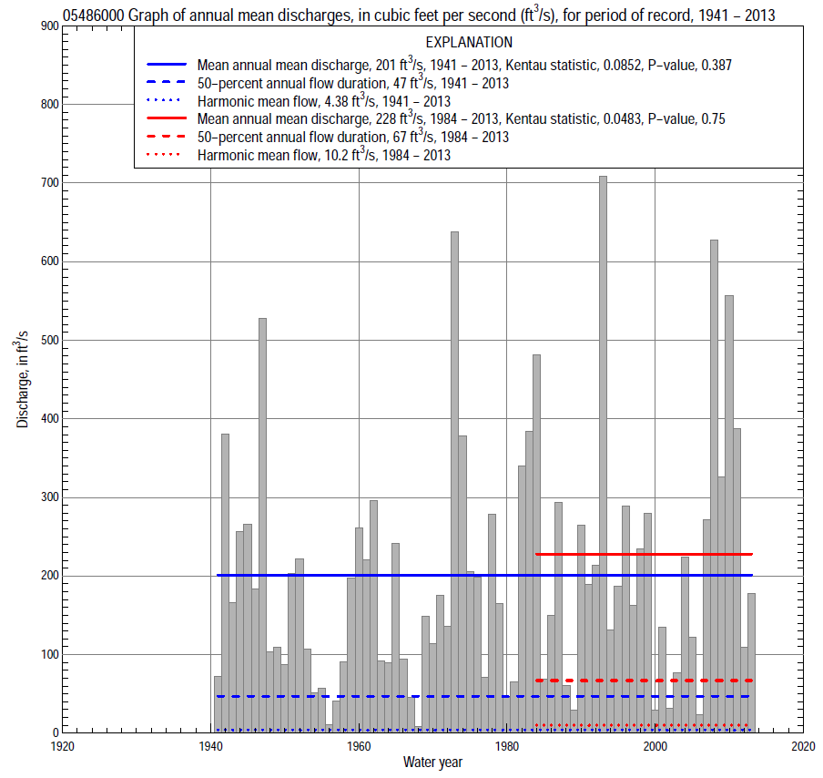

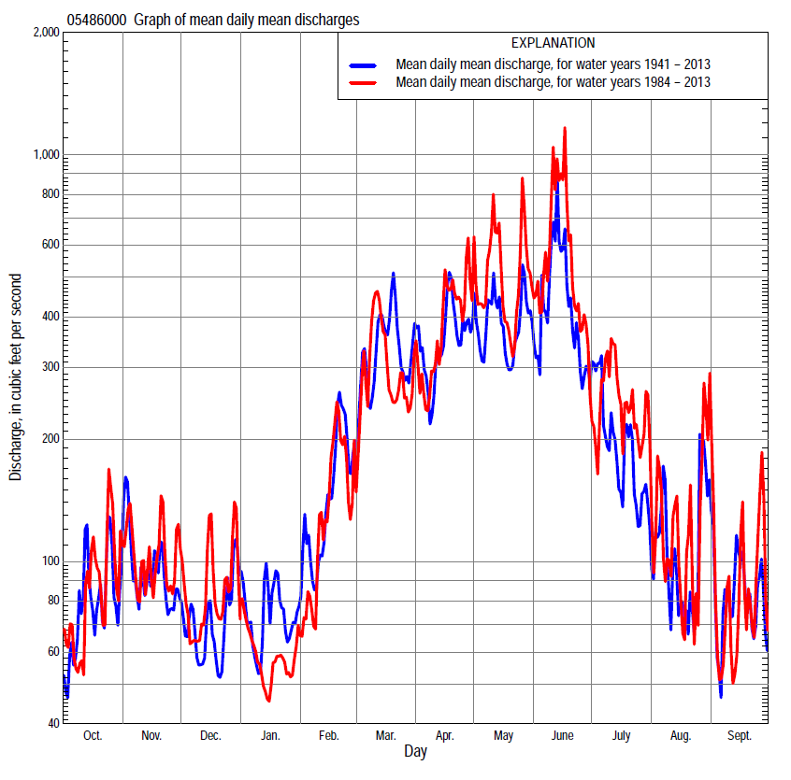

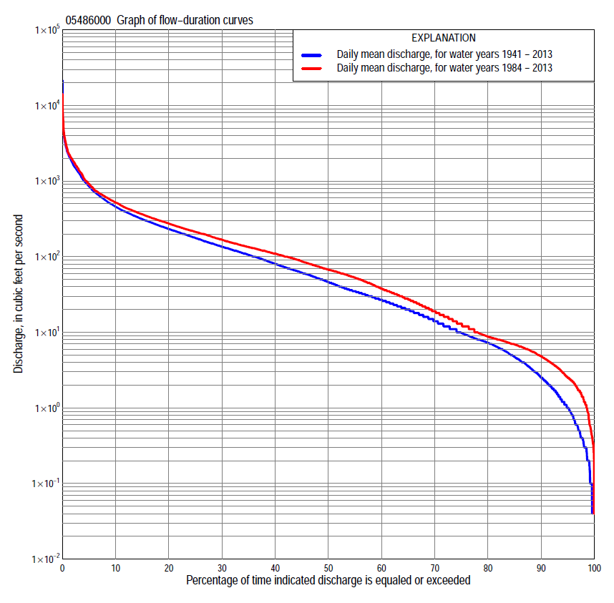

Statistics Based on the Entire Streamflow Period of Record
05486000 Monthly and annual flow durations, based on 1941–2013 period of record (73 years)
Percentage of days discharge equaled or exceeded |  |  |  |  | Discharge (cubic feet per second) |  |  |  |  |  |  |  |  | Annual flow durations
 | Oct | Nov | Dec | Jan | Feb | Mar | Apr | May | June | July | Aug | Sept | Annual | Kentau statistic | P-value
99 | 0.00 | 0.20 | 0.40 | 0.30 | 1.0 | 3.0 | 1.5 | 1.2 | 0.80 | 0.11 | 0.00 | 0.00 | 0.20 | 0.120 | 0.120
98 | 0.10 | 0.40 | 0.50 | 0.40 | 1.1 | 4.0 | 4.2 | 2.7 | 1.5 | 0.30 | 0.15 | 0.10 | 0.33 | 0.138 | 0.078
95 | 0.20 | 0.80 | 1.2 | 1.1 | 2.1 | 7.2 | 7.4 | 5.2 | 4.4 | 1.6 | 0.47 | 0.33 | 1.0 | 0.138 | 0.081
90 | 0.40 | 1.6 | 2.0 | 1.8 | 4.0 | 11 | 17 | 9.7 | 12 | 5.6 | 1.6 | 0.66 | 2.6 | 0.134 | 0.094
85 | 0.92 | 2.4 | 2.8 | 3.3 | 6.6 | 19 | 26 | 24 | 22 | 8.0 | 3.4 | 1.2 | 4.8 | 0.124 | 0.121
80 | 1.5 | 5.1 | 4.1 | 4.8 | 9.2 | 32 | 36 | 39 | 36 | 11 | 4.7 | 2.0 | 7.4 | 0.114 | 0.154
75 | 3.0 | 7.4 | 6.0 | 6.6 | 14 | 45 | 48 | 64 | 53 | 17 | 6.0 | 3.3 | 10 | 0.111 | 0.165
70 | 4.9 | 10 | 8.0 | 8.0 | 21 | 61 | 62 | 88 | 66 | 23 | 7.8 | 4.5 | 14 | 0.099 | 0.217
65 | 6.3 | 13 | 10 | 10 | 26 | 75 | 80 | 112 | 83 | 28 | 9.9 | 6.1 | 20 | 0.100 | 0.214
60 | 8.0 | 17 | 13 | 13 | 31 | 96 | 102 | 136 | 103 | 37 | 12 | 7.7 | 27 | 0.092 | 0.251
55 | 11 | 21 | 16 | 17 | 39 | 115 | 129 | 165 | 126 | 45 | 16 | 9.2 | 35 | 0.109 | 0.173
50 | 15 | 25 | 20 | 21 | 50 | 139 | 162 | 203 | 149 | 58 | 20 | 11 | 47 | 0.110 | 0.169
45 | 21 | 30 | 26 | 27 | 60 | 173 | 204 | 242 | 175 | 74 | 24 | 16 | 62 | 0.121 | 0.132
40 | 28 | 35 | 35 | 34 | 78 | 214 | 232 | 280 | 211 | 89 | 32 | 22 | 81 | 0.111 | 0.167
35 | 33 | 45 | 45 | 43 | 100 | 250 | 269 | 321 | 255 | 110 | 42 | 30 | 107 | 0.113 | 0.157
30 | 42 | 69 | 65 | 60 | 123 | 295 | 312 | 373 | 311 | 137 | 53 | 39 | 136 | 0.122 | 0.127
25 | 56 | 110 | 81 | 75 | 150 | 350 | 371 | 431 | 389 | 169 | 66 | 51 | 179 | 0.126 | 0.115
20 | 74 | 150 | 108 | 100 | 190 | 436 | 455 | 517 | 486 | 212 | 86 | 72 | 234 | 0.121 | 0.130
15 | 117 | 191 | 135 | 126 | 230 | 574 | 604 | 652 | 711 | 286 | 117 | 103 | 316 | 0.123 | 0.124
10 | 197 | 260 | 171 | 160 | 350 | 763 | 822 | 902 | 1,030 | 415 | 188 | 169 | 460 | 0.096 | 0.232
5 | 348 | 408 | 256 | 250 | 650 | 1,410 | 1,450 | 1,580 | 1,740 | 868 | 394 | 362 | 860 | 0.051 | 0.526
2 | 713 | 680 | 438 | 500 | 1,100 | 2,140 | 2,380 | 2,430 | 3,140 | 1,900 | 1,200 | 812 | 1,690 | 0.033 | 0.682
1 | 1,230 | 1,020 | 700 | 870 | 1,500 | 3,000 | 3,400 | 3,130 | 4,900 | 2,360 | 1,780 | 1,400 | 2,370 | 0.064 | 0.424

05486000 Annual exceedance probability of instantaneous peak discharges, in cubic feet per second (ft³/s), based on the Weighted Independent Estimates method,
Annual exceed-ance probability | Recur-rence interval (years) | Discharge (ft³/s) | 95-percent lower confi-dence interval (ft³/s) | 95-percent upper confi-dence interval (ft³/s)
0.500 | 2 | 3,610 | 2,960 | 4,400
0.200 | 5 | 7,300 | 5,990 | 8,900
0.100 | 10 | 10,500 | 8,500 | 12,900
0.040 | 25 | 15,200 | 12,000 | 19,200
0.020 | 50 | 18,600 | 14,300 | 24,300
0.010 | 100 | 22,100 | 16,300 | 29,800
0.005 | 200 | 27,100 | 19,300 | 38,100
0.002 | 500 | 30,900 | 20,800 | 45,700
and based on the expected moments algorithm/multiple Grubbs-Beck analysis computed using a historical period length of 74 years (1940–2013)
0.500 | 2 | 3,540 | 2,870 | 4,340
0.200 | 5 | 7,110 | 5,770 | 8,990
0.100 | 10 | 10,100 | 8,080 | 13,500
0.040 | 25 | 14,700 | 11,300 | 21,600
0.020 | 50 | 18,500 | 13,700 | 29,800
0.010 | 100 | 22,800 | 16,200 | 40,100
0.005 | 200 | 27,500 | 18,600 | 53,100
0.002 | 500 | 34,500 | 21,800 | 75,300
Kentau statistic |  | 0.082
P-value |  | 0.305
Begin year |  | 1940
End year |  | 2013
Number of peaks |  | 74

05486000 Annual exceedance probability of high discharges, based on 1941–2013 period of record (73 years)
Annual exceedance probability | Recur-rence interval (years) | Maximum average discharge (ft³/s) for indicated number of consecutive days
 |  | 1 | 3 | 7 | 15 | 30
0.990 | 1.01 | 398 | 258 | 158 | 105 | 64
0.950 | 1.05 | 768 | 555 | 350 | 232 | 149
0.900 | 1.11 | 1,070 | 806 | 514 | 340 | 223
0.800 | 1.25 | 1,580 | 1,230 | 790 | 521 | 351
0.500 | 2 | 3,190 | 2,490 | 1,620 | 1,060 | 735
0.200 | 5 | 6,070 | 4,480 | 2,900 | 1,890 | 1,320
0.100 | 10 | 8,310 | 5,840 | 3,760 | 2,440 | 1,710
0.040 | 25 | 11,400 | 7,500 | 4,790 | 3,090 | 2,150
0.020 | 50 | 13,900 | 8,680 | 5,500 | 3,540 | 2,440
0.010 | 100 | 16,500 | 9,790 | 6,160 | 3,950 | 2,710
0.005 | 200 | 19,300 | 10,800 | 6,770 | 4,340 | 2,950
0.002 | 500 | 23,000 | 12,100 | 7,510 | 4,800 | 3,240
Kentau statistic |  | 0.063 | 0.081 | 0.084 | 0.108 | 0.126
P-value |  | 0.432 | 0.315 | 0.293 | 0.178 | 0.115

 | 05486000 Annual nonexceedance probability of low discharges, based on April 1940 to March 2013 period of record (73 years)
Annual nonexceed-ance probability | Recur-rence interval (years) | Minimum average discharge (ft³/s) for indicated number of consecutive days
 |  | 1 | 3 | 7 | 14 | 30 | 60 | 90 | 120 | 183
0.01 | 100 | 0.00 | 0.00 | 0.00 | 0.00 | 0.00 | 0.10 | 0.15 | 0.20 | 0.50
0.02 | 50 | 0.00 | 0.00 | 0.00 | 0.00 | 0.03 | 0.18 | 0.28 | 0.37 | 0.86
0.05 | 20 | 0.00 | 0.00 | 0.00 | 0.03 | 0.16 | 0.42 | 0.67 | 0.89 | 1.9
0.10 | 10 | 0.05 | 0.07 | 0.13 | 0.18 | 0.39 | 0.87 | 1.4 | 1.9 | 3.7
0.20 | 5 | 0.27 | 0.33 | 0.46 | 0.58 | 1.0 | 2.0 | 3.3 | 4.3 | 7.8
0.50 | 2 | 1.9 | 2.2 | 2.6 | 3.3 | 5.0 | 8.8 | 14 | 19 | 30
0.80 | 1.25 | 10 | 10 | 11 | 14 | 21 | 33 | 51 | 65 | 97
0.90 | 1.11 | 21 | 22 | 23 | 28 | 41 | 62 | 92 | 116 | 169
0.96 | 1.04 | 44 | 45 | 49 | 54 | 81 | 116 | 165 | 204 | 292
0.98 | 1.02 | 71 | 72 | 77 | 82 | 123 | 170 | 234 | 286 | 408
0.99 | 1.01 | 107 | 108 | 115 | 115 | 176 | 237 | 315 | 379 | 541
Kentau statistic |  | 0.191 | 0.199 | 0.213 | 0.209 | 0.175 | 0.123 | 0.084 | 0.091 | 0.043
P-value |  | 0.017 | 0.013 | 0.008 | 0.009 | 0.028 | 0.126 | 0.293 | 0.259 | 0.590

05486000 Annual nonexceedance probability of seasonal low discharges, based on April 1940 to September 2013 period of record (73–74 years)
Annual nonexceed-ance probability | Recur-rence interval (years) | Minimum average discharge (cubic feet per second) for indicated number of consecutive days
 |  | 1 | 7 | 14 | 30 |  | 1 | 7 | 14 | 30
 |  | January-February-March |  |  |  |  | April-May-June
0.01 | 100 | 0.16 | 0.18 | 0.22 | 0.32 |  | 0.08 | 0.26 | 0.43 | 1.1
0.02 | 50 | 0.26 | 0.31 | 0.37 | 0.57 |  | 0.20 | 0.53 | 0.85 | 2.0
0.05 | 20 | 0.56 | 0.68 | 0.80 | 1.3 |  | 0.71 | 1.5 | 2.3 | 4.9
0.10 | 10 | 1.1 | 1.3 | 1.6 | 2.6 |  | 2.0 | 3.4 | 5.0 | 10
0.20 | 5 | 2.3 | 2.8 | 3.4 | 5.7 |  | 5.9 | 8.6 | 12 | 23
0.50 | 2 | 8.9 | 11 | 13 | 23 |  | 33 | 39 | 54 | 93
0.80 | 1.25 | 32 | 39 | 47 | 75 |  | 113 | 131 | 179 | 291
0.90 | 1.11 | 59 | 73 | 86 | 132 |  | 183 | 220 | 303 | 482
0.96 | 1.04 | 110 | 134 | 159 | 230 |  | 272 | 353 | 492 | 772
0.98 | 1.02 | 163 | 197 | 231 | 321 |  | 334 | 460 | 650 | 1,010
0.99 | 1.01 | 230 | 273 | 321 | 426 |  | 389 | 569 | 814 | 1,270
Kentau statistic |  | 0.109 | 0.093 | 0.104 | 0.055 |  | 0.191 | 0.195 | 0.196 | 0.176
P-value |  | 0.173 | 0.247 | 0.195 | 0.496 |  | 0.016 | 0.014 | 0.014 | 0.027
 |  | July-August-September |  |  |  |  | October-November-December
0.01 | 100 | 0.00 | 0.00 | 0.00 | 0.09 |  | 0.00 | 0.00 | 0.00 | 0.07
0.02 | 50 | 0.00 | 0.00 | 0.01 | 0.17 |  | 0.00 | 0.00 | 0.02 | 0.14
0.05 | 20 | 0.00 | 0.00 | 0.10 | 0.39 |  | 0.02 | 0.07 | 0.15 | 0.36
0.10 | 10 | 0.13 | 0.21 | 0.29 | 0.81 |  | 0.16 | 0.28 | 0.43 | 0.83
0.20 | 5 | 0.48 | 0.70 | 0.86 | 1.9 |  | 0.64 | 0.93 | 1.3 | 2.2
0.50 | 2 | 3.0 | 3.8 | 5.0 | 8.9 |  | 4.8 | 6.1 | 7.9 | 12
0.80 | 1.25 | 14 | 16 | 22 | 37 |  | 24 | 30 | 38 | 52
0.90 | 1.11 | 28 | 33 | 41 | 74 |  | 51 | 63 | 79 | 107
0.96 | 1.04 | 57 | 67 | 77 | 151 |  | 105 | 131 | 163 | 217
0.98 | 1.02 | 88 | 99 | 111 | 236 |  | 161 | 204 | 253 | 336
0.99 | 1.01 | 128 | 138 | 149 | 346 |  | 232 | 298 | 369 | 487
Kentau statistic |  | 0.167 | 0.156 | 0.137 | 0.068 |  | 0.094 | 0.095 | 0.101 | 0.106
P-value |  | 0.036 | 0.049 | 0.085 | 0.393 |  | 0.243 | 0.236 | 0.207 | 0.187

Statistics Based on the 1984–2013 Streamflow Period of Record
05486000 Monthly and annual flow durations, based on 1984–2013 period of record (30 years)
Percentage of days discharge equaled or exceeded |  |  |  |  | Discharge (cubic feet per second) |  |  |  |  |  |  |  |  | Annual flow durations
 | Oct | Nov | Dec | Jan | Feb | Mar | Apr | May | June | July | Aug | Sept | Annual | Kentau statistic | P-value
99 | 0.28 | 0.59 | 1.9 | 1.6 | 1.7 | 4.9 | 6.8 | 6.0 | 3.8 | 2.1 | 0.35 | 0.33 | 0.69 | -0.044 | 0.745
98 | 0.54 | 1.1 | 2.1 | 2.1 | 2.1 | 7.4 | 7.2 | 6.9 | 4.5 | 2.9 | 0.44 | 0.43 | 1.3 | -0.023 | 0.871
95 | 1.0 | 2.1 | 2.5 | 2.8 | 3.4 | 8.6 | 8.9 | 11 | 8.1 | 5.6 | 1.3 | 0.84 | 2.5 | -0.062 | 0.641
90 | 1.7 | 3.8 | 3.7 | 4.3 | 7.6 | 15 | 23 | 29 | 19 | 7.7 | 3.1 | 1.4 | 4.8 | -0.067 | 0.617
85 | 3.0 | 5.6 | 5.0 | 6.0 | 12 | 30 | 37 | 66 | 37 | 9.8 | 4.2 | 2.0 | 6.9 | -0.039 | 0.775
80 | 4.0 | 7.2 | 6.9 | 7.9 | 17 | 45 | 51 | 102 | 60 | 16 | 5.1 | 3.2 | 8.8 | -0.044 | 0.747
75 | 5.4 | 9.4 | 8.1 | 9.3 | 24 | 59 | 69 | 127 | 80 | 23 | 6.2 | 4.1 | 13 | -0.039 | 0.775
70 | 6.0 | 12 | 9.3 | 12 | 31 | 75 | 94 | 152 | 100 | 31 | 7.4 | 5.7 | 19 | -0.044 | 0.748
65 | 7.1 | 16 | 12 | 14 | 38 | 95 | 117 | 190 | 123 | 44 | 10 | 6.7 | 27 | -0.048 | 0.721
60 | 8.7 | 18 | 14 | 18 | 48 | 116 | 141 | 219 | 148 | 61 | 14 | 7.8 | 38 | -0.046 | 0.734
55 | 12 | 22 | 20 | 25 | 56 | 130 | 185 | 263 | 172 | 78 | 21 | 9.2 | 53 | -0.030 | 0.830
50 | 16 | 27 | 37 | 33 | 64 | 156 | 220 | 299 | 211 | 92 | 29 | 11 | 67 | -0.028 | 0.844
45 | 21 | 36 | 50 | 38 | 75 | 180 | 249 | 337 | 251 | 111 | 40 | 15 | 87 | 0.000 | 1.000
40 | 28 | 62 | 66 | 52 | 90 | 207 | 281 | 380 | 310 | 133 | 49 | 22 | 110 | 0.002 | 1.000
35 | 34 | 79 | 79 | 64 | 105 | 239 | 320 | 426 | 367 | 154 | 58 | 28 | 134 | 0.009 | 0.957
30 | 54 | 113 | 96 | 73 | 122 | 269 | 383 | 486 | 430 | 186 | 65 | 36 | 168 | 0.023 | 0.872
25 | 63 | 145 | 112 | 96 | 143 | 308 | 455 | 552 | 518 | 221 | 79 | 49 | 213 | 0.067 | 0.617
20 | 80 | 175 | 132 | 110 | 172 | 368 | 586 | 652 | 632 | 288 | 98 | 70 | 275 | 0.078 | 0.556
15 | 140 | 211 | 150 | 128 | 213 | 472 | 713 | 818 | 870 | 390 | 132 | 105 | 364 | 0.115 | 0.382
10 | 267 | 269 | 196 | 148 | 270 | 662 | 955 | 1,080 | 1,500 | 583 | 230 | 174 | 520 | 0.113 | 0.392
5 | 416 | 385 | 281 | 190 | 510 | 1,090 | 1,390 | 1,990 | 2,300 | 1,110 | 446 | 386 | 916 | 0.076 | 0.568
2 | 739 | 586 | 438 | 240 | 950 | 2,010 | 2,100 | 2,870 | 4,170 | 1,970 | 1,290 | 805 | 1,850 | 0.122 | 0.354
1 | 1,290 | 830 | 700 | 290 | 1,400 | 2,650 | 2,880 | 3,860 | 6,860 | 2,360 | 2,250 | 1,400 | 2,450 | 0.152 | 0.246

05486000 Annual exceedance probability of high discharges, based on 1984–2013 period of record (30 years)
Annual exceedance probability | Recur-rence interval (years) | Maximum average discharge (ft³/s) for indicated number of consecutive days
 |  | 1 | 3 | 7 | 15 | 30
0.990 | 1.01 | 259 | 199 | 136 | 101 | 70
0.950 | 1.05 | 591 | 469 | 308 | 222 | 155
0.900 | 1.11 | 892 | 714 | 463 | 328 | 231
0.800 | 1.25 | 1,430 | 1,140 | 735 | 512 | 362
0.500 | 2 | 3,270 | 2,550 | 1,630 | 1,110 | 784
0.200 | 5 | 6,800 | 4,980 | 3,270 | 2,170 | 1,520
0.100 | 10 | 9,610 | 6,730 | 4,510 | 2,970 | 2,070
0.040 | 25 | 13,500 | 8,970 | 6,180 | 4,040 | 2,780
0.020 | 50 | 16,600 | 10,600 | 7,460 | 4,850 | 3,310
0.010 | 100 | 19,800 | 12,200 | 8,750 | 5,670 | 3,830
0.005 | 200 | 23,100 | 13,700 | 10,000 | 6,490 | 4,350
0.002 | 500 | 27,600 | 15,600 | 11,700 | 7,560 | 5,020
Kentau statistic |  | 0.122 | 0.108 | 0.122 | 0.131 | 0.149
P-value |  | 0.354 | 0.412 | 0.354 | 0.318 | 0.254

 | 05486000 Annual nonexceedance probability of low discharges, based on April 1983 to March 2013 period of record (30 years)
Annual nonexceed-ance probability | Recur-rence interval (years) | Minimum average discharge (ft³/s) for indicated number of consecutive days
 |  | 1 | 3 | 7 | 14 | 30 | 60 | 90 | 120 | 183
0.01 | 100 | 0.00 | 0.00 | 0.07 | 0.13 | 0.22 | 0.31 | 0.56 | 0.84 | 0.94
0.02 | 50 | 0.00 | 0.00 | 0.12 | 0.20 | 0.35 | 0.49 | 0.87 | 1.3 | 1.5
0.05 | 20 | 0.07 | 0.10 | 0.27 | 0.42 | 0.69 | 1.0 | 1.7 | 2.4 | 2.9
0.10 | 10 | 0.26 | 0.34 | 0.54 | 0.77 | 1.2 | 1.8 | 2.9 | 4.1 | 5.2
0.20 | 5 | 0.76 | 0.91 | 1.2 | 1.6 | 2.4 | 3.6 | 5.5 | 7.7 | 10
0.50 | 2 | 3.8 | 4.2 | 4.8 | 5.9 | 8.5 | 13 | 18 | 24 | 34
0.80 | 1.25 | 15 | 16 | 18 | 20 | 28 | 41 | 56 | 73 | 105
0.90 | 1.11 | 28 | 30 | 33 | 36 | 49 | 72 | 99 | 127 | 183
0.96 | 1.04 | 53 | 57 | 61 | 68 | 90 | 129 | 175 | 223 | 323
0.98 | 1.02 | 78 | 84 | 90 | 100 | 132 | 186 | 251 | 318 | 460
0.99 | 1.01 | 108 | 117 | 125 | 140 | 184 | 255 | 345 | 434 | 626
Kentau statistic |  | 0.078 | 0.069 | 0.053 | 0.057 | -0.005 | -0.034 | -0.080 | -0.067 | -0.094
P-value |  | 0.556 | 0.605 | 0.695 | 0.669 | 0.986 | 0.803 | 0.544 | 0.617 | 0.475

05486000 Annual nonexceedance probability of seasonal low discharges, based on October 1983 to September 2013 period of record (30 years)
Annual nonexceed-ance probability | Recur-rence interval (years) | Minimum average discharge (cubic feet per second) for indicated number of consecutive days
 |  | 1 | 7 | 14 | 30 |  | 1 | 7 | 14 | 30
 |  | January-February-March |  |  |  |  | April-May-June
0.01 | 100 | 0.46 | 0.60 | 0.89 | 1.1 |  | 0.75 | 1.0 | 1.4 | 2.8
0.02 | 50 | 0.71 | 0.92 | 1.3 | 1.7 |  | 1.4 | 1.8 | 2.5 | 4.8
0.05 | 20 | 1.3 | 1.7 | 2.3 | 3.2 |  | 3.1 | 4.1 | 5.6 | 10
0.10 | 10 | 2.3 | 2.9 | 3.8 | 5.5 |  | 6.2 | 7.9 | 11 | 20
0.20 | 5 | 4.2 | 5.3 | 6.7 | 10 |  | 14 | 17 | 24 | 41
0.50 | 2 | 13 | 16 | 19 | 29 |  | 50 | 60 | 85 | 141
0.80 | 1.25 | 35 | 44 | 51 | 73 |  | 145 | 174 | 249 | 400
0.90 | 1.11 | 56 | 71 | 82 | 112 |  | 233 | 282 | 401 | 640
0.96 | 1.04 | 91 | 118 | 135 | 170 |  | 365 | 446 | 630 | 1,000
0.98 | 1.02 | 122 | 161 | 183 | 218 |  | 473 | 584 | 820 | 1,310
0.99 | 1.01 | 158 | 211 | 239 | 269 |  | 585 | 730 | 1,020 | 1,620
Kentau statistic |  | -0.133 | -0.099 | -0.080 | -0.117 |  | 0.186 | 0.166 | 0.177 | 0.163
P-value |  | 0.309 | 0.454 | 0.544 | 0.372 |  | 0.154 | 0.205 | 0.175 | 0.212
 |  | July-August-September |  |  |  |  | October-November-December
0.01 | 100 | 0.12 | 0.23 | 0.28 | 0.36 |  | 0.00 | 0.09 | 0.19 | 0.41
0.02 | 50 | 0.18 | 0.32 | 0.39 | 0.52 |  | 0.00 | 0.17 | 0.31 | 0.64
0.05 | 20 | 0.34 | 0.54 | 0.66 | 0.92 |  | 0.13 | 0.39 | 0.67 | 1.2
0.10 | 10 | 0.60 | 0.88 | 1.1 | 1.5 |  | 0.47 | 0.81 | 1.3 | 2.2
0.20 | 5 | 1.2 | 1.6 | 2.0 | 3.0 |  | 1.4 | 1.9 | 2.8 | 4.3
0.50 | 2 | 4.8 | 5.8 | 6.9 | 11 |  | 6.8 | 8.4 | 11 | 16
0.80 | 1.25 | 20 | 23 | 27 | 47 |  | 27 | 32 | 39 | 55
0.90 | 1.11 | 42 | 48 | 57 | 104 |  | 51 | 62 | 73 | 104
0.96 | 1.04 | 94 | 112 | 132 | 252 |  | 96 | 120 | 138 | 205
0.98 | 1.02 | 161 | 197 | 232 | 453 |  | 142 | 179 | 205 | 317
0.99 | 1.01 | 261 | 332 | 389 | 779 |  | 197 | 253 | 289 | 467
Kentau statistic |  | 0.021 | 0.011 | 0.021 | -0.016 |  | -0.014 | -0.044 | -0.053 | -0.039
P-value |  | 0.886 | 0.943 | 0.887 | 0.915 |  | 0.929 | 0.748 | 0.695 | 0.775

