LOCATION.--Lat 41°25'27", long 93°35'14" referenced to North American Datum of 1927, in SE 1/4 SE 1/4 SW 1/4 sec.35, T.77 N., R.24 W., Warren County, IA, Hydrologic Unit 07100008, on right bank 10 ft downstream from bridge on 115th Avenue, 1.5 mi upstream from bridge on U.S. Highway 69, 4.6 mi northwest of Indianola, 0.4 mi upstream from Cavitt Creek, and 14.8 mi upstream from mouth.

DRAINAGE AREA.--489.4 mi².

PERIOD OF RECORD.--Discharge records from March 1940 to current year.

GAGE.--Water-stage recorder. Datum of gage is 776.15 ft above National Geodetic Vertical Datum of 1929 (U.S. Army Corps of Engineers benchmark). Prior to June 11, 1946, June 9, 1947, to November 23, 1948, and September 8, 1951, to October 30, 1952, non-recording gage at site 1.6 mi downstream at datum 2.81 ft lower; June 11, 1946, to June 8, 1947, destroyed by flood; November 24, 1948, to September 7, 1951, and October 31, 1952, to September 30, 1962, water-stage recorder at site 1.6 mi downstream at datum 2.81 ft lower.

A summary of all available data for this streamgage is provided through the USGS National Water Information System web interface (NWISWeb). The following link provides access to current/historical observations, daily data, daily statistics, monthly statistics, annual statistics, peak streamflow, field measurements, field/lab water-quality samples, and the latest water-year summaries. Data can be filtered by parameter and/or dates, and can be output in various tabular and graphical formats.
http://waterdata.usgs.gov/nwis/inventory/?site_no=05486490

The USGS WaterWatch Toolkit is available at:
http://waterwatch.usgs.gov/?id=ww_toolkit
Tools for summarizing streamflow information include the duration hydrograph builder, the cumulative streamflow hydrograph builder, the streamgage statistics retrieval tool, the rating curve builder, the flood tracking chart builder, the National Weather Service Advanced Hydrologic Prediction Service (AHPS) river forecast hydrograph builder, and the raster-hydrograph builder. Entering the above number for this streamgage into these toolkit webpages will provide streamflow information specific to this streamgage.

A description of the statistics presented for this streamgage is available in the main body of the report at:
http://dx.doi.org/10.3133/ofr20151214
A link to other streamgages included in this report, a map showing the location of the streamgages, information on the programs used to compute the statistical analyses, and references are included in the main body of the report.

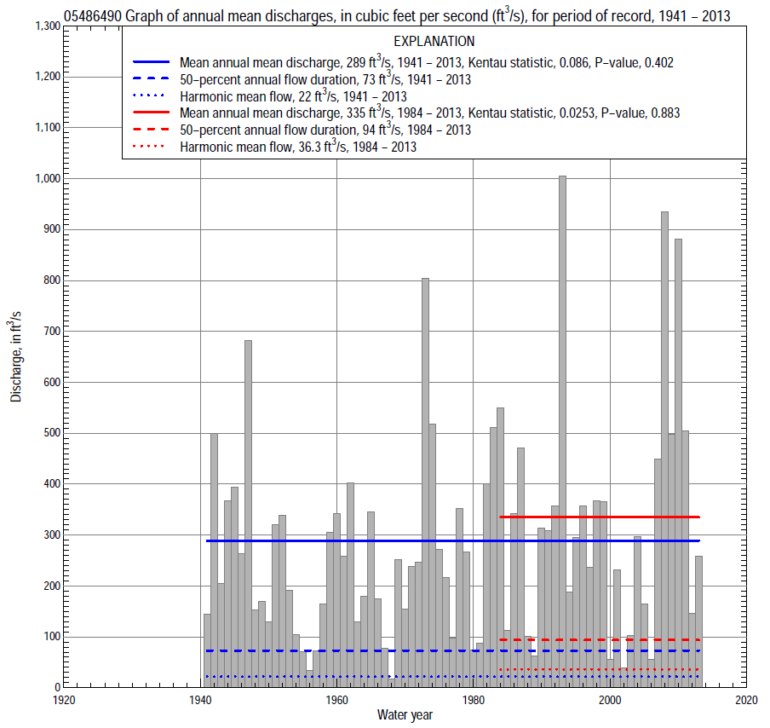

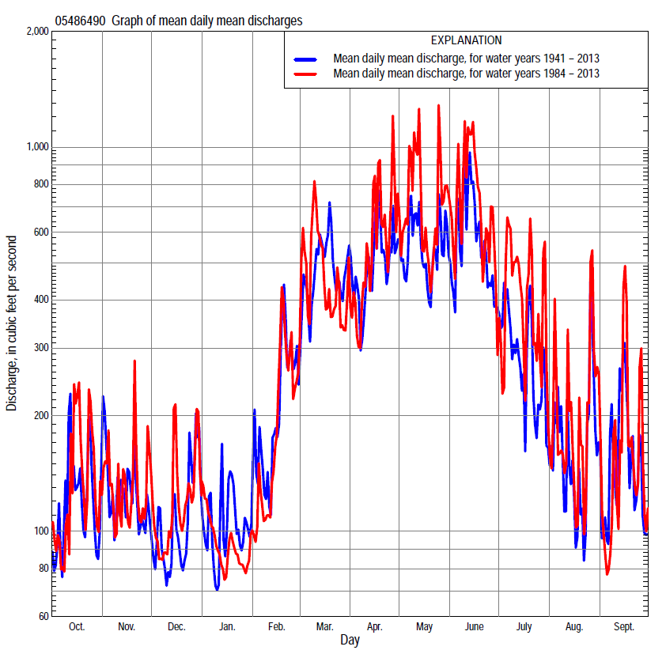

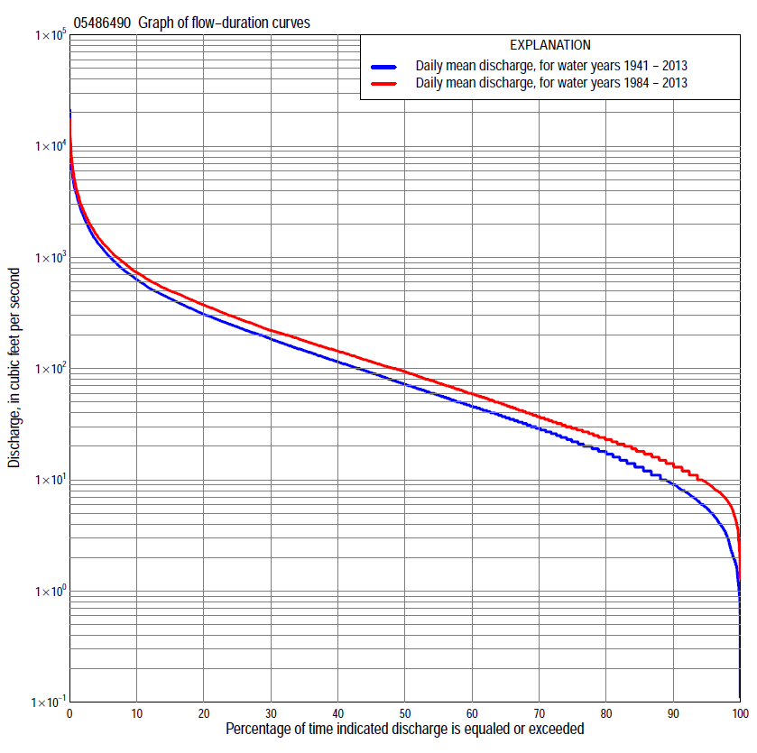

Statistics Based on the Entire Streamflow Period of Record
05486490 Monthly and annual flow durations, based on 1941–2013 period of record (73 years)
Percentage of days discharge equaled or exceeded |  |  |  |  | Discharge (cubic feet per second) |  |  |  |  |  |  |  |  | Annual flow durations
 | Oct | Nov | Dec | Jan | Feb | Mar | Apr | May | June | July | Aug | Sept | Annual | Kentau statistic | P-value
99 | 1.6 | 2.7 | 1.7 | 0.98 | 2.2 | 7.0 | 5.6 | 5.0 | 3.8 | 1.8 | 1.9 | 1.9 | 2.0 | 0.166 | 0.038
98 | 2.6 | 3.5 | 2.1 | 1.6 | 2.5 | 8.8 | 12 | 8.0 | 5.0 | 3.7 | 3.3 | 2.2 | 3.2 | 0.166 | 0.038
95 | 3.8 | 5.7 | 4.2 | 2.8 | 5.0 | 13 | 22 | 15 | 15 | 12 | 6.5 | 5.4 | 5.6 | 0.153 | 0.055
90 | 5.0 | 7.9 | 6.7 | 4.8 | 7.2 | 24 | 35 | 24 | 29 | 19 | 11 | 7.0 | 9.1 | 0.155 | 0.053
85 | 6.3 | 9.4 | 9.2 | 8.0 | 11 | 36 | 50 | 48 | 46 | 26 | 15 | 8.4 | 13 | 0.150 | 0.060
80 | 7.8 | 13 | 11 | 11 | 15 | 50 | 65 | 75 | 61 | 33 | 19 | 10 | 18 | 0.137 | 0.087
75 | 9.8 | 16 | 14 | 13 | 21 | 70 | 80 | 102 | 79 | 41 | 22 | 12 | 23 | 0.129 | 0.107
70 | 13 | 19 | 16 | 15 | 29 | 92 | 99 | 124 | 99 | 49 | 25 | 15 | 29 | 0.098 | 0.221
65 | 15 | 23 | 19 | 18 | 37 | 110 | 119 | 154 | 116 | 56 | 28 | 18 | 37 | 0.097 | 0.226
60 | 19 | 29 | 22 | 22 | 44 | 136 | 139 | 185 | 137 | 65 | 32 | 21 | 46 | 0.082 | 0.306
55 | 22 | 34 | 28 | 29 | 56 | 163 | 173 | 219 | 163 | 75 | 38 | 24 | 58 | 0.076 | 0.343
50 | 26 | 39 | 33 | 34 | 70 | 198 | 227 | 261 | 197 | 85 | 44 | 29 | 73 | 0.077 | 0.336
45 | 33 | 45 | 42 | 42 | 90 | 231 | 265 | 306 | 228 | 102 | 50 | 36 | 92 | 0.079 | 0.324
40 | 42 | 54 | 52 | 50 | 112 | 275 | 301 | 358 | 278 | 118 | 58 | 44 | 116 | 0.093 | 0.247
35 | 54 | 66 | 64 | 62 | 150 | 330 | 354 | 423 | 338 | 139 | 69 | 52 | 146 | 0.100 | 0.214
30 | 68 | 90 | 80 | 80 | 190 | 403 | 423 | 496 | 417 | 168 | 79 | 71 | 187 | 0.092 | 0.251
25 | 84 | 126 | 102 | 110 | 230 | 481 | 507 | 585 | 501 | 210 | 95 | 93 | 239 | 0.105 | 0.190
20 | 110 | 167 | 138 | 140 | 274 | 600 | 631 | 703 | 640 | 257 | 121 | 129 | 310 | 0.118 | 0.141
15 | 156 | 215 | 176 | 170 | 350 | 854 | 805 | 911 | 875 | 358 | 170 | 188 | 428 | 0.125 | 0.119
10 | 239 | 292 | 235 | 230 | 500 | 1,180 | 1,120 | 1,320 | 1,320 | 550 | 278 | 306 | 635 | 0.104 | 0.197
5 | 463 | 522 | 380 | 370 | 959 | 2,040 | 1,970 | 2,240 | 2,340 | 1,180 | 592 | 594 | 1,190 | 0.085 | 0.288
2 | 925 | 915 | 735 | 712 | 1,500 | 3,350 | 3,350 | 3,920 | 4,400 | 2,590 | 1,410 | 1,250 | 2,420 | 0.002 | 0.981
1 | 1,770 | 1,290 | 1,220 | 1,000 | 2,220 | 4,180 | 5,320 | 4,940 | 6,870 | 3,790 | 2,850 | 2,130 | 3,760 | 0.023 | 0.779

05486490 Annual exceedance probability of instantaneous peak discharges, in cubic feet per second (ft³/s), based on the Weighted Independent Estimates method,
Annual exceed-ance probability | Recur-rence interval (years) | Discharge (ft³/s) | 95-percent lower confi-dence interval (ft³/s) | 95-percent upper confi-dence interval (ft³/s)
0.500 | 2 | 7,640 | 6,740 | 8,670
0.200 | 5 | 11,500 | 10,100 | 13,000
0.100 | 10 | 14,000 | 12,200 | 16,000
0.040 | 25 | 17,200 | 14,600 | 20,100
0.020 | 50 | 19,400 | 16,100 | 23,300
0.010 | 100 | 21,600 | 17,500 | 26,700
0.005 | 200 | 24,500 | 19,200 | 31,300
0.002 | 500 | 26,800 | 20,100 | 35,700
and based on the expected moments algorithm/multiple Grubbs-Beck analysis computed using a historical period length of 74 years (1940–2013)
0.500 | 2 | 7,670 | 6,700 | 8,700
0.200 | 5 | 11,700 | 10,300 | 13,500
0.100 | 10 | 14,400 | 12,600 | 17,000
0.040 | 25 | 17,700 | 15,200 | 22,000
0.020 | 50 | 20,100 | 16,900 | 26,000
0.010 | 100 | 22,400 | 18,400 | 30,400
0.005 | 200 | 24,700 | 19,800 | 35,300
0.002 | 500 | 27,700 | 21,400 | 42,500
Kentau statistic |  | 0.184
P-value |  | 0.020
Begin year |  | 1940
End year |  | 2013
Number of peaks |  | 74

05486490 Annual exceedance probability of high discharges, based on 1941–2013 period of record (73 years)
Annual exceedance probability | Recur-rence interval (years) | Maximum average discharge (ft³/s) for indicated number of consecutive days
 |  | 1 | 3 | 7 | 15 | 30
0.990 | 1.01 | 650 | 484 | 308 | 198 | 124
0.950 | 1.05 | 1,460 | 1,000 | 630 | 406 | 261
0.900 | 1.11 | 2,120 | 1,420 | 888 | 572 | 373
0.800 | 1.25 | 3,200 | 2,100 | 1,300 | 838 | 555
0.500 | 2 | 6,130 | 3,950 | 2,410 | 1,570 | 1,070
0.200 | 5 | 9,950 | 6,540 | 3,930 | 2,580 | 1,820
0.100 | 10 | 12,100 | 8,110 | 4,850 | 3,200 | 2,300
0.040 | 25 | 14,300 | 9,870 | 5,870 | 3,900 | 2,850
0.020 | 50 | 15,600 | 11,000 | 6,520 | 4,350 | 3,220
0.010 | 100 | 16,700 | 12,000 | 7,100 | 4,760 | 3,550
0.005 | 200 | 17,700 | 12,900 | 7,620 | 5,120 | 3,860
0.002 | 500 | 18,600 | 14,000 | 8,210 | 5,540 | 4,220
Kentau statistic |  | 0.167 | 0.110 | 0.130 | 0.156 | 0.158
P-value |  | 0.037 | 0.172 | 0.104 | 0.051 | 0.048

 | 05486490 Annual nonexceedance probability of low discharges, based on April 1940 to March 2013 period of record (73 years)
Annual nonexceed-ance probability | Recur-rence interval (years) | Minimum average discharge (ft³/s) for indicated number of consecutive days
 |  | 1 | 3 | 7 | 14 | 30 | 60 | 90 | 120 | 183
0.01 | 100 | 0.22 | 0.32 | 0.42 | 0.57 | 0.92 | 1.4 | 1.7 | 2.0 | 2.8
0.02 | 50 | 0.36 | 0.50 | 0.63 | 0.83 | 1.3 | 1.9 | 2.4 | 2.8 | 4.0
0.05 | 20 | 0.75 | 1.0 | 1.2 | 1.4 | 2.1 | 3.1 | 3.9 | 4.6 | 6.7
0.10 | 10 | 1.4 | 1.7 | 1.9 | 2.3 | 3.2 | 4.7 | 6.0 | 7.2 | 11
0.20 | 5 | 2.7 | 3.1 | 3.5 | 4.1 | 5.4 | 7.8 | 10 | 12 | 18
0.50 | 2 | 8.8 | 9.2 | 10 | 11 | 14 | 20 | 28 | 34 | 51
0.80 | 1.25 | 24 | 24 | 26 | 30 | 37 | 53 | 75 | 92 | 143
0.90 | 1.11 | 37 | 39 | 42 | 48 | 61 | 86 | 125 | 154 | 243
0.96 | 1.04 | 56 | 61 | 68 | 78 | 102 | 145 | 218 | 266 | 426
0.98 | 1.02 | 72 | 81 | 90 | 106 | 142 | 202 | 311 | 378 | 612
0.99 | 1.01 | 88 | 102 | 116 | 139 | 191 | 272 | 429 | 518 | 846
Kentau statistic |  | 0.187 | 0.187 | 0.185 | 0.179 | 0.164 | 0.131 | 0.091 | 0.088 | 0.049
P-value |  | 0.020 | 0.019 | 0.021 | 0.025 | 0.041 | 0.102 | 0.255 | 0.271 | 0.545

05486490 Annual nonexceedance probability of seasonal low discharges, based on March 1940 to September 2013 period of record (73–74 years)
Annual nonexceed-ance probability | Recur-rence interval (years) | Minimum average discharge (cubic feet per second) for indicated number of consecutive days
 |  | 1 | 7 | 14 | 30 |  | 1 | 7 | 14 | 30
 |  | January-February-March |  |  |  |  | April-May-June
0.01 | 100 | 0.59 | 0.65 | 0.76 | 1.0 |  | 1.1 | 1.6 | 2.2 | 3.7
0.02 | 50 | 0.89 | 1.0 | 1.2 | 1.6 |  | 2.0 | 2.8 | 3.7 | 6.1
0.05 | 20 | 1.6 | 1.9 | 2.2 | 3.1 |  | 4.6 | 6.1 | 7.9 | 13
0.10 | 10 | 2.7 | 3.3 | 3.8 | 5.5 |  | 9.1 | 12 | 15 | 23
0.20 | 5 | 5.1 | 6.2 | 7.2 | 11 |  | 19 | 23 | 29 | 46
0.50 | 2 | 16 | 20 | 23 | 35 |  | 59 | 70 | 90 | 145
0.80 | 1.25 | 49 | 59 | 68 | 107 |  | 134 | 164 | 225 | 386
0.90 | 1.11 | 85 | 101 | 118 | 184 |  | 185 | 231 | 335 | 602
0.96 | 1.04 | 152 | 176 | 204 | 321 |  | 243 | 312 | 484 | 921
0.98 | 1.02 | 219 | 248 | 289 | 455 |  | 279 | 367 | 596 | 1,180
0.99 | 1.01 | 302 | 335 | 392 | 616 |  | 310 | 417 | 706 | 1,460
Kentau statistic |  | 0.113 | 0.104 | 0.098 | 0.063 |  | 0.161 | 0.157 | 0.148 | 0.140
P-value |  | 0.160 | 0.197 | 0.221 | 0.432 |  | 0.043 | 0.048 | 0.063 | 0.078
 |  | July-August-September |  |  |  |  | October-November-December
0.01 | 100 | 0.34 | 0.97 | 1.5 | 2.8 |  | 0.51 | 0.67 | 0.83 | 1.5
0.02 | 50 | 0.59 | 1.4 | 2.0 | 3.5 |  | 0.75 | 0.96 | 1.2 | 2.0
0.05 | 20 | 1.3 | 2.3 | 3.0 | 4.9 |  | 1.3 | 1.7 | 2.0 | 3.2
0.10 | 10 | 2.3 | 3.5 | 4.4 | 6.8 |  | 2.2 | 2.7 | 3.2 | 4.8
0.20 | 5 | 4.6 | 5.9 | 7.0 | 10 |  | 4.0 | 4.8 | 5.7 | 8.1
0.50 | 2 | 15 | 15 | 17 | 25 |  | 13 | 14 | 17 | 23
0.80 | 1.25 | 36 | 39 | 44 | 65 |  | 37 | 44 | 52 | 67
0.90 | 1.11 | 54 | 62 | 71 | 112 |  | 65 | 77 | 94 | 122
0.96 | 1.04 | 78 | 100 | 120 | 208 |  | 116 | 143 | 175 | 232
0.98 | 1.02 | 96 | 135 | 170 | 315 |  | 169 | 212 | 264 | 356
0.99 | 1.01 | 113 | 177 | 231 | 464 |  | 235 | 303 | 381 | 525
Kentau statistic |  | 0.130 | 0.110 | 0.096 | 0.039 |  | 0.175 | 0.150 | 0.141 | 0.127
P-value |  | 0.102 | 0.169 | 0.227 | 0.627 |  | 0.029 | 0.061 | 0.079 | 0.113

Statistics Based on the 1984–2013 Streamflow Period of Record
05486490 Monthly and annual flow durations, based on 1984–2013 period of record (30 years)
Percentage of days discharge equaled or exceeded |  |  |  |  | Discharge (cubic feet per second) |  |  |  |  |  |  |  |  | Annual flow durations
 | Oct | Nov | Dec | Jan | Feb | Mar | Apr | May | June | July | Aug | Sept | Annual | Kentau statistic | P-value
99 | 3.6 | 5.2 | 6.1 | 3.8 | 2.6 | 11 | 17 | 10 | 11 | 6.5 | 4.3 | 2.8 | 5.1 | -0.025 | 0.858
98 | 4.2 | 7.3 | 7.9 | 5.0 | 5.7 | 12 | 21 | 16 | 14 | 11 | 5.7 | 5.1 | 6.6 | -0.016 | 0.914
95 | 5.8 | 8.6 | 9.4 | 9.3 | 9.3 | 17 | 26 | 23 | 23 | 18 | 9.4 | 6.2 | 9.4 | -0.044 | 0.748
90 | 7.6 | 12 | 12 | 12 | 13 | 29 | 39 | 59 | 37 | 25 | 13 | 7.8 | 14 | -0.023 | 0.872
85 | 9.3 | 16 | 14 | 14 | 20 | 42 | 56 | 87 | 52 | 35 | 17 | 9.3 | 18 | -0.011 | 0.943
80 | 12 | 19 | 16 | 16 | 28 | 63 | 73 | 119 | 70 | 44 | 20 | 11 | 23 | -0.037 | 0.789
75 | 15 | 23 | 18 | 18 | 36 | 84 | 99 | 155 | 96 | 52 | 23 | 13 | 29 | -0.083 | 0.532
70 | 18 | 28 | 22 | 22 | 44 | 104 | 121 | 189 | 114 | 59 | 26 | 17 | 37 | -0.108 | 0.412
65 | 21 | 33 | 27 | 29 | 54 | 137 | 150 | 222 | 144 | 70 | 30 | 20 | 47 | -0.101 | 0.443
60 | 23 | 37 | 30 | 32 | 68 | 162 | 193 | 274 | 177 | 81 | 36 | 23 | 59 | -0.099 | 0.454
55 | 26 | 41 | 36 | 39 | 80 | 189 | 231 | 327 | 216 | 96 | 45 | 27 | 74 | -0.108 | 0.412
50 | 31 | 49 | 45 | 47 | 92 | 213 | 267 | 389 | 262 | 110 | 53 | 32 | 94 | -0.087 | 0.509
45 | 37 | 60 | 60 | 57 | 101 | 242 | 319 | 445 | 317 | 130 | 62 | 37 | 115 | -0.064 | 0.630
40 | 47 | 79 | 80 | 70 | 120 | 280 | 377 | 499 | 383 | 153 | 72 | 45 | 144 | -0.021 | 0.886
35 | 59 | 96 | 100 | 98 | 150 | 316 | 456 | 561 | 469 | 186 | 81 | 54 | 177 | -0.016 | 0.915
30 | 73 | 124 | 126 | 113 | 193 | 384 | 528 | 643 | 532 | 224 | 94 | 70 | 220 | -0.025 | 0.858
25 | 85 | 154 | 150 | 135 | 220 | 453 | 624 | 753 | 654 | 281 | 114 | 91 | 284 | -0.011 | 0.943
20 | 119 | 192 | 170 | 151 | 262 | 553 | 756 | 929 | 846 | 378 | 149 | 121 | 373 | 0.037 | 0.789
15 | 189 | 234 | 198 | 170 | 305 | 775 | 961 | 1,210 | 1,170 | 528 | 223 | 178 | 500 | 0.062 | 0.643
10 | 330 | 301 | 263 | 215 | 414 | 1,120 | 1,320 | 1,710 | 1,600 | 800 | 403 | 359 | 730 | 0.048 | 0.721
5 | 538 | 496 | 392 | 312 | 829 | 1,880 | 2,070 | 2,800 | 3,000 | 1,580 | 704 | 642 | 1,320 | 0.085 | 0.521
2 | 1,060 | 815 | 756 | 422 | 1,260 | 2,910 | 3,210 | 4,280 | 5,780 | 3,740 | 1,700 | 1,220 | 2,680 | 0.097 | 0.464
1 | 1,850 | 1,050 | 1,040 | 575 | 1,700 | 4,260 | 5,320 | 6,120 | 7,930 | 5,690 | 3,940 | 1,940 | 4,080 | 0.099 | 0.454

05486490 Annual exceedance probability of high discharges, based on 1984–2013 period of record (30 years)
Annual exceedance probability | Recur-rence interval (years) | Maximum average discharge (ft³/s) for indicated number of consecutive days
 |  | 1 | 3 | 7 | 15 | 30
0.990 | 1.01 | 430 | 396 | 269 | 176 | 118
0.950 | 1.05 | 1,170 | 899 | 590 | 390 | 261
0.900 | 1.11 | 1,860 | 1,330 | 861 | 571 | 384
0.800 | 1.25 | 3,070 | 2,060 | 1,310 | 873 | 591
0.500 | 2 | 6,690 | 4,250 | 2,640 | 1,760 | 1,210
0.200 | 5 | 11,800 | 7,600 | 4,640 | 3,080 | 2,190
0.100 | 10 | 14,700 | 9,770 | 5,940 | 3,930 | 2,830
0.040 | 25 | 17,700 | 12,300 | 7,460 | 4,920 | 3,610
0.020 | 50 | 19,500 | 14,100 | 8,490 | 5,590 | 4,150
0.010 | 100 | 20,900 | 15,600 | 9,440 | 6,190 | 4,650
0.005 | 200 | 22,100 | 17,100 | 10,300 | 6,740 | 5,110
0.002 | 500 | 23,300 | 18,800 | 11,300 | 7,390 | 5,680
Kentau statistic |  | 0.145 | 0.140 | 0.085 | 0.048 | 0.030
P-value |  | 0.269 | 0.284 | 0.521 | 0.721 | 0.830

 | 05486490 Annual nonexceedance probability of low discharges, based on April 1983 to March 2013 period of record (30 years)
Annual nonexceed-ance probability | Recur-rence interval (years) | Minimum average discharge (ft³/s) for indicated number of consecutive days
 |  | 1 | 3 | 7 | 14 | 30 | 60 | 90 | 120 | 183
0.01 | 100 | 0.70 | 0.91 | 1.2 | 1.6 | 2.6 | 3.6 | 4.1 | 4.1 | 4.2
0.02 | 50 | 1.0 | 1.3 | 1.7 | 2.2 | 3.2 | 4.5 | 5.1 | 5.4 | 5.8
0.05 | 20 | 1.8 | 2.2 | 2.7 | 3.3 | 4.6 | 6.3 | 7.3 | 8.2 | 9.3
0.10 | 10 | 2.9 | 3.4 | 4.0 | 4.8 | 6.3 | 8.6 | 10 | 12 | 14
0.20 | 5 | 5.0 | 5.6 | 6.4 | 7.4 | 9.4 | 13 | 15 | 18 | 24
0.50 | 2 | 13 | 14 | 15 | 17 | 21 | 27 | 35 | 44 | 62
0.80 | 1.25 | 31 | 33 | 35 | 39 | 46 | 61 | 83 | 104 | 162
0.90 | 1.11 | 47 | 49 | 53 | 59 | 72 | 94 | 134 | 165 | 266
0.96 | 1.04 | 70 | 74 | 81 | 91 | 116 | 151 | 227 | 269 | 452
0.98 | 1.02 | 90 | 96 | 106 | 121 | 160 | 207 | 322 | 370 | 637
0.99 | 1.01 | 111 | 120 | 135 | 156 | 213 | 275 | 445 | 494 | 865
Kentau statistic |  | 0.032 | 0.044 | 0.062 | 0.053 | 0.030 | -0.039 | -0.108 | -0.117 | -0.145
P-value |  | 0.817 | 0.748 | 0.643 | 0.695 | 0.830 | 0.775 | 0.412 | 0.372 | 0.269

05486490 Annual nonexceedance probability of seasonal low discharges, based on October 1983 to September 2013 period of record (30 years)
Annual nonexceed-ance probability | Recur-rence interval (years) | Minimum average discharge (cubic feet per second) for indicated number of consecutive days
 |  | 1 | 7 | 14 | 30 |  | 1 | 7 | 14 | 30
 |  | January-February-March |  |  |  |  | April-May-June
0.01 | 100 | 0.85 | 1.6 | 2.0 | 3.1 |  | 4.4 | 5.4 | 5.7 | 7.3
0.02 | 50 | 1.4 | 2.3 | 2.9 | 4.4 |  | 6.5 | 7.9 | 8.5 | 11
0.05 | 20 | 2.6 | 4.1 | 5.1 | 7.3 |  | 11 | 14 | 15 | 21
0.10 | 10 | 4.6 | 6.6 | 8.1 | 11 |  | 18 | 22 | 25 | 37
0.20 | 5 | 8.5 | 11 | 14 | 19 |  | 30 | 36 | 44 | 68
0.50 | 2 | 24 | 30 | 35 | 47 |  | 72 | 88 | 117 | 196
0.80 | 1.25 | 59 | 70 | 80 | 108 |  | 153 | 189 | 278 | 497
0.90 | 1.11 | 88 | 105 | 118 | 160 |  | 214 | 269 | 417 | 769
0.96 | 1.04 | 128 | 156 | 173 | 239 |  | 297 | 379 | 621 | 1,180
0.98 | 1.02 | 159 | 199 | 218 | 306 |  | 360 | 463 | 791 | 1,530
0.99 | 1.01 | 191 | 244 | 267 | 378 |  | 422 | 549 | 971 | 1,900
Kentau statistic |  | -0.159 | -0.122 | -0.117 | -0.122 |  | 0.124 | 0.113 | 0.136 | 0.163
P-value |  | 0.225 | 0.354 | 0.372 | 0.354 |  | 0.344 | 0.392 | 0.301 | 0.212
 |  | July-August-September |  |  |  |  | October-November-December
0.01 | 100 | 1.8 | 2.3 | 3.2 | 4.6 |  | 1.7 | 2.0 | 2.3 | 2.6
0.02 | 50 | 2.3 | 2.9 | 3.7 | 5.2 |  | 2.2 | 2.6 | 3.0 | 3.4
0.05 | 20 | 3.3 | 4.0 | 4.9 | 6.5 |  | 3.2 | 3.7 | 4.4 | 5.2
0.10 | 10 | 4.7 | 5.5 | 6.4 | 8.3 |  | 4.6 | 5.2 | 6.2 | 7.6
0.20 | 5 | 7.3 | 8.2 | 9.2 | 12 |  | 7.1 | 8.1 | 9.6 | 12
0.50 | 2 | 18 | 19 | 21 | 27 |  | 17 | 19 | 23 | 30
0.80 | 1.25 | 46 | 50 | 56 | 78 |  | 44 | 50 | 57 | 78
0.90 | 1.11 | 78 | 87 | 100 | 152 |  | 73 | 84 | 94 | 130
0.96 | 1.04 | 141 | 162 | 198 | 338 |  | 129 | 148 | 163 | 226
0.98 | 1.02 | 209 | 248 | 317 | 595 |  | 187 | 217 | 235 | 324
0.99 | 1.01 | 299 | 367 | 494 | 1,020 |  | 263 | 308 | 328 | 450
Kentau statistic |  | 0.062 | 0.034 | 0.021 | -0.002 |  | -0.009 | 0.007 | -0.016 | -0.048
P-value |  | 0.643 | 0.803 | 0.887 | 1.000 |  | 0.957 | 0.972 | 0.915 | 0.721

