LOCATION.--Lat 41°20'14", long 93°29'10" referenced to North American Datum of 1927, in NE 1/4 SW 1/4 SE 1/4 sec.34, T.76 N., R.23 W., Warren County, IA, Hydrologic Unit 07100008, on left bank 15 ft downstream from bridge on 168th Avenue, 2.2 mi southwest of Ackworth, 0.5 mi downstream from Otter Creek, and 13.7 mi upstream from mouth.

DRAINAGE AREA.--460 mi².

PERIOD OF RECORD.--Discharge records from March 1940 to current year.

GAGE.--Water-stage recorder. Datum of gage is 769.97 ft above National Geodetic Vertical Datum of 1929. Prior to June 12, 1946, and April 14, 1960, to September 30, 1961, non-recording gage, and June 12, 1946, to April 13, 1960, water-stage recorder, all at site 4.0 mi downstream at datum 8.06 ft lower.

EXTREMES OUTSIDE PERIOD OF RECORD.--Flood in June 1930 reached a stage of 24.50 ft, from information by local residents, discharge about 30,000 ft³/s, at site and datum in use prior to October 1, 1961.

A summary of all available data for this streamgage is provided through the USGS National Water Information System web interface (NWISWeb). The following link provides access to current/historical observations, daily data, daily statistics, monthly statistics, annual statistics, peak streamflow, field measurements, field/lab water-quality samples, and the latest water-year summaries. Data can be filtered by parameter and/or dates, and can be output in various tabular and graphical formats.
http://waterdata.usgs.gov/nwis/inventory/?site_no=05487470

The USGS WaterWatch Toolkit is available at:
http://waterwatch.usgs.gov/?id=ww_toolkit
Tools for summarizing streamflow information include the duration hydrograph builder, the cumulative streamflow hydrograph builder, the streamgage statistics retrieval tool, the rating curve builder, the flood tracking chart builder, the National Weather Service Advanced Hydrologic Prediction Service (AHPS) river forecast hydrograph builder, and the raster-hydrograph builder. Entering the above number for this streamgage into these toolkit webpages will provide streamflow information specific to this streamgage.

A description of the statistics presented for this streamgage is available in the main body of the report at:
http://dx.doi.org/10.3133/ofr20151214
A link to other streamgages included in this report, a map showing the location of the streamgages, information on the programs used to compute the statistical analyses, and references are included in the main body of the report.

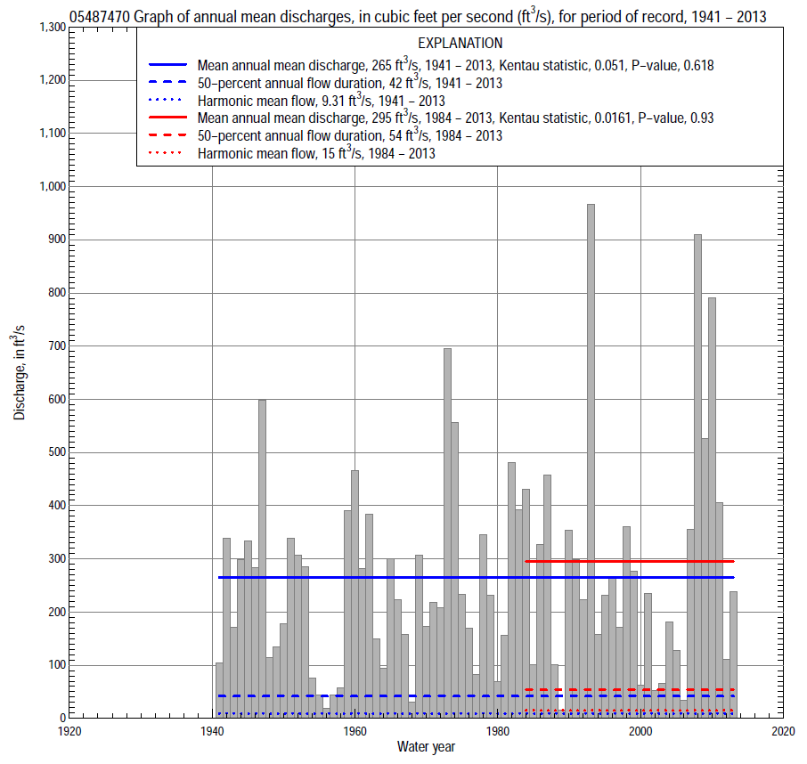

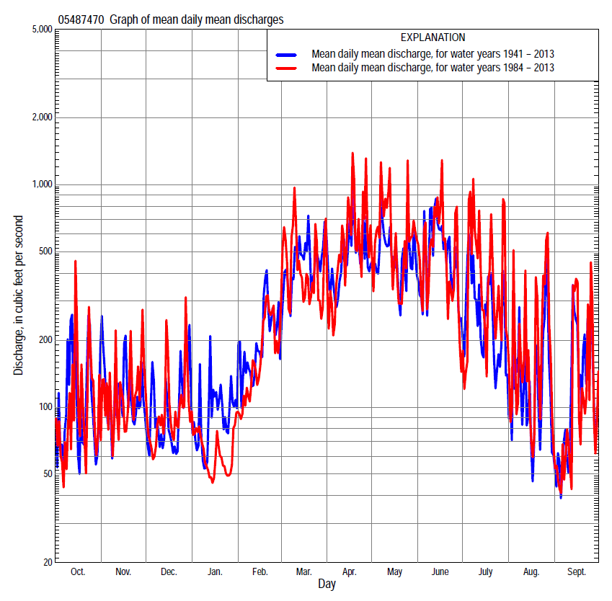

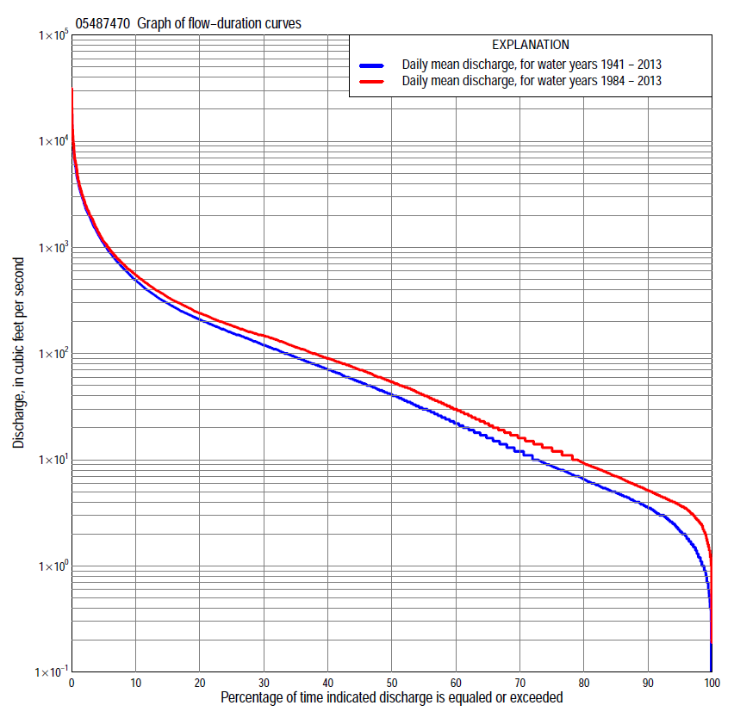

Statistics Based on the Entire Streamflow Period of Record
05487470 Monthly and annual flow durations, based on 1941–2013 period of record (73 years)
Percentage of days discharge equaled or exceeded |  |  |  |  | Discharge (cubic feet per second) |  |  |  |  |  |  |  |  | Annual flow durations
 | Oct | Nov | Dec | Jan | Feb | Mar | Apr | May | June | July | Aug | Sept | Annual | Kentau statistic | P-value
99 | 0.50 | 0.90 | 0.80 | 0.70 | 1.3 | 2.5 | 1.8 | 1.3 | 1.6 | 0.85 | 1.0 | 0.70 | 0.90 | 0.133 | 0.094
98 | 0.70 | 1.2 | 1.1 | 1.0 | 1.6 | 3.0 | 3.6 | 3.4 | 2.1 | 1.0 | 1.4 | 0.90 | 1.3 | 0.146 | 0.066
95 | 1.3 | 2.0 | 2.0 | 1.5 | 2.8 | 5.6 | 7.3 | 5.8 | 3.6 | 2.5 | 2.1 | 1.8 | 2.2 | 0.173 | 0.030
90 | 2.0 | 3.0 | 2.6 | 2.5 | 4.0 | 13 | 16 | 12 | 7.9 | 4.7 | 3.7 | 2.8 | 3.6 | 0.184 | 0.021
85 | 2.8 | 3.8 | 3.4 | 4.1 | 5.4 | 21 | 28 | 22 | 13 | 7.0 | 4.7 | 3.5 | 5.0 | 0.172 | 0.032
80 | 3.5 | 4.8 | 4.6 | 5.1 | 9.4 | 32 | 42 | 37 | 21 | 9.4 | 5.7 | 4.0 | 6.6 | 0.189 | 0.018
75 | 4.0 | 6.0 | 6.0 | 6.9 | 17 | 45 | 54 | 54 | 29 | 12 | 6.7 | 4.6 | 8.8 | 0.175 | 0.029
70 | 4.7 | 7.2 | 8.0 | 8.6 | 22 | 59 | 67 | 71 | 37 | 14 | 7.5 | 5.3 | 12 | 0.152 | 0.057
65 | 5.4 | 8.7 | 11 | 11 | 30 | 76 | 84 | 87 | 47 | 17 | 8.5 | 6.0 | 16 | 0.134 | 0.093
60 | 6.1 | 12 | 13 | 14 | 39 | 96 | 112 | 102 | 61 | 21 | 9.5 | 7.0 | 22 | 0.123 | 0.125
55 | 7.4 | 15 | 17 | 17 | 46 | 117 | 137 | 122 | 76 | 25 | 11 | 8.2 | 31 | 0.108 | 0.179
50 | 9.3 | 20 | 24 | 21 | 60 | 137 | 164 | 141 | 98 | 30 | 14 | 10 | 42 | 0.102 | 0.203
45 | 12 | 29 | 32 | 29 | 76 | 168 | 191 | 170 | 120 | 36 | 17 | 12 | 55 | 0.111 | 0.167
40 | 18 | 46 | 40 | 36 | 95 | 199 | 220 | 198 | 149 | 45 | 21 | 15 | 72 | 0.100 | 0.212
35 | 27 | 58 | 50 | 50 | 119 | 238 | 253 | 234 | 185 | 56 | 27 | 20 | 93 | 0.089 | 0.269
30 | 39 | 76 | 66 | 61 | 150 | 291 | 311 | 285 | 235 | 72 | 35 | 28 | 121 | 0.086 | 0.284
25 | 49 | 96 | 80 | 82 | 177 | 370 | 385 | 358 | 310 | 95 | 46 | 39 | 158 | 0.085 | 0.288
20 | 68 | 121 | 102 | 110 | 212 | 500 | 497 | 474 | 408 | 129 | 69 | 63 | 210 | 0.086 | 0.282
15 | 100 | 165 | 145 | 140 | 300 | 705 | 696 | 693 | 633 | 198 | 104 | 103 | 300 | 0.069 | 0.391
10 | 175 | 237 | 200 | 166 | 457 | 1,140 | 1,100 | 1,160 | 1,080 | 377 | 176 | 197 | 495 | 0.049 | 0.545
5 | 409 | 459 | 332 | 290 | 864 | 2,000 | 2,230 | 2,370 | 2,200 | 1,100 | 490 | 470 | 1,100 | -0.002 | 0.981
2 | 1,080 | 1,040 | 695 | 752 | 1,700 | 3,570 | 3,980 | 4,410 | 4,800 | 2,860 | 1,220 | 1,380 | 2,540 | -0.018 | 0.830
1 | 2,080 | 1,580 | 1,210 | 1,150 | 2,360 | 4,770 | 5,600 | 6,210 | 7,400 | 5,180 | 2,370 | 2,790 | 4,210 | -0.005 | 0.954

05487470 Annual exceedance probability of instantaneous peak discharges, in cubic feet per second (ft³/s), based on the Weighted Independent Estimates method,
Annual exceed-ance probability | Recur-rence interval (years) | Discharge (ft³/s) | 95-percent lower confi-dence interval (ft³/s) | 95-percent upper confi-dence interval (ft³/s)
0.500 | 2 | 11,200 | 9,590 | 13,000
0.200 | 5 | 18,400 | 16,000 | 21,200
0.100 | 10 | 23,100 | 19,900 | 26,800
0.040 | 25 | 29,000 | 24,400 | 34,600
0.020 | 50 | 33,200 | 27,100 | 40,700
0.010 | 100 | 37,300 | 29,500 | 47,200
0.005 | 200 | 43,000 | 32,800 | 56,200
0.002 | 500 | 47,400 | 34,500 | 64,900
and based on the expected moments algorithm/multiple Grubbs-Beck analysis computed using a historical period length of 84 years (1930–2013)
0.500 | 2 | 11,400 | 9,580 | 13,400
0.200 | 5 | 19,300 | 16,500 | 22,600
0.100 | 10 | 24,700 | 21,100 | 29,600
0.040 | 25 | 31,400 | 26,300 | 39,900
0.020 | 50 | 36,300 | 29,500 | 48,300
0.010 | 100 | 41,000 | 32,200 | 57,400
0.005 | 200 | 45,600 | 34,400 | 67,300
0.002 | 500 | 51,400 | 36,900 | 81,800
Kentau statistic |  | 0.118
P-value |  | 0.138
Begin year |  | 1940
End year |  | 2013
Number of peaks |  | 74

05487470 Annual exceedance probability of high discharges, based on 1941–2013 period of record (71 years)
Annual exceedance probability | Recur-rence interval (years) | Maximum average discharge (ft³/s) for indicated number of consecutive days
 |  | 1 | 3 | 7 | 15 | 30
0.990 | 1.01 | 1,110 | 683 | 356 | 186 | 109
0.950 | 1.05 | 2,120 | 1,250 | 686 | 392 | 241
0.900 | 1.11 | 2,920 | 1,690 | 947 | 560 | 352
0.800 | 1.25 | 4,210 | 2,400 | 1,360 | 831 | 535
0.500 | 2 | 7,920 | 4,470 | 2,550 | 1,600 | 1,060
0.200 | 5 | 13,700 | 7,820 | 4,340 | 2,690 | 1,820
0.100 | 10 | 17,600 | 10,200 | 5,530 | 3,380 | 2,290
0.040 | 25 | 22,500 | 13,400 | 6,980 | 4,160 | 2,830
0.020 | 50 | 26,100 | 15,700 | 8,020 | 4,670 | 3,180
0.010 | 100 | 29,500 | 18,100 | 9,000 | 5,140 | 3,490
0.005 | 200 | 32,900 | 20,500 | 9,930 | 5,560 | 3,770
0.002 | 500 | 37,100 | 23,600 | 11,100 | 6,050 | 4,090
Kentau statistic |  | 0.074 | 0.046 | 0.056 | 0.049 | 0.089
P-value |  | 0.356 | 0.571 | 0.487 | 0.539 | 0.267

 | 05487470 Annual nonexceedance probability of low discharges, based on April 1940 to March 2013 period of record (73 years)
Annual nonexceed-ance probability | Recur-rence interval (years) | Minimum average discharge (ft³/s) for indicated number of consecutive days
 |  | 1 | 3 | 7 | 14 | 30 | 60 | 90 | 120 | 183
0.01 | 100 | 0.00 | 0.00 | 0.00 | 0.00 | 0.11 | 0.55 | 0.62 | 0.64 | 1.0
0.02 | 50 | 0.14 | 0.19 | 0.27 | 0.36 | 0.21 | 0.76 | 0.87 | 1.0 | 1.5
0.05 | 20 | 0.35 | 0.43 | 0.57 | 0.72 | 0.49 | 1.2 | 1.5 | 1.8 | 2.9
0.10 | 10 | 0.61 | 0.72 | 0.90 | 1.1 | 1.0 | 1.9 | 2.4 | 3.0 | 5.1
0.20 | 5 | 1.1 | 1.3 | 1.5 | 1.8 | 2.2 | 3.4 | 4.3 | 5.8 | 10
0.50 | 2 | 3.1 | 3.4 | 3.8 | 4.6 | 7.4 | 10 | 14 | 20 | 35
0.80 | 1.25 | 8.3 | 8.8 | 10 | 12 | 19 | 32 | 49 | 72 | 118
0.90 | 1.11 | 13 | 14 | 16 | 19 | 28 | 60 | 96 | 140 | 219
0.96 | 1.04 | 22 | 24 | 27 | 33 | 39 | 120 | 201 | 284 | 416
0.98 | 1.02 | 31 | 33 | 38 | 46 | 47 | 188 | 327 | 450 | 627
0.99 | 1.01 | 41 | 44 | 52 | 64 | 54 | 284 | 510 | 679 | 902
Kentau statistic |  | 0.155 | 0.163 | 0.194 | 0.207 | 0.196 | 0.150 | 0.134 | 0.120 | 0.077
P-value |  | 0.053 | 0.041 | 0.016 | 0.010 | 0.014 | 0.061 | 0.095 | 0.134 | 0.338

05487470 Annual nonexceedance probability of seasonal low discharges, based on April 1940 to September 2013 period of record (73–74 years)
Annual nonexceed-ance probability | Recur-rence interval (years) | Minimum average discharge (cubic feet per second) for indicated number of consecutive days
 |  | 1 | 7 | 14 | 30 |  | 1 | 7 | 14 | 30
 |  | January-February-March |  |  |  |  | April-May-June
0.01 | 100 | 0.30 | 0.33 | 0.36 | 0.50 |  | 0.23 | 0.42 | 0.52 | 0.83
0.02 | 50 | 0.46 | 0.52 | 0.57 | 0.82 |  | 0.44 | 0.76 | 0.96 | 1.6
0.05 | 20 | 0.86 | 0.99 | 1.1 | 1.7 |  | 1.1 | 1.7 | 2.3 | 4.3
0.10 | 10 | 1.5 | 1.8 | 2.0 | 3.1 |  | 2.3 | 3.4 | 4.7 | 9.4
0.20 | 5 | 2.9 | 3.5 | 4.1 | 6.4 |  | 5.2 | 7.2 | 11 | 23
0.50 | 2 | 10 | 12 | 15 | 24 |  | 20 | 26 | 41 | 95
0.80 | 1.25 | 34 | 41 | 50 | 83 |  | 56 | 75 | 124 | 302
0.90 | 1.11 | 63 | 76 | 92 | 154 |  | 88 | 121 | 203 | 498
0.96 | 1.04 | 122 | 143 | 173 | 288 |  | 132 | 190 | 321 | 787
0.98 | 1.02 | 185 | 214 | 259 | 426 |  | 166 | 247 | 418 | 1,020
0.99 | 1.01 | 268 | 305 | 369 | 601 |  | 199 | 306 | 519 | 1,260
Kentau statistic |  | 0.118 | 0.143 | 0.119 | 0.052 |  | 0.167 | 0.156 | 0.160 | 0.131
P-value |  | 0.140 | 0.074 | 0.139 | 0.517 |  | 0.036 | 0.050 | 0.044 | 0.099
 |  | July-August-September |  |  |  |  | October-November-December
0.01 | 100 | 0.00 | 0.14 | 0.64 | 1.3 |  | 0.00 | 0.00 | 0.24 | 0.41
0.02 | 50 | 0.35 | 0.60 | 1.0 | 1.5 |  | 0.24 | 0.36 | 0.37 | 0.60
0.05 | 20 | 0.64 | 0.94 | 1.4 | 1.9 |  | 0.57 | 0.70 | 0.72 | 1.1
0.10 | 10 | 0.96 | 1.3 | 1.9 | 2.5 |  | 0.99 | 1.2 | 1.3 | 1.9
0.20 | 5 | 1.5 | 1.9 | 2.7 | 3.6 |  | 1.8 | 2.3 | 2.5 | 3.6
0.50 | 2 | 3.8 | 4.5 | 7.0 | 8.6 |  | 5.6 | 7.0 | 9.0 | 13
0.80 | 1.25 | 10 | 12 | 18 | 26 |  | 17 | 23 | 31 | 45
0.90 | 1.11 | 17 | 22 | 32 | 52 |  | 32 | 43 | 58 | 88
0.96 | 1.04 | 32 | 43 | 73 | 118 |  | 60 | 87 | 112 | 181
0.98 | 1.02 | 47 | 69 | 129 | 209 |  | 91 | 140 | 170 | 290
0.99 | 1.01 | 69 | 107 | 224 | 361 |  | 133 | 216 | 246 | 443
Kentau statistic |  | 0.160 | 0.178 | 0.190 | 0.165 |  | 0.152 | 0.161 | 0.166 | 0.143
P-value |  | 0.044 | 0.025 | 0.017 | 0.038 |  | 0.057 | 0.045 | 0.038 | 0.074

Statistics Based on the 1984–2013 Streamflow Period of Record
05487470 Monthly and annual flow durations, based on 1984–2013 period of record (30 years)
Percentage of days discharge equaled or exceeded |  |  |  |  | Discharge (cubic feet per second) |  |  |  |  |  |  |  |  | Annual flow durations
 | Oct | Nov | Dec | Jan | Feb | Mar | Apr | May | June | July | Aug | Sept | Annual | Kentau statistic | P-value
99 | 0.93 | 2.5 | 1.7 | 2.0 | 2.9 | 3.2 | 3.6 | 3.1 | 2.1 | 1.6 | 1.1 | 1.6 | 2.0 | 0.005 | 0.985
98 | 1.5 | 2.7 | 2.0 | 3.3 | 3.0 | 4.1 | 4.0 | 4.0 | 2.5 | 2.5 | 1.8 | 2.1 | 2.6 | 0.014 | 0.927
95 | 2.8 | 4.2 | 3.8 | 5.0 | 4.1 | 8.8 | 8.5 | 7.0 | 3.8 | 3.7 | 2.7 | 2.9 | 3.7 | 0.016 | 0.914
90 | 3.6 | 5.0 | 5.3 | 6.9 | 7.5 | 18 | 20 | 23 | 9.9 | 5.9 | 4.2 | 3.5 | 5.2 | 0.021 | 0.886
85 | 4.0 | 6.3 | 6.7 | 8.4 | 14 | 34 | 33 | 41 | 17 | 8.1 | 5.3 | 4.0 | 7.0 | 0.014 | 0.929
80 | 4.4 | 7.6 | 8.2 | 10 | 17 | 50 | 47 | 63 | 24 | 11 | 6.3 | 4.7 | 9.3 | 0.011 | 0.943
75 | 5.1 | 9.4 | 11 | 12 | 22 | 67 | 61 | 83 | 36 | 14 | 7.3 | 5.4 | 13 | -0.023 | 0.872
70 | 5.8 | 12 | 12 | 14 | 30 | 85 | 80 | 100 | 52 | 17 | 8.7 | 6.1 | 16 | -0.044 | 0.748
65 | 6.9 | 15 | 14 | 16 | 37 | 100 | 113 | 116 | 69 | 21 | 10 | 7.0 | 22 | -0.074 | 0.580
60 | 8.4 | 19 | 18 | 18 | 48 | 118 | 136 | 143 | 89 | 26 | 13 | 8.3 | 30 | -0.076 | 0.568
55 | 9.5 | 23 | 26 | 21 | 60 | 135 | 157 | 166 | 115 | 31 | 15 | 10 | 41 | -0.074 | 0.580
50 | 11 | 31 | 34 | 27 | 71 | 154 | 188 | 191 | 141 | 37 | 18 | 12 | 54 | -0.092 | 0.486
45 | 15 | 48 | 48 | 37 | 86 | 180 | 218 | 225 | 163 | 46 | 23 | 15 | 70 | -0.078 | 0.556
40 | 22 | 57 | 57 | 47 | 101 | 200 | 250 | 266 | 199 | 58 | 30 | 18 | 90 | -0.083 | 0.532
35 | 30 | 70 | 70 | 54 | 126 | 227 | 309 | 314 | 245 | 70 | 38 | 24 | 115 | -0.053 | 0.695
30 | 40 | 90 | 82 | 70 | 150 | 278 | 380 | 389 | 300 | 86 | 53 | 29 | 147 | -0.087 | 0.509
25 | 56 | 105 | 100 | 85 | 180 | 344 | 481 | 471 | 384 | 114 | 77 | 38 | 184 | -0.083 | 0.532
20 | 83 | 134 | 136 | 110 | 212 | 445 | 607 | 632 | 510 | 175 | 108 | 62 | 240 | -0.064 | 0.630
15 | 137 | 170 | 160 | 135 | 272 | 601 | 840 | 894 | 693 | 287 | 176 | 106 | 339 | -0.067 | 0.617
10 | 223 | 248 | 200 | 155 | 400 | 960 | 1,230 | 1,490 | 1,060 | 767 | 341 | 213 | 550 | -0.034 | 0.803
5 | 439 | 483 | 310 | 191 | 722 | 1,850 | 2,370 | 2,980 | 2,070 | 2,090 | 702 | 432 | 1,140 | -0.028 | 0.844
2 | 915 | 1,080 | 580 | 306 | 1,260 | 3,020 | 4,100 | 4,980 | 4,290 | 4,110 | 1,770 | 1,100 | 2,720 | 0.117 | 0.372
1 | 1,720 | 1,510 | 887 | 380 | 1,860 | 4,770 | 6,520 | 6,400 | 6,890 | 6,990 | 5,100 | 1,840 | 4,360 | 0.126 | 0.335

05487470 Annual exceedance probability of high discharges, based on 1984–2013 period of record (30 years)
Annual exceedance probability | Recur-rence interval (years) | Maximum average discharge (ft³/s) for indicated number of consecutive days
 |  | 1 | 3 | 7 | 15 | 30
0.990 | 1.01 | 852 | 518 | 288 | 144 | 85
0.950 | 1.05 | 1,730 | 1,010 | 579 | 325 | 210
0.900 | 1.11 | 2,480 | 1,430 | 821 | 482 | 322
0.800 | 1.25 | 3,750 | 2,130 | 1,230 | 750 | 516
0.500 | 2 | 7,840 | 4,420 | 2,520 | 1,570 | 1,110
0.200 | 5 | 15,300 | 8,700 | 4,790 | 2,870 | 2,020
0.100 | 10 | 21,000 | 12,200 | 6,510 | 3,750 | 2,590
0.040 | 25 | 29,000 | 17,100 | 8,860 | 4,820 | 3,250
0.020 | 50 | 35,300 | 21,100 | 10,700 | 5,560 | 3,680
0.010 | 100 | 41,800 | 25,400 | 12,600 | 6,260 | 4,060
0.005 | 200 | 48,600 | 30,000 | 14,500 | 6,910 | 4,400
0.002 | 500 | 57,800 | 36,500 | 17,000 | 7,700 | 4,780
Kentau statistic |  | 0.159 | 0.113 | 0.090 | 0.067 | 0.090
P-value |  | 0.225 | 0.392 | 0.498 | 0.617 | 0.498

 | 05487470 Annual nonexceedance probability of low discharges, based on April 1983 to March 2013 period of record (30 years)
Annual nonexceed-ance probability | Recur-rence interval (years) | Minimum average discharge (ft³/s) for indicated number of consecutive days
 |  | 1 | 3 | 7 | 14 | 30 | 60 | 90 | 120 | 183
0.01 | 100 | 0.25 | 0.37 | 0.56 | 0.81 | 1.1 | 1.4 | 1.4 | 1.5 | 2.1
0.02 | 50 | 0.36 | 0.50 | 0.73 | 1.0 | 1.4 | 1.7 | 1.8 | 2.0 | 2.9
0.05 | 20 | 0.61 | 0.80 | 1.1 | 1.4 | 1.9 | 2.5 | 2.7 | 3.2 | 4.9
0.10 | 10 | 1.0 | 1.2 | 1.5 | 2.0 | 2.7 | 3.5 | 3.9 | 4.9 | 7.7
0.20 | 5 | 1.6 | 1.9 | 2.4 | 3.0 | 3.9 | 5.4 | 6.4 | 8.4 | 14
0.50 | 2 | 4.3 | 4.8 | 5.5 | 6.6 | 8.7 | 13 | 18 | 24 | 40
0.80 | 1.25 | 11 | 12 | 13 | 15 | 21 | 37 | 56 | 76 | 120
0.90 | 1.11 | 17 | 18 | 20 | 24 | 33 | 66 | 106 | 140 | 214
0.96 | 1.04 | 27 | 30 | 33 | 40 | 55 | 126 | 218 | 277 | 398
0.98 | 1.02 | 37 | 40 | 46 | 55 | 78 | 196 | 353 | 435 | 596
0.99 | 1.01 | 48 | 53 | 61 | 75 | 108 | 294 | 554 | 657 | 858
Kentau statistic |  | -0.023 | -0.034 | -0.005 | 0.016 | -0.044 | -0.016 | -0.007 | 0.002 | -0.057
P-value |  | 0.872 | 0.803 | 0.986 | 0.915 | 0.748 | 0.915 | 0.972 | 1.000 | 0.669

05487470 Annual nonexceedance probability of seasonal low discharges, based on October 1983 to September 2013 period of record (30 years)
Annual nonexceed-ance probability | Recur-rence interval (years) | Minimum average discharge (cubic feet per second) for indicated number of consecutive days
 |  | 1 | 7 | 14 | 30 |  | 1 | 7 | 14 | 30
 |  | January-February-March |  |  |  |  | April-May-June
0.01 | 100 | 0.61 | 0.96 | 1.1 | 1.7 |  | 0.68 | 0.78 | 0.79 | 1.2
0.02 | 50 | 0.90 | 1.4 | 1.6 | 2.4 |  | 1.1 | 1.3 | 1.5 | 2.3
0.05 | 20 | 1.6 | 2.3 | 2.7 | 3.9 |  | 2.3 | 2.9 | 3.5 | 6.1
0.10 | 10 | 2.7 | 3.7 | 4.3 | 6.2 |  | 4.3 | 5.4 | 7.2 | 14
0.20 | 5 | 4.9 | 6.4 | 7.5 | 11 |  | 8.5 | 11 | 16 | 33
0.50 | 2 | 15 | 18 | 21 | 30 |  | 28 | 38 | 61 | 136
0.80 | 1.25 | 42 | 50 | 58 | 80 |  | 75 | 106 | 182 | 416
0.90 | 1.11 | 71 | 85 | 96 | 133 |  | 120 | 170 | 294 | 668
0.96 | 1.04 | 123 | 146 | 165 | 228 |  | 186 | 265 | 460 | 1,020
0.98 | 1.02 | 173 | 206 | 232 | 322 |  | 243 | 344 | 593 | 1,300
0.99 | 1.01 | 235 | 281 | 315 | 437 |  | 302 | 427 | 731 | 1,560
Kentau statistic |  | -0.186 | -0.108 | -0.094 | -0.085 |  | 0.166 | 0.110 | 0.099 | 0.099
P-value |  | 0.153 | 0.412 | 0.475 | 0.521 |  | 0.205 | 0.402 | 0.454 | 0.454
 |  | July-August-September |  |  |  |  | October-November-December
0.01 | 100 | 1.1 | 1.4 | 1.8 | 2.1 |  | 0.34 | 0.63 | 0.82 | 0.93
0.02 | 50 | 1.2 | 1.5 | 1.9 | 2.3 |  | 0.50 | 0.83 | 1.1 | 1.3
0.05 | 20 | 1.4 | 1.8 | 2.2 | 2.8 |  | 0.86 | 1.3 | 1.7 | 2.1
0.10 | 10 | 1.7 | 2.1 | 2.6 | 3.5 |  | 1.4 | 1.9 | 2.5 | 3.2
0.20 | 5 | 2.2 | 2.7 | 3.4 | 4.8 |  | 2.5 | 3.1 | 4.1 | 5.6
0.50 | 2 | 4.6 | 5.6 | 7.0 | 11 |  | 7.1 | 8.5 | 11 | 16
0.80 | 1.25 | 13 | 16 | 20 | 36 |  | 20 | 25 | 32 | 51
0.90 | 1.11 | 24 | 32 | 40 | 77 |  | 33 | 45 | 58 | 93
0.96 | 1.04 | 54 | 76 | 95 | 198 |  | 55 | 85 | 109 | 180
0.98 | 1.02 | 96 | 142 | 178 | 391 |  | 78 | 131 | 167 | 278
0.99 | 1.01 | 167 | 260 | 326 | 753 |  | 105 | 194 | 246 | 413
Kentau statistic |  | -0.069 | -0.018 | -0.011 | -0.039 |  | 0.085 | 0.034 | 0.007 | -0.034
P-value |  | 0.605 | 0.901 | 0.943 | 0.775 |  | 0.521 | 0.803 | 0.972 | 0.803

