LOCATION.--Lat 41°29'19", long 93°20'17" referenced to North American Datum of 1927, in SE 1/4 NW 1/4 sec.12, T.77 N., R.22 W., Polk County, IA, Hydrologic Unit 07100008, on downstream handrail at Station 1260 on bridge on State Highway 316, 2.2 mi southeast of Runnells, 0.2 mi downstream from South River, 0.5 mi upstream from Camp Creek, 28.2 mi upstream from Red Rock Dam, and 167.4 mi upstream from mouth.

DRAINAGE AREA.--11,655 mi².

PERIOD OF RECORD.--Discharge records from October 1985 to September 2009.

GAGE.--Water-stage recorder. Datum of gage is 700.00 ft above NGVD of 1929 (U.S. Army Corps of Engineers benchmark).

REMARKS.--Records good except for estimated daily discharges, which are poor. Flow regulated by Saylorville Lake (station 05481630), 34.2 mi upstream. Stage-discharge relation is affected at times by backwater from Lake Red Rock (station 05488100).

EXTREMES OUTSIDE PERIOD OF RECORD.--Floods occurred on May 31, 1903, June 14, 1947, June 26, 1947, and June 24, 1954. No gage height or discharge were determined. Gage height and discharge information is available for these floods at other sites on the Des Moines River.

A summary of all available data for this streamgage is provided through the USGS National Water Information System web interface (NWISWeb). The following link provides access to current/historical observations, daily data, daily statistics, monthly statistics, annual statistics, peak streamflow, field measurements, field/lab water-quality samples, and the latest water-year summaries. Data can be filtered by parameter and/or dates, and can be output in various tabular and graphical formats.
http://waterdata.usgs.gov/nwis/inventory/?site_no=05487500

The USGS WaterWatch Toolkit is available at:
http://waterwatch.usgs.gov/?id=ww_toolkit
Tools for summarizing streamflow information include the duration hydrograph builder, the cumulative streamflow hydrograph builder, the streamgage statistics retrieval tool, the rating curve builder, the flood tracking chart builder, the National Weather Service Advanced Hydrologic Prediction Service (AHPS) river forecast hydrograph builder, and the raster-hydrograph builder. Entering the above number for this streamgage into these toolkit webpages will provide streamflow information specific to this streamgage.

A description of the statistics presented for this streamgage is available in the main body of the report at:
http://dx.doi.org/10.3133/ofr20151214
A link to other streamgages included in this report, a map showing the location of the streamgages, information on the programs used to compute the statistical analyses, and references are included in the main body of the report.

Statistics Based on the Regulated Streamflow Period of Record

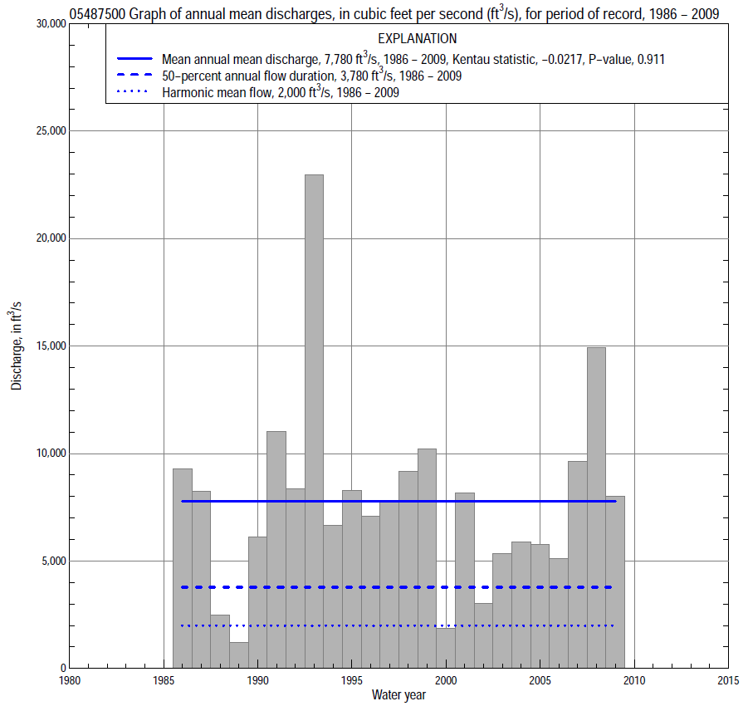

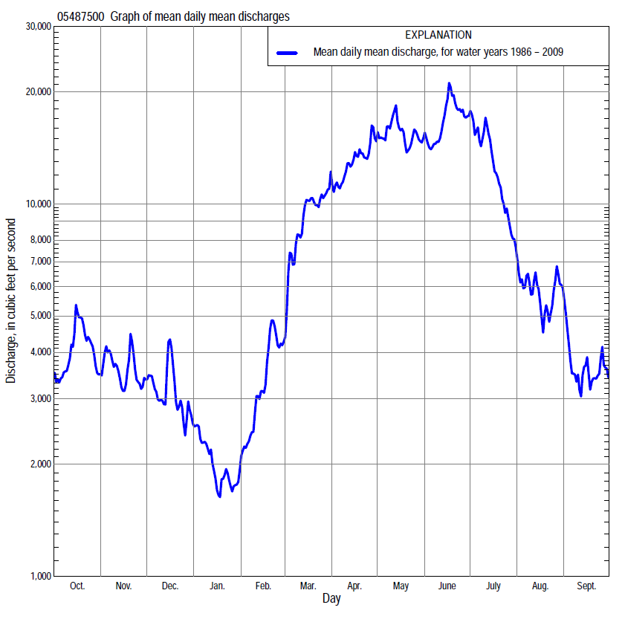

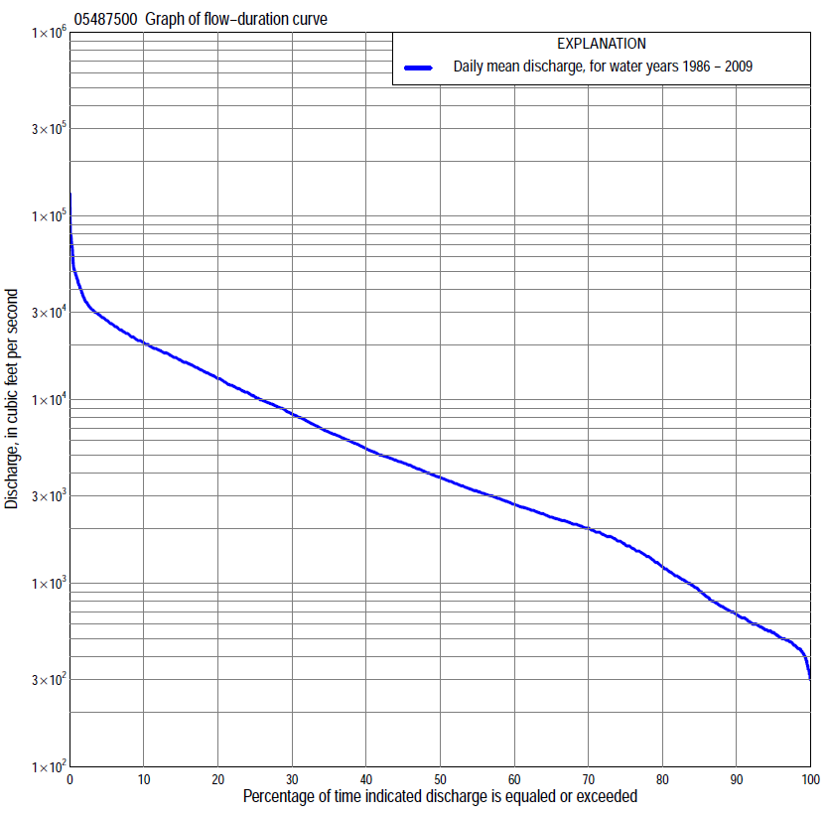

Statistics Based on the Regulated Streamflow Period of Record
05487500 Monthly and annual flow durations, based on 1986–2009 regulated period of record (24 years)
Percentage of days discharge equaled or exceeded |  |  |  |  | Discharge (cubic feet per second) |  |  |  |  |  |  |  |  | Annual flow durations
 | Oct | Nov | Dec | Jan | Feb | Mar | Apr | May | June | July | Aug | Sept | Annual | Kentau statistic | P-value
99 | 320 | 456 | 380 | 390 | 430 | 540 | 600 | 650 | 912 | 570 | 431 | 340 | 415 | 0.004 | 1.000
98 | 340 | 477 | 430 | 410 | 452 | 610 | 650 | 750 | 1,180 | 699 | 495 | 360 | 453 | 0.011 | 0.960
95 | 420 | 509 | 460 | 458 | 500 | 922 | 850 | 1,300 | 2,180 | 872 | 604 | 475 | 540 | 0.029 | 0.862
90 | 525 | 616 | 552 | 510 | 540 | 1,470 | 1,840 | 3,200 | 3,270 | 1,450 | 901 | 560 | 678 | 0.000 | 1.000
85 | 584 | 712 | 650 | 558 | 620 | 2,000 | 2,620 | 4,850 | 4,400 | 2,230 | 1,280 | 633 | 909 | -0.047 | 0.766
80 | 673 | 800 | 799 | 601 | 778 | 2,410 | 3,400 | 6,260 | 5,550 | 3,460 | 1,570 | 770 | 1,230 | -0.033 | 0.843
75 | 771 | 999 | 1,100 | 723 | 1,070 | 2,970 | 4,160 | 7,100 | 6,500 | 4,790 | 1,900 | 942 | 1,610 | -0.033 | 0.843
70 | 932 | 1,400 | 1,360 | 900 | 1,490 | 3,300 | 5,200 | 8,130 | 7,600 | 5,750 | 2,120 | 1,040 | 2,000 | -0.014 | 0.941
65 | 1,150 | 1,650 | 1,630 | 1,100 | 1,710 | 3,820 | 6,470 | 9,370 | 9,000 | 6,480 | 2,430 | 1,130 | 2,300 | -0.011 | 0.960
60 | 1,700 | 1,900 | 1,900 | 1,290 | 2,000 | 4,500 | 8,220 | 10,900 | 10,500 | 7,370 | 2,700 | 1,310 | 2,700 | 0.014 | 0.941
55 | 2,080 | 2,090 | 2,100 | 1,500 | 2,210 | 5,190 | 9,580 | 13,600 | 11,900 | 8,390 | 3,080 | 1,460 | 3,180 | 0.047 | 0.766
50 | 2,280 | 2,330 | 2,290 | 1,700 | 2,480 | 6,110 | 11,000 | 14,800 | 13,400 | 9,800 | 3,500 | 1,600 | 3,780 | 0.022 | 0.901
45 | 2,610 | 2,580 | 2,540 | 1,850 | 2,650 | 7,220 | 12,700 | 16,000 | 15,000 | 10,800 | 4,000 | 1,860 | 4,540 | -0.047 | 0.766
40 | 2,920 | 2,970 | 2,900 | 2,000 | 2,840 | 8,760 | 14,400 | 17,500 | 16,700 | 11,500 | 4,530 | 2,160 | 5,420 | -0.036 | 0.823
35 | 3,340 | 3,600 | 3,210 | 2,200 | 3,100 | 9,950 | 16,200 | 19,000 | 18,000 | 13,000 | 5,200 | 2,400 | 6,650 | -0.011 | 0.960
30 | 3,800 | 4,200 | 3,500 | 2,400 | 3,570 | 11,600 | 18,300 | 21,000 | 19,500 | 14,200 | 5,810 | 2,890 | 8,360 | 0.011 | 0.960
25 | 4,420 | 4,700 | 3,940 | 2,650 | 4,030 | 13,100 | 19,500 | 22,500 | 21,000 | 15,500 | 6,500 | 3,320 | 10,300 | 0.036 | 0.823
20 | 5,000 | 5,200 | 4,400 | 3,020 | 4,700 | 15,800 | 21,600 | 24,300 | 23,500 | 17,000 | 7,860 | 4,510 | 13,000 | 0.043 | 0.785
15 | 6,420 | 6,460 | 5,210 | 3,400 | 5,500 | 18,100 | 24,000 | 26,000 | 28,300 | 19,000 | 9,270 | 6,180 | 16,400 | 0.062 | 0.691
10 | 9,960 | 9,110 | 6,850 | 3,880 | 7,820 | 21,500 | 28,100 | 28,500 | 34,000 | 23,500 | 10,600 | 8,260 | 20,400 | 0.065 | 0.673
5 | 16,000 | 11,500 | 8,960 | 5,000 | 11,500 | 25,800 | 31,700 | 32,500 | 48,000 | 39,000 | 24,400 | 16,000 | 27,000 | 0.018 | 0.921
2 | 25,000 | 14,600 | 11,800 | 6,920 | 14,000 | 30,900 | 35,500 | 39,900 | 65,100 | 67,300 | 31,700 | 23,700 | 35,000 | 0.062 | 0.691
1 | 28,000 | 16,000 | 16,600 | 7,670 | 15,300 | 32,600 | 39,300 | 45,000 | 73,800 | 79,700 | 39,300 | 30,300 | 45,400 | 0.080 | 0.602

05487500 Annual exceedance probability of instantaneous peak dischargesª, in cubic feet per second (ft³/s)
[ND, not determined]
Annual exceed-ance probability | Recur-rence interval (years) | Discharge (ft³/s) | 95-percent lower confi-dence interval (ft³/s) | 95-percent upper confi-dence interval (ft³/s)
0.500 | 2 | ND | ND | ND
0.200 | 5 | ND | ND | ND
0.100 | 10 | ND | ND | ND
0.040 | 25 | ND | ND | ND
0.020 | 50 | ND | ND | ND
0.010 | 100 | ND | ND | ND
0.005 | 200 | ND | ND | ND
0.002 | 500 | ND | ND | ND
Kentau statistic |  | 0.101
P-value |  | 0.503
Begin year |  | 1986
End year |  | 2009
Number of peaks |  | 24
ªNot determined because of backwater effects caused by Lake Red Rock.

05487500 Annual exceedance probability of high discharges, based on 1986–2009 regulated period of recordª (24 years)
Annual exceedance probability | Recur-rence interval (years) | Maximum average discharge (cubic feet per second) for indicated number of consecutive days
 |  | 1 | 3 | 7 | 15 | 30
0.990 | 1.01 | ND | ND | ND | ND | ND
0.950 | 1.05 | ND | ND | ND | ND | ND
0.900 | 1.11 | ND | ND | ND | ND | ND
0.800 | 1.25 | ND | ND | ND | ND | ND
0.500 | 2 | ND | ND | ND | ND | ND
0.200 | 5 | ND | ND | ND | ND | ND
0.100 | 10 | ND | ND | ND | ND | ND
0.040 | 25 | ND | ND | ND | ND | ND
0.020 | 50 | ND | ND | ND | ND | ND
0.010 | 100 | ND | ND | ND | ND | ND
0.005 | 200 | ND | ND | ND | ND | ND
0.002 | 500 | ND | ND | ND | ND | ND
Kentau statistic |  | 0.080 | 0.072 | 0.138 | 0.080 | 0.072
P-value |  | 0.602 | 0.637 | 0.359 | 0.602 | 0.637
ªNot determined because of backwater effects caused by Lake Red Rock.

 | 05487500 Annual nonexceedance probability of low discharges, based on April 1986 to March 2009 regulated period of record (23 years)
Annual nonexceed-ance probability | Recur-rence interval (years) | Minimum average discharge (cubic feet per second) for indicated number of consecutive days
 |  | 1 | 3 | 7 | 14 | 30 | 60 | 90 | 120 | 183
0.01 | 100 | 210 | 216 | 217 | 218 | 218 | 219 | 246 | 254 | 305
0.02 | 50 | 240 | 248 | 253 | 254 | 254 | 274 | 313 | 329 | 390
0.05 | 20 | 295 | 305 | 319 | 327 | 341 | 382 | 443 | 481 | 561
0.10 | 10 | 356 | 370 | 390 | 411 | 440 | 508 | 599 | 665 | 772
0.20 | 5 | 451 | 469 | 498 | 539 | 598 | 710 | 855 | 973 | 1,130
0.50 | 2 | 725 | 755 | 809 | 906 | 1,060 | 1,300 | 1,630 | 1,940 | 2,280
0.80 | 1.25 | 1,200 | 1,250 | 1,340 | 1,520 | 1,870 | 2,270 | 3,000 | 3,660 | 4,500
0.90 | 1.11 | 1,590 | 1,640 | 1,750 | 1,980 | 2,490 | 3,000 | 4,050 | 5,000 | 6,370
0.96 | 1.04 | 2,160 | 2,210 | 2,350 | 2,630 | 3,380 | 3,970 | 5,530 | 6,870 | 9,140
0.98 | 1.02 | 2,650 | 2,700 | 2,850 | 3,160 | 4,100 | 4,720 | 6,710 | 8,370 | 11,500
0.99 | 1.01 | 3,190 | 3,240 | 3,390 | 3,720 | 4,870 | 5,500 | 7,960 | 9,950 | 14,100
Kentau statistic |  | -0.123 | -0.115 | -0.055 | -0.028 | 0.012 | -0.004 | 0.043 | 0.028 | -0.036
P-value |  | 0.428 | 0.460 | 0.731 | 0.874 | 0.958 | 1.000 | 0.792 | 0.874 | 0.833

05487500 Annual nonexceedance probability of seasonal low discharges, based on October 1985 to September 2009 regulated period of record (24 years)
Annual nonexceed-ance probability | Recur-rence interval (years) | Minimum average discharge (cubic feet per second) for indicated number of consecutive days
 |  | 1 | 7 | 14 | 30 |  | 1 | 7 | 14 | 30
 |  | January-February-March |  |  |  |  | April-May-June
0.01 | 100 | 193 | 213 | 234 | 234 |  | 252 | 281 | 339 | 447
0.02 | 50 | 237 | 259 | 283 | 290 |  | 371 | 416 | 498 | 669
0.05 | 20 | 321 | 347 | 378 | 402 |  | 642 | 726 | 865 | 1,190
0.10 | 10 | 418 | 450 | 490 | 535 |  | 1,020 | 1,160 | 1,370 | 1,900
0.20 | 5 | 572 | 617 | 670 | 749 |  | 1,710 | 1,960 | 2,330 | 3,230
0.50 | 2 | 1,020 | 1,120 | 1,220 | 1,400 |  | 4,170 | 4,840 | 5,780 | 7,830
0.80 | 1.25 | 1,790 | 2,050 | 2,250 | 2,540 |  | 8,890 | 10,400 | 12,700 | 16,200
0.90 | 1.11 | 2,380 | 2,800 | 3,100 | 3,430 |  | 12,600 | 14,800 | 18,300 | 22,400
0.96 | 1.04 | 3,200 | 3,910 | 4,360 | 4,690 |  | 17,500 | 20,800 | 26,100 | 30,300
0.98 | 1.02 | 3,860 | 4,850 | 5,440 | 5,720 |  | 21,400 | 25,500 | 32,200 | 36,100
0.99 | 1.01 | 4,550 | 5,880 | 6,650 | 6,810 |  | 25,200 | 30,100 | 38,500 | 41,600
Kentau statistic |  | 0.004 | 0.036 | 0.051 | 0.000 |  | 0.065 | 0.087 | 0.101 | 0.087
P-value |  | 1.000 | 0.823 | 0.747 | 1.000 |  | 0.673 | 0.568 | 0.503 | 0.568
 |  | July-August-September |  |  |  |  | October-November-December
0.01 | 100 | 381 | 407 | 447 | 494 |  | 186 | 186 | 190 | 200
0.02 | 50 | 388 | 417 | 462 | 524 |  | 234 | 234 | 241 | 260
0.05 | 20 | 407 | 442 | 497 | 589 |  | 307 | 327 | 344 | 381
0.10 | 10 | 436 | 479 | 547 | 674 |  | 389 | 438 | 468 | 530
0.20 | 5 | 497 | 554 | 645 | 829 |  | 521 | 619 | 675 | 783
0.50 | 2 | 778 | 886 | 1,060 | 1,440 |  | 921 | 1,170 | 1,330 | 1,590
0.80 | 1.25 | 1,700 | 1,940 | 2,300 | 3,170 |  | 1,660 | 2,130 | 2,560 | 3,110
0.90 | 1.11 | 3,000 | 3,380 | 3,950 | 5,300 |  | 2,270 | 2,880 | 3,570 | 4,340
0.96 | 1.04 | 6,230 | 6,850 | 7,790 | 9,980 |  | 3,190 | 3,930 | 5,040 | 6,110
0.98 | 1.02 | 10,800 | 11,600 | 12,800 | 15,800 |  | 3,990 | 4,780 | 6,280 | 7,570
0.99 | 1.01 | 18,500 | 19,400 | 21,000 | 24,600 |  | 4,880 | 5,690 | 7,620 | 9,140
Kentau statistic |  | -0.167 | -0.159 | -0.116 | -0.130 |  | -0.029 | -0.072 | -0.094 | -0.058
P-value |  | 0.264 | 0.286 | 0.442 | 0.385 |  | 0.862 | 0.637 | 0.535 | 0.710

