LOCATION.--Lat 41°36'03.1", long 93°17'44.8" referenced to North American Datum of 1927, in NW 1/4 NE 1/4 NE 1/4 sec.05, T.78 N., R.21 W., Jasper County, IA, Hydrologic Unit 07100008, on left bank on downstream side of bridge on State Highway 163, and 2.2 mi west of Prairie City.

DRAINAGE AREA.--6.78 mi².

PERIOD OF RECORD.--Discharge records from May 1995 to September 2005.

GAGE.--Water-stage recorder and concrete control. Datum of gage is 826.33 ft above National Geodetic Vertical Datum of 1929.

REMARKS.--Records good except for estimated daily discharges, which are poor.

A summary of all available data for this streamgage is provided through the USGS National Water Information System web interface (NWISWeb). The following link provides access to current/historical observations, daily data, daily statistics, monthly statistics, annual statistics, peak streamflow, field measurements, field/lab water-quality samples, and the latest water-year summaries. Data can be filtered by parameter and/or dates, and can be output in various tabular and graphical formats.
http://waterdata.usgs.gov/nwis/inventory/?site_no=05487540

The USGS WaterWatch Toolkit is available at:
http://waterwatch.usgs.gov/?id=ww_toolkit
Tools for summarizing streamflow information include the duration hydrograph builder, the cumulative streamflow hydrograph builder, the streamgage statistics retrieval tool, the rating curve builder, the flood tracking chart builder, the National Weather Service Advanced Hydrologic Prediction Service (AHPS) river forecast hydrograph builder, and the raster-hydrograph builder. Entering the above number for this streamgage into these toolkit webpages will provide streamflow information specific to this streamgage.

A description of the statistics presented for this streamgage is available in the main body of the report at:
http://dx.doi.org/10.3133/ofr20151214
A link to other streamgages included in this report, a map showing the location of the streamgages, information on the programs used to compute the statistical analyses, and references are included in the main body of the report.

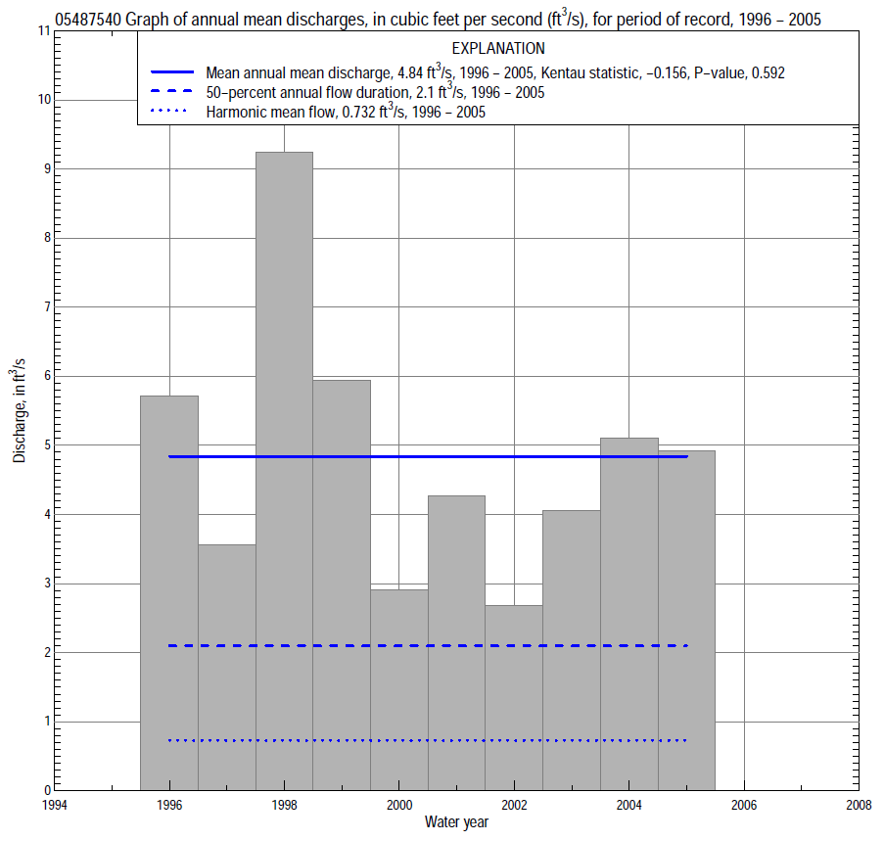

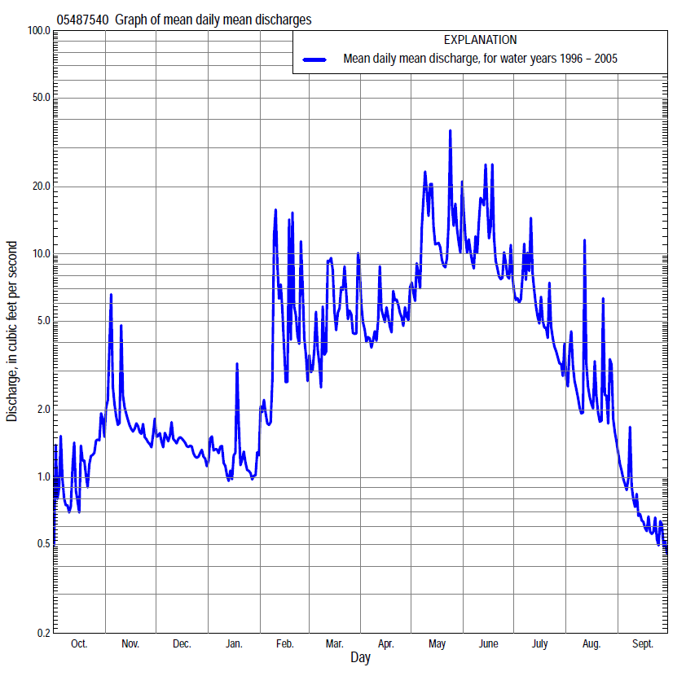

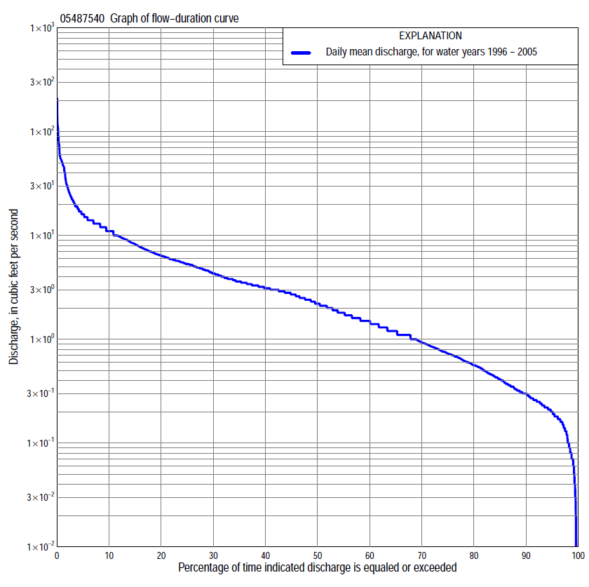

Statistics Based on the Entire Streamflow Period of Record
05487540 Monthly and annual flow durations, based on 1996–2005 period of record (10 years)
Percentage of days discharge equaled or exceeded |  |  |  |  | Discharge (cubic feet per second) |  |  |  |  |  |  |  |  | Annual flow durations
 | Oct | Nov | Dec | Jan | Feb | Mar | Apr | May | June | July | Aug | Sept | Annual | Kentau statistic | P-value
99 | 0.08 | 0.14 | 0.07 | 0.10 | 0.20 | 0.34 | 0.90 | 1.6 | 3.1 | 1.6 | 0.13 | 0.00 | 0.07 | -0.067 | 0.728
98 | 0.09 | 0.19 | 0.07 | 0.14 | 0.29 | 0.40 | 0.92 | 1.8 | 3.3 | 1.8 | 0.18 | 0.00 | 0.10 | -0.067 | 0.728
95 | 0.13 | 0.27 | 0.08 | 0.21 | 0.36 | 0.78 | 1.1 | 2.4 | 4.4 | 2.1 | 0.27 | 0.01 | 0.20 | -0.178 | 0.361
90 | 0.16 | 0.31 | 0.20 | 0.25 | 0.50 | 1.1 | 1.1 | 3.1 | 5.1 | 2.4 | 0.52 | 0.06 | 0.30 | -0.178 | 0.361
85 | 0.18 | 0.36 | 0.32 | 0.30 | 0.59 | 1.2 | 1.3 | 3.5 | 5.5 | 2.7 | 0.68 | 0.13 | 0.41 | -0.067 | 0.823
80 | 0.19 | 0.43 | 0.42 | 0.34 | 0.66 | 1.3 | 1.4 | 3.9 | 5.8 | 3.0 | 0.81 | 0.20 | 0.56 | -0.067 | 0.823
75 | 0.21 | 0.46 | 0.47 | 0.37 | 0.75 | 1.5 | 1.5 | 4.4 | 6.2 | 3.2 | 0.96 | 0.24 | 0.72 | 0.067 | 0.838
70 | 0.23 | 0.53 | 0.54 | 0.45 | 0.88 | 1.6 | 2.1 | 4.9 | 6.6 | 3.4 | 1.1 | 0.26 | 0.93 | 0.067 | 0.838
65 | 0.26 | 0.68 | 0.62 | 0.53 | 0.95 | 1.8 | 2.6 | 5.4 | 7.0 | 3.5 | 1.2 | 0.29 | 1.2 | 0.111 | 0.678
60 | 0.30 | 0.76 | 0.68 | 0.56 | 1.1 | 1.9 | 2.8 | 6.0 | 7.4 | 3.7 | 1.3 | 0.32 | 1.4 | 0.089 | 0.758
55 | 0.36 | 0.82 | 0.75 | 0.60 | 1.3 | 2.2 | 3.1 | 6.7 | 8.0 | 3.9 | 1.4 | 0.36 | 1.7 | -0.022 | 1.000
50 | 0.61 | 0.87 | 0.80 | 0.67 | 2.0 | 2.7 | 3.5 | 7.6 | 8.6 | 4.2 | 1.5 | 0.40 | 2.1 | 0.089 | 0.769
45 | 0.74 | 1.1 | 0.87 | 0.77 | 2.4 | 3.0 | 3.9 | 8.8 | 9.4 | 4.4 | 1.7 | 0.45 | 2.7 | 0.111 | 0.678
40 | 0.88 | 1.5 | 1.3 | 1.3 | 2.9 | 3.3 | 4.8 | 9.9 | 10 | 4.8 | 1.9 | 0.54 | 3.1 | 0.022 | 1.000
35 | 0.95 | 2.1 | 1.9 | 1.5 | 3.4 | 3.7 | 5.5 | 11 | 11 | 5.1 | 2.2 | 0.68 | 3.5 | 0.000 | 1.000
30 | 1.0 | 2.5 | 2.3 | 1.6 | 4.1 | 4.3 | 6.3 | 13 | 12 | 5.6 | 2.6 | 0.98 | 4.2 | 0.022 | 1.000
25 | 1.2 | 2.9 | 2.4 | 1.7 | 4.8 | 5.7 | 7.1 | 14 | 13 | 6.3 | 3.0 | 1.2 | 5.2 | 0.178 | 0.522
20 | 1.4 | 3.1 | 2.8 | 1.8 | 5.4 | 6.4 | 8.6 | 16 | 14 | 7.6 | 3.6 | 1.4 | 6.3 | 0.089 | 0.784
15 | 1.9 | 3.7 | 2.9 | 2.0 | 6.5 | 9.3 | 10 | 18 | 17 | 8.5 | 4.4 | 1.6 | 8.0 | -0.089 | 0.786
10 | 2.7 | 4.1 | 3.2 | 2.9 | 8.3 | 13 | 12 | 23 | 22 | 12 | 5.3 | 2.0 | 11 | -0.289 | 0.279
5 | 4.2 | 5.3 | 3.4 | 3.4 | 15 | 17 | 14 | 41 | 34 | 16 | 7.9 | 2.5 | 16 | -0.244 | 0.367
2 | 6.8 | 7.8 | 3.6 | 5.7 | 52 | 49 | 18 | 77 | 53 | 25 | 14 | 3.3 | 29 | -0.311 | 0.243
1 | 8.8 | 11 | 3.8 | 6.1 | 87 | 55 | 19 | 82 | 56 | 47 | 22 | 3.9 | 49 | -0.111 | 0.721

05487540 Annual exceedance probability of instantaneous peak discharges, in cubic feet per second (ft³/s), based on the Weighted Independent Estimates method,
Annual exceed-ance probability | Recur-rence interval (years) | Discharge (ft³/s) | 95-percent lower confi-dence interval (ft³/s) | 95-percent upper confi-dence interval (ft³/s)
0.500 | 2 | 500 | 345 | 725
0.200 | 5 | 966 | 695 | 1,340
0.100 | 10 | 1,460 | 1,060 | 2,000
0.040 | 25 | 2,250 | 1,630 | 3,110
0.020 | 50 | 2,810 | 1,990 | 3,970
0.010 | 100 | 3,350 | 2,300 | 4,890
0.005 | 200 | 4,220 | 2,780 | 6,410
0.002 | 500 | 4,750 | 2,970 | 7,610
and based on the expected moments algorithm/multiple Grubbs-Beck analysis computed using a historical period length of 10 years (1996–2005)
0.500 | 2 | 502 | 307 | 773
0.200 | 5 | 853 | 560 | 1,520
0.100 | 10 | 1,110 | 727 | 2,350
0.040 | 25 | 1,450 | 925 | 3,930
0.020 | 50 | 1,710 | 1,060 | 5,600
0.010 | 100 | 1,990 | 1,180 | 7,840
0.005 | 200 | 2,260 | 1,300 | 10,700
0.002 | 500 | 2,640 | 1,430 | 16,000
Kentau statistic |  | -0.333
P-value |  | 0.210
Begin year |  | 1996
End year |  | 2005
Number of peaks |  | 10

05487540 Annual exceedance probability of high discharges, based on 1996–2005 period of record (10 years)
Annual exceedance probability | Recur-rence interval (years) | Maximum average discharge (ft³/s) for indicated number of consecutive days
 |  | 1 | 3 | 7 | 15 | 30
0.990 | 1.01 | 34 | 33 | 18 | 13 | 10
0.950 | 1.05 | 47 | 37 | 21 | 15 | 12
0.900 | 1.11 | 55 | 40 | 23 | 17 | 13
0.800 | 1.25 | 68 | 45 | 27 | 19 | 14
0.500 | 2 | 102 | 57 | 36 | 25 | 18
0.200 | 5 | 152 | 78 | 51 | 35 | 25
0.100 | 10 | 188 | 94 | 63 | 42 | 30
0.040 | 25 | 235 | 117 | 79 | 51 | 37
0.020 | 50 | 272 | 137 | 93 | 59 | 43
0.010 | 100 | 311 | 158 | 109 | 67 | 50
0.005 | 200 | 350 | 182 | 126 | 76 | 57
0.002 | 500 | 405 | 217 | 151 | 88 | 67
KENTAU statistic |  | -0.556 | -0.200 | 0.111 | -0.022 | -0.111
P-level |  | 0.032 | 0.474 | 0.721 | 1.000 | 0.721

(Annual nonexceedance probability of low discharges not determined because only 9 years of annual low-flow data were available for analysis.)

05487540 Annual nonexceedance probability of seasonal low discharges, based on July 1995 to September 2005 period of record (10-11 years)
Annual nonexceed-ance probability | Recur-rence interval (years) | Minimum average discharge (cubic feet per second) for indicated number of consecutive days
 |  | 1 | 7 | 14 | 30 |  | 1 | 7 | 14 | 30
 |  | January-February-March |  |  |  |  | April-May-June
0.01 | 100 | 0.01 | 0.08 | 0.12 | 0.16 |  | 0.46 | 0.47 | 0.48 | 0.81
0.02 | 50 | 0.02 | 0.09 | 0.14 | 0.20 |  | 0.52 | 0.55 | 0.59 | 0.97
0.05 | 20 | 0.04 | 0.12 | 0.18 | 0.26 |  | 0.65 | 0.71 | 0.79 | 1.3
0.10 | 10 | 0.07 | 0.16 | 0.23 | 0.34 |  | 0.79 | 0.90 | 1.0 | 1.6
0.20 | 5 | 0.12 | 0.24 | 0.32 | 0.47 |  | 1.0 | 1.2 | 1.4 | 2.2
0.50 | 2 | 0.37 | 0.50 | 0.61 | 0.88 |  | 1.8 | 2.1 | 2.7 | 3.9
0.80 | 1.25 | 1.0 | 1.1 | 1.3 | 1.7 |  | 3.2 | 3.9 | 5.0 | 6.9
0.90 | 1.11 | 1.7 | 1.8 | 2.1 | 2.4 |  | 4.5 | 5.4 | 7.0 | 9.3
0.96 | 1.04 | 2.8 | 3.1 | 3.4 | 3.5 |  | 6.7 | 7.8 | 9.9 | 13
0.98 | 1.02 | 3.8 | 4.4 | 4.9 | 4.9 |  | 8.7 | 9.9 | 12 | 16
0.99 | 1.01 | 5.0 | 6.1 | 6.7 | 6.7 |  | 11 | 12 | 15 | 19
Kentau statistic |  | 0.178 | 0.133 | 0.022 | -0.200 |  | 0.222 | 0.156 | 0.156 | 0.156
P-value |  | 0.530 | 0.653 | 1.000 | 0.474 |  | 0.419 | 0.592 | 0.592 | 0.592
 |  | July-August-September |  |  |  |  | October-November-December
0.01 | 100 | 0.00 | 0.00 | 0.00 | 0.01 |  | 0.02 | 0.04 | 0.04 | 0.05
0.02 | 50 | 0.00 | 0.00 | 0.00 | 0.02 |  | 0.03 | 0.05 | 0.05 | 0.07
0.05 | 20 | 0.00 | 0.00 | 0.00 | 0.05 |  | 0.04 | 0.06 | 0.07 | 0.10
0.10 | 10 | 0.02 | 0.04 | 0.08 | 0.09 |  | 0.06 | 0.08 | 0.10 | 0.14
0.20 | 5 | 0.08 | 0.11 | 0.17 | 0.18 |  | 0.09 | 0.12 | 0.16 | 0.22
0.50 | 2 | 0.25 | 0.30 | 0.38 | 0.54 |  | 0.21 | 0.26 | 0.37 | 0.51
0.80 | 1.25 | 0.61 | 0.70 | 0.80 | 1.3 |  | 0.47 | 0.64 | 0.93 | 1.3
0.90 | 1.11 | 0.95 | 1.1 | 1.2 | 1.8 |  | 0.73 | 1.1 | 1.5 | 2.1
0.96 | 1.04 | 1.5 | 1.6 | 1.8 | 2.4 |  | 1.1 | 1.9 | 2.6 | 3.7
0.98 | 1.02 | 2.0 | 2.1 | 2.5 | 2.8 |  | 1.5 | 2.9 | 3.7 | 5.3
0.99 | 1.01 | 2.6 | 2.7 | 3.2 | 3.2 |  | 2.0 | 4.3 | 5.0 | 7.4
Kentau statistic |  | -0.164 | -0.091 | -0.127 | -0.164 |  | 0.222 | 0.156 | 0.067 | -0.022
P-value |  | 0.533 | 0.756 | 0.640 | 0.533 |  | 0.419 | 0.592 | 0.858 | 1.000

